Electronic Supplementary Information

Efficient lactic acid production from dilute acid pretreated lignocellulosic biomass by a synthetic consortia of engineered Pseudomonas putida and Bacillus coagulans

Lihua Zou¹, Shuiping Ouyang¹, Yueli Hu¹, Zhaojuan Zheng^{1, 2}, Jia Ouyang^{1, 2*}

¹Jiangsu Co-Innovation Center of Efficient Processing and Utilization of Forest Resources, College of Chemical Engineering, Nanjing Forestry University, Nanjing 210037, People’s Republic of China
²Jiangsu Province Key Laboratory of Green Biomass-based Fuels and Chemicals, Nanjing 210037, People’s Republic of China

*Corresponding author. Address: College of Chemical Engineering, Nanjing Forestry University, Nanjing 210037, People’s Republic of China, Tel.: 86-025-85427129, Fax: 86-025-85427587, E-mail: hgouyj@njfu.edu.cn.

Materials
Furan aldehydes and phenolic compounds were purchased from Sigma-Aldrich (USA). All chemicals used in this study were of analytical grade.
The tolerance analysis of Pseudomonas putida KT2440 towards furan aldehydes and phenolics
To investigate the tolerance of P. putida to furan aldehydes and phenolics. Furfural (FAL), 5-hydroxymethylfurfural (HMF) and six typical aromatic compounds were added in different concentrations to the Luria-Bertani (LB) (10 g/L tryptone, 5 g/L yeast extract, and 10 g/L NaCl) medium, respectively. The pH value of the medium was adjusted to 7.0 with 5 M sodium hydroxide after addition of the inhibitors. Then, 10% seed culture of P. putida was inoculated into medium containing inhibitors, and cultivated at 30 °C, 200 rpm. The samples were collected periodically for determining the cell growth and the residual substrates.

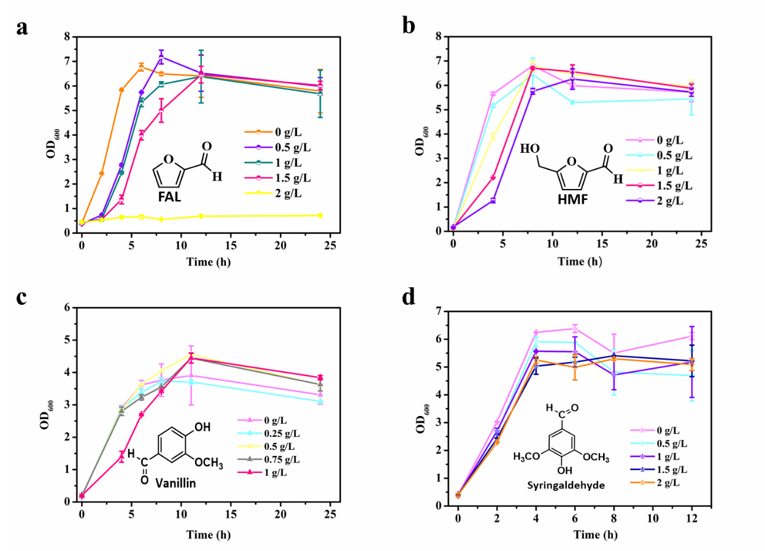
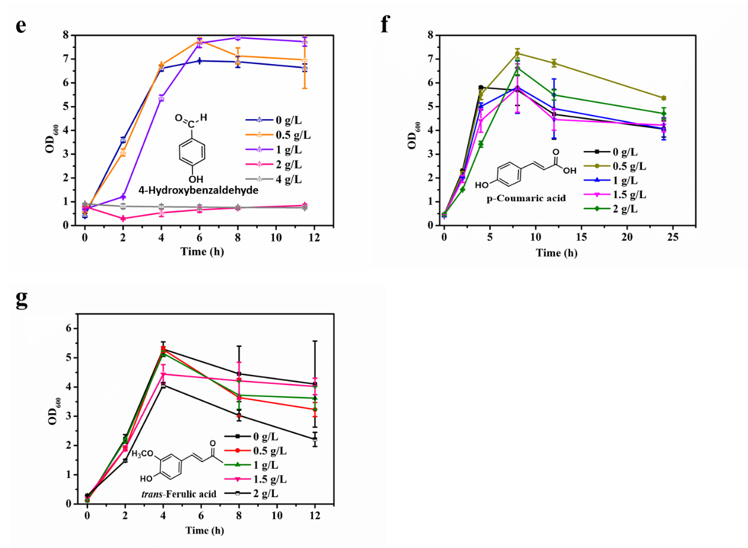
Fig. S1. Inhibition of furan aldehydes and phenolics on the growth of P. putida KT2440. FAL (a), HMF (b), Vanillin (c), Syringaldehyde (d), p-Hydroxybenzaldehyde (e), p-Hydroxybenzaldehyde (e), p-Coumaric acid (f), trans-Ferulic acid (g). All the experiments were conducted at least in duplicate, and the values were expressed as mean ± standard deviations.

Table S1. During the detoxification process of engineered P. putida, the changes of main fermentable sugars in 30%(v/v) hydrolysate.
Time  (h) | Concentration (g/L)
Time  (h) | Glucose | Xylose | Arabinose
0 | 6.7±0.1 | 36.5±0.3 | 4.0±0.0
12 | 6.5±0.0 | 35.2±0.1 | 4.0±0.0
24 | 6.5±0.2 | 35.2±0.9 | 4.6±0.9

Table S2. The change of total phenol content in 30%(v/v) hydrolysate with or without detoxified strain.
Time (h) | Experiment (g/L) | Control (g/L)
0 | 1.6±0.0 | 1.6±0.0
12 | 1.3±0.0 | 1.68±0.0
24 | 1.2±0.0 | 1.59±0.0
Experiment: Addition of detoxifying strains.
Control: No detoxified strain was added.

Table S3. Plasmids and primers used in construction of the gcd and gtsABCD knockout strain of P. putida KT2440.
Name | Relevant characteristic
Plasmids
pEASY-Blunt | Cloning vector, Km^{r}, Amp^{r}
Blunt-Δgcd | pEASY-Blunt containing the fanking regions of gcd
Blunt-ΔgtsABCD | pEASY-Blunt containing the fanking regions of gtsABCD
pK18mobsacB | Allelic exchange vector, oriColE1 Mob⁺, lacZα, sacB; Km^{r}
pK18MS-Δgcd | The flanking regions of gcd gene were inserted into pK18mobsacB
pK18MS-ΔgtsABCD | The flanking regions of gtsABCD gene were inserted into pK18mobsacB
Primers | Sequence (5’ → 3’)
gcd-up.f | GGAATTCGCGGCAGTGCCGAGGTGTCGAAGTGGCGGTGG (EcoR I)
gcd-up.r | GGCCTGAAGATCCAGAGCAGTTTCTAACCCGCGACACCGCTCCC GCAGGCTCAACCCTGAGG
gcd-down.f | GGGTTAGAAACTGCTCTGGATCTTCAGGCC
gcd-down.r | CGGGATCCGTCAGCCGGCCGCCCTCAGCGGCGCCGCCT (BamH I)
gtsABCD-up.f | GGAATTCGCATTGTTCGACACAGCCTG (EcoR I)
gtsABCD-up.r | TTATTGATGGTGTAGACGAGCGGAGCACCTTTCTTGTTGT
gtsABCD-down.f | CTCGTCTACACCATCAATAA
gtsABCD-down.r | CGGGATCCGTCGAAGTACTTCTGCTTGA (BamH I)

