Figure S1

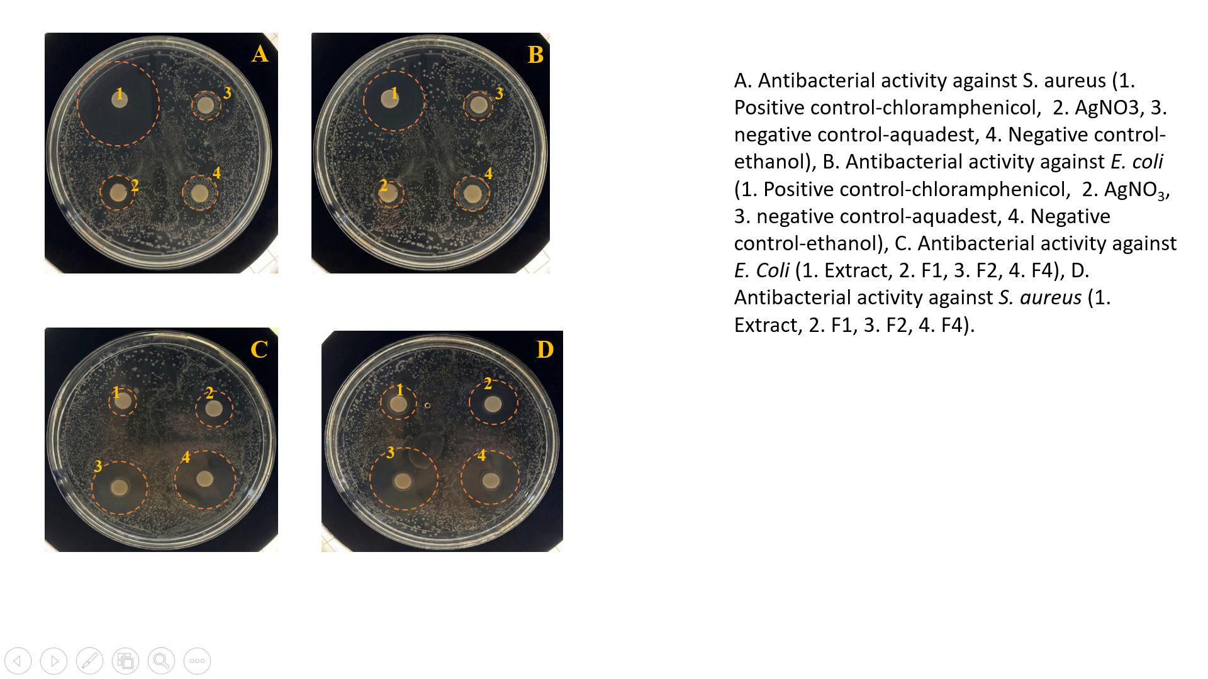

Figure S1. A. Antibacterial activity against S. aureus (1. Positive control-chloramphenicol, 2. AgNO₃, 3. negative control-aquadest, 4. Negative control-ethanol), B. Antibacterial activity against E. coli (1. Positive control-chloramphenicol, 2. AgNO₃, 3. negative control-aquadest, 4. Negative control-ethanol), C. Antibacterial activity against E. Coli (1. Extract, 2. F1, 3. F2, 4. F4), D. Antibacterial activity against S. aureus (1. Extract, 2. F1, 3. F2, 4. F4).

