Supplementary
Fig S1.
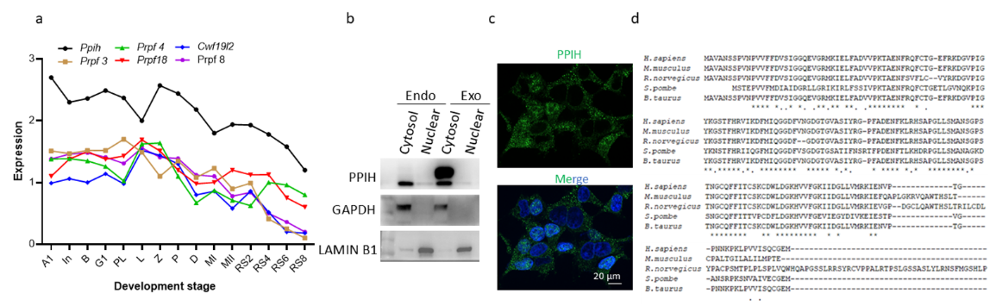
Supplementary Fig. 1: Analyzing spliceosome gene expression and localization. a. The expression level of spliceosome components from published single-cell sequence data. b. Nuclear and cytosol dissociation of HEK 293 cells and in vitro PPIH-Flag plasmid transfection indicated that PPIH was localized in the cytosol in human cells as well. Lamin B1 as a nuclear marker and β-Tubulin as a cytosol marker. c. IF stain additionally proved the cytosol localization of PPIH. d. Aligning the sequence of PPIH from different species reveals that PPIH is a highly conserved protein.
Fig S2.
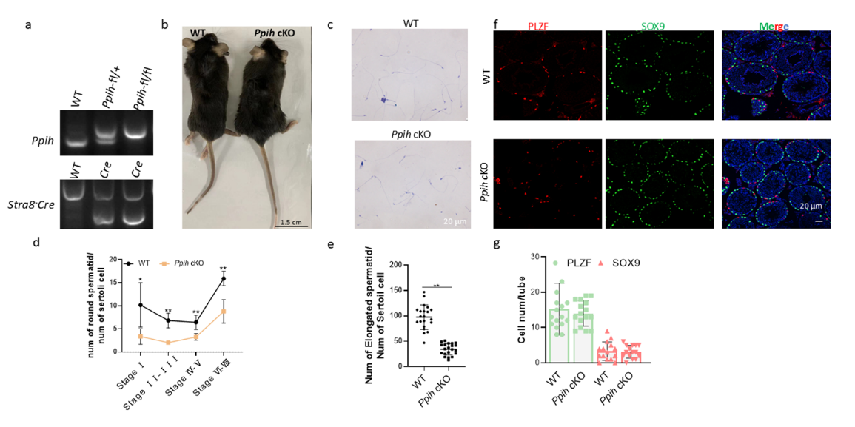
Supplementary Fig. 2 Genotype and phenotype of Ppih CKO mice. a. Verification of the Ppih mutations at the DNA level. b. The outlook of littermate WT and Ppih cKO male mice. c. The morphology of spermatozoa from WT and Ppih cKO cauda epididymis. d. Quantification of round spermatids and Sertoli cells at different stages of WT and Ppih cKO seminiferous tubules (n = 3 independent experiments). e. Quantification of elongated spermatids and Sertoli cells in WT and Ppih cKO seminiferous tubules (n = 3 independent experiments); f. Immunofluorescence staining of PLZF (Red), SOX9 (Green), and DAPI (blue) in testis sections of WT and CKO mice. g. Counting the number of PLZF-positive or SOX9 positive cell (n = 3 independent experiments).
Fig S3.
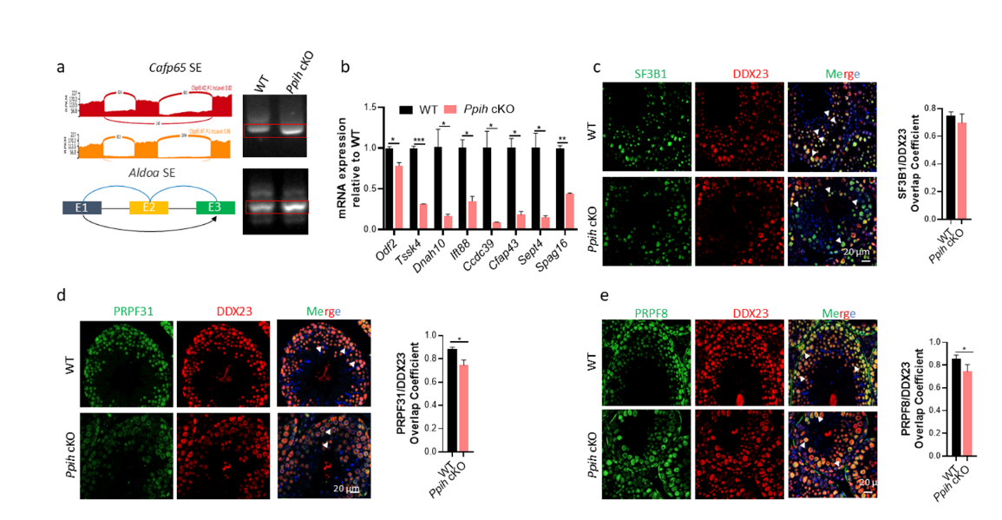
Supplementary Fig. 3 PPIH regulates alternative splicing of cilium mRNA by affecting spliceosome assembly. a. RT-PCR analyses of alternative splicing of sperm motility and sperm flagellum (Cfap65, Aldoa) genes between WT and Ppih cKO round spermatids. Visualization of the differentially spliced genes is shown using the Integrative Genomics Viewer (IGV). b. Real-time qPCR analysis of genes with aberrant alternative splicing in WT and Ppih cKO round spermatids. Data are expressed as mean ± SD of at least three independent experiments. c. Immunohistochemistry of WT and Ppih cKO testicular sections indicated that the colocalization of SF3B1/DDX23 was not affected by Ppih deletion. d. Immunohistochemistry of WT and Ppih cKO testicular sections. SF3B1/DDX23, PRPF8/ DDX23, and PRPF31/DDX23 were colocalized in WT, while the colocalization of PRPF8/DDX23 and PRPF31/DDX23 was significantly reduced in Ppih cKO testicular sections. What’s more, the expression of PRPF4, PRPF8, and PRPF31 was obviously decreased in Ppih cKO mice. The overlap coefficient was analyzed by ImageJ.

Table S1.
Supplementary Table 1. Antibodies used in this study
Antibodies | Species | application | Concentration | Company source | Cat #
PPIH | Rabbit | IF/WB/RIP | 1:100/1:2000 | Genetex | GTX118224
PRPF3 | Rabbit | IF/WB | 1:100/1:3000 | Proteintech | 10106-1-AP
PRPF6 | Rabbit | IF/WB | 1:200/1:4000 | Proteintech | 23929-1-AP
PRPF8 | Rabbit | IF/WB | 1:200/1:4000 | Proteintech | 11171-1-AP
PRPF18 | Rabbit | IF/WB | 1:200/1:4000 | Sino biological | 204414-T36
PRPF31 | Rabbit | IF/WB | 1:200/1:4000 | Proteintech | 27750-1-AP
DDX23 | Rabbit | IF/WB | 1:400/1:4000 | Proteintech | 10199-2-AP
HRP Goat anti-mouse IgG | Goat | WB | 1:5000 | Proteintech | SA00001-1
HRP Goat anti-rabbit IgG | Goat | WB | 1:5000 | abclonal | AS028
Dylight 488 Goat anti-mouse IgG | Goat | IF | 1:500 | Abbkine | A23210
Dylight 594 Goat anti-rabbit IgG | Goat | IF | 1:500 | Abbkine | A23420
Alexa FluorTM 488 Goat anti-mouse (H+L) | Goat | IF | 1:500 | proteintech | RGAM002
Alexa FluorTM 488 Goat anti-rabbit (H+L) | Goat | IF | 1:500 | proteintech | SA00013-2
Alexa FluorTM 594 Goat anti-mouse IgG (H+L) | Goat | IF | 1:500 | abclonal | AS008
Alexa FluorTM 594 Goat anti-rabbit IgG (H+L) | Mouse | RIP | 1:500 | proteintech | RGAM004
Lamin B1 | Rabbit | WB | :5000 | Invitrogen | 702972
GAPDH | Rabbit | WB | 1:4000 | Proteintech | 60004-1-Ig
γH2AX | Rabbit | IF | 1:1000 | Abcam | ab81299
γH2AX | Mouse | IF | 1:1000 | Merck | JBW301
β-TUBULIN | Mouse | IF | 1:100 | PTG | AP0687
Lectin PNA from Arachis hypogaea (peanut), Alexa Fluor® 488 conjugate |  | IF | 1:1000 | Invitrogen | L-21409
HA | Rabbit | WB | 1:4000 | Proteintech | 51064-2-AP
Flag | Mouse | WB | 1:4000 | Proteintech | 66008-4-Ig
ACSL5 | Rabbit | IF | 1:100 | Proteintech | 15708-1-AP
DOCK5 | Rabbit | WB | 1:1000 | Proteintech | 29938-1-AP
TSSK4 | Rabbit | IF/WB | 1:100/1:2000 | Proteintech | 29938-1-AP
SEPT4 | Rabbit | IF/WB | 1:100/1:2000 | Proteintech | 12476-1-AP
IFT88 | Rabbit | IF/WB | 1:100/1:2000 | Proteintech | 13967-1-AP
ODF2 | Rabbit | IF/WB | 1:100/1:2000 | Proteintech | 12058-1-AP
SF3B1 | Rabbit | IF/WB | 1:100/1:2000 | Proteintech | 27684-1-AP

Table S2.
Supplementary Table 2. Primers used in this study
Name | Sequence
Primers used for qPCR
Ppih | Forward: TGAGGAAGATCGAGAATGTTCCC
Ppih | Reverse: CCACACTGTGAGATCACCACT
Prpf3 | Forward: CTCTCCGATTTGTGGATAAGCTG
Prpf3 | Reverse: ACCTCCTTTAACTCTCGCTTTCT
Prpf4 | Forward: TCCTCCACGACAACCAAAACC
Prpf4 | Reverse: TCTTTTCCCAAAATCCCAGACTC
Prpf6 | Forward: GGCTTCACCACCCGATCAG
Prpf6 | Reverse: GGCCCACTTGAGAAGAGGC
Prpf8 | Forward: CCGCTGCCGGATTATATGTCA
Prpf8 | Reverse: TCCTTCTGAGCATCCACAAAC
Prpf18 | Forward: CATCCTGAAATCCGAGATTCTGC
Prpf18 | Reverse: AGCCACATCTTTCGTAATACGC
Prpf31 | Forward: GCATTGCCAAGCTATGGGAC
Prpf31 | Reverse: AATGACTCGGTACTCAGGAGC
Sf3b1 | Forward: GTGGGCCTTGATTCCACAGG
Sf3b1 | Reverse: GGCTTCTTCTGACCGAGCAA
Acsl5 | Forward: TCCTGACGTTTGGAACGGC
Acsl5 | Reverse: CTCCCTCAATCCCCACAGAC
Odf2 | Forward: GCCAGGTGGAGTCGAATCTG
Odf2 | Reverse: GTTCGGCTGACGTGAAGGAG
Ift88 | Forward: TGAGGACGACCTTTACTCTGG
Ift88 | Reverse: CTGCCATGACTGGTTCTCACT
Sept4 | Forward: ACGGAATCGCAACAAACTGAC
Sept4 | Reverse: TCTTTCTCCCGGATTAGCTTCTC
Tssk4 | Forward: CGCCAATCTACCAAGCGTG
Tssk4 | Reverse: TGCCGTTTAGCAGAGCTGG
Dock5 | Forward: CCTGGAACCCCTGTTTGAAC
Dock5 | Reverse: GCAATGACTTGTGATTTGCTCAG
Ccdc39 | Forward: GAGCGAAGAACATTTTAAGGCCA
Ccdc39 | Reverse: TTCAAGTCATCCAGCTTTTGAGT
Pacrg | Forward: CTGCCACAACAGACGTTCCA
Pacrg | Reverse: ATTTTCGGAAAGTGGTGGGTT
Cfap43 | Forward: GACGGTGGATGGCTATGTCT
Cfap43 | Reverse: TTTGAGGGTCTGGCATCGAT
Dnah | Forward: CTGACCTGGTCCTCGCTAAT
Dnah | Reverse: GCCGCTATCTGACAAGGAGA
Spag16 | Forward: CATACGGCATGGTTGTGTCC
Spag16 | Reverse: AGCAAGTTGGCTACCTCAAGT
Catsperg1 | Forward: GAGCACACTCTTCATTCGACA
Catsperg1 | Reverse: GAAGGACACGAGGCCATCTG
Catsperg2 | Forward: CCATGTGCGTCCTGAACTG
Catsperg2 | Reverse: CCTTTTCTTGGATACGAAGGGC
U2af1 | Forward: TCGGAGCATGTCGTCATGG
U2af1 | Reverse: GGAAGAGTTTTGAGGGTTACGG
Dync2h1 | Forward: GGAAGCCTCGGAGATGTCC
Dync2h1 | Reverse: GTTCCCGTCGTCCAAGAAGTT
Dock5 | Forward: CCTGGAACCCCTGTTTGAAC
Dock5 | Reverse: GCAATGACTTGTGATTTGCTCAG
Thbs1 | Forward: GGGGAGATAACGGTGTGTTTG
Thbs1 | Reverse: CGGGGATCAGGTTGGCATT
Abcc1 | Forward: CACCCCAAGGACTACCAATCA
Abcc1 | Reverse: GAAGGAGGTCTAGCAGTGGGA
Pik3cd | Forward: GTAAACGACTTCCGCACTAAGA
Pik3cd | Reverse: GCTGACACGCAATAAGCCG
Irs2 | Forward: CTGCGTCCTCTCCCAAAGTG
Irs2 | Reverse: GGGGTCATGGGCATGTAGC
Rasa2 | Forward: TGGGTGCGATAAACTTCTTCC
Rasa2 | Reverse: GACAGTCGTGAGGTCCGAG
Primers used for Ppih cKO genotyping
Ppih | Forward: TGTATTGCAGAAACGATGCCAAG
Ppih | Reverse: CTAGCAACGGTAACTAGCAAAGC
Stra8-Cre | Forward: ACTCCAAGCACTGGGCAGAA
Stra8-Cre | Reverse1: GCCACCATAGCAGCATCAAA
Stra8-Cre | Reverse2: CGTTTACGTCGCCGTCCAG
Primers used for alternative splicing validation
Cfap65-ES | Forward1: GGTACCATCCACCCTAACGA
Cfap65-ES | Forward2: AAAAGACCAAACCCCAAGCC
Cfap65-ES | Reverse: GCTTGACTTCCTGGCTGTTC
Aldoa-ES | Forward1: ATCCTGGCTGCAGATGAGTC
Aldoa-ES | Forward2: AGAACACCGAGGAGAACAGG
Aldoa-ES | Reverse: TGGGTAGTTGTCTCGCCATT
Ift88-ES | Forward1: CTATAAGAAGCTGAACCGTC
Ift88-ES | Forward2: CCCAAGCTCTGTCTAAACTG
Ift88-ES | Reverse: CCCAAGCTCTGTCTAAACTG
Tssk4-IR | Forward: GGTGGCAAGGCTTTAAGAGG
Tssk4-IR | Reverse1: ACTACTCTGGTGAAAGGGGC
Tssk4-IR | Reverse2: CTCGAGCAGCCTGATTTCAT
Sept4-A5SS | Forward: AGGATTTGGGGATGCAGTCA
Sept4-A5SS | Reverse: TTTGCATTTCTTTCGGTCCAC
Catsperg1-ES | Forward: TCCCCAAGGAGTCCACCATC
Catsperg1-ES | Reverse: CTCTGTGCGTGATGCATGCT
Catsperg2-IR | Forward: GTCGCACACTGAACACCATC
Catsperg2-IR | Reverse: CTTTTTGTCCTCGGTGGTCC
Dync2h1-IR | Forward: GCTATGTCCCTCATCCATGG
Dync2h1-IR | Reverse: GTTCTGCAGGTGCAATGATC
U2af1-ES | Forward: CGTAATCCCCAAAACAGTGC
U2af1-ES | Reverse: CTCATCATAGTGCTCCTGCA
ALL original and uncropped films of Western blots
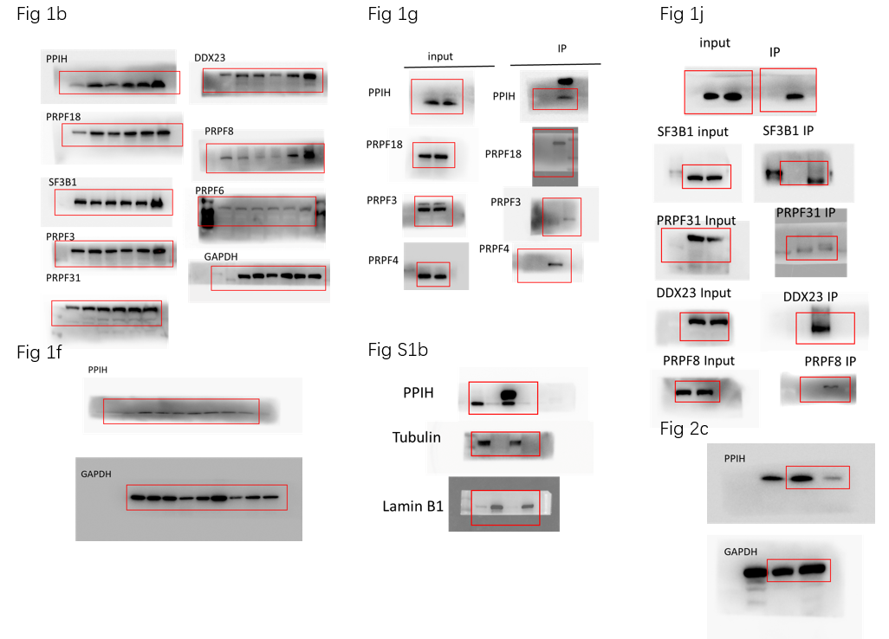
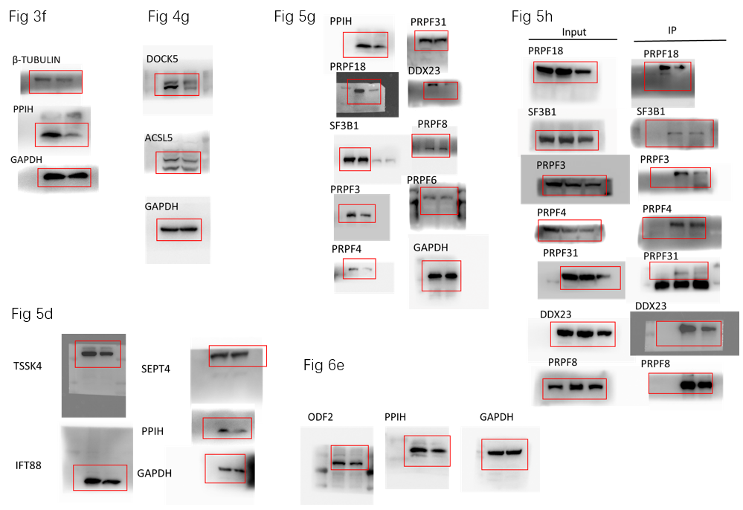
ALL original and uncropped films of PCR gels
