SUPPLEMENTARY INFORMATION
Suppl. Methods. A detailed description of patients’ clinical data, immunoblotting assays and K-ε-GG profiling and proteome analysis by liquid chromatography–mass spectrometry (LC-MS).
Figure S1. Tumor samples available and USP9X IHC along time for the three patients.
Figure S2. Patient 1 somatic mutations in longitudinal tumor samples.
Figure S3. Distribution of USP9X mutations along the gene.
Figure S4. Western blot analysis of USP9X depleted cells shows no major alteration in mTOR pathway.
Figure S5. Global ubiquitinome analysis in Hela and 786-O cell models.
Figure S6. Model depicting loss of USP9X and increased mTOR inhibitor sensitivity through p62 ubiquitination.
Table S1. List of somatic variants leading to non-synonymous coding or loss-of-function (LOF) variants in patients 1, 2 and 3 detected by WES.
Table S2. Quantitative K-ɛ-GG site analysis for HeLa and 786-O control and USP9X depleted cells.

SUPPLEMENTARY METHODS
Patients
The first patient (Patient 1) was a 34-years old woman diagnosed with a chRCC (10.5 cm tumor in the right kidney) stage IV due to retroperitoneal lymh nodes, multiple lung nodules and a lesions in the proximal right femur diaphysis. After 15 months of temsirolimus treatment at a standard dose of 25 mg/m² weekly intravenous, the renal tumor volume decreased by 80% and there was a complete response in all metastatic lesions. Nephrectomy was performed and the patient continued temsirolimus treatment for 39 months during which she was disease free. Twenty months after stopping temsirolimus an abdominal CT scan showed retroperitoneal relapse, so a lymph node dissection was performed and the diagnosis of metastasis was confirmed. Thirty eight months after the surgery the metastasis of the right femur was again detected and temsirolimus treatment was started. Thirteen months later a complete response was obtained. The patient stopped temsirolimus treatment after 13 more months and she is currently disease free, 13 years after the initial diagnosis. A detailed description of the initial response to temsirolimus has been published ¹.
The second patient (Patient 2) was a 49 years old man diagnosed with a localized chRCC, that 15 years after the nephrectomy developed a retrovesical/ perirectal mass confirmed to be chRCC. After partial exeresis of the tumor the patient started temsirolimus treatment at a standard dose. Radiologic response was observed by pelvic MRIs, and temsirolimus treatment continued for 23 months. At that point, complete resection of the lesion was achieved, and local radiotherapy was applied. The patient was disease free for 52 months after the surgery when a peritoneal implant near the liver parenchyma (30 mm), a periureteral implant and lessions in contact with the ipsilateral psoas were detected. The patient started temsirolimus treatment again and 3 months later a decrease in the perihepatic lesion is observed. In addition a grade 2 pneumonitis caused by temsirolimus was treated with corticoids. After 1 year of treatment, response is maintained and temsirolimus treatment stops. Twenty months later, growth of the left periureter implant is detected, after 5 months a left ureterolysis plus metastatis exeresis is performed. At the moment, 8 months after the last surgery some implants <10 mm (perihepatic abdominal and lumbar fossa) are observed, and monitoring of the patient continues without considering temsirolimus treatment unless significant clinical progression is detected.
The third patient (Patient 3) was a 68 years old woman that underwent nephrectomy and local radiotherapy due to a pT3a grade 4 chRCC. Forty two months later a retroperitoneal lymph node metastasis was detected, after 9 months of sunitinib treatment retroperitoneal lymp node dissection was performed. One year later new retroperitoneal adenopathies were detected with a slow growth and emergence of new supraclavicular lymph nodes. Temsirolimus treatment started at a standard dose of 25 mg/m² weekly and achieved a partial response (35% reduction in tumor size per RECIST v1.1, at 4 months of treatment) but toxicity required dose reduction to 20 mg/m², and then suspension of temsirolimus after 1 year of treatment. Eleven months later, an increase of supraclavicular lymph node size was detected, so a surgery and local radiotherapy was performed. Five months later, because of retroperitoneal progression, temsirolimus was started at 20 mg/m² weekly. Temsirolimus was administered for 14 months with stabilization of disease as best response, but during this time the toxicity required a dose reduction to 15 mg/m². Later on, the patient stopped temsirolimus treatment due to mobility problems derived from osteoporotic bone fractures and her deteriorated performance status.
Immunoblotting
Cells were washed two times in PBS and lysed with RIPA buffer supplemented with proteases and phosphatases inhibitors (1 h at 4°C). 30 µg of protein extracts were subjected to SDS-PAGE electrophoresis, transferred to PDVF membrane and phospho- and total proteins were detected using the antibodies in the table below. Signal was detected with on a ChemiDocTM MP Imaging System (BioRad) machine using HRP-bounded secondary antibodies and Luminata Classico Western HRP Substrate (Milipore) or SuperSignal West Femto Maximum Sensitivity Substrate (Thermo Scientific).
Protein | Origin | Mono/poli | Reference | Company
GAPDH | Mouse | Monoclonal | FF26A | CNIO Monoclonal antibody Warehouse
USP9X | Rabbit | Monoclonal | ab19879 | Abcam
pS6K1 Thr 389 | Rabbit | Monoclonal | #9234 | Cell Signaling
Total S6K1 | Rabbit | Monoclonal | #9202 | Cell Signaling
pS6 Ser235/236 | Rabbit | Monoclonal | #2211 | Cell signaling
Total S6 | Mouse | Monoclonal | #2317 | Cell Signaling
Akt Ser 473 | Rabbit | Monoclonal | #4060 | Cell Signaling
Raptor | Rabbit | Monoclonal | #2280 | Cell Signaling
p62 SQSTM1 | Mouse | Monoclonal | Clon3 | BD Biosciences
LC3B | Rabbit | Monoclonal | #2775 | Cell Signaling
Ubiquitin | Rabbit | Polyclonal | #3933 | Cell Signaling

K-ε-GG profiling and proteome analysis by liquid chromatography–mass spectrometry (LC-MS)
Sample preparation. Cells were collected after washing two times in PBS. Pellets were lysed in cold lysis buffer (8 M urea, 50 mM Tris, pH 8, and 150 mM NaCl) plus protease inhibitors (Roche Applied Science). The lysate was cleared by centrifugation at 20,000g for 10 min at 4 °C. 1 mg of total protein was used per condition. Proteins were reduced for 1 h with 1 mM DTT at 40 °C and subsequently alkylated for 30 min with 5.5 mM 2-chloroacetamide (Sigma) at RT in the dark. Lysates were diluted 1:1 with 50 mM Tris HCl, pH 8, and proteins were digested for 2 h with Lys-C from Acromobacter lyticus M497-1 (Wako) (enzyme/substrate ratio of 1:100) at 25 °C. Samples were further diluted 1:5 with 25 mM Tris, pH 8, and proteins were digested overnight at 37 °C with sequencing-grade trypsin (Promega). Digests were quenched with TFA, and the peptide solutions were cleared by centrifugation. Peptides were desalted with 50 mg C18 SepPak SPE cartridges (Waters). Samples were dried completely with vacuum centrifugation.
Immunoprecipitation of di-Gly–containing peptides. Enrichment of K-ε-GG peptides was performed with the PTMScan ubiquitin remnant motif (K-ε-GG) kit (Cell Signaling Technology, cat. no. 5562) containing anti–K-ε-GG antibody cross-linked to protein A beads. Digested proteins were resuspended in 750 μl of immunoaffinity purification (IAP) buffer (50 mM MOPS, pH 7.4, 10 mM Na2HPO4, and 50 mM NaCl) and centrifuged at maximal speed for 5 min. Enrichment was completed as previously described71. The supernatants were mixed with 20 μl of anti–K-ε-GG antibody beads and incubated for 1 h at 4 °C with rotation. Beads were washed twice with 1 ml of ice-cold IAP buffer, and this was followed by three washes with ice-cold PBS. K-ε-GG peptides were eluted from the antibody with 2 × 50 μl of 0.15% TFA. For proteome analysis, 1% of the flow through from each IAP was used. Samples were desalted with StageTips conditioned by washing with 50 μl of 50% MeCN/0.1% formic acid (FA) followed by 2 × 50 μl of 0.1% FA. Samples for K-ε-GG and proteome analysis were loaded on StageTips, washed twice with 50 μl of 0.1% FA and eluted with 50 μl 50% MeCN/0.1% formic acid (FA). Eluted peptides were dried completely with vacuum centrifugation. Samples were reconstituted in 3% MeCN/0.1% FA.
Mass spectrometry analysis. All samples were analyzed with an LTQ-Orbitrap Velos mass spectrometer (Thermo Scientific) coupled to a nanoLC Ultra system (Eksigent) equipped with a nanoelectrospray ion source (Proxeon Biosystems). For K-ε-GG and proteome samples, 5–10 μl and 5–20 μl, respectively, were injected into the mass spectrometer. Samples were loaded onto a reversed-phase C18, 5 μm, 0.1 × 20 mm trapping column (NanoSeparations) and washed for 15 min at 2.5 μl/min with 0.1% FA. Peptides were eluted at a flow rate of 300 nl/min onto a homemade analytical column packed with ReproSil-Pur C18-AQ beads, 3 μm, 75 μm × 50 cm, heated to 45 °C. Solvent A was 4% ACN in 0.1% FA, and solvent B was acetonitrile in 0.1% FA. For K-ε-GG analysis, the following gradi-ent was used: 0–2 min, 2% B; 2–103 min, 6–35% B; 103–103.5 min, 35–98% B; 103.5–113.5 min, 98% B; and 114–120 min, 2% B. For proteome analysis, the following gradient was used: 0–2 min, 2% B; 2–133 min, 6–30% B; 133–133.5 min, 30–98% B; 133.5–143.5 min, 98% B; 144–150 min, 2% B.
The MS acquisition times used for each K-ε-GG and proteome sample were 120 min and 150 min, respectively. The LTQ Orbitrap Velos was operated in data-dependent mode. The spray voltage was set to 1.8 kV, and the temperature of the heated capillary was set to 325 °C. The MS survey scan was performed in the FT analyzer, scanning a window between 350 and 1,500 m/z with a resolution of 60,000 FWHM at m/z 400. The m/z values triggering MS/MS with a repeat count of 1 were placed on an exclusion list for 60 s. The minimum MS signal for triggering MS/MS was set to 800 counts. In all cases, one microscan was recorded. The 15 most abundant isotope patterns with charge ≥2 from the survey scan were sequentially isolated with an isolation window of 1.5 m/z and fragmented in the linear ion trap (LTQ) by collision induced dissociation (CID) with a normalized collision energy of 35%. The Q value was 0.25, and the activation time was 10 ms. Maximum ion injection times for the survey scan and the MS/MS scans were 500 ms and 100 ms, respectively, and the ion target values were set to 1 × 106 and 5,000, respectively, for each scan mode.
Mass spectrometry data analysis. Both K-ε-GG–enriched data and proteome data were processed with the MaxQuant (version 1.5.1.2) package. Peak lists were searched against a human database (SwissProt canonical, 20,187 sequences, February 14 2014 release), and Andromeda was used as a search engine. The enzyme specificity was set to trypsin, the maximum number of missed cleavages was set to two, the precursor mass tolerance was set to 20 p.p.m. for the first search, and the tolerance was set to 6 p.p.m. for the main search. Carbamidomethylation of cysteines was searched as a fixed modifi-cation, and addition of glycine-glycine to lysine, oxidation of methionines and N-terminal acetylation of proteins were searched as variable modifications. For identification, the minimum peptide length was set to six, and the false discovery rate for peptide, protein, and side chain identification was set to 1%. Only peptide identifications with K-ε-GG localization probabilities ≥0.75 and score differences ≥5 were considered. In addition, diglycine sites localized to a C-terminal lysine residue of a peptide were considered to be false positives and were manually removed from the data set. Log2 ratios between the intensities of quantified UQ sites were estimated for USP9X-depleted/Wildtype. Global protein expression levels were used to normalize changes in the abundance of ubiquitin sites (log2 protein-normalized K-ε-GG (USP9X-depleted/Wildtype).

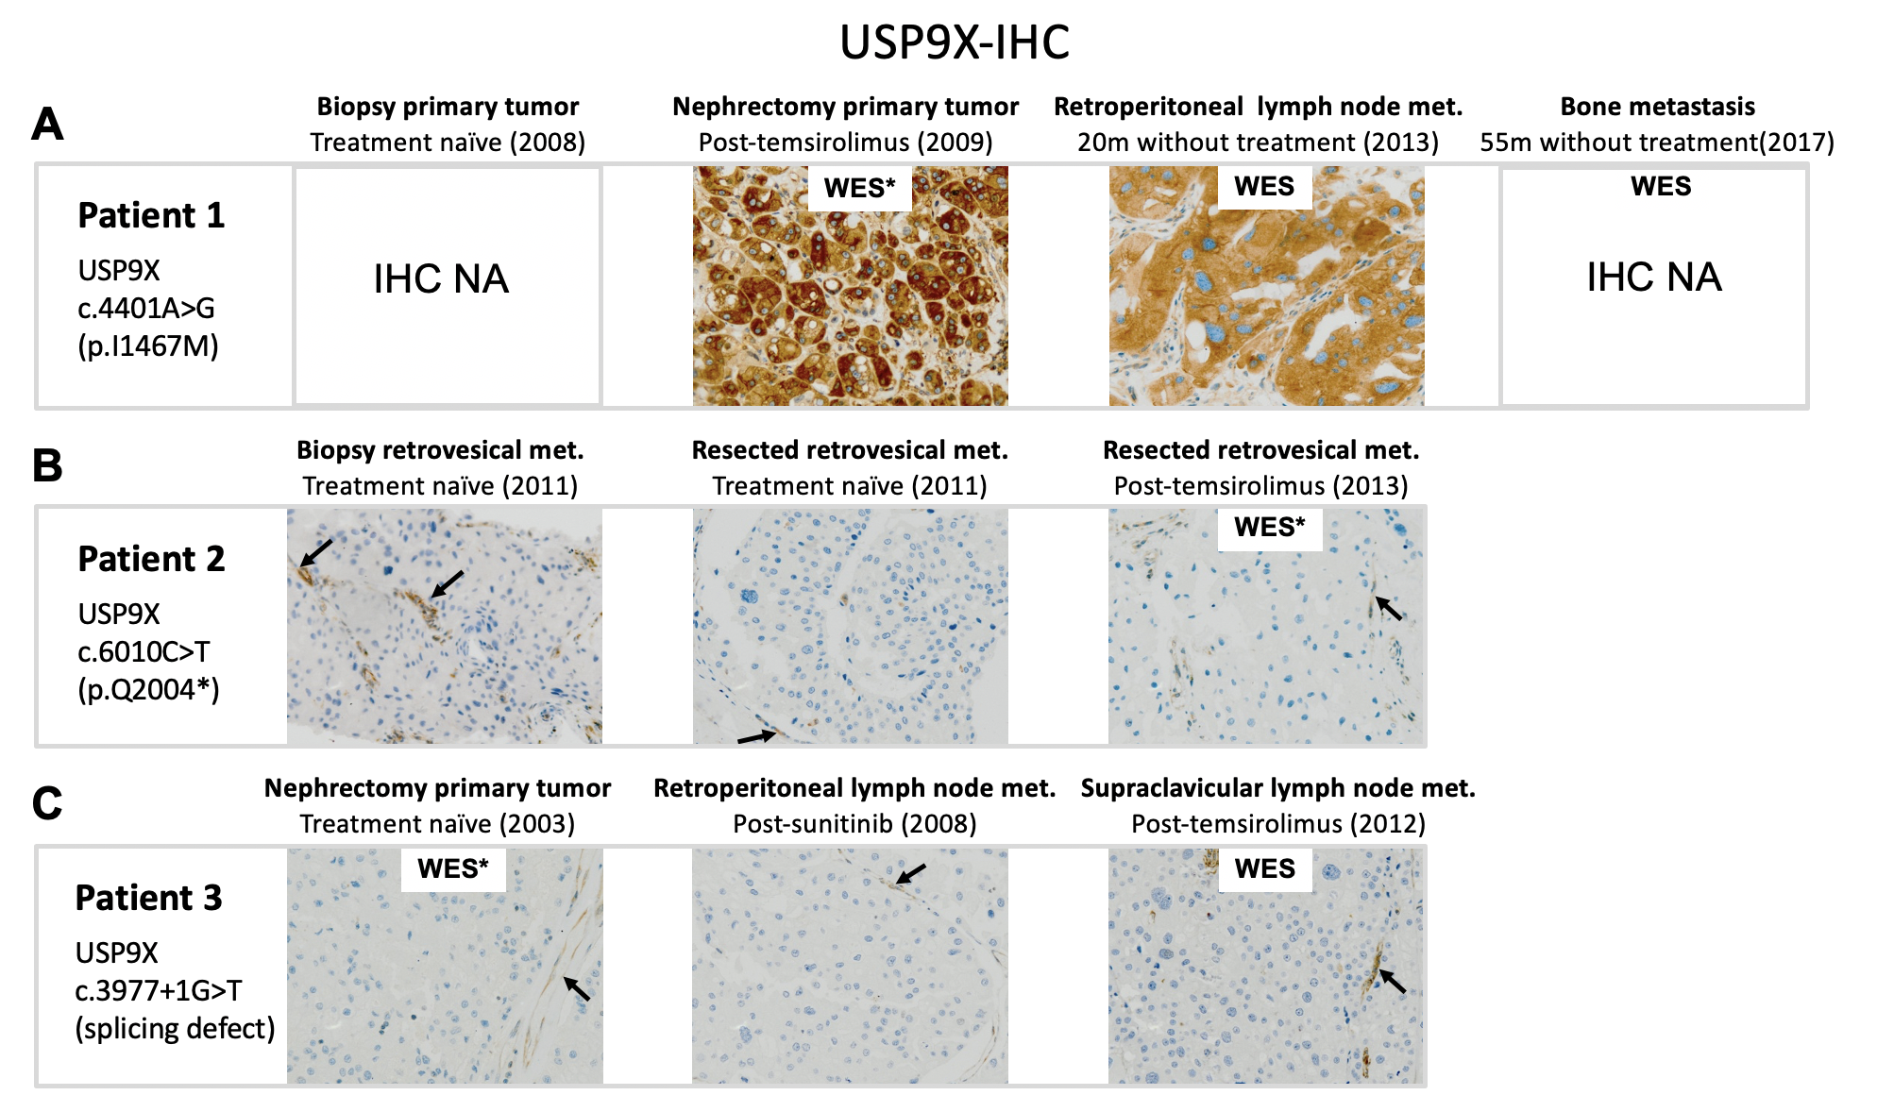
Figure S1. Tumor samples available and USP9X IHC along time for the three patients. A) Patient 1 has a positive IHC staining, in agreement with p.I1467M missense mutation, in the primary tumor and lymph node metastasis. B) Patient 2 (p.Q2004*) presented negative IHC staining in all tumor cells in the pre-treatment and post-treatment samples analyzed. C) Patient 3 (splicing defect c.3977+1G>T) presented negative staining in all tumor cells in the pre-treatment and post-treatment samples analyzed. Black arrows indicate non-tumor cells with positive staining. Tumor tissues obtained before treatment are indicated as treatment naïve, those obtained after treatment started and while it is ongoing are indicated as post-treatment, tumors that appeared after treatment stopped are indicated with the number of months without treatment. Tumor tissues in which WES could be performed are indicated by “WES”; an asterisk indicates the tumor tissues used to generate Figure 1 Venn diagram. Metastasis (met.).

Figure S2. Patient 1 somatic mutations in longitudinal tumor samples. A) Venn diagram showing the number of variants detected by WES in three tumor tissues available from patient 1. The initial diagnostic biopsy had insufficient tumor material to perform WES. B) The allele frequencies of USP9X and TSC2 somatic mutations in patient 1 remain constant along time. Sanger sequencing chromatograms show USP9X c.4401A>G, TSC2 c.5069-1G>C and TSC2 c.3200_3201delinsAA mutations, in different tumor samples corresponding to primary tumor pre-treatment, primary tumor post-treatment and two metastasis. Allele frequencies detected by next generation sequencing (NGS) are shown above the arrows, except for the initial biopsy in which NGS data is not available (NA). The year of surgery of the different lesions is shown in brackets.

Figure S3. Distribution of USP9X mutations along the gene. USP9X somatic mutations are represented along the protein with the ubiquitin C-terminal hydrolase (UCH) domain indicated as a green box. A) Mutations found in 84 chromophobe RCC patients described by Roldan-Romero (Roldan-Romero et al., 2020).B) Mutations in 65 chromophobe RCC tumors from TCGA-KICH. C) Mutations in PanCancer TCGA study including 10967 tumor samples (10953 individuals) across 32 tumor types.
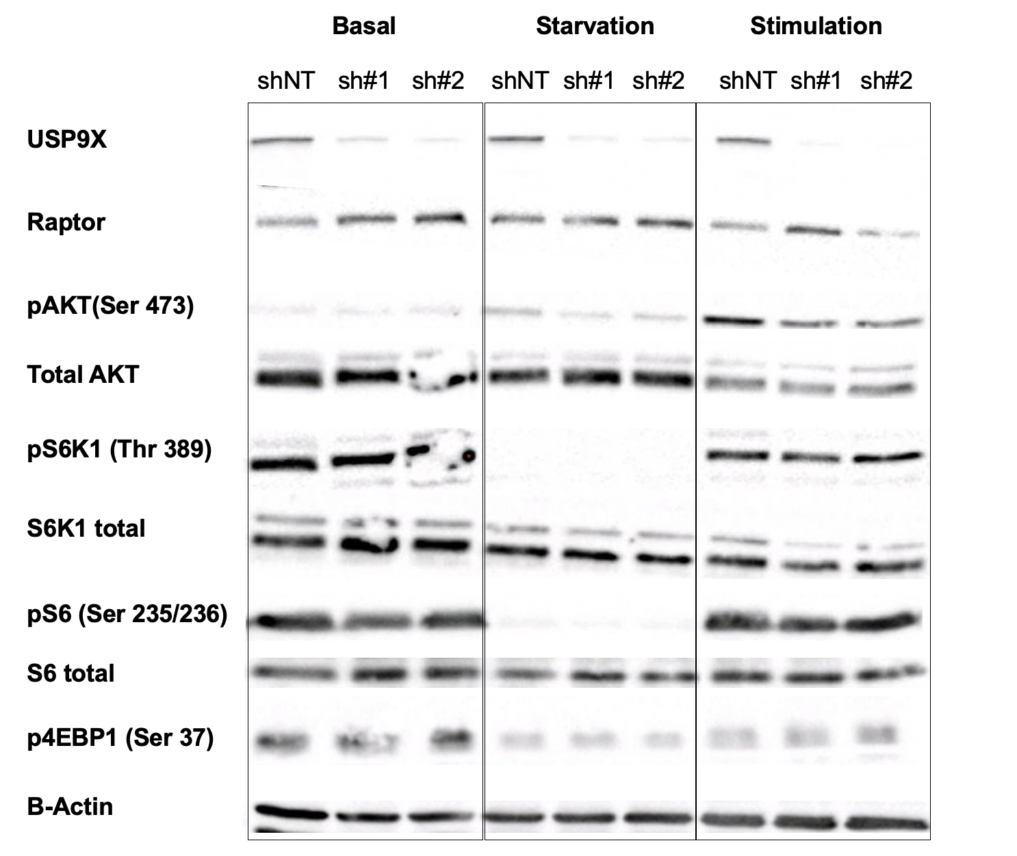
Figure S4. Western blot analysis of USP9X depleted cells shows no major alteration in mTOR pathway. Representative western blot images from HeLa cells expressing doxycycline‐inducible shRNAs targeting USP9X (sh #1, sh #2) or a non-target shRNA (sh NT) cultured in basal conditions (DMEM 10% FBS) (Basal), after double starvation (16h without FBS plus 1h in PBS) (Starvation) or stimulated with DMEM 20% FBS after double starvation (Stimulation).
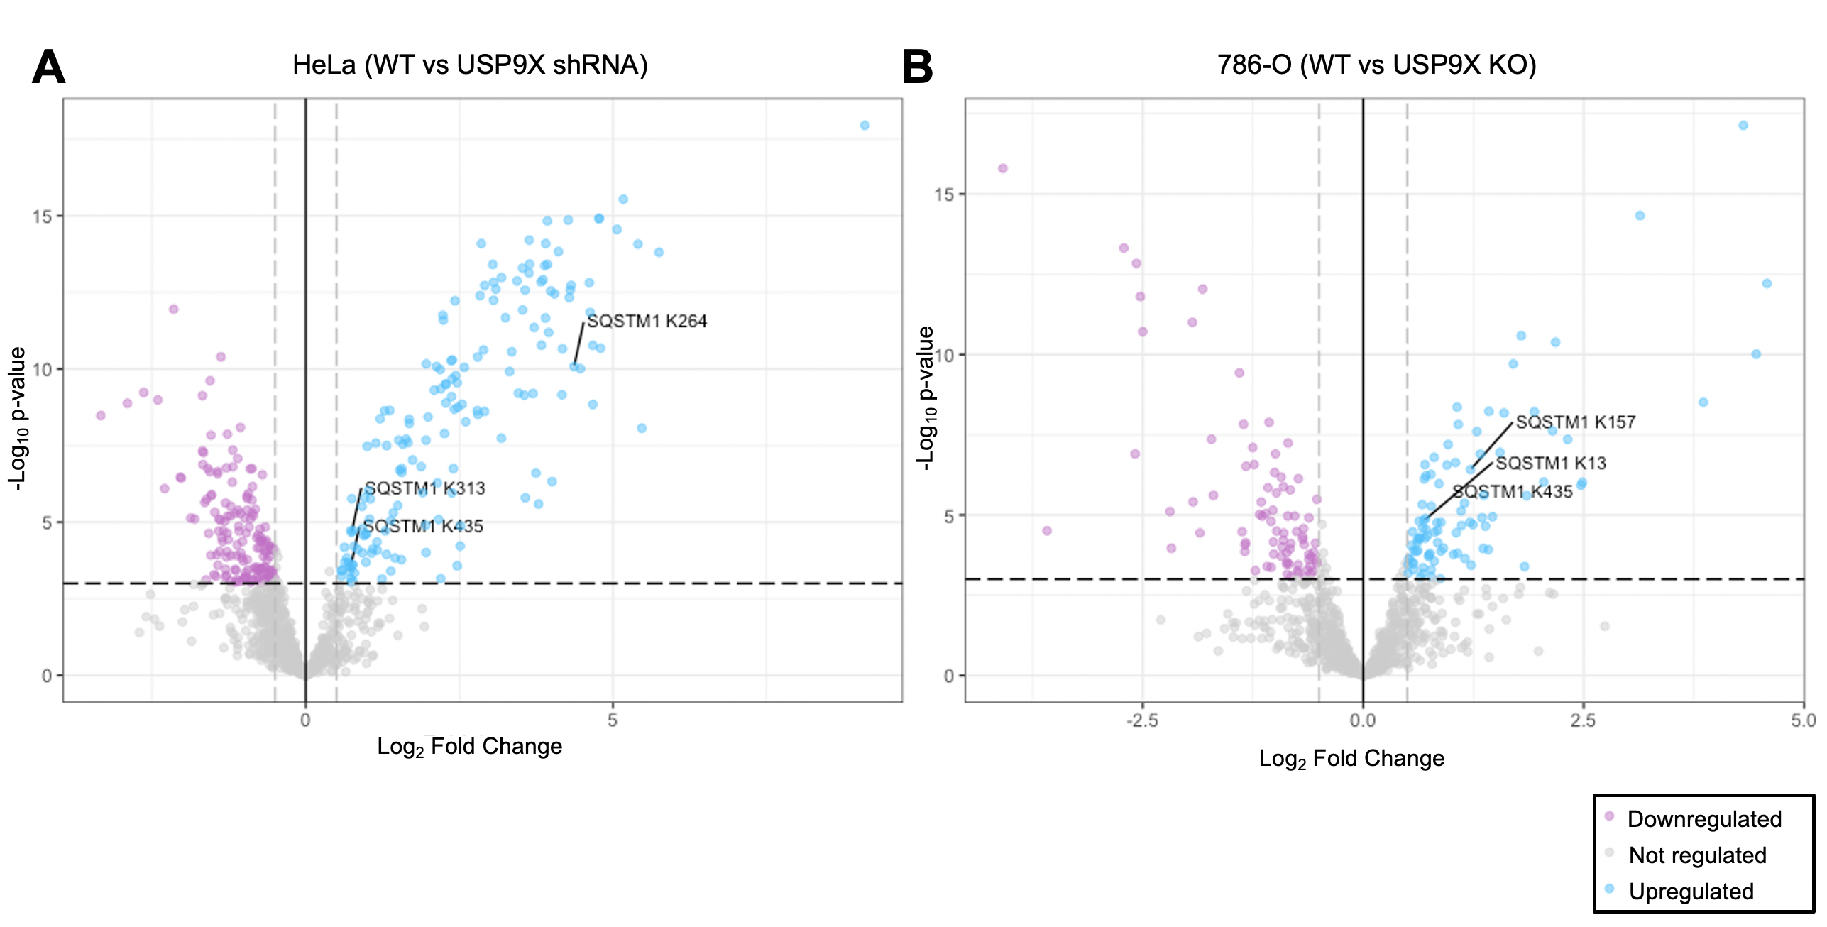Figure S5. Global ubiquitinome analysis in Hela and 786-O cell models. Ubiquitinated peptides upregulated or downregulated in USP9X depleted versus control cells are shown in Volcano-plots. Ubiquitinated peptides with statistically significant differential enrichment (≥±0.5-fold change, -log₁₀ p value ≥3) are represented with blue dots for increased (direct substrates) and purple dots for decreased quantities. A) Results for HeLa cells correspond to seven days of doxycycline induction using USP9X sh #1, #2 and #3 or of a non-target shRNA. The total number of ubiquitinated peptides detected was 1153 among which 315 had a significantly altered expression. B) Results for 786-O USP9X knockout clones (KO#1, KO#2, KO#3). The total number of ubiquitinated peptides detected was 942 among which 173 had a significantly altered expression.

Figure S6. Model depicting loss of USP9X and increased mTOR inhibitor sensitivity through p62 ubiquitination.

Table S1. List of somatic variants leading to non-synonymous coding or loss-of-function (LOF) variants in patients 1, 2 and 3 detected by WES. Figure 1 Venn diagram showing patients 1, 2 and 3 mutations correspond to the surgeries in 2009, 2013 and 2003, respectively.
Table S2. Quantitative K-ɛ-GG site analysis for HeLa and 786-O control and USP9X depleted cells. Log2-transformed intensities for each ubiquitinated peptide across samples was obtained using the median of 2 determinations for the control cells and each of the shRNAs or KO clones used with 2 technical replicates in all determinations. Sites with a p value < 0.001 and a log2 FC ratio >0.5 or <-0.5 were defined as regulated. FDR was 1.07% and 0.96% for HeLa and 786-O.

1. Maroto, P. et al. Biallelic TSC2 Mutations in a Patient With Chromophobe Renal Cell Carcinoma Showing Extraordinary Response to Temsirolimus. J Natl Compr Canc Netw. 16, 352-358 (2018).

