Appendix 1: Organisational Structural Orientation of the Comparative Framework
^{b} Sources: The literature (Malik, 2018)

Appendix 2: Patent Vocabulary Ratio in Exploratory and Exploitative Tech. Orientation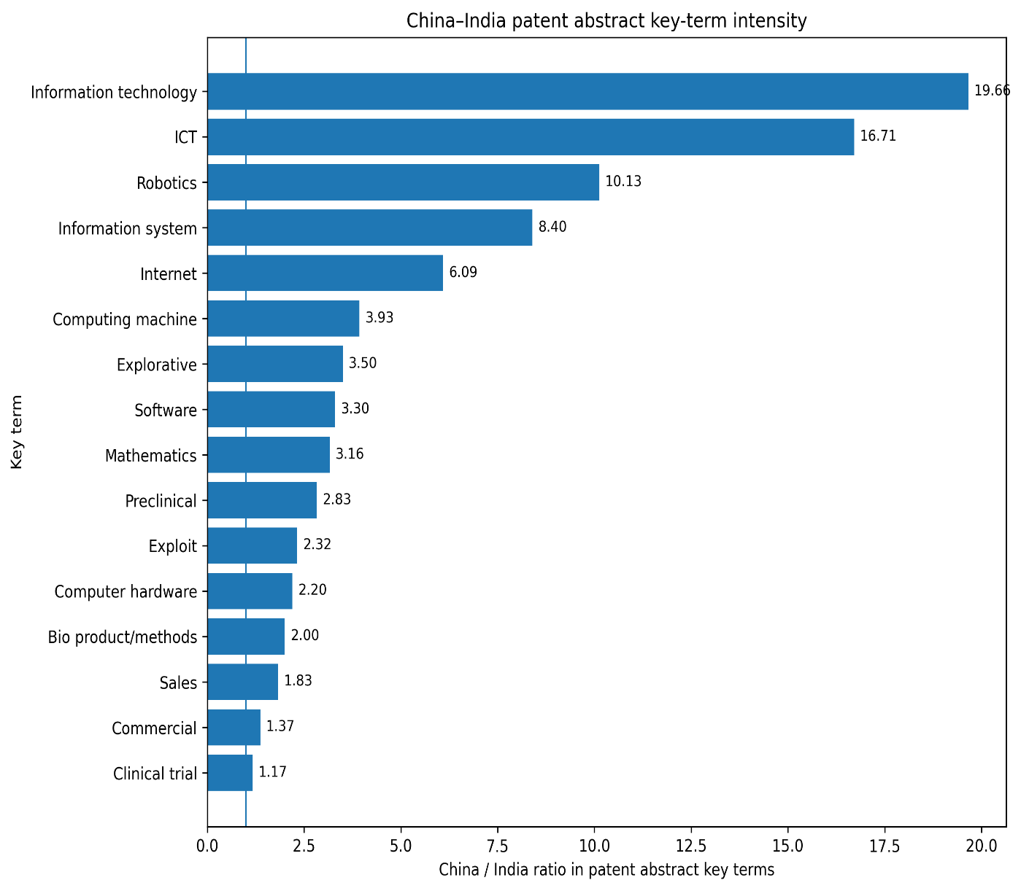

Appendix 3: China–India Ratios in OECD and International Partnership Structure