Supplementary data overview
Supplementary Note Detailed analysis of myostatin levels and the Olink and SomaScan discrepancy.
Supplementary Figures 1-4 Manhattan plots presenting the DXA-derived lean mass discovery meta-analyses in Iceland and UK Biobank (150,119 whole-genome sequenced, WGS) for arm, leg, trunk ant total lean mass.
Supplementary Figure 5 Regional plot presenting the association of the missense variant p.Ile225Thr with DXA-derived leg lean mass in the discovery meta-analysis of Iceland and UK Biobank.
Supplementary Figure 6 Carrier info for p.Ile225Thr in MSTN in main datasets.
Supplementary Figure 7 Global map presenting the allele frequency distribution of p.Ile225Thr (rs143242500-G).
Supplementary Figure 8 Associations of the MSTN p.Ile225Thr with body composition phenotypes with (left) and without (right) BMI adjustment.
Supplementary Figure 9 Associations of the MSTN p.Ile225Thr with cardiovascular quantitative traits.
Supplementary Figure 10 Associations of the MSTN p.Ile225Thr with dilated cardiomyopathy by cohorts.
Supplementary Figure 11 Manhattan plot presenting a GWAS of myostatin blood levels (N = 46,446).
Supplementary Figure 12 Regional plot presenting the association of the missense variant p.Ile225Thr with GWAS of myostatin blood levels (N = 46,446).
Supplementary Figure 13 Distribution of myostatin concentration measured using the R-PLEX Human GDF-8 Assay (Cat. K151ACER-2, Meso Scale Discovery) across 12 plates.
Supplementary Figure 14 Distribution of myostatin concentration measured using the GDF-8/Myostatin Quantikine ELISA (cat. DGDF80, R&D Systems) across 12 plates.
Supplementary Figure 15 Overview of plasma samples from genotyped Icelanders measured using R&D Systems (RD) and Meso Scale Discovery (MSD) platforms to evaluate the association of the MSTN p.Ile225Thr variant with increased myostatin levels observed on the Olink platform (OID20115), and to evaluate the discrepancy of Olink and SomasScan measurements.
Supplementary Figure 16 Pearson correlation of myostatin measurements across R&D Systems (RD), Meso Scale Discovery (MSD), Olink, and SomaScan platforms.
Supplementary Figure 17 Spearman correlation of myostatin measurements with R&D Systems Quantikine GDF-8 ELISA (RD) and Olink platform.
Supplementary Figure 18 Spearman correlation of myostatin measurements with R-PLEX Human GDF-8 Assay (Cat. K151ACER-2, Meso Scale Discovery) and Olink platform.
Supplementary Figure 19 Distribution of carrier–control comparisons for the MSTN p.Ile225Thr variant using RD, MSD and the MSD/RD ratio, with values adjusted for sex, age at sampling, and plate.
Supplementary Figure 20 Density distribution and Q-Q plots of carrier–control comparisons for p.Ile225Thr for RD, MSD and MSD/RD measurement ratio, each adjusted for sex, age at sampling, and plate.
Supplementary Figure 21 Regional plot presenting the association of the intergenic variant rs10201285-A (chr2:189940276) with creatinine blood levels (N = 144,075) in meta-analysis of the UK Biobank African cohort, NASHBio African cohort and the Million Veterans African (MVP) cohort.
Supplementary Figure 22 Regional plot presenting the association of the intergenic variant rs10201285-A (chr2:189940276) with myostatin blood levels (N = 1,505) in UK Biobank African cohort.

Supplementary Table overview (Excel)
Supplementary Table 1 Summary of DXA-derived lean mass associations for 63 independent loci, including muscle-related and anthropometric traits, and their effects on gene expression and protein levels.
Supplementary Table 2 Association between p.Ile225Thr and secondary phenotypes.
Supplementary Table 3 Rare predicted loss-of-function variants included in the MSTN burden analysis.
Supplementary Table 4 Carrier count for p.Ile225Thr and rare MSTN Loss of function variants in UK Biobank dataset and NASHBio.
Supplementary Table 5 Detailed information on gene expression datasets
Supplementary Table 6 Number of participants in the UK Biobank with image-derived phenotypes (IDPs) from DXA or MRI scans.
Supplementary Table 7 LD score regression heritability of the DXA lean mass GWA meta-analysis.
Supplementary Table 8 Assessment of appendicular lean mass variants from 'The genetic architecture of appendicular lean mass characterized by association analysis in the UK Biobank study' (Pei YF et al., PubMed ID: 33097823).
Supplementary Table 9 FinnGen Consortium membership and roles.
Supplementary Table 10 DBDS Genomic Consortium memberships and affiliations
Supplementary Table 11 Estonian Genome Research Team and affiliations

Supplementary Note. Detailed analysis of myostatin levels and the Olink and SomaScan discrepancy.
The p.Ile225Thr variant was the top cis-pQTL for MSTN, substantially increasing circulating myostatin levels in Olink (OID20115, β = 0.84 [95% CI: 0.70, 0.98], P = 7.6 × 10⁻³²; N = 46,446) (Supplementary Fig. 4). However, in the SomaScan platform, there was no association with myostatin measurement (SeqID.14583-49, P = 0.68) and only nominal with another probe (SeqId.2765-4, β = 0.175, P = 9.6 x 10⁻⁴) which does not distinguish between myostatin and GDF11⁶⁶. The myostatin measurements from the two platforms showed low correlation when assessed in the same set of Icelandic samples (OID20115 and SeqID.14583-49, r = 0.2, P = 5.0 x 10⁻²⁵)¹. Also, the Olink measurement (OID20115) correlates with the unspecific myostatin/GDF11 probe (r = 0.61, P = 1.9 x 10⁻¹⁴⁹)^{24,67} but not with the myostatin specific probe (SeqID.14583-49, r = 0.2, P = 5.0 x 10⁻²⁵)²⁴.
Due to the discrepancy between Olink and SomaScan platforms we quantified plasma myostatin levels in Icelanders using two additional immunoassays to determine which measurement reflected myostatin levels. Because the bioactive myostatin domain is largely inhibited by binding to its propeptide within an inhibitory complex², we aimed to determine which measurement captured total rather than bioactive myostatin levels. Accordingly, the two assays chosen had different properties. One assay was performed under denaturing conditions, measuring total myostatin (RD) whereas the other was performed without a denaturing step, measuring bioactive myostatin (MSD). The Icelandic samples consisted of age- and sex-matched pairs of p.Ile225Thr carriers and non-carrier controls. All samples had previously been measured with SomaScan (N=930), and a subset had been measured with Olink (N=252). Olink measurements correlated more strongly with total myostatin than with bioactive myostatin (Pearson’s ρ = 0.73, P < 2.0 × 10⁻¹⁶; Pearson’s ρ = 0.30, P = 1.5 × 10⁻⁶; N = 252), indicating that the Olink assay reflects total circulating myostatin (Supplementary Fig.9). In contrast, the SomaScan measurement showed low correlation with either assay (Pearson’s ρ = 0.12, P = 2.1 × 10⁻⁴; Pearson’s ρ = 0.023, P = 0.48; N = 930, both adjusted for age, sex and plate).
Since the phenotypic effects of p.Ile225Thr are consistent with reduced myostatin activity, as reflected by increased muscle mass, we hypothesize that the association with increased circulating myostatin levels indicates that the Olink pQTL capture total rather than bioactive myostatin levels. Counter to most missense cis-pQTLs, which correlate with reduced protein abundance³, likely due to impaired probe binding rather than true reductions in protein levels⁴, p.Ile225Thr was associated with increased myostatin levels. We therefore examined whether carriers had higher bioactive myostatin relative to their total myostatin levels compared to non-carriers. Carriers had increased total myostatin concentration compared to controls (mean difference = 0.81, Wilcoxon signed-rank P = 1.6 × 10⁻⁴⁶, N matched pairs = 395). Moreover, carriers had lower bioactive myostatin when adjusted for total myostatin levels (mean difference = -0.32, Wilcoxon signed-rank P = 1.6 × 10⁻⁷; ANCOVA mature myostatin estimate for carriers, -0.57 [95% CI: -1.1, -0.079], P = 0.023, Supplementary Fig. 8, 12-13). Together, these results support the interpretation that p.Ile225Thr elevates total circulating myostatin while reducing the relative amount of the bioactive form. Ile225 is predicted to form a hydrogen bond with the conserved Cys138 in the propeptide⁵, and substitution with threonine could stabilize this bond⁶ without disrupting the inhibitory complex⁷. Such stabilization could reduce proteolytic cleavage and thereby reduce levels of mature, bioactive myostatin relative to total circulating levels. Thus, we propose that p.Ile225Thr reduces myostatin activity by stabilizing the inhibitory complex.
1. Eldjarn, G.H. et al. Large-scale plasma proteomics comparisons through genetics and disease associations. Nature 622, 348-358 (2023).
2. Hill, J.J. et al. The myostatin propeptide and the follistatin-related gene are inhibitory binding proteins of myostatin in normal serum. J Biol Chem 277, 40735-41 (2002).
3. Dhindsa, R.S. et al. Rare variant associations with plasma protein levels in the UK Biobank. Nature 622, 339-347 (2023).
4. Nicholas, J.C. et al. Cross-ancestry comparison of aptamer and antibody protein measures. Nature Communications 17, 1054 (2026).
5. Cheng, J. et al. Accurate proteome-wide missense variant effect prediction with AlphaMissense. Science 381, eadg7492 (2023).
6. Mazmanian, K., Sargsyan, K., Grauffel, C., Dudev, T. & Lim, C. Preferred Hydrogen-Bonding Partners of Cysteine: Implications for Regulating Cys Functions. J Phys Chem B 120, 10288-10296 (2016).
7. Cotton, T.R. et al. Structure of the human myostatin precursor and determinants of growth factor latency. EMBO J 37, 367-383 (2018).

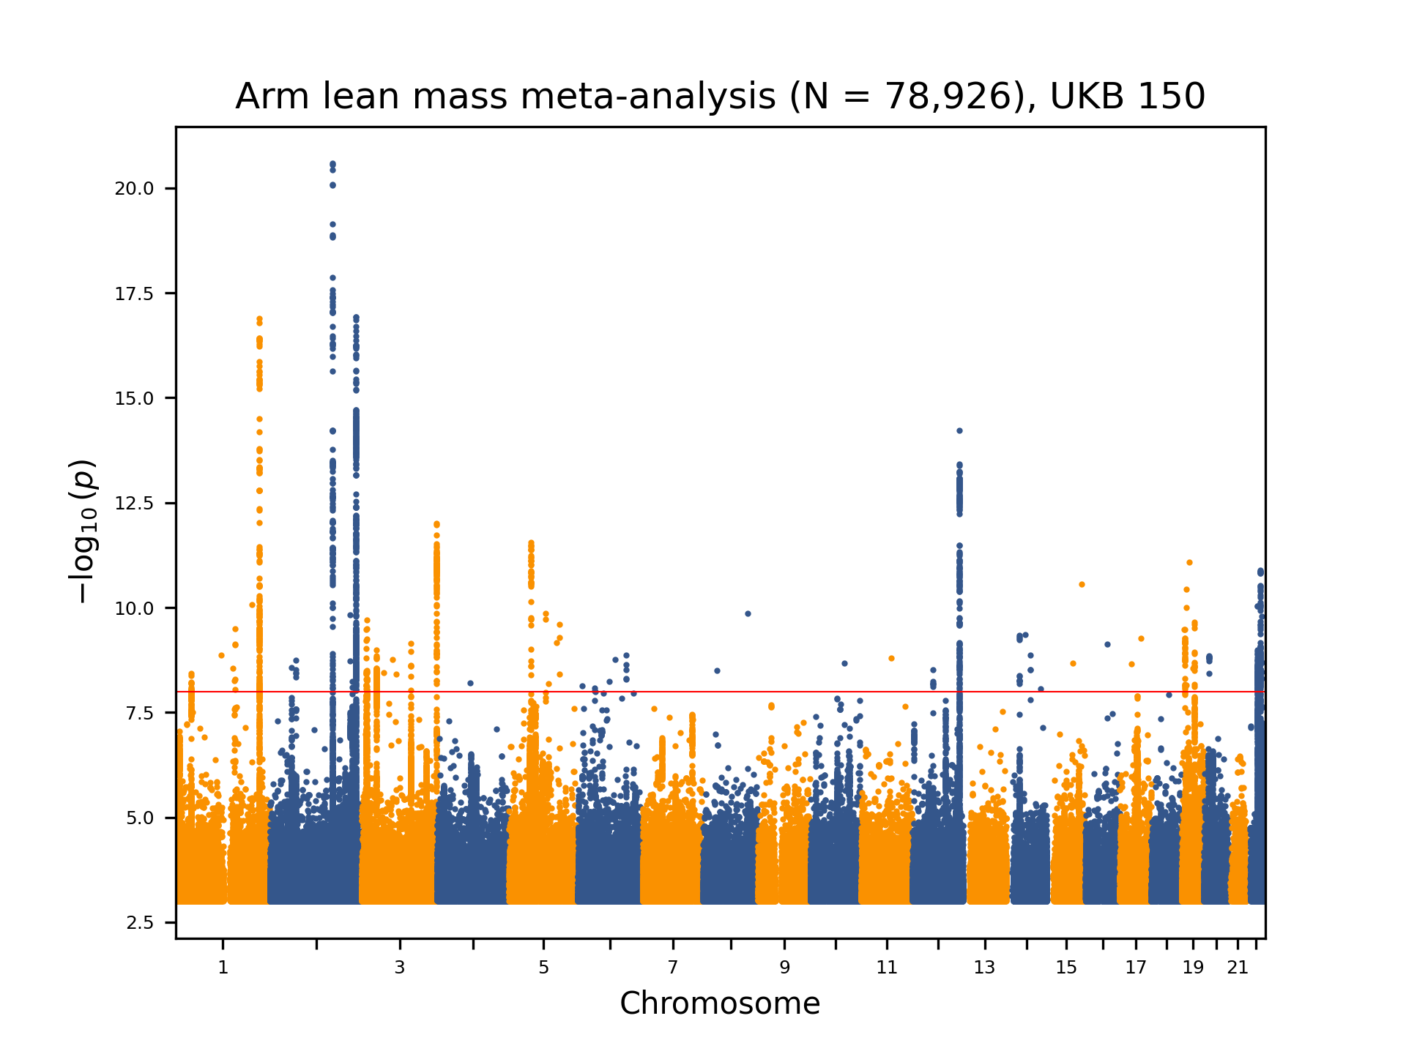Supplementary Figure 1. Manhattan plot presenting the DXA-derived arm lean mass discovery meta-analysis in Iceland and UK Biobank (150,119 whole-genome sequenced, WGS). The significance of association between each variant and the phenotype, -log₁₀(P), is plotted on the left y-axis against chromosomal position on the x-axis. Only variants with P < 0.001 are shown.

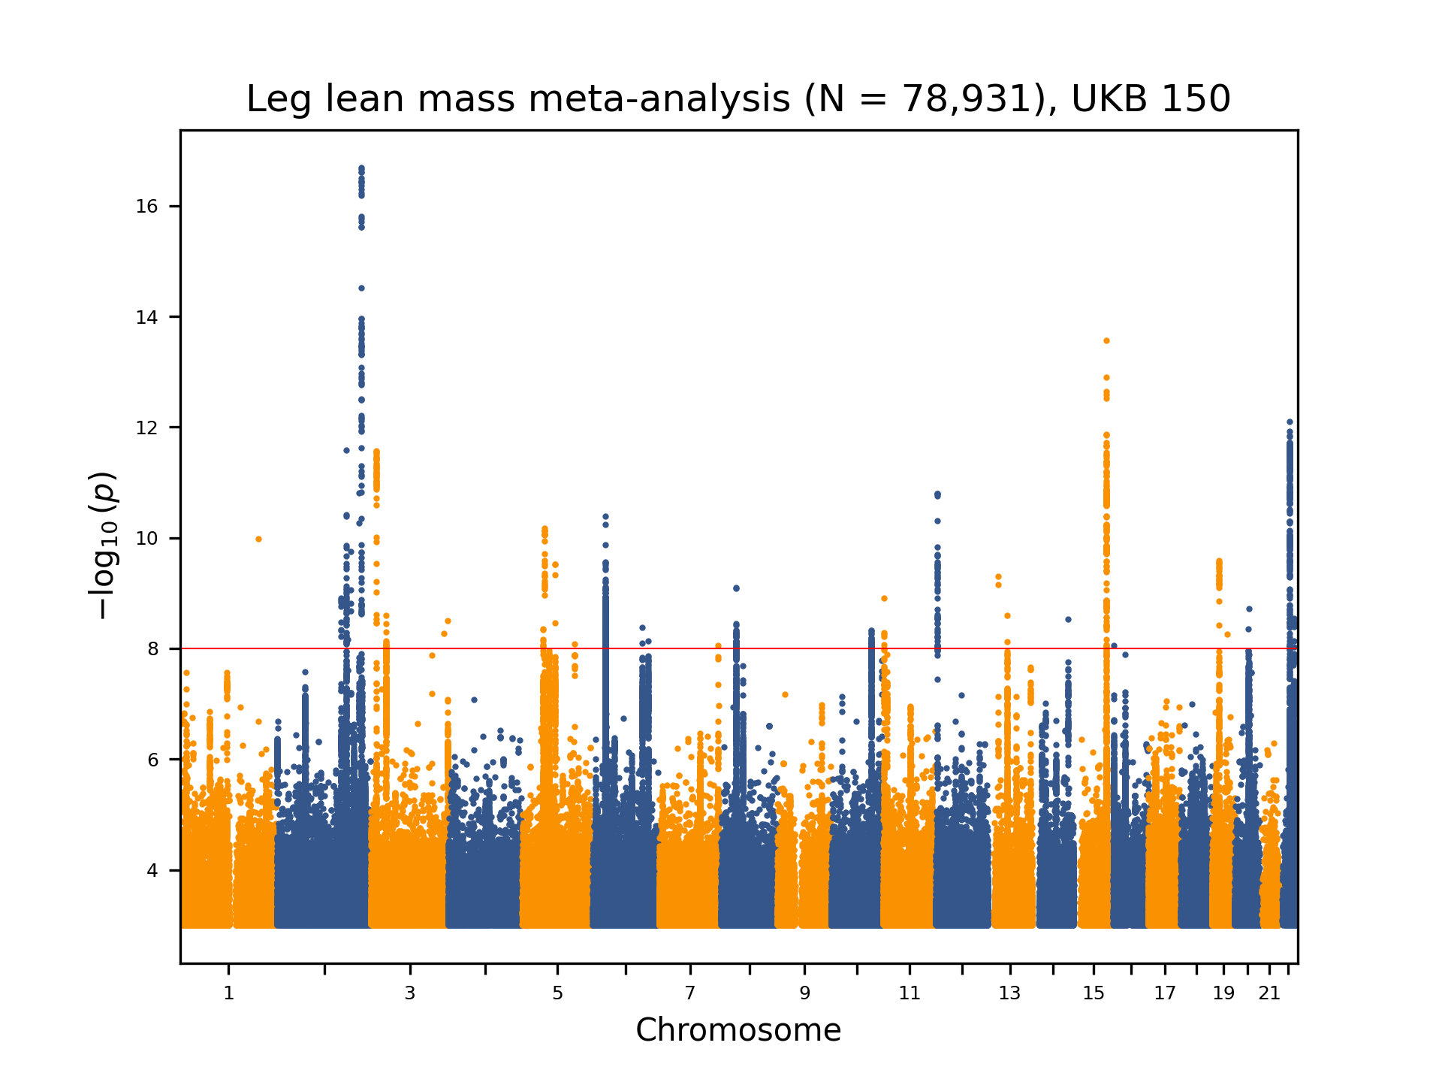
Supplementary Figure 2. Manhattan plot presenting the DXA-derived leg lean mass discovery meta-analysis in Iceland and UK Biobank (150,119 whole-genome sequenced, WGS). The significance of association between each variant and the phenotype, -log₁₀(P), is plotted on the left y-axis against chromosomal position on the x-axis. Only variants with P < 0.001 are shown.

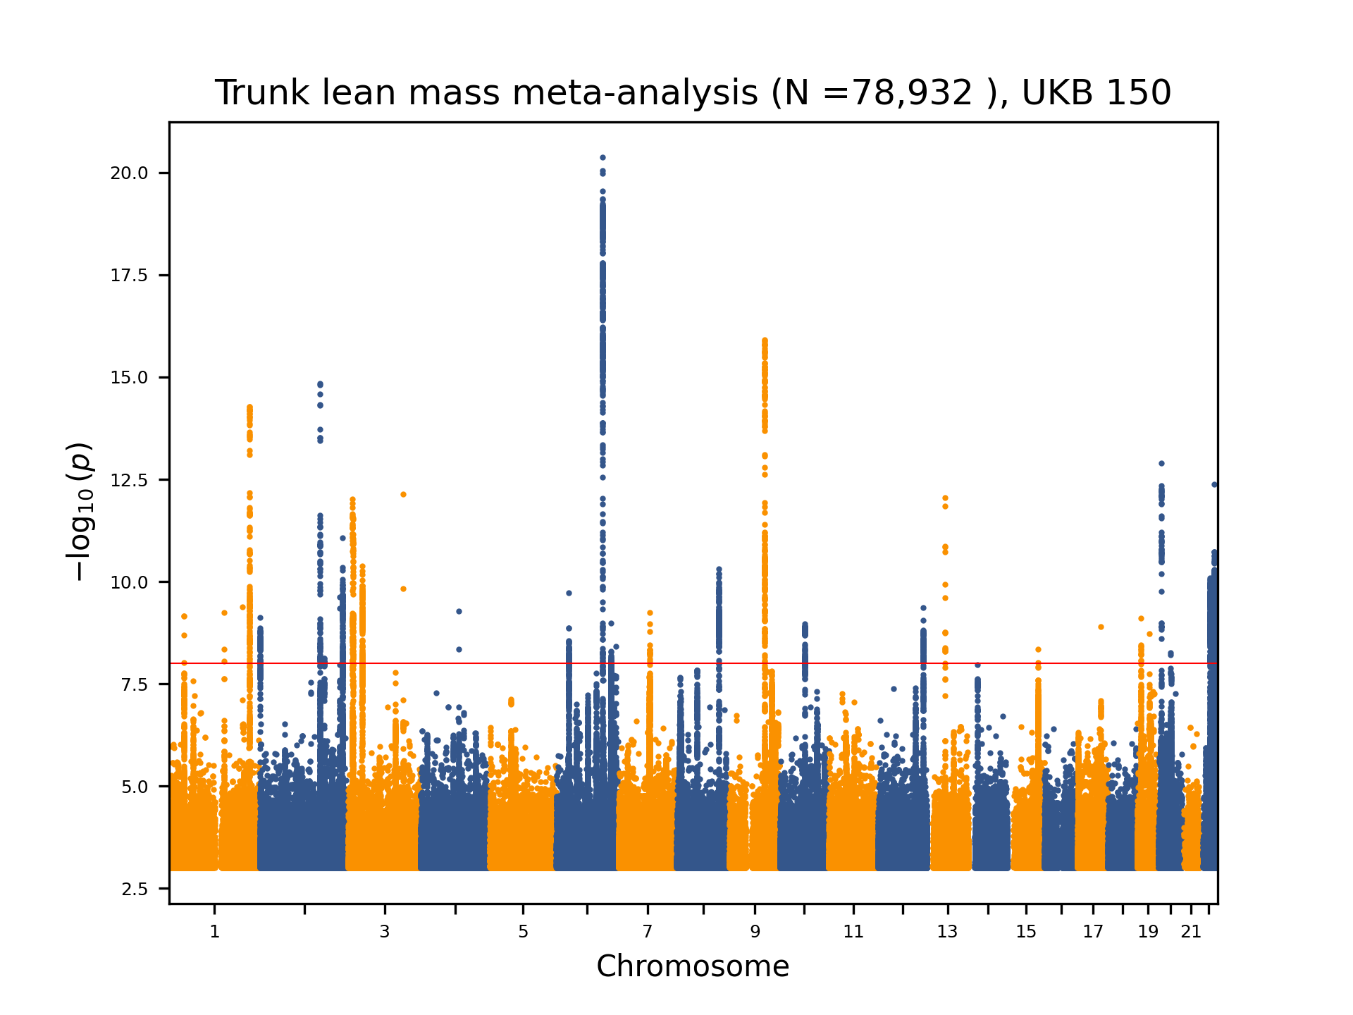Supplementary Figure 3. Manhattan plot presenting the DXA-derived trunk lean mass discovery meta-analysis in Iceland and UK Biobank (150,119 whole-genome sequenced, WGS). The significance of association between each variant and the phenotype, -log₁₀(P), is plotted on the left y-axis against chromosomal position on the x-axis. Only variants with P < 0.001 are shown.
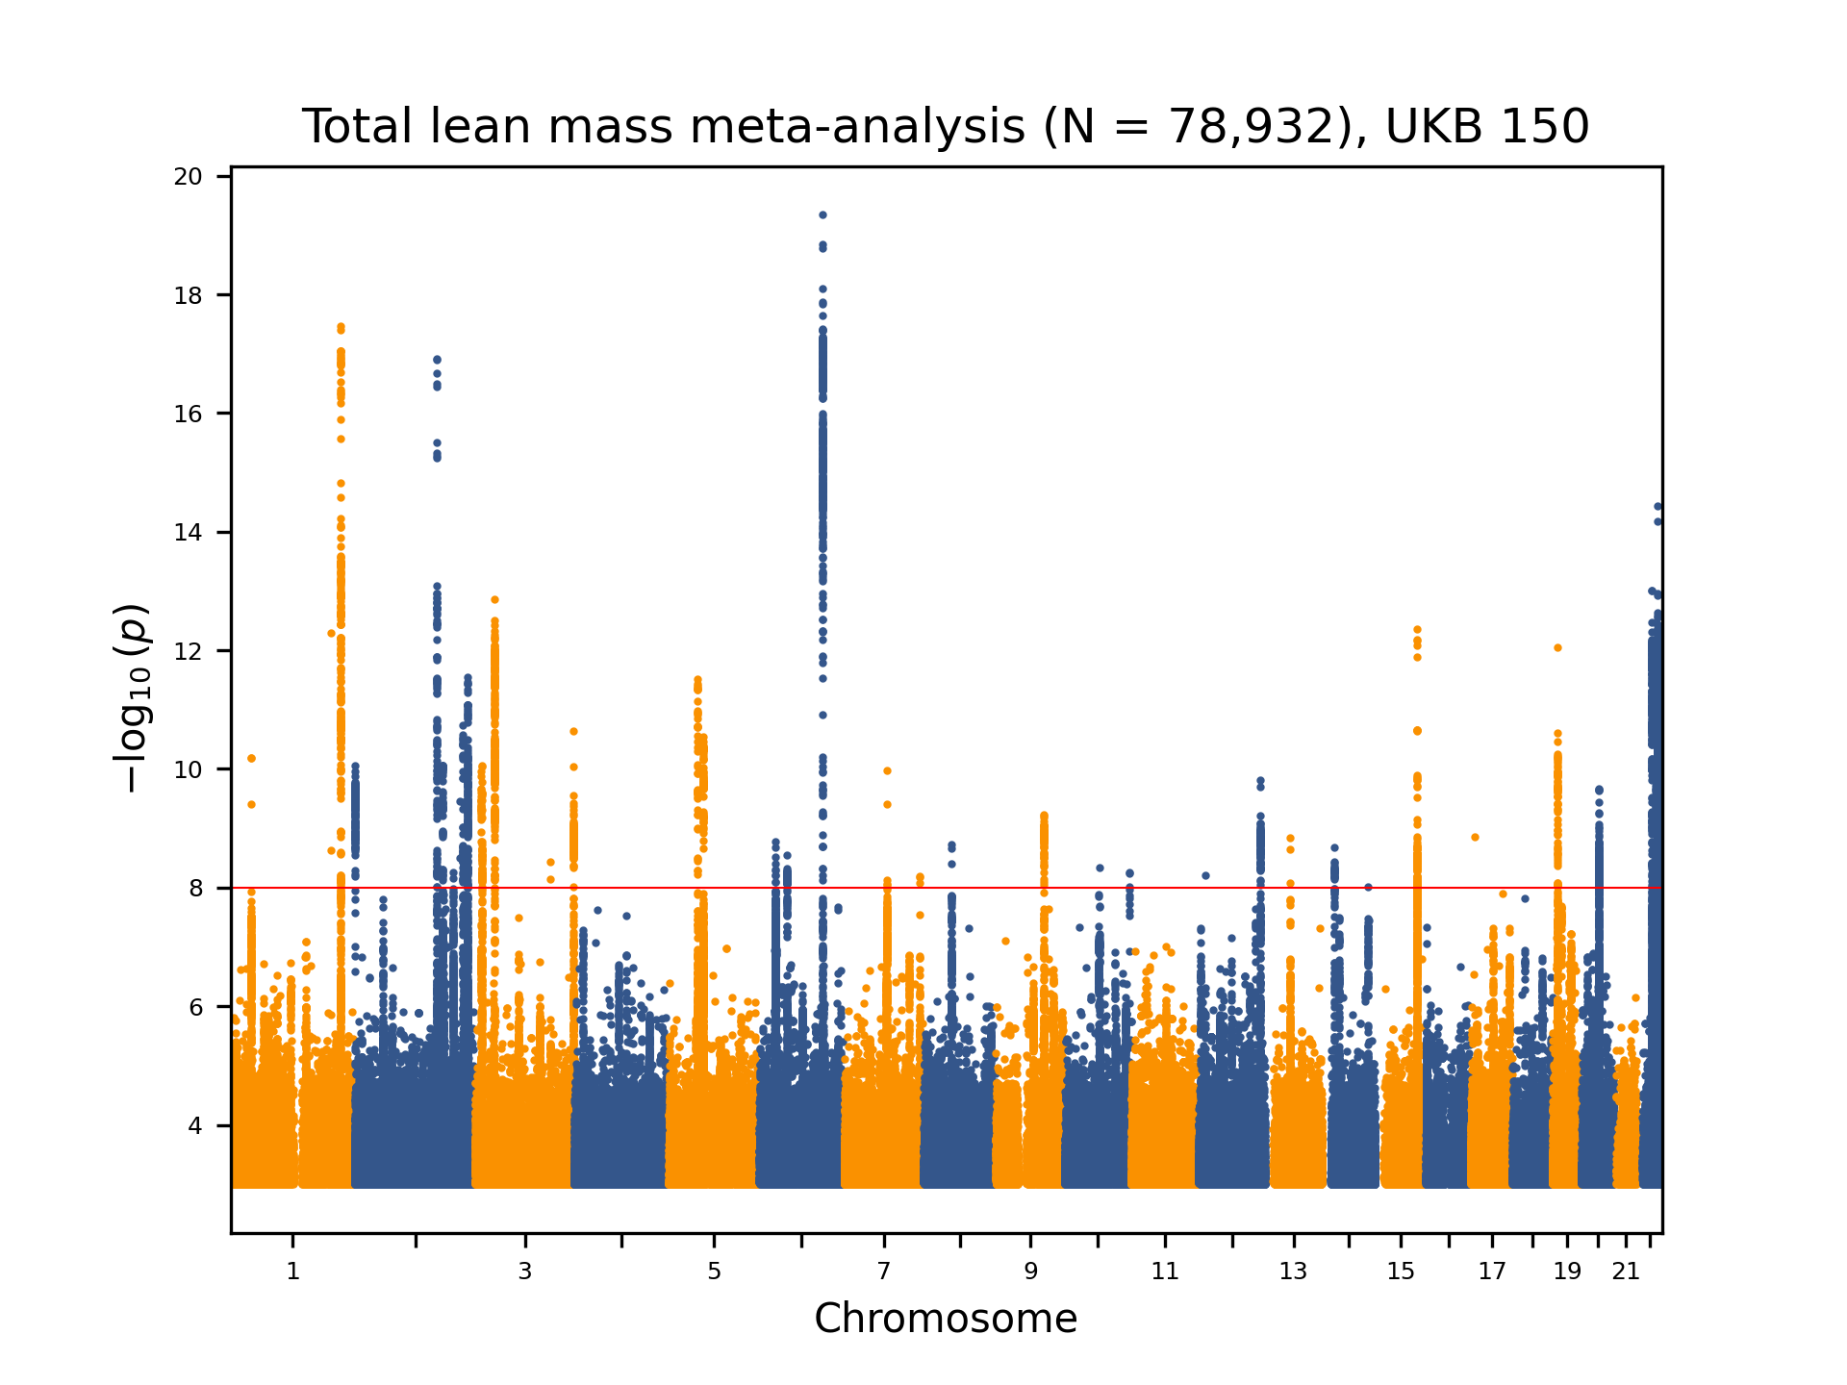
Supplementary Figure 4. Manhattan plot presenting the DXA-derived total lean mass discovery meta-analysis in Iceland and UK Biobank (150,119 whole-genome sequenced, WGS). The significance of association between each variant and the phenotype, -log₁₀(P), is plotted on the left y-axis against chromosomal position on the x-axis. Only variants with P < 0.001 are shown.

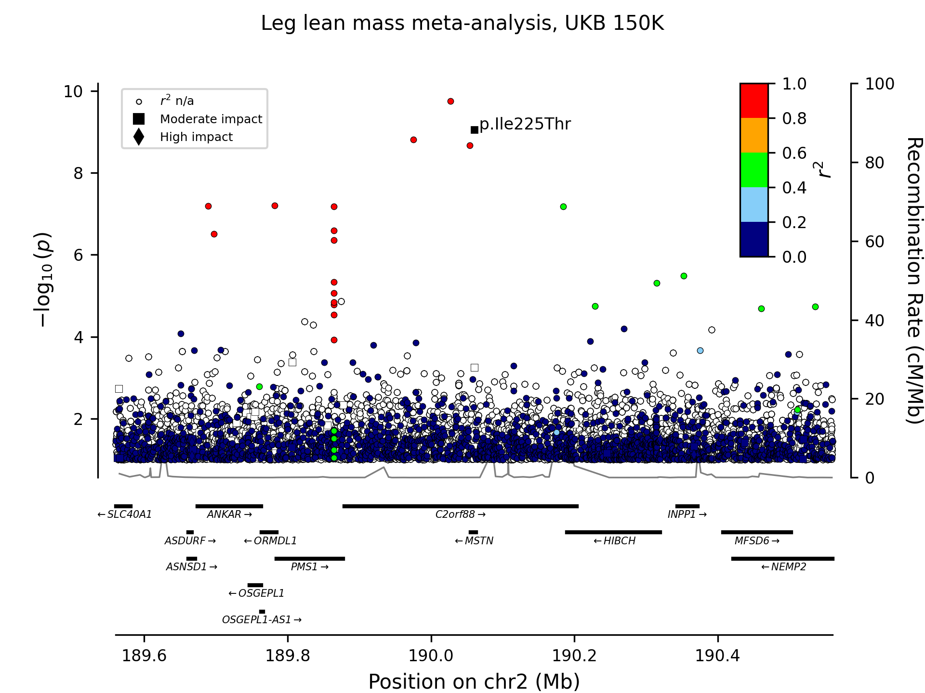

Supplementary Figure 5. Regional plot presenting the association of the missense variant p.Ile225Thr with DXA-derived leg lean mass in the discovery meta-analysis of Iceland and UK Biobank (150,119 whole-genome sequenced, WGS). The degree of linkage disequilibrium (r²) of variants with p.Ile225Thr within a 500 KB window is shown, based on phased Icelandic genotypes. Moderate- and high-impact variants, as defined by variant annotation, are represented by squares and triangles, respectively. The significance of association between each variant and the phenotype, -log₁₀(P), is plotted on the left y-axis against chromosomal position on the x-axis. The right y-axis shows calculated recombination rates at the chromosomal location, plotted as a solid black line. Only variants with P < 0.1 are shown.

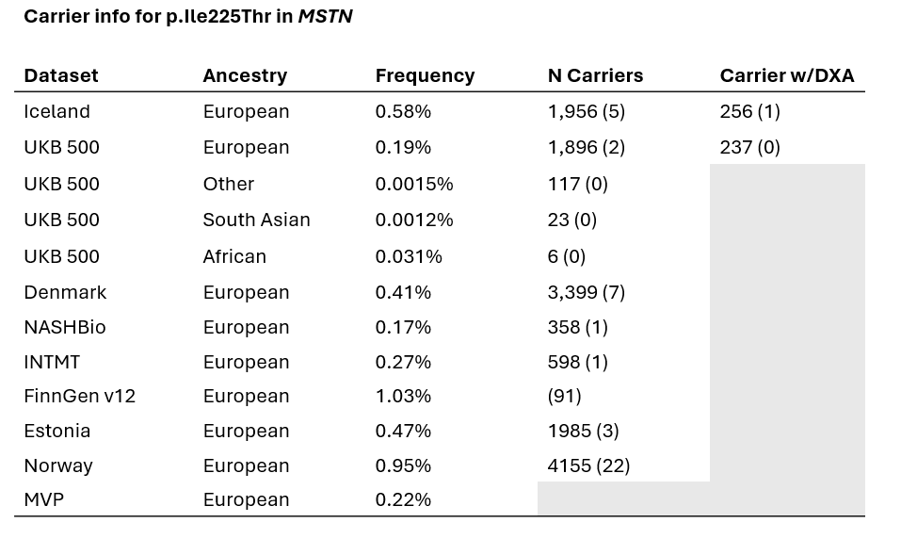
Supplementary Figure 6. Carrier info for p.Ile225Thr in MSTN in main datasets. Frequency within each dataset is shown. Carrier counts are shown when available, with number in parentheses indicating homozygous carriers.

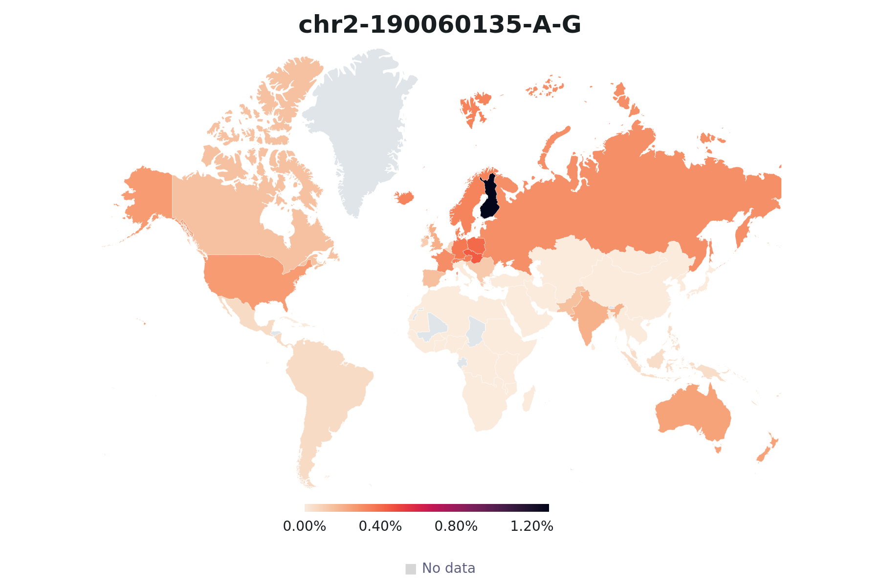

Supplementary figure 7. Allele frequency distribution of p.Ile225Thr (rs143242500-G) shown on a world map. The map is based on genotype data from 488,240 individuals of the UK Biobank 500K dataset. Allele frequency is represented by lighter to darker color shades (lower to higher frequency). Gray indicates countries not represented in the UKB dataset. The highest frequencies were observed among people reporting Finnish origin (See also Supplementary Figure 5).

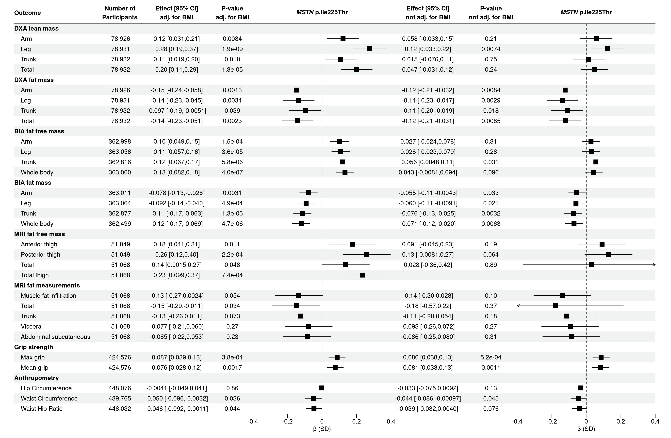
Supplementary Figure 8. Associations of the MSTN p.Ile225Thr with body composition phenotypes with (left) and without (right) BMI adjustment. Number of participants in each GWAS is shown. DXA measurements, hip circumference, waist circumference, and waist-to-hip ratio are meta-analyses of Iceland and UK Biobank data, whereas BIA and MRI measurements and grip strength were available only in UK Biobank. To replicate the DXA findings, the BIA association testing was performed in an independent subset where all participants with DXA measurements were removed. For refined assessment of the MSTN p.Ile225Thr, analyses were performed in up to 490,193 whole-genome sequenced UK Biobank participants. Squares and whiskers display effect sizes and 95% confidence intervals (CI).

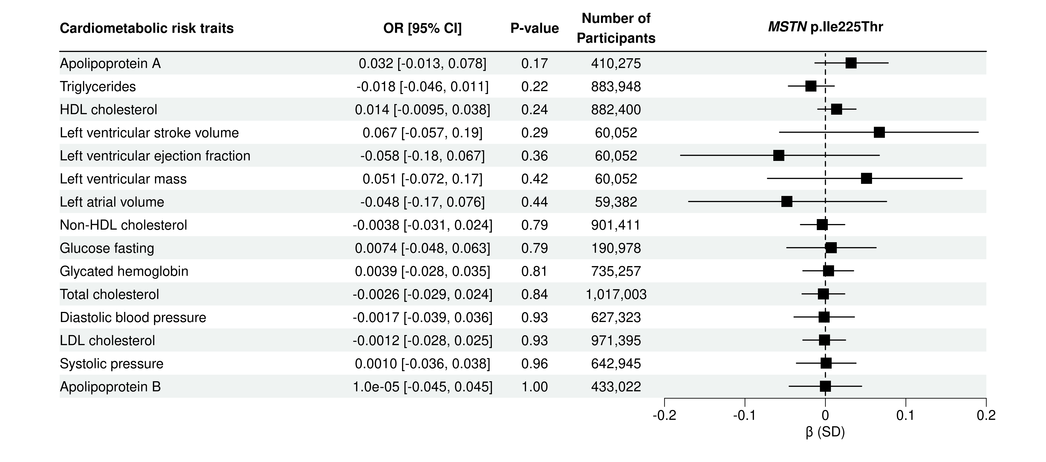
Supplementary Figure 9. Associations of the MSTN p.Ile225Thr with cardiovascular risk traits. Number of participants in each GWAS is shown. For refined assessment of the MSTN p.Ile225Thr, analyses were performed in up to 490,193 whole-genome sequenced UK Biobank participants when available. Detailed information on cohorts for each trait is found in Supplementary Table 6. Squares and whiskers display effect sizes and 95% confidence intervals (CI).

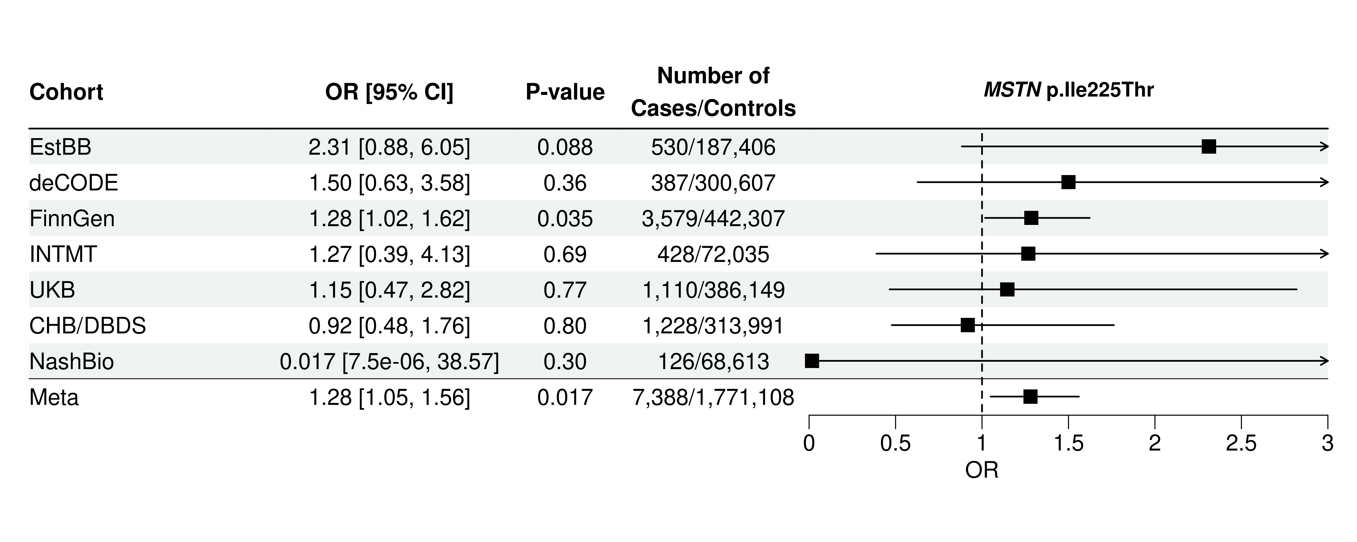
Supplementary Figure 10. Associations of the MSTN p.Ile225Thr with dilated cardiomyopathy by cohorts. Definition of the phenotype can be found in Supplementary Table 6. Squares and whiskers display effect sizes and 95% confidence intervals (CI).

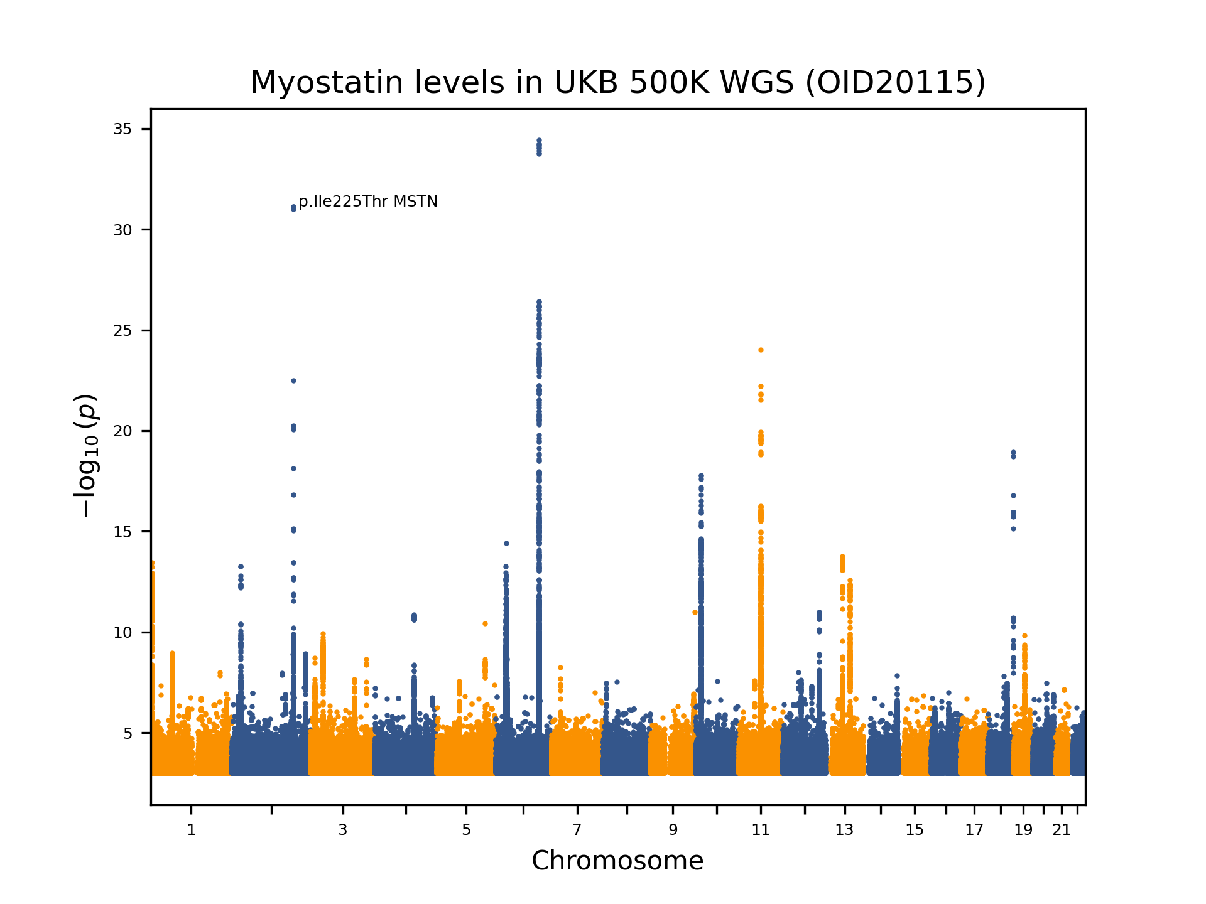
Supplementary Figure 11. Manhattan plot presenting a GWAS of myostatin blood levels (N = 46,446). MSTN p.Ile225Thr is marked. The significance of association between each variant and the phenotype (-log₁₀(P)) is plotted on the y-axis against the chromosomal position on the x-axis. Only variants with P < 0.003 are shown.

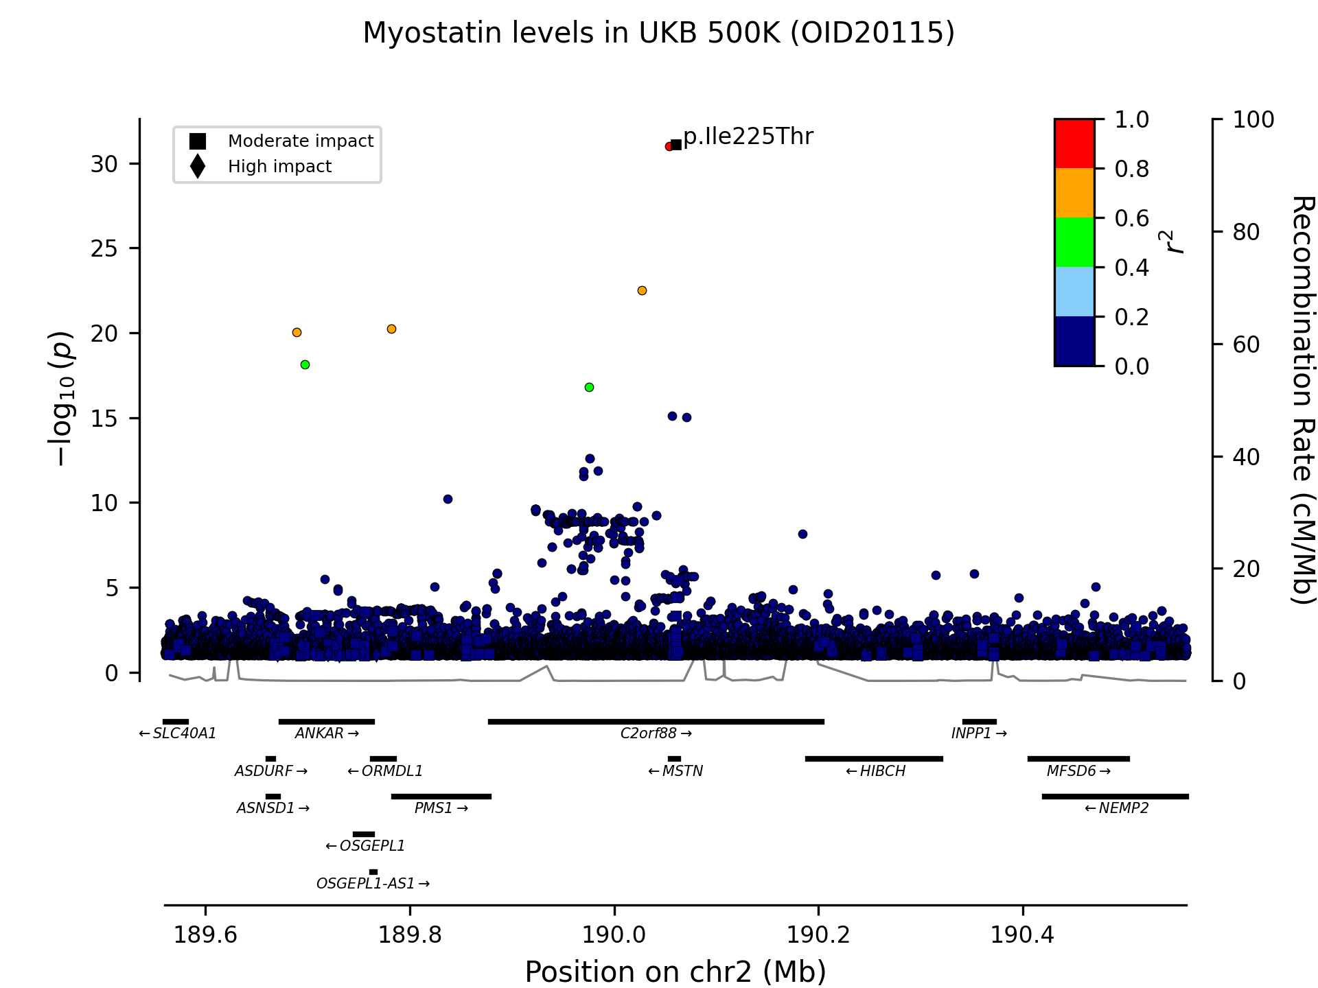
Supplementary Figure 12. Regional plot presenting the association of the missense variant p.Ile225Thr with GWAS of myostatin blood levels (N = 46,446). The degree of linkage disequilibrium (r²) of variants with p.Ile225Thr within a 500 kb window is shown, based on imputed UK Biobank genotypes. Moderate- and high-impact variants, as defined by variant annotation, are represented by squares and triangles, respectively. The significance of association between each variant and the phenotype (-log₁₀(P)) is plotted on the left y-axis against chromosomal position on the x-axis. Associations were tested in the refined whole-genome-sequenced dataset of 490,193 UK Biobank participants. The right y-axis shows calculated recombination rates at the chromosomal location, plotted as a solid black line. Only variants with P < 0.1 are shown.

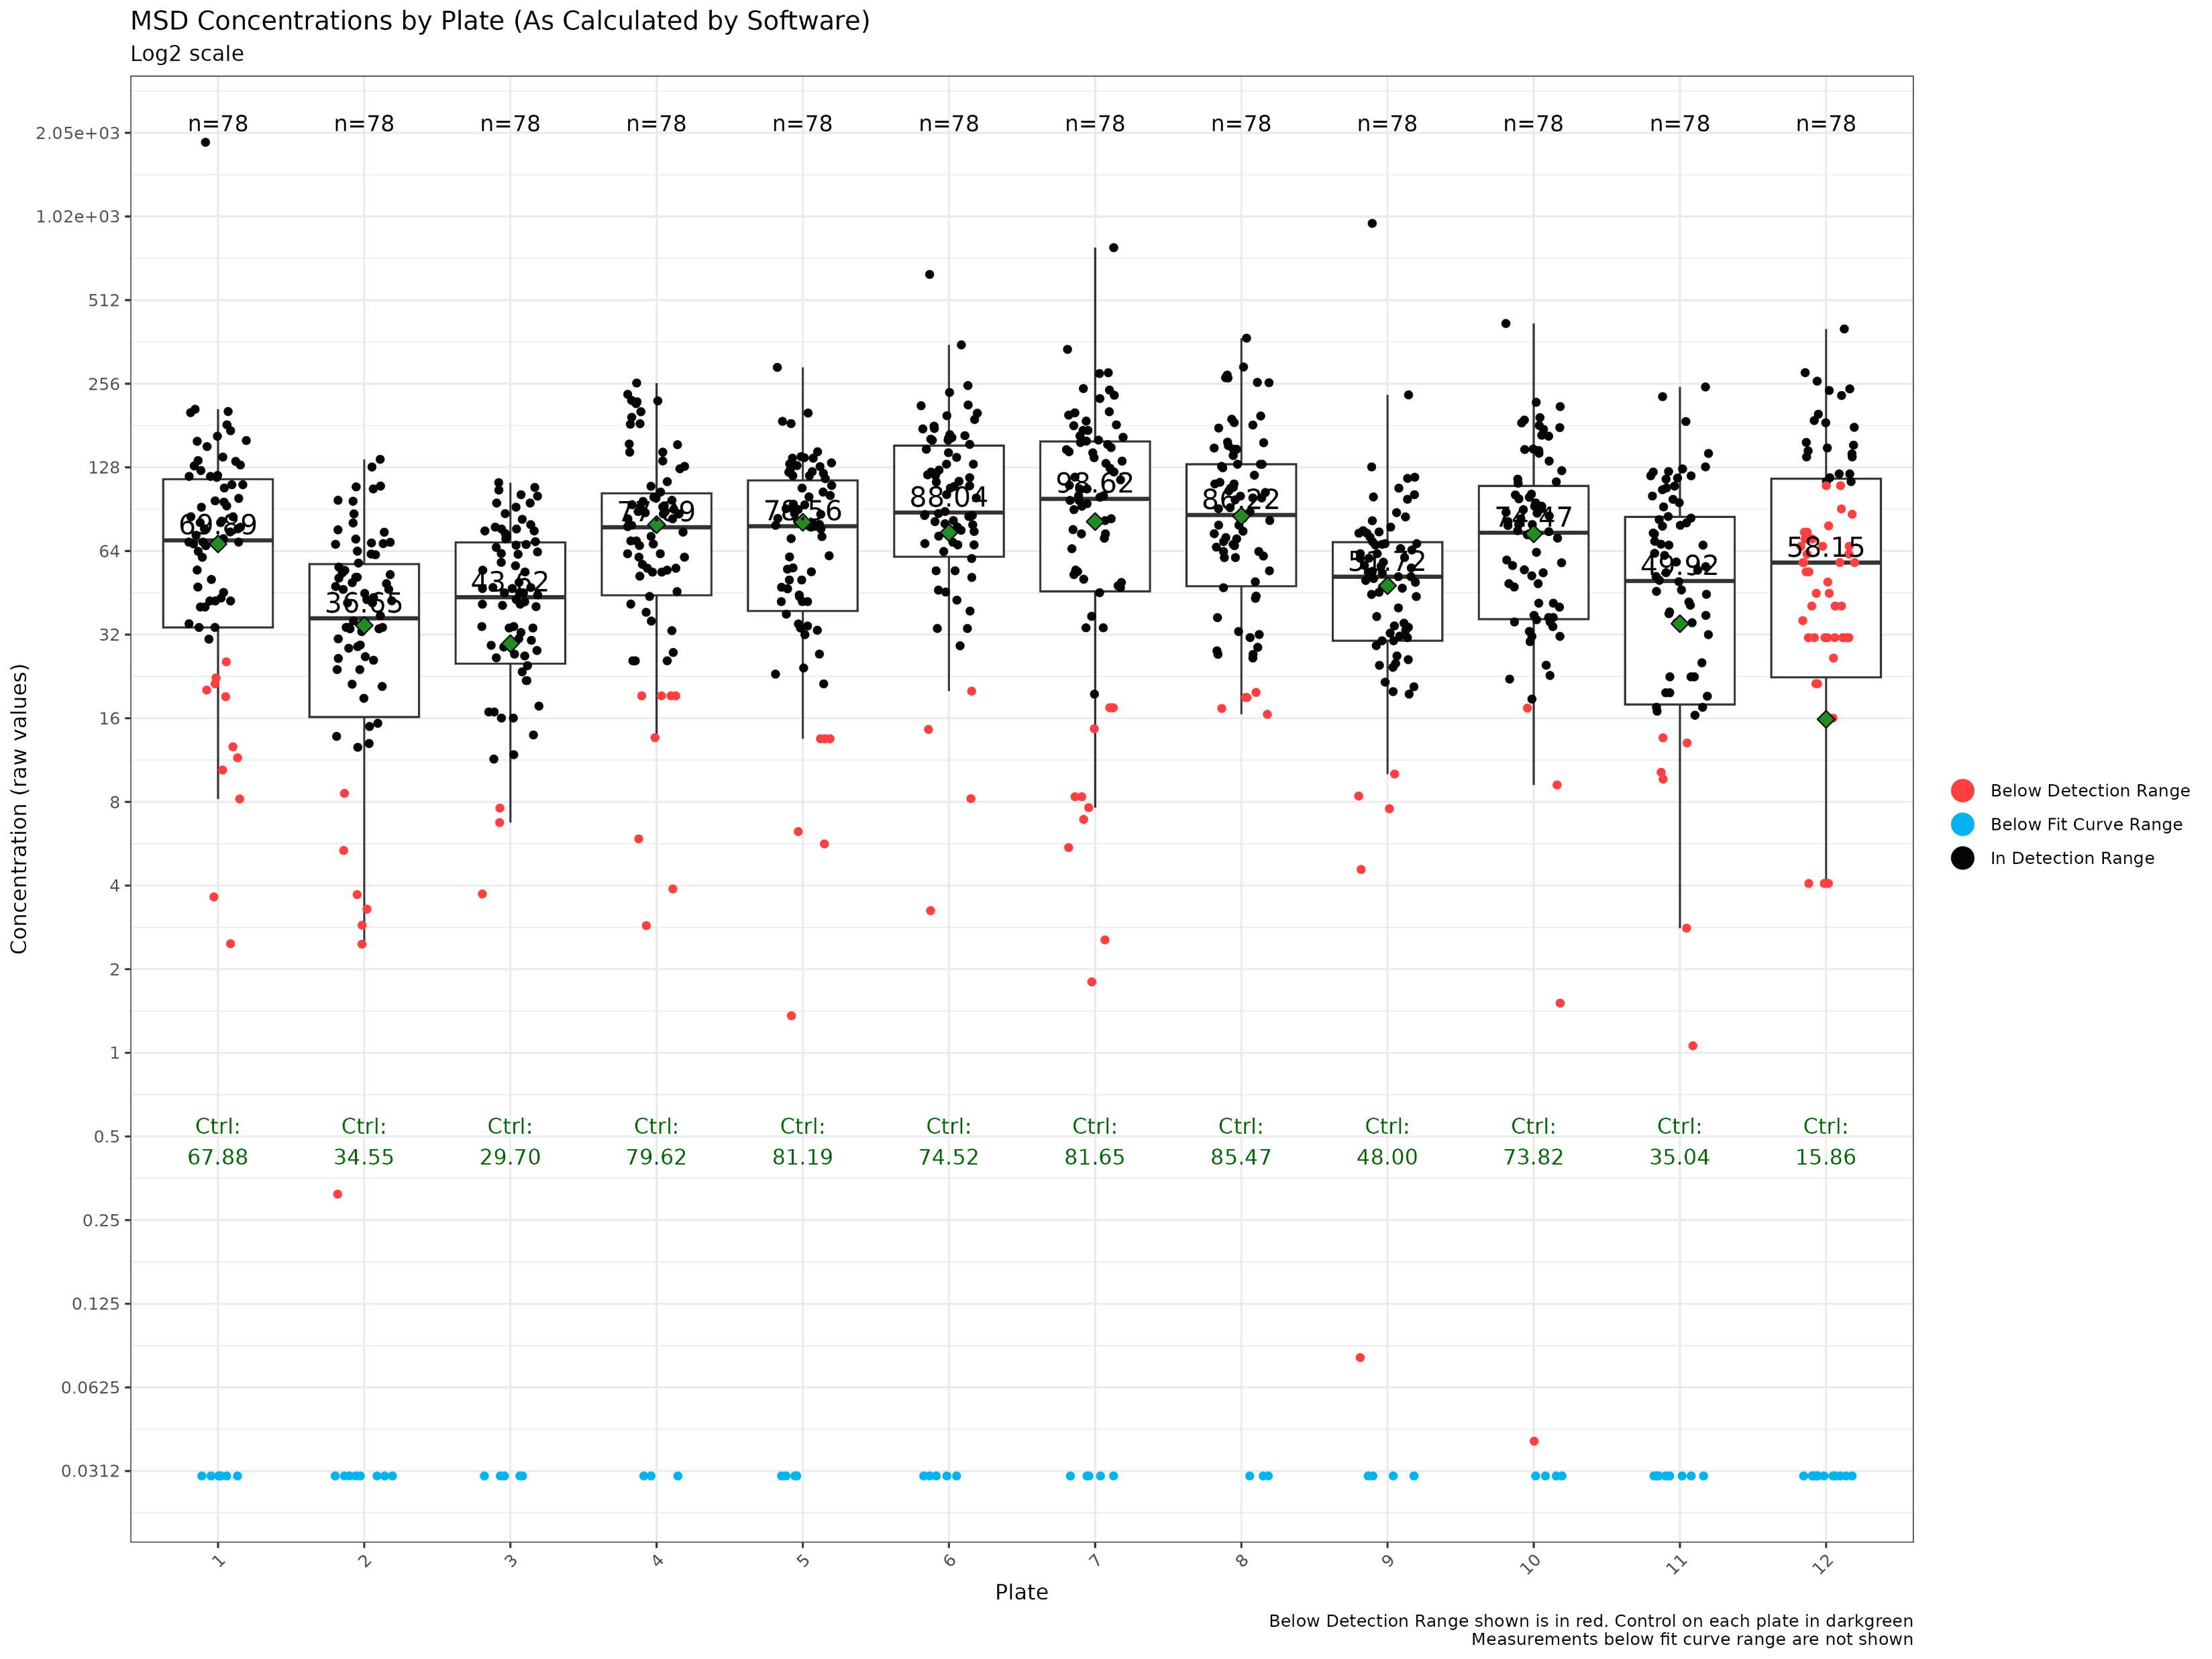
Supplementary Figure 13. Distribution of myostatin concentration measured using the R-PLEX Human GDF-8 Assay (Cat. K151ACER-2, Meso Scale Discovery) across 12 plates. Myostatin is also known as growth differentiation factor 8 (GDF8). Concentration was derived from optical density using DISCOVERY WORKBENCH 4.0 Analysis Software. The y-axis is displayed on a log₂ scale to aid visualization. Values below detection range are highlighted red. Measurements below the fit curve were assigned a value of 0.03pg/L. All samples were undiluted. A pooled control sample, composed of samples from several individuals, was included on each plate, with plate-specific concentration shown in green. In total, 936 samples (one per participants) were analyzed. Samples from 6 participants were not genotyped and were therefore excluded from other analysis of the study. Plate 12 passed sensitivity analyses and was therefore deemed suitable for inclusion; thus, no plates were excluded from downstream analyses. The distribution shows plate-to-plate consistency, supporting inclusion of all plates in downstream analysis.

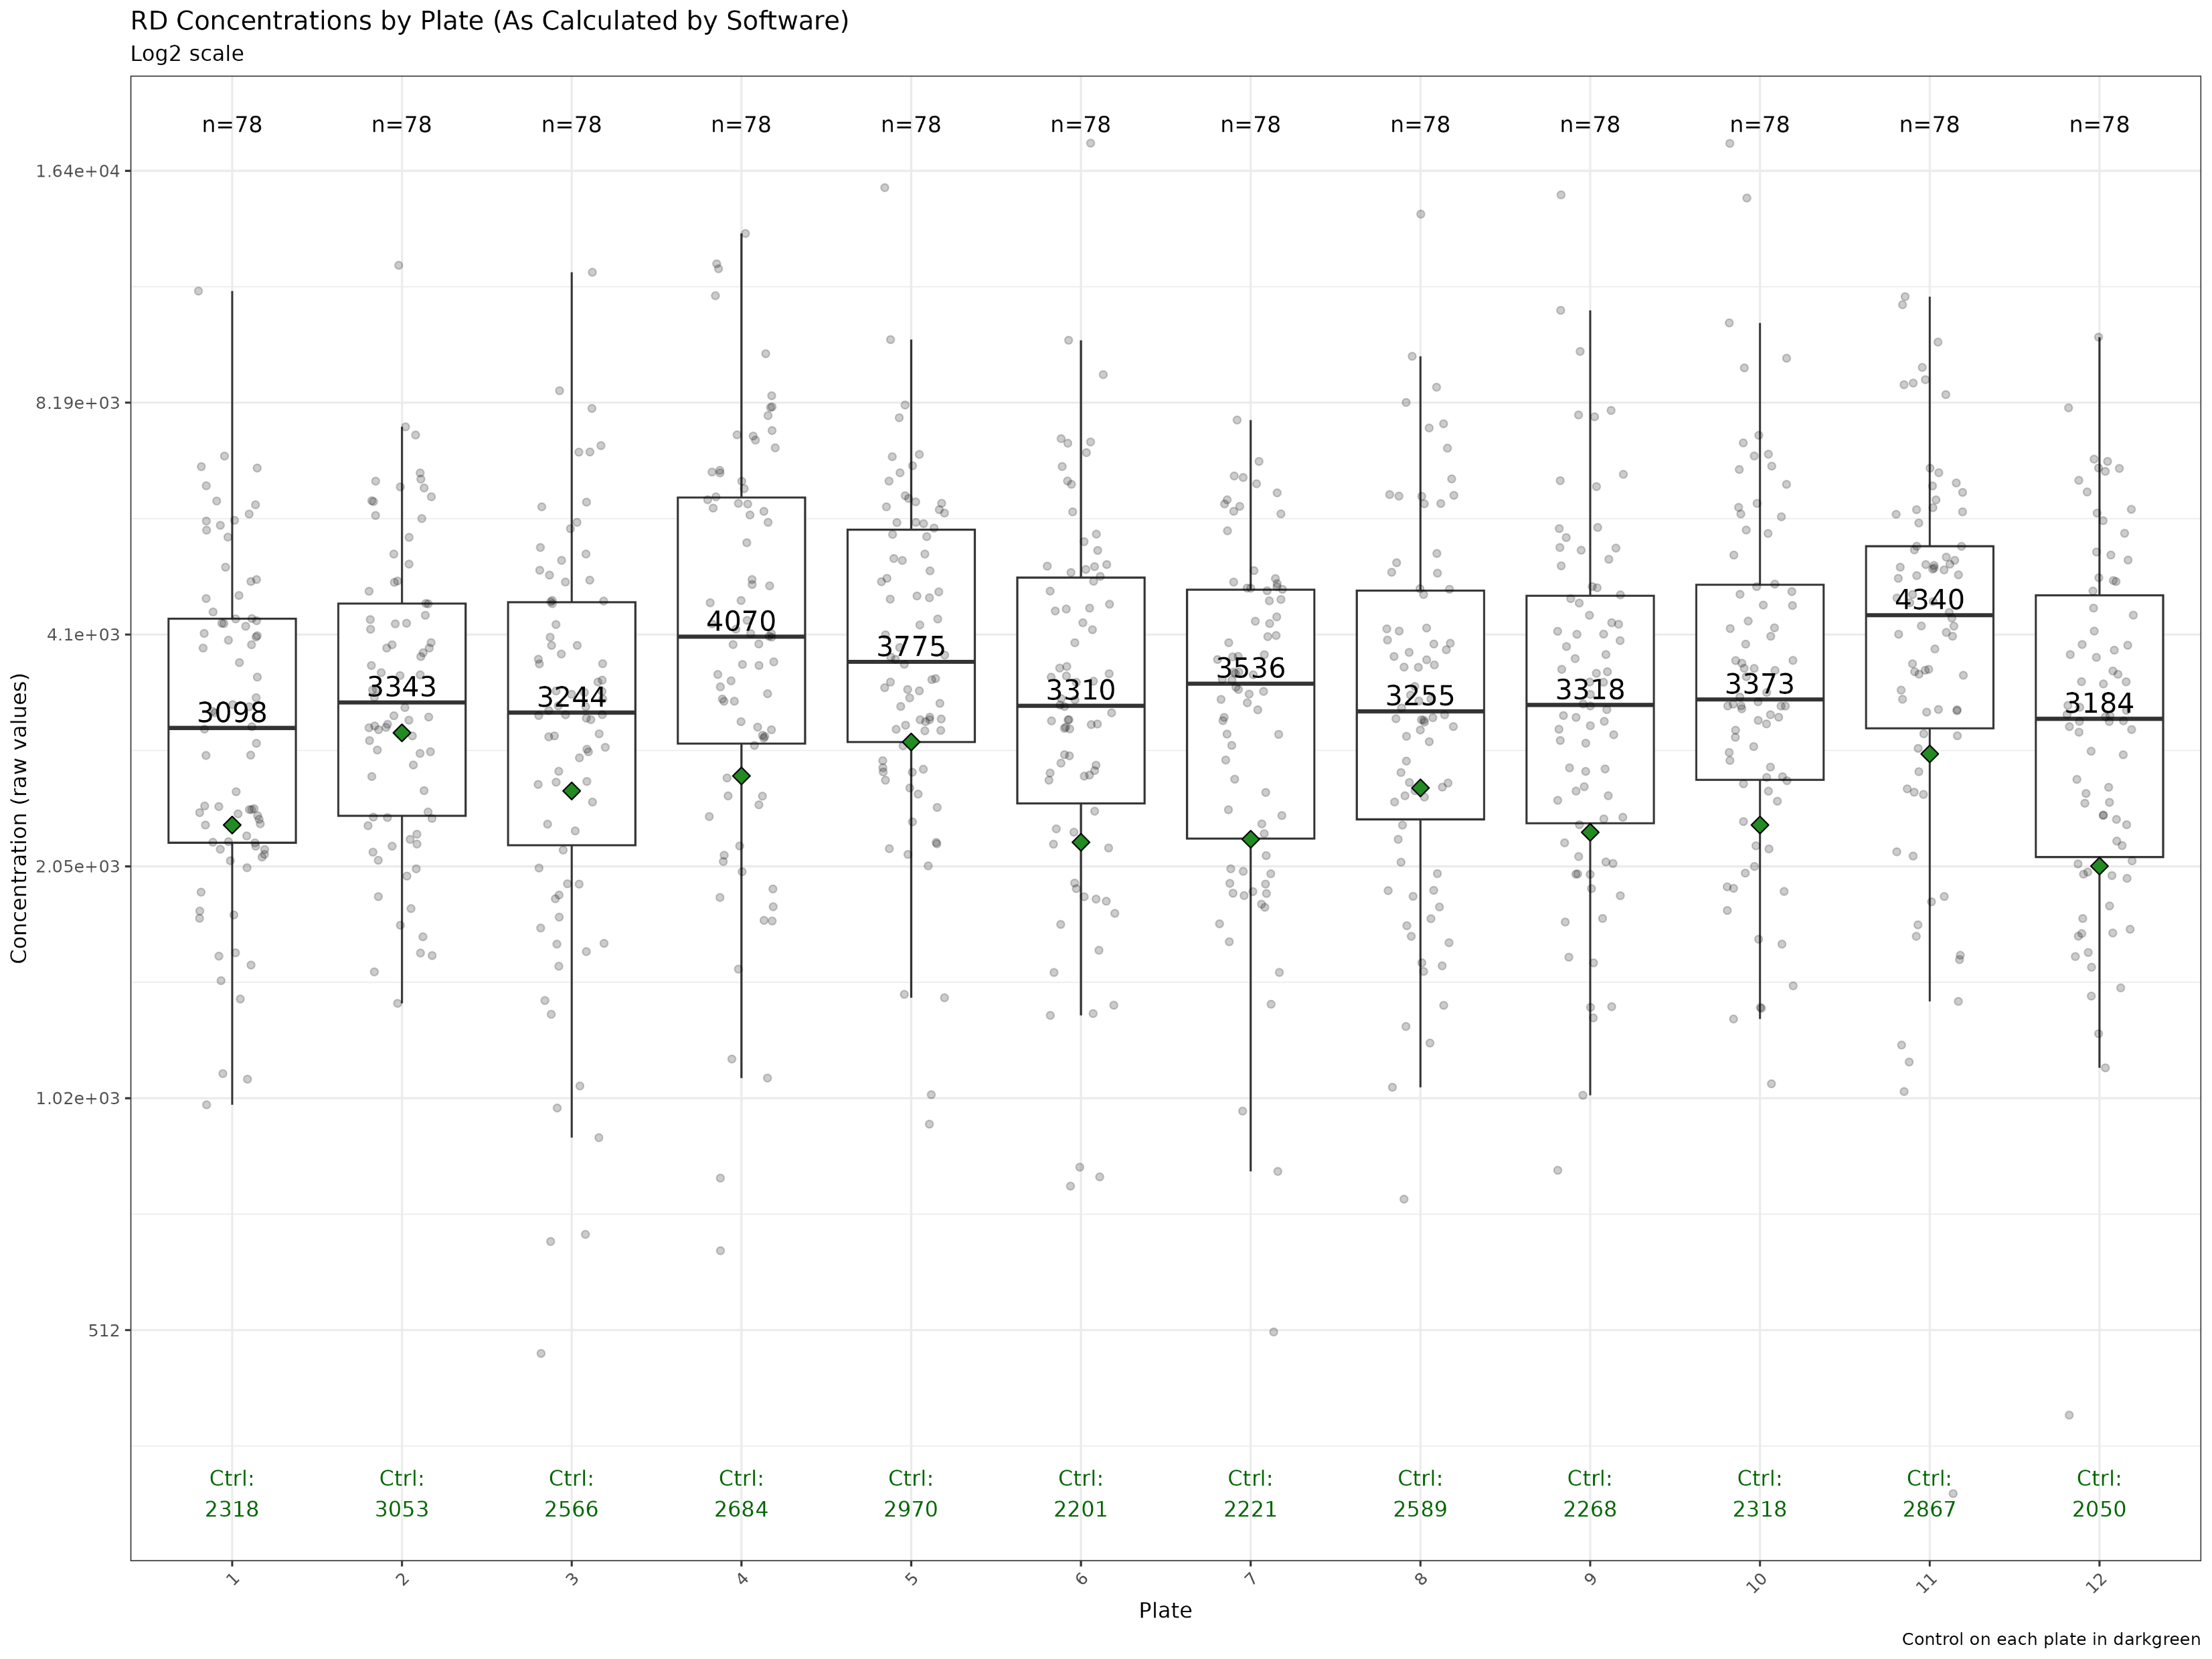
Supplementary Figure 14. Distribution of myostatin concentration measured using the GDF-8/Myostatin Quantikine ELISA (cat. DGDF80, R&D Systems) across 12 plates. Myostatin is also known as growth differentiation factor 8 (GDF8). Concentration was derived from optical density using four parameter logistic (4-PL) curve-fit. The y-axis is displayed on a log₂ scale to aid visualization. All samples were diluted 1:12, except for 1:4 on plate 1. A pooled control sample, composed of samples from several individuals, was included on each plate, with plate-specific concentration shown in green. In total, 936 samples (one per participants) were analyzed. Samples from 6 participants were not genotyped and were therefore excluded from other analysis of the study. The distribution shows plate-to-plate consistency, supporting inclusion of all plates in downstream analysis.

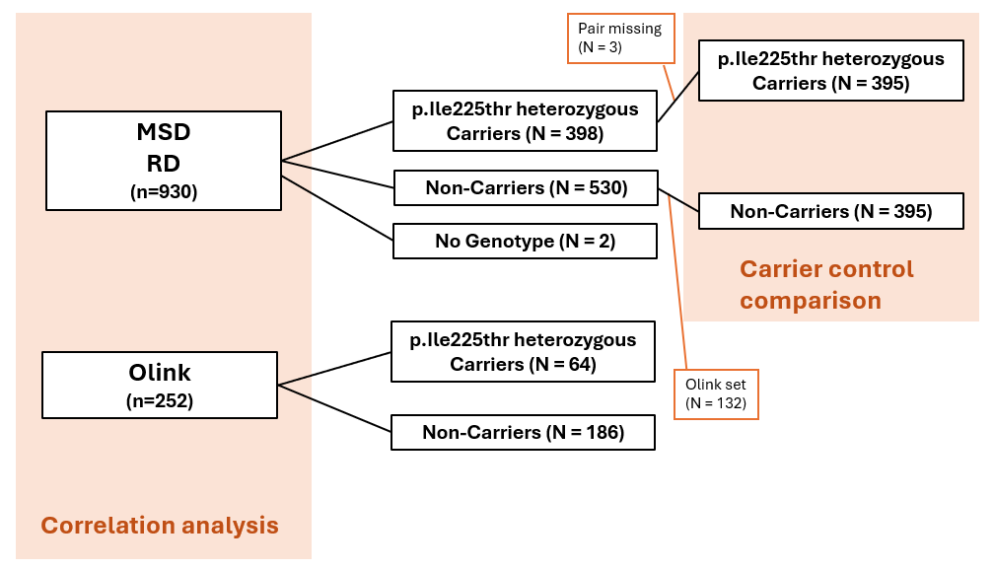
Supplementary Figure 15. Overview of plasma samples from genotyped Icelanders measured using R&D Systems (RD) and Meso Scale Discovery (MSD) platforms to evaluate the association of the MSTN p.Ile225Thr variant with increased myostatin levels observed on the Olink platform (OID20115), and to evaluate the discrepancy of Olink and SomasScan measurements. No association with the MSTN p.Ile225Thr variant was observed for the GDF8 specific SomaScan probe SeqId.14583-49 (P = 0.68). To validate and interpret these findings, circulating myostatin levels were quantified using two independent ELISA-based assays: RD Quantikine GDF-8 ELISA and MSD R-PLEX Human GDF-8 assay. Plasma samples were obtained from 930 Icelandic participants with available SomaScan and/or Olink measurements, including 398 MSTN p.Ile225Thr heterozygous carriers and sex- and age-matched (within 5 years) controls. All assays were performed blinded to genotype. The samples were used for correlation with the Olink measurements (subset of 252 had previously been measured with Olink (OID20115)) and for carrier–control comparisons using the matched case–control pairs. Three samples from the original sample pairing were unavailable.

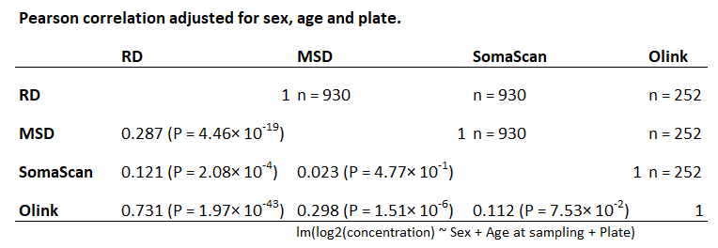
Supplementary Figure 16. Pearson correlation of myostatin measurements across R&D Systems (RD), Meso Scale Discovery (MSD), Olink, and SomaScan platforms. No association with the MSTN p.Ile225Thr variant was observed for the GDF8 specific SomaScan probe SeqId.14583-49 (P = 0.68). To validate and interpret these findings, circulating myostatin levels were quantified using two independent ELISA-based assays: RD Quantikine GDF-8 ELISA and MSD R-PLEX Human GDF-8 assay. Plasma samples were obtained from 930 Icelandic participants with available SomaScan and/or Olink measurements, including 398 MSTN p.Ile225Thr heterozygous carriers and sex- and age-matched (within 5 years) controls. All assays were performed blinded to genotype. Correlation analysis with the Olink measurements were performed in a subset of 252 samples previously measured using Olink (OID20115)). The figure shows Pearson correlations of the residuals from log₂-transformed concentration adjusted for sex, age at sampling and plate.

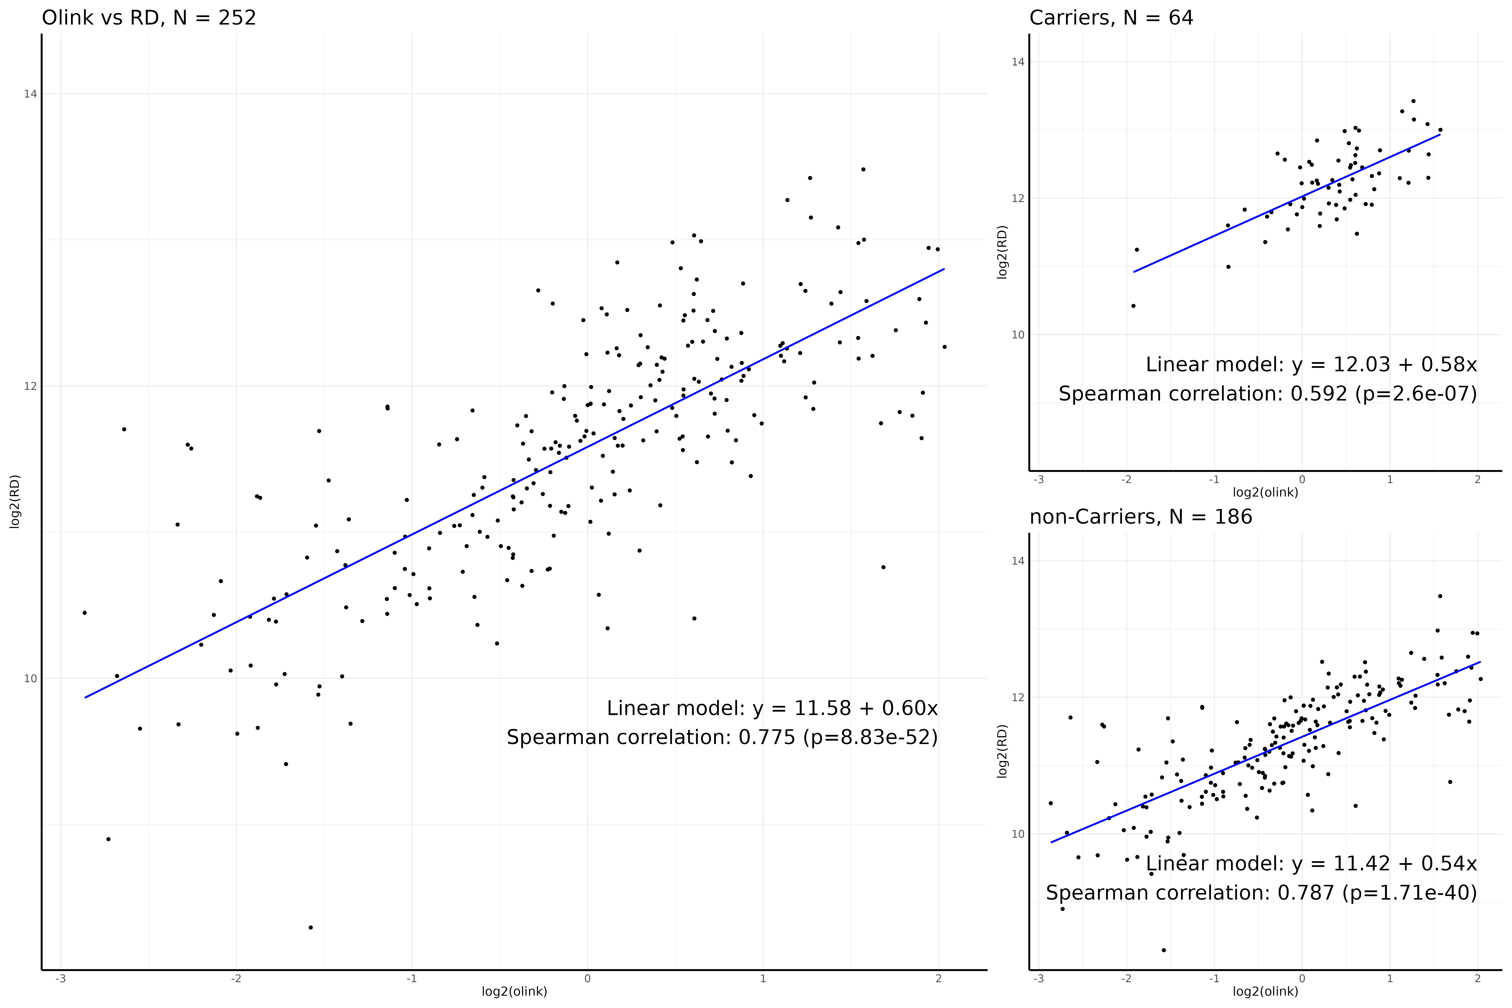
Supplementary Figure 17. Spearman correlation of myostatin measurements with R&D Systems Quantikine GDF-8 ELISA (RD) and Olink platform. Plasma samples were obtained from 930 Icelandic participants with available SomaScan and/or Olink measurements, including 398 MSTN p.Ile225Thr heterozygous carriers and sex- and age-matched (within 5 years) controls. All assays were performed blinded to genotype. Correlation analysis with the Olink measurements were performed in a subset of 252 samples previously measured using Olink (OID20115)). The figure shows Spearman correlations of the log₂-transformed concentration. The subset of MSTN p.Ile225Thr and non-carriers is shown (right). Pearson’s correlation after adjusting for sex, age at sampling, and plate was ρ= 0.73, P = 8.3 × 10⁻⁵².

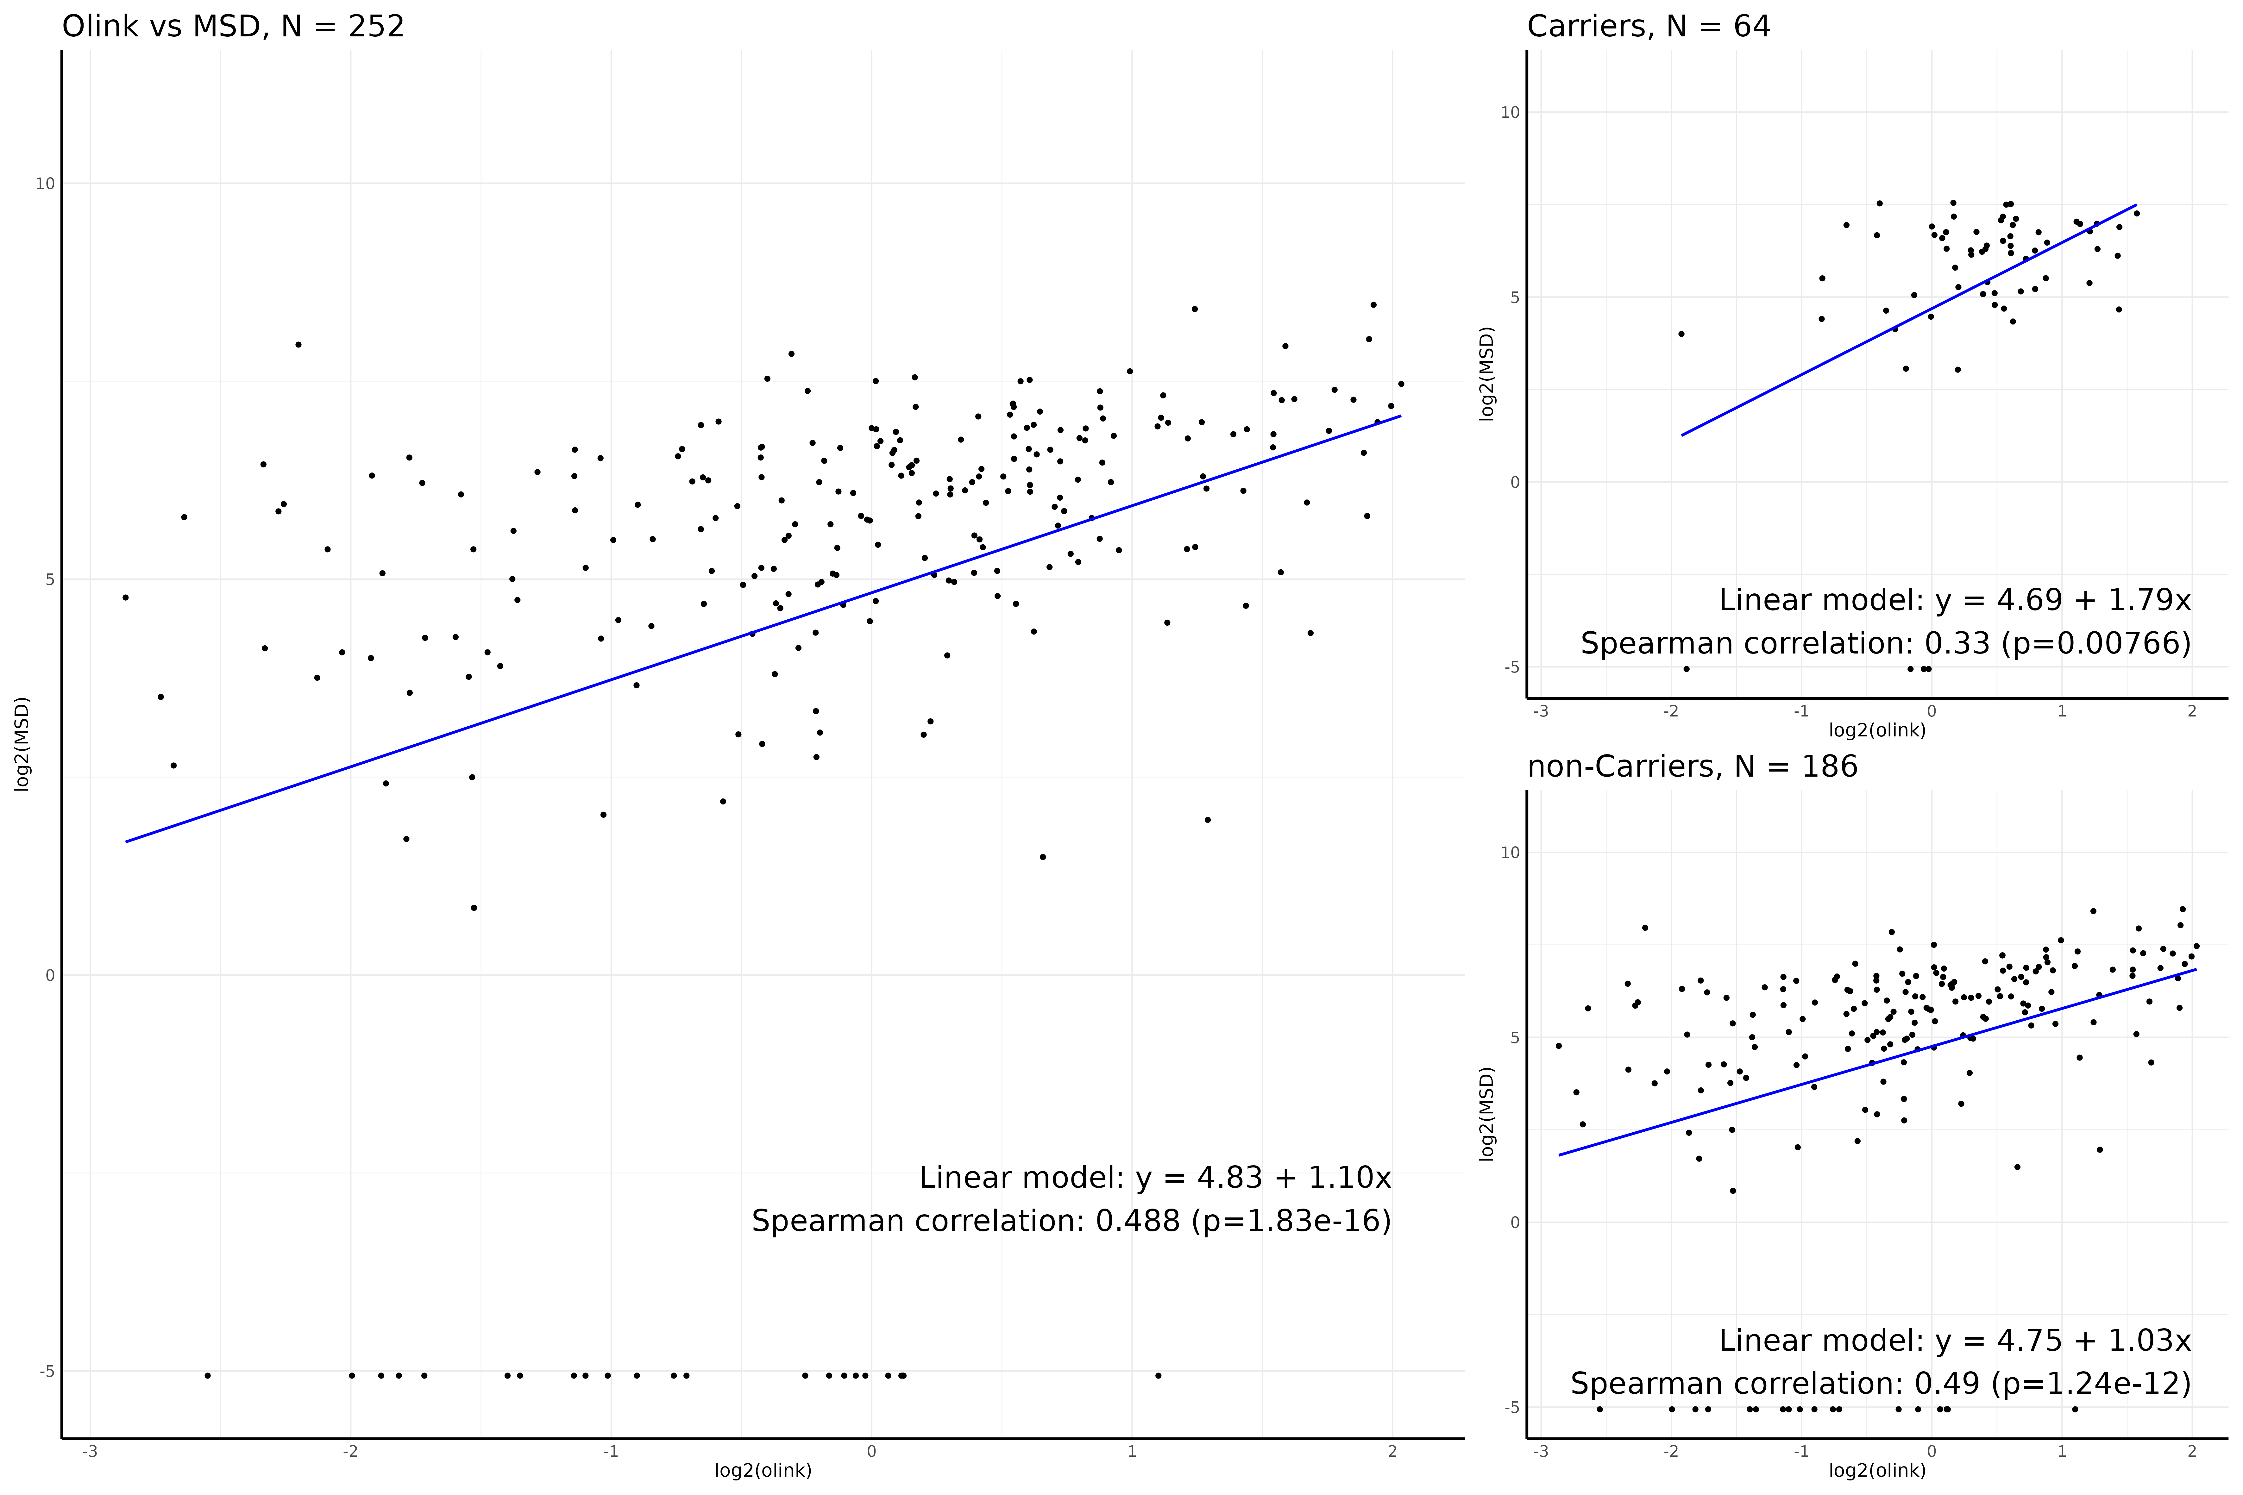
Supplementary Figure 18. Spearman correlation of myostatin measurements with R-PLEX Human GDF-8 Assay (Cat. K151ACER-2, Meso Scale Discovery) and Olink platform. Plasma samples were obtained from 930 Icelandic participants with available SomaScan and/or Olink measurements, including 398 MSTN p.Ile225Thr heterozygous carriers and sex- and age-matched (within 5 years) controls. All assays were performed blinded to genotype. Correlation analysis with the Olink measurements were performed in a subset of 252 samples previously measured using Olink (OID20115)). The figure shows Spearman correlations of the log₂-transformed concentration. The subset of MSTN p.Ile225Thr and non-carriers is shown (right).
Pearson’s correlation after adjusting for sex, age at sampling, and plate was ρ= 0.29, P = 1.8 × 10⁻¹⁶.

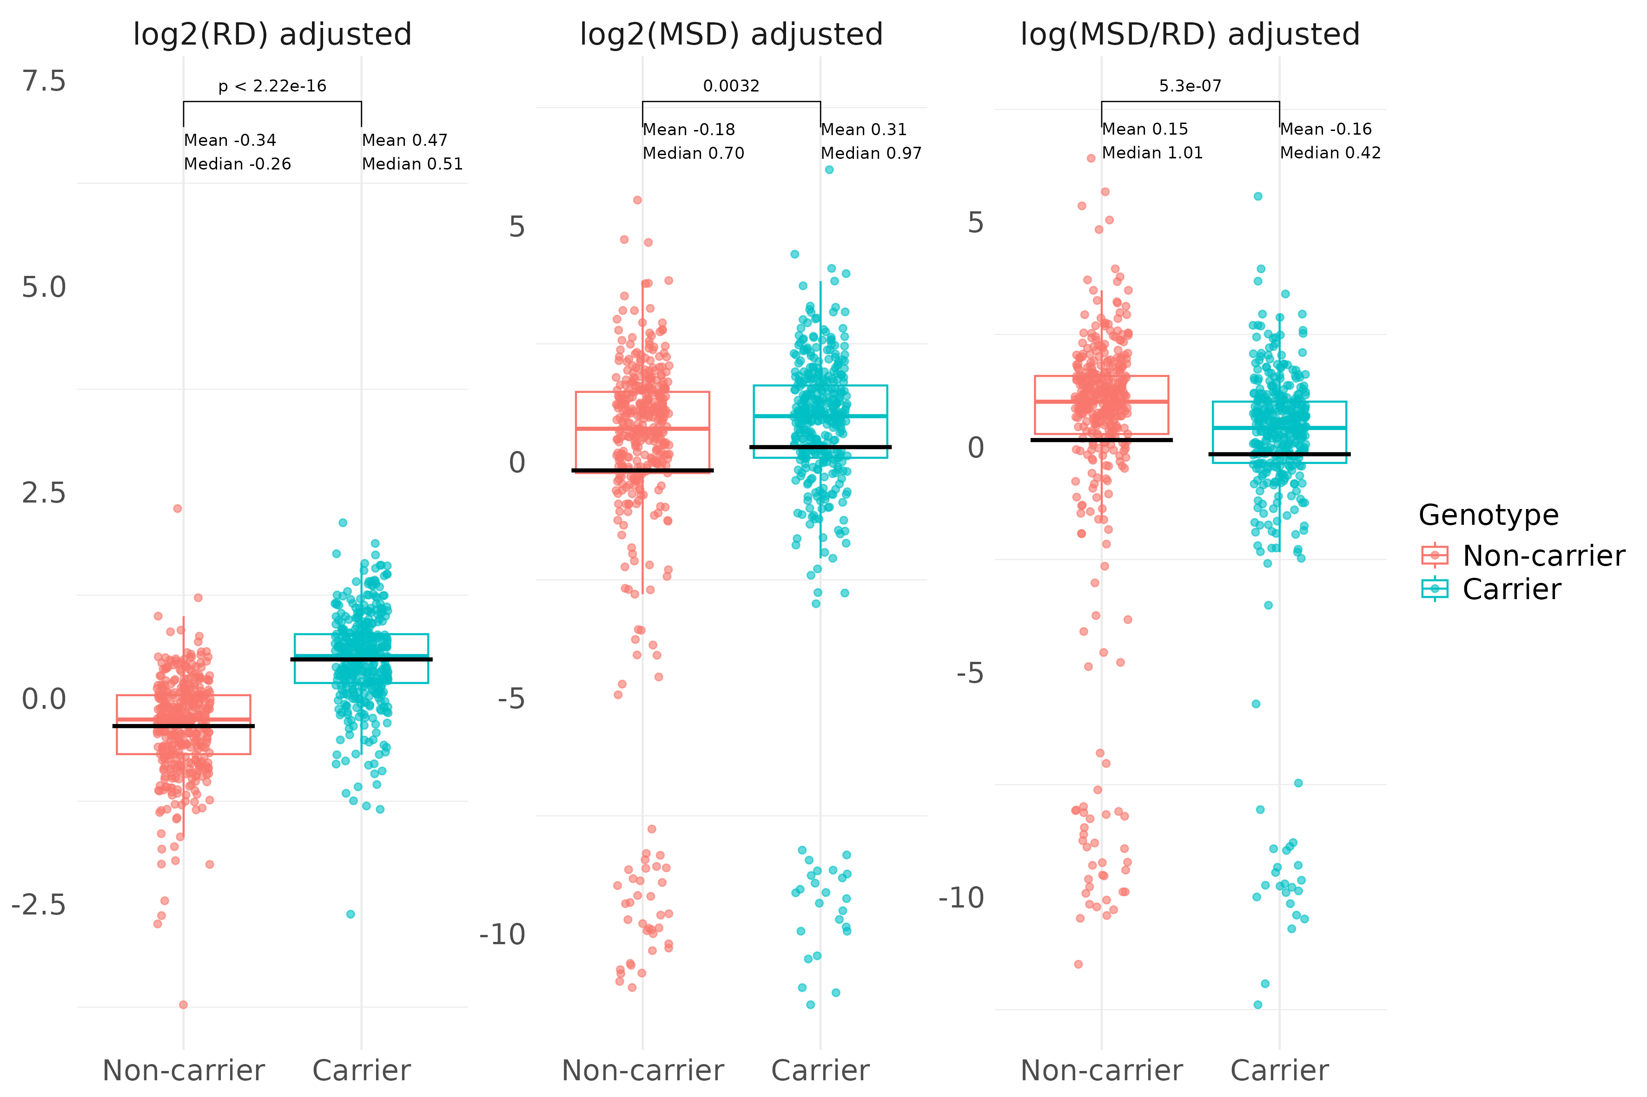
Supplementary Figure 19. Distribution of carrier–control comparisons for the MSTN p.Ile225Thr variant using RD, MSD and the MSD/RD ratio, with values adjusted for sex, age at sampling, and plate. Circulating myostatin levels were quantified using two independent ELISA-based assays: RD Quantikine GDF-8 ELISA and MSD R-PLEX Human GDF-8 assay. Plasma samples were obtained from 930 Icelandic participants with available SomaScan and/or Olink measurements, including 398 MSTN p.Ile225Thr heterozygous carriers and sex- and age-matched (within 5 years) controls. All assays were performed blinded to genotype. For the adjusted Wilcoxon signed-rank test the mean difference (MD) and P-values were: RD, MD = 0.81, P = 2.6 × 10⁻⁵⁰; MSD, MD = 0.49, P = 0.032; and MSD/RD, MD = -0.32, P = 5.3 × 10⁻⁷. For the unadjusted Wilcoxon signed-rank test, corresponding results were: RD, MD = 0.81, P = 1.6 × 10⁻⁴⁶; MSD, MD = 0.49, P = 0.022; and MSD/RD MD =-0.32, P = 1.6 × 10⁻⁷ for RD; MSD; and MSD/RD respectively. The figure shows that MSTN p.Ile225Thr carriers have lower MSD/RD ratio compared to non-carriers.

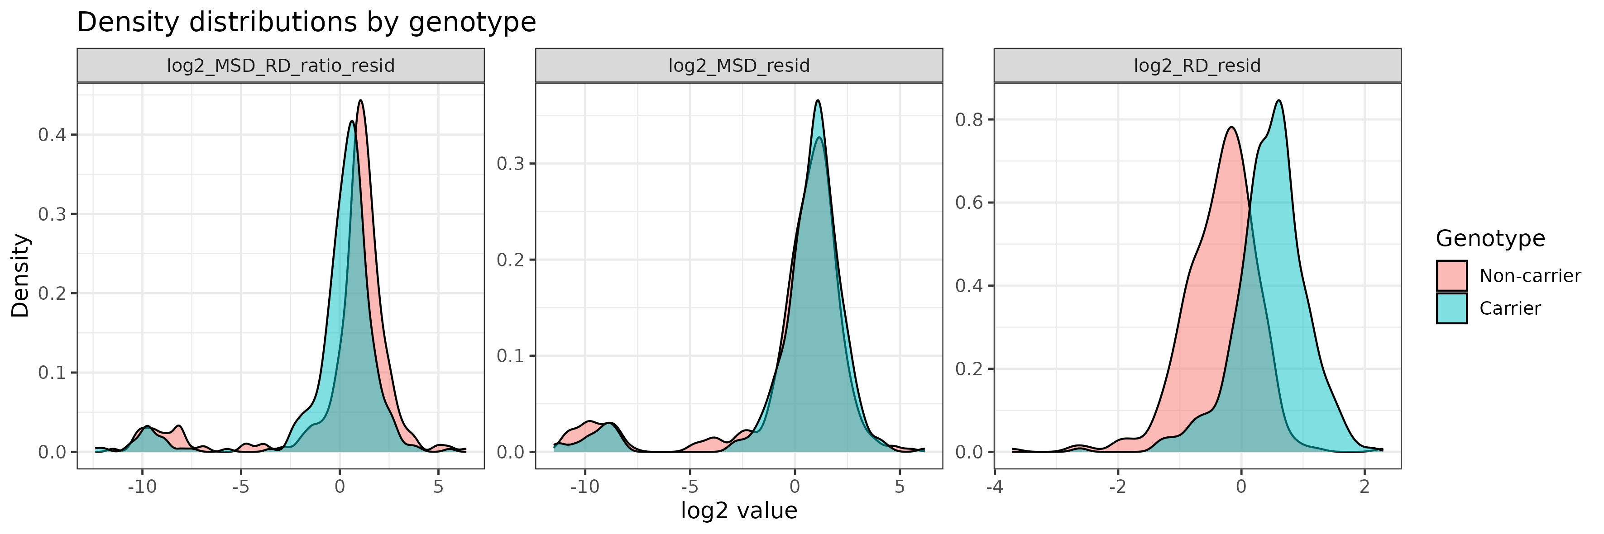
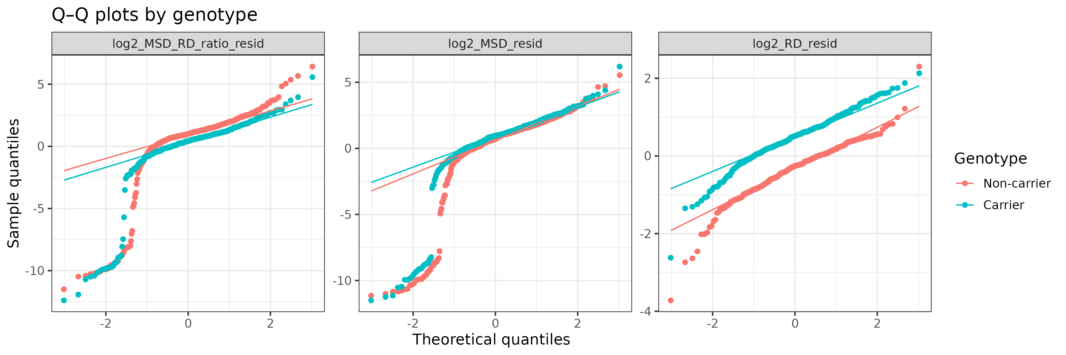
Supplementary figure 20. Density distribution and Q-Q plots of carrier–control comparisons for p.Ile225Thr for RD, MSD and MSD/RD measurement ratio, each adjusted for sex, age at sampling, and plate. Details Supplementary Figure 12 caption.

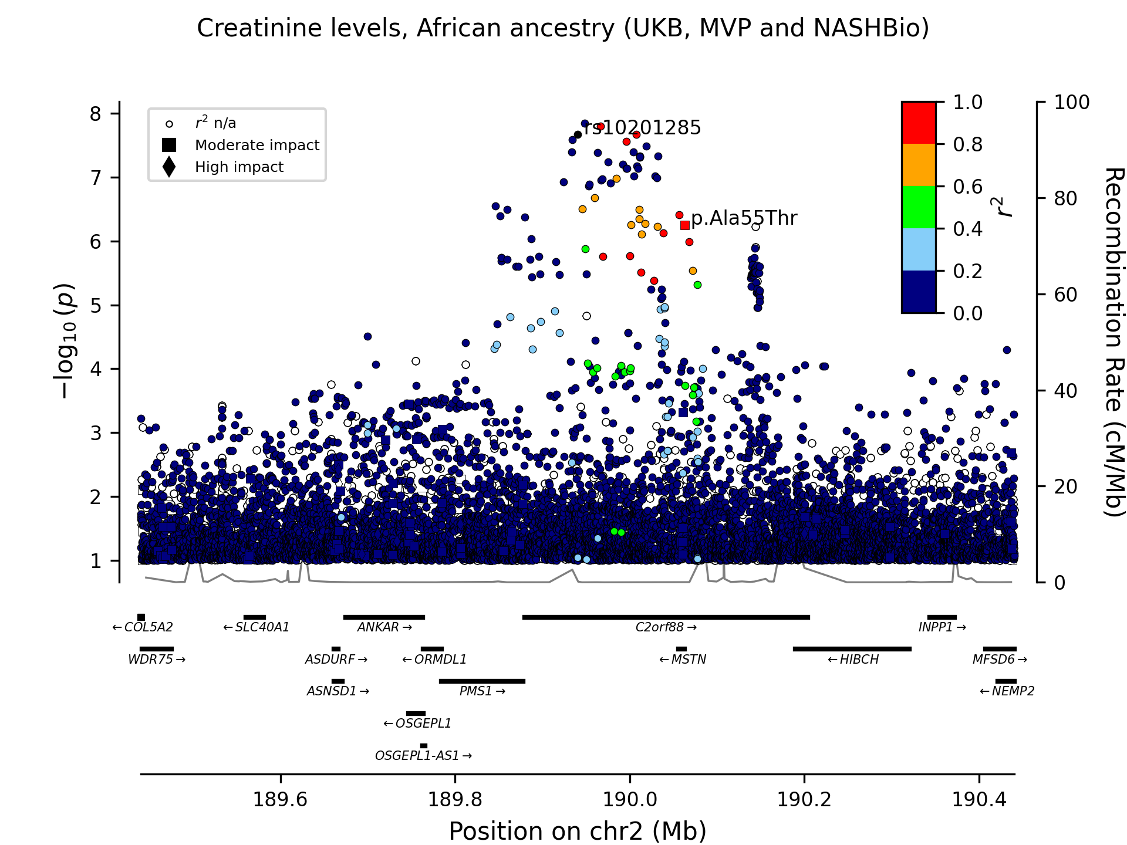
Supplementary figure 21. Regional plot presenting the association of the intergenic variant rs10201285-A (chr2:189940276) with creatinine blood levels (N = 144,075) in meta-analysis of the UK Biobank African cohort, NASHBio African cohort and the Million Veterans African (MVP) cohort. rs10201285-A is in high LD (r² = 0.84) with a previously published missense variant, p.Ala55Thr (rs1805085 at chr2:190062434), also shown in the figure. The degree of linkage disequilibrium (r²) of variants with rs10201285-A within a 500 KB window is shown, based on imputed UK Biobank genotypes. Moderate- and high-impact variants, as defined by variant annotation, are represented by squares and triangles, respectively. The significance of association between each variant and the phenotype, -log₁₀(P), is plotted on the left y-axis against chromosomal position on the x-axis. The right y-axis shows calculated recombination rates at the chromosomal location, plotted as a solid black line. Only variants with P < 0.1 are shown.

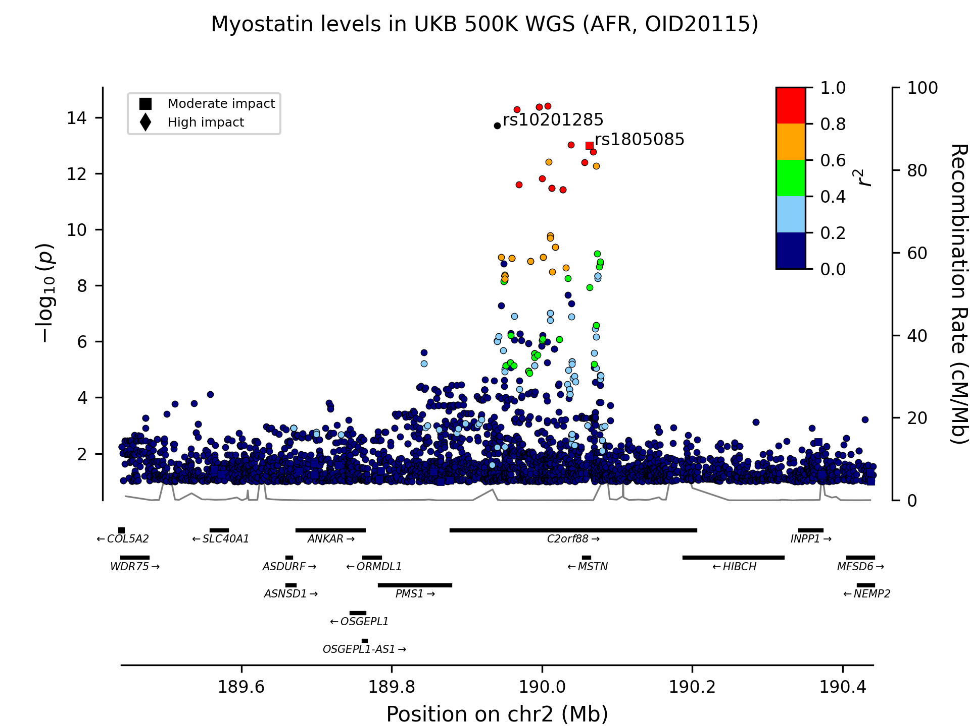
Supplementary figure 22. Regional plot presenting the association of the intergenic variant rs10201285-A (chr2:189940276) with myostatin blood levels (N = 1,505) in UK Biobank African cohort. rs10201285-A is in high LD (r² = 0.84) with a previously published missense variant, p.Ala55Thr (rs1805085 at chr2:190062434), also shown in the figure. The degree of linkage disequilibrium (r²) of variants with rs10201285-A within a 500 KB window is shown, based on imputed UK Biobank genotypes. Moderate- and high-impact variants, as defined by variant annotation, are represented by squares and triangles, respectively. The significance of association between each variant and the phenotype, -log₁₀(P), is plotted on the left y-axis against chromosomal position on the x-axis. The right y-axis shows calculated recombination rates at the chromosomal location, plotted as a solid black line. Only variants with P < 0.1 are shown.

