HERCULES: an integrative deep-learning framework for predicting RNA-binding propensity and mutation effects at single-residue resolution

Jonathan Fiorentino,^{1, #} Michele Monti,^{1,#}
Alexandros Armaos,^{1,} Dimitrios Miltiadis-Vrachnos,^{1,2}
Lorenzo Di Rienzo^{3,4} and Gian Gaetano Tartaglia^{1,$}

¹ RNA Systems Biology Lab, Centre for Human Technologies, Istituto Italiano di Tecnologia, Via Enrico Melen, 83, 16152 Genova GE
² Sapienza University of Rome, Department of Biology and Biotechnologies, Piazzale Aldo Moro 5, 00185, Rome
³ Center for Life Nano- & NeuroScience, Fondazione Istituto Italiano di Tecnologia, Viale Regina Elena 291, 00161, Rome
⁴ Sapienza University of Rome, Department of Biochemical Sciences “A. Rossi Fanelli”, P.le Aldo Moro 5, 00185 Rome

# These authors contributed equally to this work
$ correspondence to be addressed to gian.tartaglia@iit.it

Supplementary Tables
Supplementary Table S1. Global RNA-binding propensity scores computed by HERCULES for all reviewed human UniProt entries. The table includes annotation indicating whether each protein was included in the training or independent test sets used for binary RBP classification.
Supplementary Table S2. Dataset of human proteins containing RNA-binding domains (RBDs), classified as RNABinding, NonClassical, or UnknownPutative.
Supplementary Table S3. Dataset of experimentally validated mutations reported to impair RNA-binding activity, retrieved from UniProt and manually curated.
Supplementary Table S4. Mapping of feature names and categorization in feature families.
Supplementary Table S5. Dataset of proteins extracted from experimentally determined protein–RNA complexes deposited in the Protein Data Bank (PDB).

Supplementary figures on parameter optimization and dataset selection

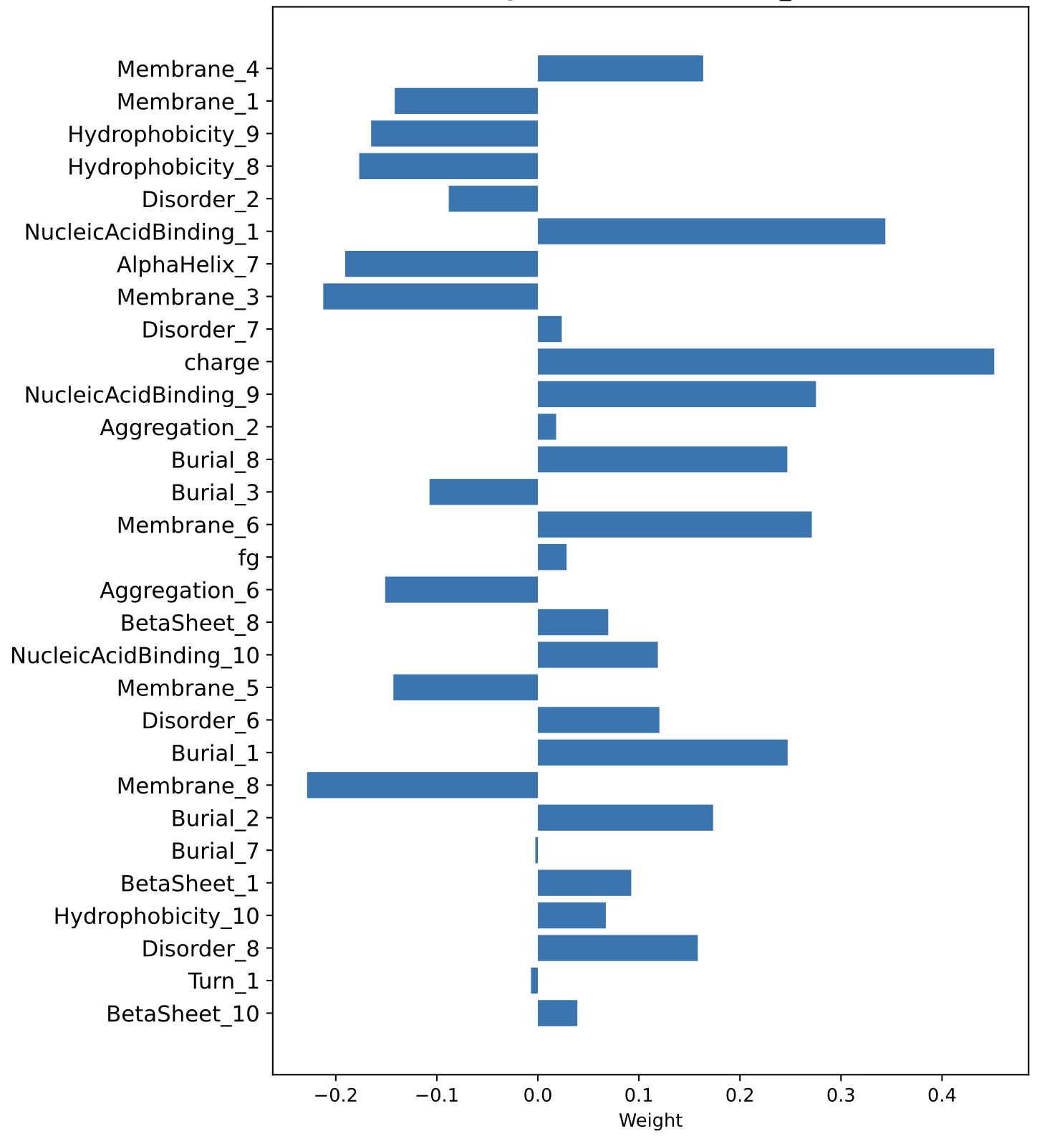

Supporting Figure S1. Bar plot showing the weights of the selected physicochemical features, illustrating their relative contributions to the local physicochemical information used to quantify RNA-binding propensity. The features were selected from a pool of physicochemical scales reported in Supplementary Table S4, which contains a collection of 10 predictors for each category.

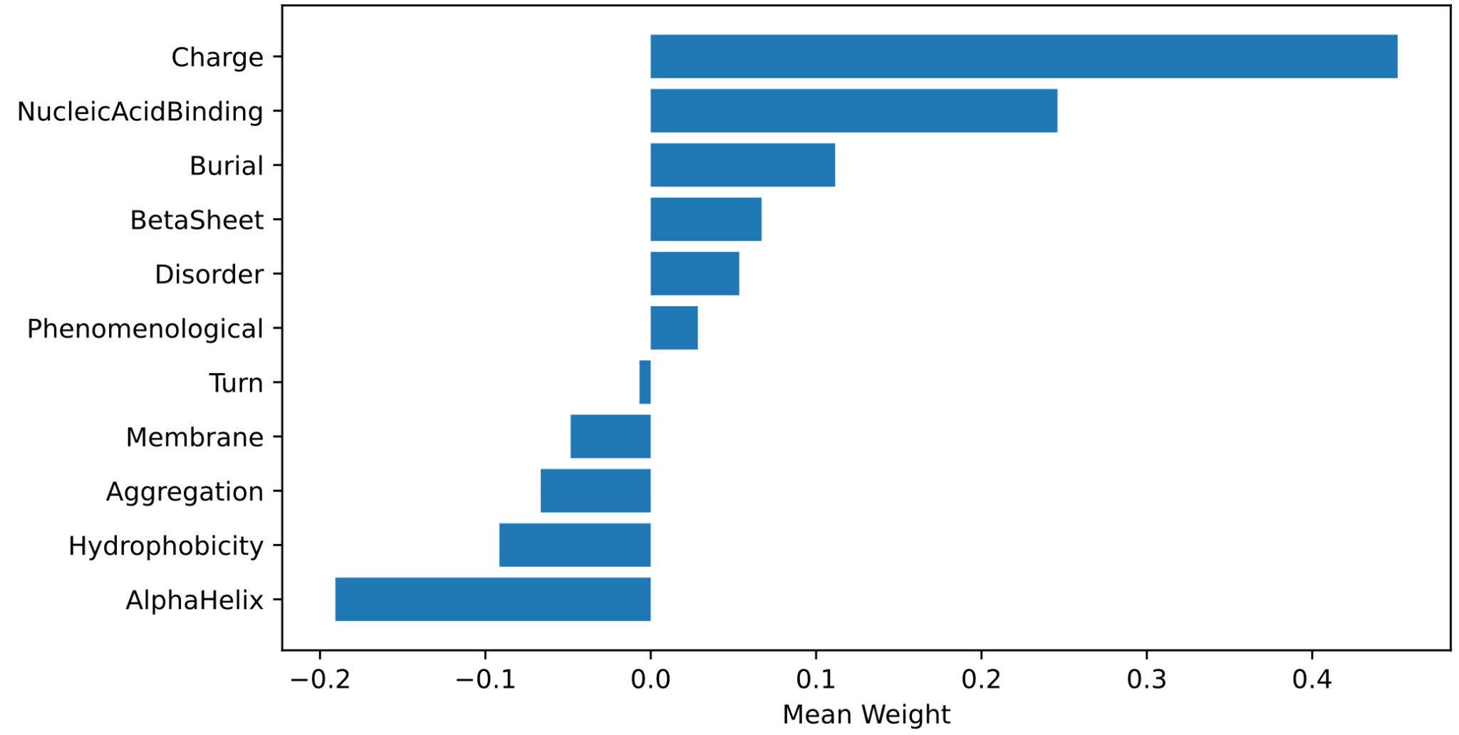
Supplementary Figure S2. Contribution of the differences in physicochemical properties that are used to score the model, in particular the mutation effect.

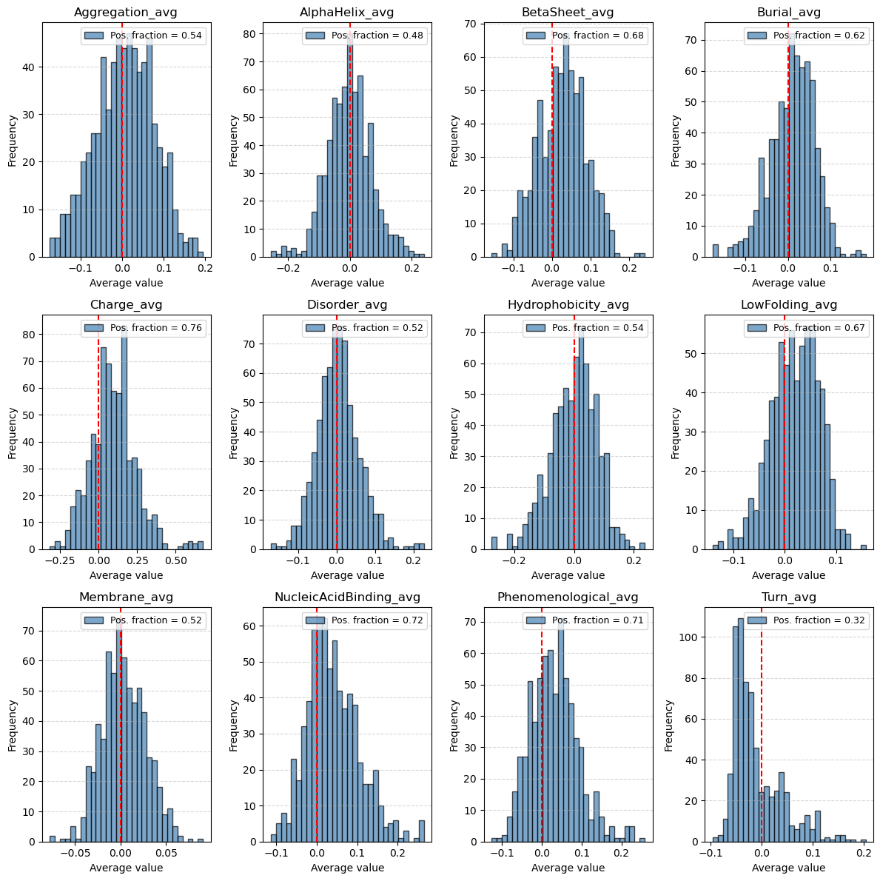
Supplementary Figure S3. Histograms of the differences in physicochemical properties between the wild-type (WT) and mutated proteins, highlighting the fraction of positive differences. No single averaged property alone is able to reproduce the same performance in recognizing deleterious mutations as the combined linear model that integrates all properties.

Supplementary figures on global score and residue-level profile validation

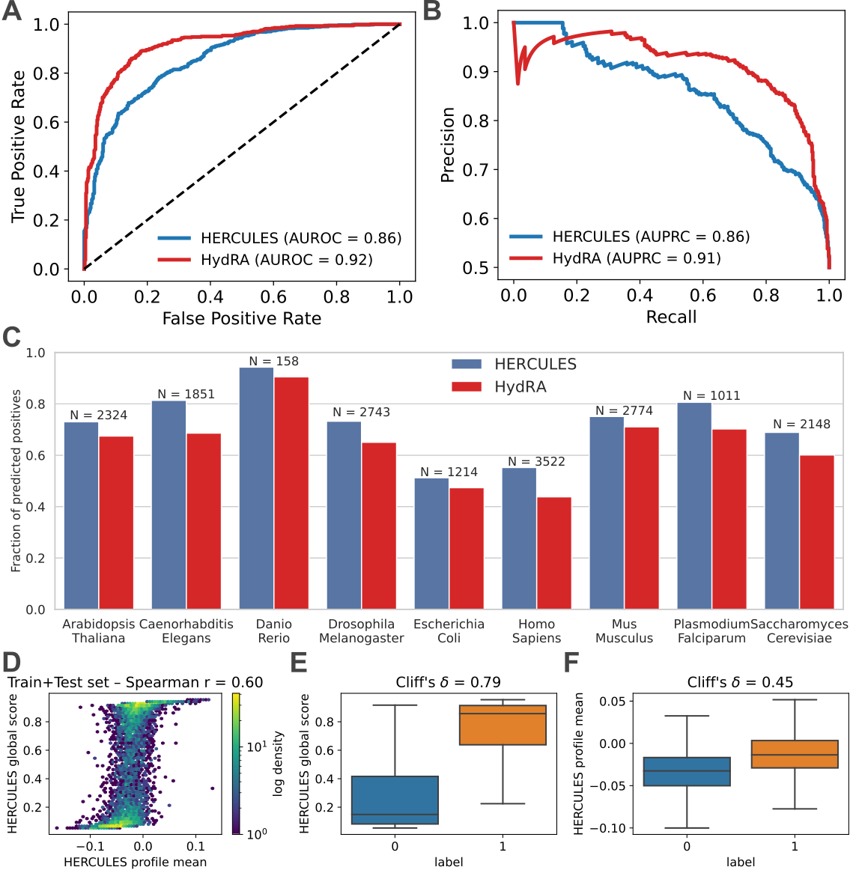
Supplementary Figure S4. Performance of the HERCULES global score in predicting RNA-binding proteins. (A) Receiver operating characteristic (ROC) curves comparing HERCULES and HydRA on an independent human test set. The dashed line indicates random performance. (B) Precision–recall curves for the same dataset. (C) Fraction of predicted RBPs across nine organisms using RBPs curated from RBP2GO. Bars show the proportion of proteins classified as RNA-binding by binarized HERCULES and HydRA scores; the number of proteins analyzed in each organism is indicated above each bar. (D) Density-colored scatter plot showing the relationship between the HERCULES global score and the mean of the residue-level RNA-binding propensity profile on the train–test set (Spearman ρ = 0.59). (E) Box plots illustrating separation of RBPs (label = 1) and non-RBPs (label = 0) by the HERCULES global score, with a Cliff’s δ effect size indicated. (F) Box plots showing separation of RBPs and non-RBPs by the mean of the residue-level HERCULES profile.

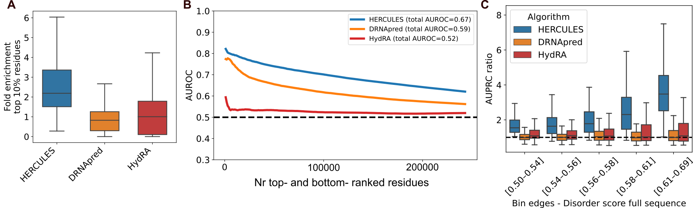Supplementary Figure S5. Additional evaluation of residue-level RNA-binding predictions. (A) Box plots showing the fold enrichment of RNA-binding residues within the top 10% highest-scoring positions for the Pfam-annotated protein dataset used in Figure 2. (B) Area Under the Receiver Operating Characteristic curve (AUROC) computed as a function of the number of top- and bottom-ranked residues (k) for the same dataset. AUROC on the full dataset for each algorithm is shown in the legend. (C) Box plots showing the AUPRC ratio to random for different algorithms, stratified by intervals of the intrinsic disorder score of the full-length protein sequence.
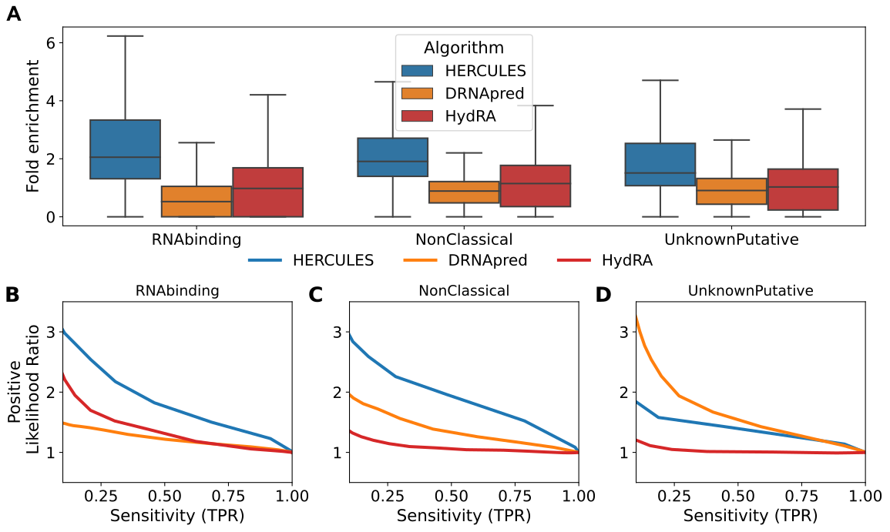
Supplementary Figure S6. Additional evaluation of predictions of canonical and non-canonical RBDs. (A) Box plots of fold enrichment in the top 10% highest-scoring residues for proteins grouped by RNA-binding domain class (RNABinding, NonClassical, UnknownPutative), corresponding to the dataset analyzed in Figure 3. (B-D) Positive likelihood ratio as a function of sensitivity for each RNA-binding domain class. Each panel corresponds to one domain class and reports the performance of the three algorithms evaluated in panel A.
Supplementary figures on the mutation dataset
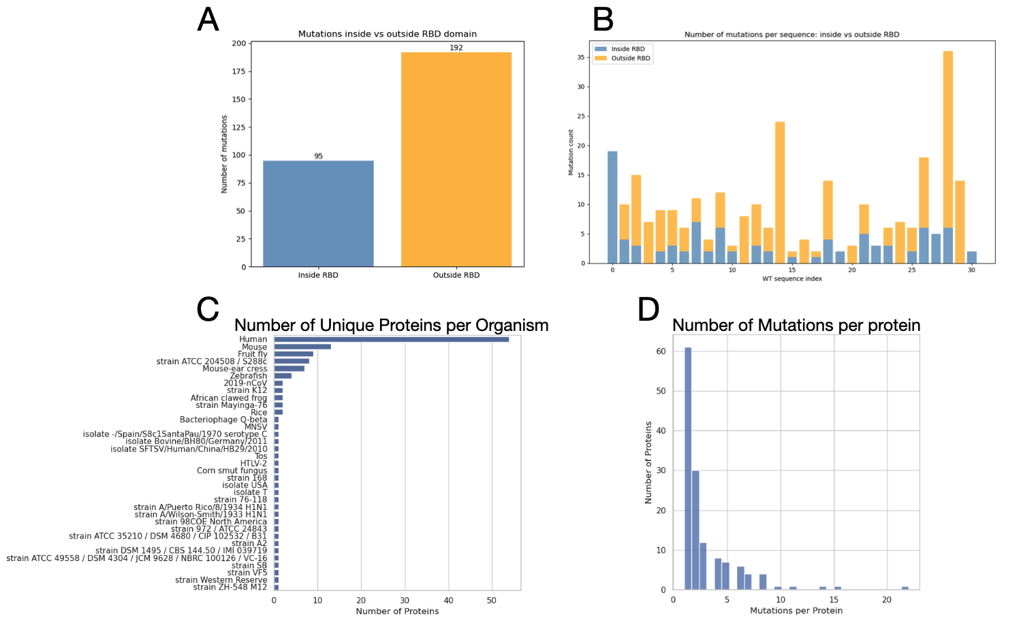
Supplementary Figure S7. Summary statistics of RNA-binding-disrupting mutations. (A) Bar plot showing the number of negative mutations occurring within and outside the RNA-binding domain (RBD) for human proteins. (B) Stacked bar plot showing the number of mutations inside (blue) or outside (yellow) the RBD for each human protein in our curated mutation dataset. (C) Bar plot showing the number of proteins per organism in the curated mutation dataset. (D) Histogram of the number of mutations per protein.

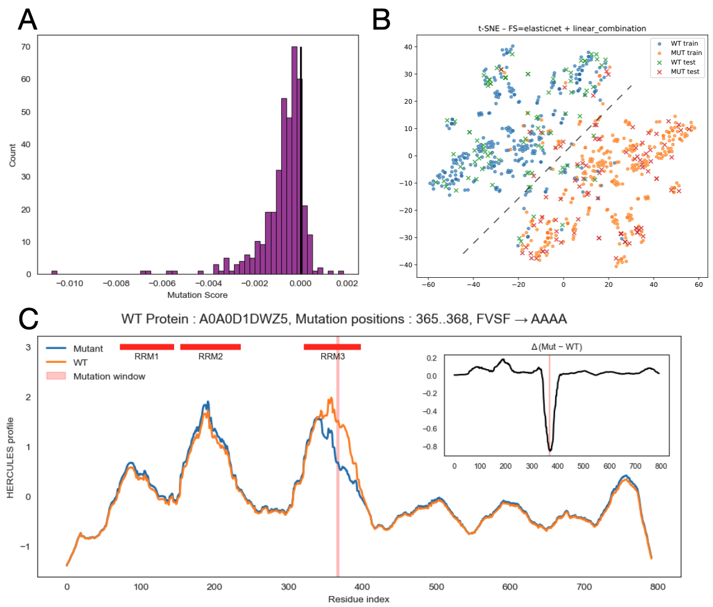
Supplementary Figure S8. (A) Histogram of mutation scores, defined as the difference between the means of the wild-type (WT) and mutant RNA-binding propensity profiles (mutant-WT), computed for all variants in the held-out test set of the curated mutation dataset. The fraction of mutations predicted to cause loss of RNA binding (positive scores) is 0.87. (B) t-SNE representation of the score difference between mutated and wild-type (WT) sequences. Dots indicate training samples, while crosses denote test samples. (C) HERCULES residue-level RNA-binding propensity profiles for the WT (orange) and mutant (blue) sequences around the mutation region. The example protein (UniProt ID A0A0D1DWZ5) carries a four–amino-acid substitution (positions 365–368, FVSF → AAAA). The inset shows the profile difference (mutant − WT), highlighting a localized decrease in RNA-binding propensity at the mutation sites.

Supplementary figures on the PDB protein-RNA complexes dataset

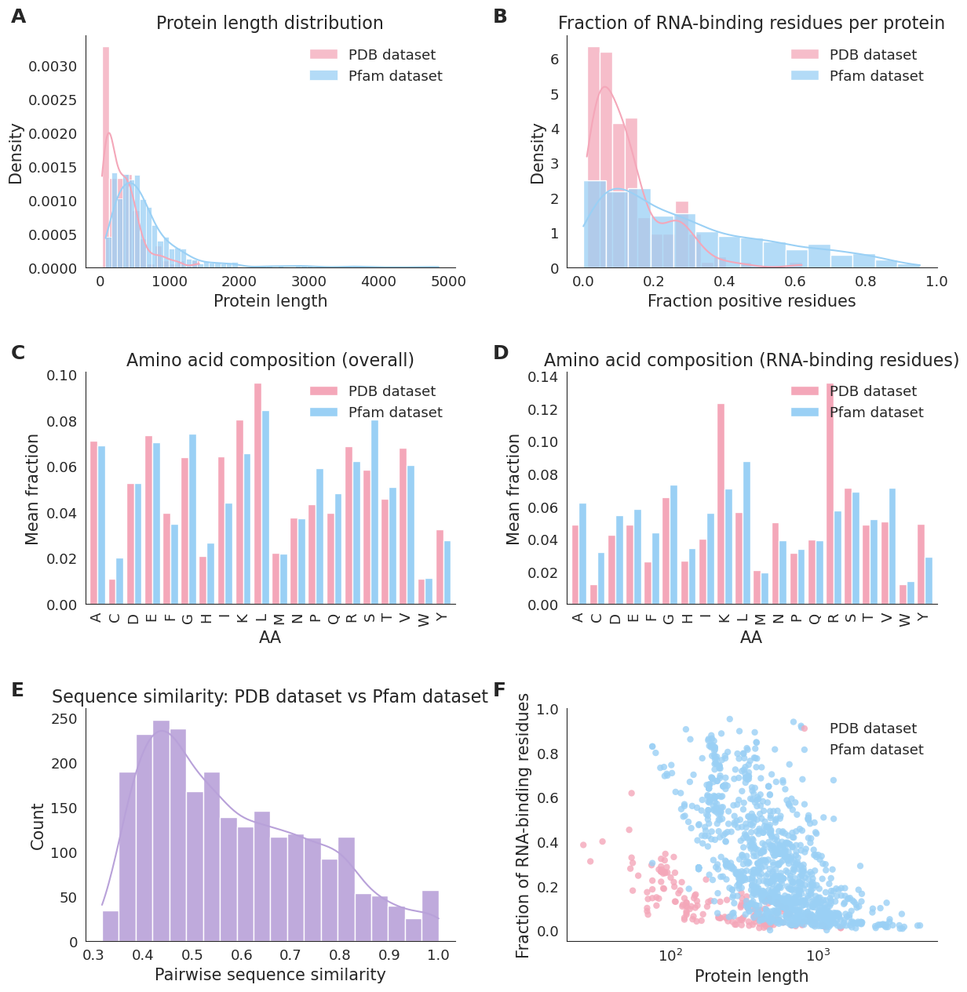
Supplementary Figure S9. Comparison between Pfam and PDB datasets. (A) Distribution of protein lengths in the PDB and Pfam datasets. (B) Distribution of the fraction of residues annotated as RNA-binding per protein. (C) Mean amino acid composition computed over full protein sequences. (D) Mean amino acid composition restricted to RNA-binding residues. (E) Distribution of pairwise sequence similarity scores computed between randomly sampled proteins from the two datasets. (F) Relationship between fraction of RNA-binding residues and protein length, shown for individual proteins.
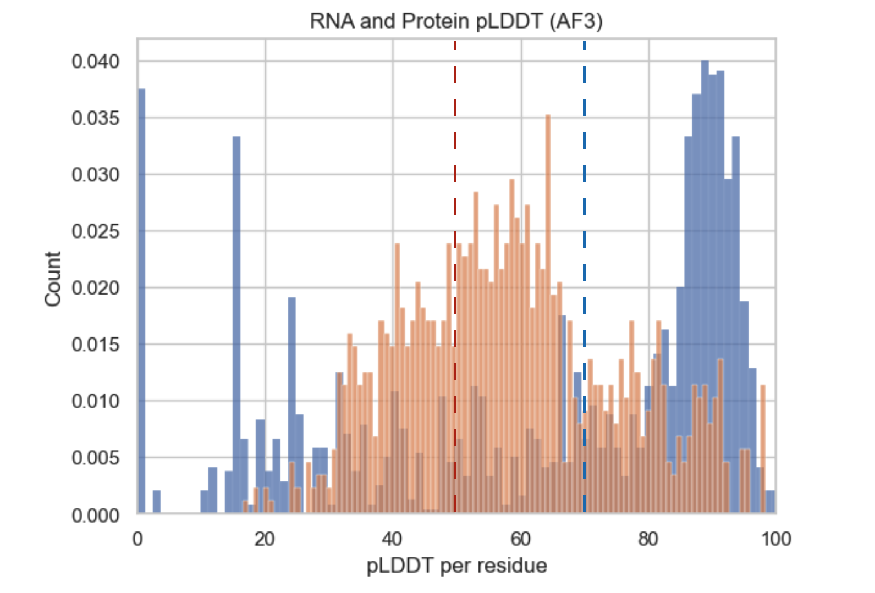
Supplementary Figure S10. Histogram of per-residue pLDDT scores for all protein–RNA complexes predicted by AF3 in association with G-quadruplex RNAs. The average pLDDT is 51 for the RNA components and 72 for the protein components. These values indicate that the selected predicted complexes exhibit overall moderate to good confidence, supporting their structural reliability for downstream analyses.

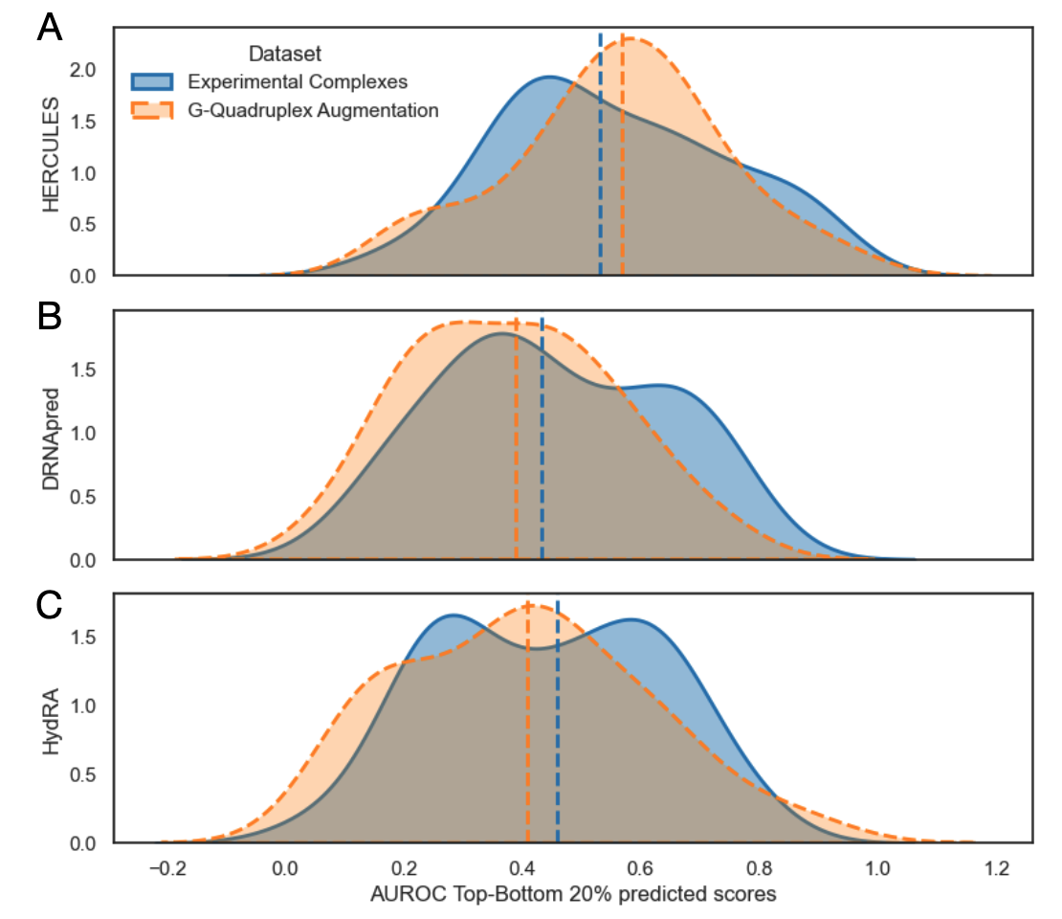Supplementary Figure S11. Distributions of per-protein AUROC values computed from the top and bottom 20% of residue-level predictions for Hercules (A), DRNApred (B) and Hydra (C). Solid lines correspond to AUROC distributions obtained using experimentally resolved protein–RNA complexes from the PDB, while dashed lines correspond to the augmented dataset, in which the same proteins were additionally evaluated using AlphaFold3-predicted complexes with multiple G-quadruplex RNAs to identify supplementary RNA-contacting residues. The dashed lines mark the median of each distribution.

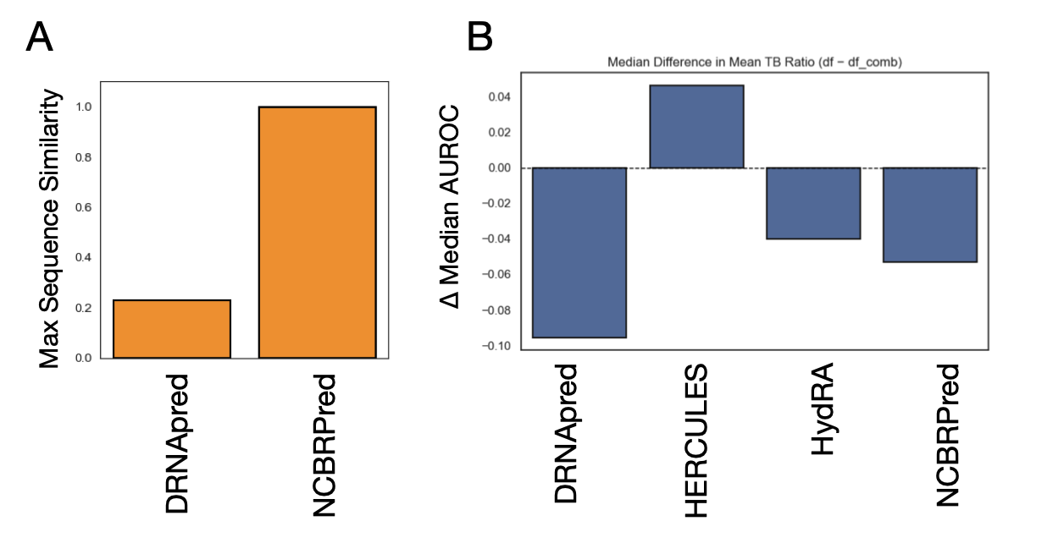
Supplementary Figure S12. (A) Evaluation of sequence similarity within the training datasets of DRNA and NCBPred to ensure that the observed differences are not biased by redundancy in the training data. All the NCBPRed dataset is contained in our selected PDB test set so we have decided to exclude this algorithm to the comparisons. (B) We compared the difference in median values between the top 20% and bottom 20% of single-protein measurements. We compare experimentally determined complexes versus AF3-predicted complexes enriched for G-quadruplex RNA interactions. This comparison allows us to assess how enrichment for G-quadruplexes influences the distribution of protein–RNA interaction scores and highlights trends that may be specific to these structured RNA elements.

