Extended data

Extended Data Fig. 1 │Trial design for the monotherapy cohort.
HLA, human leukocyte antigen; MAGE-A4, melanoma-associated antigen A4; uza-cel, uzatresgene autoleucel.
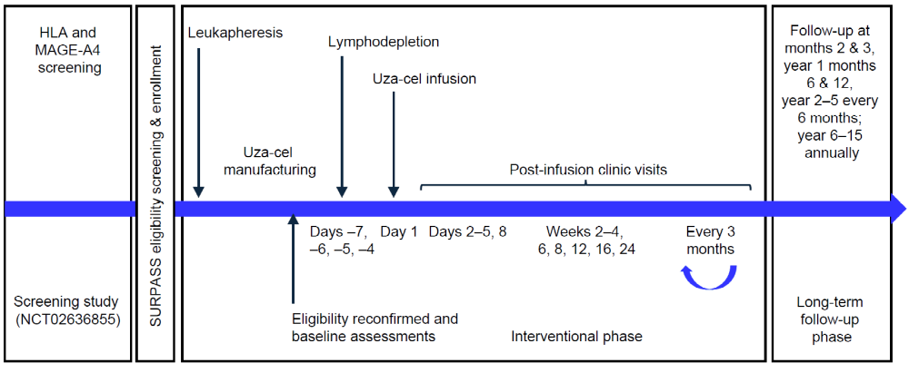

Extended Data Fig. 2 │CONSORT diagram of patient disposition.
AE, adverse event; HLA, human leukocyte antigen; MAGE-A4, melanoma-associated antigen A4; RECIST, Response Evaluation Criteria in Solid Tumors; uza-cel, uzatresgene autoleucel.
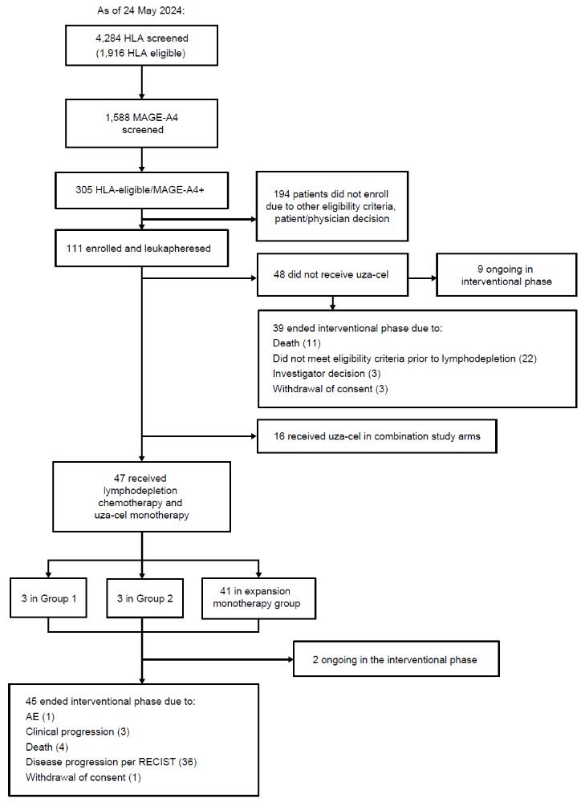

Extended Data Table 1 │HLA-A and MAGE-A4 expression details of 47 monotherapy patients.
Tumor type |  | HLA-A_1 | HLA-A_2 | MAGE-A4 H scoreª
Esophageal |  | 02:BMSUH | 32:01:00 | 260
Esophageal |  | 02:BMSUH | 23:01 | 275
Esophageal |  | 02:CZHNR | 31:CDBKP | 195
Esophageal |  | 02:01:01G | 11:01:01G | 280
EGJ |  | 02:01 | 31:RVXR | 180
EGJ |  | 02:01 | 30:02:00 | 300
EGJ |  | 02:BMSUH | 02:BMSUH | 210
EGJ |  | 02:BMSUH | 24:BKKPV | 180
EGJ |  | 02:BMSUH | 11:BKKPP | 250
EGJ |  | 01:CUHJE | 02:CZHNR | 160
EGJ |  | 02:CZHNR | 03:DFFSX | 245
EGJ |  | 02:01:01G | 02:01:01G | 300
EGJ |  | 02:01:01G | 02:01:01G | 200
Gastric |  | 02:CZHNR | 30:01:00 | 200
Esophageal, EGJ, and gastric median (min, max) |  |  |  | 227.5 (160, 300)
Head and neck |  | 01:BKKPK | 02:BMSUH | 295
Head and neck |  | 02:BMSUH | 03:BKKPN | 140
Head and neck |  | 02:CZHNR | 24:DFJDB | 280
Head and neck |  | 02:CZHNR | 26:BMCND | 300
Head and neck median (min, max) |  |  |  | 287.5 (140, 300)
Melanoma |  | 02:BMSUH | 26:BMCND | 300
Melanoma |  | 02:01:01G | 68:01:02G | 220
MRCLS |  | 02:01 | 03:01 | 200
NSCLC |  | 01:BKKPK | 02:BMSUH | 300
NSCLC |  | 02:CZHNR | 02:CZHNR | 295
Ovarian |  | 02:01 | 03:01 | 200
Ovarian |  | 02:BMSUH | 29:BKKPW | 295
Ovarian |  | 02:BMSUH | 03:BKKPN | 225
Ovarian |  | 02:BMSUH | 24:BKKPV | 285
Ovarian |  | 02:BMSUH | 29:BKKPW | 130
Ovarian |  | 02:BMSUH | 02:BMSUH | 250
Ovarian |  | 02:BMSUH | 03:BKKPN | 295
Ovarian |  | 02:CZHNR | 30:02:00 | 280
Ovarian |  | 02:CZHNR | 02:CZHNR | 165
Ovarian |  | 02:CZHNR | 11:CETGT | 170
Ovarian |  | 01:CUHJE | 02:CZHNR | 300
Ovarian |  | 02:CZHNR | 03:DFFSX | 95
Ovarian |  | 02:01:01G | 29:02:01G | 195
Ovarian |  | 02:01:01G | 03:01:01G | 300
Ovarian |  | 01:01:01G | 02:01:01G | 90
Ovarian median (min, max) |  |  |  | 225 (90, 300)
Synovial sarcoma |  | 02:BMSUH | 11:BKKPP | 300
Urothelial |  | 02:01 | 02:01 | 280
Urothelial |  | 02:CZHNR | 32:ADGUH | 300
Urothelial |  | 01:CUHJE | 02:CZHNR | 205
Urothelial |  | 02:CZHNR | 02:CZHNR | 145
Urothelial |  | 02:02 | 34:02:00 | 130
Urothelial |  | 02:01:01G | 29:02:01G | 260
Urothelial |  | 01:01:01G | 02:01:01G | 200
Urothelial |  | 02:01:01G | 33:01:01G | 90
Urothelial median (min, max) |  |  |  | 202.5 (90, 300)
ªH score of immunohistochemical staining strength calculated as: 1 x (% of 1+ cells) + 2 x (% of 2+ cells) + 3 x (% of 3+ cells).
EGJ, esophagogastric junction; HLA, human leukocyte antigen; MAGE-A4 melanoma-associated antigen A4; MRCLS, myxoid/round cell liposarcoma; NSCLC, non-small cell lung carcinoma.

Extended Data Table 2 │Additional AEs.
AEs and grade ≥ 3 AEs deemed related to either T-cell infusion or lymphodepletion with fludarabine/cyclophosphamide; and serious AEs (SAEs) of any relationship occurring in ≥ 2 patients in the overall monotherapy group
Events, n (%) | Group 1  (N = 3) | Group 2 (N = 3) | Expansion monotherapy group  (N = 41) | Overall monotherapy group  (N = 47)
Any AEs related to T-cell infusion or lymphodepletion | 3 (100) | 3 (100) | 41 (100) | 47 (100)
Any AE related to cyclophosphamide | 3 (100) | 3 (100) | 39 (95.1) | 45 (95.7)
Any AE related to fludarabine | 3 (100) | 3 (100) | 39 (95.1) | 45 (95.7)
Any grade ≥ 3 AEs related to T-cell infusion or lymphodepletion | 3 (100) | 3 (100) | 36 (87.8) | 42 (89.4)
Any SAE | - | 1 (33.3) | 31 (75.6) | 32 (68.1)
CRS | - | 1 (33.3) | 15 (36.6) | 16 (34.0)
Pyrexia | - | - | 5 (12.2) | 5 (10.6)
Immune effector cell-associated neurotoxicity syndrome | - | - | 4 (9.8) | 4 (8.5)
Hypoxia | - | - | 3 (7.3) | 3 (6.4)
Dyspnea | - | - | 2 (4.9) | 2 (4.3)
Pleural effusion | - | - | 2 (4.9) | 2 (4.3)
Drug reaction with eosinophilia and systemic symptoms | - | - | 2 (4.9) | 2 (4.3)
AE, adverse event; CRS, cytokine release syndrome; SAE, serious adverse event.

Extended Data Fig. 3 │Insertional oncogenesis in 9 patients.
a, Pielou evenness index, between 0 and 1, where 1 means the distribution of all the sites is completely even, that is, no clonal dominance. b, Relative abundance of top clones, with oncogenes (as included on the COSMIC oncogene list) denoted by tilde (~). The numbers above each column are the numbers of cells that were sampled.¹⁹ These counts help provide context for the relative abundance values. COSMIC, catalogue of somatic mutations in cancer.
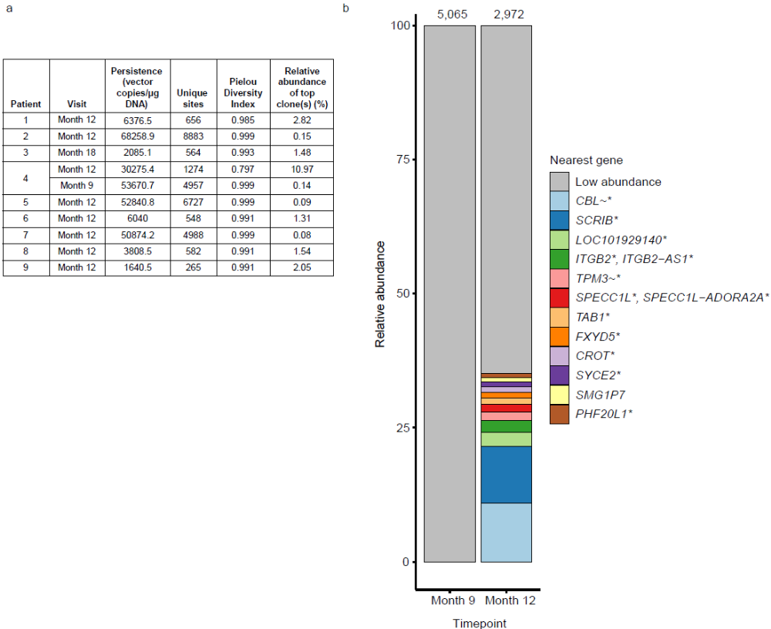

Extended Data Fig. 4 │Illustrative scans of patients with a response.
a, A 69-year-old man with stage IV SCC head and neck cancer, with baseline MAGE-A4 expression in tumor cells of 85% at 3+,10% at 2+, and 5% at 1+ staining intensity (H score of 280). Baseline sum of lesion diameters was 111 mm across 5 target lesions. Prior systemic therapies were platinum-based therapy, nivolumab, and taxane/cetuximab. He was treated with 5 billion transduced T cells, and the partial response was initially reported at week 4 and later confirmed. b, A 68-year-old patient with high grade serous ovarian cancer with prior history of multiple surgeries and systemic therapies. Baseline tumor MAGE-A4 expression was 25% tumor cells with 3+, 45% with 2+, and 30% with 1+ staining (H score of 195). She received 6.6 billion transduced T cells, and the partial response was seen at week 4 and confirmed at week 8. c, A 56-year-old patient with high grade serous ovarian cancer with prior history of multiple surgeries and systemic therapies. Baseline tumor MAGE-A4 expression was 95% tumor cells with 3+, and 5% with 2+ staining (H score of 295). She received 3.24 billion transduced T cells, and the complete response was seen at week 4 and confirmed at week 8.
H score of immunohistochemical staining strength calculated as: 1 x (% of 1+ cells) + 2 x (% of 2+ cells) + 3 x (% of 3+ cells); MAGE-A4, melanoma-associated antigen A4; SCC, squamous cell carcinoma.
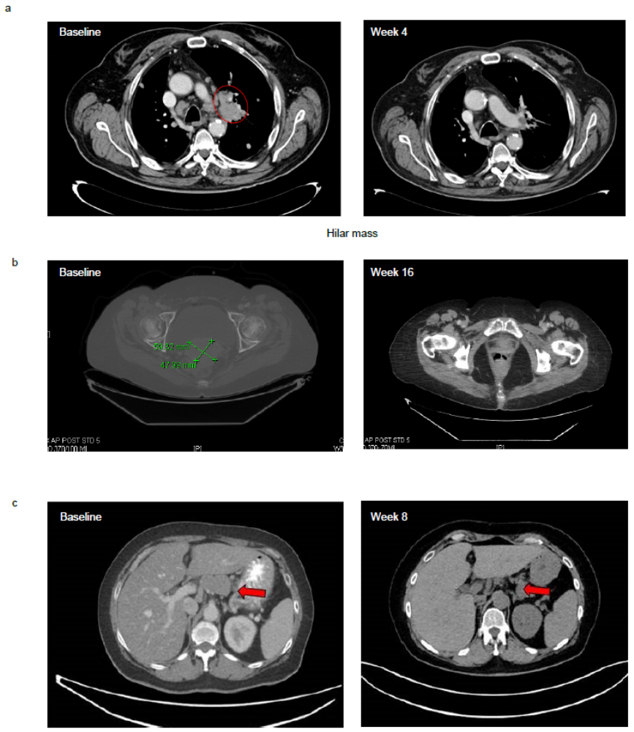

Extended Data Fig. 5 │Prognostic characteristics of patients in the monotherapy cohort.
Forest plot of post-hoc subgroup analysis of overall response rate (with 95% CI by Clopper-Pearson/exact binomial) in different subgroups of patients in the monotherapy cohort. H score of immunohistochemical staining strength calculated as: 1 x (% of 1+ cells) + 2 x (% of 2+ cells) + 3 x (% of 3+ cells); CRS, cytokine release syndrome; MAGE-A4, melanoma-associated antigen A4; SLD, sum of lesion diameters.
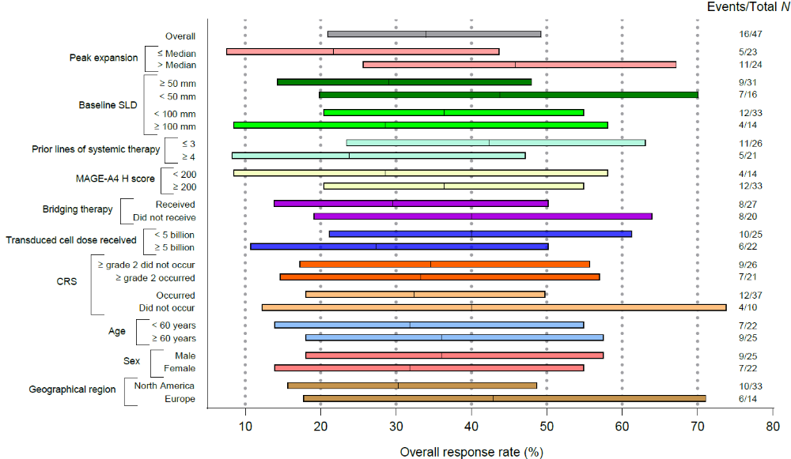

Extended Data Fig. 6 │Uzatresgene autoleucel initiates a broad intra-tumoral adaptive and innate immune response.
a, Ratio of M2 macrophages:cytotoxic T lymphocytes in the tested patient biopsies as of their best overall response as of the data cutoff 29 July 2024. b, Representative multiplex immunofluorescence images of post-infusion biopsies from an ovarian (upper) and urothelial (lower) tumor stained for CD3 (yellow), CD4 (orange), CD8 (green), granzyme B (white), panCK/Sox10 (pale blue), M1 macrophage (red), M2 macrophage (green), with nuclei dark blue. Note the limitation that this analysis is based on N=14. CR, complete response; CTL, cytotoxic T lymphocyte; PD, progressive disease; PR, partial response; SD, stable disease.
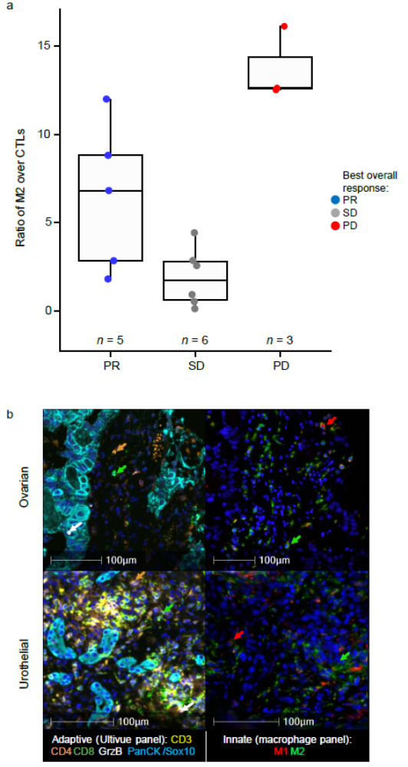

Extended Data Fig. 7 │Uzatresgene autoleucel reduces antigen positive tumor cells; the greatest reduction observed in patients with a response.
a, Quantification of MAGE-A4 expression in available tumor biopsies following uza-cel infusion measured by immunohistochemistry. MAGE-A4 expression was significantly different across all groups (P = 0.018 by Kruskal Wallis) and was significantly reduced in the group with PR compared with SD (P = 0.047) or with PD (P = 0.029), both by Mann Whitney U test. b, Representative immunohistochemistry showing MAGE-A4 (brown) tumoral expression changes. The green arrow indicates the patient whose representative images are shown on the left hand side of panel b, and the red arrow indicates the patient whose representative images are shown on the right of panel b. Note the limitation that this analysis is based on N=15. H score of immunohistochemical staining strength calculated as: 1 x (% of 1+ cells) + 2 x (% of 2+ cells) + 3 x (% of 3+ cells); MAGE-A4, melanoma-associated antigen A4; NSCLC, non-small cell lung cancer; PD, progressive disease; PR, partial response; SD, stable disease.
