Tables
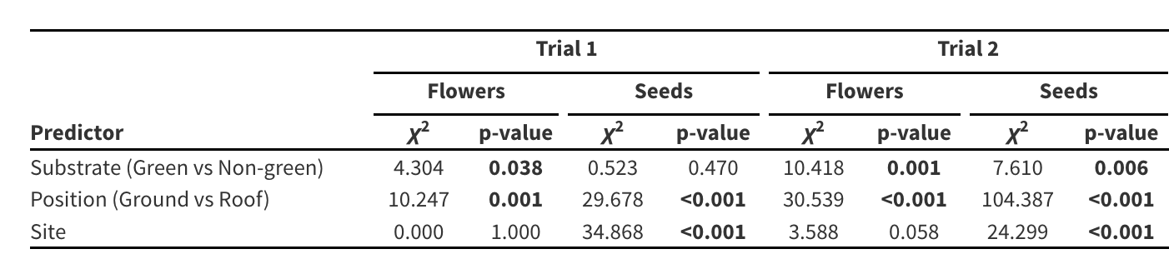
Table 1. The effects of building roof type (green versus nongreen roof), position (ground versus rooftop), and site on the number of flowers and seeds in July (Trial 1) and August (Trial 2). The number of seeds is a measure of pollen dispersal because male sterile plants set seeds only when pollen from hermaphroditic RCBr- st plants fertilize them. Results from a mixed model are included with χ² and p-values. p-values <0.05 are shown in bold.

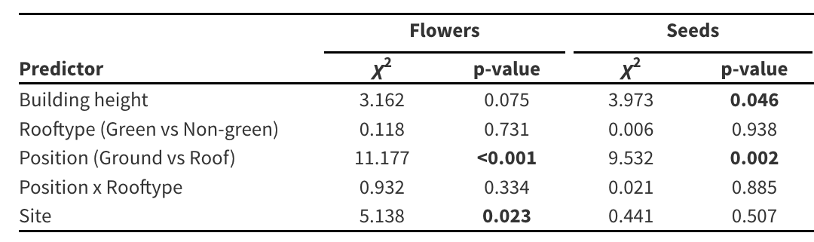
Table 2. The effects of building height, roof type, position, and site on the number of flowers and seeds of hermaphroditic plants (July). In this test, number of seeds is a quantification of localized pollinator-mediated plant reproduction because each bucket contains four self-incompatible hermaphroditic plants that can pollinate each other when visited by pollinators. Results from a mixed model are included with χ² and p-values. p-values <0.05 are shown in bold.

