Urban Ecosystems
Supplementary Information
How does the 3-dimensional built environment and green infrastructure impact plant pollinator interactions?
Nehal Vijay Naik, Marc TJ Johnson
Affiliations
Department of Ecology and Evolutionary Biology, University of Toronto, Toronto, Ontario, Canada
Department of Biology, University of Toronto Mississauga, Mississauga, Ontario, Canada
*Corresponding author: Nehal Vijay Naik, University of Toronto Mississauga, 3359 Mississauga Rd, Mississauga, ON, Canada, nehal.naik@mail.utoronto.ca

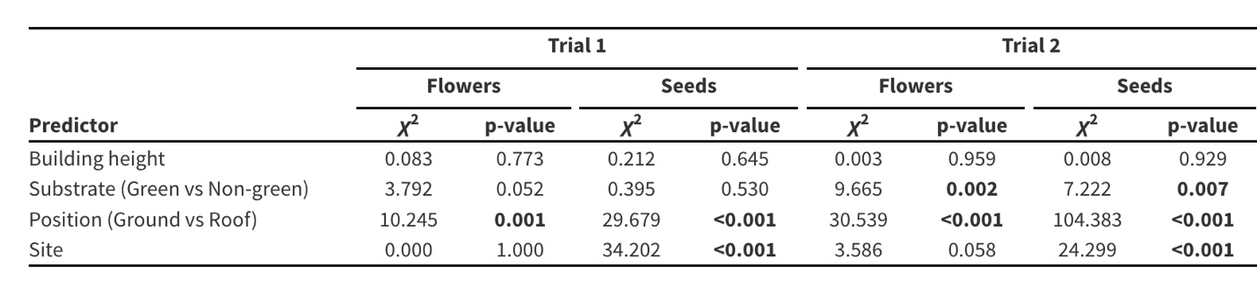
Table S1. The effects of building height, roof type (green versus nongreen roof), position (ground versus rooftop), and site on the number of flowers and seeds in July (Trial 1) and August (Trial 2). The number of seeds is a measure of pollen dispersal because male sterile plants set seeds only when pollen from hermaphroditic RCBr- st plants fertilize them. Results from a mixed model are included with χ² and p-values. p-values <0.05 are shown in bold.

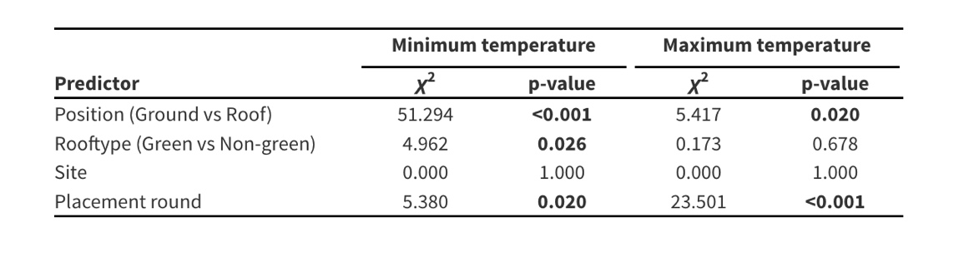
Table S2. The effects of position, roof type, site, and placement round on minimum and maximum temperatures. Placement round was used as a random effect to account for iButtons that were deployed simultaneously in the same trial versus different trials. Results from a mixed model are included with χ² and p-values. p-values <0.05 are shown in bold.

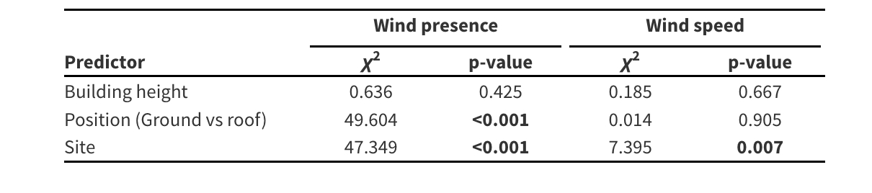
Table S3. The effects of building height, position (ground vs roof), and site on wind presence and speed. Results from a mixed model are included with χ² and p-values. p-values <0.05 are shown in bold.

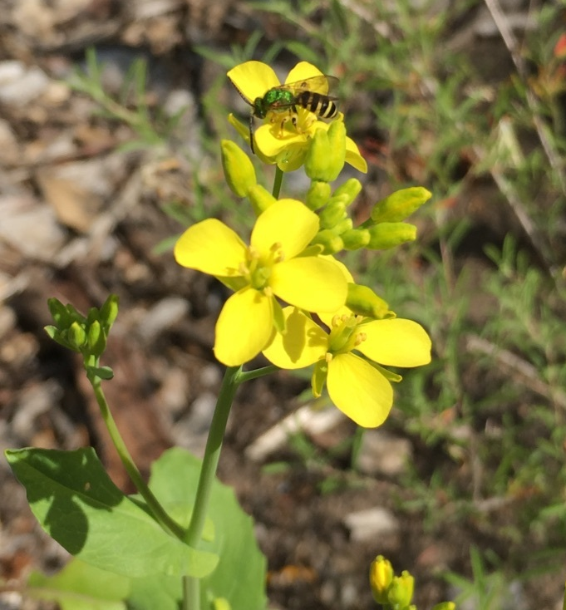

Figure S1. A photo of Rapid Cycling Brassica rapa with a sweat bee.

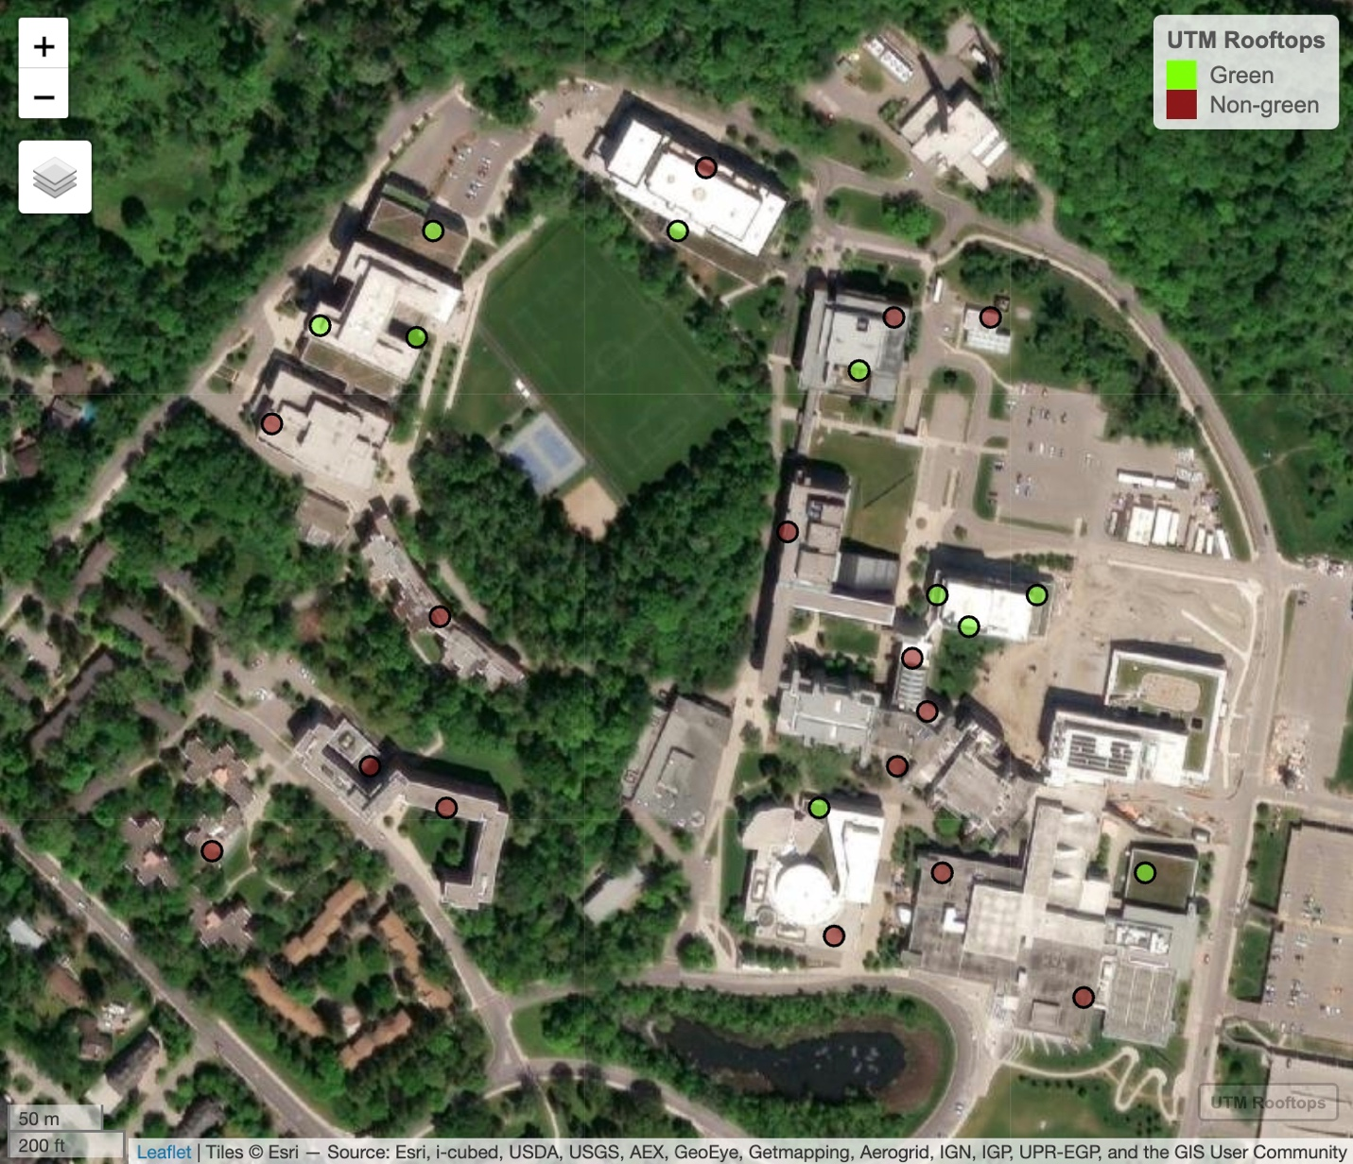

Figure S2. 25 Sites at University of Toronto Mississauga campus, green pins indicating green roofs and brown pins indicating non-green roofs.

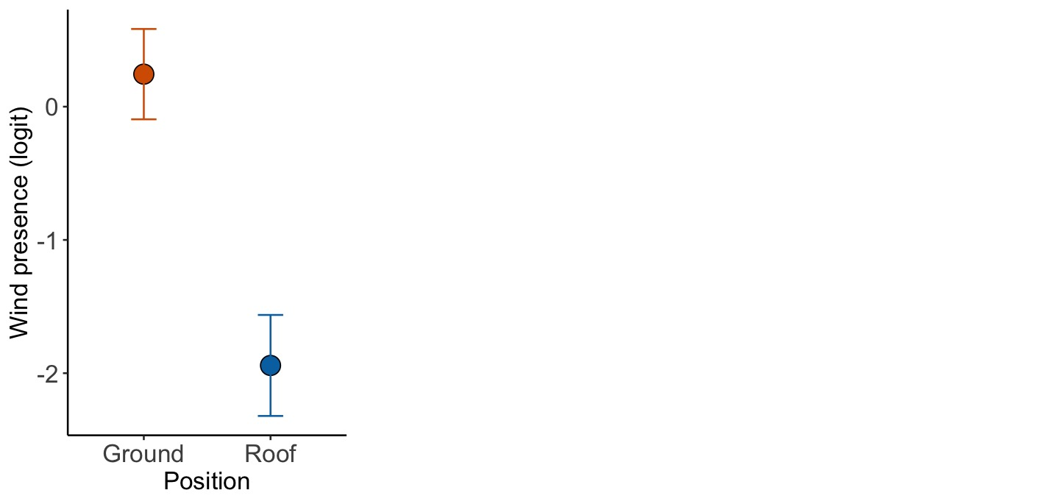
Figure S3. The effects of vertical position (ground vs roof) on wind presence. Wind presence is presented on a logit scale.

