Supplementary
Embedded multilayer strain architectures create self-sensing multifunctional titanium in additive manufacturing

Surface Roughness and Wettability of Tripropylene Glycol Diacrylate (TPGDA)

Surface Roughness

Characterisation of TPGDA layers
The Tripropylene Glycol Diacrylate (TPGDA) dielectric layer influences the overall resolution of the strain gauge. To understand the effectiveness of the dielectric layer post-mortem characterisation was carried out to understand key properties like substrate wetting, surface roughness and material properties.

Atomic force microscopy (AFM)
The overall surface roughness affected the overall printability of the strain gauge, as these sensors are directly printed onto the dielectric layer. Atomic force microscopy (AFM) is used to characterise overall surface topography and the effect that the different types of curing (such as plasma and electron beam irradiation, EBI) have on the overall surface roughness.
AFM (EOL JSTM-4200D) using tips (NCHV-A, Bruker Ltd.) in tapping mode was used to capture topological data, which was extracted (WSxM software ¹) and analysed in Python ². All roughness analysis was conducted according to the ISO 11562-1996 and ASME B46-1995 ³ standards, where roughness measurements are calculated from a mean line over the sampling length.

Printing parameters
Supplementary Table 1 Process parameters for surface treatment for tripropylene glycol diacrylate (TPGDA) for printing onto Ti-6Al-4V substrates using roll-to-roll (R2R)
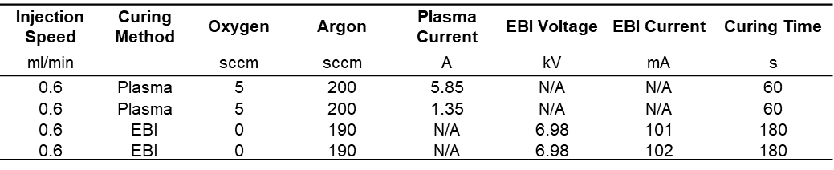

Surface roughness imaging
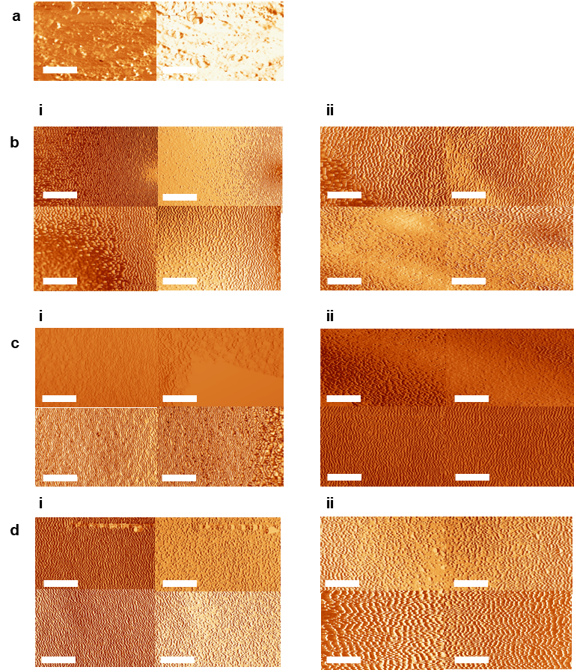
Supplementary Figure 1 Atomic force microscopy (AFM) images of substrates. (a) uncoated additive manufactured (AM) Ti-6AI-4V. (b)i and (b)ii For AM Ti-6AI-4V coated tripropylene glycol diacrylate (TPGDA) printed via roll-to-roll (R2R) and plasma treated at 1.35 A. (c)i and (c)ii For AM Ti-6AI-4V coated TPGDA printed via R2R and plasma treated at 5.85 A. (d)i and (d)ii For AM Ti-6AI-4V coated TPGDA electron beam irradiation (EBI) treated at 6.98 A. All scale bars are 1 µm

Roughness measurements
Supplementary Table 2 Roughness parameter results for Ti-6AI-4V coated tripropylene glycol diacrylate (TPGDA) where three different surface treatments were analysed (plasma at 1.35 A, 5.85 A and electron beam at 6.98 kV). TPGDA was deposited on Ti-6Al-4V using roll-to-roll (R2R) printing
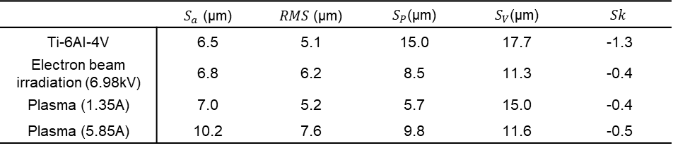
Supplementary Table 3 Absolute roughness parameter results for Ti-6AI-4V coated tripropylene glycol diacrylate (TPGDA) where three different surface treatments were analysed (plasma at 1.35 A, 5.85 A and electron beam irradiation, EBI at 6.98 kV). TPGDA was deposited on Ti-6Al-4V using roll-to-roll (R2R) printing
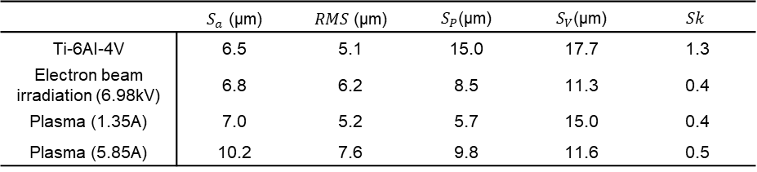
Supplementary Table 4 Normalised roughness parameter Ti-6AI-4V coated tripropylene glycol diacrylate (TPGDA) where three different surface treatments were analysed (plasma at 1.35 A, 5.85 A and electron beam irradiation, EBI at 6.98 kV). TPGDA was deposited on Ti-6Al-4V using roll-to-roll (R2R) printing
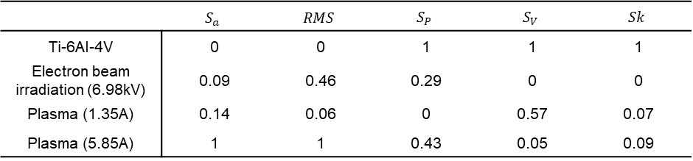

Surface Treatment

Ink bleeding
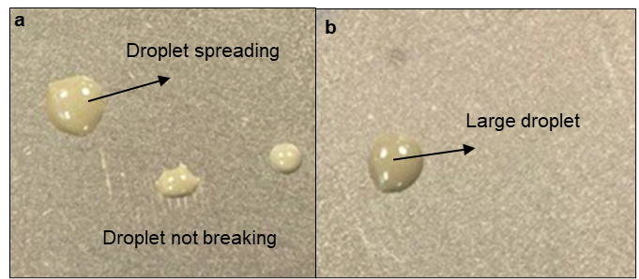
Supplementary Figure 2 Optical imaging showing the effect of droplet spreading at a fast rate for: (a) 50 wt. % dispersion in tripropylene glycol mono methyl ether (TPM) silver nanoparticle ink for Ti-6AI-4V coated tripropylene glycol diacrylate (TPGDA) plasma 5.85 A and (b) TPM silver nanoparticle ink for Ti-6AI-4V coated TPGDA for electron beam irradiation (EBI) at 6.98 kV.

Thermal Constraints of the Dielectric Layer Define Curing Conditions for Nanoparticle Strain Gauges

Thermogravimetric Analysis (TGA) and Differential Scanning Calorimetry (DSC)

Sample Preparation
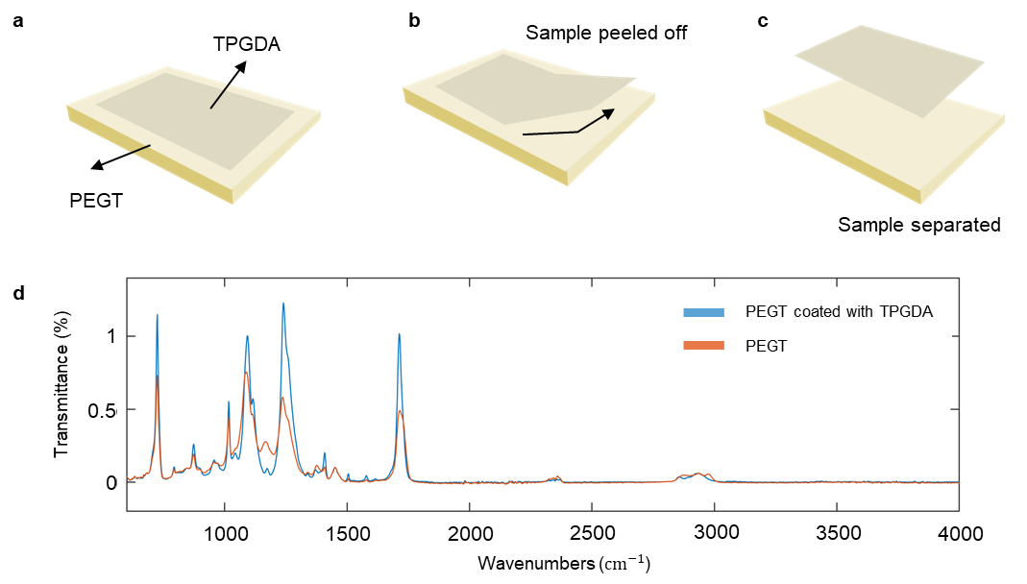
Supplementary Figure 3 Schematic of steps to remove thin film tripropylene glycol diacrylate (TPGDA) sample for (thermogravimetric analysis) TGA and differential scanning calorimetry (DSC) preparation. (a) TPGDA is printed onto polyethylene terephthalate glycol (PEGT). (b)The TPGDA is peeled off the PEGT sample. (c) Once peeled samples are separated where TPGDA is used for TGA and DSC. (d) Fourier-transform infrared spectroscopy (FTIR) of the PEGT material and PEGT coated in TPGDA before DSC and TGA was done

High-Resolution Strain Gauge Embedding via Printing and Thermal Management Strategies

Nozzle Analysis

Nozzle parameter
Supplementary Table 5 Measurement of the effect the Ramp has on the nozzle tip size for the outer and inner diameter. Comparison parameters taken from ref.⁴
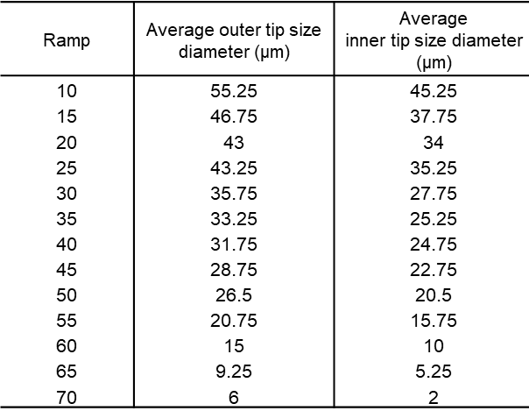
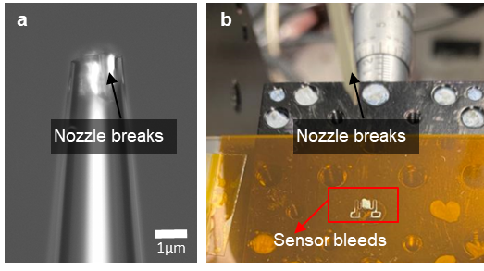

Supplementary Figure 4 (a) optical imaging of the nozzle tip of 2.5 µm for the pull velocity (14) shows breakage and (b) the effect of bleeding due to nozzle tip breakage

Finite Element Analysis
The thermal protective layer plays a significant role in providing a thermal barrier which protects and reduces the potential effect of thermal attack causing sensor degradation during the embedding process. During the laser powder bed fusion (LPBF) process, 1 mm of powder is utilised to protect the sensor, which is effective in previous studies ^{5,6}. To embed the strain gauge sensor under safe conditions the effect of the powder protective layer was analysed using finite element modelling (FEM) which was performed using FEM solver Abaqus ⁷ in transient heat transfer mode with a quadrilateral mesh with 15946 element size for a rectangular shape with 1 mm protect powder layer. The simulation was run under a laser P = 190 W and v = 1.2 ms⁻¹. The results were used to understand the thermal effect the laser scanning process has on the sensor. The material properties of Ti-6AI-4V used. The laser scanning process was modelled using the DFLUX subroutine. A moving volumetric heat flux according to the modified Goldak’s semi-ellipsoid model was used ^{8,9}: $Q\left(x,y,z,t\right)=\left[\frac{2AP}{\frac{abcπ}{π}}\right]exp⁡[-\left(\frac{{\left(x+vt\right)}^{2}}{a}+\frac{y^{2}}{b}+\frac{z^{2}}{c}\right)]$ , where A the absorptivity of material; P the laser power; v the scanning speed; and a,b and c are the ellipsoid semi-axis. Here a = e, b = r/e and c = d, where e is the melt pool eccentricity; r is the laser radius and d is the laser penetration depth. The thermal conductivity of the powder was calculated using Sih and Barlow equation ¹⁰ and the FFC coefficient was used to approximate the density ¹⁰.

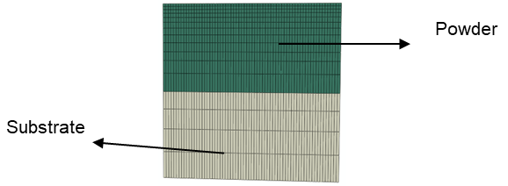
Supplementary Figure 5 Computational grid for the Ti-6AI-4V part where the green section is the powder and the grey section an additive manufactured (AM) T-6AI-4V substrate

Parameter
Supplementary Table 6 Temperature dependent material properties used for the simulation in Figure 3 with $C_{p}$ the specific heat capacity and k the thermal conductivity for the solid and powder ¹¹
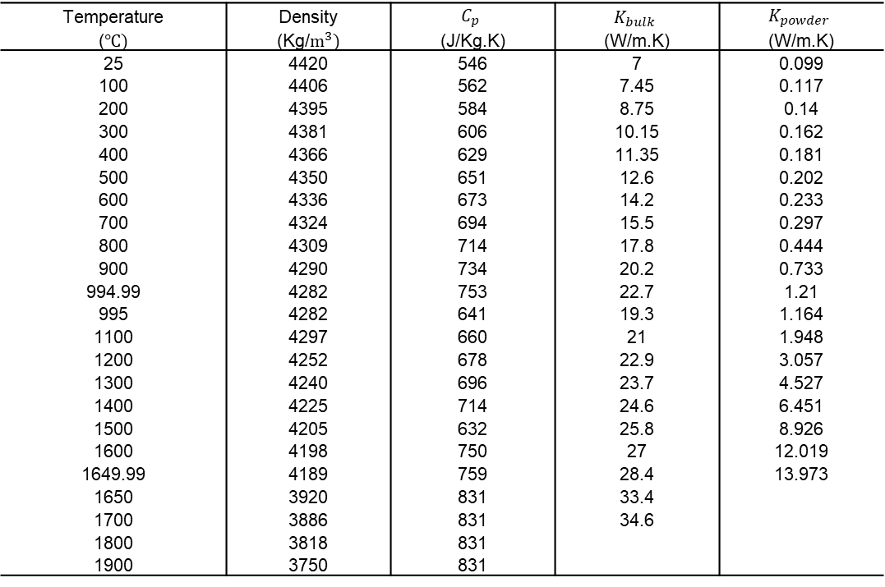
Supplementary Table 7 Latent heat, solidus and liquidus temperature for Ti-6AI-4V used for the simulation shown in Figure 3

Supplementary Table 8 Properties used for the simulation shown in Figure 3
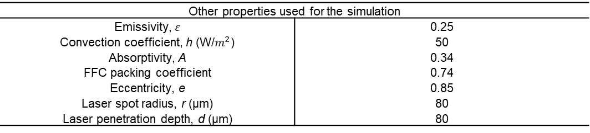
An estimate using the model to calculate the thermal diffusion length is used ¹²: $L≈\sqrt{ατ}$, where $α$ is the thermal diffusivity, $τ$ is the laser interaction time. To calculate $τ$ which is typically which is approximated by the laser diameter ($\sim$ 2$×$radius): where $τ$ = $1×{10}^{-4}$/ 1.2 = $8.3×{10}^{-5}\text{ s}$. The thermal diffusivity for solid is $α≈2.5×{10}^{-6}$ and powder is $α≈(0.5\text{–}1.5)×{10}^{-6}$ $m^{2}$/s. For the estimate a conservative powder value used of $α=1×{10}^{-6}$ $m^{2}$/s ¹³. Therefore, $L=\sqrt{\left(1×{10}^{-6})(8.3×{10}^{-5}\right)}$ . So, the thermal penetration depth ≈ 10 µm, which is orders of magnitude smaller than your 1 mm powder layer.

Integrated Fabrication and Performance of Embedded Strain Gauges
The cytotoxicity of four strain gauges was explored to highlight the potential application of the embedded LPBF Ti-6AI-4V component for biomedical applications (e.g., smart prosthesis impacts ^{14,15}) Strain gauges have the potential to be deposited on various complex geometrical surfaces due to the flexibility of fibre backed sensors, which have the potential to be used for many medical devices ¹⁶. For biomedical sensing these sensors will have direct human contact with the component so, it is essential to ensure biocompatibility with tissues/cells. Though there have been many reports on the biocompatibility of polyamide (PI) ^{17–19}, there are very few reports regarding the cytotoxicity of commercially available PI-backed constantan alloy foil gauge, glass fibre (GF)-reinforced phenolic and TPGDA. Also, high doses of TPM silver nanoparticle ink when exposed to biological tissues can cause cytotoxicity due to high reactivity ²⁰.
The cytotoxicity properties for the four strain gauges (Section 2.1) were evaluated on human dermal fibroblast (HDF) cell lines by fluorescence and methyl tetrazolium (MTT) assays. The cells were cultured in Dulbecco’s Modified Eagle Medium (DMEM) medium supplemented with 10% of (Fetal Bovine Serum) FBS, 1% of Antibiotic-Antimycotic (100X, ThermoFisher Scientific) and 2% of GlutaMAXTM I (200 mM, 100X, ThermoFisher Scientific) under standard cell culture conditions of 37 °C and 5% of CO₂. After 80% confluence, cells were detached by using 0.25% trypsin- ethylenediaminetetraacetic acid (EDTA) (0.25%, ThermoFisher Scientific) and then were seeded at appropriate density (5$×$10⁴ number of live cells/mL) for three days incubation before the start of experimentation.
A LIVE/DEAD cell viability assay kit (ThermoFisher, L3224) was carried out to test the cell viability. Before seeding cells, each kind of strain gauge was immersed in 4 mL of PBS for three days and three weeks to obtain eight kinds of sample extracts in total. This was to allow potential toxicities to be drawn out of the multilayer strain gauge described in Section 2.1. Then, 5×10⁴ number of live cells / mL of HDF cells were treated with 50 μL sample extract and the remaining volume of 400 μL was the DMEM media in each well of 48-well plate. After three days of incubation, 80% confluence was achieved by observing under a microscope (EVOSM5000). On the day of measurement, the LIVE/DEAD assay stock solution was prepared by mixing 5 μL of calcein acetoxymethyl ²¹ (Component A) and 20 μL of ethidium homodimer-1 ²²(Component B) with 10 mL of PBS. After three times washing with PBS, the medium was replaced with 400 μL LIVE/DEAD assay stock solution in each well and the cells were then incubated at 37 °C under an atmosphere of 5% of CO₂ for 30 mins. An EVOS M5000 microscope (ThermoFisher Scientific) was used to observe fluorescence images.
The four sets of strain gauges were also evaluated by using MTT [3-(4,5-dimethylthiazol-2-yl)-2,5-diphenyltetrazolium bromide] assay. The procedures and concentrations of seeding cells are the same as the fluorescence test above. To create a 5 mg/mL MTT stock solution, one vial of MTT Component A was manually dissolved in 1 mL PBS by using a pipette. Cells were washed three times with PBS, and the medium was replaced with 200 μL fresh DMEM media. 20 μL of the MTT stock solution was then added to each well.

Next, all the well plates were incubated at 37 °C with 5% CO₂ for 4 hours. After that, the medium was replaced with 200 μL Dimethylsulfoxide (DMSO) to dissolve formazan crystals and was incubated again for 20 minutes. A microplate plate reader (TECAN, 200 Pro, Switzerland) was used to measure the absorbance at 570 nm. The percentage of cells viability (CyQUAN^{TTM} MTT Cell Viability Assay kit ) of each sample ($\frac{\left(absorbance of samples well\right)-(absorbance of blank well)}{\left(absorbance of control well\right)-(absorbance of blank well)}×100\%$) was calculated and all measurements were performed in triplicate.
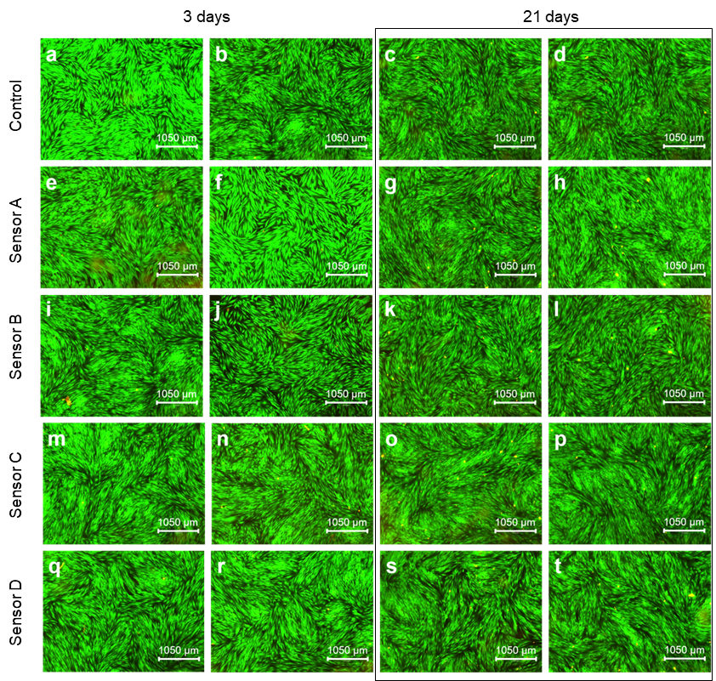
Supplementary Figure 6 Full biocompatibility with repeats

Methodology

Material Properties
Four sensors were embedded using LPBF each consisting of a backing (dielectric) layer and a sensing layer. The four sensors include; (1) a commercial linear mechanical strain gauge (Omega, UK) which has a PI backing layer and a sensing layer composed of a constantan alloy foil gauge; (2) a direct ink write (DIW) printed strain gauge with a commercial PI backing (DuPont Kapton 200 HN, Materials Direct, UK); (3) DIW printed strain gauge with a GF reinforced phenolic backing (RS Component International, UK) and (4) DIW printed strain gauge with a TPGDA backing that is printed using a R2R system . The three sensors that are printed using DIW used a commercial 50 wt. % dispersion in tripropylene glycol mono methyl ether (TPM) silver nanoparticle ink (Sigma-Aldrich, Merk, US) with a nominal particle size between d₅₀ = 70 nm and d₉₀ = 115 nm. TPM silver nanoparticle ink is commonly used for printed PCB and has been used for antibacterial materials as well as large-scale applications ^{23–25}.

Bonding techniques
For the commercial strain gauge, DIW printed strain gauge with a commercial PI backing and GF-reinforced phenolic backing these strain gauges were directly adhered to the Ti-6AI-4V base layer using adhesive (Omega Engineering, UK) for bonding. The DIW printed strain gauge with a thin film ($\sim$100 nm) TPGDA backing, which is printed using a R2R system, compression of the rollers is used to adhere the strain gauge to the Ti-6AI-4V base layer.

Laser powder bed fusion (LPBF)
The strain gauge base layer for the TPGDA backing sensors and the embedding process uses LPBF printing. The samples were bulti using Ti-6AI-4V powder with a nominal range of 15-106 µm (Carpenter Additive, UK). The samples were built using an Aconity Lab (Aconity 3D, Germany) on a Ti-6AI-4V base plate in an argon atmosphere. A hatching (bi-directional) laser scanning strategy is used, and parameter optimisation was conducted from previous research as outlined in ref.²⁶. The Aconity Lab uses a laser beam which selectively melts the metal powder layer by layer into a desired geometrical component ²⁷. During the LPBF printing process a laser power (P) of 190 W and laser scanning speed (v) of 1.2 ${ms}^{-1}$ (linear energy density of 1${Jm}^{-1}$) was used, which was kept consistent during the embedding process.

Roll-to-roll (R2R)
TPGDA is used as a dielectric layer (backing) for the strain gauge. Discontinuous (one-time injection) deposition is used to coat the Ti-6AI-4V AM-built substrate in a thin film TPGDA layer ($\sim$ 300 nm). Within a R2R vacuum web coater the Ti-6AI-4V substrate was taped onto the coating drum which is rotated at a linear speed of 25 $\frac{m}{min}$ . Under a vacuum of ${10}^{-4}$mbar a TPGDA monomer is injected at a rate of 0.6 $\frac{ml}{min}$ to deposit a thin layer of TPGDA dielectric polymer by flash evaporation. A hot tank initially vaporises the TPGDA monomer and deposits it via a heated nozzle to condense as a liquid onto the Ti-6AI-4V substrates. The deposited monomer is cured using one of three different mechanisms: low density argon plasma (1.35 A), high plasma (5.85 A) and electron beam irradiation (EBI) (6.98 kV), to initiate a cross-linking reaction of the monomer to form a solid polymer on the substrate.

Material Characterization

Fourier transform infrared (FTIR) spectroscopy
To characterise the effect that different curing methods have on substrate wetting Fourier transform infrared (FTIR) spectroscopy was conducted. FTIR (Thermo Fisher FTIR for Transmission) was conducted using infrared light to scan uncoated and TPGDA (cured by plasma or EBI) coated Ti-6AI-4V substrates to observe changes in the TPGDA chemical properties. FTIR results were exported using Thermo Scientific OMNIC software ²⁸ and analysed in Python.

Differential scanning calorimetry (DSC) and Thermogravimetric analysis (TGA)
During the embedding process and strain gauge sensor curing the dielectric TPGDA layer is exposed to thermal attack. To better understand the allowable heat for TPGDA and the effect heat has on the chemical and physical properties of the dielectric layer, differential scanning calorimetry (DSC) and Thermogravimetric analysis (TGA) were used. A simultaneous DSC and TGA instrument (Discovery SDT 650) was used, where 200 mg of thin film TPGDA sample was placed into a platinum sample holder. To prepare the sample for DSC and TGA the thin film TPGDA sample was printed onto glossy Polyethylene Terephthalate Glycol-modified (PETG) to allow easy sample separation. TRIOS software (TA Instrument, USA) was used to record and extract DSC and TGA measurements in real-time, which were plotted using Python.

Substrate wetting
Contact angle measurements were carried out to understand the effect curing has on substrate wetting for printability. The contact angles were measured using a custom goniometry set up ^{29,30}. The setup consisted of a syringe pump (Cole-Parmer Single-syringe infusion pump), a needle (BD PrecisionGlideTM needles) and a camera for imaging (Thorlab, model DCC1240). Droplets are approximately 5 µl were deposited onto the surface and the droplet dynamics is captured and extracted in Image J (Fiji version 1.52i ^{31,32}).

Direct ink write (DIW)
DIW printing is used to print a sensing layer (strain gauges design) onto the dielectric layer. There are three key components of the DIW printing system which include ³³: (1) the nozzle assembly composed of bespoke tip, (2) a PC-controlled stage that controls three micro-translation stages (x, y, and z with repeatability of 100 nm), and (3) a nitrogen gas supply with an electronic pneumatic regulator, which applies a pressure to the syringe barrel to push the ink out of the nozzle. A micro-translational stage (Physik Instrumente, M-111.12 S) is used, that has a step resolution of 50 nm ³³ and a working range of 15 mm. The DIW consists of three stepper motor controllers (Physik Instrumente, model: C-663), which are controlled through the Physik Instrumente (PIMikroMove) software and using LabView (National Instruments) script. The printing speed of the micro-translation stage is kept at 0.75 $\frac{mm}{s}$ throughout the strain gauge printing process. The strain gauge was designed using Autodesk Eagle ³⁴, where the generated Gerber file was then converted into G-code using FlatCAM ³⁵, and then communicated to the PC-controlled stage to print the strain gauge design.

Nozzle manufacturing
To achieve a high-resolution durable nozzle for printing a nozzle parameter tip study was conducted. The tapered glass capillaries (nozzles) were manufactured using a P-1000 Micropipette puller (Sutter Instrument, USA), where a box filament (FB255B, Sutter Instrument, USA). The nozzles are made of borosilicate glass with a thick wall with filament (BF120-69-10). The P-1000 Micropipette puller has a pre-built standard pulling setting, where ramp(heat) and pull velocity are adjusted through trial and error to achieve the desired tip size ³⁶. The ramp refers to the amount of current that is applied across the filament, which caused the filament to heat up. To melt the glass capillary with the filament there must be sufficient heating that is dependent on the glass wall thickness and the filament type. The pull velocity is related to the rate of separation of the puller bars holding the glass capillary. The glass capillary inside the filament begins to pull apart once melting occurs, which is detected by a transducer inside the puller.
Nozzle durability is an important factor when printing sensors as it affects the resolution and repeatability of the sensor design during DIW printing ^{36,37}. Scanning electron microscopy (SEM) was used to image and measure the inner and out nozzle diameter to determine nozzle durability. The glass capillary nozzle was sputter coated (Quorum Q150T ES Sputter Coater) with gold nanoparticles (AuNPs) at 4 nm and then mounted vertically using carbon conductive adhesive tape (Agar Scientific) to effectively use SEM (JEOL JSM-6610LV, JEOL Ltd., Japan) imaging to capture the inner and outer nozzle diameter.

Sensor curing
The sensing layer is printed with TPM silver nanoparticle ink, which requires light sintering (curing) ³⁸. The sintering process allows the TPM silver nanoparticles to make physical contact with each other and form a continuous percolating network in the printed strain gauge design. The effects curing has on the dielectric and sensing layer were quantified. A droplet using a 10 µl micropipette (Sigma-Aldrich, Merk, US) of TPM silver nanoparticle ink was dropped on the TPGDA-coated Ti-6AI-4V substrates. The substrates were placed in a furnace (Muffle furnace, Fisher Scientific, UK) where temperature ranges between 100 and 250$℃$ were investigated. A digital mulitmeter (Fluke 175 Handheld, RS Component International, UK) was used to measure the effect heat has on the resistance (R), which is vital as this provided insight into the maximum allowable temperature that the dielectric and sensing layer was cable to withstand.

Strain gauge embedding process by laser powder bed fusion (LPBF)

Cold-cured strain gauge embedding process
A schematic of the proposed sensor embedding process for the DIW printed strain gauge with PI backing, DIW printed strain gauge with GF reinforced phenolic backing and commercial linear mechanical strain gauge (see section 4.5.2.) with PI backing. The embedding component, which is printed using LPBF composed of four key parts: base layer, sensor layer, side wall and top wall. Once the component is printed to validate whether the strain gauges were able to withstand the embedding process mechanical testing (three-point flexural testing). To thermally protect the strain gauges, form laser heating during the scanning process a 6-step fabrication was devised. Step 1: a flat base layer was printed, which is 1 mm thick; Step 2: two vertical wall layers are printed; Step 3: the unmelted powder was blown away; Step 4: using adhesive the sensor is bonded to the base layer ³⁹; Step 5: a protective layer of 1mm of Ti-6AI-4V powder is spread across the build and strain gauge; and Step 6: the top wall of the component was printed, where the remaining Ti-6AI-4V powder is blown away.

TPGDA-backed strain gauge embedding process
The multi-layer strain gauge structure incorporating a TPGDA thin film produced by R2R deposition a different fabrication process has been proposed to embed the strain gauge, which highlights the need for hybrid printing and multilayer printing. Supplementary Figure 7 shows a schematic of the proposed embedding with an 8-step fabrication process. To embed the TPGDA-backed strain gauge. Step 1: Ti-6AI-4V substrate was coated in TPGDA via R2R deposition before the embedding process (Supplementary Figure 7a), Step 2: the coated substate was bonded to the LPBF base plate (sample holder) with adhesive (Supplementary Figure 7b), Step 3: Ti-6AI-4V powder is spread across the substrate (Supplementary Figure 7c), Step 4: side wall is printed 1 mm away from the polymer coated section (Supplementary Figure 7d), where the 1mm protective layer is kept constant, Step 5: the remaining powder is blown away (Supplementary Figure 7e), Step 6: the strain gauge design is printed through DIW printing and cured on the dielectric layer (Supplementary Figure 7f), Step 7: powder is spread on the substrate and the remaining top wall is printed with a 1 mm protective layer (Supplementary Figure 7g), and Step 8: remaining Ti-6AI-4V powder is blown away leaving the embedded component (Supplementary Figure 7h). The embedded component from Supplementary Figure 7 with be removed using a diamond wire saw (Well, Model 3241).
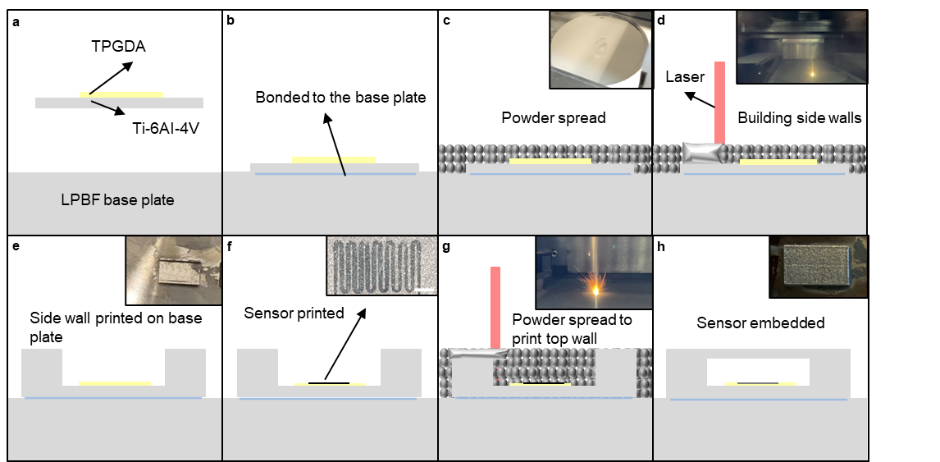
Supplementary Figure 7 Schematic of depositing the hybrid sensor where: (a) substrate of AM Ti-6AI-4V is coated with thin film TPGDA, (b) the sample is bonded to the base plate firmly using adhesive (X280, HBM, Darmstadt, Germany), (c) powder is spread over the sample where the 1 mm protective layer is used to protect the dielectric layer, (d) the wall are built around the substrate, (e) the powder is blown away leaving the wall, (f) the strain gauge design is printed using direct ink write (DIW) and cured where the sample is remounted and aligned, (g) powder is re-spread across the sample where 1 mm is used again a protective layer to protect the sample and (h) the sensor is embedded. All scale bars are 20µm.

Sensor Characterisation

Optical imaging
The four strain gauge sensors before and after embedding were imaged and non-destructively examined by a high-resolution optical microscope (Keyence VHX-7000, Keyence, Japan)⁴⁰. Using the VHX-7000 software (Keyence VHX-7000, Keyence, Japan) images were extracted as tag image file format (TIFF) and formatted in ImageJ (Fiji version 1.52i).

Three-point flexural testing
To validate the effectiveness of the powder protective layer of the embedded strain gauges, mechanical testing was conducted and compared to the bare strain gauges (before embedding). Compression mechanical testing is conducted (CT100 Deben, UK), where a customised sample holder enables three-point flexural testing. A compression force of 100 N load was applied to each sample and recorded using an Arduino microcontroller.

Data acquisition
To obtain stress and strain data of the embedded strain gauge , a commercial circuit board (Arduino Uno) was used to convert sensor data so that it could be read from a laptop by the use of a Bluetooth module as shown in Supplementary Figure 8. The Wheatstone Bridge circuit was implemented as Supplementary Figure 8a shows with a 5V DC voltage from the Arduino. The circuit consists of two parts a transmitter as shown in Supplementary Figure 8b, where an HX711 load cell amplifier ⁴¹ is used to get measurable data out from a load cell and the strain gauge, which is connected to the receiver as shown in Supplementary Figure 8c, where a HC-12 Bluetooth module is used ⁴². The stress and strain data are recorded using the open-source Arduino IDE software ⁴³, then exported using CoolTerm 2.0 ⁴⁴, and plotted using MATLAB 2019b ⁴⁵.
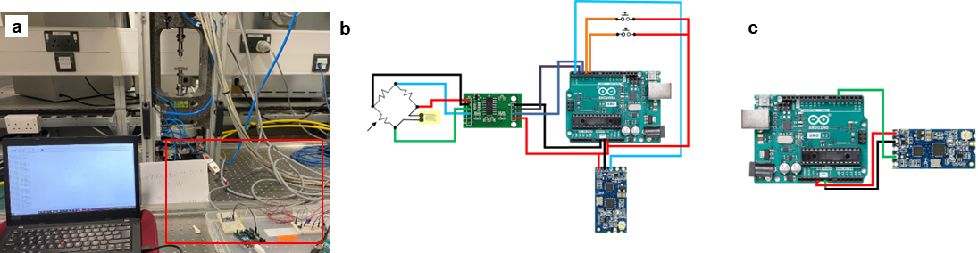
Supplementary Figure 8(a) data reading set up for monitoring of in-situ stress-strain measurements of the embedded sensor by laser powder bed fusion (LPBF) Ti-6AI-4V. (b) schematic of the Wheatstone bridge for measuring the stress and strain which is Bluetooth via a transmitting HC-12 module. (c) schematic of the HC-12 receiving module.

Reference
1. Horcas, I. et al. WSXM: a software for scanning probe microscopy and a tool for nanotechnology. Rev. Sci. Instrum. 78, 13705 (2007).
2. Van Rossum, G. & Drake Jr, F. L. The Python Language Reference: Expressions. Python reference manual (2009).
3. Brown, C. A. Roughness. Handbook of Lubrication and Tribology, Volume II: Theory and Design, Second Edition 123, 3-1-3–13 (2012).
4. Wei, C. et al. Easy-to-operate fabrication of tapered glass capillaries for microdroplet generation. Journal of Micromechanics and Microengineering 29, 0–9 (2019).
5. Jung, I. D. et al. Embedding sensors using selective laser melting for self-cognitive metal parts. Addit. Manuf. 33, 101151 (2020).
6. Lee, M. S. et al. Selective Laser Melting Process for Sensor Embedding into SUS316L with Heat Dissipative Inner Cavity Design. Metals and Materials International 28, 297–305 (2022).
7. Systemes, D. Abaqus Unified FEA (2017). URL https://www. 3ds. com/products-services/simulia/products/abaqus.
8. Hocine, S. et al. Operando X-ray diffraction during laser 3D printing. Materials Today 34, 30–40 (2020).
9. Zhang, Q. et al. A metallurgical phase transformation framework applied to SLM additive manufacturing processes. Mater. Des. 166, (2019).
10. Sih, S. S. & Barlow, W. J. The prediction of the thermal conductivity of powders. International Solid Freeform Fabrication Symposium 11, 2371–2373 (1995).
11. Hocine, S., Van Swygenhoven, H. & Van Petegem, S. Verification of selective laser melting heat source models with operando X-ray diffraction data. Addit. Manuf. 37, 101747 (2021).
12. Bergman, T. L. . & Levine, A. S. . Fundamentals of Heat and Mass Transfer. (John Wiley & Sons, Inc., 2019).
13. Eylon, D. & Froes, F. H. (Sam). Titanium Powder Metallurgy Products. in Properties and Selection: Nonferrous Alloys and Special-Purpose Materials 647–660 (ASM International, 2018). doi:10.31399/asm.hb.v02.a0001083.
14. Ledet, E. H., Liddle, B., Kradinova, K. & Harper, S. Smart implants in orthopedic surgery, improving patient outcomes: a review. Innov. Entrep. Health Volume 5, 41–51 (2018).
15. Ponder, R. I., Safaei, M. & Anton, S. R. Development of Surrogate Biomedical Knee Implants for Validation of Embedded Smart Sensors. Preprint at https://doi.org/10.1115/SMASIS2017-3879 (2017).
16. Owens, C. E. et al. Substrate-Versatile Direct-Write Printing of Carbon Nanotube-Based Flexible Conductors, Circuits, and Sensors. Adv. Funct. Mater. 31, 1–14 (2021).
17. Worch, J. C. et al. Elastomeric polyamide biomaterials with stereochemically tuneable mechanical properties and shape memory. Nat. Commun. 11, 1–11 (2020).
18. Abdal-Hay, A., Abdelrazek Khalil, K., Al-Jassir, F. F. & Gamal-Eldeen, A. M. Biocompatibility properties of polyamide 6/PCL blends composite textile scaffold using EA.hy926 human endothelial cells. Biomedical Materials (Bristol) 12, (2017).
19. Hassanein, N., Bougherara, H. & Amleh, A. In- vitro evaluation of the bioactivity and the biocompatibility of a novel coated UHMWPE biomaterial for biomedical applications. J. Mech. Behav. Biomed. Mater. 101, 103409 (2020).
20. Wang, M., Lai, X., Shao, L. & Li, L. Evaluation of immunoresponses and cytotoxicity from skin exposure to metallic nanoparticles. Int. J. Nanomedicine 13, 4445–4459 (2018).
21. Miles, F. L., Lynch, J. E. & Sikes, R. A. Cell-based assays using calcein acetoxymethyl ester show variation in fluorescence with treatment conditions. J. Biol. Methods 2, (2015).
22. Blanc, A., Tran-Khanh, N., Filion, D. & Buschmann, M. D. Optimal processing method to obtain four-color confocal fluorescent images of the cytoskeleton and nucleus in three-dimensional chondrocyte cultures. J. Histochem. Cytochem. 53, 1171–1175 (2005).
23. Shiwaku, R. et al. A printed organic amplification system for wearable potentiometric electrochemical sensors. Sci. Rep. 8, 1–8 (2018).
24. Demelas, M. et al. An organic, charge-modulated field effect transistor for DNA detection. Sens. Actuators B Chem. 171–172, 198–203 (2012).
25. Mizukami, M. et al. A Solution-Processed Organic Thin-Film Transistor Backplane for Flexible Multiphoton Emission Organic Light-Emitting Diode Displays. IEEE Electron Device Letters 36, 841–843 (2015).
26. Snell, R. M. et al. Towards understanding and eliminating defects in additively manufactured CubeSat mirrors. 28 (2022) doi:10.1117/12.2629935.
27. Obeidi, M. A. et al. Additive manufacturing virtual reality lab for training industry employees and engineering students. 1–7 (2022).
28. Zapata, F. et al. Introducing ATR-FTIR Spectroscopy through Analysis of Acetaminophen Drugs: Practical Lessons for Interdisciplinary and Progressive Learning for Undergraduate Students. J. Chem. Educ. 98, 2675–2686 (2021).
29. Michalska, M. et al. A route to engineered high aspect-ratio silicon nanostructures through regenerative secondary mask lithography. Nanoscale 14, 1847–1854 (2022).
30. Zhang, J., Singh, V., Huang, W., Mandal, P. & Tiwari, M. K. Self-Healing, Robust, Liquid-Repellent Coatings Exploiting the Donor-Acceptor Self-Assembly. ACS Appl. Mater. Interfaces 15, 8699–8708 (2023).
31. Schneider, C. A., Rasband, W. S. & Eliceiri, K. W. NIH Image to ImageJ: 25 years of image analysis. Nat. Methods 9, 671–675 (2012).
32. Rueden, C. T. et al. ImageJ2: ImageJ for the next generation of scientific image data. BMC Bioinformatics 18, 529 (2017).
33. Aabith, S. et al. 3D direct-write printing of water soluble micromoulds for high-resolution rapid prototyping. Addit. Manuf. 58, 103019 (2022).
34. Kamble, P., Khoje, S. & Lele, J. Implementation of Paper PCB Using Conductive Ink 2D Plotter. Proceedings - 2018 4th International Conference on Computing, Communication Control and Automation, ICCUBEA 2018 1–6 (2018) doi:10.1109/ICCUBEA.2018.8697781.
35. Rajan, M. R., Syedibrakim, M. D., Alagu Selvam, M. R. & Yamuna, M. M. Automatic Pcb Designer Based on Cnc System. International Research Journal of Engineering and Technology 5358–5361 (2019).
36. Wei, C. et al. Easy-to-operate fabrication of tapered glass capillaries for microdroplet generation. Journal of Micromechanics and Microengineering 29, (2019).
37. Caulfield, R., Fang, F. & Tiwari, M. K. Drops, Jets and High-Resolution 3D Printing: Fundamentals and Applications. 44, 123–162 (2018).
38. Mo, L. et al. Silver Nanoparticles Based Ink with Moderate Sintering in Flexible and Printed Electronics. Int. J. Mol. Sci. 20, (2019).
39. Silva, A. L., Varanis, M., Mereles, A. G., Oliveira, C. & Balthazar, J. M. A study of strain and deformation measurement using the Arduino microcontroller and strain gauges devices. Revista Brasileira de Ensino de Fisica 41, (2019).
40. Drakopoulos, M. Engineering Science at the I12 Beamline at Diamond Light Source. Synchrotron Radiat. News 30, 41–47 (2017).
41. Al-Mutlaq, S. & The Giant, A. Load Cell Amplifier HX711 Breakout Hookup Guide - learn.sparkfun.com. 1–8 (2015).
42. Khan, M. U. A. et al. A Silver-Coated Conductive Fibre HC12 Sewed Chipless RFID Tag on Cotton Fabric for Wearable Applications. in Proceedings - 2020 23rd IEEE International Multi-Topic Conference, INMIC 2020 1–5 (2020). doi:10.1109/INMIC50486.2020.9318155.
43. Khorassani, S. M. H. et al. A facile synthesis of stable phosphorus ylides derived from harmin, harman, and carbazole. Phosphorus Sulfur Silicon Relat. Elem. 181, 567–572 (2006).
44. Kinchin, J. Using an Arduino and cheap thermistor to make a simple temperature sensor. Phys. Educ. 53, (2018).
45. Sobie, E. A. An introduction to MATLAB. Science signaling vol. 4 tr7 Preprint at https://doi.org/10.1126/scisignal.2001984 (2011).

