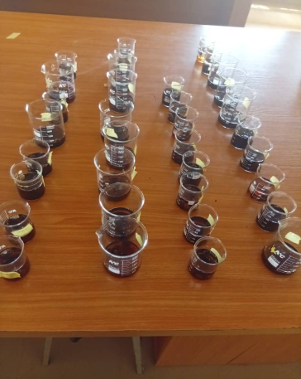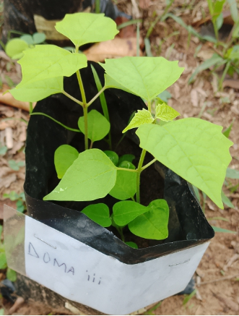
Plate 1: Water retention capacity of Gmelina arborea Plate 2: Plant growth at 4WAP

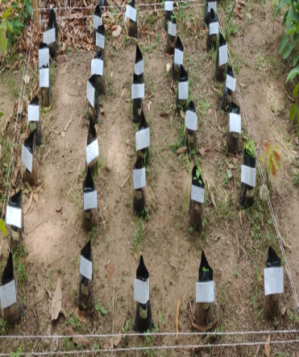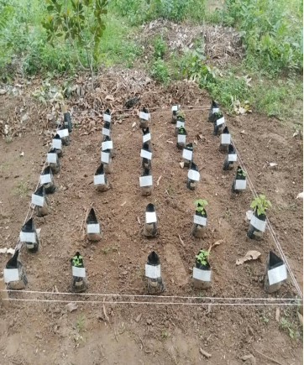
Plate 3: Experimental layout in the nursery Plate 4: Plant growth at 2 WAP

