Supporting Information
Borophene Nanosheets grafted Covalent Organic Framework: A 2D Hybrid Porous material for hydrogen adsorption studies

Anamika Gogoi,^{[a]} Somnath Sengupta,^{[b]} Abhishek Rathore,^{[c]} V.M. Kabilan,^{[b]} Shanmukha Rao Abothu,^{[a]} Muthiah Bootharajan,^{[b]} Cherukuri Venkata Siva Brahmananda Rao,^{[b]} Sesha Vempati,*^{[c]} Balija Sreenivasulu*^{[b]} and Raghavender Medishetty*^{[a]}

ª Department of Chemistry, Indian Institute of Technology Bhilai, Durg, Chhattisgarh 491002, India.
^{b} Materials Chemistry and Metal Fuel Cycle Group, Indira Gandhi Centre for Atomic Research, Kalpakkam 603102, Tamil Nadu, India; Homi Bhabha National Institute, Training School Complex, Anushakti Nagar, Mumbai, Maharashtra 400094, India.
^{c} Department of Physics, Indian Institute of Technology Bhilai, Durg, Chhattisgarh 491002, India

*Correspondence: sesha@iitbhilai.ac.in, bsrinu@igcar.gov.in, raghavender@iitbhilai.ac.in.

Table of contents
- Materials and methods
1.1 General procedure for H₂ adsorption experiments
1.2 Computational methodology for GCMC simulations
1.3 Computational methodology for DFT calculations
- Synthesis
2.1 Synthesis of 1,3,5-triformylphloroglucinol (Tp)
2.2 Synthesis procedure of borophene.
2.3 Synthesis of TpPa-1
2.4 Synthesis of borophene-TpPa-1 (BNS@TpPa-1) hybrid
- Characterization
- Adsorption isotherm equations
- GCMC Simulation
- DFT calculation

- Materials and methods
All the chemicals and solvents used were of reagent grade purchased from different commercial resources and used without any further purification. Tp was synthesized according to the reported method.¹ A PerkinElmer FT-IR spectrometer operating in ATR mode was used to record the IR spectra. Powder X-ray diffraction (PXRD) data were recorded on a Bruker D8 Advance A25 system with Cu Kα radiation (λ = 1.54056 Å) at room temperature (298 K). The surface morphology and elemental mapping of the materials were recorded using Field Emission Scanning Electron Microscopy (FESEM) from Zeiss, model Gemini SEM 500, and JEOL & JEM-F200 High Resolution Transmission Electron Microscope (HRTEM). For the N₂ isotherm, all samples were degassed at 120 °C for 6 hours under vacuum, and adsorption-desorption measurements were conducted at 77 K on a Quantachrome Autosorb iQ gas sorption analyzer. Thermogravimetric analysis (TGA) was performed using NETZSCH STA 449F3 under a nitrogen atmosphere at a heating rate of 10 °C min⁻¹. Nuclear Magnetic Resonance (NMR) spectra were recorded on an ASCEND Advance NEO 600 MHz spectrometer from Bruker with solvent signals as reference.

1.1 General procedure for H₂ adsorption experiments
The Sievert gas adsorption arrangement was in-house designed and used to conduct hydrogen adsorption experiments at low pressures and low temperatures (77 K).² Initially, experiments were carried out at 1.999, 1.333, 0.999, and 0.667 bar using the empty sample vessel to get the actual H₂ adsorption values for our samples. First, the sample vessel with or without a sample was connected to the Sievert apparatus and evacuated using a vacuum pump, followed by filling H₂ gas of 1.999 bar (1500 torr) from the hydrogen gas cylinder to a known volume of the Sievert apparatus at room temperature. Then, the sample vessel was immersed in liquid nitrogen to a certain height, and the pressure fell due to the decrease in temperature was recorded in the interval of 30 seconds until it reached a constant value. Further, the sample vessel was allowed to reach the room temperature by removing the liquid nitrogen, and the pressure increase was recorded accordingly until it reached near the initial value. Similarly, adsorption and desorption studies were repeated for all other pressures. The adsorbed H₂ weight% for the sample was calculated based on the pressure difference (ΔP) value obtained from ΔP₂ (with sample) and ΔP₁ (without sample), with temperature difference. However, here we calculate the results based on the ideal behavior of a gas with a known volume of the Sievert apparatus.
1.2 Computational methodology for GCMC simulations
The TpPa-1 fragment was modelled according to its established 2D COF topology, and a single TpPa-1 layer was stacked with a single borophene layer to construct the composite unit cell. The borophene sheet was obtained from its reported crystal structure, and its in-plane lattice parameters were adjusted to align with those of the TpPa-1 layer, ensuring minimal lattice mismatch and avoiding mechanical strain at the interface. To investigate the gas adsorption behavior of the composite, Grand Canonical Monte Carlo (GCMC) simulations were carried out using the RASPA 2.0 simulation package.³ The simulations were performed at 77 K and at pressures 0.667 bar, 0.999 bar, 1.333 bar, 1.667 bar and 1.999 bar to evaluate hydrogen uptake. A Lennard-Jones (LJ) 12–6 potential combined with coulombic interactions was employed to describe non-bonded interactions. LJ parameters for framework atoms were adopted from the Universal Force Field (UFF),⁴ while hydrogen was modeled using the Darkrim-Levesque (DL) potential, treating H₂ as a rigid diatomic molecule with a fixed bond length of 0.74 Å.⁵ Partial charges on the framework atoms were assigned using the extended charge equilibration (EQ_{eq}) method. Lorentz–Berthelot mixing rules were applied to calculate cross-interactions between hydrogen and framework atoms. Electrostatic interactions were treated using the Ewald summation method with a cutoff of 12.8 Å for the LJ potential. Each simulation included 50,000 equilibration and 50,000 production cycles. Monte Carlo moves included translation, rotation, insertion, deletion, and regrowth. The final adsorption isotherms were analyzed to understand the effect of borophene confinement on hydrogen storage performance. The isosteric heat of adsorption (Qₛₜ) was calculated from statistical fluctuations in energy and particle number using fluctuation theory as implemented in RASPA 2.0. This method allows for the estimation of Qₛₜ at each pressure point without requiring multiple temperatures and provides insight into the thermodynamic nature of the adsorbate–framework interactions. All simulations were performed in rigid frameworks, and the computed values represent ensemble averages over the production phase.

1.3 Computational methodology for DFT calculations
Adsorption of hydrogen molecule on TpPa-1 (borophene) was examined by first principle methods based on Density Functional Theory, implemented in the Quantum Espresso software.⁶ The exchange correlation functional of Perdew–Burke–Ernzerhof (PBE) approximated by generalized gradient approximation (GGA) were used.⁷ Norm-conserving ultrasoft pseudopotentials were used to describe the interaction between ionic cores and valence electrons. Vacuum spacing of 15 Å was used so that the interaction between the layers of COF is minimum. The hydrogen molecule was placed at a distance of 2.37 Å (from the center of the H-H bond to the plane of TpPa-1(borophene) in each configuration. The structural optimization was performed by relaxing a single hydrogen molecule on TpPa-1 (borophene) on the positions given in the schematic in Figure 1(Figure 2) with a convergence threshold of 10⁻² eV/Å(2 x 10⁻² eV/Å). A plane-wave basis set with cutoff energy of 25 Ry (60 Ry) and charge cutoff of 225 Ry (600 Ry) is used and non-spin-polarized calculations were used for all configurations. The adsorption of hydrogen on hybrid heterostructure was also examined using the same parameters (convergence threshold, cutoff energy and cutoff charge) used for TpPa-1. Charge density difference plots arecalculated manually by subtracting the charge density of the components from the total system: $Δρ=ρ_{total}-ρ_{substrate}-ρ_{adsorbate}$
In order to have the borophene supercell fit perfectly in the TpPa-1 unit cell to act as the substrate, the co-ordinates of individual atoms in the unit cell of the β₁₂-borophene were transformed in such a way that the bond length was same for the whole unit cell (the cell parameters didn’t change, only the coordinates of each atom changed). The strain effects due to the change in co-ordinates are ignored. The borophene layer is fixed in space, the TpPa-1 layer is only allowed to move in Z-direction and the H₂ molecule is allowed to move freely in space.

- Synthesis
2.1 Synthesis of 1,3,5-triformylphloroglucinol (Tp)
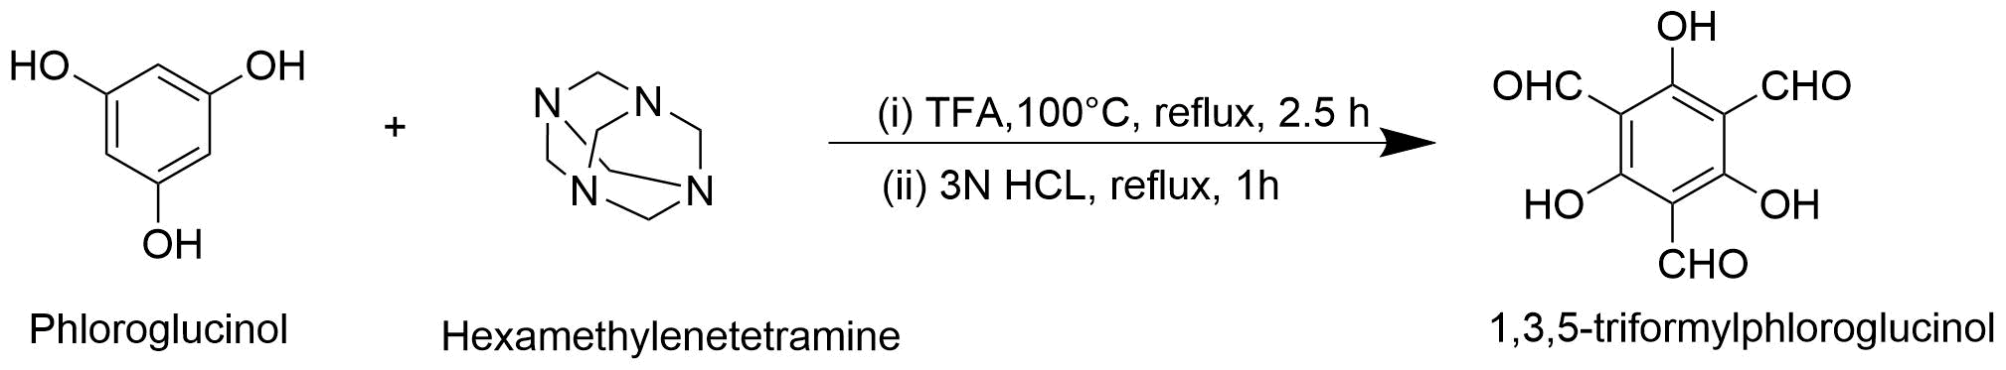
Scheme 1. Schematic illustration of the synthesized 1,3,5-triformylphloroglucinol (Tp).
Tp was synthesized using the previously reported procedure.¹ In this procedure, phloroglucinol (6.014 g, 47 mmol), hexamethylenetetramine (15.098 g, 107 mmol), and trifluoroacetic acid (80 mL) were taken in a 100 mL pressure tube. The solution was heated at 100 ºC for 2.5 hours, followed by the addition of 3N HCl solution to it, and continued to stir it for another 1 hour. After cooling the reaction mixture to room temperature, it was filtered through a celite bed and extracted 3-4 times using dichloromethane (DCM), and the organic layer was evaporated to get the solid compound. Yield: 2.0 g (19.48⁒). ¹H NMR (600 MHz, CDCl₃, 293 K): δ (ppm)10.15 (s, 3H), 14.11 (s, 3H). ¹³C NMR (150 MHz, CDCl₃) δ (ppm) 101.87, 172.58, 191.05.
2.2 Synthesis procedure of borophene.
Borophene nanosheets (BNS) were synthesized via sonochemical liquid phase exfoliation in DMF as a solvent. 1g of boron powder was taken in 100 ml of DMF in a beaker and was subjected to sonication for 20 hours with 2s on and 2s off pulse mode using a 40 kHz probe sonicator. After that, the suspension was subjected to centrifugation at 4000 rpm for 5 minutes to remove the bulk boron powder. The few-layered borophene nanosheets (BNS) were collected as a solid after centrifuging the supernatant at 10000 rpm. Mostly fresh samples were used for better activity. Whenever needed, these samples were stored at -20 °C.
2.3 Synthesis of TpPa-1
The β-ketoenamine TpPa-1 covalent organic framework was synthesized via aminocatalytic approach using pyrrolidine as a catalyst according to the reported procedure with slight modification.⁸ A mixture of 1,3,5-triformylphloroglucinol (Tp, 315 mg, 1.5mmol), p-phenylenediamine (Pa1, 243mg, 2.25mmol) and pyrrolidine (37.5µL, 0.45mmol) in 80 mL dichloromethane (DCM) was stirred at room temperature for 7 days. The resultant powder was washed with ethanol and acetone and vacuum dried at 120 °C for 12 hours.
2.4 Synthesis of borophene-TpPa-1 (BNS@TpPa-1) hybrid
The BNS@TpPa-1 hybrid was synthesized by physical blending of a highly dispersed borophene nanosheet solution with precursors of the TpPa-1. First, we dispersed borophene nanosheets in isopropyl alcohol (IPA) (5 ml), as in pure dichloromethane (DCM), agglomeration was observed. Then we added 1,3,5-triformylphloroglucinol (Tp, 315 mg, 1.5 mmol), p-phenylenediamine (Pa1, 243 mg, 2.25 mmol), pyrrolidine (37.5 µL, 0.45 mmol), and 80 ml of DCM, and the mixture was sonicated for 10 minutes for homogeneous dispersion and stirred at room temperature for 7 days. The resultant powder was washed with ethanol and acetone to remove the catalyst and impurities. The red-colored powder was vacuum-dried at 120 °C for 12 hours.

- Characterization
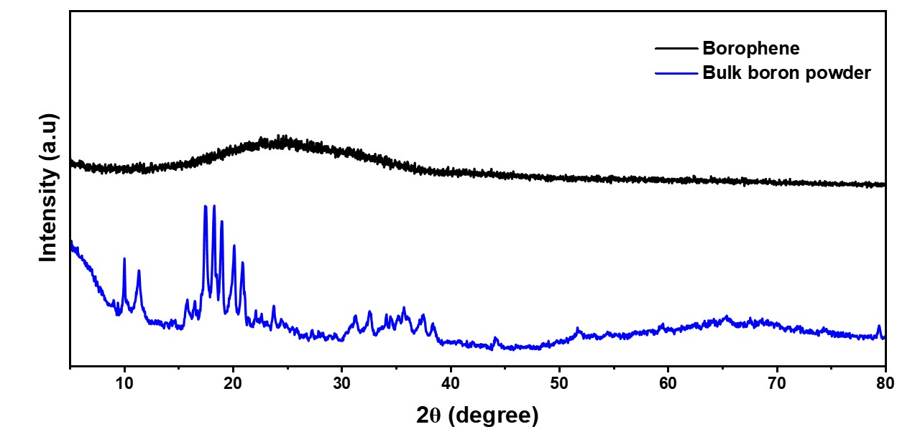Figure S1. PXRD of boron powder (blue) and as synthesized BNS (black)

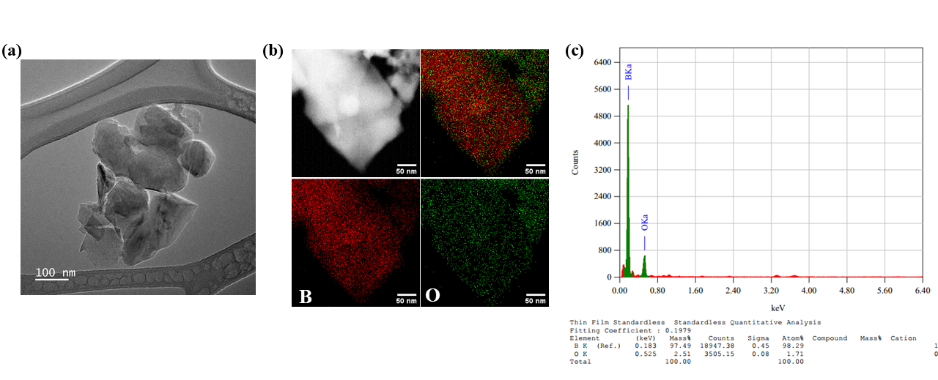Figure S2. (a) Low resolution TEM image of BNS (b) HDAAF mapping of BNS and (c) corresponding EDX spectra.

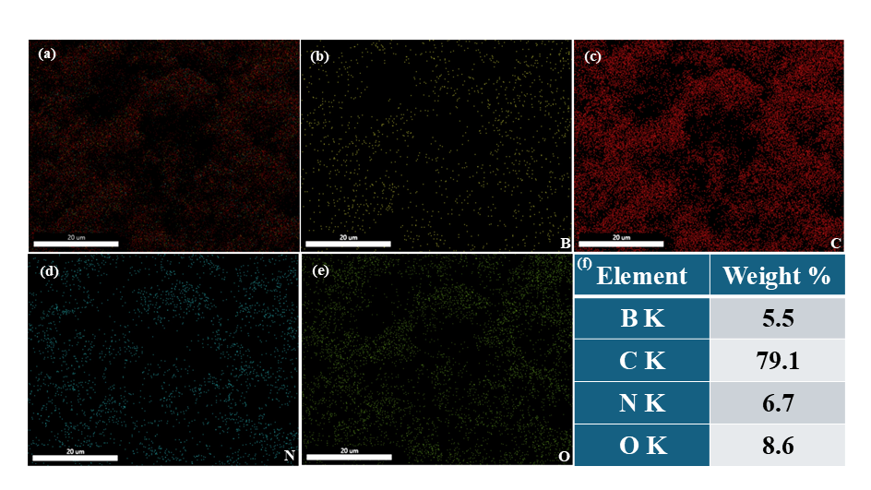
Figure S3. (a-e) Elemental mapping of BNS@TpPa-1 and (f) corresponding element%.
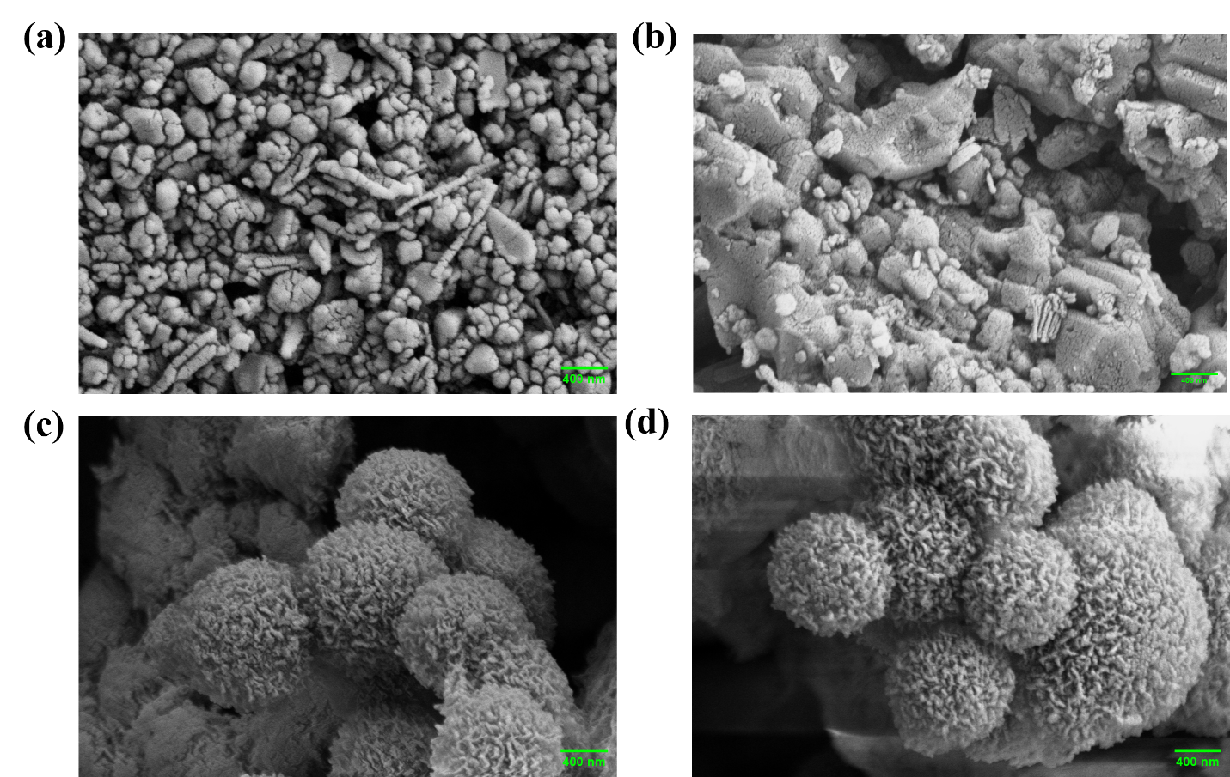
Figure S4. (a) FESEM image of BNS, (b) boron powder, (c) TpPa-1 and (d) BNS@TpPa-1.

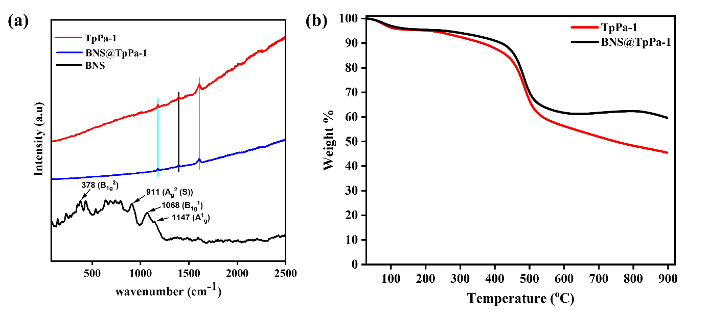
Figure S5. (a) Raman spectra for BNS (black), TpPa-1 (red) and BNS@TpPa-1 (blue), (b) TGA plot of TpPa-1 and BNS@TpPa-1.

Table S1. Table contains the pressure difference obtained for the empty sample vessel at different pressures.
Initial pressure (P₀) (torr) | Pressure difference (ΔP) (torr)
1500 | 433
1250 | 362
1000 | 290
750 | 212
500 | 141

Table S2. calculated H₂ adsorption weight% at different pressures for TpPa-1 and BNS@TpPa-1.
 | TpPa-1 |  | BNS@TpPa-1
Pressure (bar) | ΔP (bar) | Adsorption capacity (wt%) | ΔP (bar) | Adsorption capacity (wt%)
0.667 | 0.0723 | 0.124 | 0.0519 | 0.194
0.999 | 0.0861 | 0.146 | 0.0611 | 0.229
1.333 | 0.0934 | 0.159 | 0.0657 | 0.248
1.667 | 0.0993 | 0.168 | 0.0717 | 0.267
1.999 | 0.1006 | 0.175 | 0.0730 | 0.277

Table S3. Desorption wt% of H₂ at different pressure within 10 minutes.
 | TpPa-1 |  | BNS@TpPa-1
Pressure (bar) | desorption capacity (wt%) | desorption capacity (wt%)
0.667 | 0.119 | 0.189
0.999 | 0.144 | 0.224
1.333 | 0.155 | 0.238
1.667 | 0.166 | 0.262
1.999 | 0.168 | 0.263

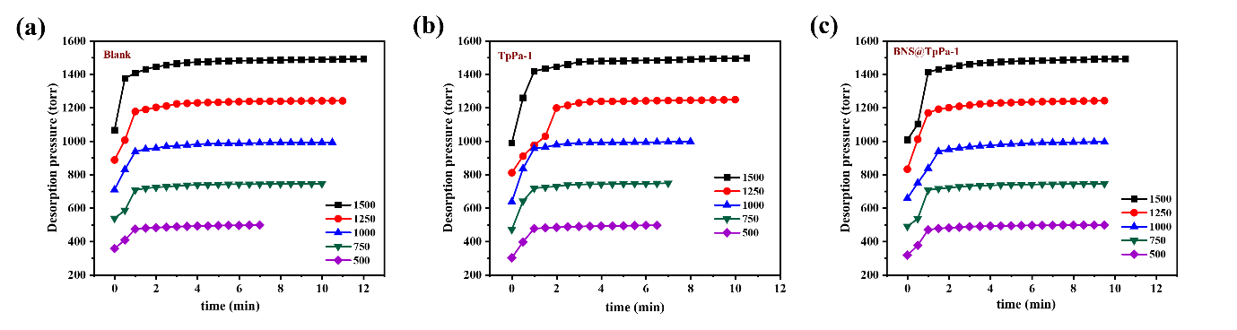
Figure S6. Kinetics of H₂ desorption at different pressures for (a) Blank sample holder (b) with TpPa-1 and (c) BNS@TpPa-1.

4. Adsorption isotherms.
The equilibrium relationship between the COF samples and the adsorbate H₂ gas at different pressures at a particular temperature was evaluated using the Freundlich and Langmuir isotherms. The adsorption data were fitted according to the following equations
$q_{e}=\frac{q_{m}KP}{1+KP}$ (1)
$q_{e}=KP^{\frac{1}{n}}$ (2)
where q_{e}, is the equilibrium hydrogen adsorption capacity, P is the pressure, and K & n are the adsorption constants.

5. GCMC simulation
Table S4. GCMC simulated H₂ adsorption weight% at different pressures for TpPa-1 and B-COF.
Pressure (bar) | TpPa-1 (wt%) | BNS@TpPa-1 (wt%)
0.667 | 0.196 | 0.778
0.999 | 0.28 | 0.791
1.333 | 0.389 | 0.794
1.667 | 0.469 | 0.796
1.999 | 0.551 | 0.797

6. DFT calculation
6.1 Schematic of TpPa-1 and identification of active sites
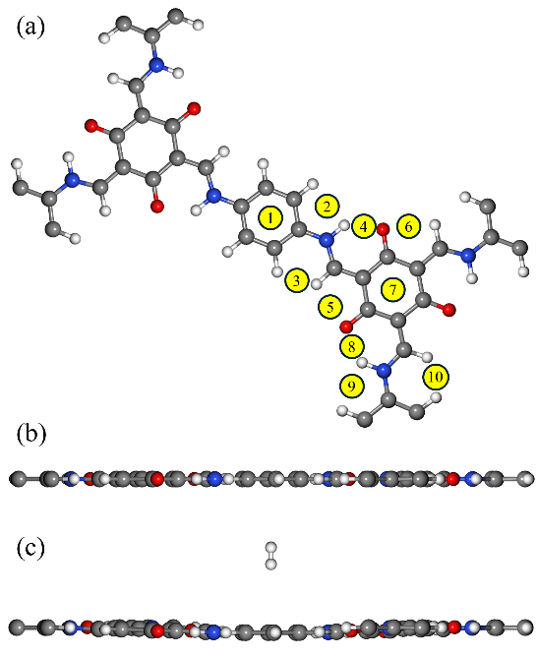
Figure S7. (a) top, (b) side views of TpPa-1 and (c) H₂ molecule adsorbed at configuration1.

6.2 Schematic of borophene and identification of active sites
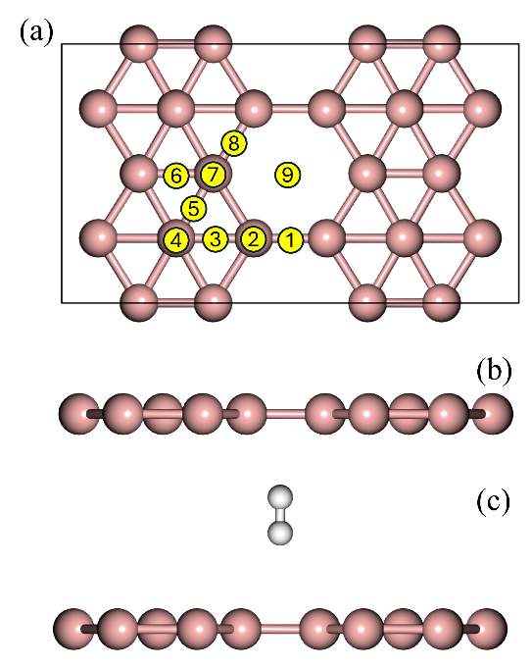
Figure S8. (a) top, (b) side views of borophene and (c) H₂ molecule adsorbed at configuration 1

Table S5. Adsorption energies for different configurations of TpPa-1 and borophene. Please note that the enumerated sites of TpPa-1 and borophene are not equivalent.
 | TpPa-1 | Borophene
Configuration | Adsorption Energy (eV) | Adsorption Energy (meV)
1 | -1.829 | -10.083
2 | -1.820 | -13.839
3 | -1.829 | -10.744
4 | -1.837 | -15.229
5 | -1.839 | -63.626
6 | -1.839 | -63.179
7 | -1.815 | -67.074
8 | -1.837 | -63.268
9 | -1.819 | -63.464
10 | -1.828 | _

The charge density difference is visualised using VESTA software and all other visualisation is done using BURAI software.

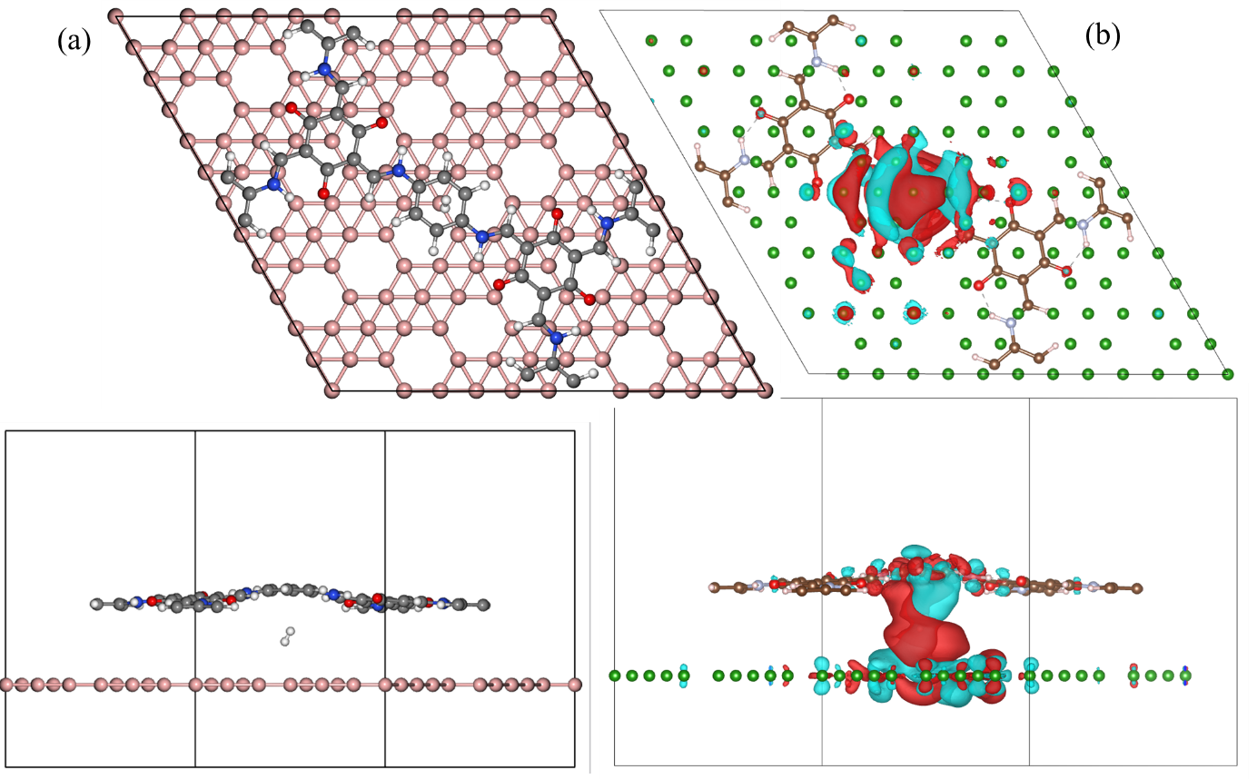
Figure S9. configuration 1 (a) top and side view of optimized structure (b) top and side view of charge density difference Blue = depletion of charge, Red = accumulation of charge, Isosurface Level:- 2.43215e-05 e$Å^{-3}$
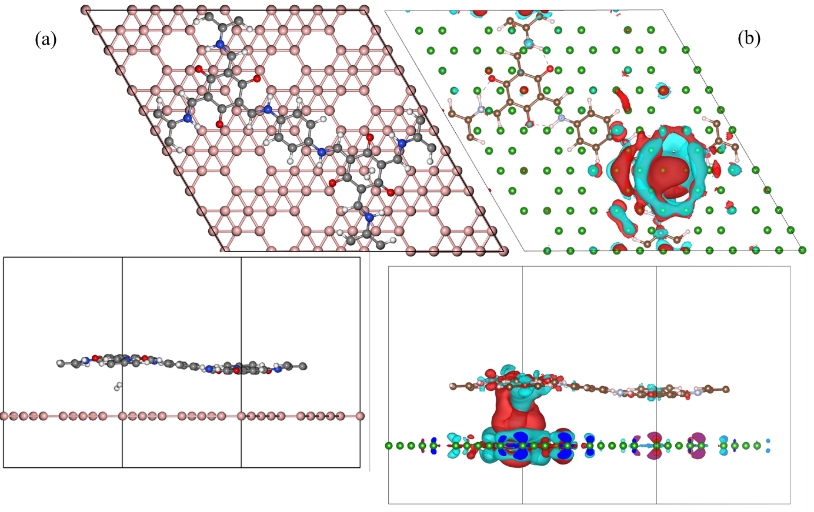
Figure S10. configuration 7 (a) top and side view of optimized structure (b) top and side view of charge density difference Blue = depletion of charge, Red = accumulation of charge, Isosurface Level:- 2.91839e-05 e$Å^{-3}$
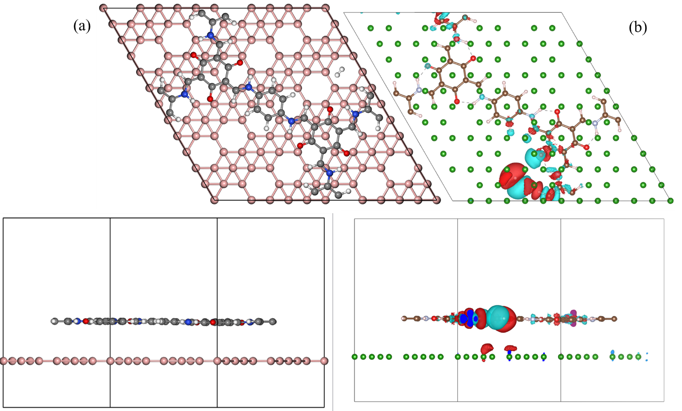
Figure S11. configuration 8 (a) top and side view of optimized structure (b) top and side view of charge density difference Blue = depletion of charge, Red = accumulation of charge, Isosurface Level: 1.68878e-05 e$Å^{-3}$
In configuration 8 where the H₂ is placed at the edge of TpPa-1, the charge transfer mostly takes place at the TpPa-1 layer with a little charge transfer at the borophene layer but when the H₂ molecule is placed in between the layers, the charge transfer takes place at both layers and also in case of configuration 8 the deformation in the layer of TpPa-1 is minimal whereas in configurations where the H₂ is between the layers, there is visible deformation in the TpPa-1 layer.
Table S6. Table of reported Q_{st} for different COFs.
COFs | Q_{st} (kJmol⁻¹) | References
PECONF-4 | 9.5–10.5 | ⁹
Li@TPB-DMTP-COF | 7.2 | ¹⁰
COF-1 | 8.8 | ¹¹
COF-5 | 4.6 | ¹¹
COF-102 | 5.7 | ¹¹
COF-102 | 5.8 | ¹¹
COF-103 | 5.6 | ¹¹
COF-108 | 7.4 | ¹¹
3D-F-COF | 8.4 | ¹²
3D-MeO-COF | 7.8 | ¹²
COF-300 | 7.9 | ¹²

Table S7. Table of reported theoretical hydrogen storage wt% for metal decorated borophene.
Hydrogen storage wt% | Metal decorated borophene | References
6.08 wt% | BL-Li₄ | ¹³
5.74 wt% | 4Y@β₁₂- borophene | ¹⁴
8.76 wt% | Li₂B₂₀ - β₁₂ | ¹⁵
10.79 wt% | Li₂B₁₆ - χ3 | ¹⁵
15.065 wt% | B₁₆Ti₄- χ3 | ¹⁶
8.36 wt.%–13.96 wt.% | Li & Na decorated borophene | ¹⁷

Table S8. Table of reported theoretical hydrogen adsorption/binding energy for metal decorated borophene.
Metal decorated borophene | Adsorption Energy (eV) | Binding Energy (eV) | References
Bilayer-Li₄ | - | 0.16ª | ¹³
Bilayer |  | 0.08 | ¹³
Y@β₁₂- Borophene | -0.178 | - | ¹⁴
β₁₂- Borophene | -0.158 | - | ¹⁴
Li - β₁₂ | 0.38ª | - | ¹⁵
Li - χ3 | 0.39ª | - | ¹⁵
B₁₆Ti₄ - 1H₂ | 0.554ª | - | ¹⁶
Li, Na & K decorated 2-Pmmn borophene^{b} | -0.243, -0.148 & -0.139 | - | ¹⁷
Li, Na & K decorated β₁₂ borophene^{b} | -0.263, -0.215 & -0.171 | - | ¹⁷
Li, Na & K decorated χ3 borophene^{b} | -0.290, -0.231 & -0.189 | - | ¹⁷
2Li, 2Na & 2Ca decorated borophene | -0.36, -0.34 & -0.12^{c} |  | ¹⁸
Li@β₁₂ - borophene | -0.312 | - | ¹⁹
Li@β₁₂ – borophene/graphene bilayer | -0.308 | - | ¹⁹

ª The positive adsorption/binding energy is due to the definition $E_{b}=E_{H_{2}}+E_{Host}-E_{Host-H_{2}}$ where $E_{b}$ is adsorption/binding energy of one H₂ molecule, $E_{H_{2}}$ is total energy of one H₂ molecule, $E_{Host}$ and $E_{Host-H_{2}}$ are the total energies of just the host sheet and host sheet with H₂ molecule respectively.
^{b} In the Ref. ¹⁷, the authors report three types of borophene, denoted as S1, S2 and S3, which we have identified as 2-Pmmn, β₁₂ and χ3 borophene.
^{c} Here the adsorption energies are average adsorption energy per hydrogen molecule for the metal decorated borophene.

References:
(1) Yelamaggad, C. V.; Achalkumar, A. S.; Rao, D. S. S.; Prasad, S. K. Luminescent, Liquid Crystalline Tris(N-salicylideneaniline)s: Synthesis and Characterization. J. Org. Chem. 2009, 74 (8), 3168-3171.
(2) Vaddanam, V. S.; Bootharajan, M.; Sengupta, S.; Balija, S.; Brahmananda Rao, C. V. S.; Suresh, A. Hydrogen Adsorption Behavior of Highly Stable Assorted Functionalized UiO-66-MOFs at Low Pressures: A Combined Experimental and DFT Study. J. Phys. Chem. C 2023, 127 (36), 17663-17676.
(3) Dubbeldam, D.; Calero, S.; Ellis, D. E.; Snurr, R. Q. RASPA: molecular simulation software for adsorption and diffusion in flexible nanoporous materials. Mol. Simul. 2016, 42 (2), 81-101.
(4) Rappe, A. K.; Casewit, C. J.; Colwell, K. S.; Goddard, W. A., III; Skiff, W. M. UFF, a full periodic table force field for molecular mechanics and molecular dynamics simulations. J. Am. Chem. Soc. 1992, 114 (25), 10024-10035.
(5) Darkrim, F.; Levesque, D. Monte Carlo simulations of hydrogen adsorption in single-walled carbon nanotubes. J. Chem. Phys. 1998, 109 (12), 4981-4984.
(6) Giannozzi, P.; Baroni, S.; Bonini, N.; Calandra, M.; Car, R.; Cavazzoni, C.; Ceresoli, D.; Chiarotti, G. L.; Cococcioni, M.; Dabo, I.; et al. QUANTUM ESPRESSO: a modular and open-source software project for quantum simulations of materials. J. Phys. Condens. Matter 2009, 21 (39), 395502.
(7) Perdew, J. P.; Burke, K.; Ernzerhof, M. Generalized Gradient Approximation Made Simple. Phys. Rev. Lett. 1996, 77 (18), 3865-3868.
(8) Li, F.; Kan, J.-L.; Yao, B.-J.; Dong, Y.-B. Synthesis of Chiral Covalent Organic Frameworks via Asymmetric Organocatalysis for Heterogeneous Asymmetric Catalysis. Angew. Chem. Int. Ed. 2022, 61 (25), e202115044.
(9) Murialdo, M.; Weadock, N. J.; Liu, Y.; Ahn, C. C.; Baker, S. E.; Landskron, K.; Fultz, B. High-Pressure Hydrogen Adsorption on a Porous Electron-Rich Covalent Organonitridic Framework. ACS Omega 2019, 4 (1), 444-448.
(10) Tang, Z.; Chen, J.; Xu, Y.; Li, Z.; Sheng, L.; Hu, Y.; Wang, X.; Wang, J.; Tang, Y.; He, X.; et al. Lithium-Induced Covalent Organic Frameworks with Enhanced Sorption Heat for Efficient Hydrogen Storage. Chem. Mater. 2024, 36 (9), 4437-4443.
(11) Han, S. S.; Furukawa, H.; Yaghi, O. M.; Goddard, W. A., III. Covalent Organic Frameworks as Exceptional Hydrogen Storage Materials. J. Am. Chem. Soc. 2008, 130 (35), 11580-11581.
(12) Chen, J.; Tang, Z.; Zhu, D.; Sheng, L.; Li, Z.; Yang, Y.; Wang, J.; Tang, Y.; He, X.; Xu, H. Three-Dimensional Covalent Organic Framework for Efficient Hydrogen Storage through Polarization-Wall Engineering. Nano Lett. 2025, 25 (15), 6268-6275.
(13) Liu, Z.; Zhao, W.; Chai, M. Li-decorated bilayer borophene as a potential hydrogen storage material: A DFT study. Int. J. Hydrogen Energy 2024, 51, 229-235.
(14) Ledwaba, K.; Karimzadeh, S.; Jen, T.-C. Enhancement in the hydrogen storage capability of borophene through yttrium doping: A theoretical study. J. Energy Storage 2022, 55, 105500.
(15) Ji, Y.; Dong, H.; Li, Y. Theoretical Predictions on Li–Decorated Borophenes as Promising Hydrogen Storage Materials. ChemistrySelect 2017, 2 (31), 10304-10309.
(16) Wen, T. Z.; Xie, A. Z.; Li, J. L.; Yang, Y. H. Novel Ti-decorated borophene χ3 as potential high-performance for hydrogen storage medium. Int. J. Hydrogen Energy 2020, 45 (53), 29059-29069.
(17) Wang, L.; Chen, X.; Du, H.; Yuan, Y.; Qu, H.; Zou, M. First-principles investigation on hydrogen storage performance of Li, Na and K decorated borophene. Appl. Surf. Sci. 2018, 427, 1030-1037.
(18) Haldar, S.; Mukherjee, S.; Singh, C. V. Hydrogen storage in Li, Na and Ca decorated and defective borophene: a first principles study. RSC Adv. 2018, 8 (37), 20748-20757.
(19) Kumar, N.; Sharma, M.; Pandey, R.; Tit, N. Borophene/graphene heterostructure for effective hydrogen storage with facile dehydrogenation. Int. J. Hydrogen Energy 2024, 70, 510-521.

