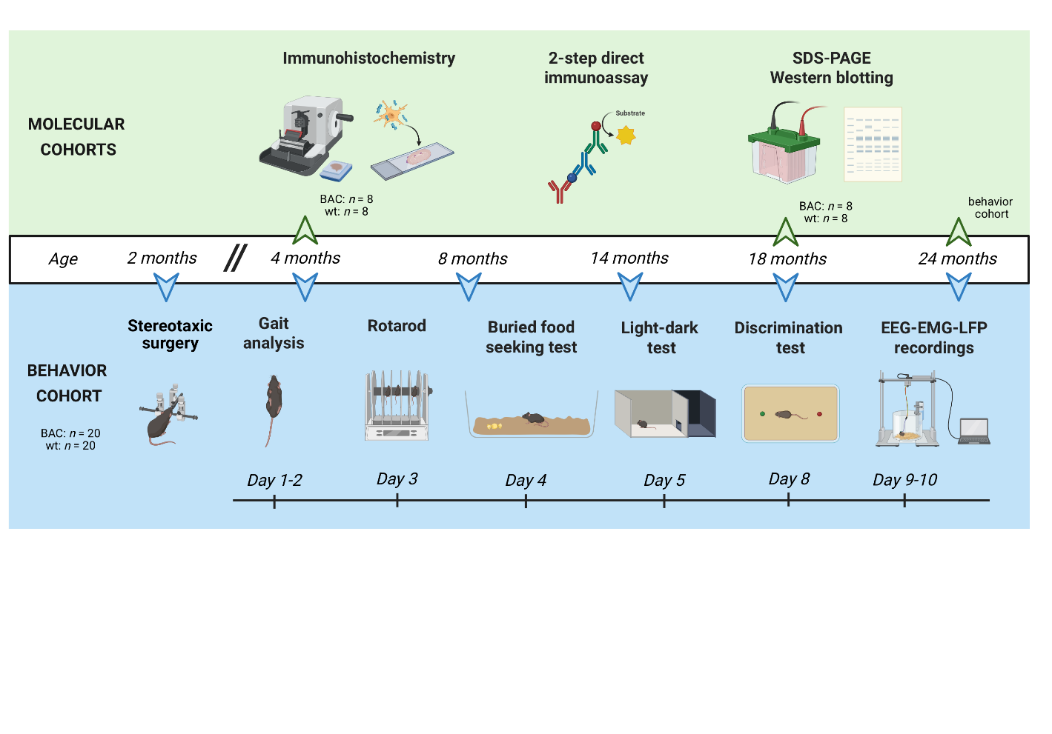
Supplementary Materials
Supplementary Figure 1 Schematic representation of the experimental design. A behavior cohort (wt: n = 21; SNCA^{A53T/-}: n = 20), designated to explore functional readouts related to Parkinson’s disease, underwent a stereotaxic brain surgery at 2 months of age to implement epidural, intracortical and intramuscular electrodes. These mice were followed longitudinally until the age of 24 months by a battery of behavioral assessments including CatWalk gait analysis at day 1-2, Rotarod motor performance at day 3, buried food seeking test at day 4, light-dark test at day 5, olfactory discrimination test at day 8 and EEG-EMG and LFP recordings at day 9-10. Additionally, molecular pathology was assessed by immunohistochemistry at intermediate stages (4 months and 8 months: wt: n = 8 and SNCA^{A53T/-}: n = 8) and at 24 months in mice from the behavior cohort, together with a two-step direct immunoassay and SDS-PAGE western blotting. This approach allowed correlation of functional outcomes with pathology. This figure was created through BioRender.com. wt = wild-type mice, BAC = heterozygous A53T-SNCA BAC mice, LFP = local field potential.

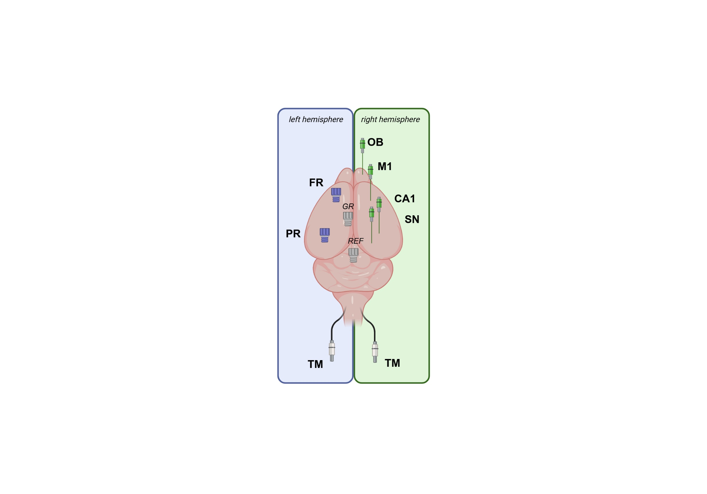
Supplementary Figure 2 Overview of electrode configuration. Left hemisphere is implemented with epidural electrodes for EEG recording. Right hemisphere is implemented with intracortical electrodes for LFP recording. Two fine-wired electrodes will be inserted in left and right trapezius muscles. FR = frontal cortex, PR = parietal cortex, GR = ground, REF = reference, OB = olfactory bulb, M1 = primary motor cortex, CA1 = cornus ammonis 1, SN = substantia nigra, TM = trapezius muscle.

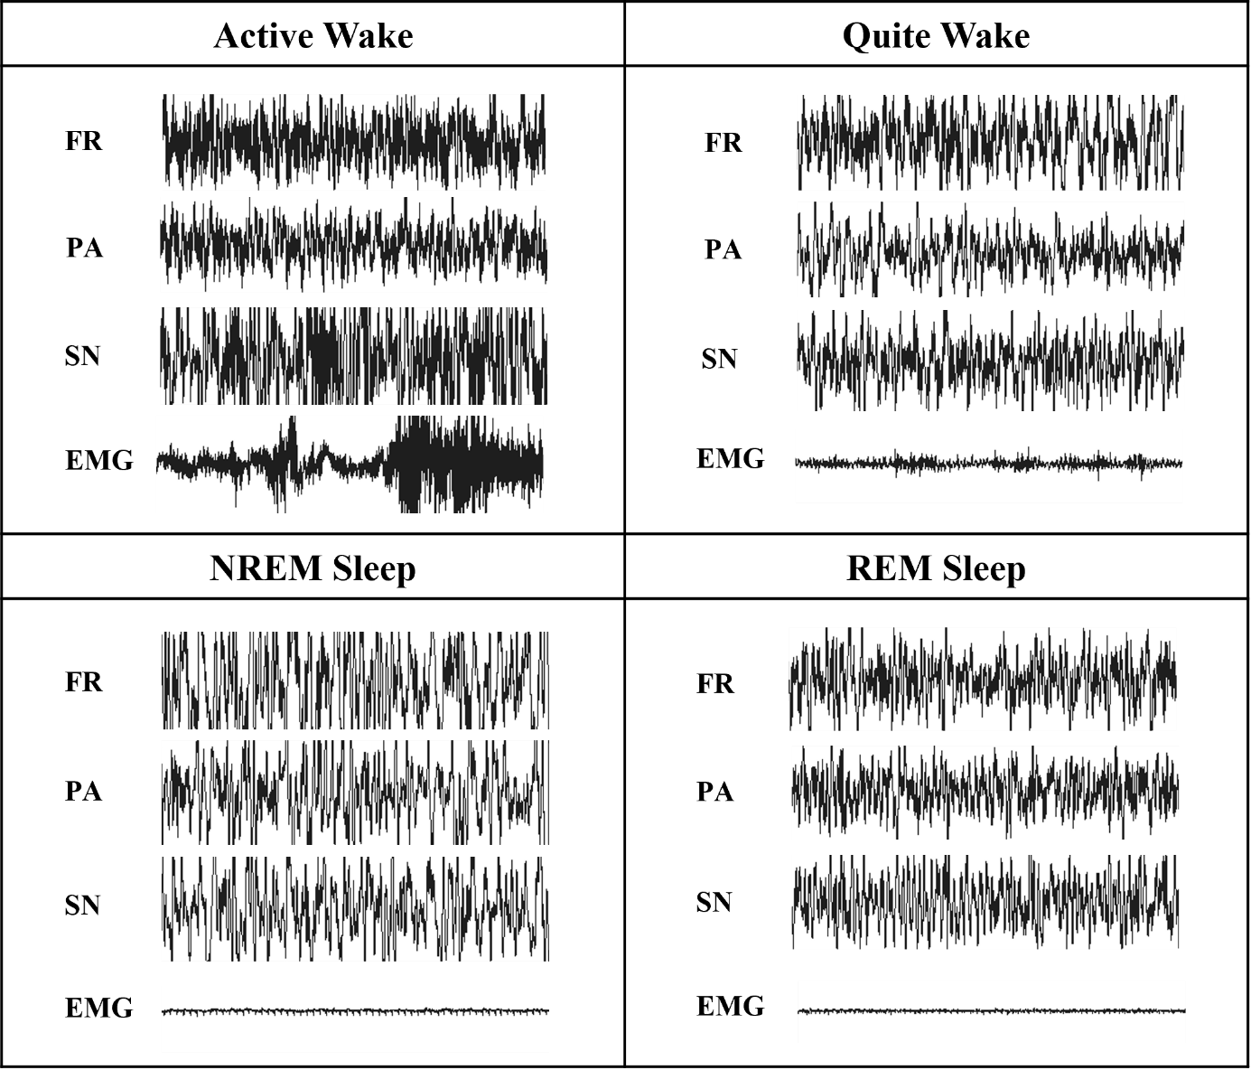
Supplementary Figure 3 Electrophysiological traces of each vigilance state. REM = Rapid Eye Movement, NREM = Non-Rapid Eye Movement, FR = Frontal Epidural Electrode, PA = Parietal Epidural Electrode, SN = Substantia Nigra Intracortical Electrode, EMG = electromyography.

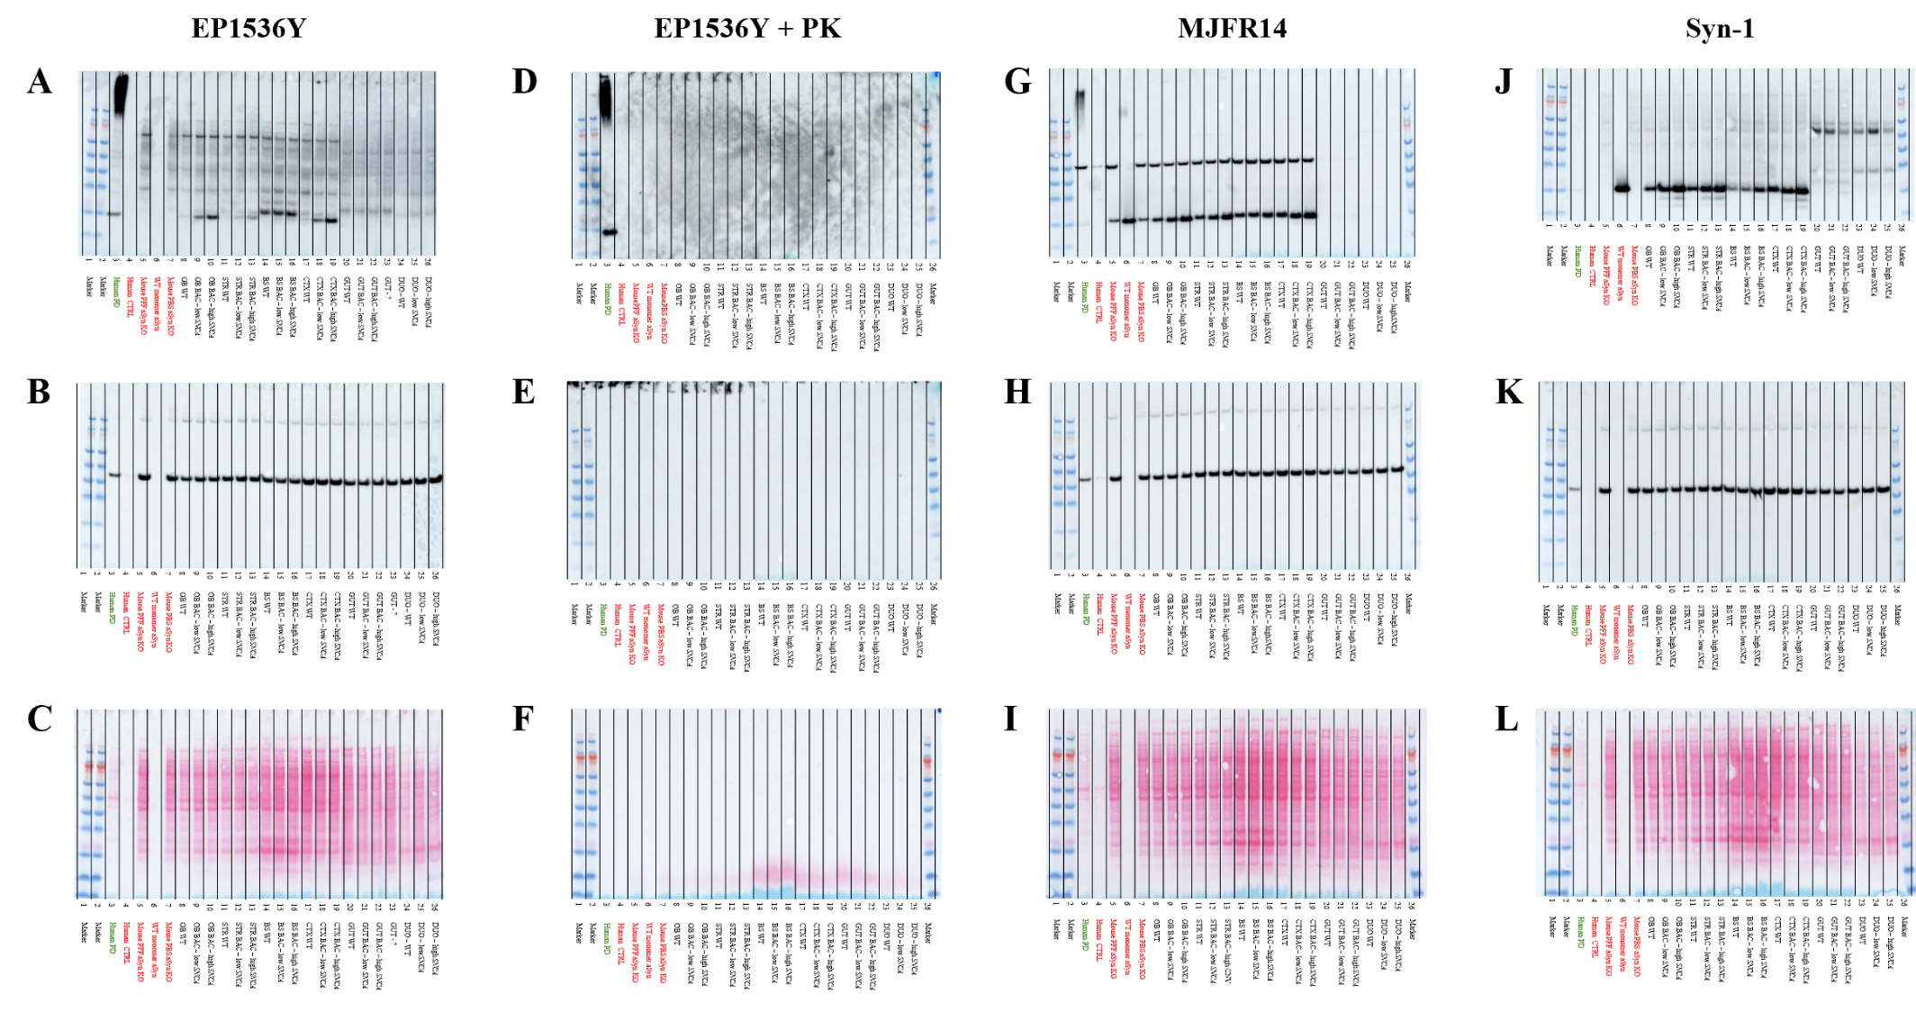
Supplementary Figure 4 Original SDS-PAGE Western blot membranes of pooled olfactory bulb, striatum, brainstem and cortex homogenates of 24-month-old SNCA^{A53T/-} BAC mice. (A-C) All original membranes correspond to Figure 2A, including EP1536Y staining with 30s-exposure (A), β-actin staining with 30s-exposure (B) and Ponceau staining (C). (D-F) All original membranes correspond to Figure 2B, including EP1536Y staining on Proteinase K-treated homogenates with 30sec exposure (D), β-actin staining with 30s-exposure (E) and Ponceau staining (F). (G-I) All original membranes correspond to Figure 2C, including MJFR14 staining with 30s-exposure (G), β-actin staining with 30s-exposure (H) and Ponceau staining (I). (J-L) All original membranes correspond to Figure 2D, including Syn-1 staining with 10sec exposure (J), β-actin staining with 30sec exposure (K) and Ponceau staining (L). Abbreviations are as follows: PK = proteinase K, PD = Parkinson’s Disease, CTRL = control, α-Syn = α-Synuclein, PBS = phosphate-buffered saline, PFF = α-Syn preformed fibrils, α-Syn KO = α-Syn knock-out, WT = wild-type, BAC = bacterial artificial chromosome, OB = olfactory bulb, STR = striatum, BS = brainstem, CTX = cortex, GUT = stomach, DUO = duodenum.

Supplementary Figure 5 pS129-α-Syn immunoreactivity in SNCA^{A53T/-} BAC mice does not evolve over time. Representative images of olfactory bulbs of wild-type and high SNCA^{A53T/-} mice reveal an increase in pS129-α-Syn [EP1536Y] immunoreactivity that remains constant over time. 4 months: wt (n = 6) and high SNCA^{A53T/-} (SNCA copies: 57.7, n = 3) & 18 months: wt (n = 13) and high SNCA^{A53T/-} (SNCA copies: 56.5, n = 6). SNCA^{A53T/-} BAC mice exhibit pS129-α-Syn depositions in inner plexiform layer, granule cell layer and subependymal zone, absent in wild-type mice. I = anterior olfactory bulb; II = glomerular to granular layers; III = subependymal zone.
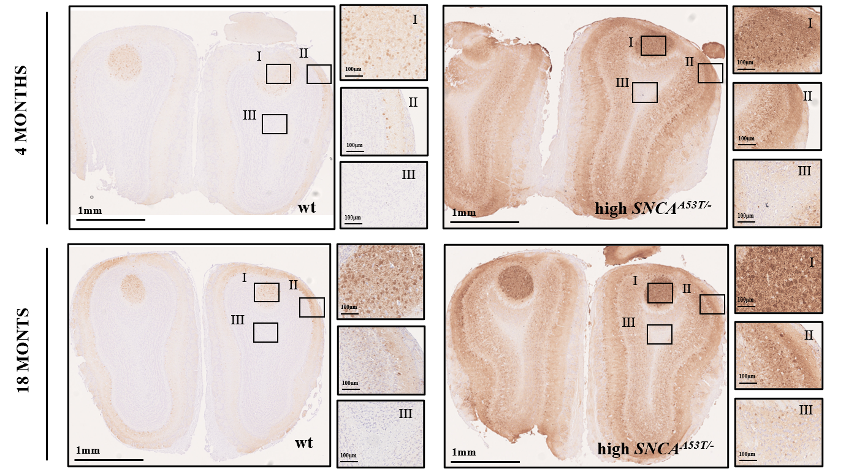

Supplementary Table 1 List of Primary and Secondary Antibodies
Antibody | Application | Working Concentration/Dilution | Host | Reference Number | Company
Anti-pS129-α-Synuclein antibody [EP1536Y] | Immunohistochemistry  1h incubation | 0.5µL/mL in primary antibody diluent (Leica, AR9352) | Rabbit | ab51253 | Abcam
Anti-pS129-α-Synuclein antibody [EP1536Y] | SDS PAGE Western blotting | 1µg/mL in 5% non-fat milk blocking buffer | Rabbit | ab51253 | Abcam
Anti-Tyrosine Hydroxylase antibody | Immunohistochemistry  Overnight incubation | 1:1000 in primary antibody diluent (Leica, AR9352) | Rabbit | AB152 | Millipore
Dako EnVision+ System - HRP Labelled Polymer Anti-Rabbit | Immunohistochemistry | NA – ready to use | Goat | K4003 | Agilent
Anti-α-Synuclein aggregate antibody  [MJFR-14-6-4-2] | SDS PAGE Western blotting | 1µg/mL in 5% non-fat milk blocking buffer | Rabbit | ab209538 | Abcam
Anti-β-Actin-Peroxidase antibody | SDS PAGE Western blotting | 1:20 000 in in 5% non-fat milk blocking buffer | Mouse | A3854 | Sigma-Aldrich
HRP Labelled Anti-Mouse | SDS PAGE Western blotting | 1:3000 in TBS-T wash buffer | Sheep | NA931V | Cytiva
HRP Labelled Anti-Rabbit | SDS PAGE Western blotting | 1:5000 in TBS-T wash buffer | Donkey | NA934V | Cytiva
Anti-pS129-α-Synuclein antibody  [MJF-R13 (8-8)] | 2-step direct immunoassay  (Coating) | 0.5µg/mL in PBS | Rabbit | ab168381 | Abcam
Anti-pS129-α-Synuclein  antibody  [81A] | 2-step direct immunoassay  (Primary Detection) | 1µg/mL in 0.1% casein in PBS | Mouse | 825701 | Biolegend
SULFO-TAG Labelled Anti-Mouse | 2-step direct immunoassay (Secondary Detection) | 1µg/mL in 0.1% casein in PBS | Rabbit | R32AB-1 | MSD

