Supporting Information
Hyperpolarized ¹²⁹Xe MRI Using Dissolution DNP on a Commercial Polarizer: From Solid-State Optimization to In Vivo Lung Imaging
Emma Wiström,^{1*} Jean-Noël Hyacinthe,¹ Esben Søvsø Szocska Hanssen,² Michael Væggemose,² Christoffer Laustsen,² Andrea Capozzi,^{1,3*}

¹LIFMET, Department of Physics, EPFL, Station 6 (Bâtiment CH), 1015 Lausanne (Switzerland).
²The MR-Research Centre, Department of Clinical Medicine, Aarhus University, Palle Juul-Jensens Boulevard 99, 8200 Aarhus N (Denmark).
³Polarize ApS, Asmussen Alle 1, 1808 Frederiksberg (Denmark).

AUTHOR INFORMATION
Corresponding Authors
*Andrea Capozzi, PhD: email: andrea.capozzi@epfl.ch ORCID: 0000-0002-2306-9049

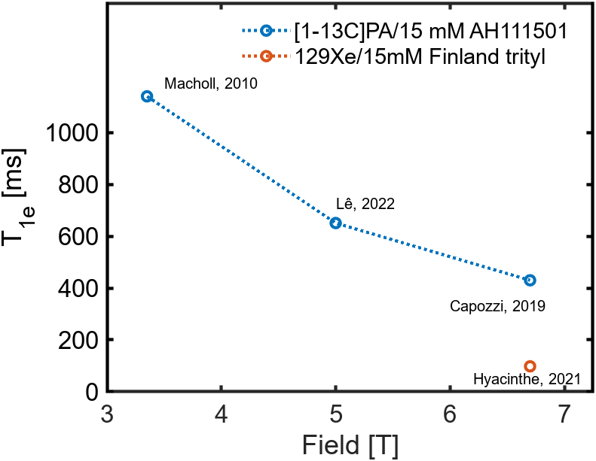
Figure S1. Reported values of T_{1e} from the trityl radical 15 mM (corporate ID AH111501) in [1-13C]PA [1], [2], [3], and xenon/trityl [4].

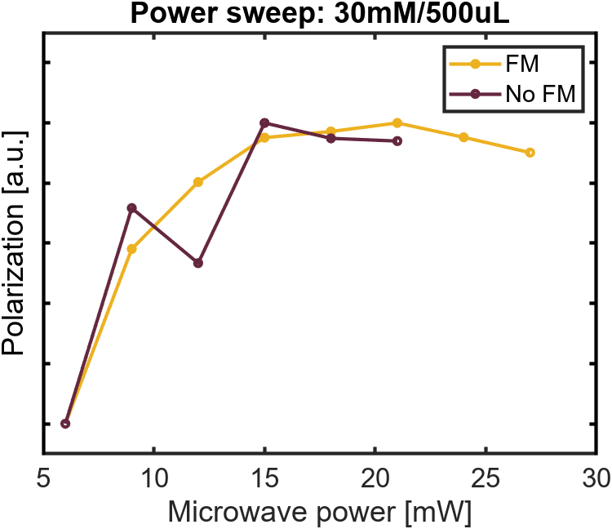
Figure S2. Power sweeps of sample 30 mM Finland acid trityl in isobutanol, in a total sample volume of 500 µL, with and without frequency modulation. The microwave power reaches an optimal value before the curve saturates and eventually declines.
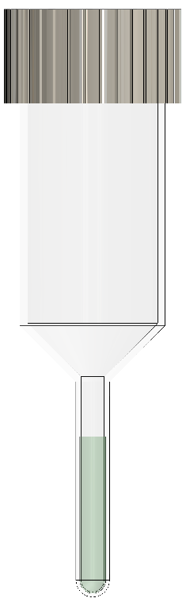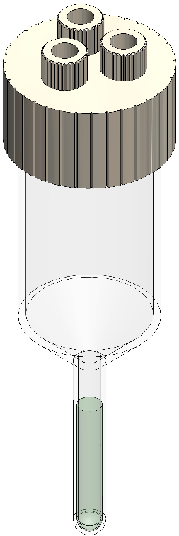
Figure S3. 2D illustrations of phase separator used in the sublimation setup, custom ordered from Prototech (the Netherlands). The receiver cup is of Polychlorotrifluoroethylene (PTCFE) connected to a Polyether ether ketone (PEEK) lid with an O-ring, sustaining low pressure sufficiently long for dissolutions. The lid’s inlets are compatible with Flangeless Fittings (IDEX P-335, BGB Analytik AG, USA) for 1/8” outer diameter tubing.

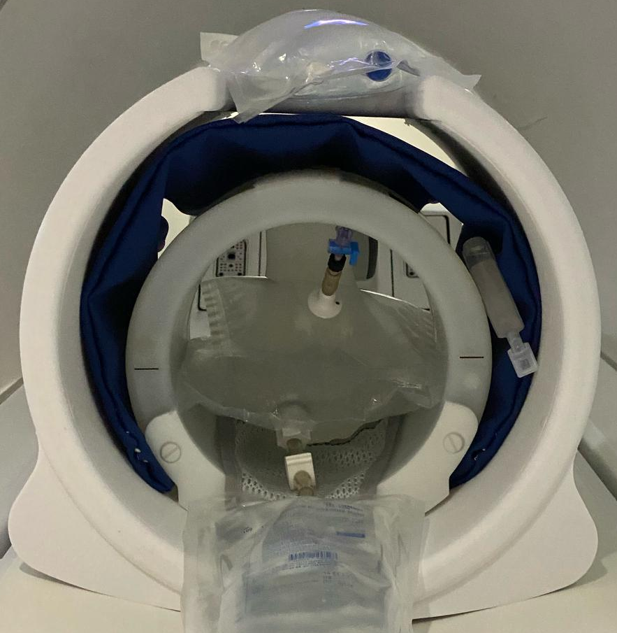
Figure S4. Ventilation imaging were measured on the Tedlar bags concurrently, acquiring with an 8-channel vest, and both Tedlar bags placed in the centre. Similar setup was used during the T1 relaxation time acquisition, but with one Tedlar bag at a time (figure 4 in main article).

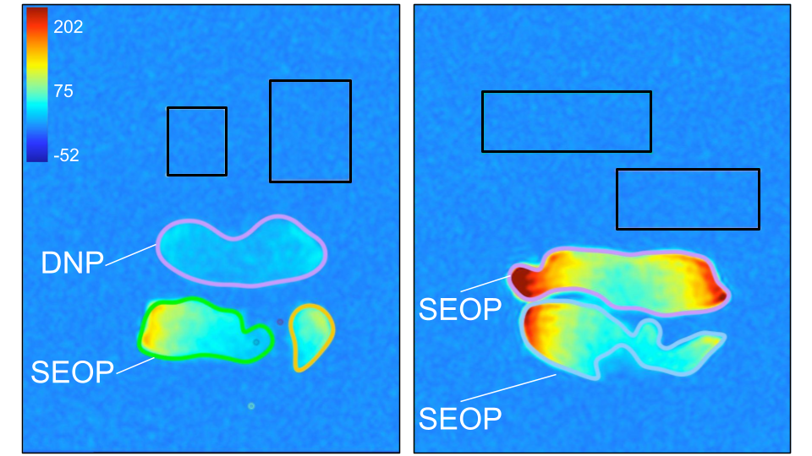
Figure S5. Ventilation image slices of hyperpolarized xenon in two Tedlar bags in a GE Scanner (setup in S4). All Tedlar bags have xenon concentration close to 3%, but SEOP uses enriched ¹²⁹Xe of 86% compared to the natural abundant xenon gas of 26% used in DNP. Ventilation sequence: 3D coronal balanced steady-state free precession (b-SSFP) ; voxel size of 5 × 5 × 10 mm 3, matrix size of 80 × 80 × 30, repetition time (TR) = 3.2 ms, echo time (TE) = minimum (~1 ms), flip angle (FA) = 10°, bandwidth = 31.25 kHz, and total acquisition time of 6 s. The signal intensity differs between all the bags due to coil sensitivity, as seen on the dual SEOP bags image on the right.

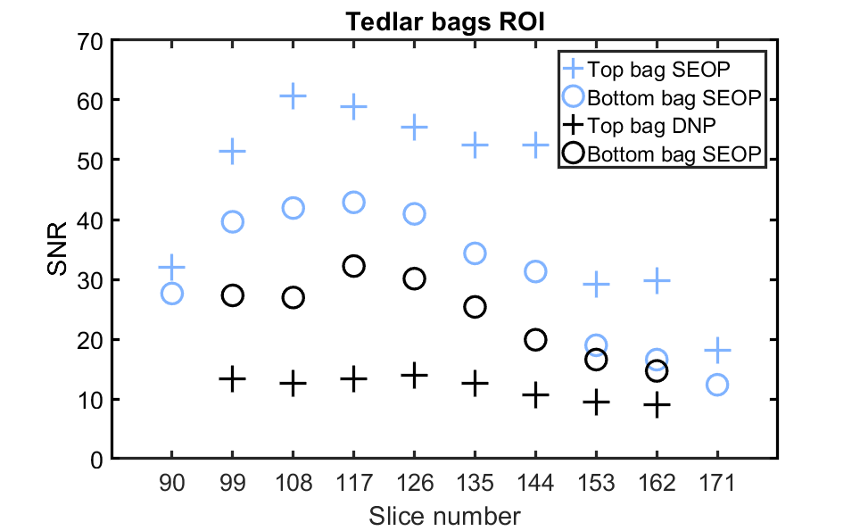

Figure S6. The ventilation images were processed with Horos (version 3.3.6, Annapolis, MD, USA). The signal-to-noise ratio (SNR) values calculated from the mean signal intensity value in the region of interest (ROI) provided by the Max Intensity Projection (MIP) in HOROS, and standard deviation from noise outside the ROI.
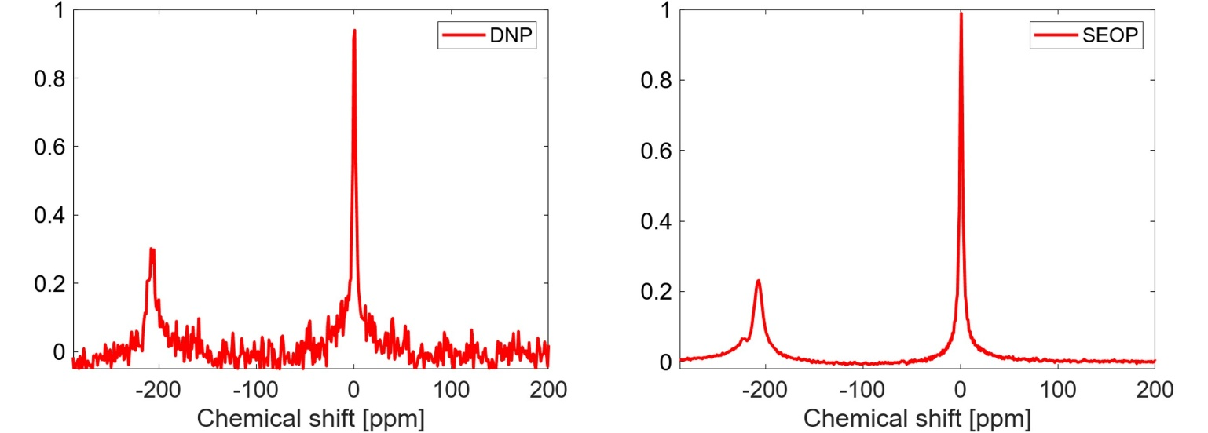
Figure S7. In vivo spectra of hyperpolarized 129Xe produced by DNP and SEOP, showing signal peaks of the gas phase as well as dissolved signal at 200 ppm. The noise of the DNP spectrum is 100 times larger than the SEOP spectrum due to a difference in SNR.

References
[1] S. Macholl, H. Jóhannesson, and J. H. Ardenkjaer-Larsen, “Trityl biradicals and 13C dynamic nuclear polarization,” Physical Chemistry Chemical Physics, vol. 12, no. 22, pp. 5804–5817, 2010, doi: 10.1039/C002699A.
[2] T. P. Lê, J. N. Hyacinthe, and A. Capozzi, “How to improve the efficiency of a traditional dissolution dynamic nuclear polarization (dDNP) apparatus: Design and performance of a fluid path compatible dDNP/LOD-ESR probe,” Journal of Magnetic Resonance, vol. 338, p. 107197, May 2022, doi: 10.1016/J.JMR.2022.107197.
[3] A. Capozzi, S. Patel, W. T. Wenckebach, M. Karlsson, M. H. Lerche, and J. H. Ardenkjær-Larsen, “Gadolinium Effect at High-Magnetic-Field DNP: 70% 13C Polarization of [U-13C] Glucose Using Trityl,” Journal of Physical Chemistry Letters, vol. 10, no. 12, pp. 3420–3425, Jun. 2019, doi: 10.1021/acs.jpclett.9b01306.
[4] A. Capozzi, J. H. Ardenkjear-Larsen, and J.-N. Hyacinthe, “129Xe gas hyperpolarized via sublimation DNP at 6.7 T and 1.1 K using a reusable purpose built fluid path,” in P063, EuroIsmar, 2019, p. 273.

