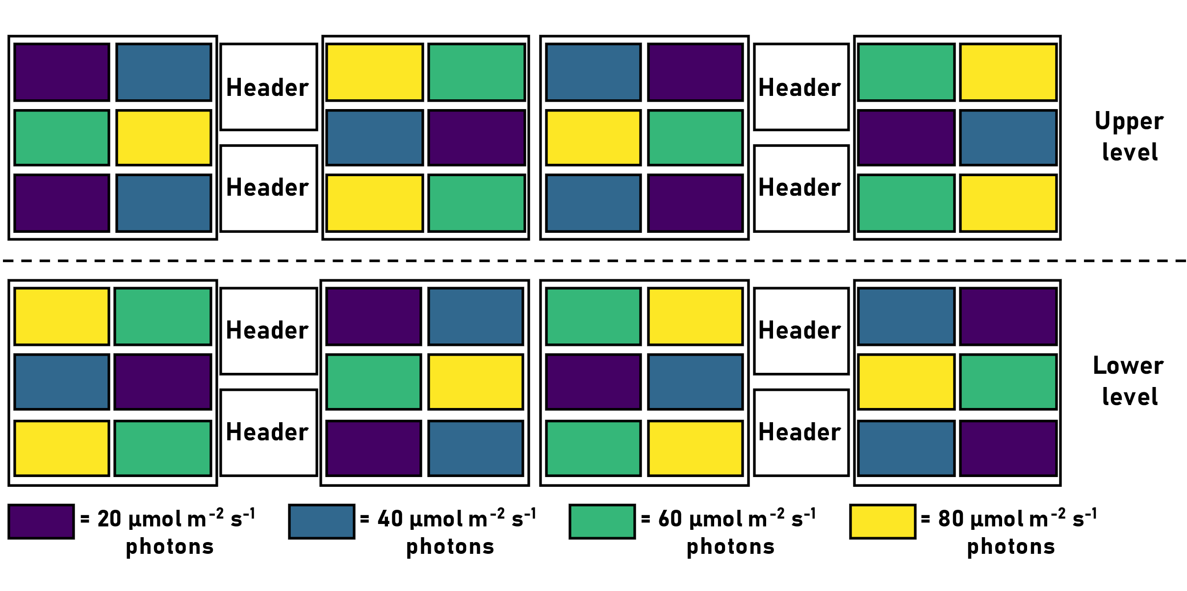
Supplementary material
Figure S1. Schematic of the experimental setup. Colour code for treatments will be used in other figures in the remainder of the text.

Table S1. Mean (± standard error (SE)) carbonate chemistry (dissolved inorganic carbon (DIC), temperature (T), total alkalinity (A_{T}), pH total (pH_{T}), and light conditions over the course of the experiment. Mean irradiance values for each treatment represent 120 individual data points taken from 12 tanks over noon (10 points from each tank). Mean T, pH_{T}, A_{T} and DIC all n = 159.
Treatment | Irradiance  (μmol photons m⁻² s⁻¹) | T  (°C) | pH_{T} | A_{T}  (μmol kg⁻¹) | DIC  (μmol kg⁻¹)
20 | 25 ± 3 | 16.42 ± 0.10 | 8.01 ± 0.01 | 2275.11 ± 4.88 | 2065.65 ± 8.11
40 | 40 ± 3 | 16.45 ± 0.10 | 8.02 ± 0.01 | 2278.19 ± 4.83 | 2066.02 ± 8.74
60 | 57 ± 3 | 16.36 ± 0.10 | 8.02 ± 0.01 | 2279.77 ± 3.41 | 2064.72 ± 7.72
80 | 82 ± 3 | 16.44 ± 0.10 | 8.02 ± 0.01 | 2278.14 ± 4.07 | 2067.56 ± 8.12
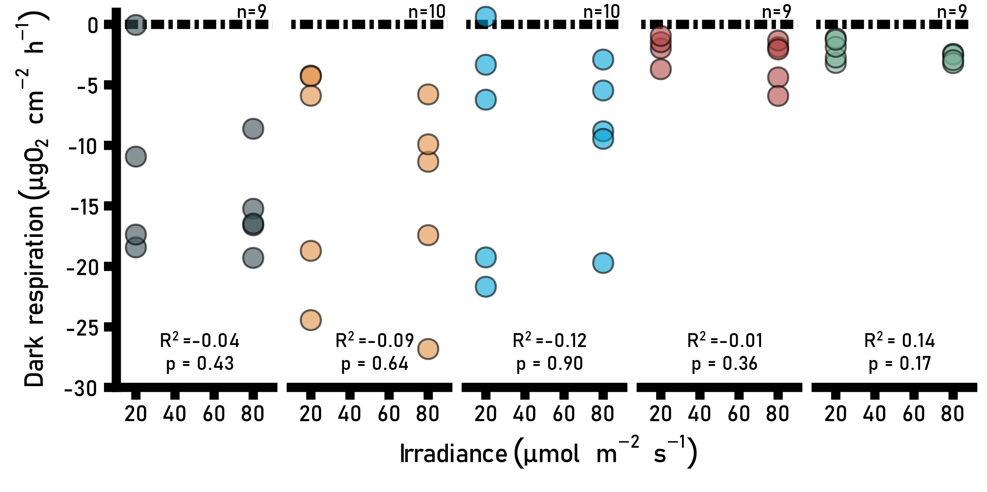
Figure S2. Effect of irradiance on dark respiration rates of study species. Points are individual rates. Colours indicate species (colour code see Fig. 2). Adjusted proportions of variations (R²) and probability values (p-values) were obtained from linear models.
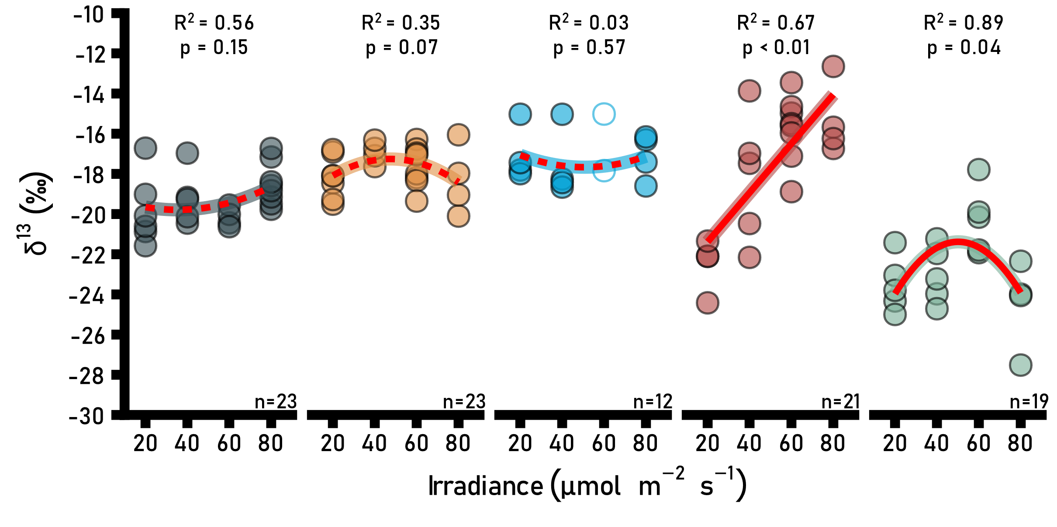
Figure S3. Effect of irradiance on organic carbon isotope content of study species. Points show individual values and colours indicate species (colour code see Fig. 2) Lines indicate whether parabolic or linear models were fitted onto the data (dashed = non-significant; solid = significant). R² and p-values were obtained from full linear mixed effect models. Open circles show data points that were not included in model calculation (L. carpophylli only).
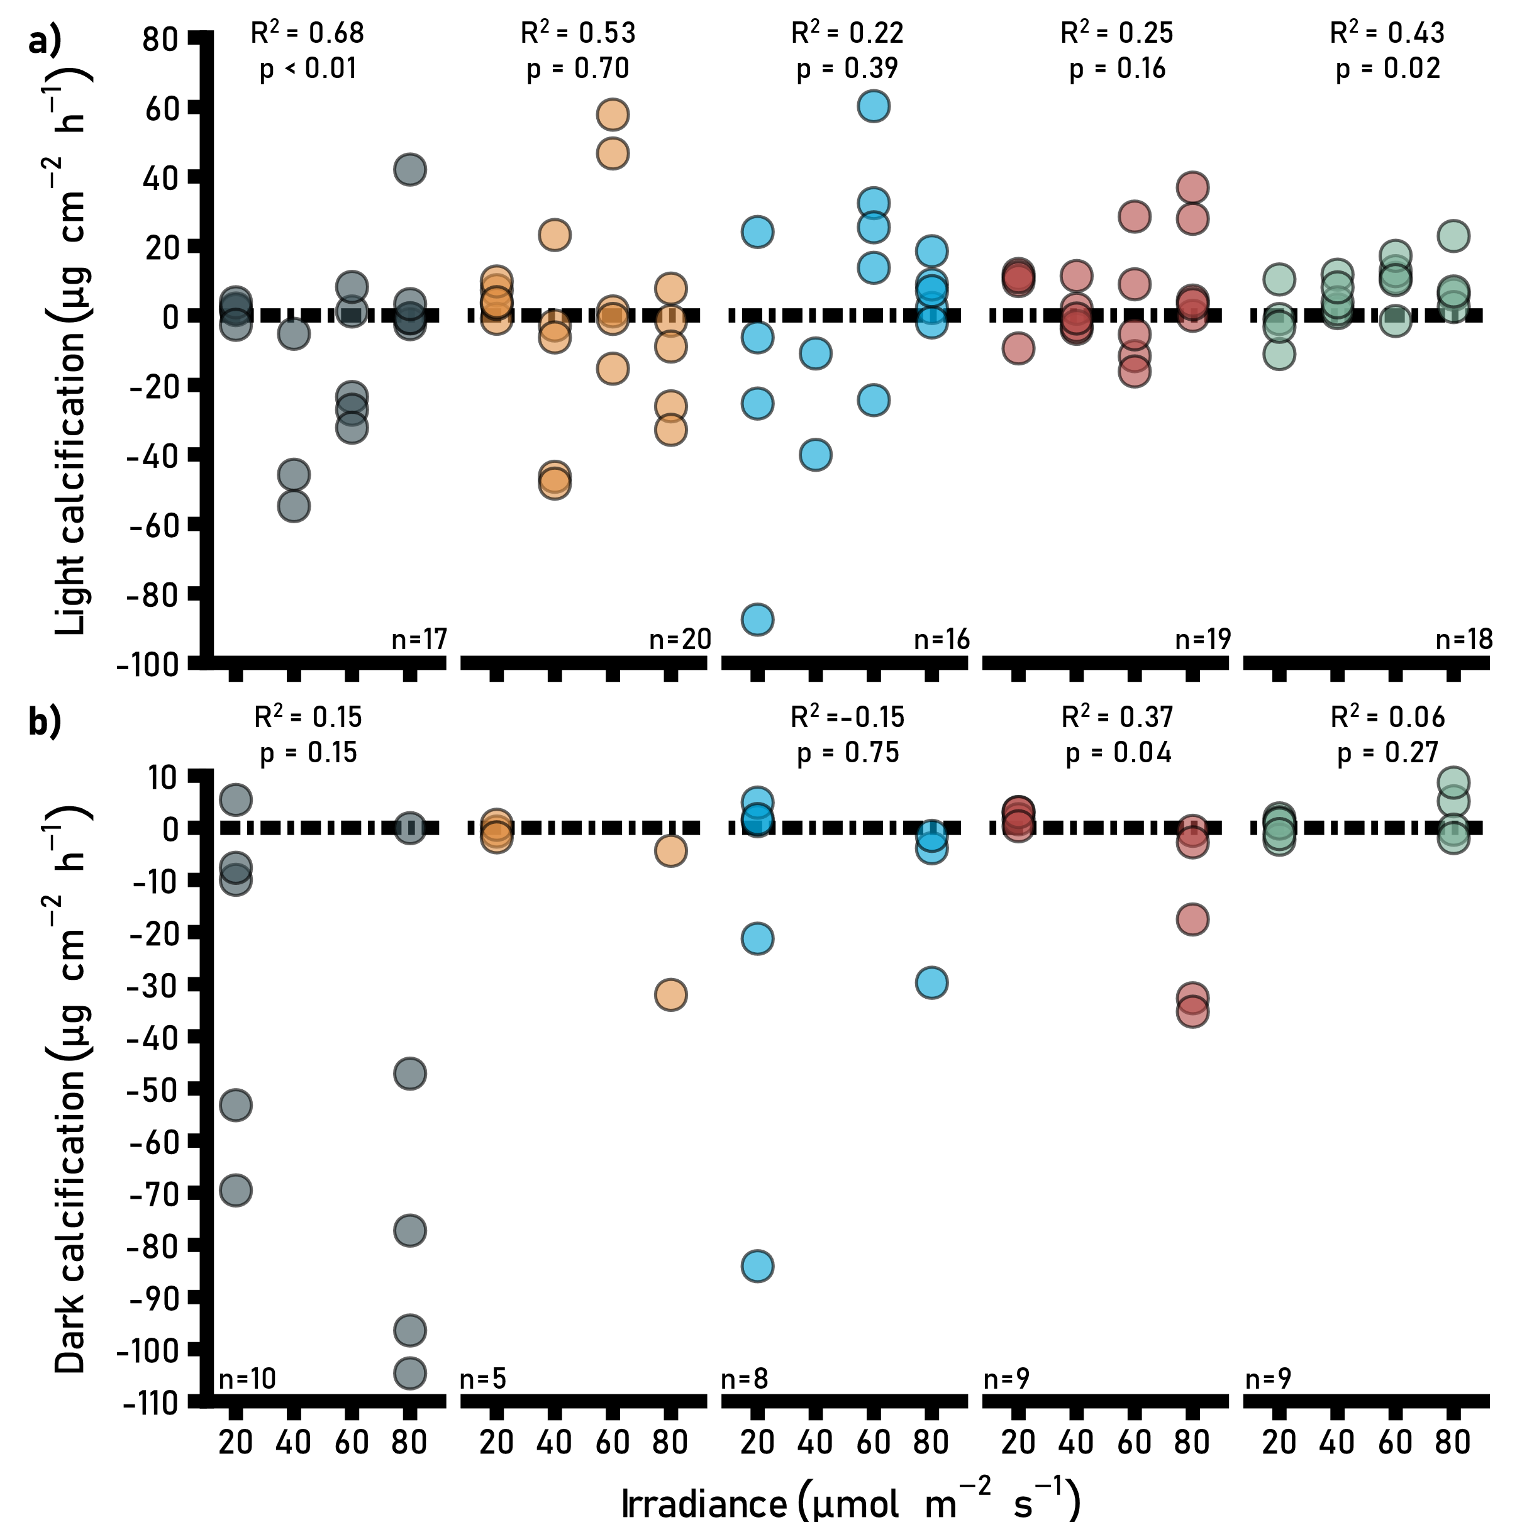
Figure S4. Effect of irradiance on A) light and B) dark calcification rates of study species. Colours indicate species (colour code see Fig. 2), and points show individual rates. Lines show whether parabolic or linear models were used (dashed = non-significant; solid = significant). R² and p-values for light calcification were obtained from full linear mixed effect models. For dark calcification, adjusted R² and p-values were obtained from linear models. Please note: R² and p values could not be calculated for Corallina/Arthrocardia “fine” due to lack of data in the high light treatment.

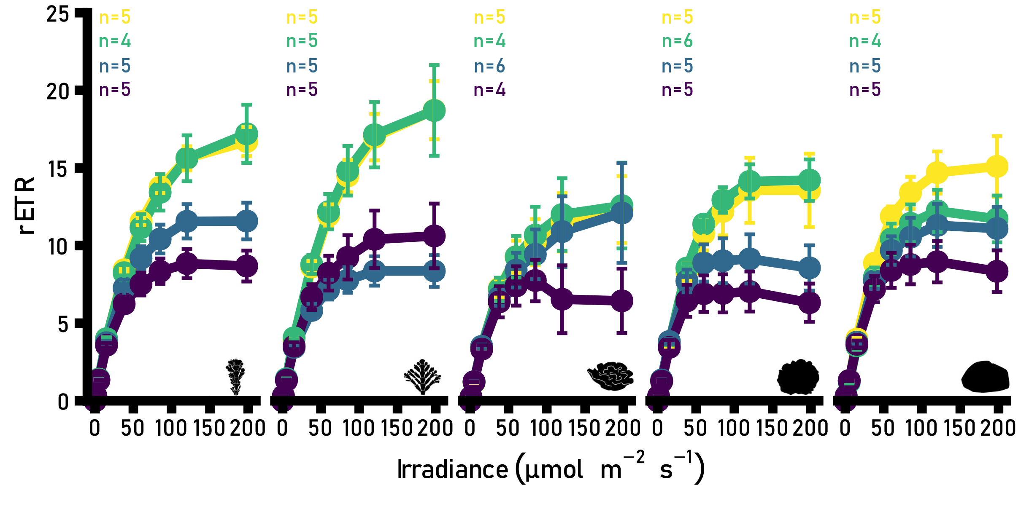
Figure S5. Effect of irradiance on relative electron transport rates (rETR) from study species after long-term exposure to different light levels. Points show mean (±SE) and colours indicate treatments (colour code see Supplementary Fig. S1). Schematics indicate species (code see Figure 2).
Table S2. Maximum relative electron transport rates (rETR_{max}), maximum saturation intensity (E_{k}) and light use efficiency (α) obtained from rapid light curves. Model statistics are from full linear mixed effect models. Fitted models were all linear.
Species | Treatment | rETR_{max} |  | E_{k} |  | α
Species | Treatment | Mean (±SE) | Model statistics | Mean (±SE) | Model statistics |  | Mean (±SE) | Model statistics
Corallina/  Arthrocardia  “fine” | 80 | 38.4±5.1 | df = 15.1 | 164.8±16.9 | df = 14.0 |  | 0.13±<0.1 | df = 17.0
Corallina/  Arthrocardia  “fine” | 60 | 32.6±5.8 | t value = 5.3 | 159.4±25.6 | t value = 7.0 |  | 0.18±<0.1 | t value =-4.7
Corallina/  Arthrocardia  “fine” | 40 | 9.4±1.0 | p < 0.001 | 84.2±7.7 | p < 0.001 |  | 0.28±<0.1 | p < 0.001
Corallina/  Arthrocardia  “fine” | 20 | 12.7±3.8 | R² = 0.77 | 38.2±7.5 | R² = 0.84 |  | 0.29±<0.1 | R² = 0.63
Corallina/  Arthrocardia  “fine” |  | n = 20 |  | n = 20 |  |  | n = 20
Corallina/  Arthrocardia “robust” | 80 | 21.2±1.8 | df = 13.0 | 55.2±4.2 | df=15.5 |  | 0.32±<0.1 | df = 9.0
Corallina/  Arthrocardia “robust” | 60 | 20.2±3.5 | t value = 3.1 | 61.0±5.9 | t value = 4.7 |  | 0.30±<0.1 | t value =-1.3
Corallina/  Arthrocardia “robust” | 40 | 13.7±2.0 | p = 0.008 | 39.2±3.4 | p < 0.001 |  | 0.30±<0.1 | p = 0.232
Corallina/  Arthrocardia “robust” | 20 | 9.4±1.3 | R² = 0.81 | 29.6±3.0 | R² = 0.74 |  | 0.29±<0.1 | R² = 0.8
Corallina/  Arthrocardia “robust” |  | n = 18 |  | n = 19 |  |  | n = 19
L. carpophylli | 80 | 18.3±6.8 | df = 14.2 | 43.6±10.3 | df = 12 |  | 0.30±<0.1 | df = 15.0
L. carpophylli | 60 | 19.9±7.5 | t value = 1.8 | 36.2±10.0 | t value = 3.1 |  | 0.33±<0.1 | t value <-0.1
L. carpophylli | 40 | 12.6±4.6 | p = 0.094 | 22.9±2.7 | p < 0.001 |  | 0.31±<0.1 | p = 0.965
L. carpophylli | 20 | 9.0±2.0 | R² = 0.37 | 25.0±2.7 | R² = 0.65 |  | 0.32±<0.1 | R² = 0.11
L. carpophylli |  | n = 18 |  | n = 17 |  |  | n = 18
Phymatolithopsis complex | 80 | 17.1±4.7 | df = 17.0 | 42.0±7.6 | df = 17.0 |  | 0.34±<0.1 | df=16.6
Phymatolithopsis complex | 60 | 19.3±2.4 | t value = 2.6 | 42.4±5.1 | t value = 4.7 |  | 0.35±<0.1 | t value =-2.1
Phymatolithopsis complex | 40 | 12.3±2.5 | p = 0.018 | 21.7±3.7 | p < 0.001 |  | 0.42±<0.1 | p = 0.050
Phymatolithopsis complex | 20 | 8.7±1.7 | R² = 0.27 | 18.7±2.2 | R² = 0.77 |  | 0.41±<0.1 | R² = 0.31
Phymatolithopsis complex |  | n = 19 |  | n = 21 |  |  | n = 20
Pneophyllum  complex | 80 | 21.0±2.9 | df = 17 | 43.7±7.0 | df = 18.2 |  | 0.36±<0.1 | df = 16.0
Pneophyllum  complex | 60 | 18.4±2.9 | t value = 2.4 | 34.6±3.0 | t value = 3.8 |  | 0.36±<0.1 | t value =-1.5
Pneophyllum  complex | 40 | 14.9±3.2 | p = 0.030 | 32.3±3.6 | p = 0.001 |  | 0.34±<0.1 | p = 0.164
Pneophyllum  complex | 20 | 11.1±1.9 | R² = 0.75 | 23.3±2.7 | R² = 0.80 |  | 0.38±<0.1 | R² = 0.69
Pneophyllum  complex |  | n = 21 |  | n = 21 |  |  | n = 19
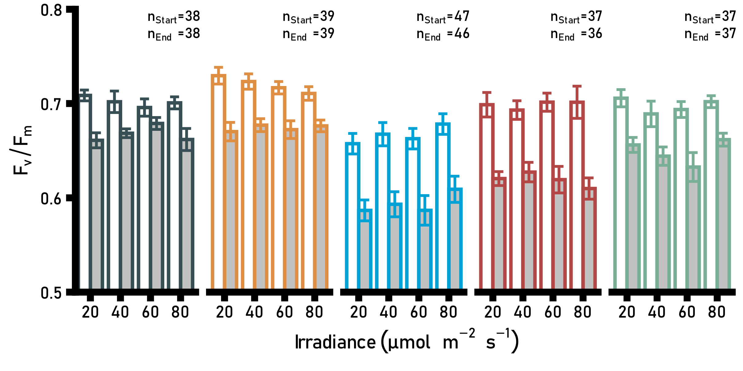
Figure S6. Effect of irradiance on photosynthetic efficiency at the start (white filling) and at the end of the experiment (grey filling) for each treatment and species (colour code see Fig. 2). Bars are mean (±SE). Points are individual values.

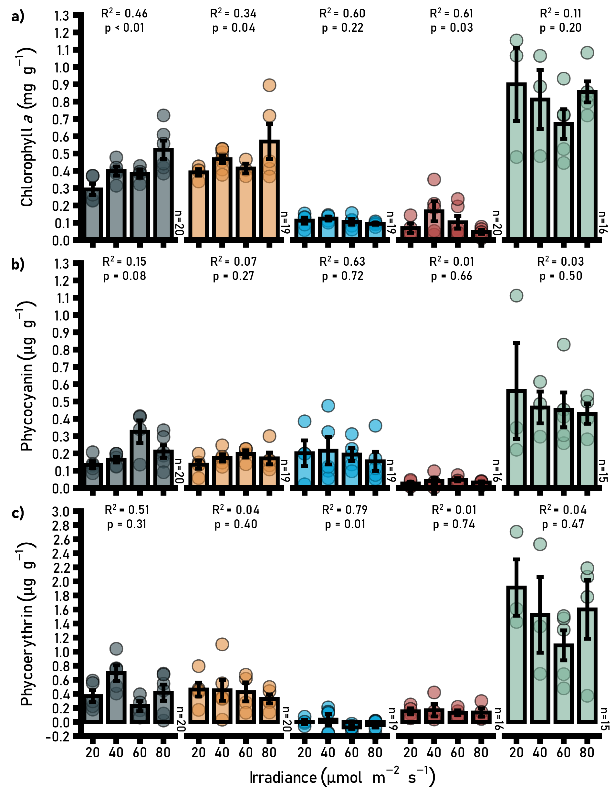
Figure S7. Effect of irradiance on: A) chlorophyll a (Chl a); B) phycocyanin; and C) phycoerythrin content in study species. Bars are mean (±SE). Points are individual values. Colours indicate species (colour code see Fig. 2). R² and p-values from full linear mixed effect models. Fitted models were all linear except for Chl a of Pneophyllum complex (green) and Phymatolithopsis complex (red) where a parabolic model fitted best. Please note: a significant, negative relationship between phycoerythrin and light was detected in L. carpophylli, despite the likely absence of this pigment (mean content -0.08–0.03 μg g⁻¹).

