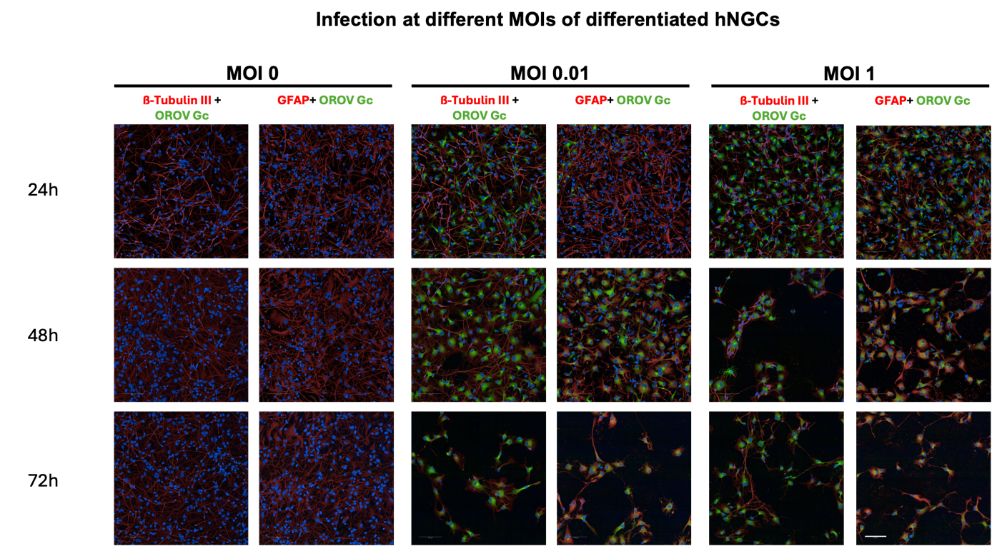
Supplementary figure 1 : Immunolabelling with anti-Gc (OROV), anti-ß-III-Tubulin and/or anti-GFAP antibodies. Scale Bar represents: 100µm.

