Supplementary data

Effect of a Solanesol-Enriched Extract from Nicotiana tabacum L. on Intracellular Oxidative Stress in Endothelial Cells
Yudeyki Almuiña Guerra¹, Oscar Galarce-Bustos* ¹, Claudio Aguayo Tapia ², Camilo Obregón Fernández¹, Deliany González Hernández¹, Marcia Avello Lorca ^{1*}

¹Laboratorio de Farmacognosia, Departamento de Farmacia, Facultad de Farmacia, Universidad de Concepción, Concepción, Chile.
²Departamento de Bioquímica Clínica e Inmunología, Facultad de Química y Farmacia, Universidad de Concepción, Concepción, Chile.

*Corresponding autor: Marcia Avello Lorca, Laboratorio de Farmacognosia, Departamento de Farmacia, Facultad de Farmacia, Universidad de Concepción, Concepción, Chile. Email: maavello@udec.cl
Oscar Galarce-Bustos, Laboratorio de Farmacognosia, Departamento de Farmacia, Facultad de Farmacia, Universidad de Concepción, Concepción, Chile. Email: oscargalarce@udec.cl

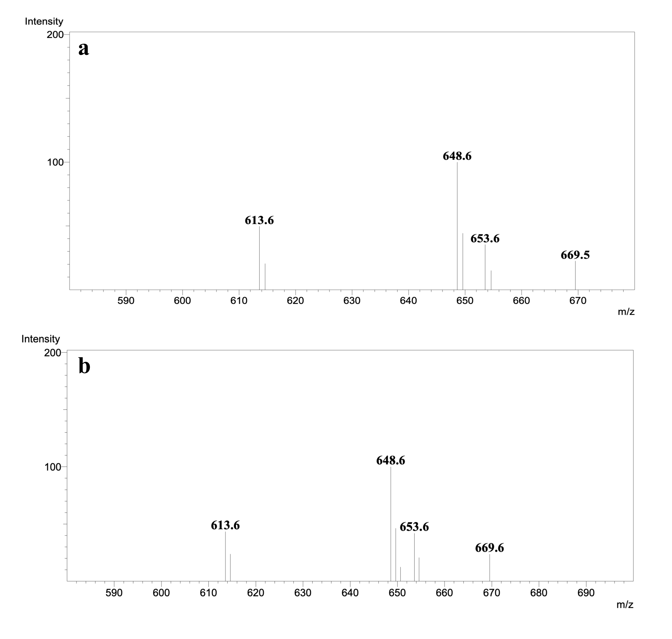
Figure S1. Mass spectrum obtained in positive SCAN mode at m/z 635 [M+H] ⁺. (a) solanesol standard, (b) crude extract.

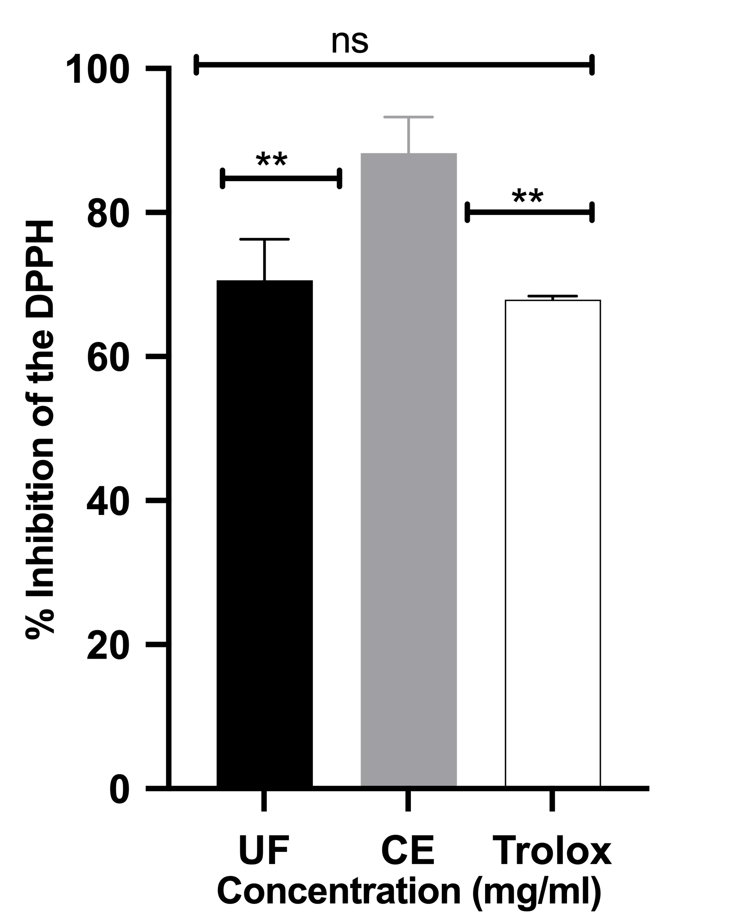
Fig. S2. DPPH radical inhibition, expressed as percentage of protection. Data are presented as the mean ± standard error of triplicates. *Different letters indicate statistically significant differences between means, according to one-way ANOVA, p < 0.05

Table S1. DPPH radical scavenging activity of the crude extract (CE), unified fraction (UF), and derived fractions from Nicotiana tabacum L. Values are expressed as mean ± SD. Inhibition percentages were determined at equivalent concentrations to allow comparison among samples.

Samples | Inhibition (%)
F7 | 37.5 ± 0.08
F8 | 60.8 ± 0.76
F9 | 69.3 ± 0.26
F10 | 30.6 ± 0.35
UF | 70.57 ± 0.05
CE | 88.25 ± 0.05
Trolox | 86.6 ± 0.009

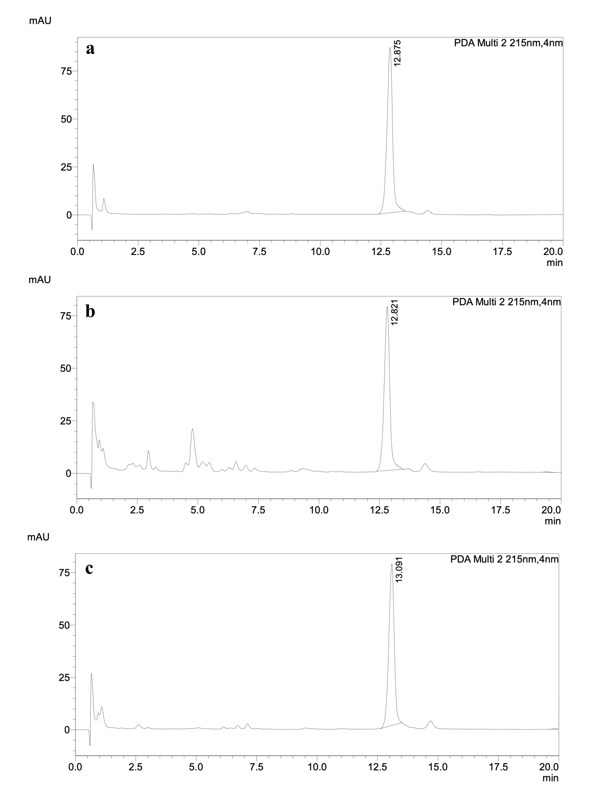
Figure S2. Chromatogram of solanesol at 215 nm. (a) solanesol standard, (b) crude extract, and (c) fraction 7-14

