Salinity stress calibration on SV WT plants
Salinity stress was imposed by irrigating wheat seedlings with 150 mM of sodium chloride (NaCl) starting four days after germination (Duarte et al., 2019). The salt concentration used in the study, 150 mM NaCl, is commonly used for testing salt tolerance in wheat since it is considered a moderate-to-severe salt stress condition, simulating saline soil environments (Tao et al., 2021; Hong et al., 2024; Khanfir et al., 2024). Control plants received water as needed. Irrigation with 150mM of NaCl or water was done at a two-day interval. Tissues were harvested at six, ten, and fourteen days after salinity stress was applied.
First, we determined the electrical conductivity of soil after irrigating with 150mM of NaCl by diluting 5 g of soil with 25 ml of double-distilled water (DDW) in a 1:5 ratio in a falcon tube (Sonmez et al., 2008). As shown in Fig. S1A, the level of EC was increased as the amount of NaCl irrigation intensified. Next, we checked the accumulation of BXDs in response to salinity stress in wheat leaf and root tissues at different time points. Different forms of BXDs were detected and showed different levels of accumulation upon salinity stress (Fig. S1). Thus, the concentration of NaCl used in the study stimulates BXD accumulation in the leaves or roots of wheat plants. Although BXDs are induced at different time points, we selected 14d due to the abundance of BXDs yet maintained high salinity level for comparison with bxd-deficient mutant plants.
Figure S1. Calibration of salinity stress on SV WT plants. A) Measurement analysis of soil electrical conductivity. B) Analysis of BXDs in salt-stressed second leaves and roots of SV WT wheat at different time points by High-performance Liquid Chromatography coupled to Diode Array Detector (HPLC-DAD). Student’s t-test was performed to study the effect of salt on BXD levels within each time point. Two-way ANOVA analysis was performed to assess the effect of age or salt or their interactions. In the ANOVA table, P-values in bold are statistically significant parameters. Error bars represent standard errors of the mean (n=4).

Generating a bx6 mutant in a Triticum turgidum cv. Svevo wheat background
A stable mutation on the TtBX6 gene was generated using the CRISPR-Cas9 system in the background of Svevo WT wheat plants following the protocol described by Hayta et al., 2021. Briefly, immature embryos were isolated, inoculated with Agrobacterium that holds target gene plasmid constructs, regenerated on Hygromycin B antibiotic, and acclimatized in soil (Fig. S2).
The genomic sequence of a target gene, TtBX6 (NCBI GeneBank accession: KY924305; IWGSC gene ID: TRITD2Bv1G015490), was retrieved from the Ensembl plant database (https://plants.ensembl.org/index.html). CRISPR guide RNAs were designed to target exons in the 5’ region of the gene using the CRISPOR software (http://crispor.tefor.net/). The first and second top-ranked guide RNAs were selected based on their low probability of off-targets. Guide RNAs were assembled into the JD633 vector containing the Cas9 coding sequence and the growth-regulating factor GR4-GIF using Golden Gate assembly (Debernardi et al., 2020).
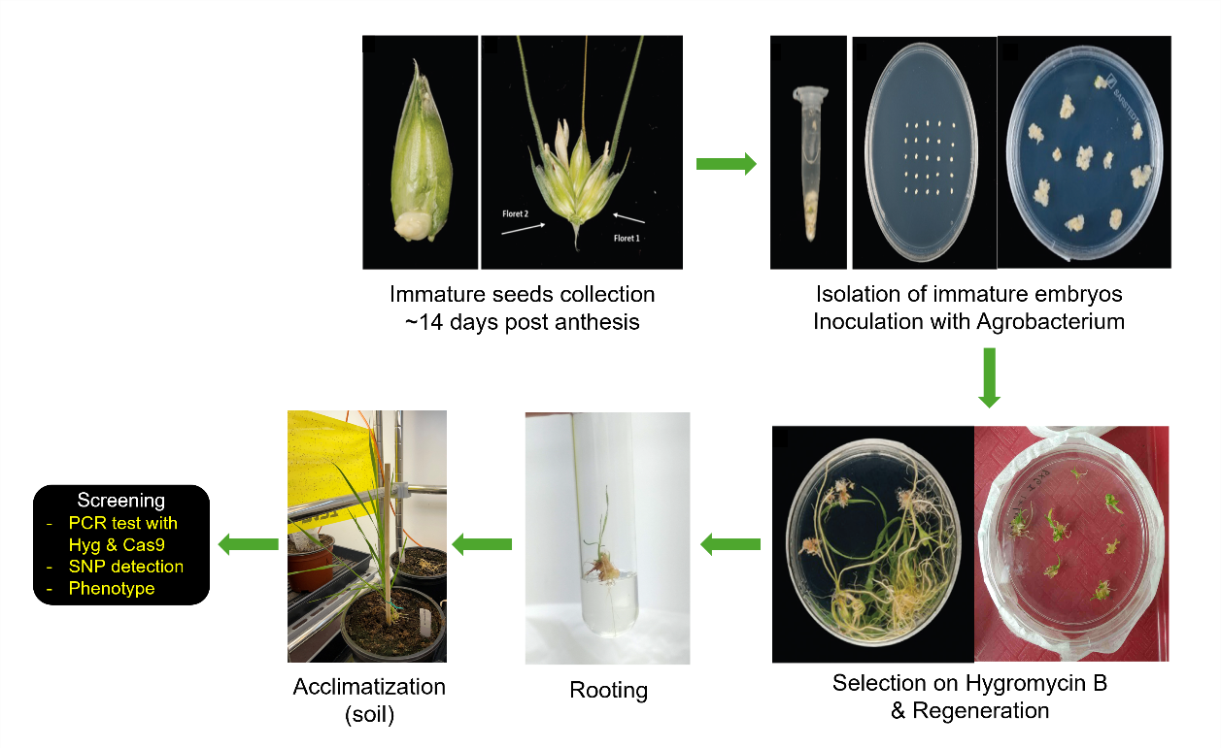
Figure S2. Working process of genome editing by the CRISPR-Cas9 system in tetraploid wheat (Triticum turgidum cv. Svevo).
Selection of T₀ transformants was performed using Hygromycin primers for PCR since the plasmid (JD633) contains the hygromycin resistance gene (HPTIII). PCR amplification showed most of the lines are positive to the hygromycin test, except the bx6-10 line (Fig. S3A). To test whether the CRISPR-Cas9 was integrated into the genome or not, we performed PCR on T₀ genomic DNA using Cas9 primers. As shown in Figure S3B, line bx6-10 showed no amplification in the Cas9 PCR test, meaning that the CRISPR construct was not integrated into the genome. Thus, this line was discarded.
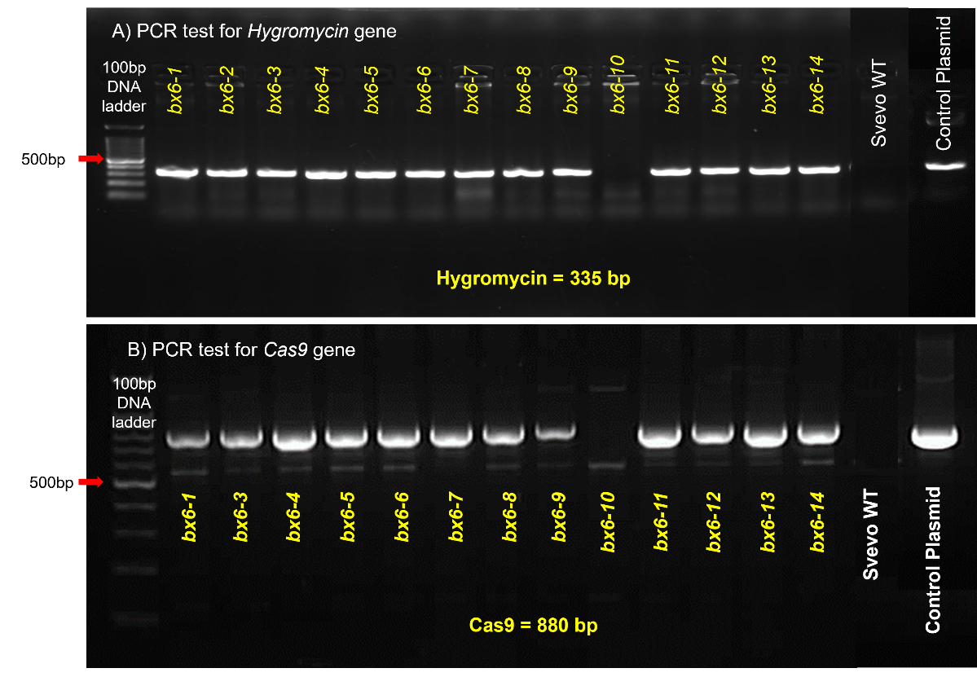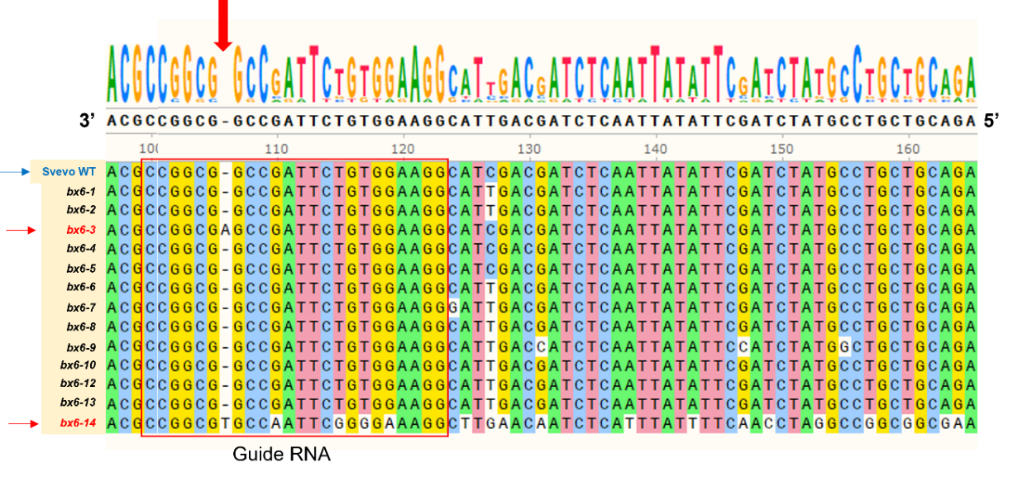
C)
Figure S3. Selection of T₀ transformants. PCR amplification with (A) hygromycin and (B) Cas9 primers. PCR amplification was done using the genomic DNA of T₀ transformants. The control plasmid is the vector plasmid used for transformation, JD633. C) Sanger sequencing: genomic DNA from T₀ transformants was used for sequencing. The multiple sequence alignment was performed using the MUSCLE tool in SnapGene.
Next, we amplified the targeted TtBX6 gene from the genomic DNA of positive transformants for both HYG and CAS9 PCR tests and produced seeds or SV WT as a control. The PCR product was run on 2% agarose gel, and the correct amplicon was gel-purified and sent for sequencing. The sequencing was performed on the reverse strand. The sequence results were aligned in SnapGene software and compared with the reference sequence of WT.
As shown in Figure S3C, transformant line numbers 3 and 14 (bx6-3 & bx6-14) had an indel insertion mutation in the guide RNA region, while a few of the other lines showed mismatches in the promoter region. Thus, bx6-3 and bx6-14 were considered successful events and selected to grow for the next generation. However, we received only two seeds from the bx6-14, which showed a severe phenotype and died before the flowering stage. Thus, we obtained seeds only from line bx6-3 and grew them to receive homozygous lines.

3.2.2 (ii) Screening phenotypes of bx6-3 mutant plants
We first performed Sanger sequencing on T₂ generation plants of bx6-3 to check for the homozygous mutation (Fig. S4B) and observed the same indel insertion mutation in the T₂ lines of bx6-3 mutant plants as we observed in the T₀ stage. Next, to confirm whether the BX6 gene was knocked out in the bx6-3 mutant lines, gene expression analysis was performed on T₂ plants using RT-qPCR. Leaf tissues were collected from 14-day-old SV WT or bx6-3 mutant.
As shown in Figure S4C, the transcript level of the TtBX6 gene was significantly lower in the bx6-3 mutants. Finally, we checked the constitutive levels of BXDs in the mutant plants using HPLC coupled with DAD. A higher accumulation of DIBOA-Glc or its aglucon form (DIBOA), the substrate of BX6, was observed either in the leaf or root of the mutant plants compared to WT (Fig. S4D). However, the mutants lack the product of the BX6 (DIMBOA-Glc and its aglucon form – DIMBOA) or downstream compounds (DIM₂BOA-Glc and HDMBOA-Glc) in both leaf and root tissues (Fig. S4D).
Figure S4. Screening of homozygous bx6-3 mutant plants. A) Simplified biosynthetic pathway of benzoxazinoids in wheat. B) Sanger sequencing on wheat bx6 mutant plants. C) Validation of wheat BX6 gene expression using qRT-PCR. Expression level was normalized to a reference gene, Actin-1, and data are presented as fold changes relative to SV WT plants. D) Benzoxazinoids profile of wheat bx6-3 mutants analyzed by HPLC-DAD. Leaf tissues were collected from 14-day-old plants. A Student’s t-test was performed to assess the difference in BX6 gene expression or individual BXD levels in bx6-3 leaves or roots compared to SV WT. Asterisks indicate statistically significant difference, * P-value < 0.05 or ** P-value < 0.01, whereas n.d. denotes not detected. Error bars represent standard errors of the mean (n=4).

Given the results of the Sanger sequencing, gene expression, and BXD phenotype, we can confirm that the wheat BX6 gene in SV wheat was completely knocked out and nonfunctional in the stable bx6-3 mutant plants.
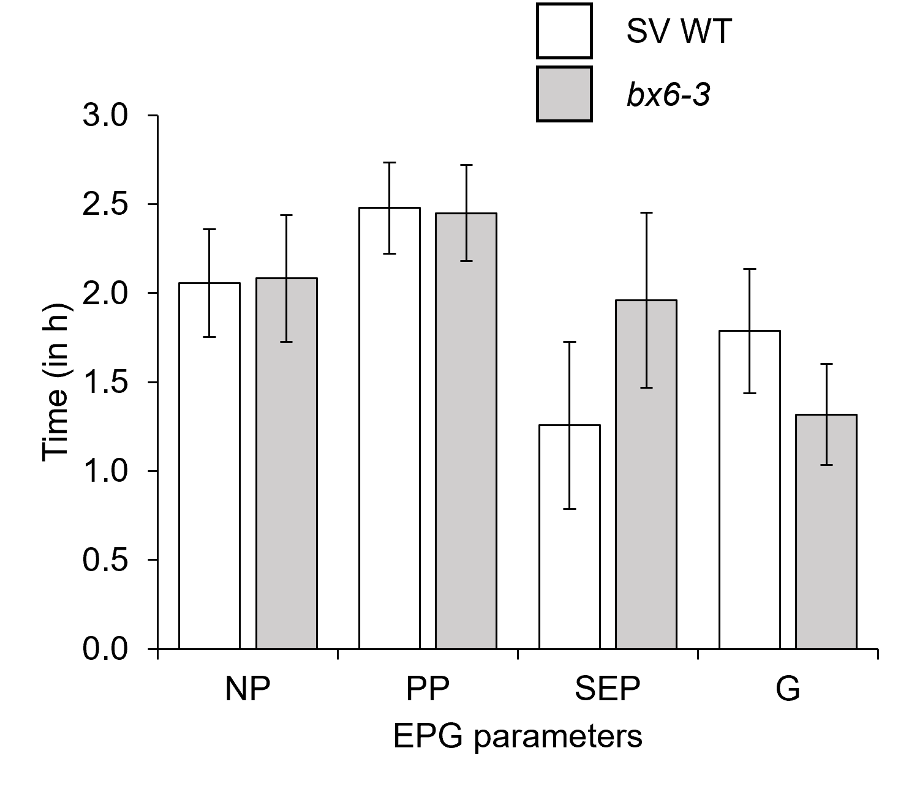
Figure S5. Overall feeding behavior of R. padi on bx6-3 mutant plants. Waveforms were analyzed using Stylet+a software and Excel for automatic parameter workbook for calculation (Sarria et al., 2009).

Table S1. Feeding behavior of R. padi on bx6-3 mutants. Waveforms were analyzed using StyletA software, and Excel for automatic parameter workbook for calculation (Sarria et al., 2009). In red and bold are significant parameters relative to wildtype by Wilcoxon test, P < 0.05 or P < 0.1, respectively.
Phase | Parameter short name | Parameter full name | Unit | SV WT |  |  | bx6-3 |  |  | ChiSquare  (H Statistic) | P-Value,  Wilcoxon test
 |  |  |  | n = 16 |  |  | n = 19 |  |  | ChiSquare  (H Statistic) | P-Value,  Wilcoxon test
 |  |  |  | mean |  | SE | mean |  | SE | ChiSquare  (H Statistic) | P-Value,  Wilcoxon test
Epidermis | Time to 1st probe from start of EPG | t_1Pr | hr | 0.21 | ± | 0.05 | 0.44 | ± | 0.22 | 1.05 | 0.3047
Epidermis and mesophyll | Number of F | n_F | count | 1.19 | ± | 0.44 | 0.84 | ± | 0.36 | 3.61 | 0.0575
 | Total duration of F | s_F | hr | 1.13 | ± | 0.38 | 0.45 | ± | 0.13 | 2.40 | 0.1213
 | % of probing spent in F | %probtimeinF | % | 18.88 | ± | 5.79 | 7.96 | ± | 2.15 | 1.67 | 0.1967
All tissue | Number of probes | n_Pr | count | 9.13 | ± | 1.38 | 7.47 | ± | 1.27 | 0.90 | 0.3437
 | Number of np | n_Np | count | 9.56 | ± | 1.39 | 7.58 | ± | 1.29 | 1.24 | 0.2656
 | Number of pd | n_pd | count | 80.56 | ± | 10.00 | 70.63 | ± | 10.19 | 0.69 | 0.4077
 | Duration of nonprobe period before the 1st E | s_np.1E | hr | 0.68 | ± | 0.17 | 1.63 | ± | 0.37 | 2.53 | 0.1120
 | Total duration of np | s_np | hr | 2.06 | ± | 0.30 | 2.08 | ± | 0.36 | 0.05 | 0.8167
 | Number of pd-S during the 6th hour | n_pd-S.in6thH | count | 10.13 | ± | 3.18 | 2.47 | ± | 1.12 | 3.14 | 0.0766
 | Total duration of pd | s_pd | hr | 0.10 | ± | 0.01 | 0.09 | ± | 0.01 | 0.53 | 0.4663
 | Number of C | n_C | count | 16.63 | ± | 2.09 | 13.37 | ± | 1.81 | 1.67 | 0.1961
 | Total duration of C | s_C | hr | 2.48 | ± | 0.25 | 2.45 | ± | 0.27 | 0.001 | 0.9736
 | % of probing spent in C | %probtimeinC | % | 42.08 | ± | 3.91 | 44.41 | ± | 5.33 | 0.004 | 0.9472
Phloem | Number of E1 | n_E1 | count | 5.56 | ± | 0.95 | 4.42 | ± | 0.98 | 1.62 | 0.2027
 | Mean duration of E1 | a_E1 | hr | 0.02 | ± | <0.001 | 0.02 | ± | <0.001 | 0.22 | 0.6383
 | Total duration of E1 | s_E1 | hr | 0.12 | ± | 0.04 | 0.12 | ± | 0.04 | 0.33 | 0.5629
 | Total duration of E1 followed by E2 | s_E1followedbyE2 | hr | 0.06 | ± | 0.02 | 0.07 | ± | 0.03 | 0.01 | 0.9223
 | % of probing spent in E1 | %probtimeinE1 | % | 1.89 | ± | 0.54 | 1.81 | ± | 0.57 | 0.22 | 0.6383
 | Number of E2 | n_E2 | count | 2.06 | ± | 0.54 | 2.00 | ± | 0.51 | 0.59 | 0.4434
 | Total duration of E2 | s_E2 | hr | 1.52 | ± | 0.58 | 2.33 | ± | 0.54 | 1.74 | 0.1877
 | Mean duration of E2 | a_E2 | hr | 0.90 | ± | 0.37 | 1.24 | ± | 0.33 | 2.29 | 0.1304
 | Potential E2 index | E2index | % | 61.08 | ± | 9.36 | 61.08 | ± | 9.36 | 5.29 | 0.0214
 | % E2 >10 min | %sE2/E2 | % | 57.74 | ± | 12.81 | 63.97 | ± | 8.70 | 0.002 | 0.9666
 | Total duration of E | s_E | hr | 1.34 | ± | 0.49 | 2.07 | ± | 0.51 | 1.10 | 0.2944
 | % of probing spent in E2 | %probtimeinE2 | % | 24.09 | ± | 8.90 | 34.55 | ± | 7.42 | 1.26 | 0.2617
Xylem | Number of G | n_G | count | 2.25 | ± | 0.42 | 1.74 | ± | 0.24 | 3.07 | 0.0799
 | Duration of G | s_G | hr | 2.20 | ± | 0.33 | 1.47 | ± | 0.29 | 3.31 | 0.0687
 | % of probing spent in G | %probtimeinG | % | 38.01 | ± | 5.47 | 25.88 | ± | 4.57 | 3.31 | 0.0687

