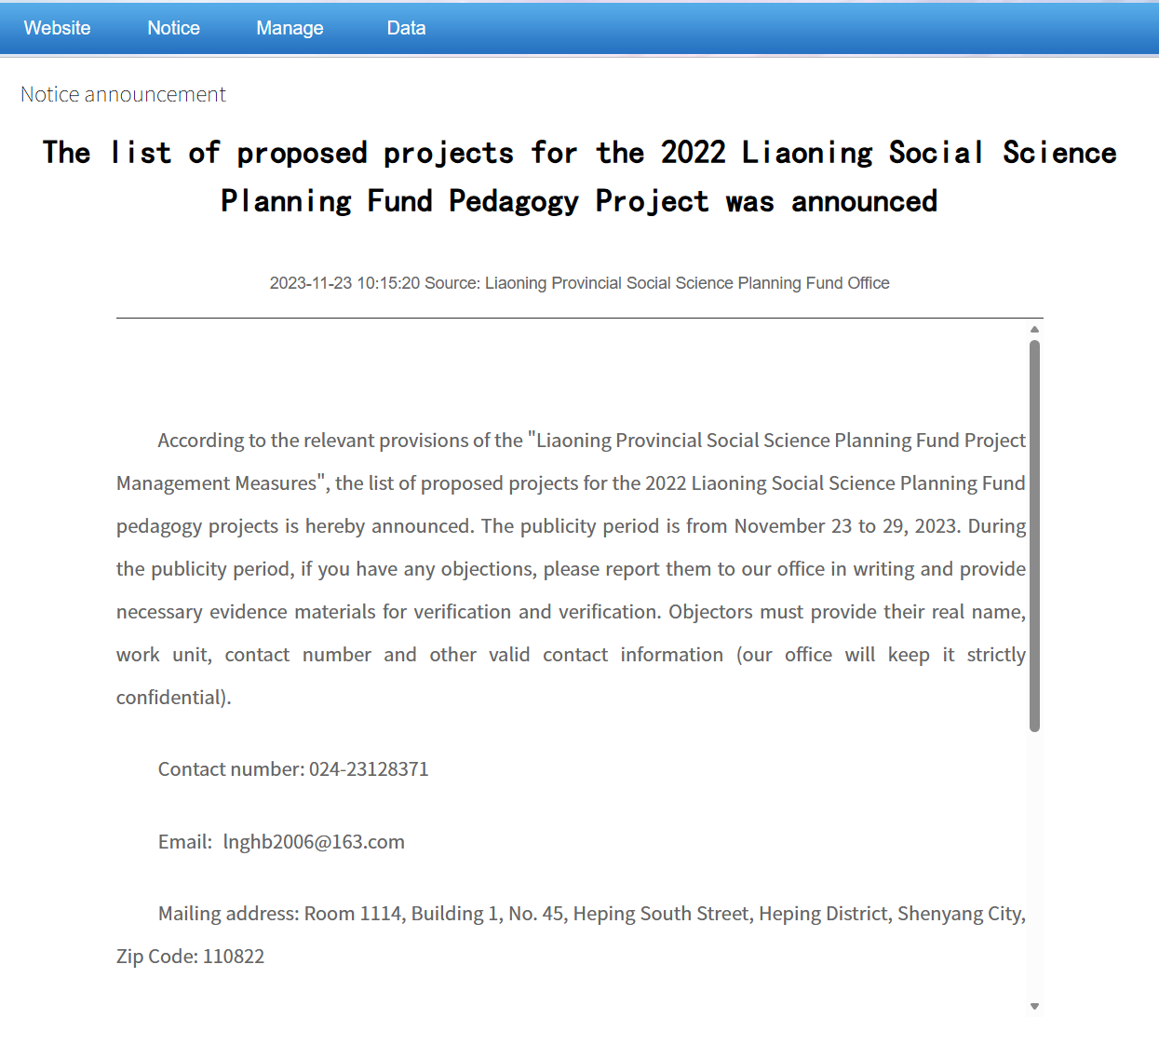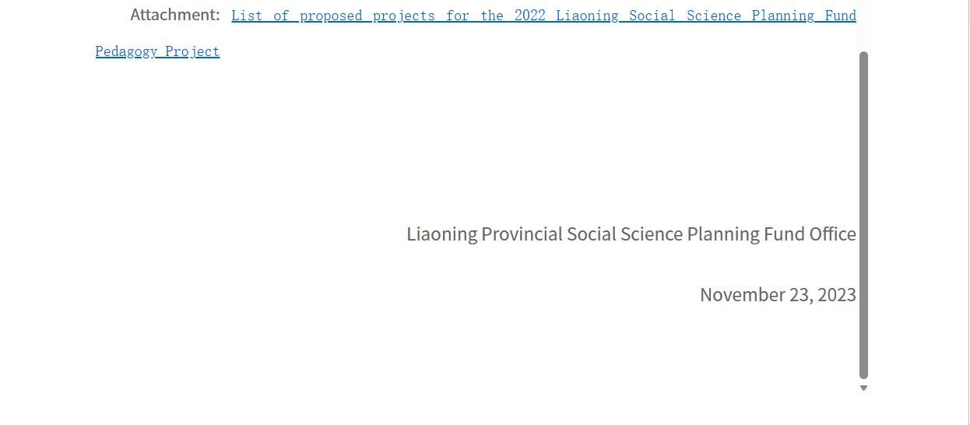

List of proposed projects for the 2022 Liaoning Social Science Planning Fund Education Project
Serial number | Project name | Moderator | Work unit | Project category | Funding funds
1 | Research on the reform and practice of normal student training mode based on the cultivation of good teachers in big countries | Zhao Hongmei | Bohai University | Key projects | 20,000 yuan
2 | Big data empowers provincial higher education governance modernization research | Wang Yang | Liaoning Institute of Education | Key projects | 20,000 yuan
3 | Research and practice of Liaoning to build an integrated implementation path for aesthetic education in large and middle schools | Li Chunyan | Liaoning University of Science and Technology | Key projects | 20,000 yuan
4 | Research on the action-oriented teaching method of "six integrations, six points, and six learnings" based on the training of on-site engineers | Sun Wei | Liaoning Light Industry Vocational College | Key projects | 20,000 yuan
5 | Research on the innovative practice of art benefiting the people in colleges and universities under the background of the strategy of cultural power | Peng Yunshu | Shenyang University | Key projects | 20,000 yuan
6 | Research on the local capacity building of colleges and universities in Liaodong under the background of the integration of "education, science and technology, and talents" | Dong Yukuan | Shenyang Jianzhu University | Key projects | 20,000 yuan
7 | Research on the realization of the "cohesion core" function of unified Chinese textbooks in the vision of the consciousness of the Chinese national community | Feng Xuyang | Shenyang Normal University | Key projects | 20,000 yuan
8 | Research on the relationship between the optimization of higher education structure and regional economic growth in Liaoning in the new era | Fu Shuyong | Shenyang Pharmaceutical University | Key projects | 20,000 yuan
9 | The evaluation and management of the deep integration of digital technology and medical education and teaching | Li Rongmei | Shenyang Medical College | Key projects | 20,000 yuan
10 | Research on the construction mechanism of first-class disciplines in colleges and universities in Liaoning Province | Tang Guohua | China Medical University | Key projects | 20,000 yuan
11 | Investigation and strategy research on the current situation of childcare services for infants and toddlers aged 0-3 in Anshan City | Li Haiyan | Anshan Normal University | General items | 10,000 yuan
12 | Research on the integration of Manchu music culture education into the primary school curriculum system | Li Jingrong | Anshan Normal University | General items | 10,000 yuan
13 | Research on the reform of the college system and the construction of the future Chinese university model | A gentle breeze blows from a hundred miles away | Bohai University | General items | 10,000 yuan
14 | Research on the construction and effectiveness of the education assistance model of school education community | Zhang Wenyu | Bohai University | General items | 10,000 yuan
15 | Research on the growth law and training path of scientific and technological innovation reserve talents in ordinary high schools in the new era | Lei Xin | Chaoyang No. 2 Senior High School | General items | 10,000 yuan
16 | Research on the construction and improvement strategy of the evaluation index system of the responsibility of postgraduate tutors in colleges and universities | Liang Yingnan | Dalian University of Technology | General items | 10,000 yuan
17 | Research on the integration of labor education in primary and secondary schools under the background of education modernization | Zhang Zhiyuan | Northeastern University | General items | 10,000 yuan
18 | Research on the development and implementation of school-based curriculum in primary school ecological civilization education | Sun Hongjun | Jianchang New District Primary School | General items | 10,000 yuan
19 | The construction of clinical medicine undergraduate training mode based on job competency in the context of new medicine | Wang Rong | Jinzhou Medical University | General items | 10,000 yuan
20 | Research on the development path of information technology and medical education | Yang Jingming | Jinzhou Medical University | General items | 10,000 yuan
21 | Liaoning promotes policy design and measure innovation for the classified management of private education | Wang Huiying | Liaoning Institute of Education | General items | 10,000 yuan
22 | Exploration and practice of a new model of innovative talent training for digital media majors that deeply integrates the OBE concept | Zhang Jian | Liaoning Institute of Technology | General items | 10,000 yuan
23 | Research on the New Teaching Method System in Preservice Teacher Education | Zhou Chenghai | Liaoning Normal University | General items | 10,000 yuan
24 | Research on the symbiosis mechanism of entrepreneurial ecosystem in maker space | Ma Jian | Shenyang Jianzhu University | General items | 10,000 yuan
25 | Research on the development status and improvement path of evidence-based decision-making ability of leaders in Liaoning universities | Li Xiaohong | Shenyang Normal University | General items | 10,000 yuan
26 | Research on the problem and countermeasures of teacher turnover in Liaoning colleges and universities | Zhao Wei | Shenyang Normal University | General items | 10,000 yuan
27 | Effectively implement the whole book reading strategy and practice of the extended learning task group | Ren Na | No. 5 Primary School of Zhujiang Street, Huanggu District, Shenyang City | General items | 10,000 yuan
28 | Research on the construction of the combination of government, industry, academia, research and medical and nursing alliance under the background of new medicine | Jin Zhe | Shenyang Medical College | General items | 10,000 yuan
29 | Integrate resources to build a "123" model of higher vocational colleges and practice education community research | Li Zhaoqing | Shenyang Vocational and Technical College | General items | 10,000 yuan
30 | Research on the Path of Teachers' Practical Ability Training in Industrial Colleges and Universities: From the Perspective of Public Security Colleges and Universities | In the group | China Criminal Police Academy | General items | 10,000 yuan
31 | Research on teacher training and development based on accurate analysis of big data | Cui Ge | Anshan Normal University | Optional items | None
32 | Research on the integration model of physical education and health education in schools with parent participation based on cognitive load theory | Liu Dong | Anshan Normal University | Optional items | None
33 | Research on the evaluation of classroom teaching effectiveness of mathematics teachers in the compulsory education stage | Peng Yangui | Anshan Normal University | Optional items | None
34 | An empirical study on the changes and influencing factors of college and middle school students' physics learning attitudes based on CLASS | Wang Yahong | Dalian University of Technology | Optional items | None
35 | Research on the construction of college students' innovation ability cultivation system based on critical information literacy education | Cheng Wenzhi | Jinzhou Medical University | Optional items | None
36 | Research on the evaluation system of blended teaching effect in medical schools | Ji Hong | Jinzhou Medical University | Optional items | None
37 | Research on the training mode of undergraduate professionals in digital economy in Liaoning | Wang Meng | Liaoning University of Science and Technology | Optional items | None
38 | Two-way linkage to build a long-term mechanism of "three comprehensive education" | He Xiaojiao | Liaoning Institute of Technology | Optional items | None
39 | Research on the path of assessment and improvement of learning ability of higher vocational students | Shan Yibin | Liaoning Vocational University of Technology | Optional items | None
40 | Research on the design, implementation strategy and effectiveness evaluation of farmer training programs | Zhang Mo | Shenyang Agricultural University | Optional items | None
41 | A field study on the social role of the new generation of rural teachers in western Liaoning from the perspective of rural revitalization | Dong Lili | Bohai University | Youth Program | 10,000 yuan
42 | Research on the construction and application of Shaobei martial arts mixed curriculum in physical education from the perspective of Internet + | Li Jun | Bohai University | Youth Program | 10,000 yuan
43 | Research on the target direction and implementation path of school physical education reform in Liaoning Province under the background of sports and education integration | Li Xiaolong | Dalian Ocean University | Youth Program | 10,000 yuan
44 | Research on the social role and cultivation strategy of technical scientists in China | Cui Linwei | Dalian University of Technology | Youth Program | 10,000 yuan
45 | Based on the construction and empirical study of the clinical thinking ability training program of APT undergraduate intern nursing students | Cai Yingjie | Dalian Medical University | Youth Program | 10,000 yuan
46 | The construction of school-based curriculum for traditional sports for ethnic minorities in Liaoning Province under the awareness of the Chinese national community | Wang Chun | Liaoning University of Science and Technology | Youth Program | 10,000 yuan
47 | Research on the endogenous mechanism and cultivation strategy of college teachers' teaching sensitivity | Guo Chaohua | Liaoning Normal University | Youth Program | 10,000 yuan
48 | Research on the connotation, influencing factors and training countermeasures of vocational enlightenment for primary and secondary school students in Liaoning Province from the perspective of craftsman spirit | Chen Chen | Liaoning Medical Vocational College | Youth Program | 10,000 yuan
49 | Exploration and research on the training mode of applied talents in private undergraduate colleges based on innovation and entrepreneurship education | Sun Wei | Shenyang Institute of Urban Construction | Youth Program | 10,000 yuan
50 | Research on the construction of mechanisms for "home-school-community" to coordinate to promote the high-quality development of school sports under the "double reduction" policy | Teach the heavenly chapter | Shenyang Institute of Physical Education | Youth Program | 10,000 yuan

