Supplementary material
Supplementary Figure legends
All survival curves were estimated using the Kaplan–Meier method and compared using the log-rank test. In SEER, “no documented/unknown RT” reflects registry coding and includes patients without a recorded treatment receipt.

Supplementary Figure S1. SEER: Radiotherapy-associated overall survival stratified by FIGO stage.
Kaplan–Meier curves of overall survival (OS) comparing radiotherapy (RT) versus no documented/unknown RT in the SEER cohort, stratified by FIGO stage (I–II vs III–IV). P values were calculated using the log-rank test.

Supplementary Figure S2. SEER: Radiotherapy-associated overall survival stratified by tumor size.
Kaplan–Meier curves of OS comparing RT versus no documented/unknown RT in the SEER cohort, stratified by tumor size (≤4 cm vs >4 cm). P values were calculated using the log-rank test.

Supplementary Figure S3. SEER: Radiotherapy-associated overall survival stratified by lymph-node status.
Kaplan–Meier curves of OS comparing RT versus no documented/unknown RT in the SEER cohort, stratified by lymph-node status (negative vs positive). P values were calculated using the log-rank test.

Supplementary Figure S4. SEER: Radiotherapy-associated overall survival stratified by distant metastasis.
Kaplan–Meier curves of OS comparing RT versus no documented/unknown RT in the SEER cohort, stratified by distant metastasis (no vs yes). P values were calculated using the log-rank test.

Supplementary Figure S5. Overall survival in the external institutional cohort.
Kaplan–Meier curve of OS for the external institutional cohort (N=52). The shaded area indicates the 95% confidence interval.

Supplementary Figure S6. Overall survival by radiotherapy status in the external institutional cohort.
Kaplan–Meier curves comparing OS between patients who received RT and those who did not (no RT) in the external cohort (N=52). P values were calculated using the log-rank test.

Supplementary Table legends

Supplementary Table S1. Baseline characteristics of the SEER training cohort versus the internal validation cohort.
Data are presented as median (IQR) or n (%). P values were calculated using appropriate tests according to variable type (e.g., Mann–Whitney U test for continuous variables and χ²/Fisher’s exact test for categorical variables). Abbreviations: FIGO, International Federation of Gynecology and Obstetrics; IQR, interquartile range; RT, radiotherapy.

Supplementary Table S2. Overall survival rates in the SEER cohort (N=609).
Overall survival rates at 1, 3, and 5 years are shown as % (95% CI), estimated using the Kaplan–Meier method. Abbreviations: CI, confidence interval.

Supplementary Table S3. Baseline clinicopathologic characteristics of the external institutional cohort (N=52).
Data are presented as median (IQR) or n (%). Percentages were calculated based on the number of patients with available data for each variable. Abbreviations: FIGO, International Federation of Gynecology and Obstetrics; IQR, interquartile range; LVSI, lymphovascular space invasion; RT, radiotherapy.

Supplementary Table S4. Overall survival rates in the external institutional cohort (N=52).
Overall survival rates at 1, 3, and 5 years are shown as % (95% CI), estimated using the Kaplan–Meier method. Abbreviations: CI, confidence interval.

Supplementary Figures

Supplementary Figure S1. SEER: RT-associated OS stratified by FIGO stage.
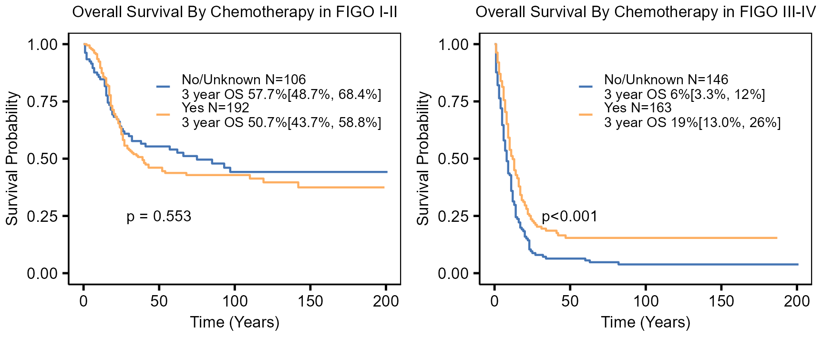

Supplementary Figure S2. SEER: RT-associated OS stratified by tumor size.
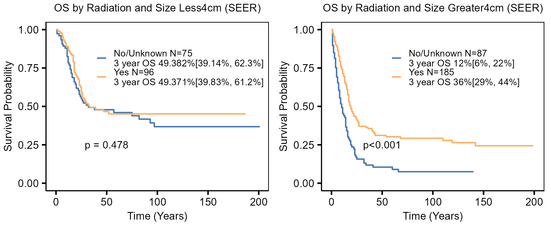

Supplementary Figure S3. SEER: RT-associated OS stratified by lymph-node status.
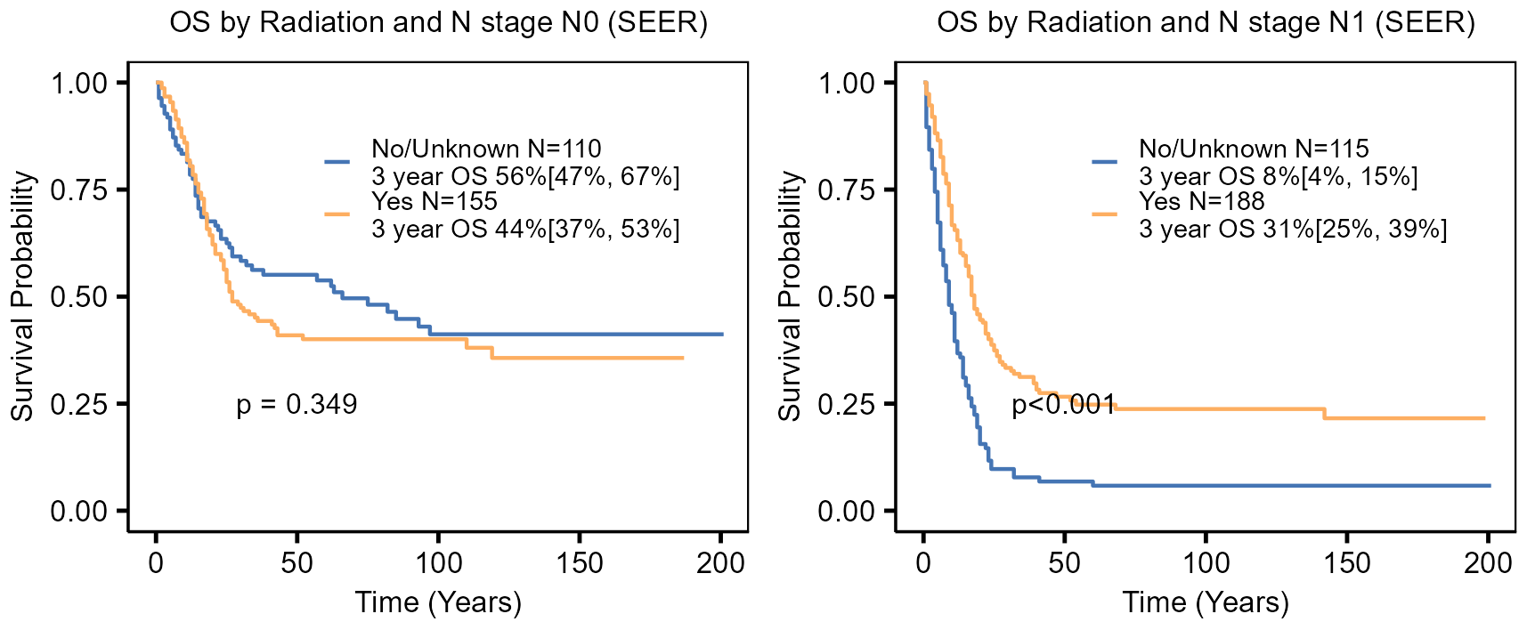

Supplementary Figure S4. SEER: RT-associated OS stratified by distant metastasis.
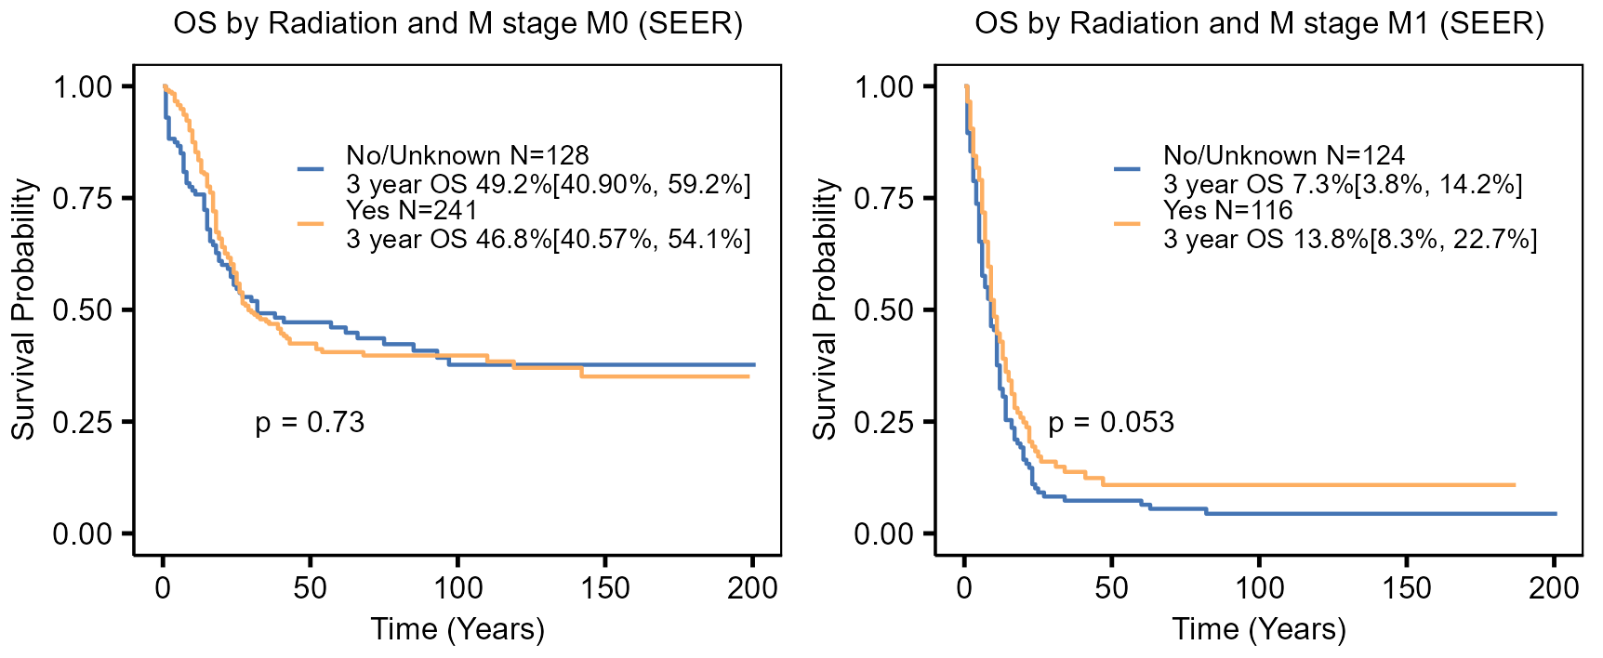

Supplementary Figure S5. Overall survival in the external institutional cohort.
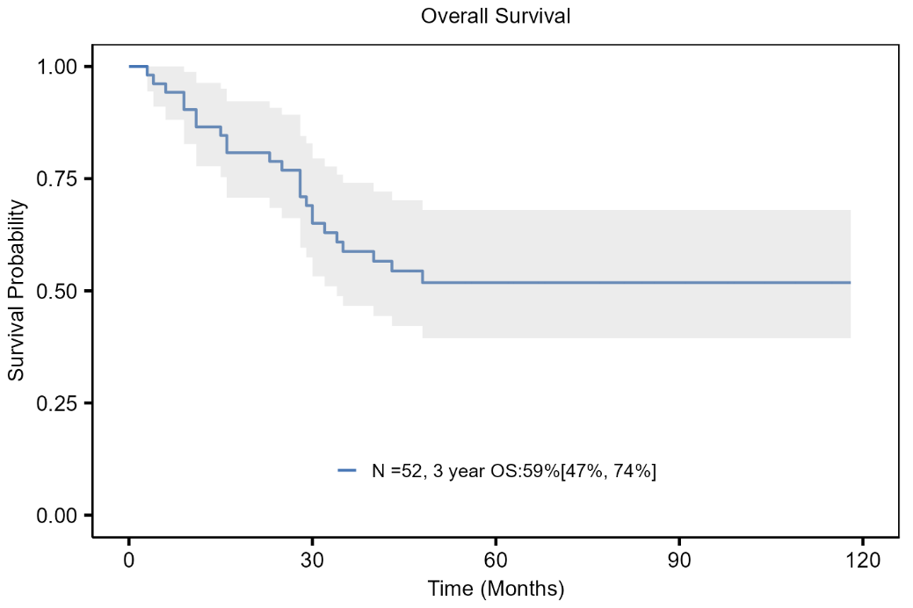

Supplementary Figure S6. Overall survival by radiotherapy status in the external institutional cohort.
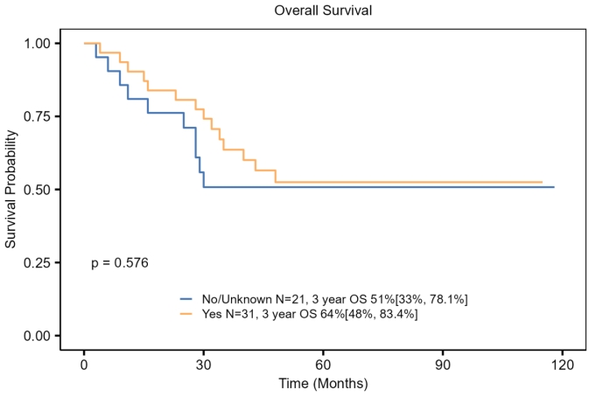

Supplementary Tables

Supplementary Table S1. Baseline characteristics of the SEER training cohort versus the internal validation cohort
Variable | Internal validation (n=183) | Training (n=426) | Statistic | P value
Age, median (IQR) | 45 (37–59) | 47 (36–58) | 38165.5 | 0.683
Race |  |  | 0.296 | 0.863
Black | 25 (13.81%) | 64 (15.02%)
Other (including Asian) | 28 (15.47%) | 60 (14.08%)
White | 128 (70.72%) | 302 (70.89%)
Tumor size |  |  | 0.234 | 0.629
>4 cm | 80 (59.70%) | 192 (62.14%)
≤4 cm | 54 (40.30%) | 117 (37.86%)
Lymph-node status |  |  | 3.898 | 0.048
Negative | 92 (52.87%) | 173 (43.91%)
Positive | 82 (47.13%) | 221 (56.09%)
FIGO stage |  |  | 1.52 | 0.678
I | 68 (37.16%) | 136 (32.08%)
II | 27 (14.75%) | 67 (15.80%)
III | 18 (9.84%) | 43 (10.14%)
IV | 70 (38.25%) | 178 (41.98%)
Surgery (yes) | 73 (39.89%) | 158 (37.09%) | 0.427 | 0.514
Radiotherapy (RT) |  |  | 0.346 | 0.557
No documented/unknown | 79 (43.17%) | 173 (40.61%)
Yes | 104 (56.83%) | 253 (59.39%)
Chemotherapy |  |  | 0.293 | 0.588
No documented/unknown | 24 (13.11%) | 63 (14.79%)
Yes | 159 (86.89%) | 363 (85.21%)

Supplementary Table S2. Overall survival rates in the SEER cohort (N = 609)
Time point | 1-year | 3-year | 5-year
Overall survival, % (95% CI) | 63.8 (60.0–67.8) | 33.1 (29.4–37.4) | 29.2 (25.6–33.4)

Supplementary Table S3. Baseline clinicopathologic characteristics of the external institutional cohort (N = 52)
Variable | Available, n | Value
Age at diagnosis, years, median (IQR) | 52 | 40 (34–49)
Age group | 52
>45 years |  | 19 (37%)
≤45 years |  | 33 (63%)
Tumor size | 52
>4 cm |  | 18 (35%)
≤4 cm |  | 34 (65%)
Depth of stromal invasion | 34
≤1/3 |  | 7 (21%)
>1/3 and ≤2/3 |  | 16 (47%)
>2/3 |  | 11 (32%)
Lymphovascular space invasion (LVSI) | 38
Yes |  | 13 (34%)
No |  | 25 (66%)
Parametrial invasion | 38
Yes |  | 1 (2.6%)
No |  | 37 (97.4%)
Endocervical canal (internal os) involvement | 38
Yes |  | 1 (2.6%)
No |  | 37 (97.4%)
Uterine corpus involvement | 38
Yes |  | 0 (0%)
No |  | 38 (100%)
Vaginal cuff involvement | 38
Yes |  | 0 (0%)
No |  | 38 (100%)
Adnexal involvement | 38
Yes |  | 0 (0%)
No |  | 38 (100%)
Lymph-node status | 38
Negative |  | 30 (79%)
Positive |  | 8 (21%)
FIGO 2018 stage | 52
I |  | 25 (48%)
II |  | 4 (7.7%)
III |  | 19 (37%)
IV |  | 4 (7.7%)
Radical surgery | 52
Yes |  | 38 (73%)
No |  | 14 (27%)
Chemotherapy | 52
No |  | 4 (7.7%)
Yes |  | 48 (92%)
Radiotherapy (RT) | 52
No |  | 21 (40%)
Yes |  | 31 (60%)

Supplementary Table S4. Overall survival rates in the external institutional cohort (N = 52)
Time point | 1-year | 3-year | 5-year
Overall survival, % (95% CI) | 86.5 (77.7–96.3) | 58.8 (46.6–74.0) | 51.8 (39.5–68.0)

