Supplementary Information
As detailed in the Methods section, our analysis considers three scenarios based on shared socioeconomic and emissions pathways: SSP1–2.6, SSP1–6.0, and SSP3–6.0. The main results presented in the manuscript focus on the intermediate scenario (SSP1–6.0). Results corresponding to the alternative pathways (SSP1–2.6 and SSP3–6.0), together with additional supporting analyses, are provided in this supplementary section.

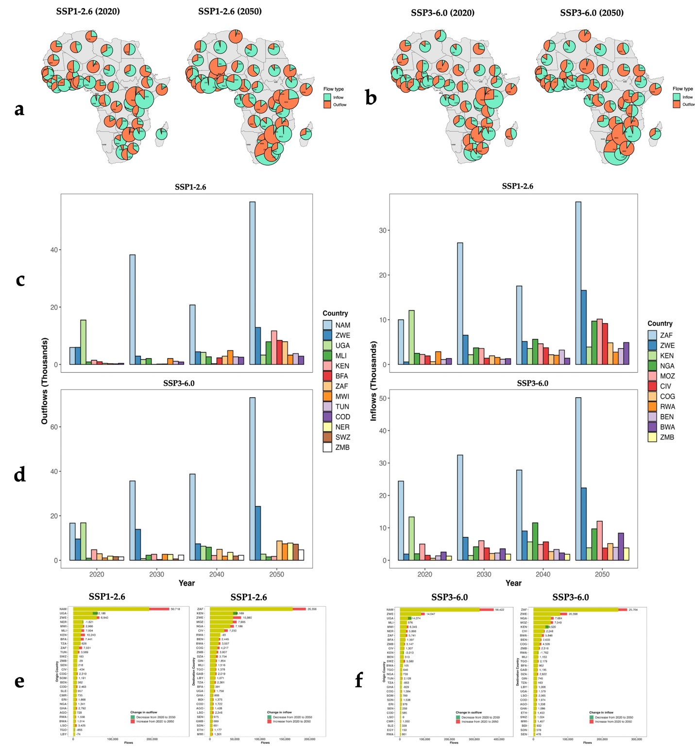
Supplementary Fig. 1. Climate-induced cross-border migration patterns in Africa from 2020 to 2050 under alternative scenarios. a,b, Spatial distribution of cross-border migration flows for 2020 and 2050 under SSP1–2.6 (a) and SSP3–6.0 (b). All maps exclude migration routes to and from Namibia. c,d, Top 10 climate-induced cross-border outflows (left panels) and inflows (right panels) under SSP1–2.6 (c) and SSP3–6.0 (d). e,f, Top 30 cross-border migration outflows (left panels) and inflows (right panels) under SSP1–2.6 (e) and SSP3–6.0 (f). Yellow bars show cumulative migration flows from 2020 to 2050, while colored segments indicate changes over time: red represents increasing flows, and green represents decreasing flows. Countries are ordered by their cumulative migration totals within each scenario. DZA = Algeria; AGO = Angola; BEN = Benin; BWA = Botswana; BFA = Burkina Faso; BDI = Burundi; CMR = Cameroon; CAF = Central African Republic; TCD = Chad; COG = Congo; COD = Democratic Republic of Congo; CIV = Côte d’Ivoire; DJI = Djibouti; EGY = Egypt; GNQ = Equatorial Guinea; ERI = Eritrea; SWZ = Eswatini; ETH = Ethiopia; GAB = Gabon; GMB = Gambia; GHA = Ghana; GIN = Guinea; GNB = Guinea-Bissau; KEN = Kenya; LSO = Lesotho; LBR = Liberia; LBY = Libya; MDG = Madagascar; MWI = Malawi; MLI = Mali; MRT = Mauritania; MAR = Morocco; MOZ = Mozambique; NAM = Namibia; NER = Niger; NGA = Nigeria; RWA = Rwanda; SEN = Senegal; SLE = Sierra Leone; SOM = Somalia; ZAF = South Africa; SDN = Sudan; TZA = Tanzania; TGO = Togo; TUN = Tunisia; UGA = Uganda; ZMB = Zambia; ZWE = Zimbabwe.
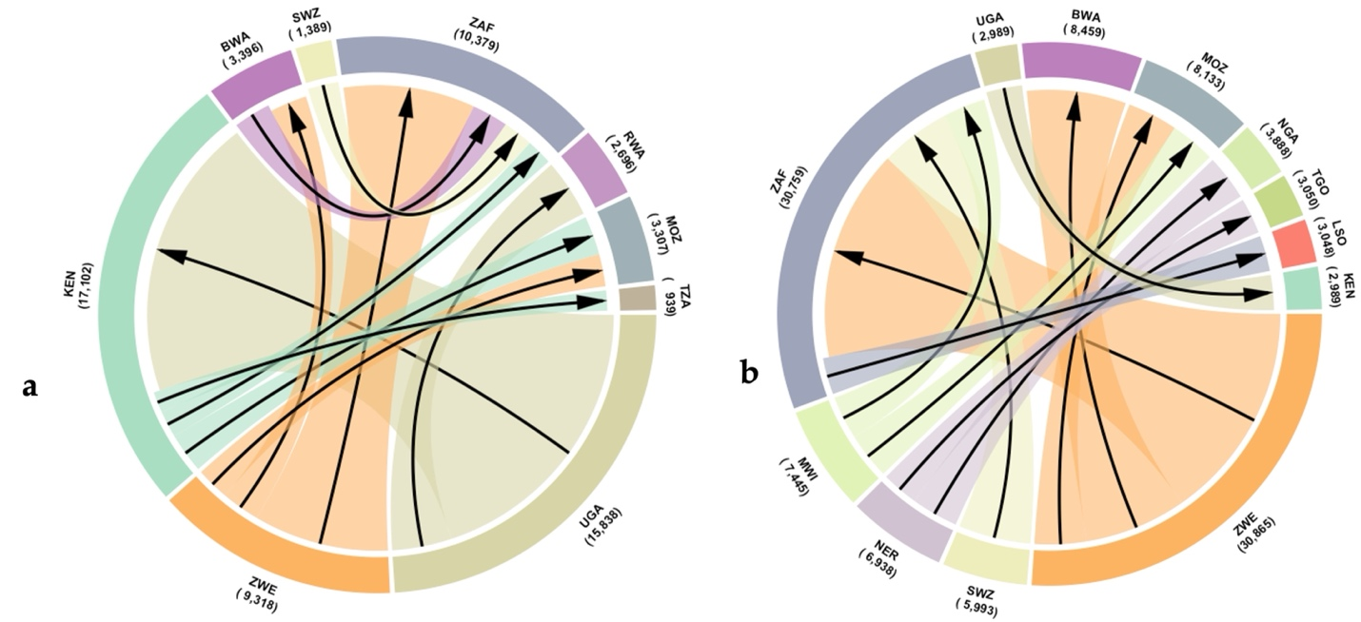
Supplementary Fig. 2. Climate-induced cross-border migration flows for 2020 (a) and 2050 (b) under the SSP160 scenario. Chord link width represents absolute migration pressure between origin and destination countries, aggregated across the top 15 corridors. Migration routes to and from Namibia are excluded. Country codes are shown in Supplementary Fig. 1.

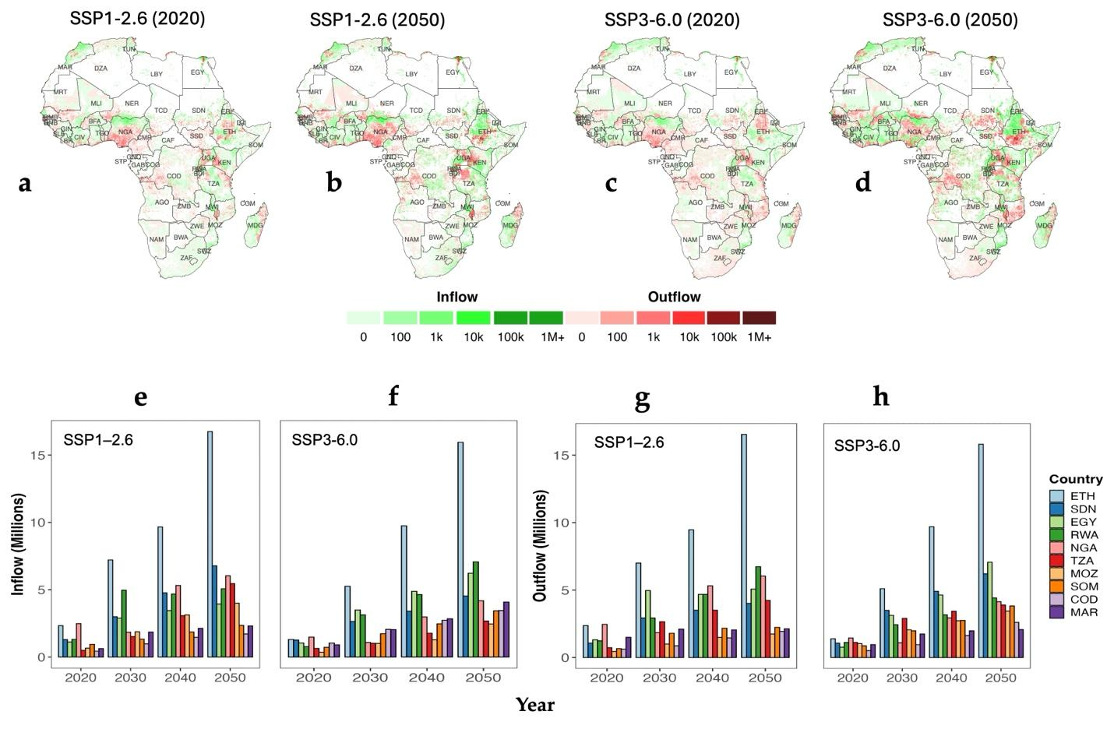
Supplementary Fig. 3. Internal climate-induced migration patterns in Africa from 2020 to 2050 under alternative scenarios. a–d, Spatial distribution of internal climate-related migration in 2020 and 2050 under SSP1–2.6 (a,b) and SSP3–6.0 (c, d). e,f, Top 10 countries with the largest internal outflows from 2020 to 2050 under SSP1–2.6 (e) and SSP3–6.0 (f). g,h, Top 10 countries with the largest internal inflows from 2020 to 2050 under SSP1–2.6 (g) and SSP3–6.0 (h). Country codes are shown in Supplementary Fig. 1.

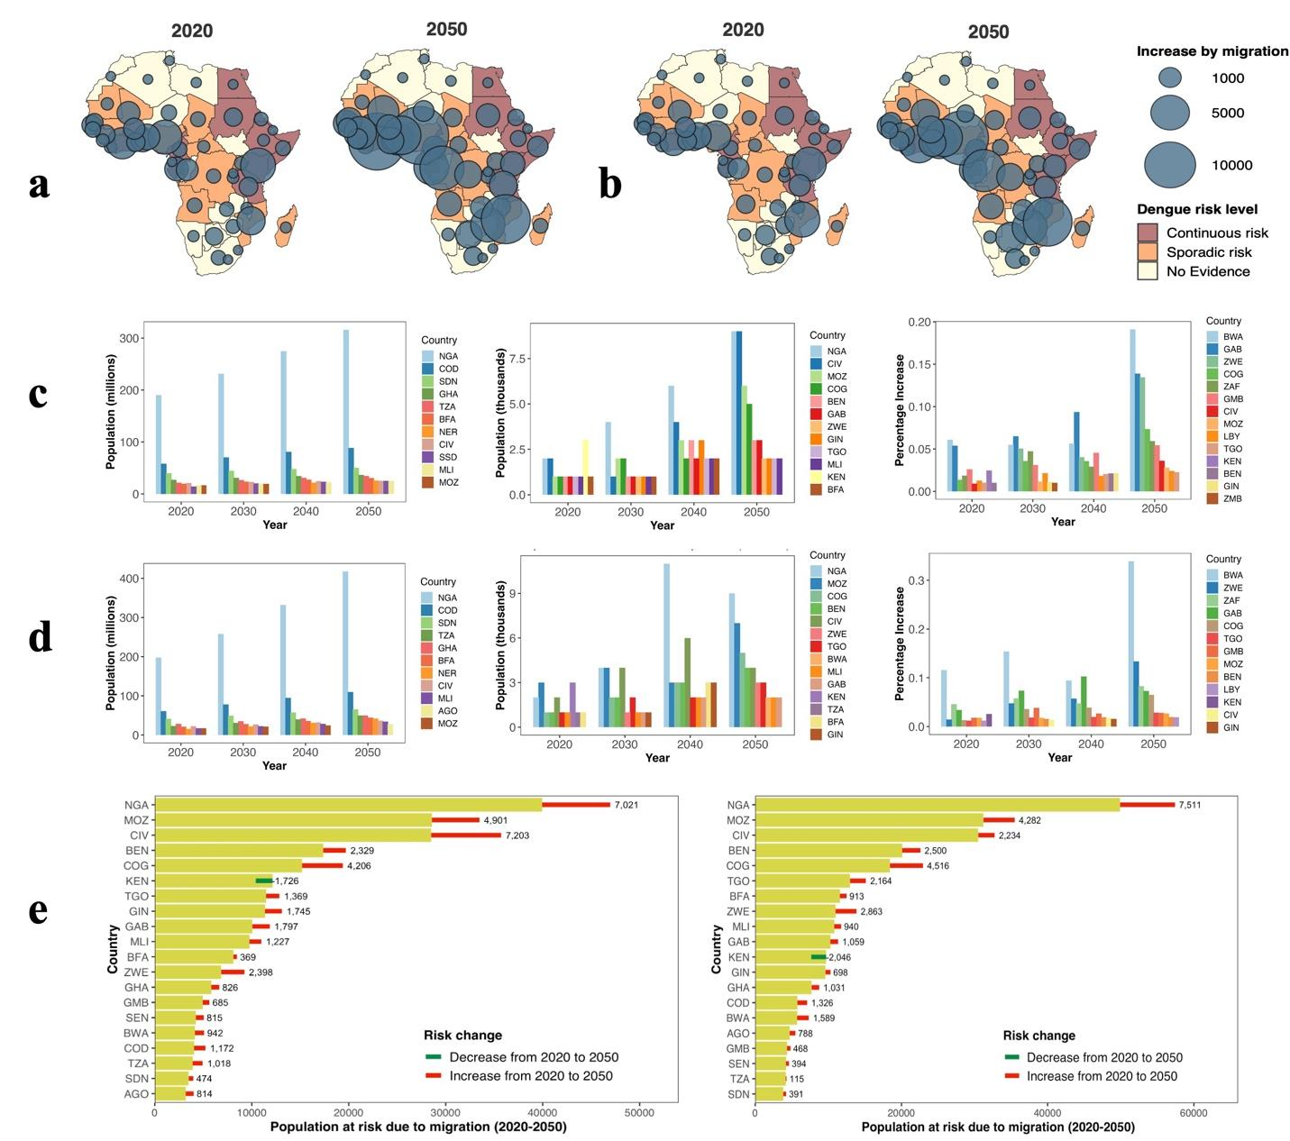
Supplementary Fig. 4. Impact of climate-induced cross-border migration on dengue transmission risk in Africa under SSP1-2.6 and SSP3-6.0. a,b, Spatial distribution of populations exposed to dengue transmission risk under climate-induced cross-border migration in 2020 and 2050 under SSP1-2.6 (a) and SSP3-6.0 (b). Bubble size represents the increase in population at risk attributable to migration, while background shading indicates country-level dengue risk in 2025 (CDC). c,d, Changes in at-risk populations across the ten most affected countries under SSP1-2.6 (c) and SSP3-6.0 (d) between 2020 and 2050. The left panels show total populations at risk after accounting for climate-induced migration (millions), the middle panels show absolute increases in at-risk population (thousands), and the right panels show percentage changes. e, Cumulative population at risk over 2020-2050 under SSP1-2.6 (left) and SSP3-6.0 (right). Yellow bars indicate total populations at risk, with red segments showing increases and green segments showing decreases attributable to migration from 2020 to 2050; all absolute changes are labeled. Country codes are shown in Supplementary Fig. 1.
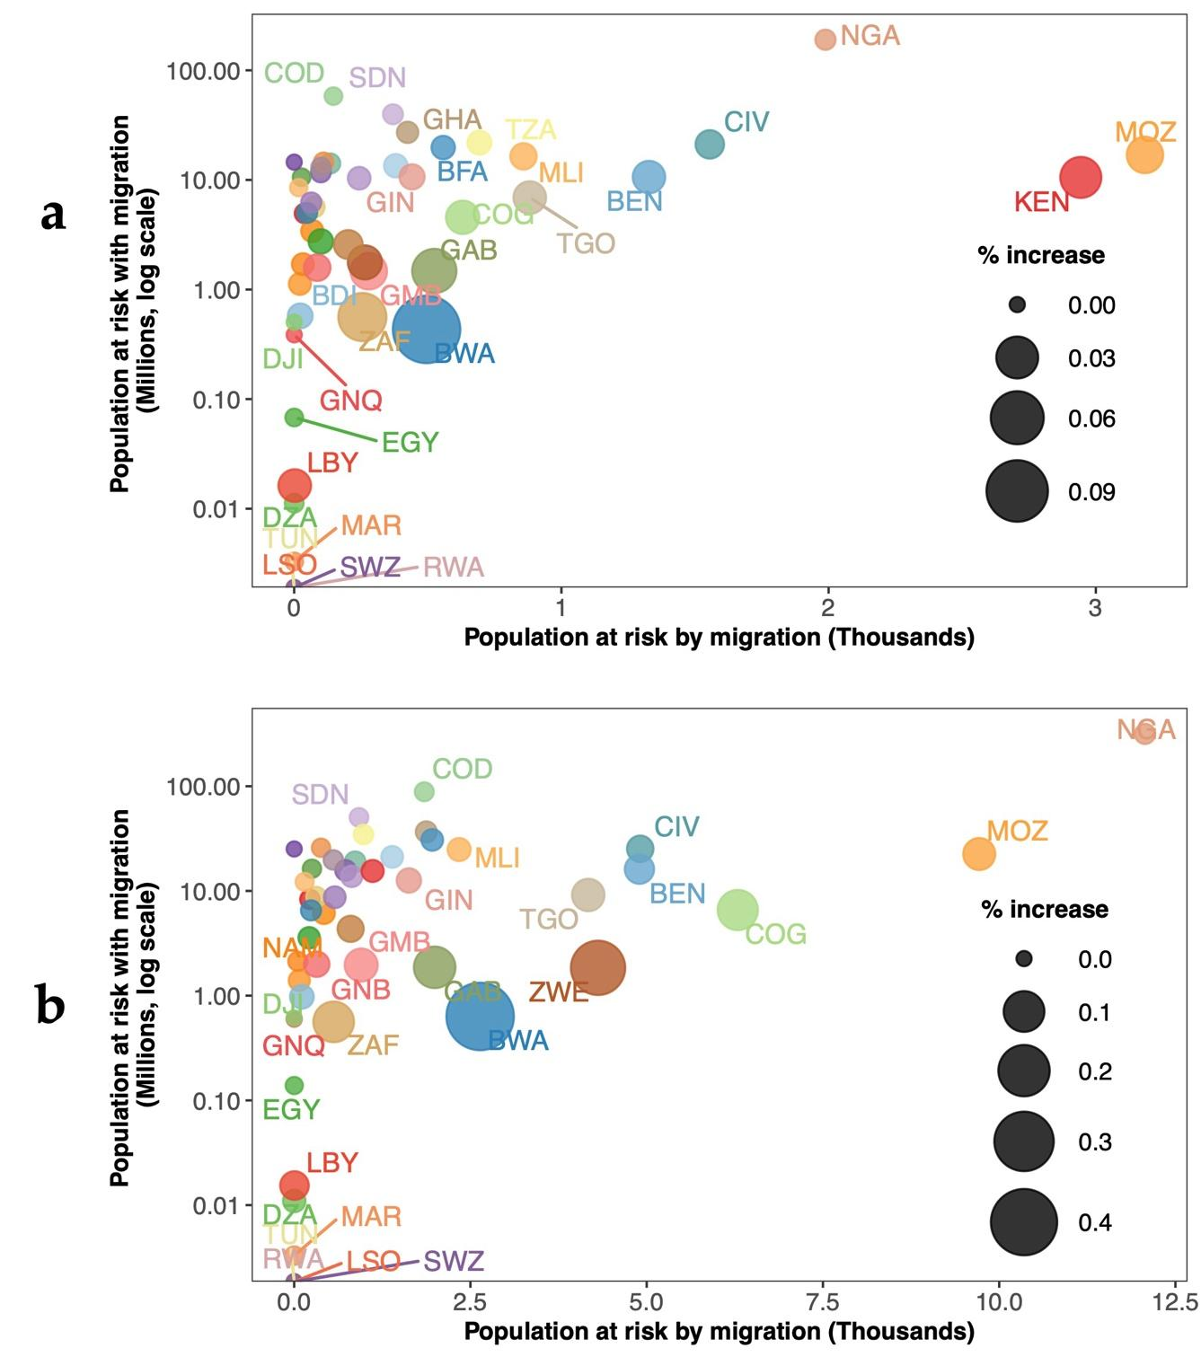
Supplementary Fig. 5. Country-level changes in populations at risk of dengue transmission due to climate-induced cross-border migration for 2020 (a) and 2050 (b) under the SSP1–6.0 scenario. The x-axis shows the number of people exposed to dengue transmission risk attributable solely to climate-induced migration. At the same time, the y-axis (on a log scale) represents the total population at risk, including both residents and immigrants (in millions). Bubble size indicates the percentage increase in population at risk due to migration, defined as the proportional increase in the population at risk after accounting for migration relative to the pre-migration population. Bubble position captures the absolute change in risk by migration (x-axis) and the total population at risk with migration (baseline population plus migrants) (y-axis). Country codes are shown in Supplementary Fig. 1.

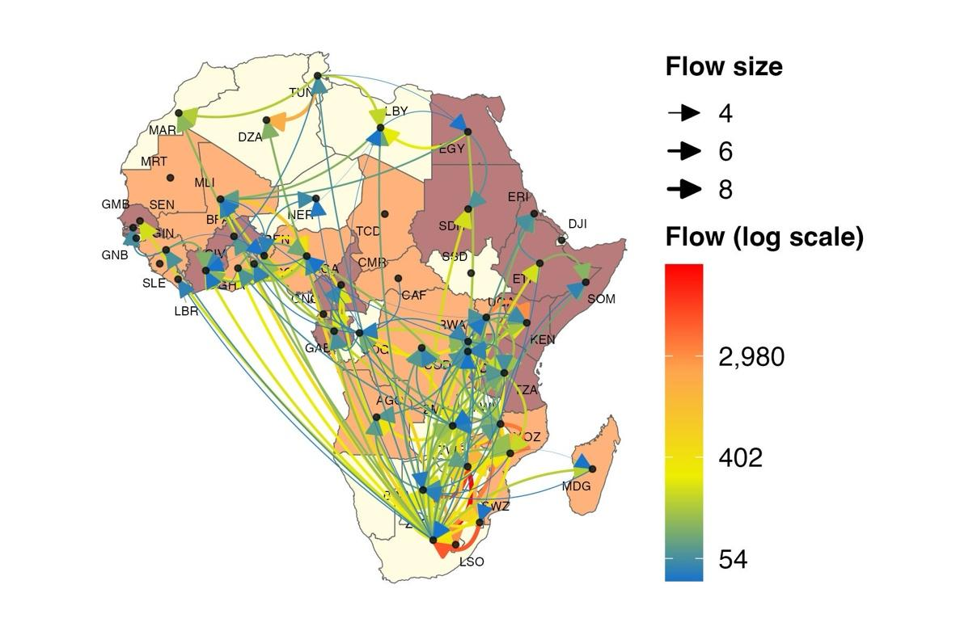
Supplementary Fig. 6. Projected top 150 cross-border migration corridors in Africa for 2050 under SSP1–6.0. Arrow thickness and color correspond to the logarithm of migrant flow size. The background choropleth shading represents current dengue risk in Africa according to the CDC. The Figure excludes migration routes to and from Namibia.
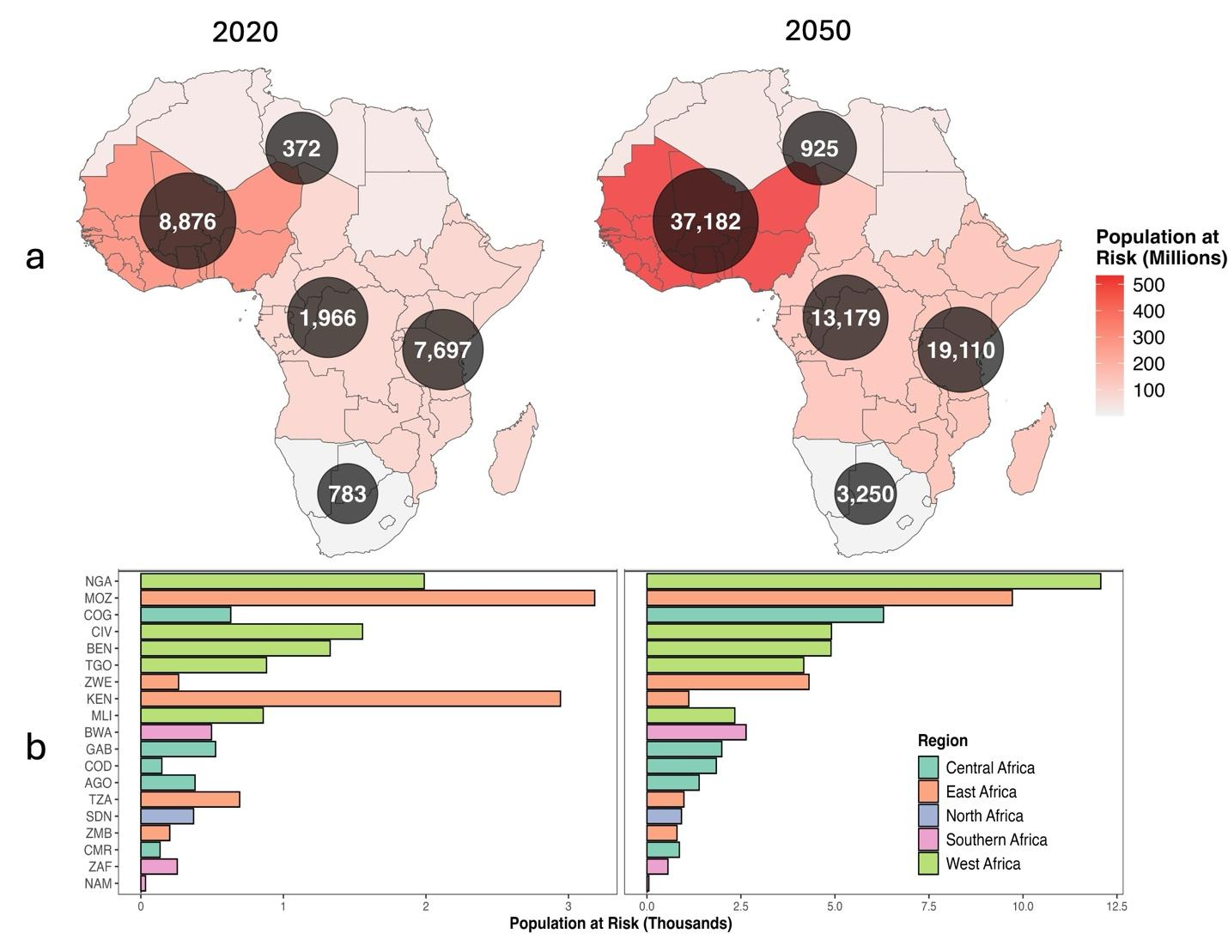
Supplementary Fig. 7. Population at risk under SSP1-6.0 in Africa at the regional level, 2020 and 2050. a, Regional distribution of populations at risk. Choropleth shading indicates total population at risk per region (millions), and overlaid circles show region-level population sizes, with labels representing absolute changes in population at risk. b, Top five countries per African region with the largest population at risk due to cross-border migration. Bars show absolute changes in population at risk, colored by region. Facets compare the baseline year (2020) with projected conditions in 2050, highlighting countries expected to experience the largest increases in at-risk populations. Country codes are shown in Supplementary Fig. 1.

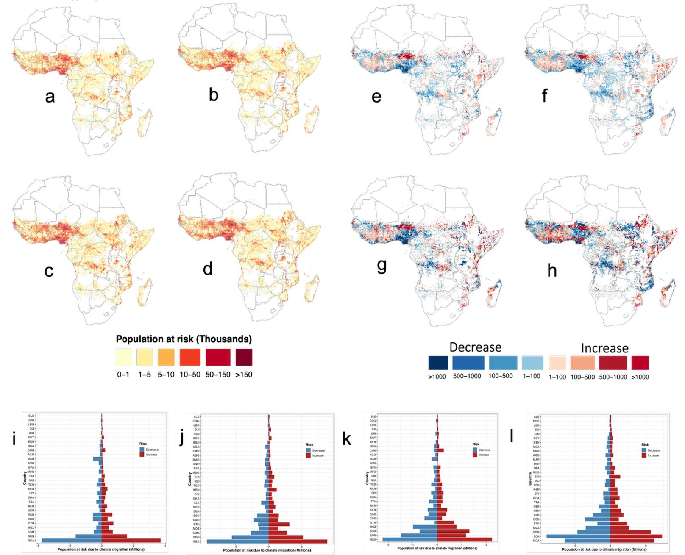
Supplementary Fig. 8. Impact of internal climate-induced migration on dengue transmission risk in 2020 and 2050 under different socio-economic scenarios. a–d, Spatial distribution of populations at risk of dengue with internal migration in 2020 under SSP1-2.6 (a) and SSP3-6.0 (b), and in 2050 under SSP1-2.6 (c) and SSP3-6.0 (d). e–h, Grid-level changes in population at risk of dengue attributable to internal migration in 2020 under SSP1-2.6 (e) and SSP3-6.0 (f), and in 2050 under SSP1-2.6 (g) and SSP3-6.0 (h). Blue shading indicates decreased exposure, while red shading indicates increased exposure. i–l, Population change in dengue risk due to internal migration across the most affected 25 countries under SSP1-2.6 in 2020 (i) and 2050 (j), and under SSP3-6.0 in 2020 (k) and 2050 (l). Country codes are shown in Supplementary Fig. 1.

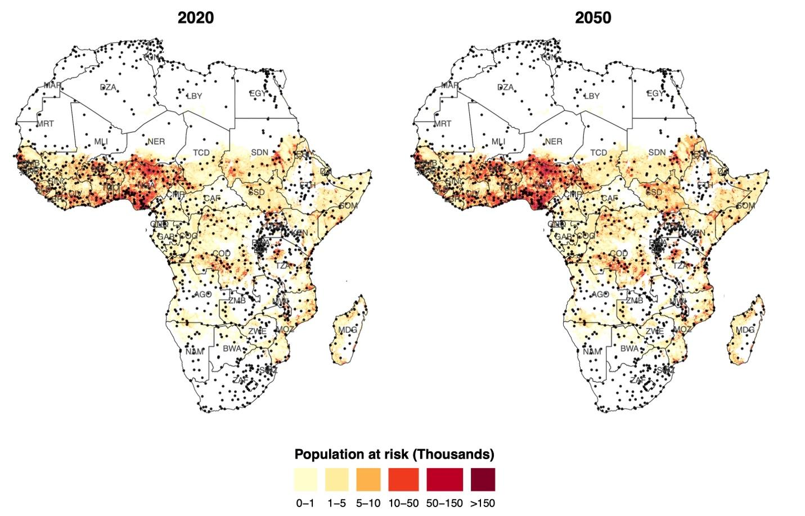Supplementary Fig. 9. Spatial distribution of populations at risk of dengue exposure in Africa under internal migration for 2020 and 2050 under the SSP1–RCP6.0 scenario, overlaid with major populated places (dots) obtained from Natural Earth (https://www.naturalearthdata.com/). Country codes are shown in Supplementary Fig. 1. Populated places represent high-connectivity population hubs where dense settlement, frequent human movement, and increased vector–human contact can sustain and amplify local dengue transmission. Incorporating populated-place layers enables assessment of whether projected internal migration flows concentrate populations in climatically suitable urban areas capable of supporting outbreaks and accelerating transmission following pathogen introduction. These layers also serve as proxies for locations where disease surveillance, healthcare access, and case reporting are typically strongest, thereby linking climate-driven population redistribution with practical points for outbreak detection and public health response. Further research is needed to explicitly examine how urban characteristics, migration dynamics, and infectious disease processes interact to shape the risk of dengue transmission under future climate scenarios.

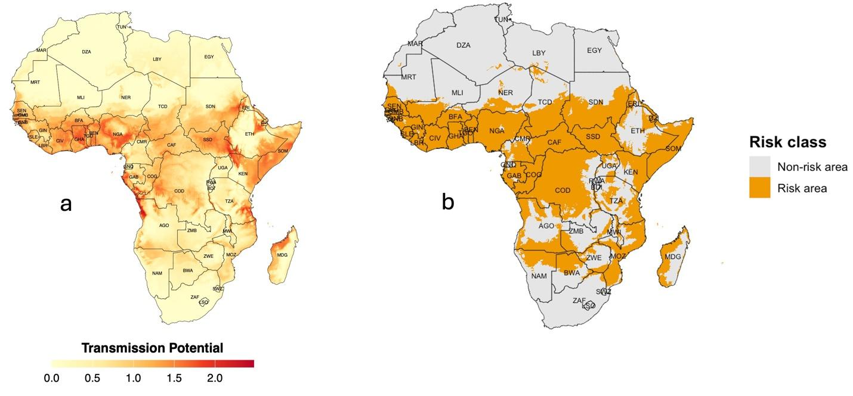Supplementary Fig. 10. Dengue transmission potential (Index P) and binary transmission risk maps in Africa, 2020. a, Spatial variation in dengue transmission potential at 1 km² resolution, derived from climate-based vector suitability models. Higher values (darker red) indicate areas more conducive to Aedes aegypti transmission. b, Binary classification of areas as “Risk area” (Index P > 0.5; orange) or “Non-risk area” (Index P ≤ 0.5; light gray), highlighting regions climatically suitable for dengue transmission versus areas with low suitability. Country codes are shown in Supplementary Fig. 1.

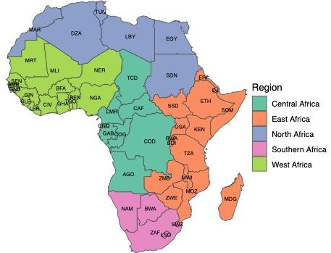
Supplementary Fig. 11. Regional classification of African countries, based on the African Climate Mobility Report. This classification is applied consistently across all migration and population-exposure analyses in the main text. Because regional groupings vary across data sources, readers should refer to this classification when interpreting our results.

