Supplementary Information for

Ensemble of Nucleic Acid Absolute Quantitation Modules for Accurate Copy Number Variation Detection and Targeted RNA Profiling

Lucia Ruojia Wu^{1,2}, Peng Dai^{1,2,3}, Michael Xiangjiang Wang¹, Sherry Xi Chen^{1,3}, Evan N. Cohen⁴, Gitanjali Jayachandran⁴, Jinny Xuemeng Zhang⁵, Angela V. Serrano⁵, Naoto T. Ueno⁶, James M. Reuben⁴, Carlos H. Barcenas^{6*}, David Yu Zhang^{1,3,7*}

¹ Department of Bioengineering, Rice University, Houston, TX, USA.
﻿²These authors contributed equally: Peng Dai, Lucia Ruojia Wu
³Present affiliation: NuProbe USA, Houston, TX, USA.
⁴Department of Hematopathology, The University of Texas MD Anderson Cancer Center, Houston, TX, USA
⁵NuProbe USA, Houston, TX, USA.
⁶Department of Breast Medical Oncology, The University of Texas MD Anderson Cancer Center, Houston, TX, USA
⁷ Systems, Synthetic, and Physical Biology, Rice University, Houston, TX, USA.

*Correspondence to: genomic.dave@gmail.com
CHBarcenas@mdanderson.org

Table of Contents

Section 1. Challenges in CNV detection ............................................................................... Page 1
Section 2. Two-plex QASeq ................................................................................................. Page 2
Section 3. Multiplexed QASeq with >2 quantitation modules ............................................. Page 4
Section 4. Mutation analysis by QASeq ............................................................................. Page 10
Section 5. RNA expression level analysis by QASeq ......................................................... Page 12
Section 6. Oligonucleotide sequences ................. Excel spreadsheet “QASeq_SI_Section_6.xlsx”

Section 1. Challenges in CNV detection

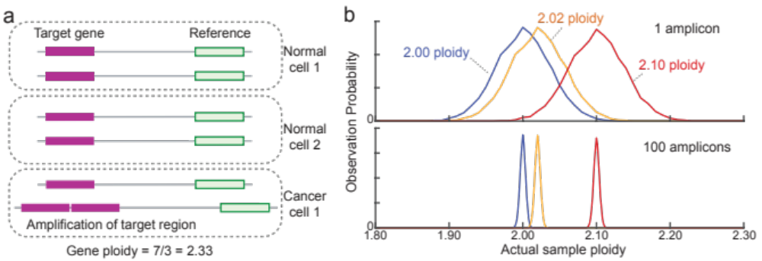
Figure S1. Challenges for detecting DNA copy number variations (CNVs). (a) Illustration of gene ploidy in a sample. Cancer cells are often mixed with normal cells in a sample, resulting in non-integer ploidy numbers. As the tumor load of a sample decreases, the ploidy approaches 2 and becomes difficult to detect by NGS or other methods. (b) Limits on CNV detection due to Poisson sampling error. The number of DNA molecules in a sample at a particular genetic locus follows a Poisson distribution. The top panel shows the distribution of actual ploidy of a gene in a sample, given different tumor ploidy values. The overlapping distributions indicate that it is not possible to confidently call even 2.10 ploidy. The Poisson distribution limitation can be overcome through increasing the number of independent genetic loci observed. The bottom panel shows the distribution of actual ploidy in a sample when considering the sum of 100 different amplicons.

Section 2. Two-plex QASeq

NGS data alignment.
Each read in the original paired-end sequencing data consists of four sequences (from left to right): spacer, UMI, amplicon and adapter. Since the longest amplicon has 112 nt and the lengths of spacer and UMI are 4 nt and 15 nt respectively, their total length is shorter than the sequencing read length of 150 nt, and adapter sequence would appear at the end of each read. In order to align each read to the reference properly, the adapter “tails” are trimmed.
Adapter trimming is performed with following steps: a) for each forward read, spacer and UMI are trimmed off and UMI of each read is recorded; b) the overlapping part of the forward and reverse read is compared; if they are not perfectly matched, then both reads are abandoned; c) if the overlapping part is longer than 41 nucleotides, then it is written into a new fastq file for alignment. The purpose of step c is to filter out those reads that come from primer dimers as they are always shorter than on-target amplicons (the shortest amplicon is 50 nt).
Alignment is performed with an existing software Bowtie2 (version 2.4.1) with default parameters. The reference that the reads are aligned to is built from the amplicon sequences instead of the whole genome.

Calculation of UMI family count.
For each amplicon sequence, the aligned reads were grouped by UMI sequences; the group of reads carrying the same UMI sequence is called a “UMI family”. The number of unique UMI families under one amplicon sequence is the “UMI family count”, and the number of reads in each UMI family is the “UMI family size”. We first removed UMI families containing obvious PCR errors, i.e. G bases found in the poly(H) UMI sequence). Next, we removed small UMI families which are likely the result of PCR-induced mutation or sequencing error in the UMI region. The cutoff for small UMI families was calculated as 5% of the mean of top 3 UMI family size values; all UMI families with a UMI family size ≤cutoff was removed. The number of accepted UMI families was the UMI family count value used in next data analysis steps. Because each DNA strand is attached with a different UMI, each original DNA input molecule should generate to 2 UMI counts assuming perfect conversion yield.

Comparison between 2-plex QASeq and ddPCR
ddPCR CNV analysis is performed following Bio-Rad Droplet Digital PCR Applications Guide. ERBB2 copy number (ploidy) is determined by calculating the ratio of target species molecule concentration to the reference molecule concentration, times the number of copies of reference species in the genome (2 for reference EIF2C1 in this study):
ERBB2 Ploidy = ERBB2 concentration/EIF2C1 concentration * 2
Copies per droplet of target species (ERBB2) and reference (EIF2C1) is calculated according to Poisson distribution:
Copies per droplet = –ln(1 – p),
where p = fraction of positive droplets for ERBB2 or EIF2C1.
Spike-in cell-line DNA samples with different expected ERBB2 ploidy were assayed by 2-plex QASeq and ddPCR, and high correlation in calculated ploidy was observed between the methods:

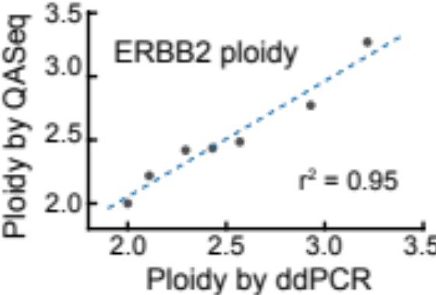
Figure S2. ERBB2 ploidy calculated from 2-plex QASeq and ddPCR. Spike-in samples with different expected ERBB2 ploidy were prepared by mixing a normal PBMC DNA sample and HER2-positive cell line (SK-BR-3) DNA.

Section 3. Multiplexed QASeq with >2 quantitation modules

QASeq ploidy correlation with ddPCR in tumor samples.
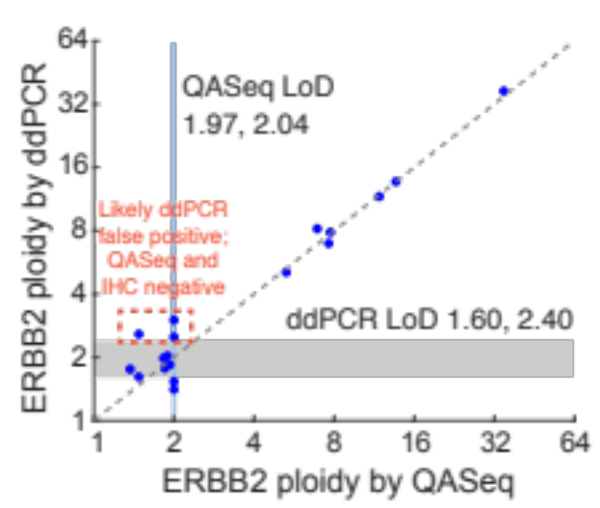
Figure S3. QASeq ERBB2 ploidy quantitation is consistent with ddPCR in FF samples.

Pairwise analysis of ploidy using every 2 modules.

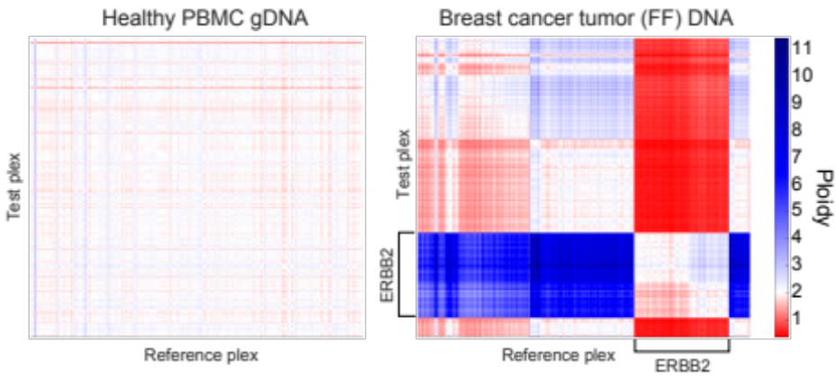
Figure S4. Pairwise ploidy analysis of 175-plex QASeq panel. Ploidy value can be calculated from the UMI family counts of any 2 modules as: ploidy = 2 × UMI family count of the test plex / UMI family count of the reference plex. In a healthy PBMC gDNA sample, the majority of ploidy values are close to 2. In a HER2-amplified FF DNA sample, the modules in ERBB2 can be distinguished from modules in other genomic regions.

Analysis of gene ploidy using >2 modules.
When analyzing QASeq panel with >2 quantitation modules, the first steps are NGS data alignment and calculation of UMI family count, which have been described in Supplementary Section 2.
A simple way to calculate the ploidy of a gene with >2 modules is to use the ratio between the mean of UMI family counts in the gene of interest and in the reference regions. In manuscript Fig. 2ab, ploidy of ERBB2 is calculated as: ploidy = 2 × mean UMI family count in ERBB2 / mean UMI family count in the reference. The ploidy for test sample was normalized against normal samples, with the mean ERBB2 ploidy of normal samples set at 2.00. In the 175-plex QASeq panel, 49-plex are in ERBB2, 123-plex in other genomic regions are used as the reference. The rest 3-plex in Chromosome X are not used in CNV analysis; they are used for mutation calling only.

Data analysis of clinical samples.
Because cancer clinical samples often contain multiple CNV regions in the genome, using the mean of UMI family counts for calculation of ploidy may generate false positives. Therefore, we developed a workflow for robust CNV calling in complex clinical samples.

We first obtained the accurate ploidy for every amplicon in the 175-plex QASeq panel by calibrating the conversion yield χ of each plex using standard (healthy) samples and normalizing the UMI family counts in patient samples by χ. In this work, we tested 2 different types of samples: FF and cfDNA. We characterized several healthy samples for each different sample type: 10 healthy blood gDNA samples as the standard for FF patient samples, and 10 healthy blood plasma cfDNA samples for cfDNA patient samples. 2 healthy samples with the highest within-sample variability were excluded and not used for χ calculation.
After obtaining χ of healthy samples, we performed the following normalization for each amplicon in the panel in every patient sample: $normalized UMI family count= \frac{observed UMI family count}{χ of the amplicon}$. Ploidy of each amplicon can be estimated as: $ploidy= \frac{normalized UMI family count}{sample input molecule number}$. The χ were calculated from the mean observed UMI family count of all healthy samples of the corresponding sample type.

Group name | Chromosome | Group size
ERBB4 | 2 | 14
PIK3CA | 3 | 7
ESR1 | 6 | 3
EGFR | 7 | 6
BRAF | 7 | 2
PTEN | 10 | 10
KRAS | 12 | 1
ERBB3 | 12 | 5
BRCA2 | 13 | 9
AKT1 | 14 | 1
TP53 | 17 | 6
ERBB2 | 17 | 49
BRCA1 | 17 | 11
Chr17p | 17 | 54
Chr17 | 17 | 114
Table S1. CNV groups of the 175-plex QASeq panel.

The QASeq panel can be used for CNV analysis of many target regions in the genome, including genes, sub-chromosomal regions, and chromosomes. The amplicons in the panel were grouped by which target region they are located. In Table S1, we showed the target regions (i.e. group names) included in the 175-plex panel, and the number of amplicons in each group (i.e. group size). Note that some smaller groups are part of a larger group: group “TP53” is part of group “Chr17p”; group “Chr17p”, “ERBB2”, and “BRCA1” are part of “Chr17”.
In cancer cells, there could be complex CNVs, aneuploidies, and structural variations in any of the chromosomes; it is difficult to find a fixed reference genomic region with stable copy number in every tumor sample. Here we use a flexible approach to determining the reference; the workflow of the algorithm is shown in Figure S4.
Because the normalized family count is proportional to ploidy of the amplicon, using ploidy or normalized family count are equivalent in the rank-based Mann-Whitney U test. In this section, we use normalized family count for Mann-Whitney U test for consistency.

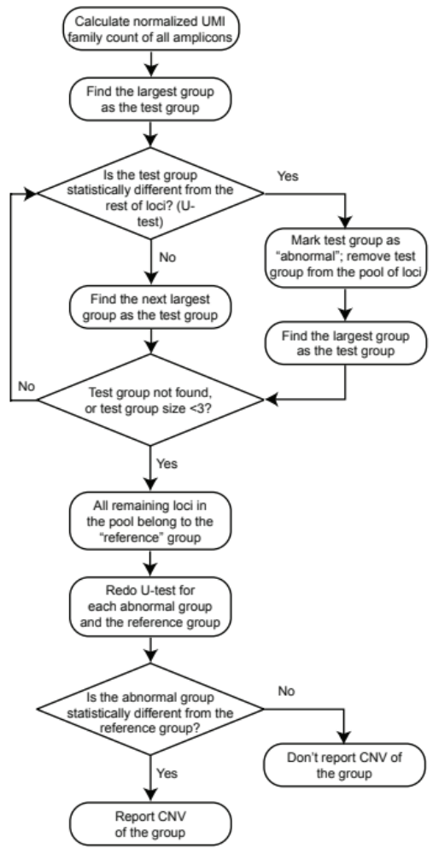
Figure S5. Workflow for copy number analysis, starting with normalized UMI family count.

We started with assigning the largest group as the test group, and all other amplicons in the panel as the reference group. A two-sided Mann-Whitney U test was performed to statistically test the null hypothesis that normalized UMI family count values in the test group have equal median to normalized UMI family count values in the reference group, against the alternative hypothesis that they do not have equal median. If the null hypothesis is rejected statistically, this group will be marked as “abnormal group”, and all amplicons from the current test group will be removed from the pool of amplicons and not to be included in later tests; the largest group in the remaining amplicons will be selected as the test group, and the rest of amplicons will become the reference group. If the null hypothesis cannot be rejected, the next largest group will become the test group, and the rest of amplicons (including the previous test group) will become the reference group. This process will be repeated until there is no group left, or the test group size is smaller than 3; the remaining amplicons in the pool will be the final reference group.
Note that everytime a group is marked as “abnormal”, the next test group will be the largest group in the remaining amplicons, although it may have been tested in previous cycles; this is because the test needs to be redone when the reference is changed compared to previous cycles.
After determining the reference group, we redo Mann-Whitney U tests to see whether the “abnormal groups” are still statistically different from the final reference group. The “abnormal groups” with $p< α$ will be reported for CNV; the ploidy of the group will be calculated as: ploidy = 2 × median normalized UMI family count in the current group / median normalized UMI family count in the reference group. For the groups with $p≥α$ and the groups not marked as “abnormal”, we will report the ploidy as 2.00. Note that it is possible that CNV was detected for a smaller group within a larger group, but the larger group itself does not have CNV.
In manuscript Fig. 2f, the exact ploidy of each amplicon was calculated as: ploidy of the amplicon = 2 × normalized UMI family count of the amplicon / median normalized UMI family count in the reference group.
The Matlab function “ranksum()” was used for Mann-Whitney U test. We did not use groups with < 3 group size as the test group; these amplicons were included to analyze clinically relevant hotspot mutations and serve as reference in CNV analysis. Therefore BRAF, KRAS, and AKT1 are not included in the CNV status report; the amplicons in these 3 groups are included in the reference group.
The $α$ value was adjusted based on Bonferroni correction; because 12 different groups were tested, there are 12 true null hypotheses, and $α$ was adjusted as $α$ = 0.05/12 = 0.0042.

Calculation of LoD.
In order to calculate the technical LoD of CNV detection, we tested aliquots of the same healthy blood gDNA sample 5 times using the 175-plex QASeq panel. For each experimental replicate, we calculated normalized UMI family count of each amplicon in the panel. The normalized UMI family count was calculated as: normalized UMI family count = observed UMI family count / standard χ; here the standard χ was the average χ of the other 4 experimental replicates.
Next, for each of the 49 amplicons in the ERBB2 group, the normalized UMI family count was multiplied by a fold change factor k. This new ERBB2 dataset was compared to the reference group (i.e. all non-ERBB2 amplicons); Mann-Whitney U test was performed to analyze whether the two groups have equal medians. We tested a lot of different k values ranging between 1.001 and 101 using a Matlab code, and found the minimum k value that generates a positive CNV gain test result for ERBB2. This minimum k value multiplied by 2 is the ploidy gain LoD of ERBB2.
Similarly, we also tested a lot of different k values ranging between 0.999 and 0, and found the maximum k value that generates a positive CNV loss test result for ERBB2. This maximum k value multiplied by 2 is the ploidy loss LoD of ERBB2.
We calculated gain LoD and loss LoD for each of the 5 experimental replicates; the median gain LoD and loss LoD of the 5 replicates are reported in Table S2. Other target CNV regions can be similarly analyzed for LoD; the median gain LoD and loss LoD of the 5 replicates are also included.

Group name | Group size | Ploidy gain LoD | Ploidy loss LoD
ERBB4 | 14 | 2.09 | 1.94
PIK3CA | 7 | 2.1 | 1.91
ESR1 | 3 | 2.22 | 1.79
EGFR | 6 | 2.11 | 1.9
PTEN | 10 | 2.08 | 1.92
ERBB3 | 5 | 2.11 | 1.88
BRCA2 | 9 | 2.08 | 1.91
TP53 | 6 | 2.14 | 1.87
ERBB2 | 49 | 2.04 | 1.97
BRCA1 | 11 | 2.07 | 1.93
Chr17p | 54 | 2.04 | 1.97
Chr17 | 114 | 2.04 | 1.96

Table S2. CNV LoD of all groups in the 175-plex QASeq panel.

Quantitation of ERBB2 in healthy blood DNA samples using 175-plex QASeq.

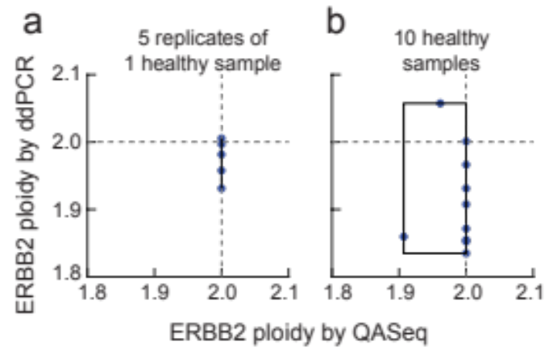
Figure S6. ERBB2 was quantitated using both ddPCR and 175-plex QASeq in healthy blood DNA samples. (a) The same healthy blood DNA sample was analyzed by both methods 5 times. ddPCR was performed using the ERBB2 copy number assay and EIF2C1 reference assay purchased from Bio-Rad; experimental and data analysis processes were performed according to Bio-Rad protocol. Using QASeq, we did not statistically observe CNV in ERBB2 by Mann-Whitney U test, so that the ploidy values are 2.00 for all 5 replicates. Using ddPCR, the ERBB2 ploidy ranges between 1.93 and 2.01. (b) 10 blood DNA samples from different healthy donors were analyzed using both methods; ddPCR showed wider ploidy range (1.84 to 2.06) than QASeq (1.91 to 2.00).
Summary of CNVs observed in tumor samples.

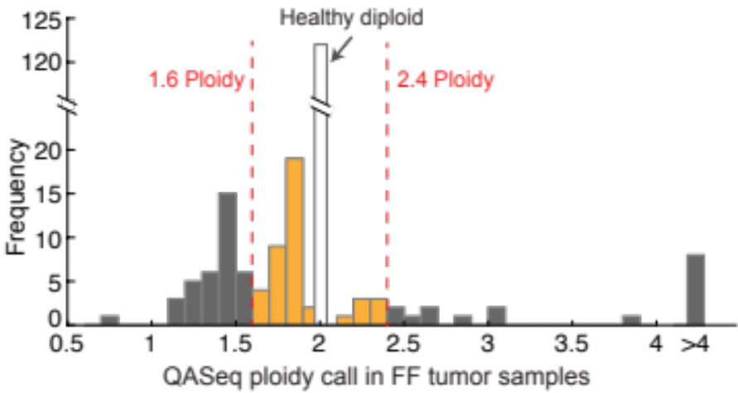
Figure S7. Histogram of observed gene ploidy values in 18 tumor DNA samples indicating improved clinical sensitivity.

Section 4. Mutation analysis by QASeq

Mutation analysis workflow.
The first steps of NGS data processing for mutation analysis were the same as described in Supplementary Section S2, including the NGS reads alignment, grouping based on UMI sequence, removing UMI families containing PCR errors, and removing small UMI families which are likely the result of PCR-induced mutation in the UMI region.
We next determined the consensus sequences of the UMI families. In each amplicon sequence, the region between the 3′ of the forward primer and the 3′ of the inner reverse primer was used for mutation analysis; this region is called the identification region (IR). The IR sequence for each NGS read in the UMI family is identified. If any of the IR sequences in the UMI family are the same as the WT sequence (i.e. sequence from the human reference genome), the consensus sequence for this UMI family will be the WT sequence. Otherwise, a majority vote process is performed: if ≥70% reads of the UMI family contain the same IR sequence, this IR sequence will be the consensus sequence; if the most common IR sequence in the UMI family is present in <70% reads, this UMI family will be discarded. The number of UMI families of each different IR sequence is called the UMI family count.
Next, we compared the consensus sequences to the WT sequences and performed mutation calling. In order to reduce false positives, only mutations with UMI family count ≥ 3 and VAF ≥ 0.05% at the same time were further considered for variant calls. Here VAF of the mutation is calculated as VAF = UMI family count of the mutation / total UMI family count in the family.
In order to remove pseudogenes from the mutation list, we designed the primers to be different enough from the pseudogene sequences, so that the primer-pseudogene hybridization ∆Gº is weak in the PCR buffer, and the pseudogene templates cannot be amplified. There are still several pseudogene sequences that cannot be completely removed by primer design; we removed them during the process of mutation calling: if a consensus sequence contains “mutations” that appear in the pseudogene sequence, this UMI family will be removed.
Based on the initial test of the protocol on 10 healthy blood DNA samples and the Horizon WT reference sample, we observed some common false positives. If a mutation is observed in ≥3 healthy samples out of the 10 and has a VAF < 10%, it is unlikely a germline SNP; we think it is either a pseudogene that cannot be found by the online Basic Local Alignment Search Tool (BLAST), or an oligonucleotide contamination in the laboratory. This type of common false positives was removed from the mutation report. We also observed high frequency length change in homopolymer regions (i.e. ≥4 same consecutive bases); for example, AAAA>AAAAA and GGGGG>GGGG. It is known that polymerase and sequencing have higher indel rate in homopolymer regions than in normal regions; therefore, we did not report indel mutation in homopolymer regions.
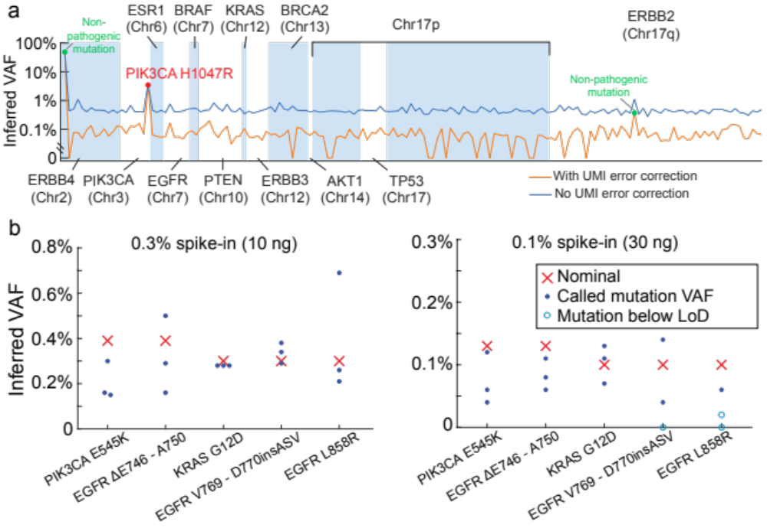
Figure S8. QASeq mutation analysis results. (a) Inferred mutation VAF with (orange line) and without (blue line) UMI correction for a breast cancer tumor section sample (8 ng input). Plotted here are the most dominant mutation in each amplicon; only mutations called are plotted as dots (red dots for pathogenic mutations, green dots for non-pathogenic mutations). The use of UMI bioinformatics in QASeq thus improves the mutation limit of detection by roughly 8-fold, from a background of roughly 0.8% to 0.1% VAF. (b) Validation of analytical sensitivity and specificity using Horizon reference cfDNA samples with 0.1% and 0.3% VAF mutations. At 10 ng DNA and 0.3% VAF, sensitivity was 100% (15/15). At 30 ng DNA and 0.1% VAF, sensitivity was 80% (12/15).

Section 5. RNA expression level analysis by QASeq

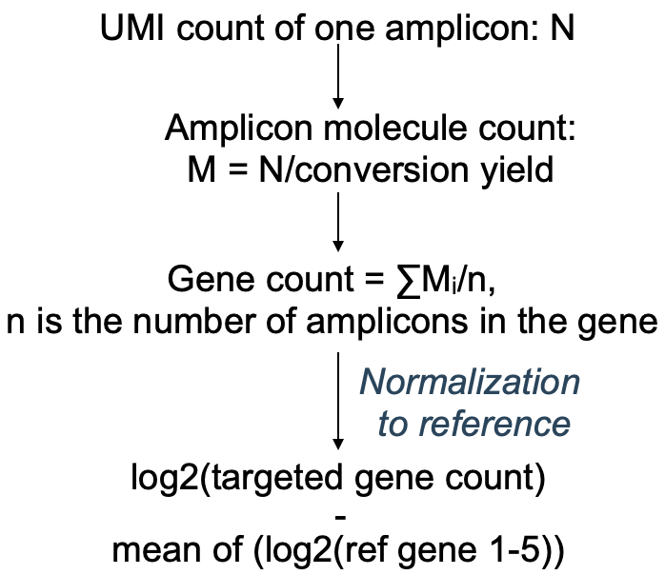
Figure S9. Expression level calculation formula.

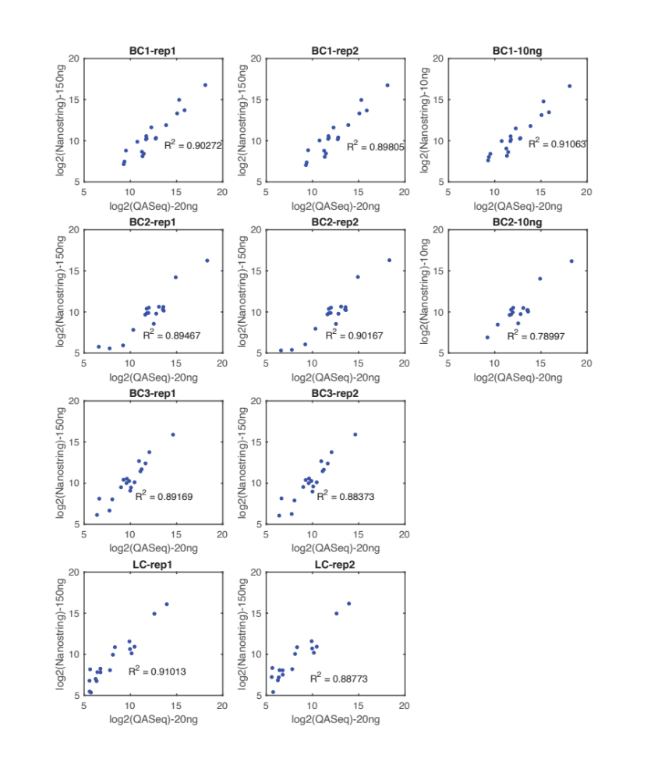
Figure S10. RNA expression level comparison between RNA QASeq and Nanostring.

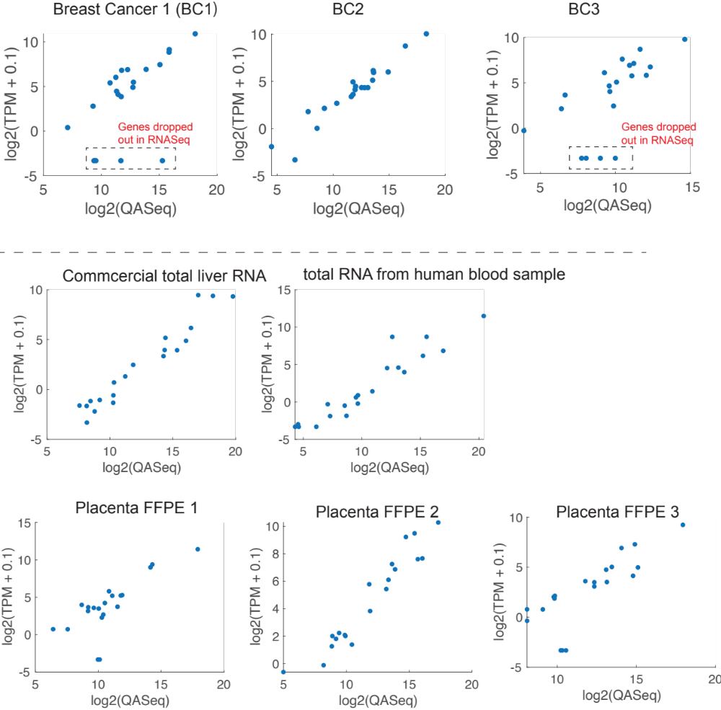
Figure S11. RNA expression level comparison between RNA QASeq and RNASeq. About 20 M reads are assigned for standard RNASeq, with ribosomal depletion. Low expression level gene may be dropped out in RNASeq especially in FFPE samples.

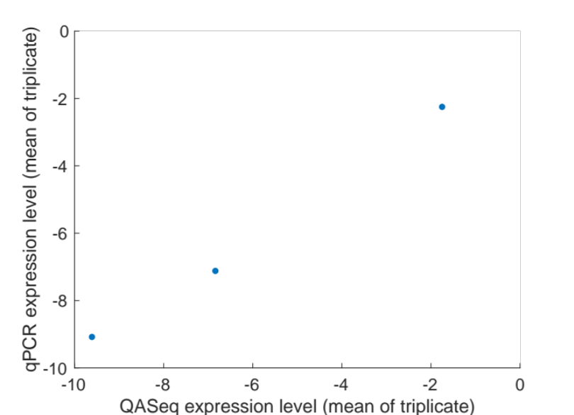
Figure S12. Comparison between QASeq and rt-qPCR. The expression level of three target genes (BAG1, MMP11, BIRC5) are normalized with five reference genes (TFRC, GUSB, RPLP0, ACTB, GAPDH). 10 ng human liver total RNA were used as input for each RNA QAseq library preparation or each rt-qPCR well. Both rt-qPCR and QASeq experiments were performed in triplicates and mean expression level are plotted. Linear regression R² = 0.995.

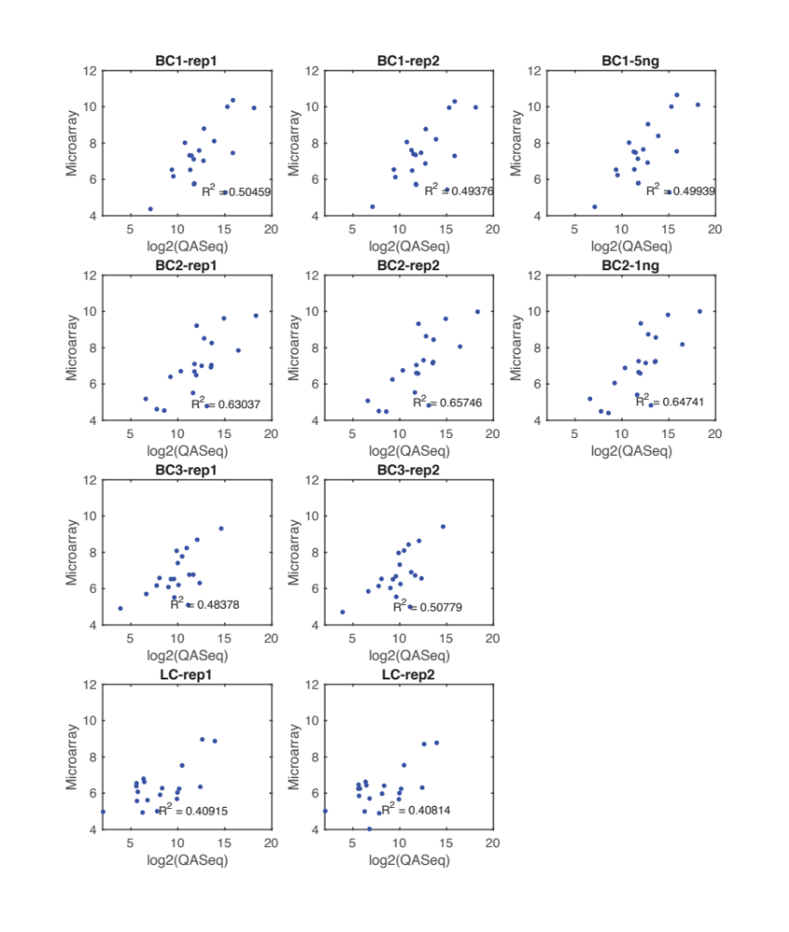
Figure S13. RNA expression level comparison between RNA QASeq and Microarray HTA.

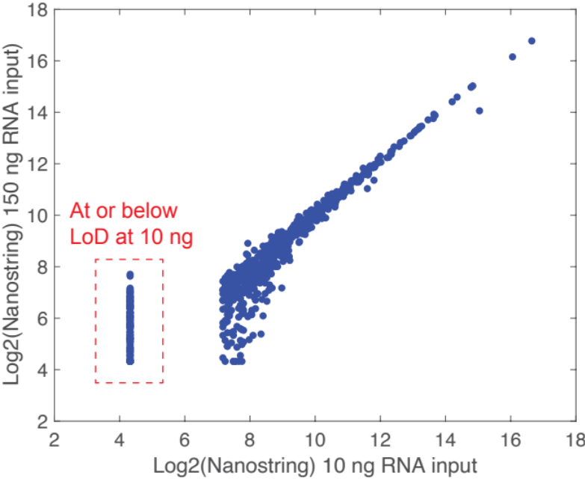
Figure S14. RNA expression level quantitation for the same FFPE RNA by Nanostring at different input amount.

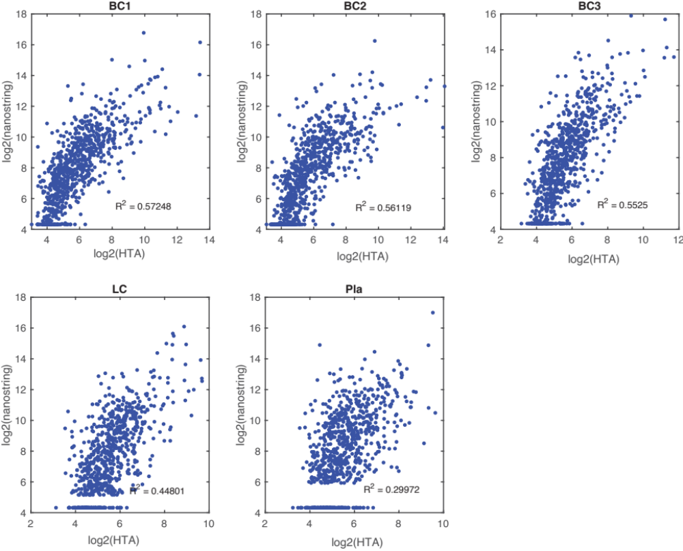
Figure S15. RNA expression level comparison between Nanostring and Microarray HTA.

