Table 1. Baseline characteristics of pediatric simple bone cyst patients stratified by anatomic site
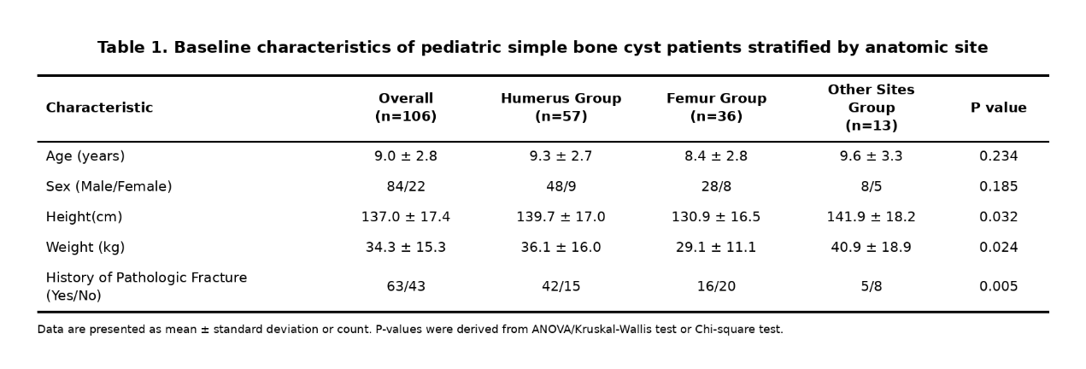
Table 2. Comparison of imaging characteristics of simple bone cysts by anatomic site
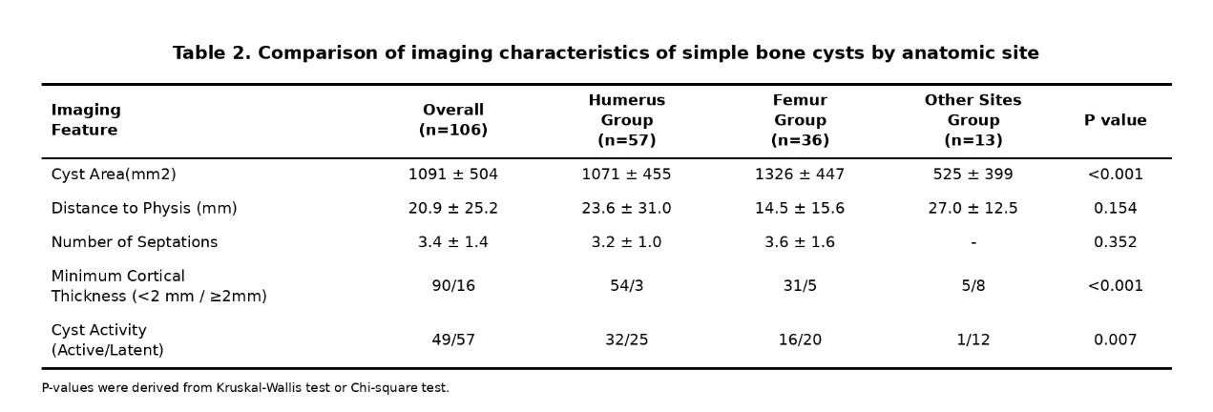
Table 3 One-way ANOVA Results
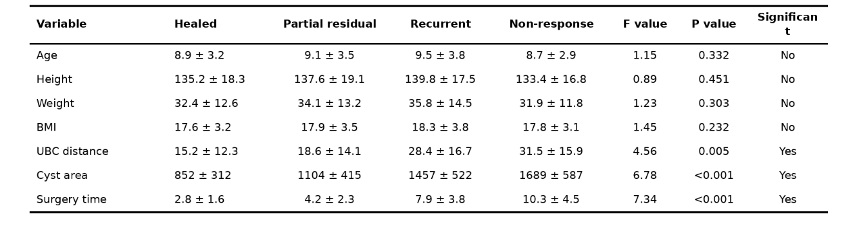
Table 4 Results of Univariate Chi-square Test
