SUPPLEMENTARY RESULTS

Table 1. Significant univariable analyses between neutrophil-to-lymphocyte ratios at diagnosis and cognitive outcomes in people with lymphoma mid-chemotherapy

Measure | Coefficient  (b) (95%  CI) | SE | t | F | Adjusted R² | p-value
Stroop Colour and Word Test
Word/colour | 1.222 | 0.467 | 2.603 | 6.776 | 0.166 | 0.0146
Interference word/colour | 1.556 | 0.381 | 4.087 | 16.7 | 0.351 | 0.0003
Trail Making Test
A score | 1.036 | 0.476 | 2.178 | 4.743 | 0.114 | 0.0380
B score | 0.768 | 0.439 | 1.749 | 3.059 | 0.066 | 0.0913
Hopkins Verbal Learning Test
Total recall | 0.889 | 0.467 | 1.906 | 3.634 | 0.0833 | 0.0670

Table 2. Significant univariable analyses between systemic immune-inflammation indices at diagnosis and cognitive outcomes in people with lymphoma mid-chemotherapy
Measure | Coefficient  (b) (95% CI) | SE | t | F | Adjusted R² | p-  value
Stroop Colour and Word Test
Word/colour | 502.600 | 253.500 | 1.983 | 3.961 | 0.0718 | 0.0573
Interference word/colour | 616.400 | 219.900 | 2.802 | 7.853 | 0.1911 | 0.0091
Trail Making Test
A score | 572.800 | 243.100 | 2.356 | 5.550 | 0.136 | 0.0257
B score | 487.400 | 220.700 | 2.209 | 4.879 | 0.118 | 0.0355
Hopkins Verbal Learning Test
Total recall | 447.400 | 242.200 | 1.847 | 3.413 | 0.077 | 0.0753

Table 3. Significant univariable analyses between platelet-to-lymphocyte ratios at diagnosis and cognitive outcomes in people with lymphoma mid-chemotherapy
Measure | Coefficient  (b) (95%  CI) | SE | t | F | Adjusted R² | p-value
Stroop Colour and Word Test
Interference word/colour | 86.200 | 28.010 | 3.078 | 9.472 | 0.226 | 0.0046
Trail Making Test
B score | 57.660 | 29.160 | 1.977 | 3.910 | 0.091 | 0.0579

Table 4. Significant univariable analyses between neutrophil-to-lymphocyte ratios at diagnosis and cognitive outcomes in people with lymphoma 6-8 weeks after chemotherapy
Measure | Coefficient  (b) (95%  CI) | SE | t | F | Adjusted R² | p-  value
Stroop Colour and Word Test
Word/colour | 1.525 | 0.492 | 3.096 | 9.587 | 0.235 | 0.0045
Interference word/colour | 1.782 | 0.393 | 4.531 | 20.530 | 0.411 | 0.0001
Trail Making Test
B score | 1.071 | 0.418 | 2.562 | 6.564 | 0.166 | 0.0163
Hopkins Verbal Learning Test
Retention | 0.866 | 0.502 | 1.724 | 2.971 | 0.066 | 0.0962
Controlled Oral Word Association Test
Category fluency | -0.770 | 0.447 | -1.720 | 2.960 | 0.065 | 0.0968

Table 5. Significant univariable analyses between systemic immune-inflammation indices at diagnosis and cognitive outcomes in people with lymphoma 6-8 weeks after chemotherapy
Measure | Coefficient  (b) (95% CI) | SE | t | F | Adjusted R² | p-  value
Stroop Colour and Word Test
Word/colour | 866.000 | 253.600 | 3.414 | 11.660 | 0.276 | 0.0020
Interference word/colour | 958.300 | 205.800 | 4.657 | 21.690 | 0.425 | < 0.0001
Trail Making Test
A score | 500.100 | 232.800 | 2.148 | 4.614 | 0.114 | 0.0408
B score | 624.800 | 215.600 | 2.899 | 8.402 | 0.209 | 0.0074

Table 6. Significant univariable analyses between platelet-to-lymphocyte ratios at diagnosis and cognitive outcomes in people with lymphoma 6-8 weeks after chemotherapy
Measure | Coefficient  (b) (95% CI) | SE | t | F | Adjusted R² | p-  value
Stroop Colour and Word Test
Word/colour | 104.08 | 33.250 | 3.131 | 9.801 | 0.239 | 0.0042
Interference word/colour | 129.701 | 25.010 | 5.186 | 26.900 | 0.481 | < 0.0001
Trail Making Test
B score | 63.640 | 29.090 | 2.187 | 4.784 | 0.119 | 0.0376
Controlled Oral Word Association Test
Category fluency | -78.820 | 28.070 | -2.808 | 7.882 | 0.197 | 0.0092

Table 7. Significant univariable analyses between stage of disease and cognitive outcomes in people with lymphoma at diagnosis

Measure | Coefficient  (b) (95% CI) | SE | t | F | Adjusted R² | p-value
 | Subjective measures
FACIT-F
Total score | 0.039 | 0.020 | 2.005 | 4.021 | 0.116 | 0.0574
 | Objective measures
Stroop Colour and Word Test
Word | -0.039 | 0.020 | -1.978 | 3.913 | 0.101 | 0.0590
Digit Span Wechsler Adult Intelligence Scale
Digit span total | -0.049 | 0.027 | -1.778 | 3.160 | 0.077 | 0.0876

Table 8. Multivariable analyses between neutrophil-to-lymphocyte ratios at diagnosis and cognitive outcomes in patients with non-Hodgkin lymphoma mid-chemotherapy
Measure | Coefficient  (b) (95% CI) | SE | t | p-  value
Age | -0.010 | 0.008 | -1.274 | 0.2164
Stroop Colour and Word Test
Interference word/colour | 0.395 | 0.111 | 3.547 | 0.0019
Trail Making Test
B score | 0.112 | 0.133 | 0.846 | 0.4068
Hopkins Verbal Learning Test
Total Recall | 0.239 | 0.122 | 1.961 | 0.0633
Note: Word/colour T-scores were dropped from the model as they were highly correlated with Interference word/colour T-scores. Trail making A test scores were dropped from the model as they were highly correlated with Trail making B test scores. |  |  | F | Adjusted R²
 |  |  | 6.246 | 0.456
Table 9. Multivariable analyses between systemic immune-inflammation indices at diagnosis and cognitive outcomes in patients with non-Hodgkin lymphoma mid-chemotherapy
Measure | Coefficient  (b) (95% CI) | SE | t | p-  value
Stroop Colour and Word Test
Interference word/colour | 0.564 | 0.162 | 3.485 | 0.0021
Trail Making Test
B score | 0.574 | 0.196 | 2.924 | 0.0079
Hopkins Verbal Learning Test
Total Recall | 0.261 | 0.190 | 1.375 | 0.1830
Note: Word/colour T-scores were dropped from the model as they were highly correlated with Interference word/colour T-scores. Trail making A test scores were dropped from the model as they were highly correlated with Trail making B test scores. |  |  | F | Adjusted R²
 |  |  | 8.042 | 0.458

Table 10. Multivariable analyses between platelet-to-lymphocyte ratios at diagnosis and cognitive outcomes in patients with non-Hodgkin lymphoma mid-chemotherapy
Measure | Coefficient  (b) (95% CI) | SE | t | p-  value
Stroop Colour and Word Test
Interference word/colour | 0.301 | 0.138 | 2.180 | 0.0398
Trail Making Test
B score | 0.266 | 0.159 | 1.669 | 0.1086
 |  |  | F | Adjusted R²
 |  |  | 3.528 | 0.1682

Table 11. Multivariable analyses between neutrophil-to-lymphocyte ratios at diagnosis and cognitive outcomes in patients with non-Hodgkin lymphoma 6-8 weeks after chemotherapy
Measure | Coefficient  (b) (95% CI) | SE | t | p-  value
Age | -0.010 | 0.009 | -1.091 | 0.289
Stroop Colour and Word Test
Interference word/colour | 0.301 | 0.117 | 2.568 | 0.0188
Trail Making Test
B score | 0.249 | 0.099 | 2.506 | 0.0215
Hopkins Verbal Learning Test
Retention | 0.128 | 0.106 | 1.200 | 0.2449
Controlled Oral Word Association Test
Category fluency | - 0.110 | 0.104 | -1.054 | 0.3052
Note: Word/colour T-scores were dropped from the model as they were highly correlated with Interference word/colour T-scores. |  |  | F | Adjusted R²
 |  |  | 7.187 | 0.563

Table 12. Significant multivariable analyses between systemic immune-inflammation indices at diagnosis and cognitive outcomes in patients with non-Hodgkin lymphoma mid-chemotherapy
Measure | Coefficient  (b) (95% CI) | SE | t | p-  value
Stroop Colour and Word Test
Interference word/colour | 0.596 | 0.140 | 4.255 | 0.0003
Trail Making Test
B score | 0.477 | 0.121 | 3.953 | 0.0007
Note: Word/colour T-scores were dropped from the model as they were highly correlated with Interference word/colour T-scores. Trail making A test scores were dropped from the model as they were highly correlated with Trail making B test scores. |  |  | F | Adjusted R²
 |  |  | 20.540 | 0.617

Table 13. Significant multivariable analyses between platelet-to-lymphocyte ratios at diagnosis and cognitive outcomes in patients with non-Hodgkin lymphoma 6-8 weeks after chemotherapy
Measure | Coefficient  (b) (95% CI) | SE | t | p-  value
Stroop Colour and Word Test
Interference word/colour | 0.425 | 0.116 | 3.659 | 0.0014
Trail Making Test
B score | 0.210 | 0.094 | 2.229 | 0.0367
Controlled Oral Word Association Test
Category fluency | -0.1611 | 0.1017 | -1.584 | 0.1281
Note: Word/colour T-scores were dropped from the model as they were highly correlated with Interference word/colour T-scores. |  |  | F | Adjusted R²
 |  |  | 12.250 | 0.585

Table 14. Diagnostic cut-off scores for white blood cell ratios to detect mild cognitive impairment 6-8 weeks after chemotherapy
Measure | AUC | Diagnostic Threshold | Sensitivity (True positives) | Specificity (True negatives)
NLR | 0.763 | 2.255 | 0.750 | 0.688
SII | 0.849 | 501.200 | 0.750 | 0.938
PLR | 0.797 | 163.750 | 0.833 | 0.688
Abbreviations; AUC, Area under the curve, NLR, neutrophil-to-lymphocyte ratio, SII, systemic immune-inflammation index, PLR, platelet-to-lymphocyte ratio
Measure | AUC | Diagnostic Threshold | Sensitivity (True positives) | Specificity (True negatives)
NLR | 0.928 | 1.600 | 0.750 | 0.950
SII | 0.969 | 501.200 | 1.000 | 0.900
PLR | 0.806 | 163.750 | 0.875 | 0.600
Abbreviations; AUC, Area under the curve, NLR, neutrophil-to-lymphocyte ratio, SII, systemic immune-inflammation index, PLR, platelet-to-lymphocyte ratio
Table 15. Diagnostic cut-off scores for white blood cell ratios to detect moderate cognitive impairment 6-8 weeks after chemotherapy

Supplementary Figure 1. Blood cell parameters were elevated in people with lymphoma at diagnosis and remained high 6-8 weeks after chemotherapy. Robust mixed linear models assessing blood cell parameters in people with lymphoma and healthy controls across time. NLRs (A) and SIIs (B) were significantly elevated in people with lymphoma compared to healthy controls at diagnosis and 6-8 weeks after chemotherapy. In people with lymphoma, chemotherapy significantly reduced NLRs and SIIs compared to those observed 6-8 weeks after chemotherapy (C) PLRs were significantly elevated in in people with lymphoma compared to healthy controls at diagnosis, during and after chemotherapy. In people with lymphoma, chemotherapy significantly increased PLRs compared to baseline and the ratios remained high 6-8 weeks after chemotherapy. + SEM, n = 102. *p < 0.05, **p < 0.01, ***p < 0.001, ****p < 0.0001. Abbreviations; PLR: Platelet-to-lymphocyte ratio, NLR: Neutrophil-to-lymphocyte ratio, SII: Systemic immune-inflammation index

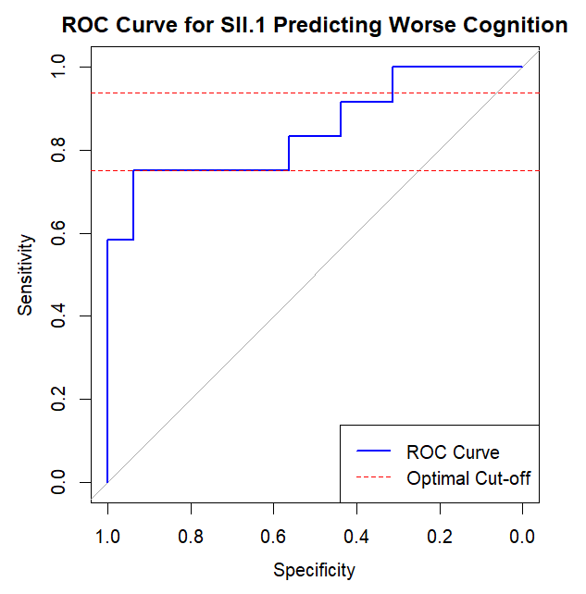
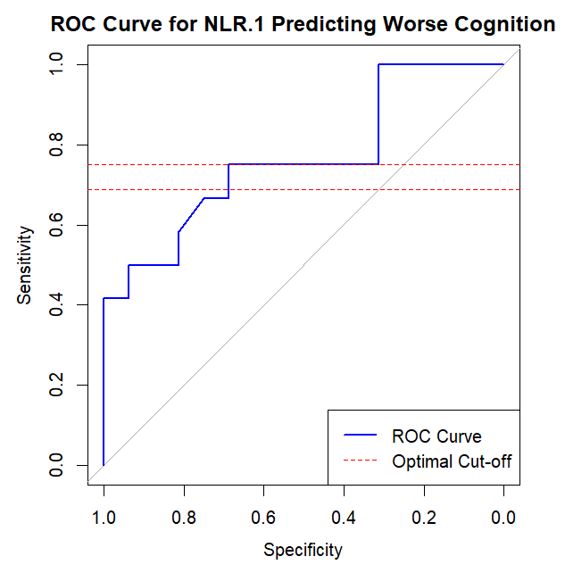
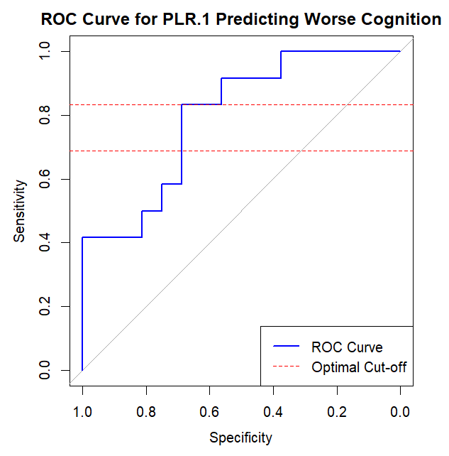
NLR
SII
PLR
A
B
C
Supplementary Figure 2. ROC curves used to generate cut-off scores to detect mild cognitive impairment in people with aggressive lymphoma 6-8 weeks after chemotherapy. ROC curves were used to determine the optimal cut-off scores for NLRs, SIIs, and PLRs to identify patients who performed 1.5 standard deviations below the mean of healthy controls on the trail making B test 6-8 weeks post-chemotherapy. A) The AUC for NLRs was 0.763 (95% CI: 0.603-0.924), indicating moderate discriminatory performance. The optimal cut-off threshold for NLRs was 2.255, with a sensitivity of 0.75 and specificity of 0.688. B) The AUC for SIIs was 0.849 (95% CI: 0.713-0.985), indicating good discriminatory performance. The optimal cut-off threshold for SII was 501.2, with a sensitivity of 0.75 and specificity of 0.938. C) The AUC for PLRs was 0.797 (95% CI: 0.641-0.953), indicating good discriminatory performance. The optimal cut-off threshold for PLRs was 163.75, with a sensitivity of 0.833 and specificity of 0.688. Abbreviations; PLR: Platelet-to-lymphocyte ratio, NLR: Neutrophil-to-lymphocyte ratio, SII: Systemic immune-inflammation index

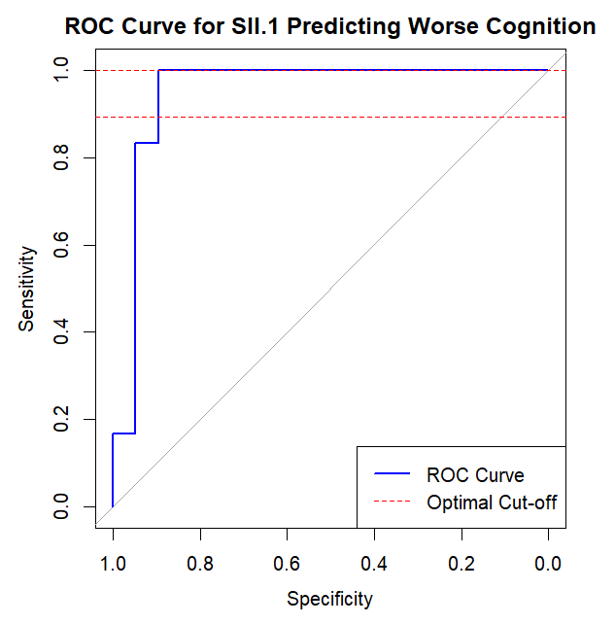
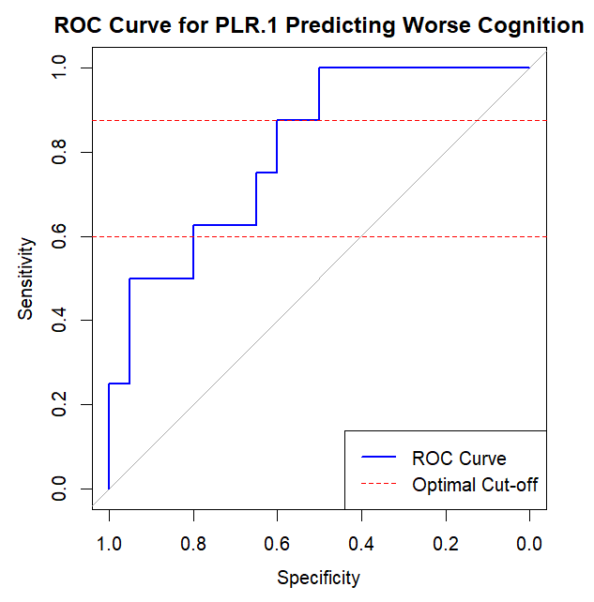
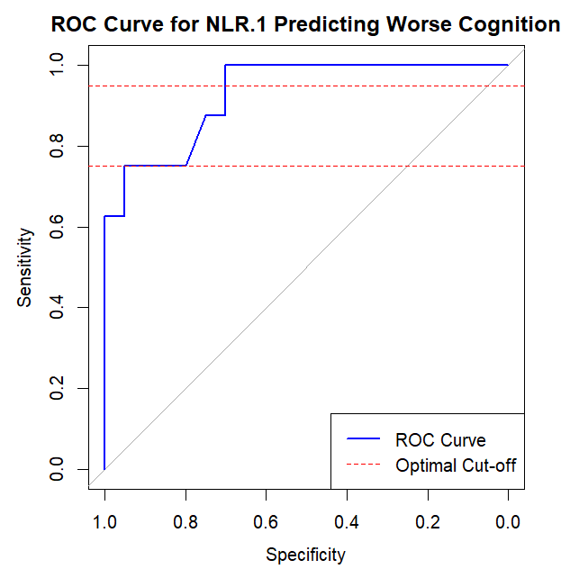
NLR
SII
PLR
A
B
C
Supplementary Figure 3. ROC curves used to generate cut-off scores to detect moderate cognitive impairment in people with aggressive lymphoma 6-8 weeks after chemotherapy. ROC curves were used to determine the optimal cut-off scores for NLRs, SIIs, and PLRs to identify patients who performed 2 standard deviations below the mean of healthy controls on the trail making B test 6-8 weeks post-chemotherapy. A) The AUC for NLRs was 0.928 (95% CI: 0.843-1.000), indicating excellent discriminatory performance. The optimal cut-off threshold for NLRs was 1.6, with a sensitivity of 0.75 and specificity of 0.95. B) The AUC for SIIs was 0.969 (95% CI: 0.919-1.000), indicating outstanding discriminatory performance. The optimal cut-off threshold for SII was 501.2, with a sensitivity of 1.0 and specificity of 0.9.C) The AUC for PLRs was 0.806 (95% CI: 0.673-0.939), indicating good discriminatory performance. The optimal cut-off threshold for PLRs was 163.75, with a sensitivity of 0.875 and specificity of 0.6. Abbreviations; PLR: Platelet-to-lymphocyte ratio, NLR: Neutrophil-to-lymphocyte ratio, SII: Systemic immune-inflammation index

