Supplementary material
Table S1. Evidence chain for each included study and effect size (with source page/table)
Supplementary table. Abbreviations and source locations are preserved from the original extraction sheet; Negative r values indicate worse cognition with greater delirium burden.
Study | Included in meta | Delirium burden metric | Cognitive outcome | Follow-up (months) | Statistic extracted | Conversion to effect size | Effect used (r) | Evidence location
Girard 2010 | Yes | Delirium duration in ICU, days: median 2 (IQR 1–5); modeled using restricted cubic splines | Cognitive performance summary score (adjusted mean T-score); impairment categories (none/mild-moderate/severe) | 12 | Adjusted regression: −6.9 points (95% CI −12.7 to −1.1) for IQR increase in delirium duration (25th=1 day; 75th=5 days). | Converted to partial r using t=β/SE (SE from CI) and df≈n−2; r ≈ −0.30. | −0.301 | Table 3, PDF p.5
van den Boogaard 2012 | Yes | Delirium during ICU (≥1 CAM-ICU+); delirium duration (days; median 2 [IQR 1–7], range 1–69) | SF-36; CIS-fatigue; CFQ (memory/distractibility/social blunders/names; total) at ~18 months | 18 months | Spearman correlation between delirium duration and memory problems on CFQ: r=0.21 (p=0.01). Higher CFQ indicates worse cognition. | Direction reversed so that negative r indicates worse cognition with greater delirium burden (r_used=−0.21). | −0.21 | Results text, PDF p.9 ("r =0.21")
Pandharipande 2013 | Yes | Delirium duration = number of hospital days with delirium during the index admission | RBANS global cognition scoreTrail Making Test Part BT-score | 12 | Adjusted regression: −5.7 points (95% CI −9.5 to −1.8) in RBANS global cognition score for IQR increase in delirium duration (25th=0 days; 75th=4 days). | Converted to partial r using t=β/SE (SE from CI) and df≈n−2; r ≈ −0.15. | −0.147 | Table 2, PDF p.8 (printed p.1313)
Denke 2018 | Yes | Delirium duration (days) and delirium presence (per above criteria) | Neuropsychological battery: CANTAB + VVLT + Stroop (SCWT); premorbid intelligence by WST | 50 | Spearman correlation between delirium duration and CANTAB verbal learning test performance (VVLPT/VVLT 1–3 correct): r=−0.519 (p=0.016). | Used as reported (r=−0.519). | −0.519 | Table 5, PDF p.12 (row VVLPT 1–3: r=−0.519; p=0.016)
Haddad 2020 | Yes | Delirium duration (days) during ICU stay (continuous; reported as 75th vs 25th percentile contrast) | RBANS global cognition score (primary; lower=worse); Trails B executive function (secondary) | 12 | Adjusted regression: delirium duration coefficient −6.72 (p=0.068) predicting 12‑month cognitive score (SE/CI not reported). | Approximate r derived from two-sided p value with df≈n−2, with sign from coefficient (exploratory; tested in sensitivity analyses). | −0.091 | Table 5, PDF p.19 (coef -6.72; p=0.068)
Collet 2021 | Yes | Delirium duration = number of delirium days during ICU stay (continuous, per day) | RBANS global cognition score (in-home or outpatient clinic by trained professionals) | 6 | Adjusted regression: delirium days coefficient −1.00 (95% CI −2.71 to 0.70) for 6‑month cognitive score. | Converted to partial r using t=β/SE (SE from CI) and df≈n−2; r ≈ −0.10. | −0.103 | Table 3, PDF p.19 (coef -1.00; 95%CI -2.71 to 0.70)
Jackson 2011 | No | Delirium duration days | Objective neuropsychological battery defining impairment (binary) at 12 months | 12 | Multivariable logistic regression; delirium days not independently associated with impairment (effect not extractable from PDF text). | Not pooled (OR format/non-extractable). |  | Table 5, PDF p.4–5 (multivariable model; delirium days not significant)
de Azevedo 2017 | No | Delirium duration planned predictor | Telephone cognitive screening at 12 months (binary) | 12 | Primary paper focused on prevalence; delirium duration included as determinant in planned analysis but extractable association not available in text. | Not pooled (non-extractable). |  | Methods/Results, PDF p.4 (planned model included delirium duration)
van der Heijden 2023 | No | Delirium course groups (e.g., no delirium, resolved, persistent) per paper | Cognitive Failure Questionnaire (CFQ) at 1-year follow-up; plus SF-36 and CIS fatigue etc | 12 months (1 year) post-ICU | Adjusted odds ratio for cognitive impairment in persistent delirium vs no delirium: aOR 3.90 (95% CI 1.47–10.35). | Not pooled with r; presented as narrative and in Supplementary Table. |  | Table 2, PDF p.2 (aOR 3.90 for cognitive impairment in persistent delirium group)
Paulino 2023 | No | Exposure is early mental status within first 72h: No-delirium/no-SSD (ICDSC=0), SSD (ICDSC 1–3), Delirium (ICDSC ≥4); grouping by highest score in first 72h | Cognitive: IQCODE-SF (phone to patient/proxy); Functional: Katz ADL | Follow-up at 3 and 6 months after hospital discharge (plus baseline/admission assessment) | SSD associated with worse cognition at 3 months with partial recovery at 6 months (effect measures not directly comparable to r). | Not pooled; narrative only. |  | Abstract, PDF p.1 (SSD and IQCODE-SF outcomes at 3 and 6 months)
Sakuramoto 2015 (short-term) | No | Delirium severity (ICDSC/CAM-ICU) | Short-term cognitive impairment (<3 months) | 1 | Follow-up <3 months; prespecified as outside long-term window. | Excluded from primary; reported in Supplement. |  | Short-term follow-up (<3 months); included in Supplement only

Table S2. Full-text exclusions (n = 99) with reasons
(post-discharge ≥3 months long-term cognition criterion)
Summary of exclusion reasons
Exclusion category | n
Other / insufficient information to confirm PICO eligibility or extract data | 37
Ineligible follow-up window: in-hospital or <30 days | 28
Review/commentary/editorial (not original research) | 10
Conference abstract/grey literature (insufficient detail or possible duplicate publication) | 6
Exposure mismatch: ICU delirium/delirium burden not evaluated as the exposure | 6
Outcome mismatch: no post-discharge cognitive outcome reported | 6
Exposure mismatch: primary exposure was hypoxia or another non-delirium factor | 4
Population mismatch: non-adult population | 1
Research question mismatch: intervention trial (delirium treatment) | 1
Excluded full-text reports (n = 99)
Title | Year | Reason for full-text exclusion (prespecified category) | One-line evidence note
Risk factors for long-term cognitive impairment in ICU survivors: a multicenter, prospective cohort study | 2021 | Population mismatch: non-adult population | Purpose: To describe the incidence of and risk factors for impaired cognitive function in intensive care unit (ICU)…
3 months after intensive care unit: post-intensive care syndrome and quality of life | 2024 | Conference abstract/grey literature (insufficient detail or possible duplicate publication) | Conference abstract (tags confirmed).
An exploratory research report on brain mineralization in postoperative delirium and cognitive decline | 2024 | Conference abstract/grey literature (insufficient detail or possible duplicate publication) | Record labeled as conference abstract or figure.
Delirium, depression and long-term cognitive impairment | 2021 | Conference abstract/grey literature (insufficient detail or possible duplicate publication) | Conference abstract (tags confirmed).
Posterior reversible encephalopathy syndrome in a patient with serotonin syndrome | 2020 | Conference abstract/grey literature (insufficient detail or possible duplicate publication) | Record labeled as conference abstract or figure.
Prospective evaluation of cognitive function following critical illness in older adults | 2020 | Conference abstract/grey literature (insufficient detail or possible duplicate publication) | Conference abstract (tags confirmed).
Delirium is an independent predictor of long-term cognitive impairment: results from the brain ICU (bringing to light the risk factors and incidence of neuropsychological dysfunction in ICU survivors) study | 2013 | Conference abstract/grey literature (insufficient detail or possible duplicate publication) | Record labeled as conference abstract or figure.
Associations between Aβ40, Aβ42, and tau and postoperative delirium in older adults undergoing cardiac surgery | 2025 | Other / insufficient information to confirm PICO eligibility or extract data | BACKGROUND: Postoperative delirium is a significant complication in older adults undergoing cardiac surgery. This study investigated associations between…
Delirium after surgery: a retrospective study of predictors, complications, and screening patterns in the national surgical quality improvement program | 2025 | Other / insufficient information to confirm PICO eligibility or extract data | Background: Postoperative delirium is a serious yet underrecognized complication affecting diverse surgical populations, with profound implications for morbidity,…
Dexmedetomidine and postoperative dementia risk in older patients | 2025 | Other / insufficient information to confirm PICO eligibility or extract data | Background: Postoperative cognitive decline (POCD) and dementia are significant risks in older patients after surgery. Dexmedetomidine, an alpha2-adrenergic…
Incidence and delirium risk factors in burn patients: a prospective cohort study | 2025 | Other / insufficient information to confirm PICO eligibility or extract data | Background: Delirium is a neurocognitive syndrome caused by systemic disturbances, leading to impaired attention, awareness, and/or cognition. It…
Longitudinal cognitive recovery after critical illness: trajectories in sepsis and non-sepsis survivors | 2025 | Other / insufficient information to confirm PICO eligibility or extract data | Background: Post-critical illness cognitive dysfunction (PCICD) is a frequent and debilitating outcome among survivors of critical illness. Although…
Postoperative delirium and cognitive dysfunction after cardiac surgery: the role of inflammation and clinical risk factors | 2025 | Other / insufficient information to confirm PICO eligibility or extract data | Background/Objectives: Postoperative delirium (POD) and postoperative cognitive dysfunction (POCD) are prevalent neurological complications following cardiac surgery, significantly affecting…
Preoperative cognitive performance and its association with postoperative complications in vascular surgery patients: a prospective study | 2025 | Other / insufficient information to confirm PICO eligibility or extract data | Background: Cognitive impairment affects nearly half of vascular surgery patients, but its association with postoperative outcomes remains poorly…
Clinical and cognitive characteristics associated with the onset of delirium in postoperative cardiovascular surgery patients admitted to the ICU | 2024 | Other / insufficient information to confirm PICO eligibility or extract data | Insufficient metadata in export; excluded per preset PICO.
Delirium in acute stroke is associated with increased cognitive and psychiatric symptoms over time: the nor-COAST study | 2024 | Other / insufficient information to confirm PICO eligibility or extract data | Background: Delirium, an acute and fluctuating mental disturbance of attention, cognition, and consciousness, commonly occurs in acute stroke.…
Effects of early goal-directed sedation on sleep quality and cognitive function in mechanically ventilated ICU patients | 2024 | Other / insufficient information to confirm PICO eligibility or extract data | Objective: To evaluate early goal-directed sedation (EGDS) in mechanically ventilated ICU patients. In this single-center randomized study, 80 intubated ICU patients were assigned to EGDS or standard sedation. EGDS improved sleep quality and MMSE scores at ICU discharge and reduced delirium incidence, but this was an interventional study rather than an exposure-based study of delirium burden.
Delirium and long-term cognitive impairment after critical illness | 2023 | Other / insufficient information to confirm PICO eligibility or extract data | Title translation: Delirium and long-term cognitive impairment after critical illness
Differences in long-term outcomes between ICU patients with persistent delirium, non-persistent delirium and no delirium: a longitudinal cohort study | 2023 | Other / insufficient information to confirm PICO eligibility or extract data | Purpose: Determine differences in physical, mental and cognitive outcomes 1-year post-ICU between patients with persistent delirium (PD), non-persistent…
Heart rate response and recovery during exercise predict future delirium risk-a prospective cohort study in middle- to older-aged adults | 2023 | Other / insufficient information to confirm PICO eligibility or extract data | BACKGROUND: Delirium is a neurocognitive disorder characterized by an abrupt decline in attention, awareness, and cognition after surgical/illness-induced…
Intraoperative electroencephalographic marker of preoperative frailty: a prospective cohort study | 2023 | Other / insufficient information to confirm PICO eligibility or extract data | Title translation: Intraoperative electroencephalographic markers of preoperative frailty: a prospective cohort study
Is postoperative delirium an independent risk factor for poorer quality of life with long-term cognitive and functional decline after cardiac surgery? | 2023 | Other / insufficient information to confirm PICO eligibility or extract data | Title translation: Is postoperative delirium an independent risk factor for poorer quality of life and long-term cognitive and functional decline after cardiac surgery?
Cognitive predictors of delirium on long-term follow-up after TIA and stroke: population-based cohort study | 2022 | Other / insufficient information to confirm PICO eligibility or extract data | Introduction: TIA and stroke cause cognitive impairment with a typical "vascular"pattern, including prominent frontal/executive deficits. Cognitive impairment is…
Presurgical thalamus volume in postoperative delirium: a longitudinal observational cohort study in older patients | 2022 | Other / insufficient information to confirm PICO eligibility or extract data | BACKGROUND: Previous studies suggest a role of the thalamus in cognitive function, while others implicate it as a…
Long-term cognitive impairment after ICU treatment: a prospective longitudinal cohort study (cog-I-CU) | 2020 | Other / insufficient information to confirm PICO eligibility or extract data | In this prospective cohort study we aimed to investigate the trajectory of the cognitive performance of patients after…
Preoperative Cognitive Impairment and Postoperative Delirium Predict Decline in Activities of Daily Living after Cardiac Surgery—A Prospective, Observational Cohort Study | 2020 | Other / insufficient information to confirm PICO eligibility or extract data | Cardiac surgery and subsequent treatment in the intensive care unit (ICU) has been shown to be associated with…
AChE and BChE activity as guidance in pharmacological therapy of delirium and cognitive impairment in intensive care patients | 2019 | Other / insufficient information to confirm PICO eligibility or extract data | Background: Delirium represents the clinical manifestation of central nervous system organ failure. Deterioration of the cholinergic neurotransmitter system…
Association between critical care admissions and cognitive trajectories in older adults* | 2019 | Other / insufficient information to confirm PICO eligibility or extract data | Objectives: Patients requiring admission to an ICU may subsequently experience cognitive decline. Our objective was to investigate longitudinal…
Association between postoperative delirium and long-term cognitive function after major nonemergent surgery | 2019 | Other / insufficient information to confirm PICO eligibility or extract data | IMPORTANCE: Postoperative delirium is associated with decreases in long-term cognitive function in elderly populations. OBJECTIVE: To determine whether…
Delirium etiology subtypes and their effect on six-month function and cognition in older emergency department patients | 2019 | Other / insufficient information to confirm PICO eligibility or extract data | ABSTRACTBackground:Delirium is heterogeneous and can vary by etiology. OBJECTIVES: We sought to determine how delirium subtyped by etiology…
Delirium's arousal subtypes and their relationship with 6-month functional status and cognition | 2019 | Other / insufficient information to confirm PICO eligibility or extract data | OBJECTIVE: We sought to determine how delirium subtyped by arousal affected 6-month function and cognition in acutely ill…
Dysfunction of the blood-brain barrier in postoperative delirium patients, referring to the axonal damage biomarker phosphorylated neurofilament heavy subunit | 2019 | Other / insufficient information to confirm PICO eligibility or extract data | Background Delirium is the most common postoperative complication of the central nervous system (CNS) that can trigger long-term…
Long-term sequelae of acute respiratory distress syndrome caused by severe community-acquired pneumonia: delirium-associated cognitive impairment and post-traumatic stress disorder | 2018 | Other / insufficient information to confirm PICO eligibility or extract data | Objective: Delirium in critically ill patients is considered a risk factor for various long-term consequences. We evaluated delirium…
Midterm outcomes after postoperative delirium on cognition and mood in patients after cardiac surgery | 2018 | Other / insufficient information to confirm PICO eligibility or extract data | Objective: Delirium is a common neurologic complication after cardiac surgery. Our primary objective was to determine the impact…
The impact of sepsis, delirium, and psychological distress on self-rated cognitive function in ICU survivors-a prospective cohort study | 2018 | Other / insufficient information to confirm PICO eligibility or extract data | Background: Many intensive care unit (ICU) survivors develop psychological problems and cognitive impairment. The relation between sepsis, delirium,…
Neuroprognostication of cardiac arrest patients: outcomes of importance | 2017 | Other / insufficient information to confirm PICO eligibility or extract data | Title translation: Neurologic outcomes after cardiac arrest: important endpoints
Postoperative delirium in elderly patients is associated with subsequent cognitive impairment | 2017 | Other / insufficient information to confirm PICO eligibility or extract data | We examined the risk for postoperative delirium (POD) in patients with mild cognitive impairment (MCI) or dementia, and…
[p4–569]: decreasing alzheimer's disease and related dementias after delirium: exercise and cognitive training | 2017 | Other / insufficient information to confirm PICO eligibility or extract data | Title translation: [p. 4-569]: Reducing post-delirium Alzheimer disease and related dementias: exercise and cognitive training
Acute and long-term cognitive consequences of treatment on intensive care units | 2016 | Other / insufficient information to confirm PICO eligibility or extract data | Background: Following treatment on the intensive care unit (ICU) patients often suffer from acute and long-term cognitive deficits.…
Cognitive impairment common after critical illness | 2014 | Other / insufficient information to confirm PICO eligibility or extract data | Title translation: Common cognitive impairment after critical illness
Long-term outcome of delirium during ICU admission in survivors of critical illness | 2013 | Other / insufficient information to confirm PICO eligibility or extract data | Introduction: In intensive care unit (ICU) patients the number of studies on delirium and long-term outcomes is limited,…
Neurocritical care: critical illness, delirium and cognitive impairment | 2013 | Other / insufficient information to confirm PICO eligibility or extract data | Title translation: Neurocritical care: critical illness, delirium, and cognitive impairment
Impact of early postoperative delirium on long-term survival rate, cognitive function, and quality of life in patients after coronary artery bypass graft surgery | 2012 | Other / insufficient information to confirm PICO eligibility or extract data | Delirium is a transient mental disorder, which occurs frequently among hospitalized elderly patients. Patients who undergo cardiac surgery…
Delirium as a predictor of long-term cognitive impairment in survivors of critical illness | 2010 | Other / insufficient information to confirm PICO eligibility or extract data | Objective: To test the hypothesis that duration of delirium in the intensive care unit is an independent predictor…
Association between the presence of delirium during intensive care unit admission and cognitive impairment or psychiatric problems: the korean ICU national data study | 2022 | Exposure mismatch: primary exposure was hypoxia or another non-delirium factor | Primary exposure is hypoxia/hypoxemia rather than delirium burden.
Critical illness and long-term cognitive impairment | 2014 | Exposure mismatch: primary exposure was hypoxia or another non-delirium factor | Primary exposure is hypoxia/hypoxemia rather than delirium burden.
Does Hypoxia Affect Intensive Care Unit Delirium or Long-Term Cognitive Impairment After Multiple Trauma Without Intracranial Hemorrhage? | 2011 | Exposure mismatch: primary exposure was hypoxia or another non-delirium factor | Primary exposure is hypoxia/hypoxemia rather than delirium burden.
Does hypoxia affect intensive care unit delirium or long-term cognitive impairment after multiple trauma without intracranial hemorrhage? (vol 70, pg 910, 2011) | 2011 | Exposure mismatch: primary exposure was hypoxia or another non-delirium factor | Primary exposure is hypoxia/hypoxemia rather than delirium burden.
Long-term cognitive function among critical illness survivors | 2025 | Exposure mismatch: ICU delirium/delirium burden not evaluated as the exposure | Title translation: Long-term cognitive function among survivors of critical illness
Longitudinal study on the trajectory and influencing factors of cognitive dysfunction in lung transplantation patients | 2024 | Exposure mismatch: ICU delirium/delirium burden not evaluated as the exposure | Introduction: Lung transplantation is an effective method for treating end-stage lung disease. It prolongs the survival time of…
Do We Have Measures to Reduce Post-operative Cognitive Dysfunction? | 2022 | Exposure mismatch: ICU delirium/delirium burden not evaluated as the exposure | Title translation: Do we have measures to reduce postoperative cognitive dysfunction?
Understanding cognitive outcome trajectories after critical illness∗ | 2019 | Exposure mismatch: ICU delirium/delirium burden not evaluated as the exposure | Title translation: Understanding cognitive outcome trajectories after critical illness*
Feasibility and safety of early combined cognitive and physical therapy for critically ill medical and surgical patients: the activity and cognitive therapy in ICU (ACT-ICU) trial | 2013 | Exposure mismatch: ICU delirium/delirium burden not evaluated as the exposure | Title translation: Feasibility and safety of early combined cognitive and physical therapy for critically ill medical and surgical patients: the ACT-ICU trial
Long-term cognitive impairment and functional disability among survivors of severe sepsis | 2010 | Exposure mismatch: ICU delirium/delirium burden not evaluated as the exposure | Context Cognitive impairment and functional disability are major determinants of caregiving needs and societal health care costs. Although…
Post-intensive care syndrome and caregiver burden a post hoc analysis of a randomized clinical trial | 2025 | Research question mismatch: intervention trial (delirium treatment) | RCT of antipsychotics for delirium treatment (intervention ≠ delirium burden exposure).
Influence of intraoperative pain management on postoperative delirium in elderly patients: a prospective single-center randomized controlled trial | 2025 | Outcome mismatch: no post-discharge cognitive outcome reported | Title translation: Influence of intraoperative pain management on postoperative delirium in elderly patients: a prospective single-center randomized controlled trial
Impact of emergence delirium on long-term survival in older patients after major noncardiac surgery: a longitudinal prospective observational study | 2024 | Outcome mismatch: no post-discharge cognitive outcome reported | Title translation: Impact of emergence delirium on long-term survival in older patients after major noncardiac surgery: a longitudinal prospective observational study
Prediction of delirium in the critically ill obstetric patients – an old friend to the rescue? | 2023 | Outcome mismatch: no post-discharge cognitive outcome reported | Title translation: Prediction of delirium in critically ill obstetric patients: an old friend to the rescue?
Long-term outcomes after delirium in the ICU: addressing gaps in our knowledge | 2021 | Outcome mismatch: no post-discharge cognitive outcome reported | Title translation: Long-term outcomes after delirium in the ICU: addressing gaps in our knowledge
Loud and clear: sensory impairment, delirium, and functional recovery in critical illness | 2016 | Outcome mismatch: no post-discharge cognitive outcome reported | Title translation: Loud and clear: sensory impairment, delirium, and functional recovery in critical illness
Delirium often not recognized or treated despite serious long-term consequences | 2010 | Outcome mismatch: no post-discharge cognitive outcome reported | Title translation: Delirium is often not recognized or treated despite serious long-term consequences
Does In-hospital depressed level of consciousness impact outcomes in critically ill patients? | 2022 | Review/commentary/editorial (not original research) | Title/Abstract indicates review/commentary; no primary data.
Delirium and long term cognition in critically ill patients | 2021 | Review/commentary/editorial (not original research) | Title/Abstract indicates review/commentary; no primary data.
Long-term cognitive and functional impairments after critical illness | 2019 | Review/commentary/editorial (not original research) | Title/Abstract indicates review/commentary; no primary data.
Postoperative delirium portends descent to dementia | 2017 | Review/commentary/editorial (not original research) | Title/Abstract indicates review/commentary; no primary data.
The ICM research agenda on intensive care unit-acquired weakness | 2017 | Review/commentary/editorial (not original research) | Title/Abstract indicates review/commentary; no primary data.
Duration of delirium and patient-centered outcomes: embracing the short-and long-term perspective | 2014 | Review/commentary/editorial (not original research) | Title/Abstract indicates review/commentary; no primary data.
Long-term cognitive impairment after critical illness | 2014 | Review/commentary/editorial (not original research) | Title/Abstract indicates review/commentary; no primary data.
Impact of cognitive impairment in a multicentric cohort of polypathological patients | 2012 | Review/commentary/editorial (not original research) | Title/Abstract indicates review/commentary; no primary data.
The long-lasting damage of delirium: another burden to intensive care unit survivors | 2012 | Review/commentary/editorial (not original research) | Title/Abstract indicates review/commentary; no primary data.
Short- and long-term cognitive outcomes in intensive care unit survivors | 2009 | Review/commentary/editorial (not original research) | Title/Abstract indicates review/commentary; no primary data.
Delirium: cognitive, functionality, and quality of life outcomes in critically ill patients | 2025 | Ineligible follow-up window: in-hospital or <30 days | Cognitive outcome assessed in-hospital/at discharge (<30d).
Delirium: long-term sequelae and aftercare with special consideration to posttraumatic stress disorder | 2025 | Ineligible follow-up window: in-hospital or <30 days | hospital discharge
Developing a prediction model for cognitive impairment in older adults following critical illness | 2024 | Ineligible follow-up window: in-hospital or <30 days | icu discharge
Long-term risk of reduced cognitive performance and associated factors in discharged older adults with COVID-19: a longitudinal prospective study | 2024 | Ineligible follow-up window: in-hospital or <30 days | Cognitive outcome assessed in-hospital/at discharge (<30d).
Post-traumatic stress disorder in patients admitted in medical intensive care unit: a prospective study | 2024 | Ineligible follow-up window: in-hospital or <30 days | Cognitive outcome assessed in-hospital/at discharge (<30d).
Postoperative delirium: an independent risk factor for poorer quality of life with long-term cognitive and functional decline after cardiac surgery | 2023 | Ineligible follow-up window: in-hospital or <30 days | hospital discharge
Subsyndromal delirium in critically ill patients-cognitive and functional long-term outcomes | 2023 | Ineligible follow-up window: in-hospital or <30 days | hospital discharge
Prevalence and risk factor analysis of post-intensive care syndrome in patients with COVID-19 requiring mechanical ventilation: a multicenter prospective observational study | 2022 | Ineligible follow-up window: in-hospital or <30 days | icu discharge
Symptoms persisting after hospitalisation for COVID-19: 12 months interim results of the CO-FLOW study | 2022 | Ineligible follow-up window: in-hospital or <30 days | hospital discharge
Frailty is associated with postoperative delirium but not with postoperative cognitive decline in older noncardiac surgery patients | 2020 | Ineligible follow-up window: in-hospital or <30 days | hospital discharge
Socioeconomic factors and intensive care unit-related cognitive impairment | 2020 | Ineligible follow-up window: in-hospital or <30 days | hospital discharge
Psychocognitive sequelae of critical illness and correlation with 3months follow up | 2019 | Ineligible follow-up window: in-hospital or <30 days | icu discharge
Cognitive function 3 and 12 months after ICU discharge - a prospective cohort study | 2018 | Ineligible follow-up window: in-hospital or <30 days | icu discharge
Relationships between markers of neurologic and endothelial injury during critical illness and long-term cognitive impairment and disability | 2018 | Ineligible follow-up window: in-hospital or <30 days | Cognitive outcome assessed in-hospital/at discharge (<30d).
Cerebral perfusion alterations and cognitive decline in critically ill sepsis survivors | 2017 | Ineligible follow-up window: in-hospital or <30 days | icu discharge
Long-term cognitive outcomes among unselected ventilated and non-ventilated ICU patients | 2017 | Ineligible follow-up window: in-hospital or <30 days | hospital discharge
Long-term cognitive impairment and delirium in intensive care (logic): a prospective cohort study | 2016 | Ineligible follow-up window: in-hospital or <30 days | hospital discharge
Severity of delirium in the ICU is associated with short term cognitive impairment. A prospective cohort study | 2015 | Ineligible follow-up window: in-hospital or <30 days | hospital discharge
Duration of subsyndromal delirium, institutionalization, mortality and cognitive impairment following critical illness | 2014 | Ineligible follow-up window: in-hospital or <30 days | hospital discharge
In-hospital acute stress symptoms are associated with impairment in cognition 1 year after intensive care unit admission | 2013 | Ineligible follow-up window: in-hospital or <30 days | hospital discharge
Long-term cognitive impairment after critical illness | 2013 | Ineligible follow-up window: in-hospital or <30 days | Cognitive outcome assessed in-hospital/at discharge (<30d).
Postoperative delirium associated with prolonged decline in cognitive function and sleep disturbances after cardiac surgery | 2013 | Ineligible follow-up window: in-hospital or <30 days | hospital discharge
Delirium in critically ill patients: impact on long-term health-related quality of life and cognitive functioning | 2012 | Ineligible follow-up window: in-hospital or <30 days | Cognitive outcome assessed in-hospital/at discharge (<30d).
Long-term outcome of delirium in critically ill patients | 2012 | Ineligible follow-up window: in-hospital or <30 days | icu discharge
A prospective investigation of long-term cognitive impairment and psychological distress in moderately versus severely injured trauma intensive care unit survivors without intracranial hemorrhage | 2011 | Ineligible follow-up window: in-hospital or <30 days | hospital discharge
Impact of delirium in critically ill patients on long-term health-related quality of life and cognitive functioning | 2011 | Ineligible follow-up window: in-hospital or <30 days | icu discharge
Long-term quality of life and cognitive functioning in delirium in critically ill patients | 2010 | Ineligible follow-up window: in-hospital or <30 days | icu discharge
Long term outcome after delirium in the intensive care unit | 2009 | Ineligible follow-up window: in-hospital or <30 days | Cognitive outcome assessed in-hospital/at discharge (<30d).

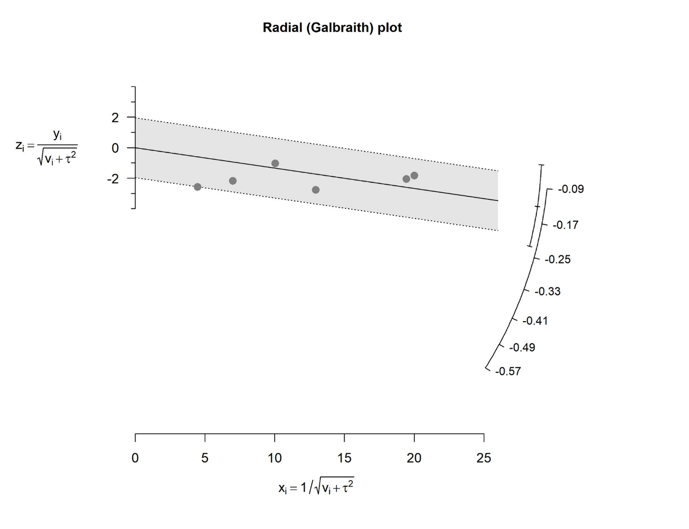
Fig. S1 Radial (Galbraith) plot. Each study is plotted with the standardized residual on the y-axis and precision (1/√(vᵖ + τ²)) on the x-axis. The solid line represents the pooled estimate; the dotted lines mark the ±2 standard deviation bounds. All six observations fall within the 95% confidence band, confirming the absence of outliers and supporting negligible heterogeneity (I² = 0.1%).

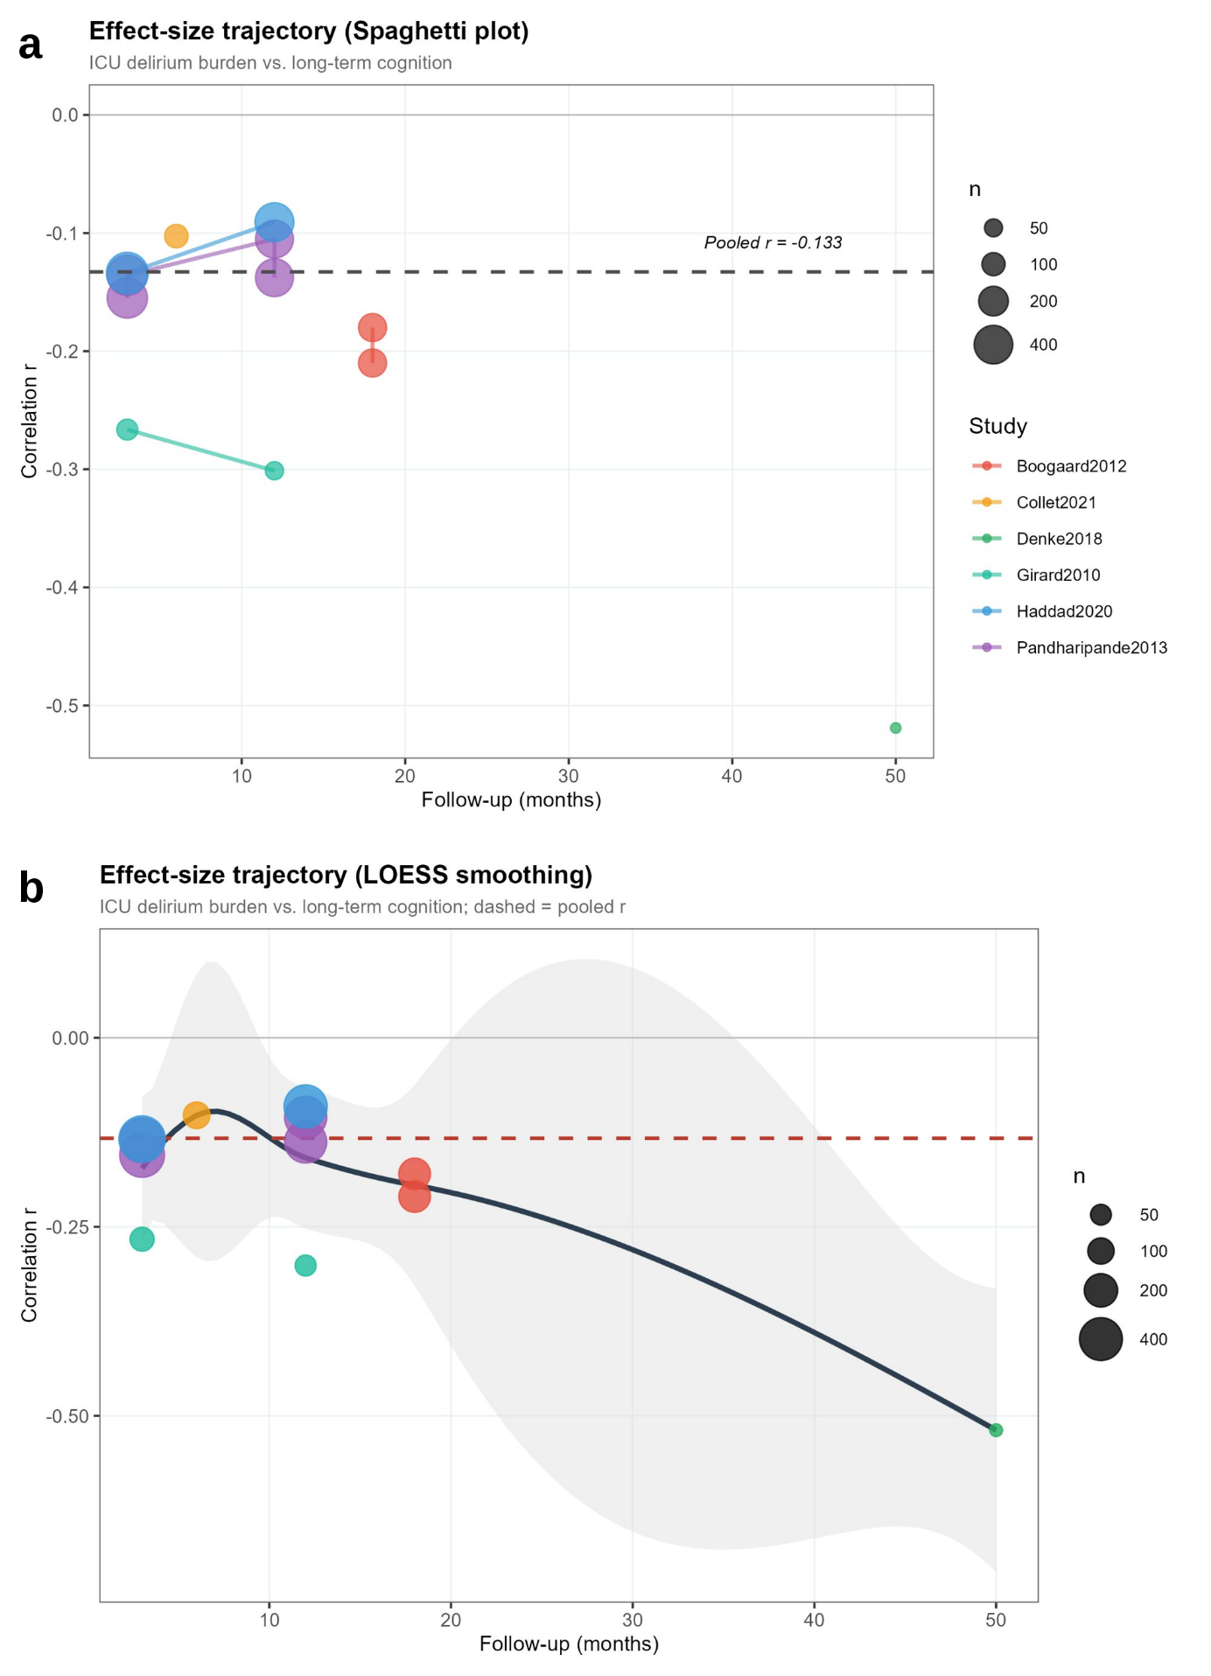
Fig. S2 Effect-size trajectory by follow-up duration. a Spaghetti plot of study-level correlations against follow-up time (months); bubble size is proportional to sample size; the dashed line indicates the overall pooled r = −0.133. b LOESS-smoothed trajectory with 95% pointwise confidence band (shaded region). The dashed red line marks the pooled r. The downward slope suggests the negative association may strengthen with longer follow-up (exploratory; k = 6). ICU, intensive care unit; LOESS, locally estimated scatterplot smoothing.

