Supplementary information
Breaking the wear resistance dilemma of nanograined metals with dispersive internal gradient heterostructure
Zhaoshuo Chen¹†, Xianzhi Bian¹†, Yan Lin, Fei Liang^{1*}, Yuntian Zhu^{2*}, Xiang Chen^{1*}
¹ Nano and Heterogeneous Materials Center, School of Materials Science and Engineering, Nanjing University of Science and Technology, Nanjing, China
² Department of Materials Science and Engineering, City University of Hong Kong, Hong Kong, China
†These authors contributed equally to this work.
*Corresponding author. E-mail: fliang@njust.edu.cn; yuntizhu@cityu.edu.hk; xiang.chen@njust.edu.cn.

Table of Contents
Supplementary Fig. 1 1
Supplementary Fig. 2 2 Supplementary Fig. 3 3
Supplementary Fig. 4 4
Supplementary Fig. 5 5
Supplementary Fig. 6 6
Supplementary Fig. 7 7
Supplementary Fig. 8 8
Supplementary Fig. 9 9

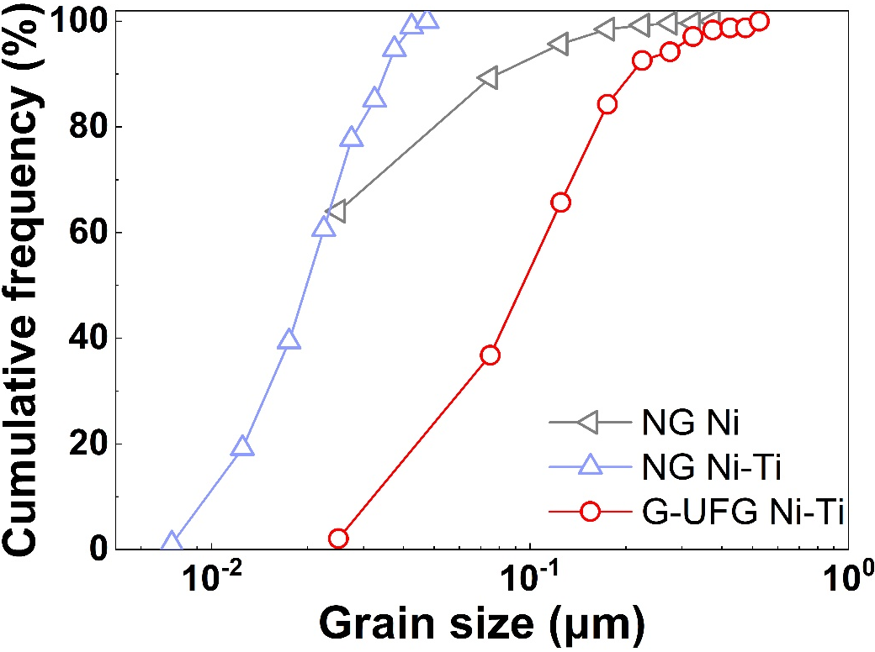
Supplementary Fig. 1. Statistical results of grain size for the as-deposited states. Cumulative frequency distribution of grain sizes in NG Ni, NG Ni-Ti and G-UFG Ni-Ti.

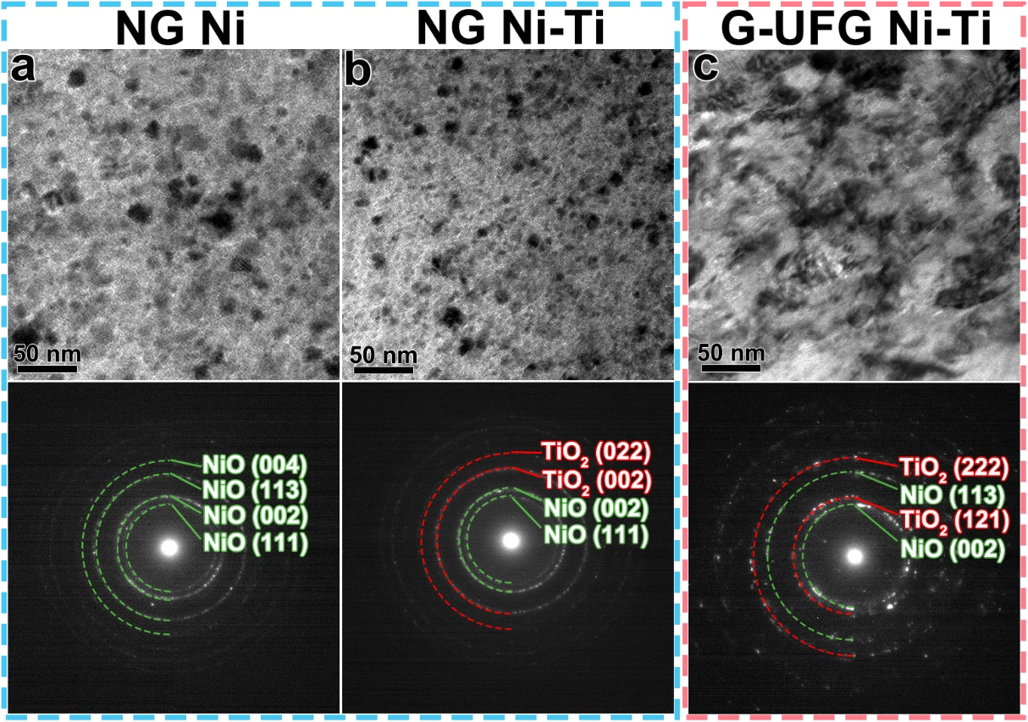
Supplementary Fig. 2. Microstructure characterization of tribolayers formed at room temperature. a-c, TEM images and corresponding selected area diffraction patterns in tribolayers of (a) NG Ni, (b) NG Ni-Ti, (c) G-UFG Ni-Ti worn at 25 ℃.

Supplementary Fig. 3. Tribo-induced thinning of Ti particle at room temperature. a,b, STEM images and corresponding EDS mapping results of refined Ti lamellae in the subsurface DRX layer of (a) G-UFG Ni-Ti and (b) NG Ni-Ti worn at 25 ℃.

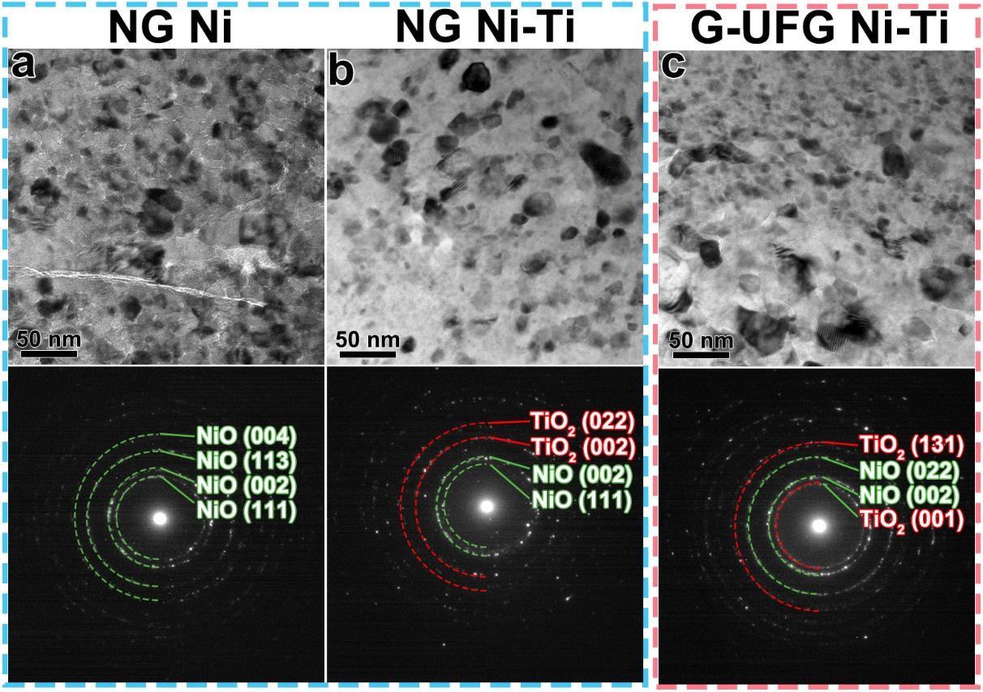
Supplementary Fig. 4. Microstructure characterization of tribolayers formed at high temperature. a-c, TEM images and corresponding selected area diffraction patterns in tribolayers of (a) NG Ni, (b) NG Ni-Ti, (c) G-UFG Ni-Ti worn at 800 ℃.

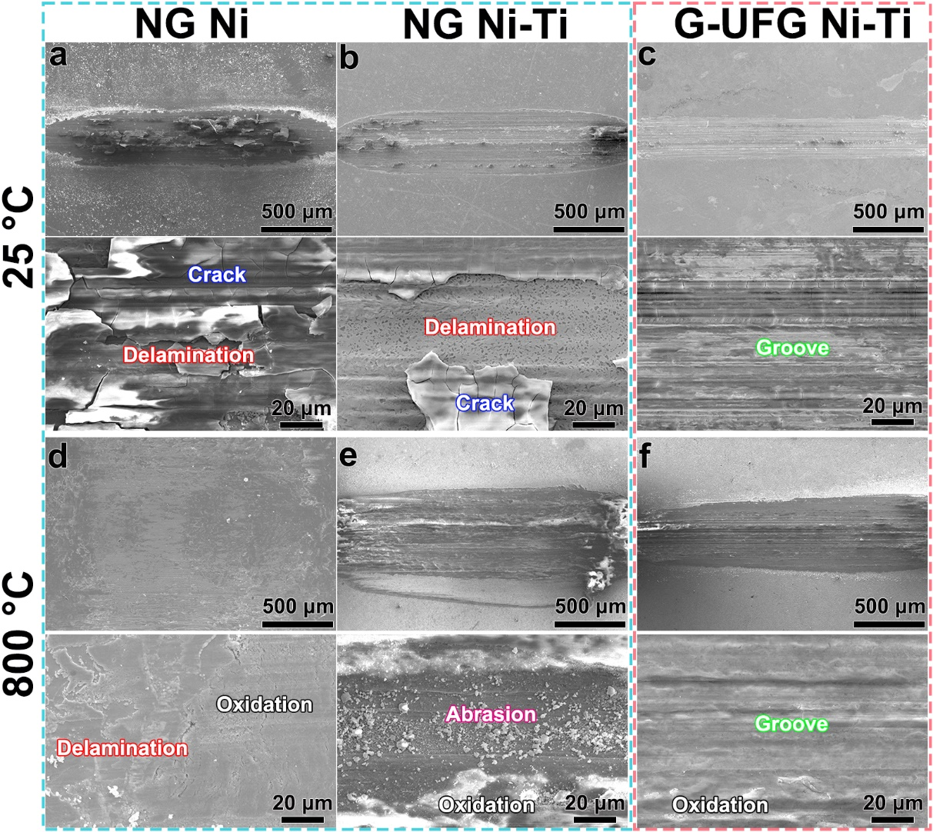
Supplementary Fig. 5. Surface morphology characterization of wear scars at room and high temperature. SEM images of typical wear scars for (a, d) NG Ni, (b, e) NG Ni-Ti, (c, f) G-UFG Ni-Ti worn at (a-c) 25 ℃ and (d-f) 800 ℃.

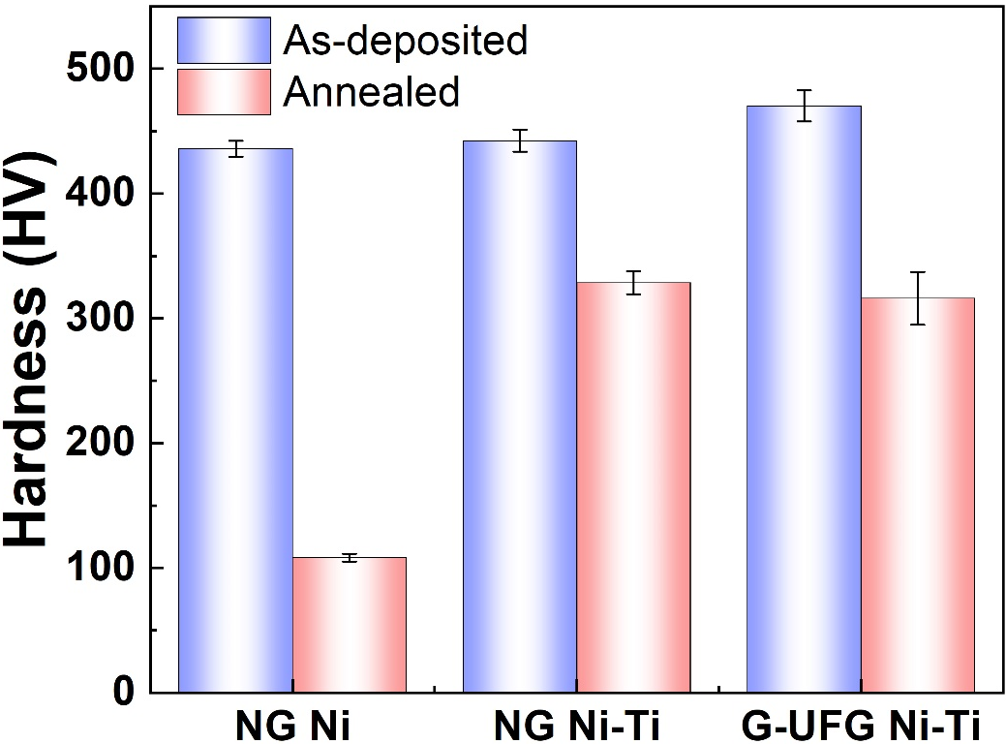
Supplementary Fig. 6. Mechanical characterization for the as-deposited and annealed states. Hardnesses of NG Ni, NG Ni-Ti and G-UFG Ni-Ti before and after annealing at 800 ℃.

Supplementary Fig. 7. Grain growth behavior of the Ni matrix adjacent to Ti particles in compressed and annealed states. a, Grain size distribution of the Ni matrix as a function of distance within ~3 μm from the tops of compressed pillars for NG Ni-Ti and G-UFG Ni-Ti. b, Grain size distribution of the Ni matrix as a function of distance for annealed NG Ni-Ti and G-UFG Ni-Ti. The solid points represent the locations of Ti particles.

Supplementary Fig. 8. Microstructure characterization of the as-deposited Ni-Nb and Ni-Ta. a,b, Inverse pole figures of the gradient nanograined Ni adjacent to (a) Nb and (b) Ta particles.

Supplementary Fig. 9. In-plane characterization of the as-deposited Ni-Ti samples. a-d, SEM images of as-deposited (a) Ni-4%Ti, (b) Ni-6%Ti, (c) Ni-11%Ti, (d) Ni-19%Ti. e, The EDS mapping depicts the distribution of Ni and Ti element in Ni-19%Ti. f, The variation of Ti particle volume fraction in Ni-Ti samples versus the concentration of Ti particles in the electrodeposition solution.

