Supplementary Materials
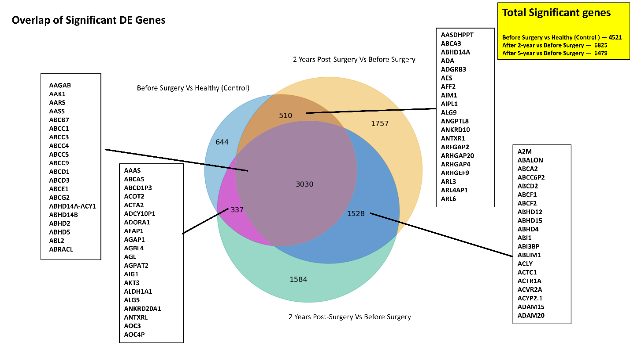
Supplementary Figure S1. Venn diagram showing the overlap of significant differentially expressed (DE) genes among three comparisons.
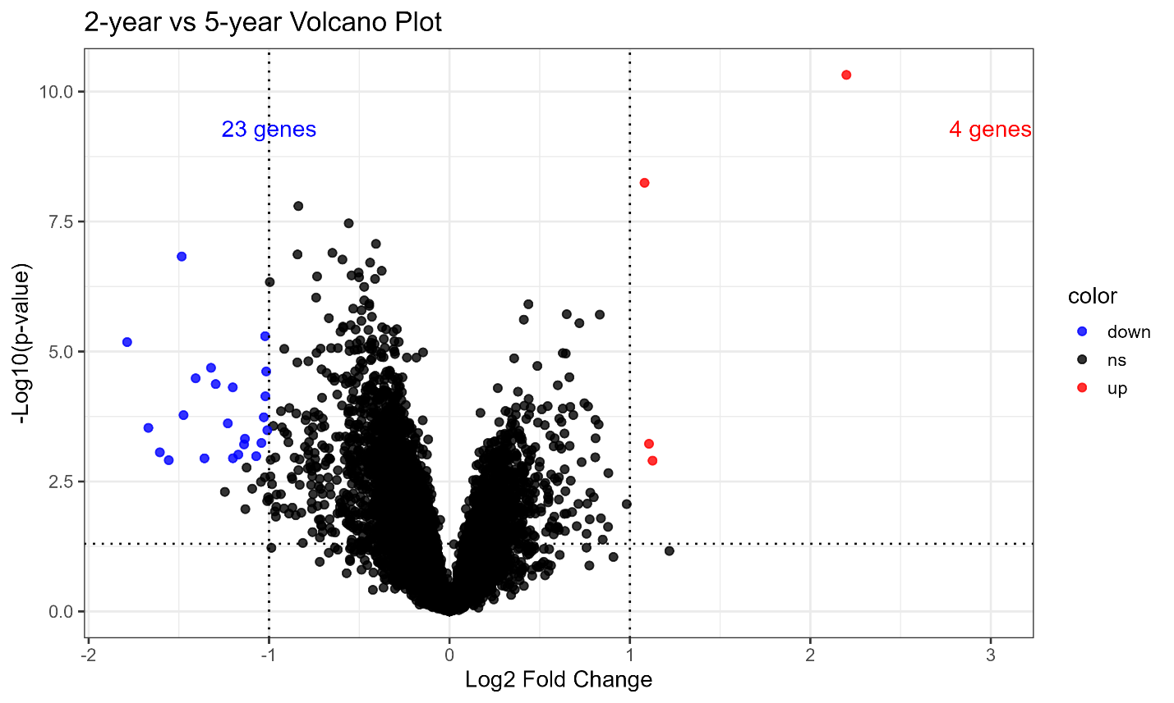
Supplementary Figure S2. Volcano plot of differential gene expression between 2-year and 5-year post-

Supplementary Section S1: Evaluation Metrics
The five evaluation metrics—weighted recall (sensitivity), specificity, precision, accuracy, and F1 score- are measured, which were mathematically defined in Equations (1)–(5).

${\text{Accuracy}}_{{\text{class}}_{j}}=\frac{TP_{j}+TN_{j}}{TP_{j}+TN_{j}+FP_{j}+FN_{j}}$ (1)
${\text{Precision}}_{{\text{class}}_{j}}=\frac{TP_{j}}{TP_{j}+FP_{j}}$ (2)
${\text{Recall}}_{{\text{class}}_{j}}=\frac{TP_{j}}{TP_{j}+FN_{j}}$ (3)
${\text{F1}\text{_}\text{score}}_{{\text{class}}_{j}}=2×\frac{{\text{Precision}}_{j}×{\text{Recall}}_{j}}{{\text{Precision}}_{j}+{\text{Recall}}_{j}}$ (4)
${\text{Specificity}}_{{\text{class}}_{j}}=\frac{TN_{j}}{TN_{j}+FP_{j}}$ (5)

Supplementary Table S1: Integrated Machine Learning Feature Importance and Statistical Significance of Differentially Expressed Genes for Top ranked genes.

Before Surgery Vs After 2 Years |  |  |  |  | Before Surgery Vs After 5 Years
feature | Mean_importance | log2FC | adj_p_value | AUC | feature | Mean_importance | log2FC | adj_p_value | AUC
BMP2K | 0.111356 | -1.39312 | 6.80E-24 | 0.975306 | FCGR2A | 0.125233 | -3.6626 | 2.53E-16 | 0.978421
IL1RN | 0.076156 | -4.10502 | 4.64E-21 | 0.977347 | NCKAP1L | 0.064406 | -2.8344 | 1.35E-18 | 0.972105
ACSS3.1 | 0.069492 | 2.229624 | 4.25E-26 | 0.987347 | BTK | 0.04743 | -1.46345 | 4.96E-19 | 0.994211
HMOX1 | 0.031021 | -1.60829 | 1.97E-23 | 0.984286 | RNU11 | 0.028273 | 2.248874 | 2.56E-22 | 0.97
PCDH18 | 0.014664 | 1.568122 | 5.53E-21 | 0.961224 | NIPSNAP3A | 0.020722 | 1.469537 | 2.22E-16 | 0.975526
UCHL1 | 0.011017 | -3.47153 | 2.98E-17 | 0.960612 | TIMP1 | 0.018431 | -2.38146 | 2.88E-21 | 0.991053
MAPRE1 | 0.010348 | -0.9102 | 1.89E-18 | 0.948776 | ECHDC2 | 0.015649 | 1.204968 | 1.11E-17 | 0.975263
ALCAM | 0.008885 | -3.15541 | 1.00E-23 | 0.99 | CDC42 | 0.012035 | -0.38734 | 2.62E-12 | 0.888684
ACACB | 0.008396 | 1.114461 | 1.20E-14 | 0.890612 | CTSC | 0.010523 | -1.58273 | 1.25E-12 | 0.916053
ADH1B | 0.008323 | 1.312612 | 2.08E-19 | 0.976327 | TYROBP | 0.010439 | -3.89832 | 3.70E-17 | 0.978684
NAALAD2 | 0.007922 | 1.401249 | 5.85E-18 | 0.957551 | SFRP4 | 0.010289 | -3.34615 | 2.69E-13 | 0.936053
NLN | 0.007634 | -1.3166 | 1.00E-23 | 0.961633 | CD53 | 0.009048 | -0.38734 | 2.62E-12 | 0.888684
PSAP | 0.007419 | -0.93062 | 7.91E-23 | 0.973061 | PIK3CG | 0.008741 | -1.42658 | 7.12E-15 | 0.930263
ACVR1C | 0.007051 | 2.097682 | 2.95E-25 | 0.985102 | FCGR3A | 0.008254 | -2.71308 | 2.32E-17 | 0.958947
SH3BGRL3 | 0.006844 | -1.91778 | 4.13E-20 | 0.970612 | CLEC7A | 0.007789 | -2.82745 | 9.88E-22 | 0.972105
FCER1G | 0.006663 | -2.81773 | 3.94E-21 | 0.979388 | HCLS1 | 0.007718 | -1.71583 | 5.70E-17 | 0.952105
ZNF326 | 0.006391 | 0.301461 | 0.005275 | 0.647347 | HACD4 | 0.007583 | -1.34714 | 2.28E-14 | 0.914737
ADHFE1 | 0.006038 | 1.30538 | 7.55E-20 | 0.962245 | FCER1G | 0.00723 | -3.68877 | 9.55E-17 | 0.98
ASAH1 | 0.00587 | -1.14086 | 9.10E-17 | 0.937143 | ADHFE1 | 0.006614 | 1.230874 | 4.91E-16 | 0.960526
TYROBP | 0.00561 | -2.72792 | 1.37E-19 | 0.966531 | PTPRC | 0.006358 | -2.56205 | 2.63E-16 | 0.946316

