Spatiotemporal control of molecular delivery in the brain using photoactivable polymersomes
- Supplemental Information -
Camille Ruffier¹, Emmanuel Ibarboure², Benjamin Chauvineau¹, Noël Pairault³, Jean-Christophe Helbling¹, Maria-Florencia Angelo¹, Rémi Kinet⁴, Benjamin Dehay⁴, Sébastien Marais⁵, Aryan Mohanani¹, Jean-Charles Nicolas¹, Baptiste Texier¹, Zahra Sebghati Mamaghani¹, Akshay Silswal³, Pierre Trifilieff¹, Nathan D. McClenaghan³, Sébastien Lecommandoux^{2,6,#}, Clémentine Bosch-Bouju^{1,#}

¹ Nutrition and Integrative Neurobiology laboratory (NutriNeuro), UMR 1286, INRAE, Université de Bordeaux, Bordeaux INP, Bordeaux, France
² Organic Polymer Chemistry laboratory (LCPO), UMR 5629, CNRS, Université de Bordeaux, Bordeaux INP, ENSMAC, Pessac, France
³ Institute of Molecular Sciences (ISM), UMR 5255, Université de Bordeaux, CNRS, Talence, France
⁴ Institut des Maladies neurodégénératives, CNRS UMR 5293, Université de Bordeaux, Centre Broca Nouvelle Aquitaine, Bordeaux, France
⁵ Bordeaux Imaging Center (BIC), UAR 3420, CNRS, Université Bordeaux, US4 INSERM, Centre Broca Nouvelle Aquitaine, Bordeaux, France
⁶ Institut Universitaire de France (IUF)
# Corresponding authors: clementine.bosch_bouju@bordeaux-inp.fr; sebastien.lecommandoux@bordeaux-inp.fr

CoolLED % (raw setting) | Mesured power  (40x objective, mW) | Normalized (%)
1 | 1.5 | 4
2 | 2.4 | 5
3 | 3.4 | 8
4 | 3.8 | 9
5 | 4.6 | 11
6 | 5.2 | 12
7 | 5.7 | 13
8 | 6.3 | 14
9 | 6.8 | 16
10 | 7.4 | 17
15 | 9.8 | 23
20 | 11.9 | 28
30 | 15.8 | 37
40 | 19.6 | 45
50 | 23.4 | 54
60 | 27.1 | 63
70 | 31.1 | 72
80 | 35.0 | 81
90 | 39.0 | 90
100 | 43.2 | 100

Supplemental Table 1. CoolLED power calibration at 40x objective (470 nm blue).
CoolLED pE-300 irradiance measurements through 40x 0.8 NA objective on Olympus scope. Power measured at focus with Thorlabs power meter, averaged 5 s per reading. Normalized % calculated as (measured power / max power at 100%) × 100.

Fiber (raw setting)  (%) | Measured power at ferrule (mW) | Normalized  (%)
1 | 0.6 | 1
2 | 2.1 | 5
3 | 3.6 | 8
4 | 8.8 | 20
5 | 19.3 | 45
6 | 31.5 | 73

Supplemental Table 2. Fiber optic power delivery (470 nm blue).
Power output from 400 µm core fiber (NA = 0.50), measured at 1.25 mm ferrule output using Thorlabs power meter. Normalized % calculated relative to maximum power at 100% setting.

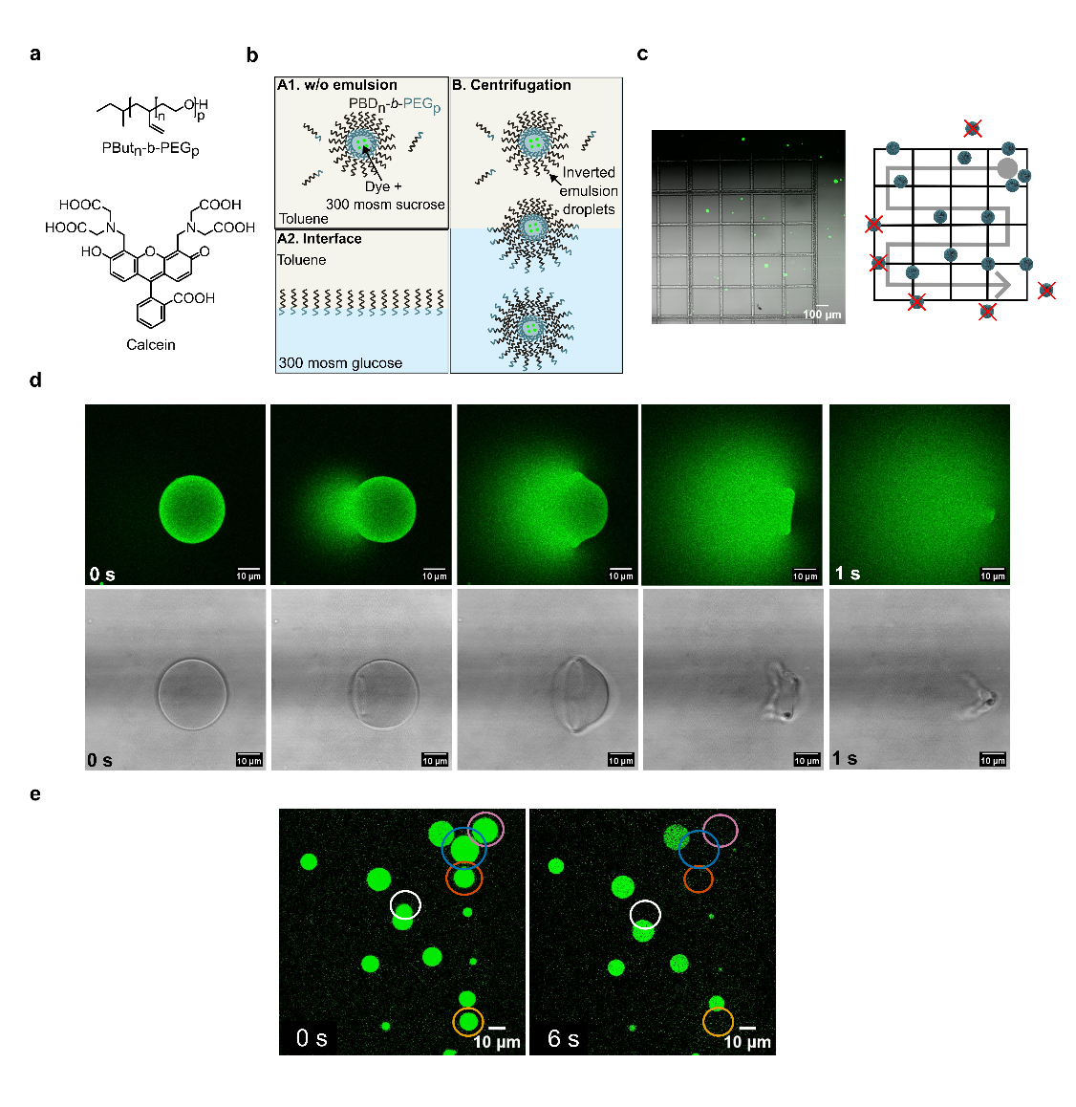
Supplementary Figure 1. Principle of photosensitive polymersomes production, quantification and photostimulation. a, Chemical structures of amphiphilic block copolymer, poly(butadiene)-b-poly(ethylene oxide) (PBut_{n}-b-PEG_{p}) and calcein. b, Schematic representation of the formation of calcein-loaded polymersomes following the emulsion-centrifugation protocol. Sucrose-containing water droplets generated by emulsion and stabilized by the copolymer in toluene (A1) were deposited on a glucose solution-toluene interface containing the same copolymer (A2). Upon centrifugation, the droplets crossed the interface to form polymersomes in the glucose phase, thereby enabling the encapsulation of calcein in the sucrose phase (B). c, (left) Merged confocal image showing polymersomes (green) overlaid with transmission image of the counting square. Polymersomes were distributed within the grid used to quantify their concentration. (right) Schematic representation of a counting square (1 × 1 mm, subdivided into 16 sub-squares of 0.25 mm) of a Fast-Read 102 cell. Polymersomes that were entirely inside or touching the upper/right edges (solid lines) were counted; those on the lower/left edges (dotted lines) were excluded to avoid double counting. d, Confocal observation of the rupture of a calcein-loaded polymersome across 1 second in the green channel and transmission channel. e, Confocal observation of the selective rupture of calcein-loaded polymersomes (green). Regions of interest (ROIs) were defined around selected polymersomes (circles) and allow specific illumination of these polymersomes. At t = 0 s, 5 vesicles (circled) were subjected to illumination at 488 nm.
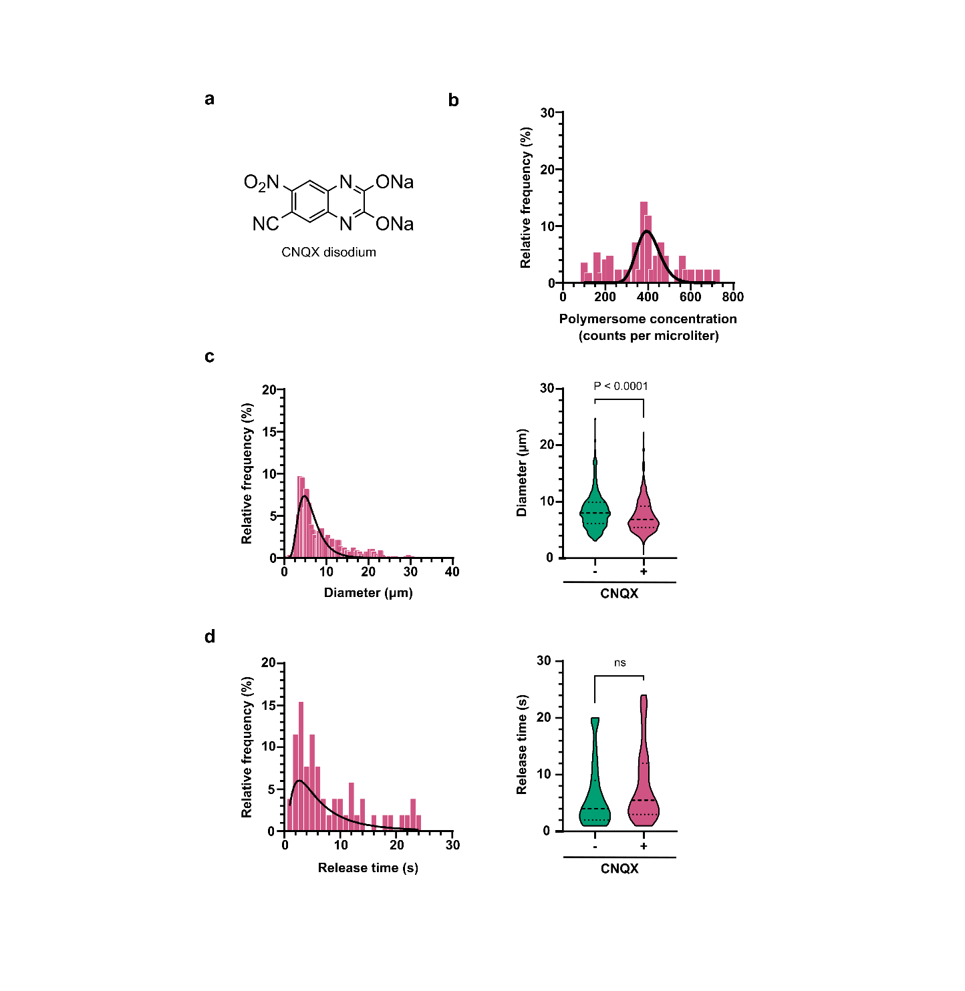
Supplementary Figure 2. Effect of CNQX loading on physical properties of photosensitive polymersomes. a, Chemical structure of CNQX disodium salt. b–d, Relative frequency (%) histograms with log-normal fits for polymersome concentration (counts/µL; b); diameter (µm; c), and release time (s; d). Right: violin plots comparing polymersomes-unloaded (−) vs. CNQX-loaded (+) polymersomes. CNQX loading reduces diameter (P < 0.0001), but not release time (t-test).

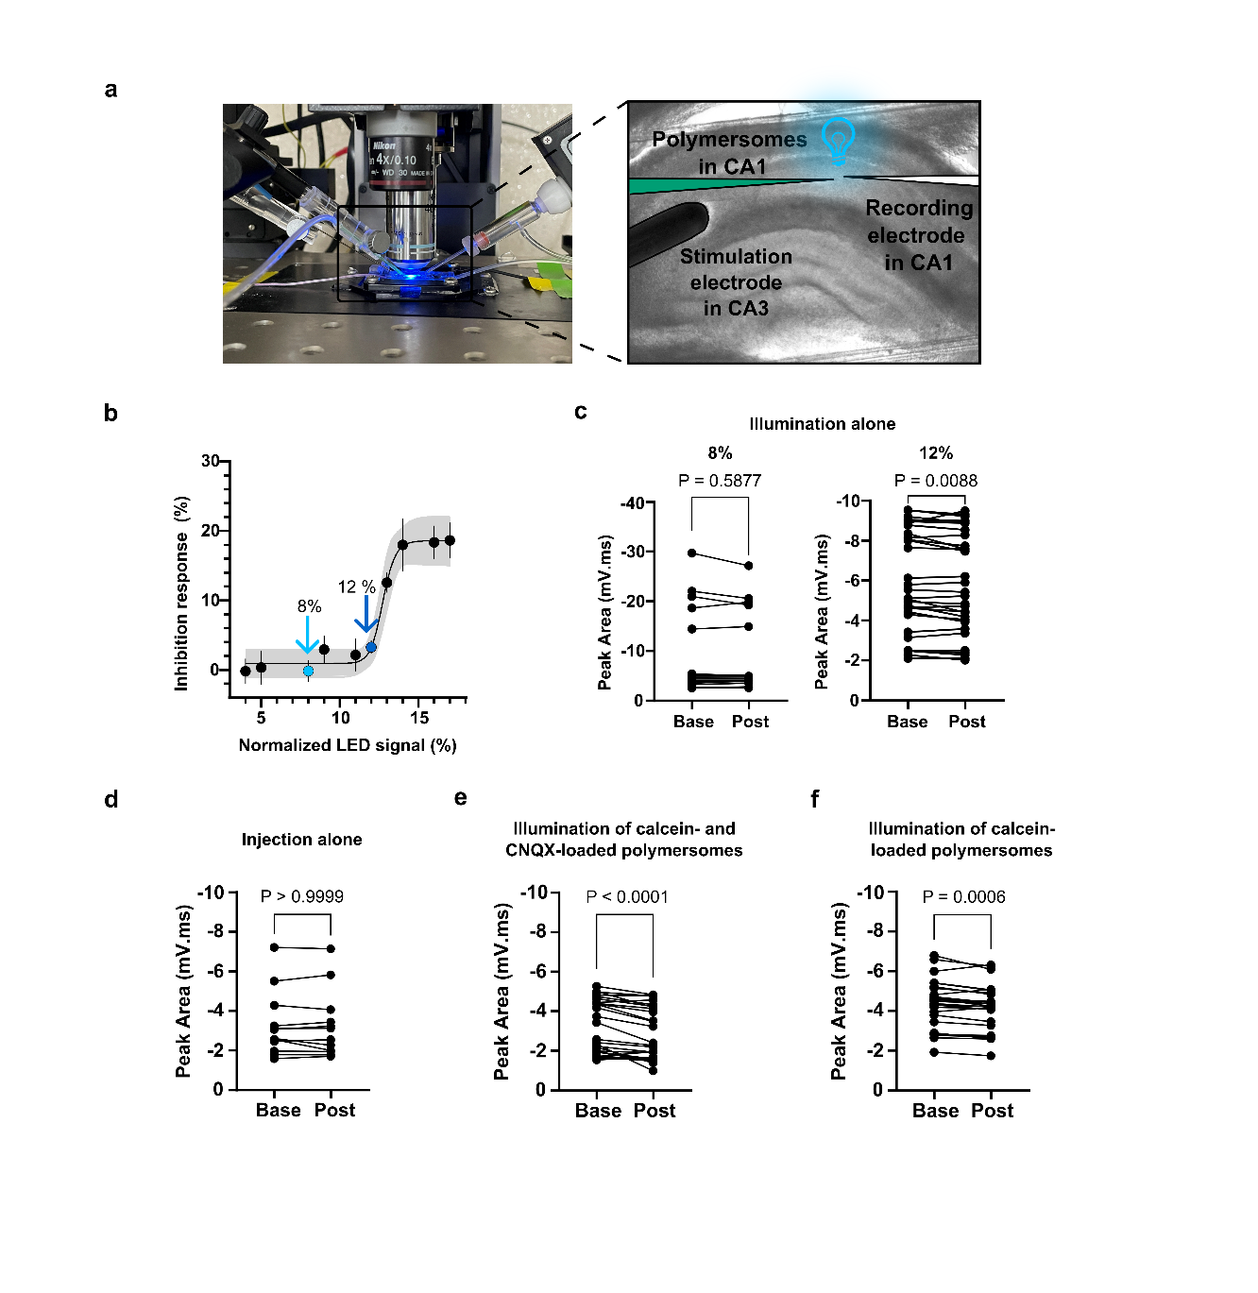

Supplementary Figure 3. Photoactivation of CNQX-loaded polymersomes reduces CA3-CA1 synaptic transmission. a, Experimental setup (left, photography). Stimulation of CA3-CA1 connexion were elicited with electrical stimulating electrode, while fEPSP recording were made in CA1, with polymersomes injection close to recording pipette. b, Inhibition of response (%) as a function of normalized LED signal intensity (%) with an adjusted sigmoid curve (4PL) (IC₅₀ = 12.73% LED; Hill slope = 31.84). R² = 0.52. c–e, fEPSP peak area (mV·ms; baseline vs. post-manipulation). Individual responses of field recording to Illumination alone (8% or 12%) (c), injection alone (d), photostimulation of calcein/CNQX-loaded polymersomes (e), or photostimulation of calcein-loaded polymersomes (f). Dots represent individual trials, paired t-test.

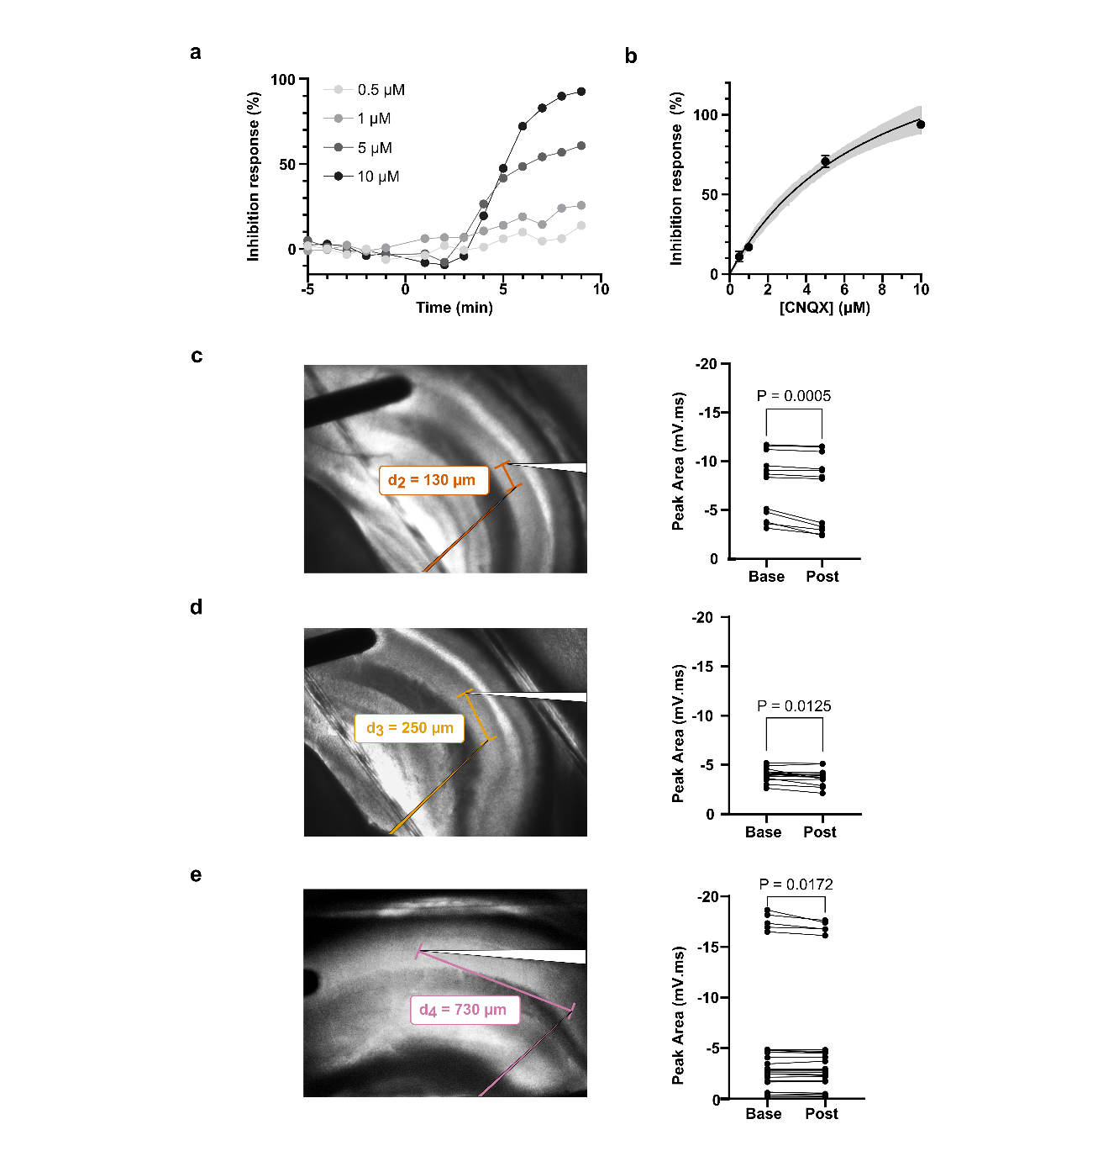
Supplementary Figure 4. Efficacy and spatial specificity of controlled-release of CNQX in hippocampal slices. a, Time course of fEPSP inhibition with increasing CNQX concentrations (0.5–10 µM). b, [CNQX]–inhibition relationship (with fit and confidence band). c–e, slice images (left) indicating the distance between the injection site and recording location (d_2=130 µm, d_3=250 µm, d_4=730 µm) with paired fEPSP peak area (mV·ms) measurements at baseline (Base) and after manipulation (Post); P values are shown for each condition.

