Evolution of an increased performance under acute challenge does not exacerbate vulnerability to chronic stress

Authors
Małgorzata M. Lipowska^{1,}*, Edyta T. Sadowska¹, Rupert Palme², Paweł Koteja¹
¹ Institute of Environmental Sciences, Jagiellonian University, Kraków, Poland
² Department of Biomedical Sciences, University of Veterinary Medicine, Vienna, Austria
* Correspondence: malgorzata.lipowska@doctoral.uj.edu.pl

Supplementary materials

Figures
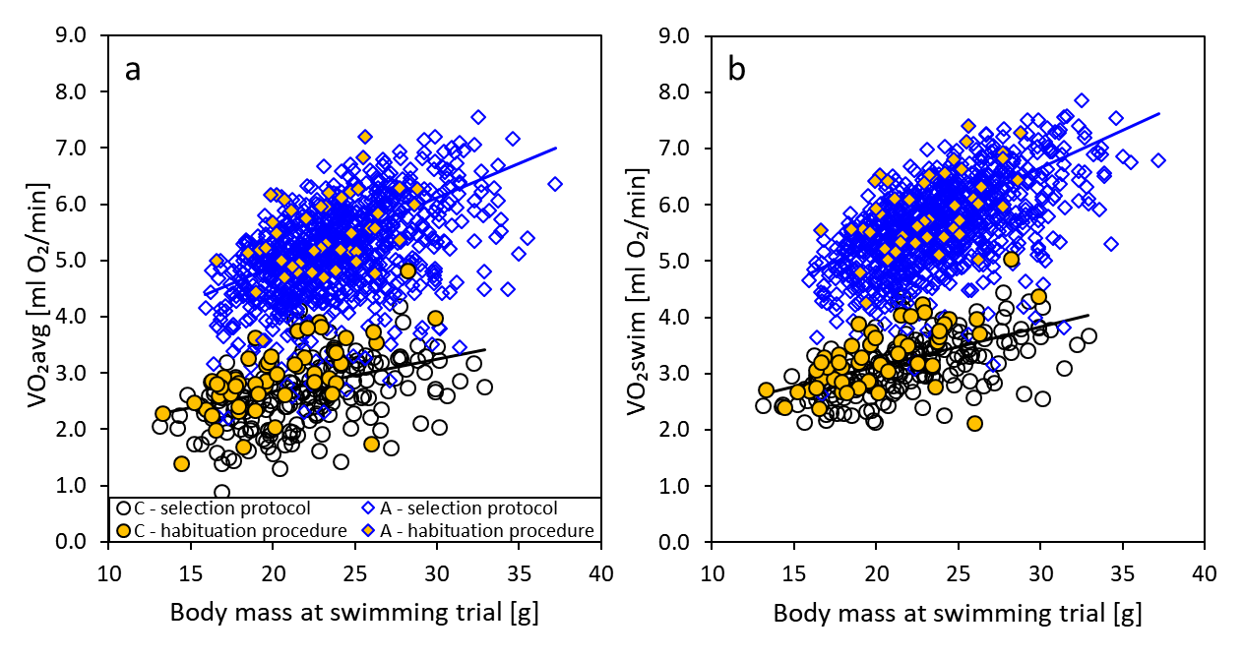
Supplementary Fig. S1 The relation between the average (a) and maximum (b) swim-induced rate of oxygen consumption (VO₂avg and VO₂swim) and body mass in bank voles from “control” (C) and “aerobic” (A) lines, undergoing habituation procedure (yellow symbols, 100 animals) or involved in a selection protocol (empty symbols, 1026 animals).

Supplementary Fig. S2 Raw values of body mass (BMavg), food intake (FI), fecal corticosterone metabolites (FCMs), and average and maximum swim-induced rate of oxygen consumption (VO₂avg and VO₂swim) measured in bank voles from the groups exposed to chronic mild stress (CMS group) and undisturbed (comfort group), collected before (Initial week) and during (First and Second week) the experiment. The experiment was performed on 48 C-line (“control”) and 46 A-line (“aerobic”) voles. Horizontal lines indicate arithmetic means within each group. Mind the logarithmic scale on panel c.
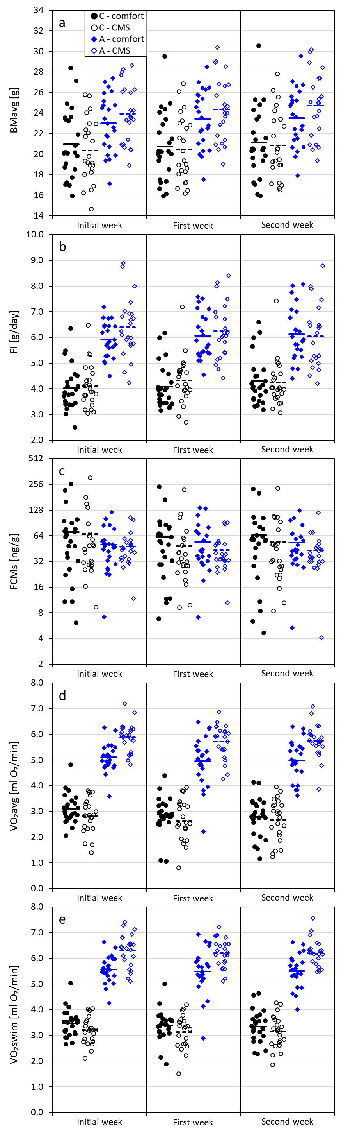

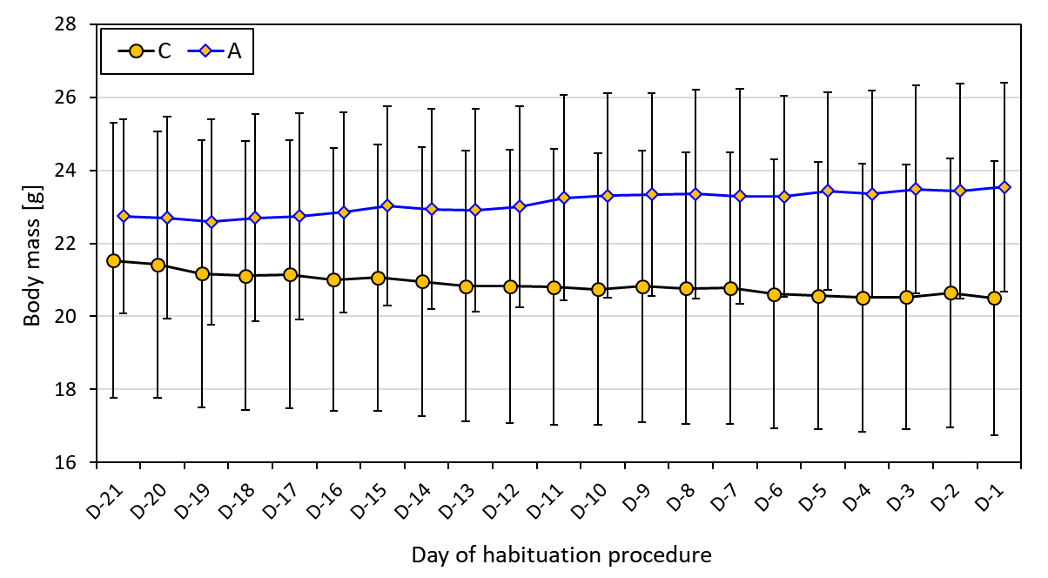
Supplementary Fig. S3 Body mass (mean ± SD) of 54 animals from the “control” (C) and 46 animals from the “aerobic” (A) lines in consecutive days of the habituation procedure. The calculation did not involve the 2 animals that died during the procedure, 3 that were recognized as diabetic and 7 in which the swimming trial at D0 was not successful.

Tables
Supplementary Table S1 Sample size and mean ± standard deviation of body mass and swim-induced metabolic rates of all animals that underwent a swimming trial in generation 25. Animals from two line types (“control” and “aerobic”) were tested either as a part of selection protocol or following a habituation procedure for the chronic stress experiment.
Variable  (abbreviation) | Variable  (full name) | “control” (C) lines |  |  | “aerobic” (A) lines
Variable  (abbreviation) | Variable  (full name) | selection  protocol | habituation  procedure |  | selection  protocol | habituation  procedure
N | number of individuals | 177 | 54 |  | 849 | 46
 | body mass at swimming trial [g] | 21.9 ± 4.1 | 20.3 ± 3.6 |  | 23.8 ± 3.7 | 23.1 ± 2.9
VO₂avg | average oxygen consumption in a swimming trial [ml O₂/min] | 2.58 ± 0.58 | 2.94 ± 0.63 |  | 5.13 ± 0.82 | 5.50 ± 0.69
VO₂swim | maximum 1-min oxygen consumption in a swimming trial [ml O₂/min] | 3.13 ± 0.50 | 3.31 ± 0.56 |  | 5.63 ± 0.76 | 5.93 ± 0.69

Supplementary Table S2 Sample size and mean ± standard deviation of values measured in the animals used in the experiment. Data collected over three consecutive weeks: initial (last week of the habituation procedure), and first and second week of the experiment, from animals representing two line types (“control” and “aerobic”) and divided into two experimental groups (comfort and CMS – Chronic Mild Stress).
Variable  (abbreviation) | Variable  (full name) | week | “control” (C) lines |  |  | “aerobic” (A) lines
Variable  (abbreviation) | Variable  (full name) | week | comfort | CMS |  | comfort | CMS
N | number of individuals |  | 24 | 23 |  | 23 | 23
BMavg | average body mass [g] | initial | 21.0 ± 3.3 | 20.3 ± 3.1 |  | 23.0 ± 2.8 | 23.9 ± 2.8
BMavg | average body mass [g] | first | 20.7 ± 3.3 | 20.5 ± 3.2 |  | 23.4 ± 2.8 | 24.3 ± 3.1
BMavg | average body mass [g] | second | 21.1 ± 3.4 | 20.9 ± 3.3 |  | 23.5 ± 2.8 | 24.7 ± 3.1
FI | apparent food intake [g/day] | initial | 4.03 ± 0.87 | 4.10 ± 0.84 |  | 5.92 ± 0.68 | 6.40 ± 1.16
FI | apparent food intake [g/day] | first | 4.08 ± 0.84 | 4.33 ± 0.92 |  | 6.06 ± 0.88 | 6.24 ± 1.09
FI | apparent food intake [g/day] | second | 4.30 ± 0.94 | 4.24 ± 0.91 |  | 6.13 ± 1.05 | 5.78 ± 1.75
FCMs | fecal corticosterone metabolites [ng/g] | initial | 70.4 ± 62.6 | 66.9 ± 67.9 |  | 50.6 ± 27.3 | 47.6 ± 20.8
FCMs | fecal corticosterone metabolites [ng/g] | first | 61.7 ± 52.1 | 48.5 ± 46.1 |  | 54.5 ± 34.7 | 43.3 ± 21.1
FCMs | fecal corticosterone metabolites [ng/g] | second | 65.1 ± 53.5 | 53.9 ± 49.4 |  | 53.1 ± 27.9 | 42.9 ± 21.7
VO₂swim | maximum 1-min oxygen consumption in a swimming trial [ml O₂/min] | initial | 3.46 ± 0.54 | 3.20 ± 0.53 |  | 5.57 ± 0.52 | 6.30 ± 0.64
VO₂swim |  | first | 3.40 ± 0.61 | 3.14 ± 0.65 |  | 5.49 ± 0.88 | 6.21 ± 0.56
VO₂swim |  | second | 3.35 ± 0.62 | 3.14 ± 0.63 |  | 5.50 ± 0.64 | 6.20 ± 0.52
VO₂avg | average oxygen consumption in a swimming trial [ml O₂/min] | initial | 3.10 ± 0.58 | 2.81 ± 0.66 |  | 5.10 ± 0.56 | 5.89 ± 0.57
VO₂avg | average oxygen consumption in a swimming trial [ml O₂/min] | first | 2.87 ± 0.71 | 2.64 ± 0.80 |  | 4.96 ± 0.97 | 5.71 ± 0.66
VO₂avg | average oxygen consumption in a swimming trial [ml O₂/min] | second | 2.78 ± 0.75 | 2.68 ± 0.81 |  | 4.98 ± 0.77 | 5.74 ± 0.65

Supplementary Table S3 Likelihood ratio (LR) test statistics for significance of random effects in ANCOVA mixed models performed on scopes of deviation from baseline trait values during the experiment. Models for body mass averaged over 4 days (BMavg), apparent daily food intake (FI), fecal corticosterone metabolites (FCMs), and measures of swimming metabolism: average oxygen consumption (VO₂avg) and maximum 1-min oxygen consumption (VO₂swim). n.a. – non-applicable (factor absent from the model). s² – covariance parameter estimate; SE – standard error of covariance parameter estimation; chi² – difference between -2 residual log likelihoods of two models used in the LR test; p – p-value. Values of s² ≤ 0 – variance estimate constrained to zero; n.a. – not applicable (tests not performed for components, where variance was constrained to zero).
Variable  (abbreviation) | Variable  (full name) |  | replicate line | replicate line × sex | replicate line × treatment | replicate line × week | replicate line × treatment × week | experimental block | experimental block × test | individual
BMavg | average body mass | s²(SE) | 0.00(0.00) | ≤ 0 | ≤ 0 | ≤ 0 | ≤ 0 | ≤ 0 | ≤ 0 | 0.00(0.00)
BMavg | average body mass | chi² | 3.6 | n.a. | n.a. | n.a. | n.a. | n.a. | n.a. | 94.4
BMavg | average body mass | p | 0.058 | n.a. | n.a. | n.a. | n.a. | 0.074 | n.a. | <0.001
FI | apparent food intake | s²(SE) | 0.00(0.00) | ≤ 0 | 0.00(0.00) | ≤ 0 | ≤ 0 | ≤ 0 | ≤ 0 | 0.00(0.00)
FI | apparent food intake | chi² | 5.4 | n.a. | 2 | n.a. | n.a. | n.a. | n.a. | 19.4
FI | apparent food intake | p | 0.020 | n.a. | 0.157 | n.a. | n.a. | <0.001 | n.a. | <0.001
FCMs | fecal corticosterone metabolites | s²(SE) | ≤ 0 | 0.00(0.00) | ≤ 0 | ≤ 0 | ≤ 0 | ≤ 0 | ≤ 0 | 0.06(0.00)
FCMs | fecal corticosterone metabolites | chi² | n.a. | 2.1 | n.a. | n.a. | n.a. | n.a. | n.a. | 33.8
FCMs | fecal corticosterone metabolites | p | n.a. | 0.147 | n.a. | n.a. | n.a. | 0.192 | n.a. | <0.001
VO₂avg | average oxygen consumption in a swimming trial | s²(SE) | 0.00(0.00) | 0.00(0.00) | ≤ 0 | ≤ 0 | ≤ 0 | ≤ 0 | 0.00(0.00) | 0.01(0.00)
VO₂avg | average oxygen consumption in a swimming trial | chi² | 11.7 | 1.3 | n.a. | n.a. | n.a. | n.a. | 3.1 | 16.6
VO₂avg | average oxygen consumption in a swimming trial | p | 0.001 | 0.254 | n.a. | n.a. | n.a. | n.a. | 0.078 | <0.001
VO₂swim | maximum 1-min oxygen consumption in a swimming trial | s²(SE) | 0.00(0.00) | 0.00(0.00) | ≤ 0 | ≤ 0 | ≤ 0 | ≤ 0 | 0.00(0.00) | 0.00(0.00)
VO₂swim | maximum 1-min oxygen consumption in a swimming trial | chi² | 7.6 | 3.3 | n.a. | n.a. | n.a. | n.a. | 1.3 | 10.7
VO₂swim | maximum 1-min oxygen consumption in a swimming trial | p | 0.006 | 0.069 | n.a. | n.a. | n.a. | 0.069 | 0.254 | 0.001

