Supplementary Materials for

Sub-nanosecond Infrared Photodetection using III-V Colloidal Quantum Dots
Bin Sun¹, Amin Morteza Najarian¹, Chao Zheng¹, Laxmi Kishore Sagar¹, Min-Jae Choi¹, Xiyan Li¹, Larissa Levina¹, Se-Woong Baek¹, Seungjin Lee¹, Ahmad R. Kirmani^{2*}, Jehad Abed¹, Mengxia Liu¹, Peicheng Li³, Lee J. Richter², Oleksandr Voznyy¹, Zheng Hong Lu³, F. Pelayo García de Arquer^{1**} and Edward H. Sargent^{1**}
Correspondence to:
**e-mail: pelayo.garciadearquer@utoronto.ca; ted.sargent@utoronto.ca

This PDF file includes:

Supplementary text
Supplementary Figs. 1 to 11

Supplementary text

DFT method was employed to investigate the mechanism of InBr₃ + DMF passivating (100) and (111) InAs surface. The bare surface energy is estimated via calculating $E_{bare-surf}$,
$$E_{bare-surf}=(E_{surface} - E_{bulk})/A$$
In which, $E_{surface}$ is the total energy of the bare surface, $E_{bulk}$ is the total energy of bulk InAs. A is the corresponding surface area. $E_{bare-surf}$ were calculated for both In-rich and As-rich surfaces. According to reported high surface energies of bare (100) and (111) surfaces^{1,2}, we focus on investigating the passivation mechanism of the two surfaces. From data in Table S1, both (100) surface energies of In-rich and As-rich conditions are higher than (111) surface energies. When comparing In-rich (100) and As-rich (100), In-rich (111) As-rich (111) surface energies, As-rich surface always has higher surface energies which are due to a larger amount of dangling bonds (DBs) exposed for cleaved As-rich surfaces.

Table S1. Calculated bare (100) and (111) surface energy for In-rich and As-rich InAs. (Unit: meV Å⁻²)
Surface | In-rich InAs | As-rich InAs
Bare (100) surface | 115.7 | 131.4
Bare (111) surface | 89.6 | 110.7

According to experiment, InBr₃ combined with DMF were found to effectively passivate the surfaces of InAs quantum dots. To investigate the passivation mechanism, we compared two types passivation method. For In-rich surfaces, Br was first used to treat the surface. Secondly, we designed the model of In-Br + DMF co-passivation. For As-rich surfaces, In-Br was first introduced, followed by passivation of In-Br + DMF. To estimate the effect of passivation, surface stabilization energy was calculated as:
$$E_{stabilization}=(E_{(In-Br)}+E_{DMF}+E_{bare}-E_{surf})/A$$
Where $E_{(In-Br)}$ is the total energy of In-Br complex, $E_{DMF}$ is the total energy of DMF molecule, $E_{bare}$ is the bare surface total energy, $E_{surf}$ is the total energy of passivated surface and A is the surface area. The corresponding passivated surface energies are listed in Table S2.

Table S2. Br and In-Br + DMF passivation. (Unit: meV Å⁻²)
Br passivation | In-rich InAs | As-rich InAs
(100) surface | 53.2 | 86.0
(111) surface | 83.5 | 113.3
In-Br + DMF passivation
(100) surface | 64.9 | 100.4
(111) surface | 116.5 | 122.4

These positive value of $E_{stabilization}$ in Table S2 indicates the surface energies lower after passivation. For both (100) and (111) In-rich surfaces, Br ions bond to surface In atoms. The introductions of Br compensate the surface DBs, which lower the surface energies by 53.2 meV Å⁻². When adding DMF molecule, a larger stabilization energy is obtained. It indicates DMF can further stabilize the In-rich surface. According to electron counting rule, In₃Br₄ complex is introduced to passivate As-rich surfaces. For both (100) and (111) As-rich surfaces, In-Br + DMF co-passivation will further lower the surface energies. Especially, we found a six-fold coordinated In complex presenting on the As-rich (111) surface which consistent with experimental observations.

In conclusion, InAs surface passivation mechanism was investigated using density functional theory.
We found that combination of In-Br and DMF renders positive stabilization energies for both In-rich and As-rich surfaces. Considering the lower surface energies of (111) bare surfaces, In-Br + DMF further stabilize (111) surfaces over (100) surfaces. These observations account for the exclusive formation of In-Br + DMF co-passivated (111) InAs quantum dots.

Computational Method: Electronic structure calculations have been performed in the framework of DFT³ and Perdew-Burke-Ernzerhof generalized gradient approximation⁴ (GGA-PBE) for the exchange-correlation functional. Van der Waals correction is considered for all calculations at a PBE+D3 level⁵. Total energies of all calculations were obtained using the Vienna ab initio simulation program (VASP) with projector augmented-wave (PAW) potentials⁶⁻⁸. The InAs slab was modeled by 5 InAs atomic layers spaced by 17.2 Å. For reciprocal space integration, 3×3×1 Monkhorst-Pack grid⁹ was used. The cutoff energy for a plane wave expansion was set at 500~eV. The bottom layer of the slab was fixed to their bulk positions during relaxation, while the rest layers were relaxed. The atomic positions were optimized with the convergence threshold 10⁻⁶ eV for energy and 0.02 eV/Å for force, respectively.

Supplementary Fig. 1. TEM image of InAs CQD capped by oleic acid.

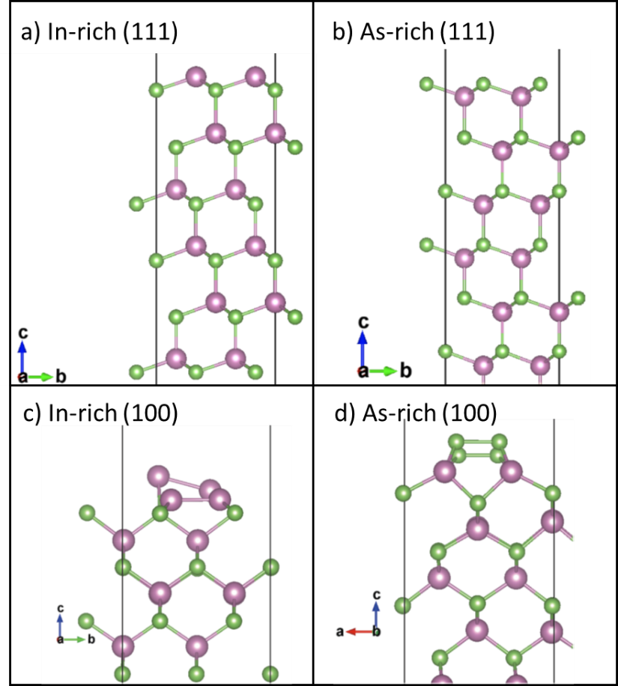
Supplementary Fig. 2. Side views of the optimized geometries for bare surface of InAs surface terminated by In (a, c) and As (b, d) on (111) facets and (100) facets, respectively.

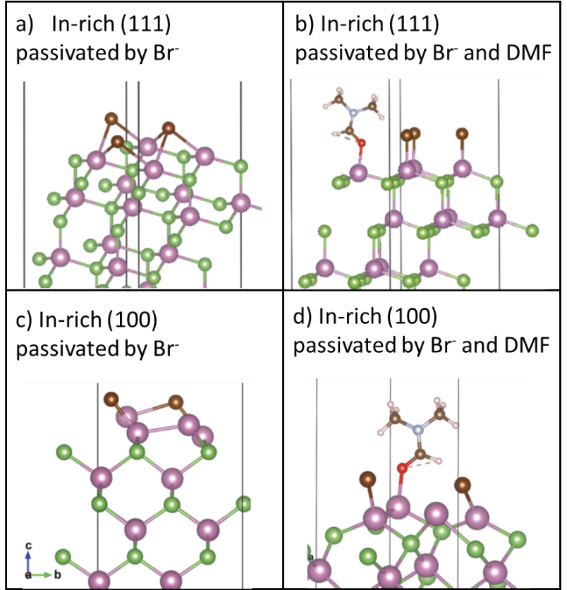
Supplementary Fig. 3. Side views of the optimized geometries for In terminated InAs surface on (111) facets and (100) facets passivated by Br⁻ ions and Br⁻ and DMF, respectively, where Br⁻ and DMF passivation shows more stabilized surface.
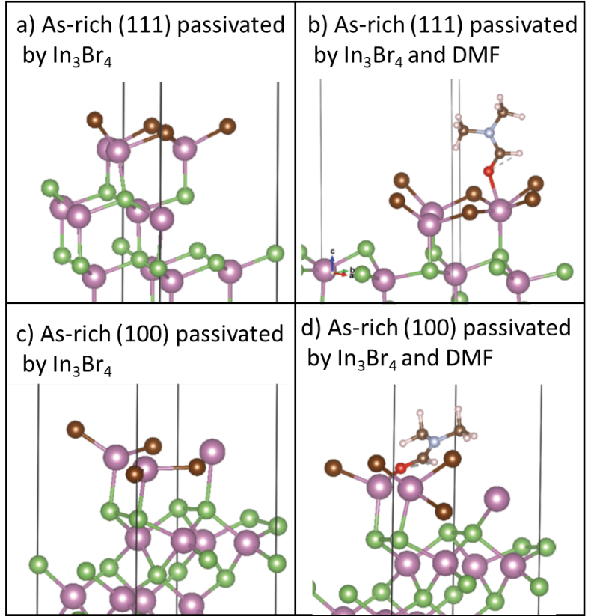
Supplementary Fig. 4. Side views of the optimized geometries for As terminated InAs surface on (111) facets and (100) facets passivated by In₃Br₄ ions and In₃Br₄ and DMF, respectively, where In₃Br₄ and DMF passivation shows more stabilized surface.

Supplementary Fig. 5. Output characteristic of FET based on InBr3-InAs CQD solids (Fig. 3c). Fabrication details in the Methods.

Supplementary Fig. 6. Capacitance vs bias of InAs CQD devices (Fig. 4a) and PbS devices (ITO/ZnO/I-PbS/EDT-PbS/Au).

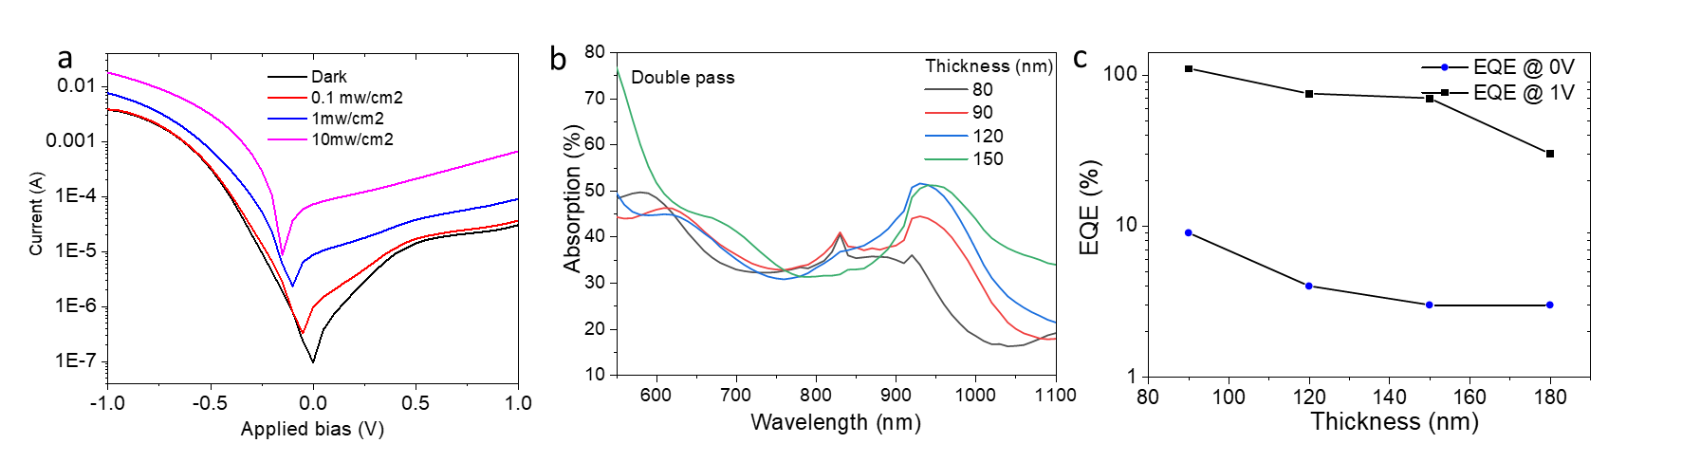
Supplementary Fig. 7. The performance of ITO / ZnO / InAs / Au devices. a, Light response of device with 90 nm thick InAs films; b, double pass absorption¹⁰ and c, EQE (biased) of devices with different thicknesses.

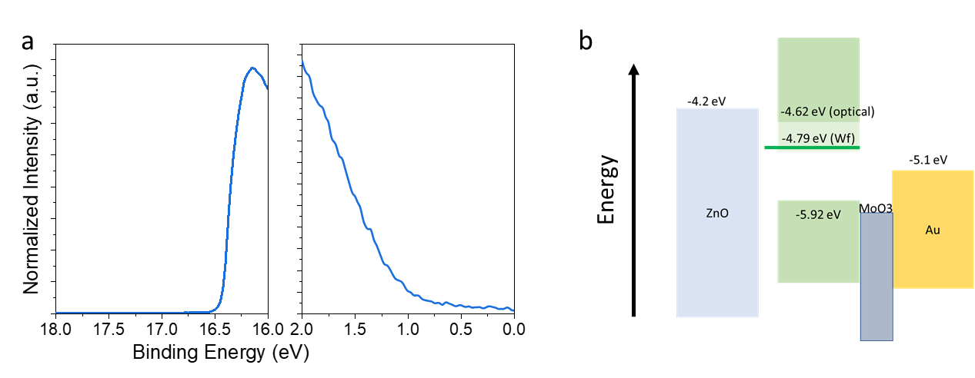
Supplementary Fig. 8. a, UPS spectrum of InBr₃-InAs CQD films and b, band alignment of device structures using ITO / ZnO / InAs / MoO3 / Au.

Supplementary Fig. 9. Detectivity of InBr₃-InAs CQD photodiodes.

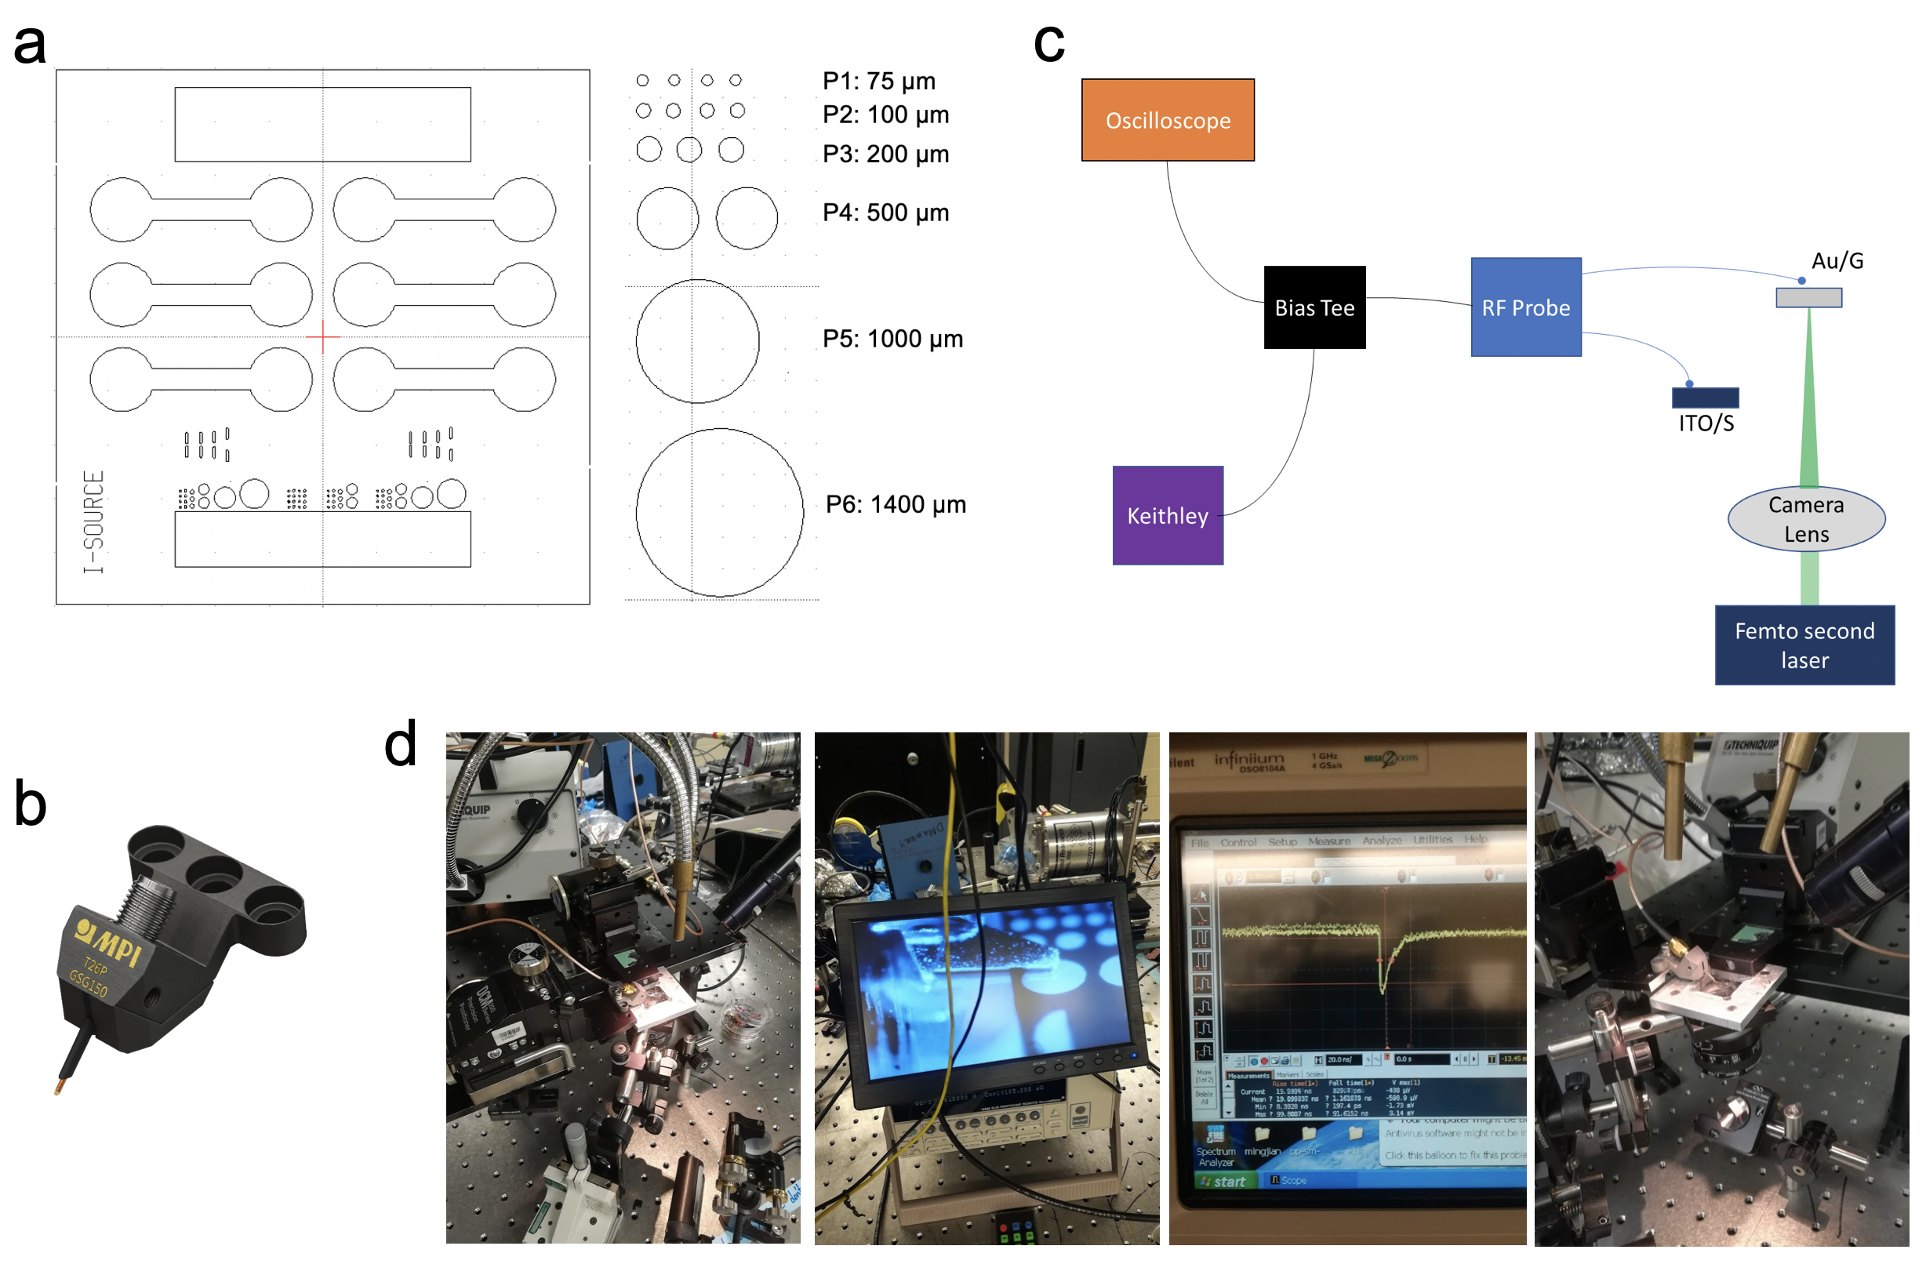
Supplementary Fig. 10. Device design for different device area. In order to make a reliable connection with small pixels, we employed a two-contact point (GS or SG) probe designed for fast signal (>20 GHz) readout. measurement known as RF probes, including the 100 fs laser source, Keithley 6517, 2 GHz Bias Tee, 1GHz oscilloscope.

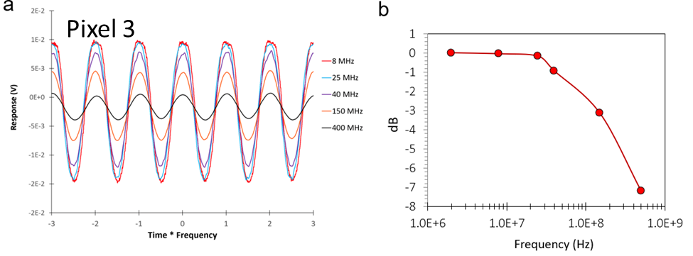
Supplementary Fig. 11. a, Response magnitude of different frequencies vs Time × Frequency for pixel 3, 200 um diameter; b, The response stays constant until 25 MHz and then reach -3dB at 150 MHz.

Suppliers disclaimer: “Certain commercial equipment, instruments, or materials are identified in this paper in order to specify the experimental procedure adequately. Such identification is not intended to imply recommendation or endorsement by the National Institute of Standards and Technology, nor is it intended to imply that the materials or equipment identified are necessarily the best available for the purpose.”

References

1. Kim, Y. et al. III-V colloidal nanocrystals: control of covalent surfaces. Chemical Science 11, 913-922 (2020).
2. Ko, J.-H., Yoo, D. & Kim, Y.-H. Atomic models for anionic ligand passivation of cation-rich surfaces of IV–VI, II–VI, and III–V colloidal quantum dots. Chemical Communications 53, 388-391 (2017).
3. Kohn, W. & Sham, L.J. Self-Consistent Equations Including Exchange and Correlation Effects. Physical Review 140, A1133-A1138 (1965).
4. Perdew, J.P., Burke, K. & Ernzerhof, M. Generalized Gradient Approximation Made Simple. Physical Review Letters 77, 3865-3868 (1996).
5. Grimme, S., Antony, J., Ehrlich, S. & Krieg, H. A consistent and accurate ab initio parametrization of density functional dispersion correction (DFT-D) for the 94 elements H-Pu. 132, 154104 (2010).
6. Kresse, G. & Furthmüller, J. Efficient iterative schemes for ab initio total-energy calculations using a plane-wave basis set. Physical Review B 54, 11169-11186 (1996).
7. Kresse, G. & Joubert, D. From ultrasoft pseudopotentials to the projector augmented-wave method. Physical Review B 59, 1758-1775 (1999).
8. Blöchl, P.E. Projector augmented-wave method. Physical Review B 50, 17953-17979 (1994).
9. Monkhorst, H.J. & Pack, J.D. Special points for Brillouin-zone integrations. Physical Review B 13, 5188-5192 (1976).
10. Sun, B. et al. Multibandgap quantum dot ensembles for solar-matched infrared energy harvesting. Nature Communications 9, 4003 (2018).

