Supplementary Material
Supplementary Figures
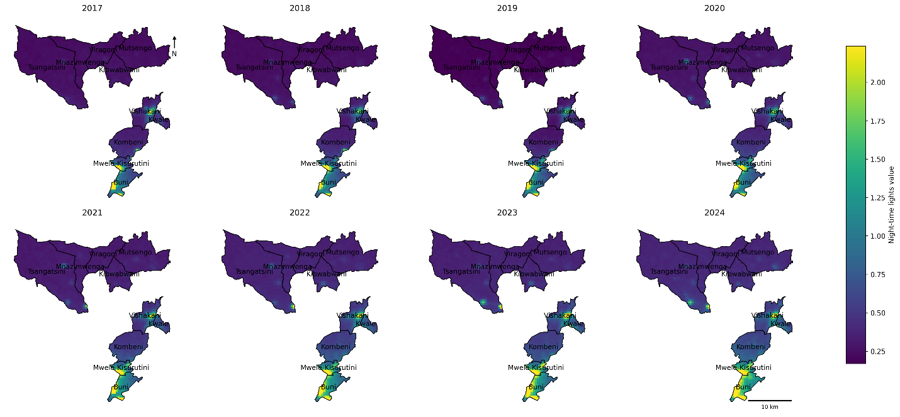
Supplementary Figure S1. Annual spatial panels of nighttime lights intensity by CHU, 2017 to 2024. Notes: Annual values are derived from VIIRS nighttime lights and summarized to the CHU scale.
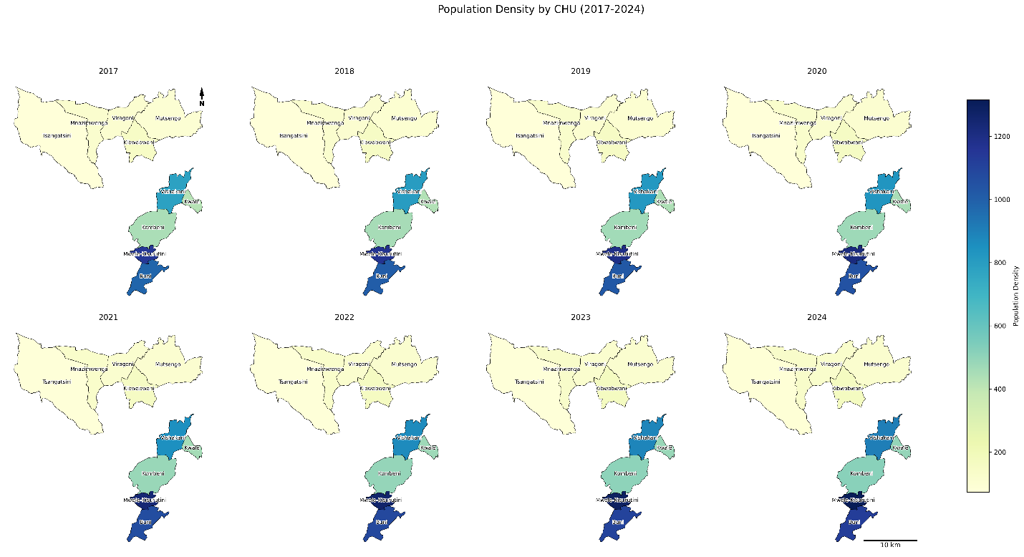
Supplementary Figure S2. Annual spatial panels of WorldPop population density by CHU, 2017 to 2024. Notes: Population density is expressed as persons per km² and summarized to the CHU scale.
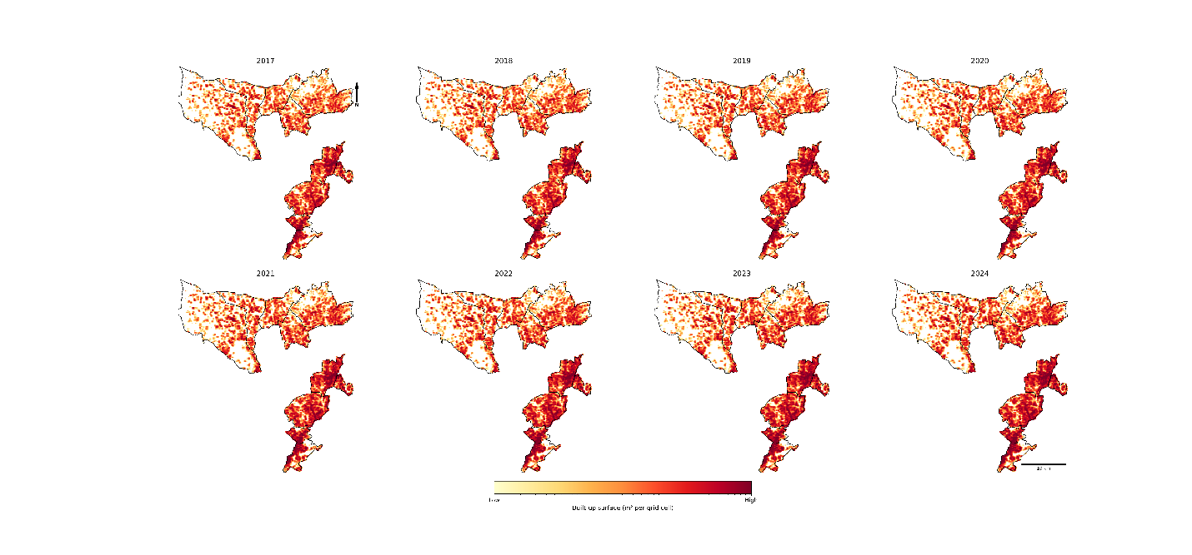
Supplementary Figure S3. Annual spatial panels of WorldPop built-up area by CHU, 2017 to 2024. Notes: Built-up area is expressed as a percentage and summarized to the CHU scale.
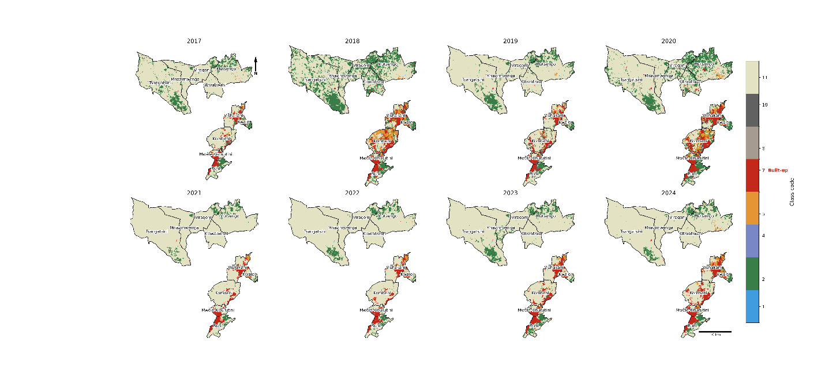
Supplementary Figure S4. Annual spatial panels of Sentinel-2 built-up percentage by CHU, 2017 to 2024. Notes: Apparent volatility should be interpreted in the context of small baseline values in some CHUs, which can amplify percent change metrics.
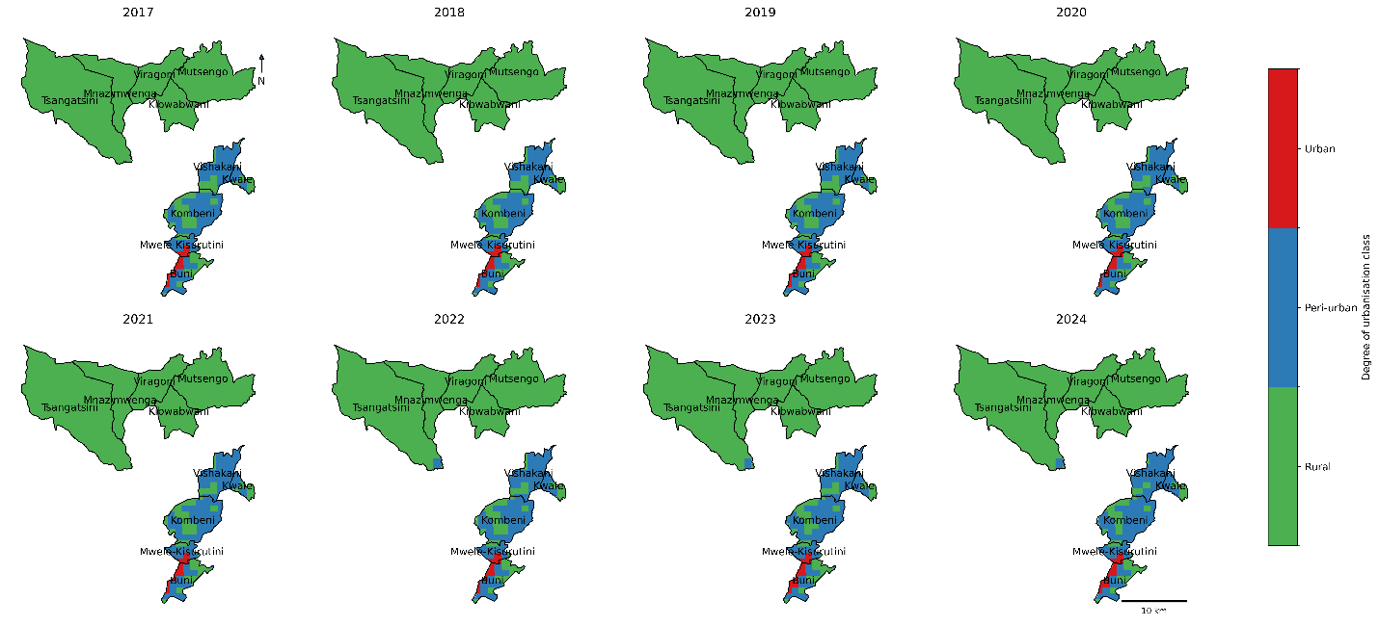
Supplementary Figure S5. Annual spatial panels of Degree of Urbanization (urban percentage) by CHU, 2017 to 2024. Notes: The figure visualizes the floor effect, including CHUs with 0% urban percentage across all years.
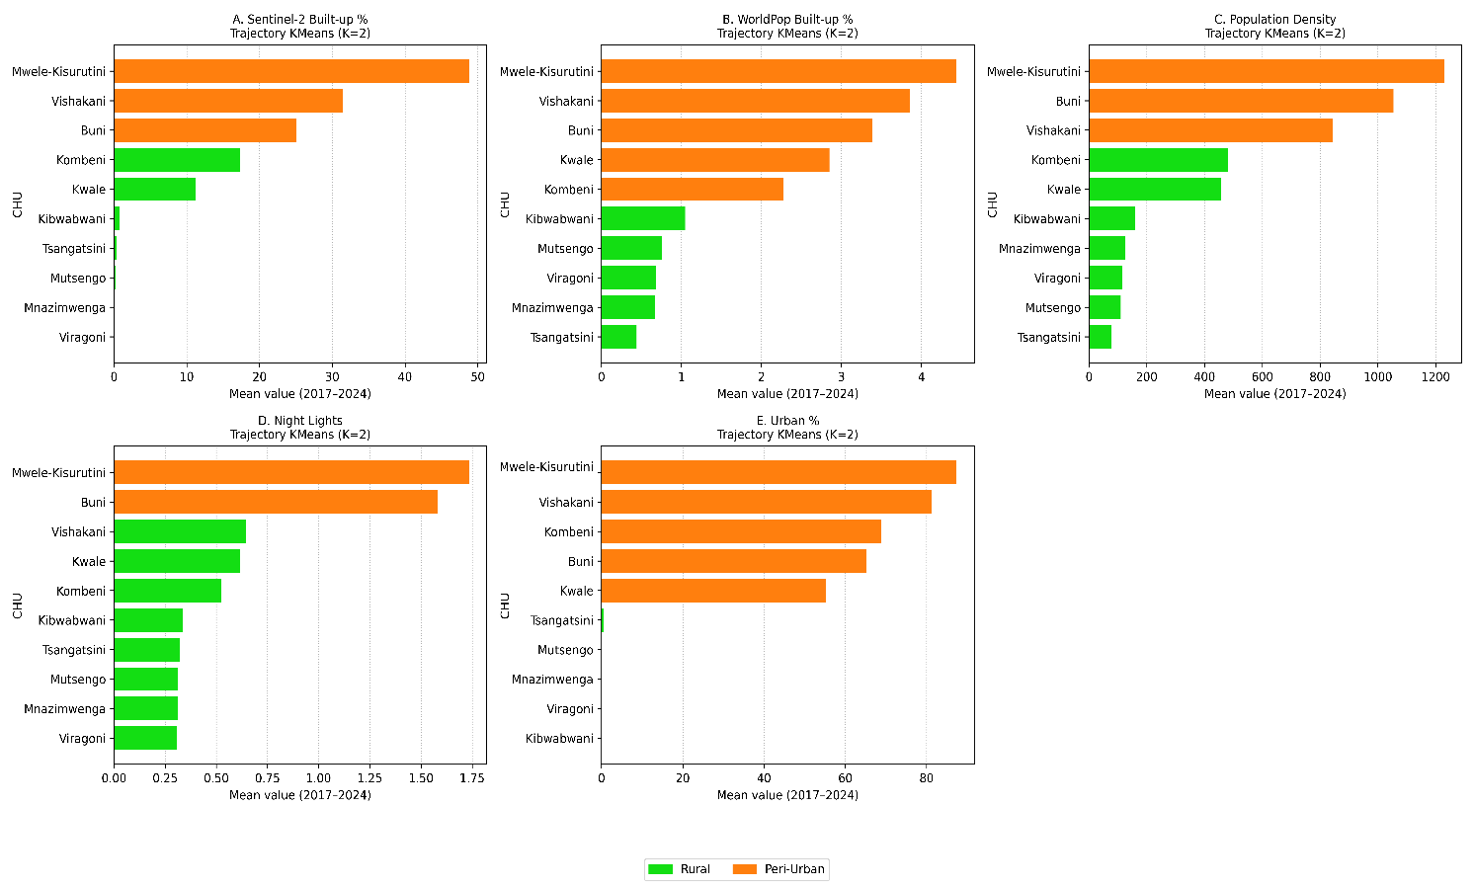
Supplementary Figure S6 (A to E). Proxy-specific k-means classification using CHU mean values, 2017 to 2024. Panel A: Sentinel-2 built-up percentage; Panel B: WorldPop built-up percentage; Panel C: WorldPop population density; Panel D: nighttime lights intensity; Panel E: Degree of Urbanization (urban percentage). Bar colour indicates cluster membership (lower-intensity: rural; higher-intensity: peri-urban). These panels provide the proxy-specific inputs used to construct the cross-proxy vote score.
Supplementary Tables
Supplementary Table S1a. CHU-level baseline, endline, absolute change, and cumulative percent change for nighttime lights intensity, 2017 to 2024.
CHU | 2017 baseline | 2024 endline | Absolute change | Cumulative % change
Buni | 1.243 | 2.184 | 0.942 | 75.8%
Kibwabwani | 0.286 | 0.437 | 0.152 | 53.2%
Kombeni | 0.405 | 0.713 | 0.307 | 75.8%
Kwale | 0.483 | 0.793 | 0.310 | 64.2%
Mnazimwenga | 0.253 | 0.405 | 0.152 | 60.2%
Mutsengo | 0.252 | 0.416 | 0.164 | 65.0%
Mwele Kisurutini | 1.321 | 1.922 | 0.602 | 45.6%
Tsangatsini | 0.256 | 0.437 | 0.181 | 70.6%
Viragoni | 0.261 | 0.395 | 0.134 | 51.3%
Vishakani | 0.536 | 0.810 | 0.274 | 51.2%
Notes: Cumulative percent change is undefined if the 2017 baseline equals zero.

Supplementary Table S1b. CHU-level baseline, endline, absolute change, and cumulative percent change for Sentinel-2 built-up percentage, 2017 to 2024.
CHU | 2017 baseline | 2024 endline | Absolute change | Cumulative % change
Buni | 20.998 | 28.417 | 7.419 | 35.3%
Kibwabwani | 0.001 | 0.392 | 0.391 | 30175.0%
Kombeni | 10.513 | 22.155 | 11.642 | 110.7%
Kwale | 6.135 | 12.412 | 6.276 | 102.3%
Mnazimwenga | 0.004 | 0.027 | 0.022 | 505.6%
Mutsengo | 0.105 | 0.335 | 0.230 | 218.9%
Mwele Kisurutini | 42.074 | 58.637 | 16.563 | 39.4%
Tsangatsini | 0.189 | 0.426 | 0.237 | 125.1%
Viragoni | 0.000 | 0.001 | 0.001
Vishakani | 25.896 | 32.454 | 6.558 | 25.3%
Notes: Large cumulative percent changes can occur when the 2017 baseline is close to zero. Cumulative percent change is undefined where the 2017 baseline equals zero.

Supplementary Table S1c. CHU-level baseline, endline, absolute change, and cumulative percent change for WorldPop built-up area, 2017 to 2024.
CHU | 2017 baseline | 2024 endline | Absolute change | Cumulative % change
Buni | 3.07 | 3.677 | 0.607 | 19.8%
Kibwabwani | 0.867 | 1.239 | 0.372 | 42.9%
Kombeni | 1.777 | 2.766 | 0.989 | 55.7%
Kwale | 2.365 | 3.386 | 1.021 | 43.2%
Mnazimwenga | 0.589 | 0.761 | 0.172 | 29.2%
Mutsengo | 0.583 | 0.930 | 0.347 | 59.5%
Mwele Kisurutini | 3.874 | 4.952 | 1.078 | 27.8%
Tsangatsini | 0.397 | 0.486 | 0.089 | 22.4%
Viragoni | 0.581 | 0.778 | 0.197 | 33.9%
Vishakani | 3.291 | 4.422 | 1.131 | 34.4%
Notes: Built-up area expressed as percentage. All CHUs have non-zero 2017 baselines.

Supplementary Table S1d. CHU-level baseline, endline, absolute change, and cumulative percent change for WorldPop population density, 2017 to 2024.
CHU | 2017 baseline | 2024 endline | Absolute change | Cumulative % change
Buni | 985.1 | 1123.8 | 138.7 | 14.1%
Kibwabwani | 147.8 | 168.9 | 21.1 | 14.3%
Kombeni | 446.4 | 515.9 | 69.5 | 15.6%
Kwale | 421.4 | 495.3 | 73.9 | 17.5%
Mnazimwenga | 118.9 | 134.1 | 15.2 | 12.8%
Mutsengo | 102.0 | 117.7 | 15.8 | 15.5%
Mwele Kisurutini | 1143.1 | 1315.2 | 172.1 | 15.1%
Tsangatsini | 73.4 | 83.2 | 9.8 | 13.4%
Viragoni | 107.9 | 122.0 | 14.1 | 13.1%
Vishakani | 785.3 | 904.9 | 119.7 | 15.2%
Notes: Population density expressed as persons per km².

Supplementary Table S1e. CHU-level baseline, endline, absolute change, and cumulative percent change for Degree of Urbanization (urban percentage), 2017 to 2024.
CHU | 2017 baseline | 2024 endline | Absolute change | Cumulative % change
Buni | 65.02% | 65.34% | 0.31 pp | 0.5%
Kibwabwani | 0.00% | 0.00% | 0.00 pp
Kombeni | 65.44% | 74.98% | 9.54 pp | 14.6%
Kwale | 52.69% | 59.62% | 6.93 pp | 13.2%
Mnazimwenga | 0.00% | 0.00% | 0.00 pp
Mutsengo | 0.00% | 0.00% | 0.00 pp
Mwele Kisurutini | 87.36% | 87.36% | 0.00 pp | 0.0%
Tsangatsini | 0.00% | 1.18% | 1.18 pp
Viragoni | 0.00% | 0.00% | 0.00 pp
Vishakani | 77.01% | 89.06% | 12.05 pp | 15.7%
Notes: Absolute change in percentage points (pp). Cumulative percent change undefined for CHUs with 0% baseline.

Supplementary Table S2. Proxy-specific cluster assignments and vote score components used to derive cross-proxy consensus classification.
CHU | NTL | Sentinel-2 | WP built up | WP density | Urban % | Score | Classification
Buni | 1 | 1 | 1 | 1 | 1 | 5 | Peri-urban
Kibwabwani | 0 | 0 | 0 | 0 | 0 | 0 | Rural
Kombeni | 0 | 0 | 1 | 0 | 1 | 2 | Rural
Kwale | 0 | 0 | 1 | 0 | 1 | 2 | Rural
Mnazimwenga | 0 | 0 | 0 | 0 | 0 | 0 | Rural
Mutsengo | 0 | 0 | 0 | 0 | 0 | 0 | Rural
Mwele Kisurutini | 1 | 1 | 1 | 1 | 1 | 5 | Peri-urban
Tsangatsini | 0 | 0 | 0 | 0 | 0 | 0 | Rural
Viragoni | 0 | 0 | 0 | 0 | 0 | 0 | Rural
Vishakani | 0 | 1 | 1 | 1 | 1 | 4 | Peri-urban
Notes: Higher-intensity cluster = 1; lower-intensity = 0. NTL = nighttime lights; WP = WorldPop. Vote score is the sum across proxies.

Supplementary Table S3. Availability of cumulative percent change outcomes from 2017 to 2024 by proxy.
Proxy | Total possible CHUs | Defined CHUs | Undefined CHUs | Reason undefined
Nighttime lights intensity | 10 | 10 | 0
Sentinel-2 built up | 10 | 9 | 1 | Baseline equals 0 for 1 CHU
WorldPop built-up area | 10 | 10 | 0
WorldPop population density | 10 | 10 | 0
Urban percentage | 10 | 5 | 5 | Baseline equals 0 for 5 CHUs
Notes: Cumulative percent change undefined when the 2017 baseline equals zero.

Supplementary Table S4A. Pearson correlations between proxies using pooled raw values (80 CHU-year observations).
Proxy pair | r (95% CI) | p-value | N
Nighttime lights vs Sentinel-2 built up | 0.815 (0.725, 0.877) | <0.0001 | 80
Nighttime lights vs WorldPop built-up area | 0.809 (0.717, 0.874) | <0.0001 | 80
Nighttime lights vs WorldPop population density | 0.907 (0.858, 0.939) | <0.0001 | 80
Nighttime lights vs urban percentage | 0.710 (0.581, 0.804) | <0.0001 | 80
Sentinel-2 built up vs WorldPop built-up area | 0.925 (0.885, 0.951) | <0.0001 | 80
Sentinel-2 built up vs WorldPop population density | 0.943 (0.912, 0.963) | <0.0001 | 80
Sentinel-2 built up vs urban percentage | 0.894 (0.840, 0.931) | <0.0001 | 80
WorldPop built-up area vs WorldPop population density | 0.954 (0.929, 0.970) | <0.0001 | 80
WorldPop built-up area vs urban percentage | 0.955 (0.931, 0.971) | <0.0001 | 80
WorldPop population density vs urban percentage | 0.906 (0.856, 0.939) | <0.0001 | 80
Notes: All p values below 0.0001.

Supplementary Table S4B. Pearson correlations between proxies using pooled year-to-year percent changes across defined transitions.
Proxy pair | r (95% CI) | p-value | N
Nighttime lights vs Sentinel-2 built up | −0.095 (−0.339, 0.161) | 0.4668 | 61
Nighttime lights vs WorldPop built-up area | −0.019 (−0.253, 0.217) | 0.8764 | 70
Nighttime lights vs WorldPop population density | −0.046 (−0.278, 0.191) | 0.7057 | 70
Nighttime lights vs urban percentage | 0.189 (−0.144, 0.483) | 0.2638 | 37
Sentinel-2 built up vs WorldPop built-up area | 0.076 (−0.179, 0.322) | 0.5586 | 61
Sentinel-2 built up vs WorldPop population density | 0.104 (−0.151, 0.347) | 0.4230 | 61
Sentinel-2 built up vs urban percentage | −0.039 (−0.359, 0.288) | 0.8165 | 37
WorldPop built-up area vs WorldPop population density | 0.484 (0.281, 0.646) | <0.0001 | 70
WorldPop built-up area vs urban percentage | 0.186 (−0.147, 0.481) | 0.2709 | 37
WorldPop population density vs urban percentage | 0.243 (−0.088, 0.526) | 0.1475 | 37
Notes: Only WorldPop built-up area and population density show a statistically significant correlation (p < 0.0001).

Supplementary Table S4C. Pearson correlations between proxies using CHU-level cumulative percent changes.
Proxy pair | r (95% CI) | p-value | N
Nighttime lights vs Sentinel-2 built up | −0.319 (−0.811, 0.438) | 0.4028 | 9
Nighttime lights vs WorldPop built-up area | 0.116 (−0.554, 0.695) | 0.7501 | 10
Nighttime lights vs WorldPop population density | 0.097 (−0.567, 0.685) | 0.7896 | 10
Nighttime lights vs urban percentage | 0.103 (−0.857, 0.903) | 0.8689 | 5
Sentinel-2 built up vs WorldPop built-up area | 0.153 (−0.569, 0.742) | 0.6952 | 9
Sentinel-2 built up vs WorldPop population density | −0.151 (−0.741, 0.570) | 0.6974 | 9
Sentinel-2 built up vs urban percentage | 0.492 (−0.689, 0.958) | 0.3993 | 5
WorldPop built-up area vs WorldPop population density | 0.552 (−0.119, 0.877) | 0.0979 | 10
WorldPop built-up area vs urban percentage | 0.782 (−0.323, 0.985) | 0.1180 | 5
WorldPop population density vs urban percentage | 0.573 (−0.626, 0.967) | 0.3128 | 5
Notes: Confidence intervals are wide owing to small effective sample sizes. No correlations are statistically significant at p < 0.05.

Supplementary Table S5. Cross-proxy vote scores and consensus classification from k-means clustering applied independently to each proxy.
CHU | Vote score (0 to 5) | Consensus classification
Buni | 5 | Peri-urban
Mwele Kisurutini | 5 | Peri-urban
Vishakani | 4 | Peri-urban
Kombeni | 2 | Rural
Kwale | 2 | Rural
Kibwabwani | 0 | Rural
Mutsengo | 0 | Rural
Mnazimwenga | 0 | Rural
Tsangatsini | 0 | Rural
Viragoni | 0 | Rural
Notes: Consensus peri-urban is defined as vote score 3 to 5.

