Table S1 Characteristics of target trees in both plantations under control and nitrogen addition conditions. Values represent mean ± SE (n = 9). Effects of tree species and nitrogen treatment on DBH and tree height were analyzed by two-way ANOVA.
 | Larch |  | Ash |  | Species | N addition | Species×  N addition
 | Control | N addition | Control | N addition | Species | N addition | Species×  N addition
Diameter at Breast Height (cm) | 22.78 ±  0.86a | 22.18 ±  0.56a | 20.54 ±  1.41a | 21.94 ±  1.44a | ns | ns | ns
Height (m) | 18.32 ±  0.43a | 19.58 ±  0.65a | 20.58 ±  0.70a | 22.20  ± 0.66a | ** | * | ns
Lowercase letters indicate significant differences (P < 0.05) between control and nitrogen addition treatments. Asterisks denote significant effects: *p < 0.05, **p < 0.01, ***p < 0.001.

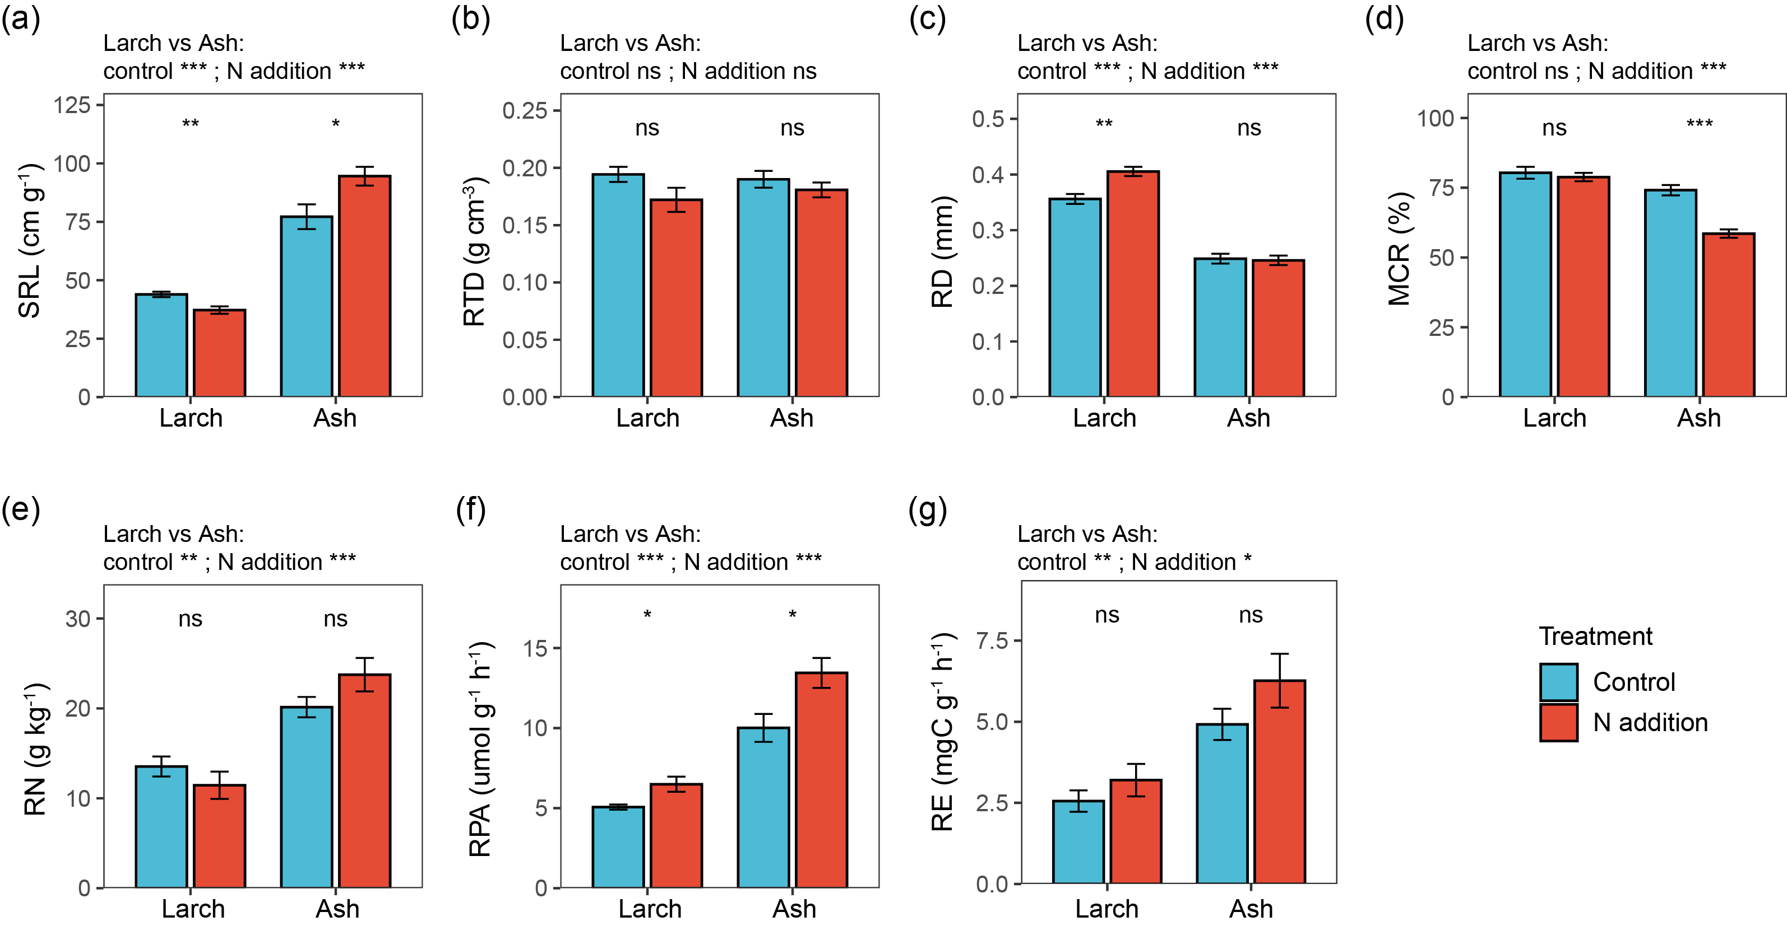
Fig. S1 Effects of nitrogen addition on fine-root functional traits in the two plantation types. The significance of the nitrogen addition effect within each plantation type, and the differences between the two plantations under the same treatment, were tested using the Wilcoxon test. ns indicates no significant difference, *p < 0.05, **p < 0.01, ***p < 0.001. Tree species abbreviations: Larch (Larix gmelinii), Ash (Fraxinus mandshurica). Abbreviations for fine-root functional traits are shown in Table 1.

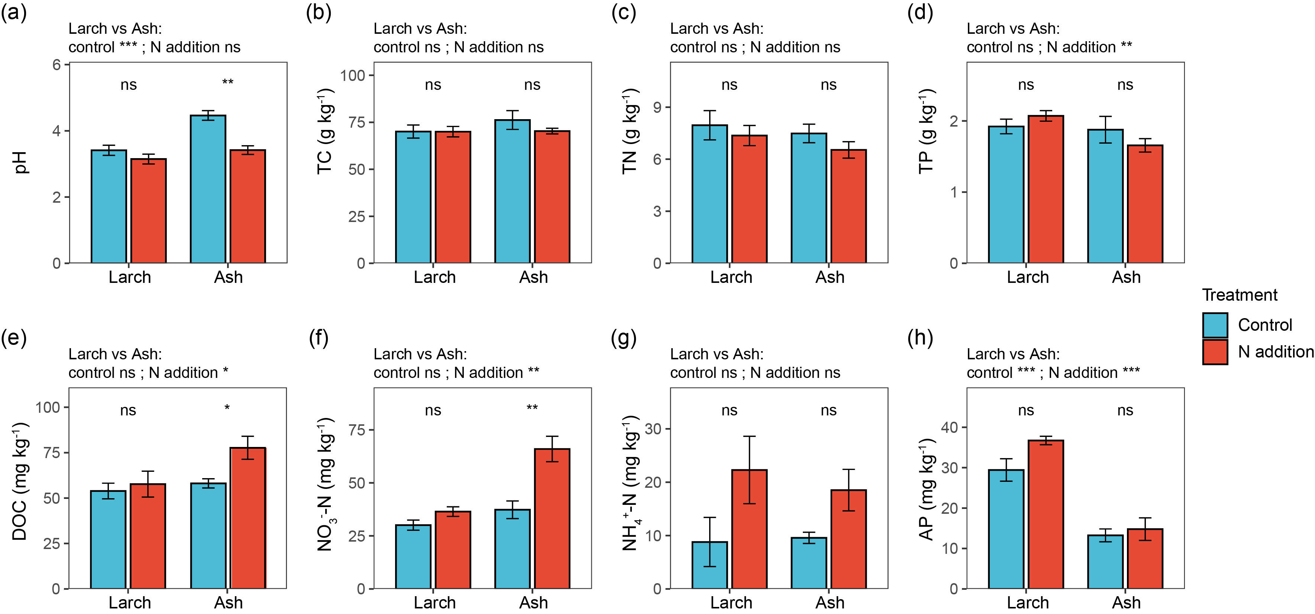
Fig. S2 Effects of nitrogen addition on rhizosphere soil properties in the two plantation types. The significance of the nitrogen addition effect within each plantation type, and the differences between the two plantations under the same treatment, were tested using the Wilcoxon test. ns indicates no significant difference, *p < 0.05, **p < 0.01, ***p < 0.001. Tree species abbreviations: Larch (Larix gmelinii), Ash (Fraxinus mandshurica). Abbreviations for soil properties are shown in Table 1.

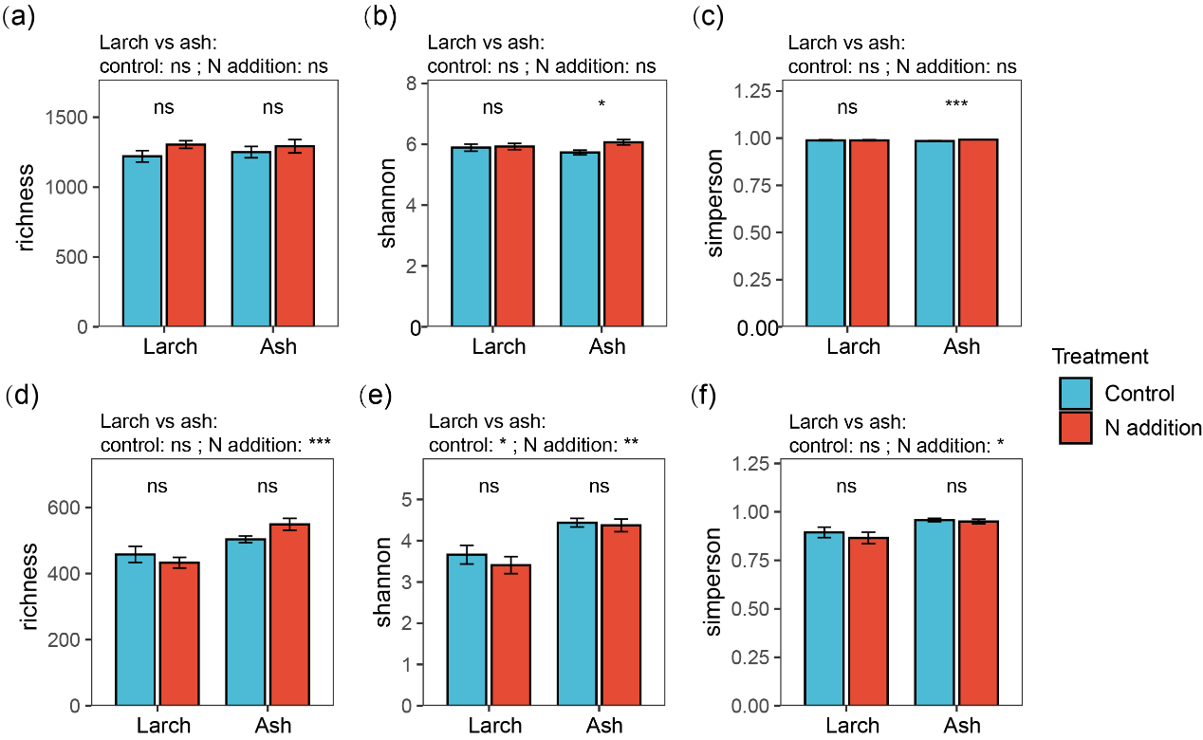
Fig. S3 Effects of nitrogen addition on rhizosphere microbial diversity in larch and ash. The significance of the nitrogen addition effect within each plantation type, and the differences between the two plantations under the same treatment, were tested using the Wilcoxon test. ns indicates no significant difference, *p < 0.05, **p < 0.01, ***p < 0.001. Tree species abbreviations: Larch (Larix gmelinii), Ash (Fraxinus mandshurica).
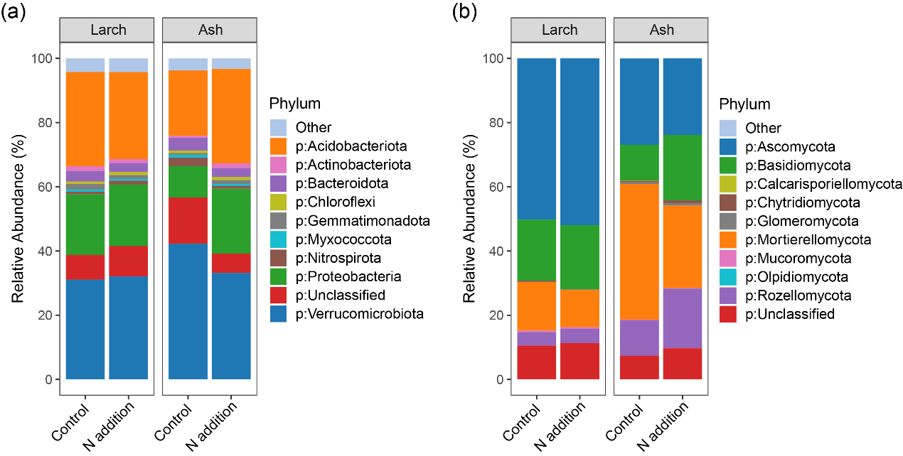
Fig. S4 Effects of nitrogen addition on the relative abundance of dominant bacterial (a) and fungal (b) phyla in the rhizosphere soil of the two plantation types.

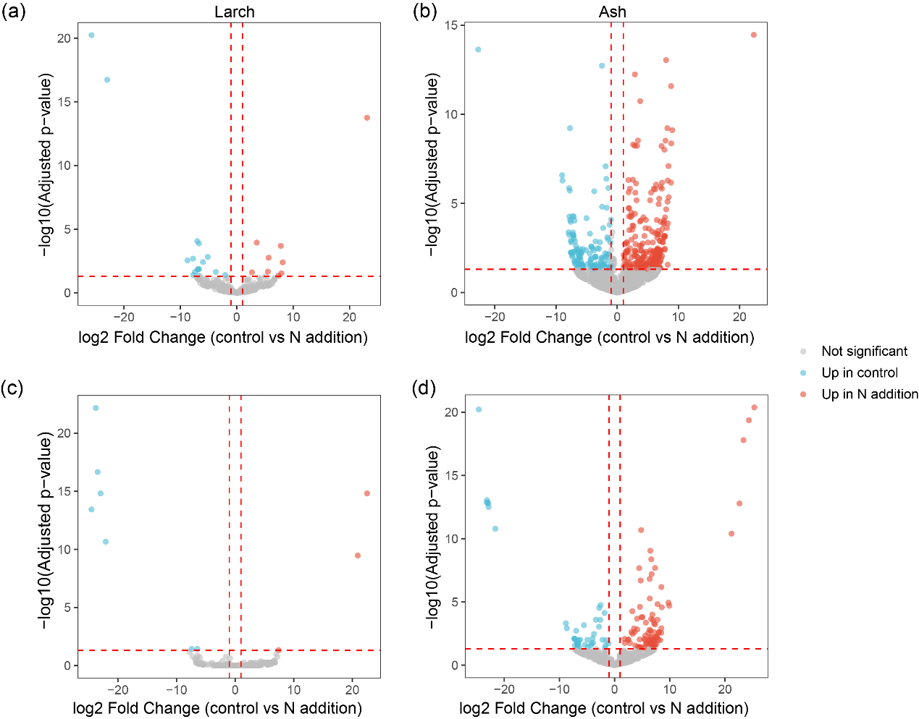
Fig. S5 Volcano plots showing species-level differences between nitrogen addition and control treatments: (a, c) bacterial and fungal communities, respectively, in larch rhizosphere; (b, d) bacterial and fungal communities, respectively, in ash rhizosphere.
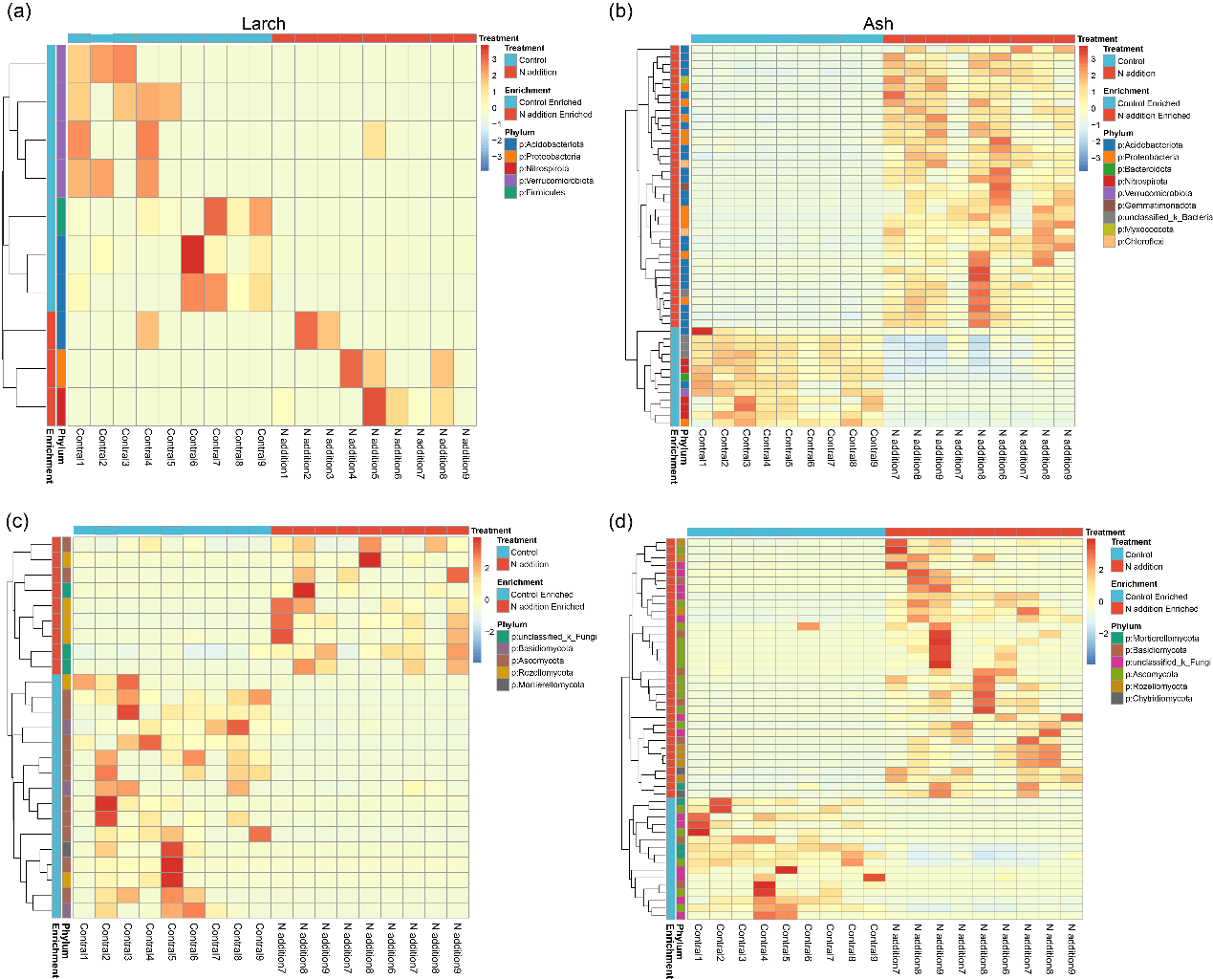
Fig. S6 Heatmap showing the enrichment patterns of differential microbial taxa (at the phyla level) identified by DESeq2 analysis under control and N addition conditions. (a) and (c) represent bacterial and fungal taxa in larch, respectively; (b) and (d) represent bacterial and fungal taxa in ash, respectively.

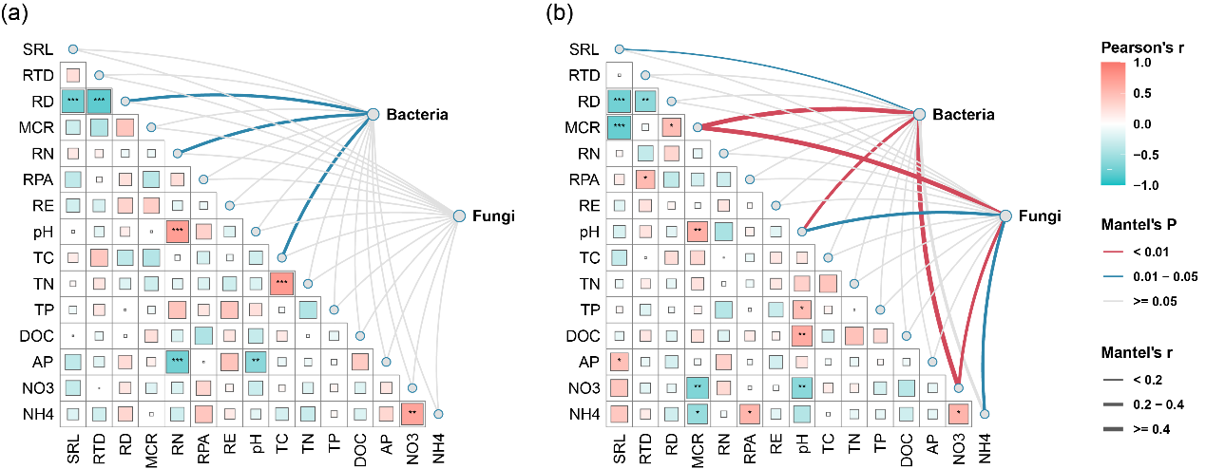
Fig. S7 Mantel test analysis examining the relationships between differential microbial taxa identified by DESeq2 analysis and fine-root functional traits as well as rhizosphere soil properties in (a) larch and (b) ash. Abbreviations for soil properties and fine-root functional traits are shown in Table 1.

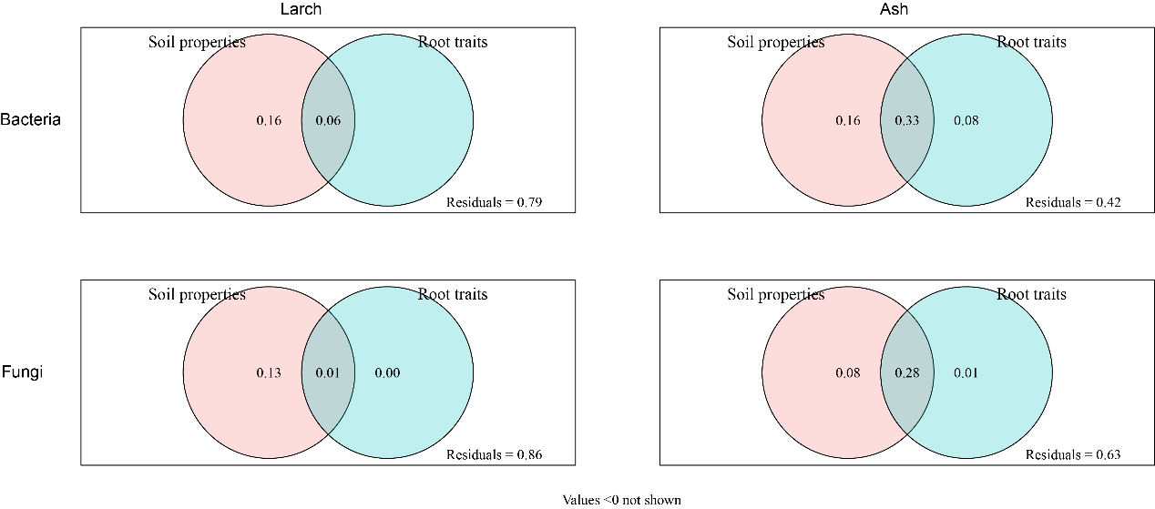
Fig. S8 Variance partitioning analysis (VPA) illustrating the relative contributions of fine-root functional traits and soil properties to the variation in the relative abundance of differential microbial taxa.

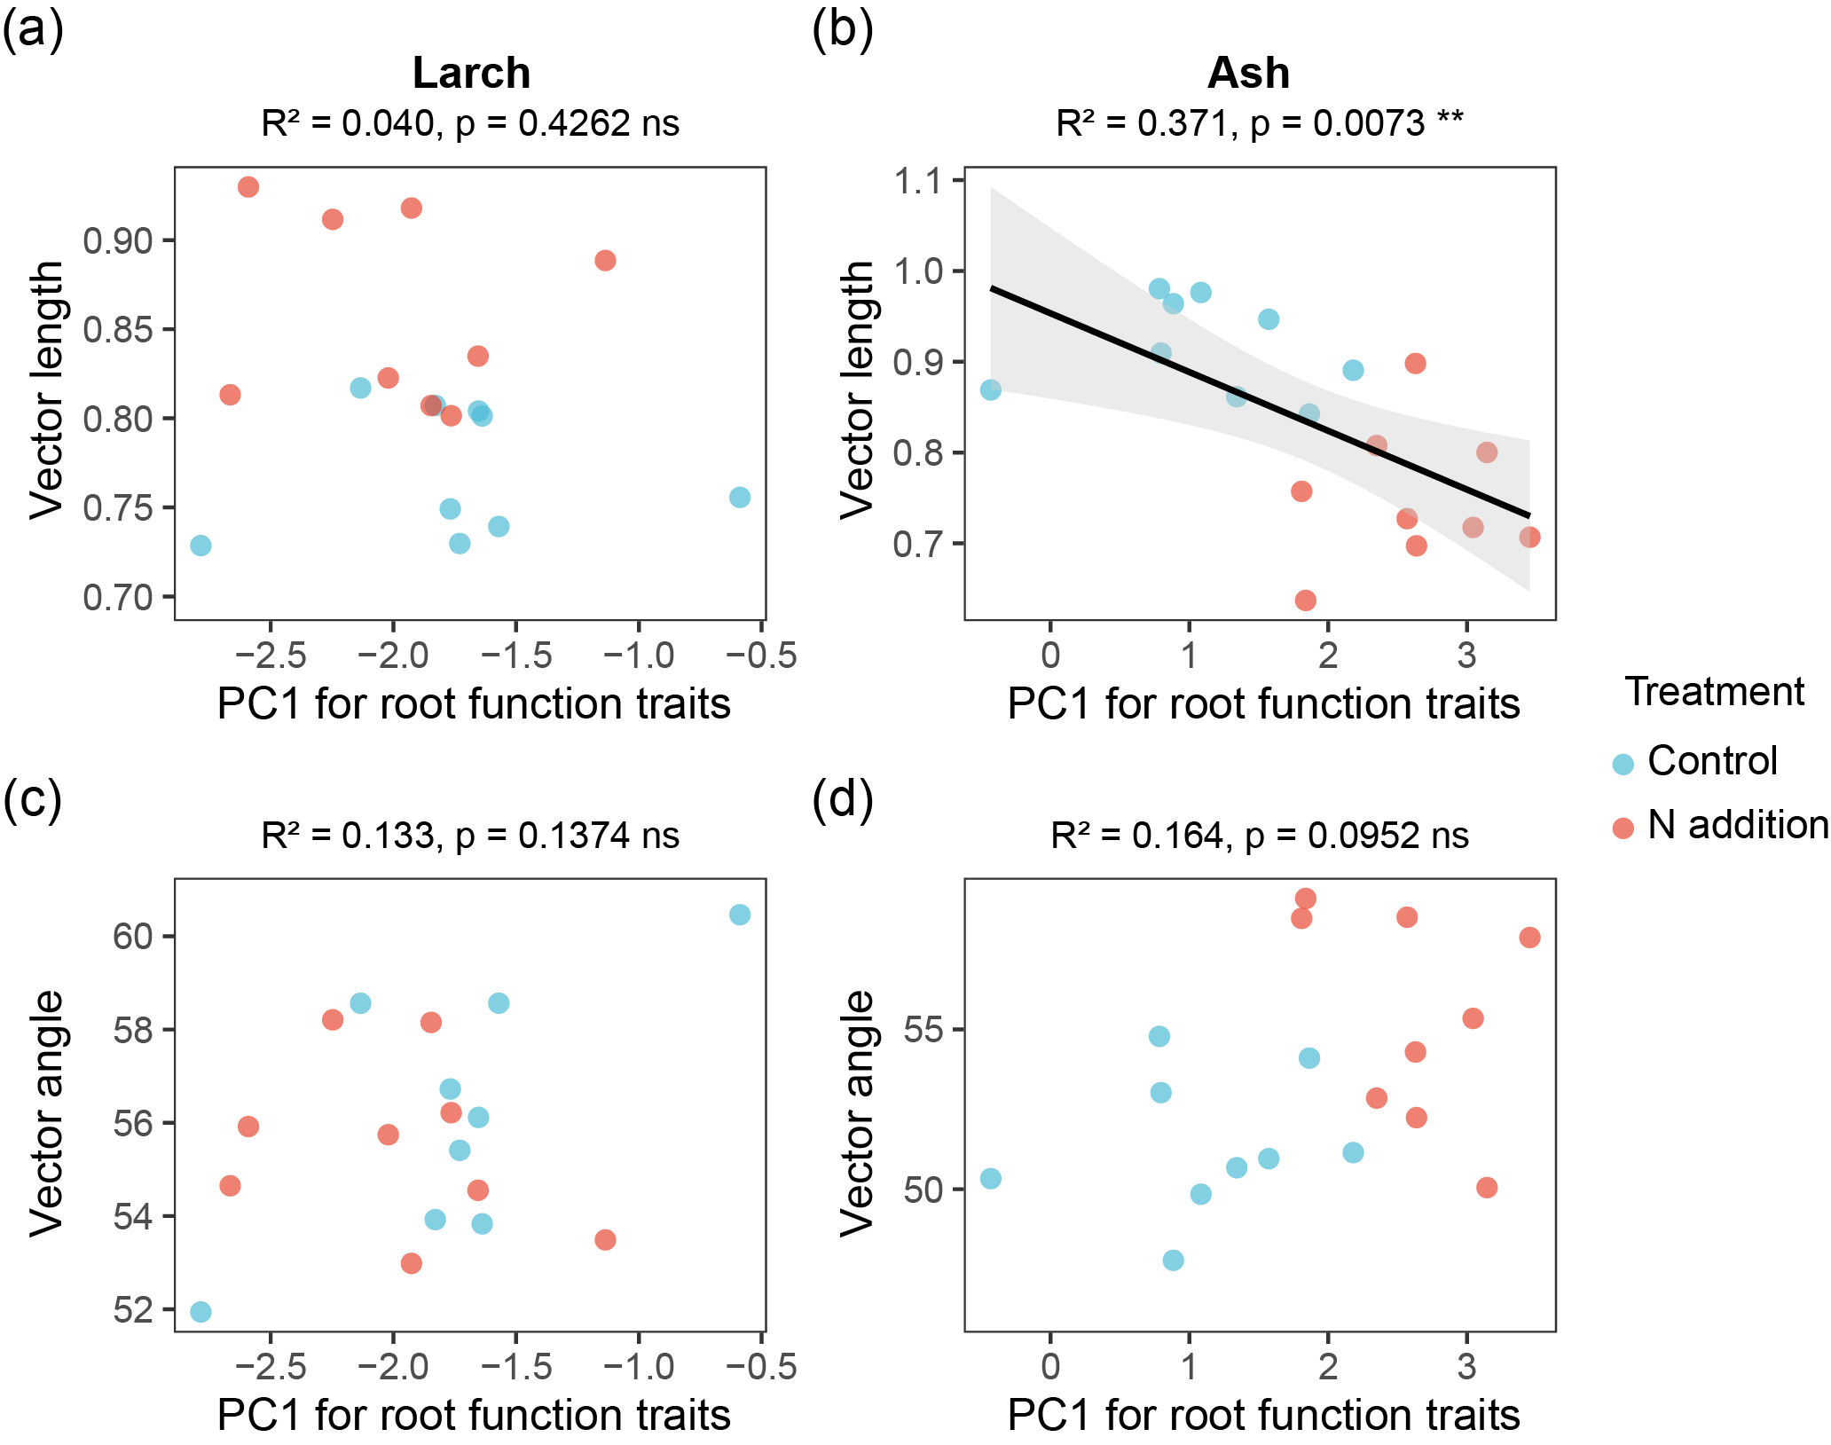
Fig. S9 Linear regression shows the relationship between PC1 axis scores for fine root traits and enzyme activity vector length and vector angle.

