Checklist criteria for qualitative studies
Consolidated criteria for reporting qualitative studies (COREQ): 32-item checklist
Domain 1: Research team and reflexivity

Items | Guide questions\description | The answers
Personal Characteristics
1. Interviewer/facilitator | Which author/s conducted the interview or focus group? | Sahar Mohammed Taresh
2. Credentials | What were the researcher's credentials? E.g. PhD, MD | PhD
3. Occupation | What was their occupation at the time of the study? | S.M.T. will conduct the intervention,  N.A.A: will methodology,  S.R: analysis and references,  A.M.M: software,  S.M.Z. recoding and collected data
4. Gender | Was the researcher male or female? | Female
5. Experience and training | What experience or training did the researcher have? | The researcher is a lecturer in the kindergarten department at Taiz University, and she has undergone several workshops to teach and educate undergraduates at the university.
Relationship with participants
6. Relationship established | Was a relationship established prior to study commencement? | Yes, the researcher will establish the relationship prior to the commencement study by providing the preschool teachers detail information on the aims of the study and the intervention details, including the number of sessions and their role in the session's activities in the assignments. The researcher will build a relationship with the teachers to help them communicate any concerns they need to make during the intervention.
7. Participant knowledge of the interviewer | What did the participants know about the researcher? e.g. personal goals, reasons for doing the research | The researcher will introduce herself to the participants and her CV. Then more information the researcher will provid the goals of the study, reasons for doing the study in oral way. Moreover, in the first session of the intervention and the written consent for the implementation of the intervention.
8. Interviewer characteristics | What characteristics were reported about the interviewer/facilitator? e.g. Bias, assumptions, reasons and interests in the research topic | 1-The researcher will be honest and direct to the participants. She will inform them that participation in this study is voluntary and nameless(coding).  2-The researcher will inform the participants that they can withdraw from this research at any time without giving any reason whatsoever.  3- The researcher will confirm that all information will be provided about the participant's identity would remain private and confidential.  4- The researcher will ask the participants if they agree/do not agree to the images/photos/video recordings/voice recordings related to their activities being will be used in any form of publication or presentation.  5-The researcher will use code instead of a name to keep the participants' information confidential and secure
Domain 2: study design
Theoretical framework
9. Methodological orientation and Theory | What methodological orientation was stated to underpin the study? e.g. grounded theory, discourse analysis, ethnography, phenomenology, content analysis. | The study will be based on two theories: Social Cognitive Theory (SCT) and the Health Belief Model (HBM).  Therefore, the orientation in SCT will be stated in this study that, once preschool teachers increase their knowledge in autism spectrum disorder, they will increase their ability to identify children with ASD at an early stage
Participant selection
10. Sampling | How were participants selected? e.g. purposive, convenience, consecutive, snowball | Data will be gathered from different schools across Taiz city. For each school involved, various steps will follow.  First, the researcher will meet the administration of each school to seek permission and explore more on the background of the teachers.  Then, the researcher will meet all the teachers to provide them with adequate information about the study.  Next, the researcher will identify the teachers who are willing to participate in the study.  After that, the researcher will send them the questionnaires via email or WhatsApp.  Next, the researcher will extract the teachers who did not meet the inclusion criteria.  Then, the researcher will meet the teachers who met the including criteria. During this meeting, the researcher will give them adequate information about the intervention. Moreover, the researcher will give them an agreement  Data was gathered from different schools across Taiz city. For each school involved, various steps were followed.  First, the researcher met the administration of each school to seek permission and explore more on the background of the teachers.  Then, the researcher met all the teachers to provide them with adequate information about the study.  Next, the researcher identified the teachers who are willing to participate in the study.  After that, the researcher sent them the questionnaires via email or WhatsApp.  Next, the researcher extracted the teachers who did not meet the inclusion criteria.  Then, the researcher met the teachers who met the inclusion criteria. During this meeting, the researcher will give them adequate information about the intervention. Moreover, the researcher will give them an agreement contract for those who are willing to enroll in the intervention. Before signing the agreement contract, some teachers will choose to drop out from the intervention.  Finally, the researcher will determine the participants who will enroll in the intervention sessions.  In addition, the researcher randomly will select a number of participants from the whole sample to participate in the video cases by using the snowball way.
11. Method of approach | How were participants approached? e.g. face-to-face, telephone, mail, email | For the data will be collected from the qualitative analysis, the researcher will use face-to-face to get individual answers to the video cases by pen and paper. For the teachers who does not have free time, the researcher will take the answers to the questions by WhatsApp or email.
12. Sample size | How many participants were in the study? | The participants will be randomly selected from the schools which will be selected from Taiz city.  For the qualitative analysis part, the researcher will be selected a number of participants (for two groups). Participants will be randomly selected for a video case analysis.
13. Non-participation | How many people refused to participate or dropped out? Reasons? | Will see the reason
Setting
14. Setting of data collection | Where was the data collected? e.g. home, clinic, workplace | for the questions regarding the video, cases will be given to the teachers in the schools' area. They will ask them to reply or send the answers by– email and WhatsApp message.
15. Presence of non-participants | Was anyone else present besides the participants and researchers? | Will be School Counselor  my supervisor by photo and video recording online
16. Description of sample | What are the important characteristics of the sample? e.g. demographic data, date | The demographic data of the study will focus on:  the age;  the educational level; and  teaching experience.  For the name, the researcher used coding.
Data collection
17. Interview guide | Were questions, prompts, guides provided by the authors? Was it pilot tested? | The videos were taken from two organizations that focused on training caregivers to deal with ASD.  The researcher had permission from the sources (see Appendix D).  After that, the researcher has presented the questions and the videos (after editing-see Appendix E) to the experts to ensure that the tools had content validity.  Lastly, the researcher conducted a pilot study of 10 preschool teachers to check the reliability and validity of the tools. Thus, The module was confirmed that it is valid to use.
18. Repeat interviews | Were repeat interviews(video case) carried out? If yes, how many? | In this study, the researcher will use the video case to collect the data. Therefore, I will not repeat the session of the video analysis as I will inform the preschool teachers before. Moreover, I will select a suitable time for each teacher. For the teacher who does not have free time, I will give her another time. All this work will conduct during the 7 days for each pretest, post-test, and follow-up test, and each of the participants will not know that they will be exposed to the video case.
19. Audio/visual recording | Did the research use the audio or visual recording to collect the data? | Paper and pencil, WhatsApp chat
20. Field notes | Were field notes made during and/or after the interview or focus group? | Before watching the video case, the researcher will brief each teacher about her role during the video as follows:  -These are two video cases of a child. Can you watch the video and answer the questions related to each video?  -The videos include two children's behavior at several locations. Just focus on his behavior and then answer the questions.  -You have to see video one and answer the questions before turning to the second video.  The videos did not take more than 10 minutes of your time.  -There is no correct or incorrect answer; the aim of this to measure the ability of the teacher to observe the behavior of the child.
21. Duration | What was the duration of the interviews or focus group? | The researcher will give them 7 days to present the video cases to each teacher. Therefore, the  researcher will manage the teachers' appointments based on their times. In all, each day, the researcher will meet around at least 6 teachers.  Some of the teachers will send their answers by WhatsApp messages.
22. Data saturation | Was data saturation discussed? | The researcher will conduct discussions with the participants on the last day of the follow-up test.
23. Transcripts returned | Were transcripts returned to participants for comment and/or correction? | No, there will be no need to return the answers to the participants because I will give them time to write and revise their answers by themselves.
Domain 3: analysis and findings
Data analysis
24. Number of data coders | How many data coders coded the data? | 20 codes
25. Description of the coding tree | Did authors provide a description of the coding tree? | No, I will not use it
26. Derivation of themes | Were themes identified in advance or derived from the data? | Each question will focus on one theme.
27. Software | What software, if applicable, was used to manage the data? | Data analysis will do manually by the researcher himself
28. Participant checking | Did participants provide feedback on the findings? | It will on the last day of the follow-up test
Reporting
29. Quotations presented | Were participant quotations presented to illustrate the themes / findings? Was each quotation identified? e.g. participant number | Yes, the researcher will use quotations to add transparency and trustworthiness to the themes and findings.
30. Data and findings consistent | Was there consistency between the data presented and the findings? | Yes
31. Clarity of major themes | Were major themes clearly presented in the findings? | Yes
32. Clarity of minor themes | Is there a description of diverse cases or discussion of minor themes? | Yes

- Permission some organizations

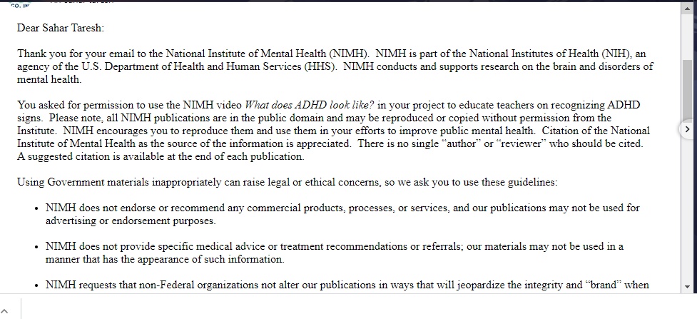
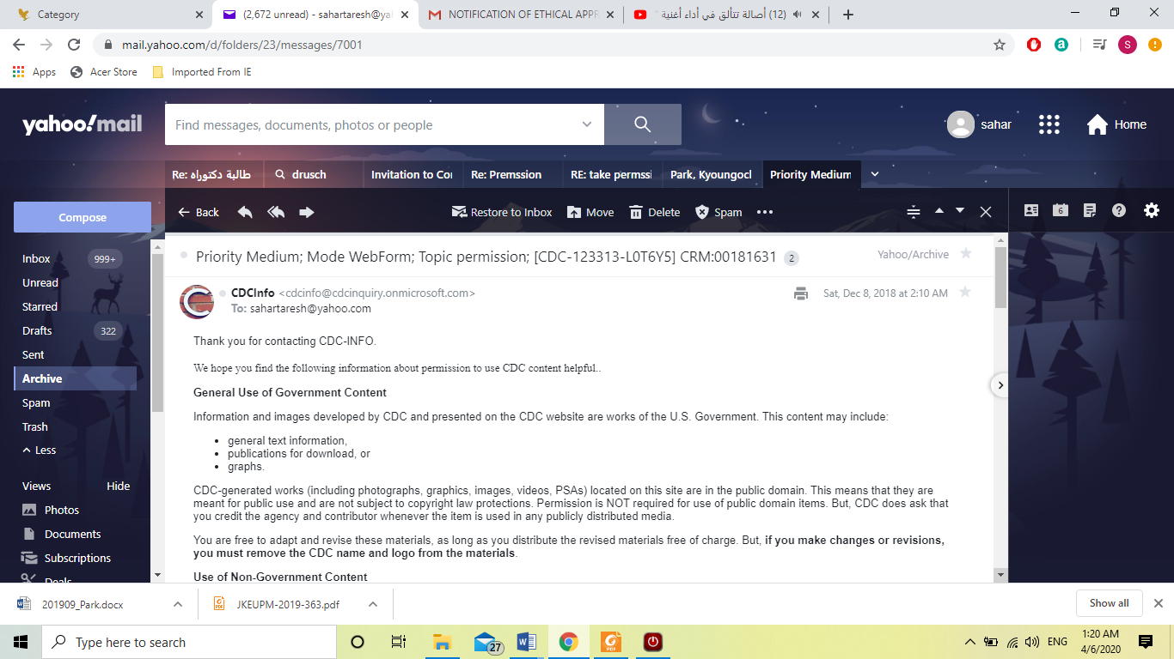

- ASD.EM panel of expert
Experts | Work | Bio Data of Expert
Assoc. Prof. Dr. Mohd Hanafi Bin Mohd Yasin | Faculty of Education  Universiti Kebangsaan Malaysia | Pedagogy And Education  Learning  Professional Development  Curriculum Development
Dr. Susan M. Schultz  Professor | Department Of Inclusive Education  Ralph C. Wilson Jr. School Of Education | College Council For Exceptional Children, Faculty Advisor
Prof.Dr. Sayyed Samaidi | Ulster University,  Institute of Nursing And Health Research,  Roy Mcconkey's Lab | Institute of Nursing and Health Research as a Research Associate
Dr. Low Hui Min | Universiti Sains Malaysia(Usm),  School Of Educational Studies | Special Education  Inclusive Education  Autism Spectrum Disorders
Dr. Kyoung Ock Park | Daegu University  Daegu, South Korea | Department of Elementary Special Education
Dr. Yingna Liu | Sun Yat-Sen University  Hensch Lab  Department Of Molecular And Cellular Biology And Centre For Brain Science. | Developmental Psychology  Clinical Psychology  Neuropsychology  Behavioural Science  Educational Psychology  Cognitive Psychology
Teacher\rose | Nanny’s centre | Centre in Malaysia
Ahamd Saad Hanafi | Speech rehabilitation specialist and autism | A head of speech disorder unit, NOOR AL HEAH EGYPT
Amira al Damarani | Specialist of rehabilitation | Centre in Egypt

One of the module’experts is Sayyed Ali Samadi, he is from Insitute of Nursing and Health Research (https://scholar.google.com/citations?user=zbp9lo0AAAAJ&hl=en
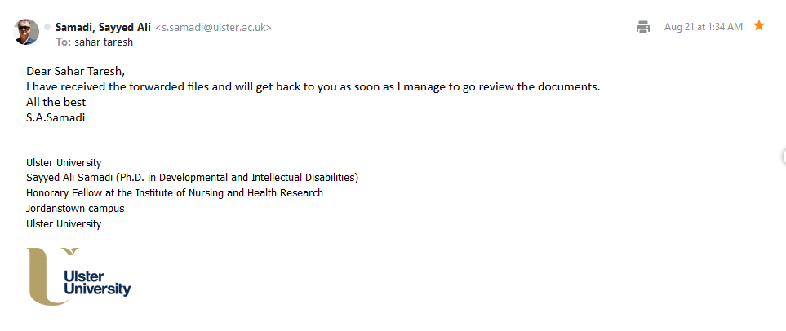

- Permissions of the questionnaires

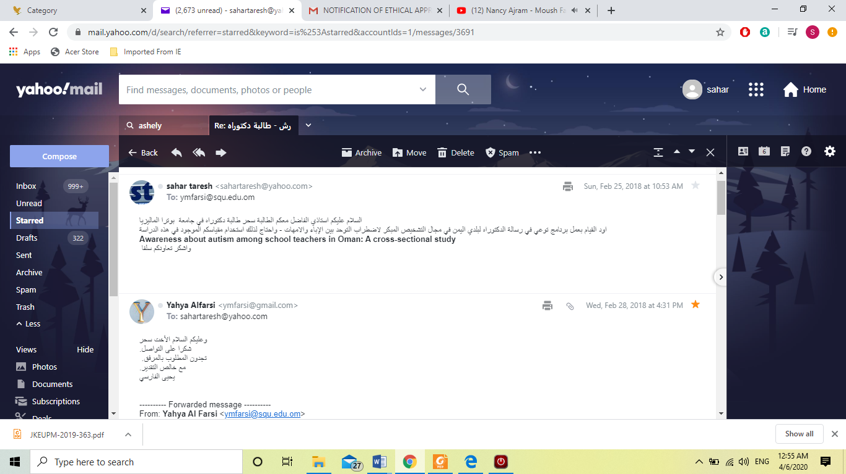
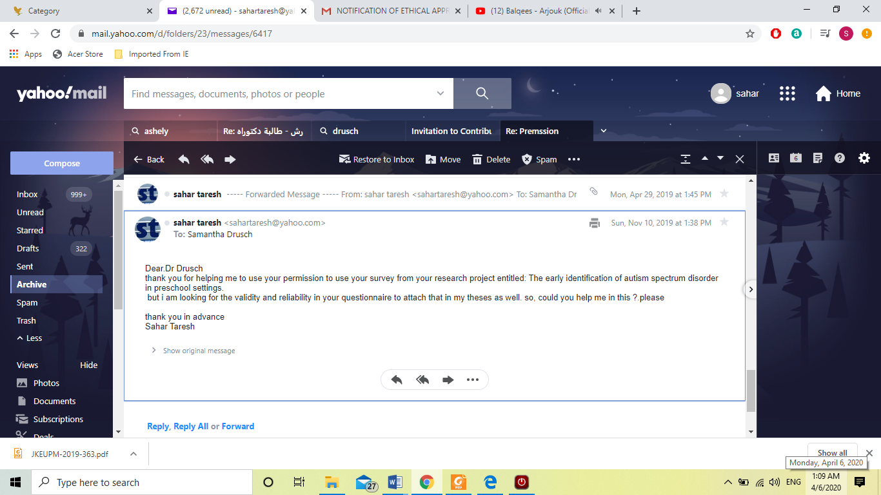
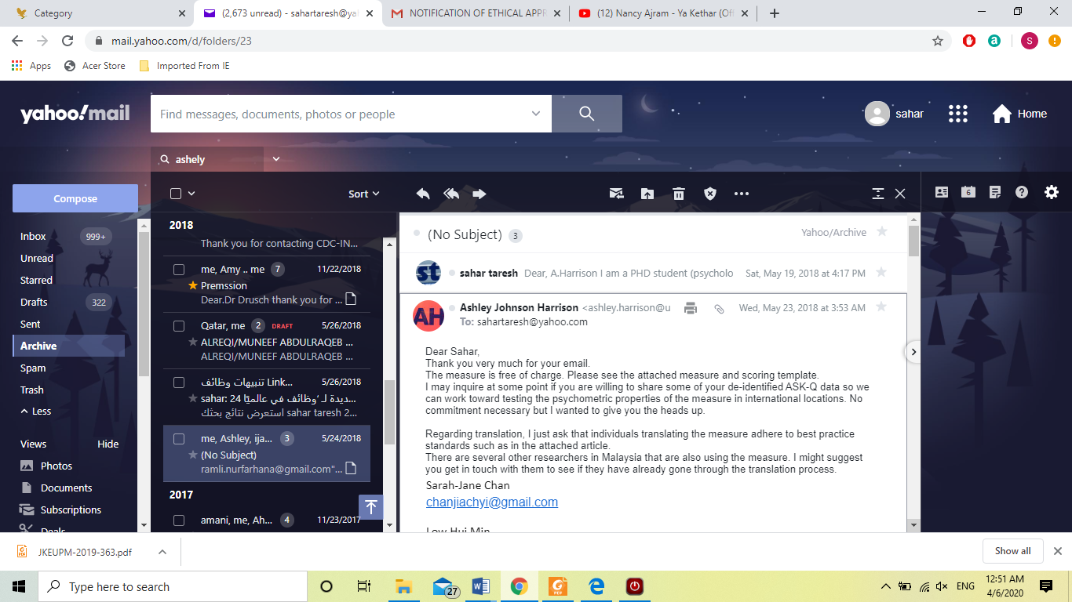

- Ethical approval
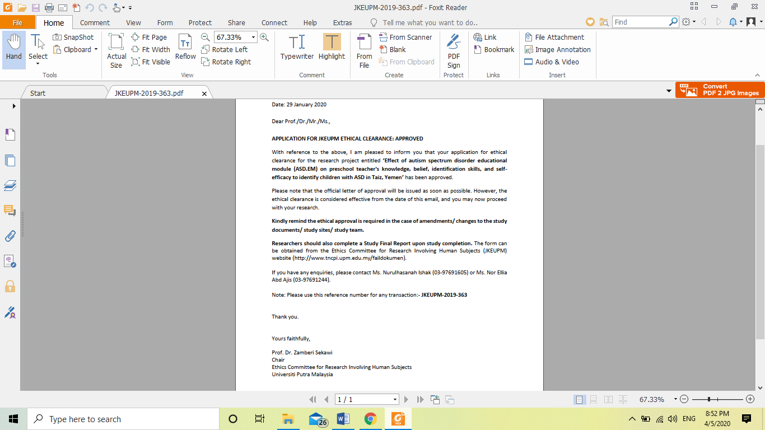

- Questionnaire in final version
