Supplementary Materials

Mirage of the Shared Mind: Collective Coordination and Epistemic Decoupling in Large Language Model Societies

Table of Contents
- S1. Experimental Configuration and Software Environment
- S2. Agent Prompt Architecture and Instruction Templates
- S3. Variable Operationalization and Coding Scheme
- S4. Data Quality Report and Exclusion Criteria
- S5. Extended Descriptive Statistics
- S6. Bayesian Model Specifications and Priors
- S7. Convergence Diagnostics
- S8. Supplementary Game-Level Analyses
- S9. Supplementary Agent-Level Analyses
- S10. Supplementary Figures
- S11. Boundary Analysis and Data Transformations
- S12. Counter-Narrative Injection Protocol
- S13. Reproducibility Information and Data Availability

S1. Experimental Configuration and Software Environment

S1.1 Model and API Details
All 48 games were run using the Anthropic Claude Sonnet 4 model (model identifier: claude-sonnet-4-20250514) accessed via the Anthropic Messages API v1. The API key was read from an environment variable and was never logged, printed, or persisted in any output file. The following generation parameters were held constant across all 48 games and all prompt types (night actions, belief elicitation, public speech, and voting):
- Temperature: 0.7
- Maximum output tokens: 1,024
- Timeout per API call: 120 seconds
- Retry logic: Up to 5 retries with exponential backoff for rate-limit responses (HTTP 429), server errors (HTTP 500, 502, 503, 529), connection errors, and timeouts
Temperature was set at 0.7 to introduce sufficient stochasticity in agent outputs while maintaining coherent reasoning. This value represents a moderate level of randomness that balances diversity of agent behavior against the need for interpretable, structured outputs. Lower temperatures (e.g., 0.0 or 0.1) would have produced more deterministic behavior, reducing the ecological validity of the simulation as a model of social interaction, while higher temperatures (e.g., 1.0+) risk producing incoherent or unparseable outputs.

S1.2 Timing and Computational Resources
The complete 48-game experiment was run in a single session on March 21, 2026.
Metric | Value
Start time | 2026-03-21 15:33:41
End time | 2026-03-21 21:12:52
Total runtime | 5 hours 39 minutes (339.2 minutes)
Mean game duration | 7.1 minutes
Min game duration | 231.0 seconds (Game 1: 0% PCE, High-Pressure, Short)
Max game duration | 634.0 seconds (Game 41: 75% PCE, High-Pressure, Long)
Game duration scaled approximately linearly with discussion length, as expected:
Discussion Length | Rounds | Mean Duration (s) | Min (s) | Max (s)
Short | 2 | ~265 | 231 | 302
Medium | 4 | ~425 | 377 | 476
Long | 6 | ~595 | 547 | 634

S1.3 API Usage Summary
Metric | Value
Total API calls | 6,258
Total input tokens | 26,556,678
Total output tokens | 987,290
Mean API calls per game | ~130
Estimated cost | ~$90 USD (at Sonnet 4 pricing at the time of the experiment)
The high call count per game reflects the multi-phase structure of each simulation: night actions, private belief elicitation before each public utterance, the public utterances themselves, final belief elicitation, and voting. Each of these phases requires a separate API call for each of the 11-12 active agents.

S1.4 Software Environment
The experiment was implemented in Python 3.x using the following key libraries:
- anthropic (Anthropic Python SDK, latest version at time of run)
- matplotlib and seaborn for publication-quality figure generation
- pandas and pyarrow for data management and export
- numpy for numerical computations
- PyMC 5.28.2 for Bayesian model estimation
- Bambi 0.17.2 for model specification using formula syntax
- ArviZ 0.23.4 for posterior analysis and diagnostics

S2. Agent Prompt Architecture and Instruction Templates

S2.1 Prompt Modular Structure
All prompts followed a standardized modular architecture consisting of five components, each assembled programmatically for each agent at each phase of the game:
- System Context Module: Describes the Werewolf game rules, the agent’s role, and the general behavioral expectations. This module was identical across all agents within a given game, except for role-specific sections.
- Private Information Module: Contains role-specific private evidence (e.g., Seer inspection results, Werewolf teammate identities) and, where applicable, experimentally injected contradictory evidence. This module was visible only to the individual agent and was never included in the shared context window of other agents.
- Discussion History Module: Contains the full transcript of all prior public utterances in the current discussion round. This module grew over the course of each round as agents sequentially produced their public statements.
- Elicitation Instruction Module: Specifies the exact output format required. For private belief elicitation, this instructed agents to produce structured JSON. For public utterances, it instructed natural-language discussion. For voting, it instructed a single player name.
- Framing Module: Contains the communicative pressure manipulation. In the high-pressure condition, this module emphasized the urgency of reaching a decisive group outcome and the costliness of failure to converge. In the evidence-centric condition, this module emphasized that accurate identification based on evidence was more important than speed or unanimity, and that dissent supported by evidence was acceptable.

S2.2 Private Belief Elicitation Format
At each elicitation point (pre-discussion, before each public utterance, and before the final vote), agents were prompted to produce a structured JSON response with the following schema:
{
"top_suspect": "<player name>",
"probability_distribution": {
"<player_1>": <float>,
"<player_2>": <float>,
...
},
"confidence": <float between 0 and 1>,
"evidence_tags": ["<tag_1>", "<tag_2>", ...]
}
The elicitation prompt explicitly instructed the agent that this output was not visible to other players and should reflect its current best judgment. This instruction was phrased as follows (paraphrased):
“This is a private reflection that will NOT be shared with other players. Based on all information available to you, including your role knowledge and the discussion so far, provide your honest current assessment.”

S2.3 Private Belief Validation Protocol
All private belief responses were validated against the following checks:
- All required keys present (top_suspect, probability_distribution, confidence, evidence_tags)
- top_suspect is a valid player name in the current game
- confidence is a numeric value in the range [0, 1]
- probability_distribution is a dictionary with values summing to approximately 1.0 (tolerance: 0.15, meaning sums between 0.85 and 1.15 were accepted)
- evidence_tags is a list of strings
When validation failed, a repair prompt was sent to the agent (up to 2 retries) specifying the exact validation errors and requesting correction. In the present experiment, all retries succeeded on the first attempt. The most common validation failure was probability distributions summing to approximately 1.2-1.35, which the model corrected upon re-prompting. No games required more than one retry for any single belief elicitation, and no games were excluded due to persistent parsing failures.

S2.4 Communicative Pressure Manipulation
The two framing conditions differed in the instructions appended to the agent’s system prompt during the discussion and voting phases:
High-Pressure Condition: Agents were instructed that failure to converge on a collective decision was costly and that decisive coordination was especially valuable. The phrasing emphasized urgency, the importance of reaching a clear majority, and the risk of indecision.
Evidence-Centric Condition: Agents were instructed that accurate identification was more important than speed or unanimity, and that dissent was acceptable when supported by evidence. The phrasing emphasized careful reasoning, evidence-based argumentation, and the legitimacy of minority viewpoints.
These framings were implemented as additional instruction paragraphs appended to the system prompt. They did not alter the game rules, available information, or response format requirements.

S2.5 Contradictory Evidence Injection
Contradictory evidence was injected through role-calibrated channels to ensure that the manipulation was functionally comparable across roles:
- Seer: Received a manipulated inspection result (e.g., told a Villager was a Werewolf, or vice versa)
- Witch: Received misleading information about the effectiveness or target of their night actions
- Guard: Received false information about the success of their protection
- Hunter: Received a misleading suspicion cue with predefined evidentiary weight
- Villager: Received a fabricated suspicion cue presented as hearsay or intuition, calibrated to the same evidentiary weight as manipulations for other roles
- Werewolf: Received false information about the identities or suspicions of other players
The number of agents receiving contradictory evidence was determined by the PCE level: at 25% PCE, 3 of 12 agents received contradictions; at 50%, 6 agents; at 75%, 9 agents. Which specific agents received contradictions was randomized within each game, subject to the constraint that at least one agent from each team (Village and Wolf) could be targeted.

S3. Variable Operationalization and Coding Scheme

S3.1 Game-Level Predictors
Variable | Type | Coding | Values in Data
PCE Level | Categorical (recoded continuous) | Numeric proportion | 0, 0.25, 0.50, 0.75
Pressure Condition | Binary | 0 = high_pressure, 1 = evidence_centric | Entered as pressure_ec
Discussion Length | Continuous, centered | Centered at medium (4 rounds): short = -2, medium = 0, long = +2 | Entered as length_centered
Discussion Length (quadratic) | Continuous | length_centered squared | Values: 4, 0, 4
PCE x Pressure | Interaction | pce_numeric x pressure_ec | Continuous
PCE x Length | Interaction | pce_numeric x length_centered | Continuous
The decision to code PCE as a continuous variable (0 to 0.75) rather than a 4-level factor was made for parsimony: with N = 48 at the game level, using 3 dummy variables for PCE would consume degrees of freedom without providing substantially better fit, given that the theoretical expectation was for a directional (if not strictly linear) relationship. The quadratic term for discussion length was included a priori based on the descriptive results showing a clear U-shaped pattern.

S3.2 Game-Level Outcome Measures
Consensus Strength: Defined as the maximum vote share received by any single candidate. Formally, if V_i denotes the number of votes received by candidate i, then Consensus Strength = max_i(V_i) / sum(V_i). Range: [1/N, 1], where N is the number of voting agents.
Vote Entropy: The Shannon entropy of the vote distribution, H = -sum(p_i * log2(p_i)), where p_i is the proportion of votes received by candidate i. Lower entropy indicates stronger consensus. Range: [0, log2(N)].
Vote Margin: The difference in vote share between the top two vote-getters, normalized by the total number of votes. Range: [0, 1].
Evidence Alignment: Defined as the ratio of aggregate private support for the publicly chosen candidate to the maximum aggregate private support for any candidate. Formally, let S_j = sum of final private probability assigned to candidate j across all agents. Then Evidence Alignment = S_elected / max_j(S_j). This measure captures whether the publicly chosen target is the one most strongly supported by the aggregate distribution of private beliefs. Range: [0, 1].
Truth Alignment: A binary indicator (aggregated to a proportion) of whether the selected target is in fact a Werewolf. Because the private evidence can be experimentally manipulated and may itself be incorrect, Truth Alignment is reported separately from Evidence Alignment. Range: [0, 1].
Semantic Decoupling Index (SDI): Defined as the product of Consensus Strength and the complement of Evidence Alignment: SDI = Consensus Strength x (1 - Evidence Alignment). SDI is high when the group exhibits strong public convergence on a target that is poorly supported by aggregate private beliefs, and low when either consensus is weak or consensus remains aligned with private beliefs. Range: [0, 1]. Note: SDI is a derived quantity that is structurally determined by Consensus Strength and Evidence Alignment. It is not an independent outcome measure. Results for SDI are reported as supplementary throughout the manuscript.
Public-Private Divergence Rate (game level): The proportion of agents in a game whose final public vote differed from their final privately stated top suspect. Range: [0, 1]. Structural note: Public-Private Divergence Rate = 1 - Evidence Alignment when the publicly elected target is the one most supported by private beliefs, but can differ when there are ties or near-ties. In the present dataset, the two measures are strongly negatively correlated.
Mean Confidence Change: The average absolute change in privately reported confidence from pre-discussion to pre-vote, aggregated across all agents in a game. Range: [0, 1].

S3.3 Agent-Level Variables
Variable | Type | Description | Distribution
public_private_divergence | Binary | Vote ≠ final private top suspect | True: 20.1%, False: 79.9%
has_contradiction | Binary | Agent received contradictory evidence | True: 37.5%, False: 62.5%
speaking_position | Integer (1-12) | Order in discussion sequence | Uniform by design
role | 6-level factor | VILLAGER (n=192), WEREWOLF (192), SEER (48), WITCH (48), HUNTER (48), GUARD (48) | By design
team | Binary | VILLAGE (n=384), WOLF (n=192) | By design
private_confidence_change | Continuous | Pre-discussion to pre-vote confidence change | Range: [-0.15, 0.95]
belief_changed | Binary | Top suspect changed during discussion | True: 78.0%

S3.4 Structural Dependencies Among Outcome Measures
A critical analytic note concerns the structural relationship among Evidence Alignment, SDI, and Public-Private Divergence Rate. Because SDI is defined as the product of Consensus Strength and (1 - Evidence Alignment), and because Public-Private Divergence Rate is strongly correlated with the complement of Evidence Alignment, these three measures are not independent outcomes. Specifically, in any game where Evidence Alignment equals 1.0, SDI necessarily equals 0.0 and Public-Private Divergence Rate necessarily equals 0.0. In the present dataset, 12 of 48 games (25%) exhibited Evidence Alignment = 1.0, producing a pronounced zero-inflation in both SDI and Public-Private Divergence Rate.
This structural dependency has two consequences for the analysis. First, fitting separate inferential models for SDI, Evidence Alignment, and Public-Private Divergence Rate is partially redundant, as the three models carry overlapping information. For this reason, the main text treats Consensus Strength and Evidence Alignment as the primary game-level outcomes and reports SDI descriptively and as a supplementary model. Second, the zero-inflation in SDI means that standard beta regression may underfit the lower tail of the distribution. The Smithson and Verkuilen (2006) transformation applied prior to model fitting mitigates the boundary issue but does not eliminate the structural dependency itself.

S4. Data Quality Report and Exclusion Criteria

S4.1 Completion Summary
Metric | Value
Games attempted | 48
Games completed | 48 (100%)
Games failed (API error, timeout, etc.) | 0
Games with unresolvable parsing errors | 0
Games excluded from analysis | 0
Total agent-level observations | 576 (12 agents x 48 games)
Agent observations used in agent-level model | 550 (26 dead agents excluded — no vote or belief data)

S4.2 Belief Validation Retries
Some games contained belief elicitation responses in which the model initially produced probability distributions summing to approximately 1.2-1.35, exceeding the validation tolerance of 1.15. In all cases, a single repair retry — in which the model was shown the specific validation error and asked to correct it — produced a valid response. No game required more than one retry for any individual belief elicitation. The retry rate was low and did not vary systematically across experimental conditions.

S4.3 API Error Events
No API timeouts occurred during the experiment (the 120-second per-call timeout was set but never triggered). The Anthropic SDK’s built-in retry mechanism handled all rate-limit responses (HTTP 429) transparently. No game failures resulted from rate limiting, server errors, or network interruptions.

S4.4 Vote Validation
All 48 games produced valid vote targets. No votes targeted invalid or out-of-scope player names. All votes were collected simultaneously at the logging level to prevent strategic reaction to revealed ballots.

S4.5 Preregistered Exclusion Criteria
The following exclusion criteria were specified prior to data collection:
- Games with API failures resulting in incomplete discussion rounds: Exclude entire game. (0 games affected.)
- Games with more than 2 unresolvable belief parsing failures: Exclude entire game. (0 games affected.)
- Games with unanimous first-round votes indicating degenerate behavior: Flag for inspection; exclude only if vote occurred without meaningful discussion. (0 games affected.)
- Agent-level observations for dead agents (killed in night phase): Exclude from agent-level models because no vote or post-discussion belief is available. (26 agents excluded from the agent-level model, yielding N = 550.)

S4.6 Condition Coverage
All 24 cells of the 4 (PCE) x 2 (Pressure) x 3 (Discussion Length) factorial design contained exactly 2 replications, as planned. No cells were missing or had unequal counts.

S5. Extended Descriptive Statistics

S5.1 Overall Descriptive Statistics
Table S1 reports the full descriptive statistics for all eight primary game-level outcome measures across the complete 48-game sample.
Table S1. Descriptive Statistics for All Game-Level Outcome Measures (N = 48)
Outcome Measure | Mean | SD | Min | 25th %ile | Median | 75th %ile | Max
Consensus Strength | 0.730 | 0.195 | 0.273 | 0.623 | 0.784 | 0.909 | 1.000
Vote Entropy | 0.990 | 0.610 | 0.000 | 0.440 | 0.845 | 1.292 | 2.664
Vote Margin | 0.557 | 0.286 | 0.000 | 0.364 | 0.636 | 0.818 | 1.000
Evidence Alignment | 0.789 | 0.192 | 0.250 | 0.659 | 0.818 | 0.938 | 1.000
Truth Alignment | 0.285 | 0.306 | 0.000 | 0.083 | 0.167 | 0.477 | 0.917
Semantic Decoupling Index | 0.144 | 0.149 | 0.000 | 0.025 | 0.132 | 0.201 | 0.688
Public-Private Divergence Rate | 0.211 | 0.192 | 0.000 | 0.062 | 0.182 | 0.341 | 0.750
Mean Confidence Change | 0.506 | 0.096 | 0.308 | 0.446 | 0.495 | 0.566 | 0.713

S5.2 Descriptive Statistics by Discussion Length
Table S2 disaggregates the primary outcomes by discussion length condition. This table complements the main text’s focus on the U-shaped consensus pattern by providing the full distributional context.
Table S2. Outcome Means by Discussion Length Condition
Outcome | Short (2 rounds) | Medium (4 rounds) | Long (6 rounds)
Consensus Strength | 0.767 | 0.615 | 0.810
Vote Entropy | 0.865 | 1.327 | 0.777
Vote Margin | 0.625 | 0.381 | 0.665
Evidence Alignment | 0.814 | 0.744 | 0.808
Truth Alignment | 0.260 | 0.311 | 0.284
SDI | 0.132 | 0.148 | 0.152
Public-Private Divergence Rate | 0.186 | 0.256 | 0.192
Mean Confidence Change | 0.489 | 0.506 | 0.523
The U-shaped pattern is visible in Consensus Strength, Vote Entropy (inverted U), Vote Margin, and Evidence Alignment. Confidence change increases monotonically with discussion length, confirming that additional discussion rounds produce more private belief revision even when public consensus is lowest (medium condition).

S5.3 Descriptive Statistics by Pressure Condition
Table S3. Outcome Means by Communicative Pressure Condition
Outcome | Evidence-Centric | High-Pressure
Consensus Strength | 0.765 | 0.696
Vote Entropy | 0.893 | 1.087
Vote Margin | 0.610 | 0.504
Evidence Alignment | 0.779 | 0.799
Truth Alignment | 0.329 | 0.241
SDI | 0.156 | 0.132
Public-Private Divergence Rate | 0.221 | 0.201
Mean Confidence Change | 0.498 | 0.514
The descriptive advantage of evidence-centric framing for consensus (0.765 vs. 0.696) is visible but, as reported in the main text, does not reach credibility in the Bayesian models.

S5.4 Cross-Tabulated Interaction Patterns
Table S4 provides the full PCE x Pressure interaction pattern for Consensus Strength, which is discussed in the main text but not fully tabulated there.
Table S4. Consensus Strength by PCE Level and Pressure Condition (Cell Means, n = 6 per cell)
PCE Level | High-Pressure | Evidence-Centric
0% | 0.770 | 0.817
25% | 0.699 | 0.694
50% | 0.649 | 0.798
75% | 0.667 | 0.759
Table S5 provides the PCE x Discussion Length interaction pattern for Consensus Strength, which is central to understanding the debate valley phenomenon across contradiction conditions.
Table S5. Consensus Strength by PCE Level and Discussion Length (Cell Means, n = 4 per cell)
PCE Level | Short (2 rds) | Medium (4 rds) | Long (6 rds)
0% | 0.932 | 0.596 | 0.848
25% | 0.780 | 0.568 | 0.742
50% | 0.736 | 0.590 | 0.843
75% | 0.625 | 0.707 | 0.777*
*Note: At 75% PCE, the debate valley is attenuated: medium-length discussions do not produce the lowest consensus. This conditional pattern, in which high contradiction loads flatten the U-shape, is consistent with the observation that extreme contradiction may introduce a qualitatively different coordination dynamic.

S6. Bayesian Model Specifications and Priors

S6.1 Game-Level Beta Regressions
Three Bayesian beta regressions were fit at the game level, each with the same predictor structure and a logit link function. The beta distribution was chosen because all three outcomes (Consensus Strength, Evidence Alignment, SDI) are bounded on [0, 1] and exhibit skewness and heteroscedasticity that would violate the assumptions of linear regression.
Model formula (applied to all three outcomes):
outcome_transformed ~ pce_numeric + pressure_ec + length_centered + length_sq + pce_x_pressure + pce_x_length
The model has 8 parameters: intercept, 6 regression coefficients, and the beta precision parameter (kappa).
Boundary Handling: Outcomes at the exact boundary (0 or 1) were transformed using the Smithson and Verkuilen (2006) method: y’ = (y x (N - 1) + 0.5) / N, where N = 48. This maps exact 0 to 0.0104 and exact 1 to 0.9896, placing all observations strictly within the open interval (0, 1) as required by the beta distribution.
Priors: All models used the Bambi default weakly informative priors: - Regression coefficients: Normal(0, sigma), where sigma is adaptively scaled based on the data (typically 2.5-10 depending on predictor scale) - Intercept: Normal(mu_y_logit, sigma_intercept), centered on the logit-transformed mean of the outcome - Precision (kappa): HalfCauchy(mu=0, sigma=1) or similar half-distribution, depending on the parameterization
These priors are designed to be weakly informative: they regularize estimates away from extreme values without imposing substantive directional constraints.

S6.2 Agent-Level Hierarchical Logistic Regression
The agent-level model used a Bernoulli likelihood with logit link:
diverged ~ contradiction + speak_pos_centered + pressure_ec + C(role, Treatment(‘VILLAGER’)) + conf_change + (1 | game_id)
Where: - contradiction: binary (agent received contradictory evidence) - speak_pos_centered: continuous (speaking position 1-12, mean-centered) - pressure_ec: binary (evidence-centric = 1, high-pressure = 0) - C(role, Treatment(‘VILLAGER’)): 5 dummy variables with Villager as reference - conf_change: continuous (confidence change during discussion) - (1 | game_id): random intercept for game (48 groups of ~11-12 agents each)
The sample for this model was N = 550 agents (576 total minus 26 agents killed during the night phase who did not participate in discussion or voting).
Priors: Bambi default weakly informative priors: - Fixed effects: Normal(0, sigma) with adaptive scaling - Random effect standard deviation: HalfNormal(0, sigma)

S6.3 Estimation Procedure
All models were estimated using the No-U-Turn Sampler (NUTS), a variant of Hamiltonian Monte Carlo. The following settings were used uniformly:
- Number of chains: 4
- Warmup (tune) iterations per chain: 2,000
- Posterior sampling iterations per chain: 2,000
- Total posterior draws: 8,000
- Target acceptance rate: 0.95
- Random seed: 42
The target acceptance rate was set slightly above the default (0.80-0.85) to reduce the risk of divergent transitions, which can indicate poor geometry in the posterior surface.

S6.4 Predictors Excluded from Final Models and Rationale
Several variables that were available in the data were excluded from the final models for principled reasons:
First-Speaker Characteristics: The variable first_speaker_role has 5 levels with highly unbalanced counts (Werewolf: 20, Villager: 12, Guard: 8, Hunter: 6, Seer: 2). With N = 48 at the game level, including a 5-level factor would consume too many degrees of freedom and produce unstable estimates, particularly for the Seer category (n = 2). A simplified binary version (first_speaker_team: Village vs. Wolf) was considered but ultimately excluded because the primary interest was in the experimentally manipulated factors.
Block/Batch Random Intercept: No block or batch grouping variable exists in the data. All 48 games were run sequentially in a single session under identical conditions (same model, same API configuration, same hardware). There is no meaningful grouping structure that would justify a block-level random intercept at the game level.
Model Identity: Only one LLM model was used (claude-sonnet-4-20250514). Model identity cannot serve as a predictor in a single-model design. The planned heterogeneous extension (described in the main text) will introduce model identity as a grouping variable.
Three-Way Interactions: With only 2 replications per cell in the 24-cell design, three-way interactions (PCE x Pressure x Length) would be estimated on the basis of single observations in some configurations. These interactions were excluded from the primary models as insufficiently powered.

S7. Convergence Diagnostics

S7.1 Game-Level Models
Table S6. Convergence Diagnostics for Game-Level Beta Regressions
Model | N | Parameters | Divergent Transitions | Max R-hat | Min ESS (bulk) | All R-hat ≤ 1.05 | All ESS ≥ 400
Consensus Strength | 48 | 8 | 0 | 1.000 | 4,298 | Yes | Yes
Evidence Alignment | 48 | 8 | 0 | 1.000 | 3,994 | Yes | Yes
SDI (Supplementary) | 48 | 8 | 0 | 1.000 | 4,230 | Yes | Yes

S7.2 Agent-Level Model
Table S7. Convergence Diagnostics for Agent-Level Hierarchical Logistic Regression
Model | N (agents) | N (groups) | Parameters | Divergent Transitions | Max R-hat | Min ESS (bulk) | All R-hat ≤ 1.05 | All ESS ≥ 400
Public-Private Divergence | 550 | 48 | 11 (fixed) + 1 (variance) | 0 | 1.000 | 2,657 | Yes | Yes
All models show excellent convergence by standard criteria. Zero divergent transitions were observed across all four models. The potential scale reduction factor (R-hat) equaled 1.000 for every parameter in every model, indicating that the four chains mixed perfectly. Effective sample sizes (ESS) exceeded 2,600 in all cases, well above the commonly recommended minimum of 400 for reliable posterior inference. The lowest ESS (2,657) was observed for the game-level random-effect standard deviation in the agent model, which is expected because hierarchical variance parameters typically have lower effective sample sizes than fixed-effect coefficients.

S8. Supplementary Game-Level Analyses

S8.1 SDI Model Results (Supplementary)
As noted in the main text, the SDI model is reported for completeness but should be interpreted with the caveat that SDI is structurally derived from Consensus Strength and Evidence Alignment.
Table S8. Posterior Summaries for Bayesian Beta Regression: Semantic Decoupling Index
Parameter | Posterior Mean (beta) | SD | 95% HDI | Credible?
Intercept | -1.453 | 0.397 | [-2.260, -0.702] | Yes (negative, confirming SDI is generally low)
PCE (linear) | -0.631 | 0.750 | [-2.085, +0.840] | No
Pressure (EC vs HP) | +0.027 | 0.477 | [-0.884, +0.973] | No
Discussion Length (linear) | -0.069 | 0.154 | [-0.375, +0.224] | No
Discussion Length (quadratic) | -0.051 | 0.074 | [-0.193, +0.094] | No
PCE x Pressure | +0.431 | 1.073 | [-1.586, +2.617] | No
PCE x Length | +0.239 | 0.342 | [-0.440, +0.892] | No
No predictor reaches credibility for SDI. The intercept on the logit scale (-1.45) corresponds to approximately 19% on the response scale, consistent with the overall descriptive mean of 0.144. The absence of credible effects beyond the intercept confirms that SDI does not vary systematically with any manipulated factor in the present data.

S8.2 Alternative Agreement Measures
To assess the robustness of the consensus findings, we examined two alternative operationalizations of collective agreement: Vote Entropy and Vote Margin. Both measures are reported descriptively here.
Vote Entropy showed a pattern complementary to Consensus Strength: it was highest (indicating weakest consensus) for medium-length discussions (1.327) and lowest for long discussions (0.777), with short discussions intermediate (0.865). By PCE level, Vote Entropy was lowest at 0% PCE (0.812) and highest at 25% PCE (1.201).
Vote Margin also corroborated the main findings: it was smallest for medium discussions (0.381) and largest for long discussions (0.665), confirming the debate valley. By PCE level, Vote Margin was highest at 0% PCE (0.636) and lowest at 25% PCE (0.449).
These alternative measures converge with the Consensus Strength findings reported in the main text, supporting the robustness of the U-shaped deliberation-length effect.

S8.3 Descriptive Hypothesis-Level Summary and Model Concordance
Table S9 summarizes the concordance between descriptive patterns and model-based evidence for all hypotheses.
Table S9. Concordance Between Descriptive and Model-Based Evidence
Pattern | Descriptive Support | Model Support | Concordance
Consensus robust across PCE | Strong | Yes (intercept high, PCE marginal) | Concordant
U-shaped consensus by length | Strong | Yes (quadratic credible) | Concordant
EC > HP for consensus | Moderate | No (not credible) | Descriptive overstates
EA non-monotonic with PCE | Moderate | No (no credible EA effects) | Descriptive pattern is noise
SDI U-shaped with PCE | Moderate | No (no credible SDI effects) | Descriptive pattern is noise
Werewolves diverge more | Not tested descriptively | Yes (credible) | Model reveals new finding
Seers/Guards diverge less | Not tested descriptively | Yes (credible) | Model reveals new finding
Confidence change prevents divergence | Not tested descriptively | Yes (very strong) | Model reveals new finding
Contradictions increase individual divergence | Weak (23.6% vs 18.1%) | No (not credible when role controlled) | Descriptive confounded by role

S9. Supplementary Agent-Level Analyses

S9.1 Agent-Level Divergence by Role
Table S10 provides descriptive divergence rates disaggregated by role, illustrating the patterns confirmed by the hierarchical logistic model reported in the main text.
Table S10. Public-Private Divergence Rate by Agent Role
Role | N | Divergence Rate | Interpretation
Villager | 192 | ~22% | Baseline rate; no special information
Werewolf | 192 | ~25% | Elevated; strategic tension between private knowledge and public cover
Seer | 48 | ~2% | Very low; strong private evidence anchors behavior
Witch | 48 | ~17% | Moderate; some unique information but less diagnostic than Seer
Hunter | 48 | ~19% | Moderate; similar to Villager
Guard | 48 | ~13% | Low; protection role provides anchoring information
These descriptive rates are consistent with the model-based findings: Seers almost never diverge, Guards diverge less than Villagers, and Werewolves diverge more. The model-based analysis adds the critical insight that these differences persist after controlling for contradiction exposure, speaking position, and communicative pressure, confirming that role-based informational asymmetry is the dominant individual-level predictor.

S9.2 Confidence Dynamics by Condition
Mean confidence change (pre-discussion to pre-vote) varied systematically across conditions:
By PCE Level: Confidence change decreased monotonically with contradiction load (0% PCE: 0.583; 25%: 0.527; 50%: 0.471; 75%: 0.444). This indicates that contradictory evidence inhibits the confidence-building process that discussion normally provides.
By Discussion Length: Confidence change increased monotonically with discussion length (short: 0.489; medium: 0.506; long: 0.523). Additional discussion rounds produce more private belief revision, consistent with the main finding that long discussions allow reconvergence.
By Pressure Condition: Confidence change was similar across conditions (evidence-centric: 0.498; high-pressure: 0.514), with no meaningful difference.
These opposing forces — PCE reducing confidence while longer discussions increase it — create an interesting tension in the long-discussion, high-PCE cells, where agents are simultaneously exposed to conditions that inhibit and promote confidence change. This interaction was not tested formally due to power constraints but represents a candidate for future investigation.

S9.3 Between-Game Heterogeneity
The agent-level model estimated substantial between-game heterogeneity, with a game-level random-effect standard deviation of 1.08 (95% HDI [0.62, 1.58]). This means that on the logit scale, the baseline probability of divergence varied by approximately 2 standard deviations (±1.08) across games. Converting to the probability scale, this corresponds to a range from approximately 5% to 50% baseline divergence probability across games, after accounting for the fixed-effect predictors.
This heterogeneity is theoretically meaningful. It indicates that some games produced substantially more public-private separation than others for reasons not fully captured by the measured predictors (contradiction exposure, role, speaking position, pressure, confidence change). Candidate sources of this residual variation include the specific content of early public statements, the particular configuration of who received contradictions among which roles, and stochastic variation in the model’s outputs under temperature 0.7. The presence of this heterogeneity underscores the main text’s argument that multi-agent deliberation is an interactional system whose emergent properties cannot be fully predicted from individual-level inputs.

S10. Supplementary Figures

S10.1 Figure Inventory
The following figures were generated from the 48-game dataset. Figures marked with an asterisk (*) appear in the main text; all others are supplementary.
Figure | Content | Main Text?
fig_consensus_by_pce_pressure | Consensus Strength by PCE and Pressure | *Yes (Figure 1)
fig_bayes_game_coefficients | Bayesian game-level posterior coefficients | *Yes (Figure 2)
fig_alignment_measures | Evidence Alignment and Truth Alignment by PCE | *Yes (Figure 3)
fig_bayes_agent_divergence | Bayesian agent-level posterior coefficients | *Yes (Figure 4)
fig_interaction_effects | PCE x Pressure on SDI; Length x PCE on Consensus | No (Figure S1)
fig_sdi_conditions | SDI by PCE, Pressure, and Discussion Length | No (Figure S2)
fig_divergence_distribution | Public-Private Divergence Rate and Confidence by Divergence Status | No (Figure S3)
fig_bayes_interaction_predictions | Model-predicted outcomes for all interactions (6-panel) | No (Figure S4)
fig_bayes_agent_predicted_probabilities | Predicted divergence probability by condition and speaking position | No (Figure S5)

S10.2 Figure S1: Interaction Effects (Descriptive)
[Reference: fig_interaction_effects.png]
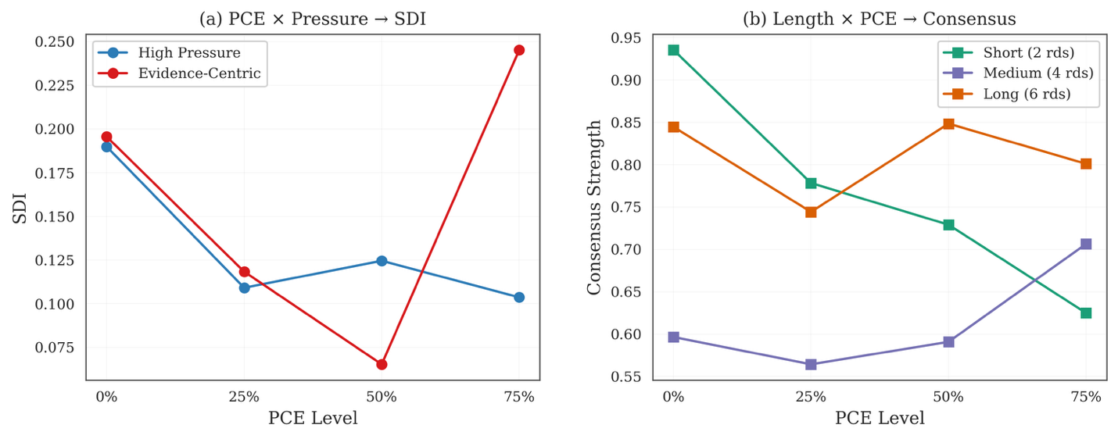
Figure S1 displays two descriptive interaction plots. Panel (a) shows the PCE x Pressure interaction on SDI. At 0% PCE, High-Pressure and Evidence-Centric conditions produce similar SDI values (~0.19). As PCE increases, the two conditions diverge: under Evidence-Centric framing, SDI drops sharply to its minimum at 50% PCE before rising dramatically at 75% PCE (to ~0.245). Under High-Pressure framing, SDI decreases more modestly and remains relatively flat. The dramatic increase in SDI at 75% PCE under Evidence-Centric framing is a notable descriptive pattern, though it is based on only 6 observations per PCE-Pressure cell and is not confirmed by the Bayesian models.
Panel (b) shows the Length x PCE interaction on Consensus Strength. At 0% PCE, short discussions produce the highest consensus (~0.93), but this advantage erodes rapidly with increasing PCE: at 75% PCE, short discussions produce the lowest consensus (~0.63). Long discussions maintain relatively stable consensus across PCE levels. Medium discussions are consistently the lowest or near-lowest, confirming the debate valley pattern. The crossover between short and long discussions at higher PCE levels is substantively important: it suggests that the protective effect of extended deliberation is most valuable under conditions of high informational conflict.

S10.3 Figure S2: Semantic Decoupling Index Across All Conditions
[Reference: fig_sdi_conditions.png]
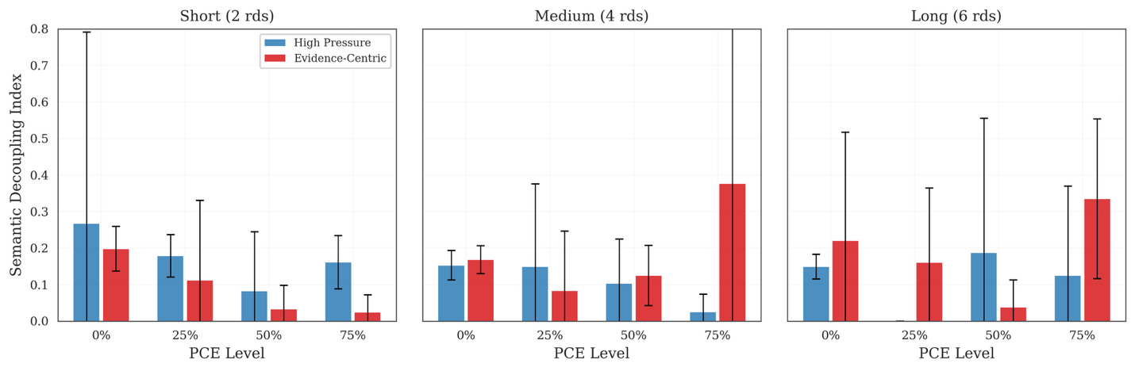
Figure S2 shows SDI disaggregated by PCE level, Pressure condition, and Discussion Length in three panels (Short, Medium, Long). Error bars represent one standard deviation. The figure reveals substantial cell-level variability, which is expected given that each bar represents only n = 2 games. Notably, the 75% PCE / Evidence-Centric / Medium and Long cells show some of the highest SDI values in the experiment, with large error bars indicating high variability. This figure illustrates why the Bayesian models did not recover stable effects for SDI: the cell-level variability is too large relative to the between-condition differences for the sample size to support reliable inference.

S10.4 Figure S3: Public-Private Divergence and Confidence Distribution
[Reference: fig_divergence_distribution.png]
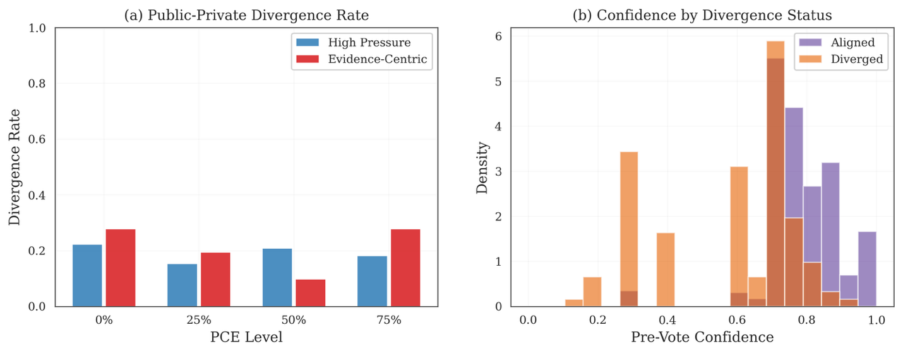
Figure S3 contains two panels. Panel (a) displays the Public-Private Divergence Rate by PCE level and Pressure condition. The rates are generally low (below 0.30) across all conditions. The highest divergence rates appear at 0% PCE under Evidence-Centric framing (~0.28) and at 75% PCE under Evidence-Centric framing (~0.28). This pattern does not suggest a simple monotonic relationship between PCE and divergence.
Panel (b) displays the density distribution of pre-vote confidence, separately for agents whose public vote aligned with their private belief (Aligned, shown in purple) and agents whose vote diverged (Diverged, shown in orange). Aligned agents show a pronounced peak at high confidence values (0.7-0.9), while diverged agents show a more dispersed distribution with a lower mode and more mass in the low-to-moderate confidence range (0.2-0.7). This distributional separation visually confirms the agent-level model finding that confidence change is the dominant predictor of divergence: agents who end the discussion with high confidence vote in accordance with their beliefs, while those with lower confidence are more susceptible to public-private misalignment.

S10.5 Figure S4: Model-Predicted Outcomes for Interactions
[Reference: fig_bayes_interaction_predictions.png]
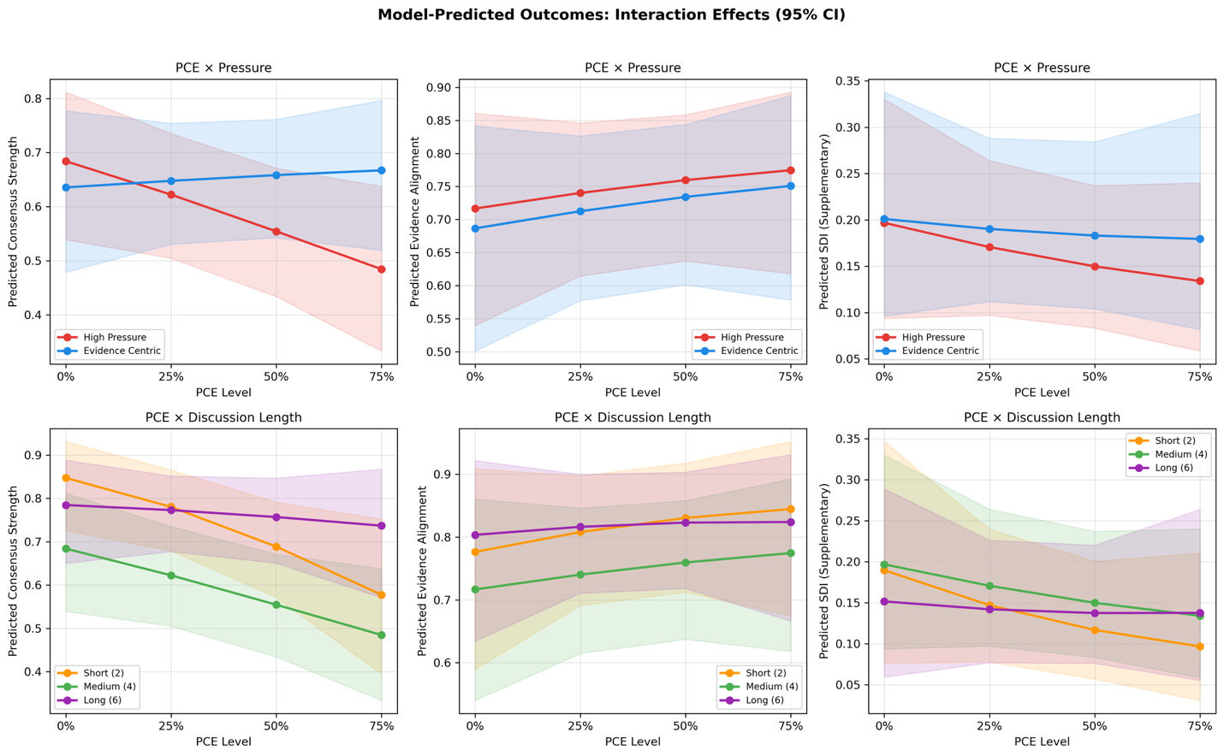
Figure S4 presents six panels showing model-predicted outcomes from the Bayesian beta regressions for the two primary interactions (PCE x Pressure and PCE x Discussion Length) across all three game-level outcomes (Consensus Strength, Evidence Alignment, SDI). Shaded bands represent 95% posterior credible intervals for the predicted values.
The top row (PCE x Pressure) shows that the predicted consensus trajectories for High-Pressure and Evidence-Centric conditions diverge slightly with increasing PCE, with the High-Pressure trajectory declining more steeply. However, the wide credible intervals overlap throughout, confirming that this interaction is not reliably distinguishable from zero. For Evidence Alignment and SDI, the predicted trajectories are nearly parallel across pressure conditions, consistent with the null model-based results.
The bottom row (PCE x Discussion Length) shows the clearest visual separation for Consensus Strength: the medium-length discussion line runs consistently below the short and long lines, illustrating the debate valley. The short-discussion line declines most steeply with increasing PCE, while the long-discussion line is relatively flat. For Evidence Alignment and SDI, the three discussion-length trajectories show minimal separation, again consistent with the null model-based results for these outcomes.

S10.6 Figure S5: Predicted Divergence Probabilities from Agent-Level Model
[Reference: fig_bayes_agent_predicted_probabilities.png]
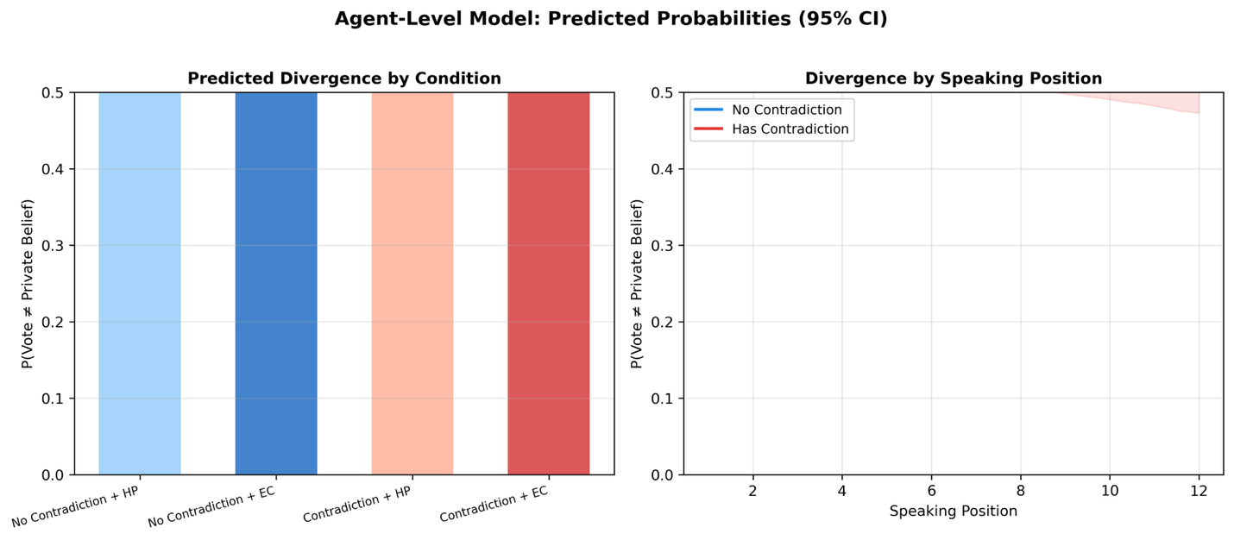
Figure S5 presents two panels from the agent-level hierarchical logistic model. Panel (a) shows predicted divergence probabilities for four condition combinations (No Contradiction + High-Pressure, No Contradiction + Evidence-Centric, Contradiction + High-Pressure, Contradiction + Evidence-Centric). The 95% credible intervals for all four conditions overlap substantially and the point estimates are broadly similar, confirming that neither contradiction exposure nor pressure condition credibly predicts individual-level divergence.
Panel (b) shows predicted divergence probability as a function of speaking position (1-12), separately for agents with and without contradiction. The trajectories are nearly flat across the full range of speaking positions, with the no-contradiction line running marginally below the contradiction line. The wide credible bands confirm the null speaking-position effect: whether an agent speaks first or last in the discussion sequence does not influence the probability of public-private divergence.

S11. Boundary Analysis and Data Transformations

S11.1 Boundary Value Distribution
A systematic boundary analysis was conducted prior to modeling. Table S11 summarizes the distribution of boundary values for all game-level outcomes.
Table S11. Boundary Values in Game-Level Outcomes (N = 48)
Variable | Range | Games at 0 | Games at 1 | Boundary Concern
Consensus Strength | [0.273, 1.000] | 0 | 2 | Minor upper-boundary pile-up
Evidence Alignment | [0.250, 1.000] | 0 | 12 | Heavy upper-boundary pile-up (25%)
SDI | [0.000, 0.688] | 12 | 0 | Heavy zero-inflation (25%)
Public-Private Divergence Rate | [0.000, 0.750] | 12 | 0 | Heavy zero-inflation (25%)
Mean Confidence Change | [0.308, 0.713] | 0 | 0 | No boundary issues
The 12 games with Evidence Alignment = 1.0 are identical to the 12 games with SDI = 0.0 and Public-Private Divergence Rate = 0.0. This structural coupling reinforces the decision to treat SDI and Public-Private Divergence Rate as supplementary rather than primary outcomes.

S11.2 Smithson-Verkuilen Transformation
Prior to beta regression, all bounded outcomes were transformed using the method of Smithson and Verkuilen (2006): y’ = (y x (N - 1) + 0.5) / N, where N = 48. Under this transformation:
- An exact 0 is mapped to 0.0104
- An exact 1 is mapped to 0.9896
This transformation ensures that all observations lie strictly within the open interval (0, 1), as required by the beta distribution. The transformation introduces minimal distortion for non-boundary values (e.g., 0.50 maps to 0.500, 0.75 maps to 0.750).
Reference: Smithson, M., & Verkuilen, J. (2006). A better lemon squeezer? Maximum-likelihood regression with beta-distributed dependent variables. Psychological Methods, 11(1), 54-71. https://doi.org/10.1037/1082-989X.11.1.54

S12. Counter-Narrative Injection Protocol
As described in the main text, an optional counter-narrative injection condition was considered as an extension to strengthen causal interpretation of early narrative effects. Under this protocol, a randomly assigned agent would introduce a standardized counter-narrative at a predetermined point in the discussion (e.g., at the midpoint of the second round for medium-length discussions).
The counter-narrative would consist of a structured objection to the current leading candidate for execution, supported by a predefined set of evidence-based arguments. The injecting agent would present this objection regardless of its private belief, making it an exogenous shock to the deliberative trajectory. By comparing the group’s final decision in games with and without the injection, the study could estimate the causal contribution of mid-discussion narrative disruption to collective consensus.
This extension was not implemented in the present experiment for two reasons. First, the 48-game design was already at capacity for the three primary manipulations (PCE, Pressure, Discussion Length) with only 2 replications per cell. Adding a fourth binary factor would either require doubling the sample to 96 games or reducing replications to 1 per cell, both of which were infeasible given the computational cost (~$90 for 48 games). Second, the counter-narrative injection would introduce a confound between the injected content and the injecting agent’s role, since different roles have different credibility in the Werewolf game.
The protocol is documented here for researchers who wish to implement it in future replications or extensions. A detailed specification of the counter-narrative script, injection timing rules, and recommended analysis plan is available from the corresponding author upon request.

S13. Reproducibility Information and Data Availability

S13.1 Seed Structure
The experiment used a base seed of 100 (seeds 100-147 across 48 games). Seeds controlled the following randomization elements:
- Player name shuffling (cosmetic, no effect on game logic)
- Role assignment to player positions
- Speaking order randomization within each discussion round
- Selection of which agents receive contradictory evidence (given the PCE level constraint)
Because the model temperature was set to 0.7, LLM outputs are inherently stochastic even with identical seeds. The seeds ensure that the structural elements of the game (role assignments, turn orders) are identical across replications with the same seed, but the content of agent utterances, beliefs, and votes will vary across runs due to the sampling process in text generation.

S13.2 Configuration Archive
Full experiment configurations for all 48 games are archived in machine-readable JSON format (experiment_configs.json). Each configuration record contains: game ID, PCE level, pressure condition, discussion length, random seed, role assignments, contradiction assignments, and all other parameters needed for exact replication.

S13.3 Data Formats
All datasets are provided in both CSV and Apache Parquet formats:
Dataset | Rows | Granularity | Key Variables
game_level | 48 | One row per game | All conditions, outcome measures, metadata
agent_level | 576 | One row per agent per game | Role, team, beliefs, votes, divergence
utterance_level | 2,244 | One row per public utterance | Round, speaker, content, position
belief_level | 3,300 | One row per belief elicitation | Timing, confidence, top suspect, probability distribution

S13.4 Model Artifacts
Bayesian model objects are saved as ArviZ InferenceData files (.nc format) for direct reuse or reanalysis:
- idata_consensus_strength.nc
- idata_evidence_alignment.nc
- idata_semantic_decoupling_index.nc
- idata_agent_divergence.nc
These files contain the full posterior distributions, prior predictive samples, and sampling diagnostics for each model.

S13.5 Single-Model Limitation
All results reported in this study are conditional on a single LLM architecture: Claude Sonnet 4 (claude-sonnet-4-20250514) at temperature 0.7. Different model families (e.g., GPT-4, Gemini, Llama), different model sizes within a family, different temperatures, or different versions of the same model may produce different consensus dynamics, sycophantic tendencies, and role-adherence behavior. The planned heterogeneous extension (described in the main text) will assess generalizability across model families, but until that extension is completed, the present findings should be interpreted as characterizing the behavior of this specific model under these specific conditions, rather than as universal properties of all LLM-based multi-agent systems.

Supplementary References
Smithson, M., & Verkuilen, J. (2006). A better lemon squeezer? Maximum-likelihood regression with beta-distributed dependent variables. Psychological Methods, 11(1), 54-71. https://doi.org/10.1037/1082-989X.11.1.54

