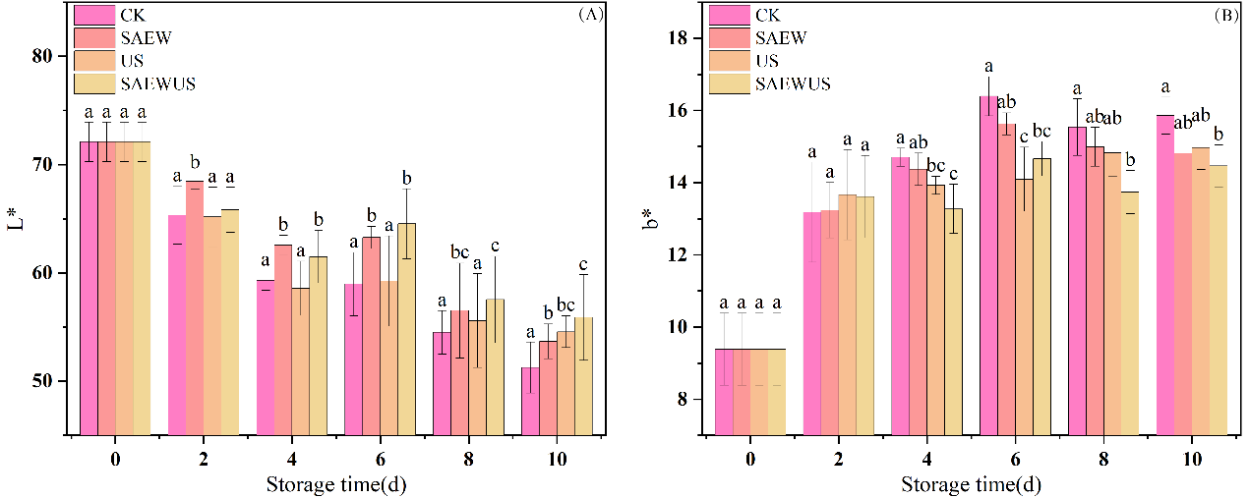
Figure S1. Changes in L* and b* values of fresh-cut Agaricus bisporus under different treatments during cold storage.

