Supplementary Materials:

Flux-bias-free flux qubit driven by low-power single-flux-quantum driver on monolithically integrated circuit
Duong Pham^{1, *}, Tomoharu Ueda², Shigeyuki Miyajima³, Hirotaka Terai³, Kunihiro Inomata⁴, Masamitsu Tanaka², Akira Fujimaki² and Taro Yamashita¹
¹ Graduate School of Engineering, Tohoku University, Sendai, Japan
² Nagoya University, Furo-cho, Chikusa-ku, Nagoya 464-8603, Japan
³ Advanced ICT Research Institute, National Institute of Information and Communications Technology (NICT), Kobe, Japan
⁴ National Institute of Advanced Industrial Science and Technology (AIST), Tsukuba, Ibaraki, Japan
* Present affiliation: ³ Advanced ICT Research Institute, National Institute of Information and Communications Technology (NICT), Kobe, Japan

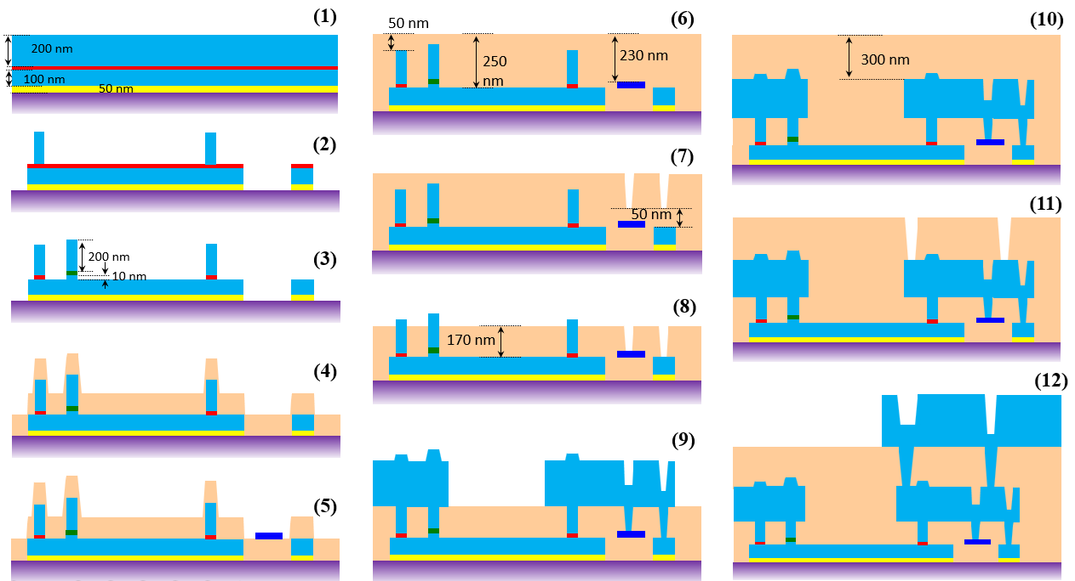
(13)
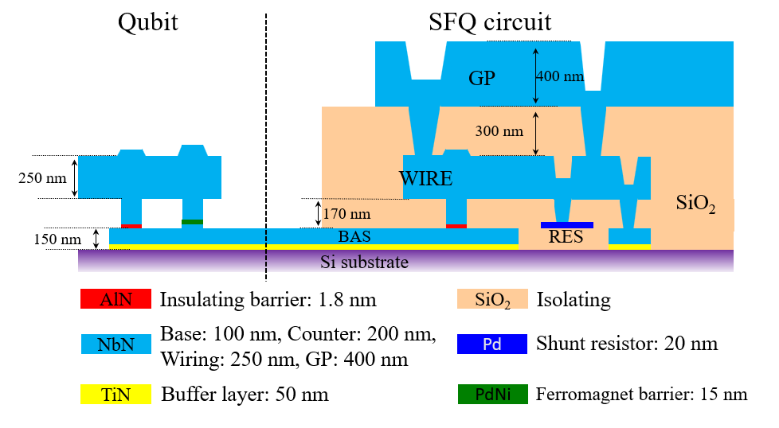
Supplementary Figure 1: Fabrication process of the monolithic quantum-classical device:
(1) Epitaxial growth of NbN/AlN/NbN trilayer on TiN/Si substrate, (2) Patterning of junctions, base electrodes, capacitor and CPWR (etching), (3) Patterning SFS junction (lift-off), (4) Deposition of the first SiO₂ isolating layer (150 nm), (5) Pattering of Palladium (Pd) shunt resistors, (6) Deposition of second SiO₂ isolating layer (300 nm), Caldera patterning and chemical mechanical planarization (CMP), (7) Etching of resistor-counter and base-wring contact holes, (8) Additional etching of whole SiO₂ layer to form contact points (etch-back), (9) Patterning of wiring layer, (10) Deposition of the third SiO₂ layer (600 nm), Caldera patterning and CMP, (11) Etching of ground-counter layer contact holes. (12) Patterning of the ground plane, (13) BHF etching of SiO₂ in the qubit part.
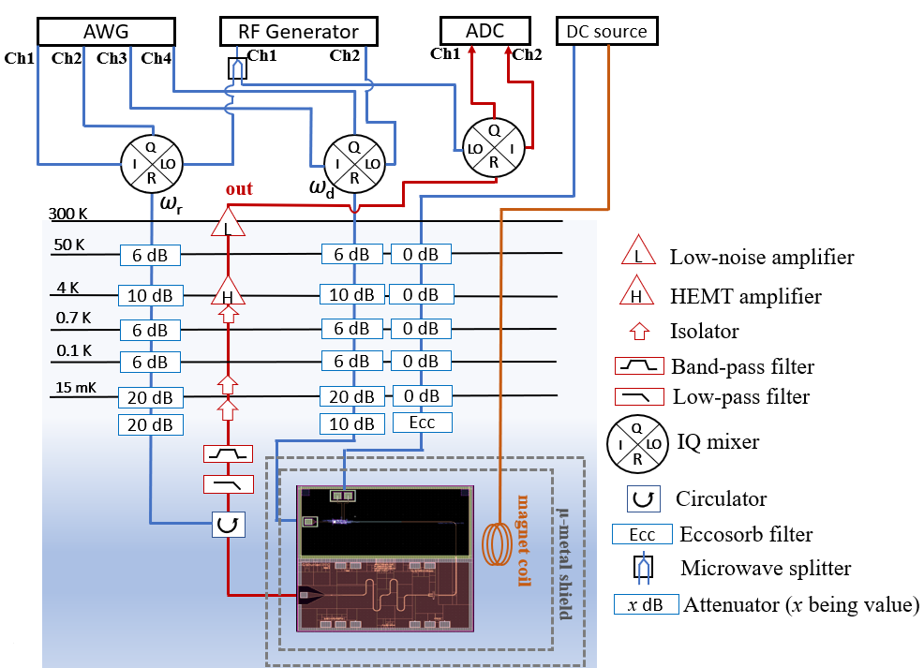
Supplementary Figure 2: The measurement setup diagram of the FBF flux qubit driven by the SFQ driver.
Supplementary Note 1: Demonstration of π-phase shift in NbN/PdNi/NbN junction at 15 mK.
In the ferromagnetic interlayer of superconductor/ferromagnet/superconductor junctions, the Cooper pairs are affected by the exchange interactions. Consequently, the superconducting order parameter spatially oscillates, and the amplitude and sign of the critical current depend on the temperature or thickness of the ferromagnetic layer. Generally, the Josephson critical current through a ferromagnetic interlayer can be represented by the equation [1]:

I_{c}R_{n} = I_{c}R_{n}(0) exp $\left(\frac{{-d}_{F}}{ξ_{F1}}\right)\left|sin\left(\frac{d_{F}}{ξ_{F2}} + ϕ\right)\right|$, (S1)

where R_{n} is the normal-state resistance of the junction, d_{F} is the thickness of the ferromagnetic interlayer, I_{c}R_{n}(0) is a fictitious fitting parameter, ξ_{F1} and ξ_{F2} are the decay length and the oscillation length, respectively. Within a certain thickness range of the ferromagnetic interlayer, the critical current might have a negative sign, and the phase difference between two superconducting electrodes becomes π in the ground state (π-junctions). These thicknesses were reported to be between 8-20 nm for the Pd₈₉Ni₁₁ ferromagnetic interlayer measured at 4.2 K [2]. The demonstration of π-state in 15 nm-thick PdNi junctions at 4.2 K has been shown in our previous study [2]. To ensure that junctions also exhibit the π-state at 15 mK, we measured the magnetic-dependent critical current of a DC-SQUID with the addition of an SFS junction into the loop. This SQUID was fabricated on the same wafer as the monolithic chip. The modulation pattern shows a clear π-phase shift, as presented in supplementary figure 3.

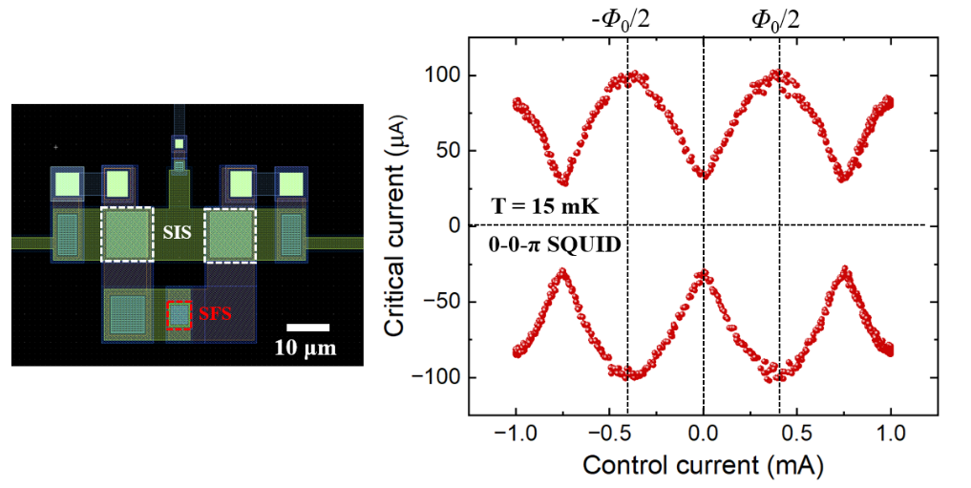
Supplementary Figure 3: The magnetic field dependence of the critical current of a 0-0-π SQUID measured at 15 mK. The SQUID includes two 10 × 10 μm² SIS junctions and a 5 × 5 μm² SFS junction. The modulation pattern indicates that SQUID has a minimum critical current at zero magnetic field and a maximum at half-flux-quantum (Φ₀/2). This characteristic is in contrast with conventional DC-SQUID, indicating that the SFS junction induced a π-phase shift within the SQUID’s loop.
Supplementary References
[1] N. O. Birge and N. Satchell, Ferromagnetic materials for Josephson π junctions, APL Mater. 12, 041105 (2024).
[2] D. Pham, R. Sugimoto, K. Oba, Y. Takeshita, F. Li, M. Tanaka, T. Yamashita, and A. Fujiamaki, Weak spin-flip scattering in Pd₈₉Ni₁₁ interlayer of NbN-based ferromagnetic Josephson junctions, Sci. Rep. 12, 6863, (2022).

