Table S1 Stroke risk and mediation analysis following combined exposure styatified by TyG index and Cystatin C in participants with kidney disease
Variables | Model 1 |  | Model 2
 | HR(95% CI) | P value | HR(95% CI) | P value
Stroke(count/total)
Group 1(108/326) | Ref |  | Ref
Group 2(53/326) | 0.67(0.13-3.42) | 0.632 | 0.65(0.12-3.39) | 0.605
Group 3(115/326) | 2.44(0.95-6.29) | 0.065 | 2.51(0.96-6.56) | 0.060
Group 4(50/326) | 3.79(1.33-10.79) | 0.013 | 3.30(1.15-9.47) | 0.026
HR, hazard ratio; CI, confidence interval; TyG, triglyceride-glucose index;
Model 1: age and gender were adjusted; model 2: age, gender, BMI, diabetes, heart disease, smoking, drinking, living place, education and marital statue were adjusted.

Table S2 Characteristics of 4,483 participants according to TyG index and Cystatin C levels
Characteristics | Overall | Group 1 | Group 2 | Group 3 | Group 4 | P value
Characteristics | N = 4483 | N = 1522 | N = 727 | N = 1626 | N = 608 | P value
Age, mean±SD | 59.2(9.1) | 56.7(8.2) | 64.35(9.5) | 57.4(8.1) | 64.0(8.9) | 0.028
BMI, mean±SD | 23.5(3.8) | 22.8(3.5) | 22.0(3.5) | 24.7(3.6) | 24.3(4.3) | 0.585
Age(%) |  |  |  |  |  | 0.028
≤59 | 2463(54.9) | 982(64.5) | 242(33.3) | 1032(63.5) | 207(34.0)
≥60 | 2020(45.1) | 540(35.5) | 485(66.7) | 594(36.5) | 401(66.0)
Gender(%) |  |  |  |  |  | 0.863
Female | 2542(56.7) | 897(58.9) | 270(37.1) | 1059(65.1) | 316(52.0)
Male | 1941(43.3) | 625(41.1) | 457(62.9) | 567(34.9) | 292(48.0)
Diabates(%) |  |  |  |  |  | 0.004
Yes | 213(4.8) | 36(2.4) | 18(2.5) | 117(7.2) | 42(6.9)
No | 4270(95.2) | 1486(97.6) | 709(97.5) | 1509(92.8) | 566(93.1)
Heart Disease(%) |  |  |  |  |  | <0.001
Yes | 454(10.1) | 115(7.6) | 75(10.3) | 179(11.0) | 85(14.0)
No | 4029(89.9) | 1407(92.4) | 652(89.7) | 1447(89.0) | 523(86.0)
Smoking status(%) |  |  |  |  |  | 0.919
Yes | 1610(35.9) | 518(34.0) | 374(51.4) | 472(29.0) | 246(40.5)
No | 2873(64.1) | 1004(66.0) | 353(48.6) | 1154(71.0) | 362(59.5)
Drinking status(%) |  |  |  |  |  | 0.634
Yes | 1352(30.2) | 467(30.7) | 265(36.5) | 436(26.8) | 184(30.3)
No | 3131(69.8) | 1055(69.3) | 462(63.5) | 1190(73.2) | 424(69.7)
Living place(%) |  |  |  |  |  | 0.640
Village | 4222(94.2) | 1444(94.9) | 689(94.8) | 1517(93.3) | 572(94.1)
City | 261(5.8) | 78(5.1) | 38(5.2) | 109(6.7) | 36(5.9)
Education level(%) |  |  |  |  |  | 0.842
College | 68(1.5) | 29(1.9) | 9(1.2) | 23(1.4) | 7(1.2)
Others | 4415(98.5) | 1493(98.1) | 718(98.8) | 1603(98.6) | 601(98.8)
Marital status(%) |  |  |  |  |  | 0.056
Married | 3983(88.8) | 1374(90.3) | 615(84.6) | 1482(91.1) | 512(84.2)
Unmarried | 500(11.2) | 148(9.7) | 112(15.4) | 144(8.9) | 96(15.8)
Group 1: low TyG & low Cystatin C; Group 2: low TyG & high Cystatin C; Group 3: high TyG & low Cystatin C; Group 4: high TyG & high Cystatin C.
SD, standard deviation; BMI, body mass index; TyG, triglyceride-glucose index.

Table S3 Subgroup analysis of stroke risk based on joint TyG index and Cystatin C
Subgroup (cases/total) | Incidence rate (1,000 PY) | Variables | HR (95% CI) | P for interaction
Age |  |  |  | <0.001
<59(2463/4483) | 5.41 | Low TyG & low Cystatin C | Reference
 | 7.49 | Low TyG & high Cystatin C | 1.41(0.65-3.04)
 | 8.42 | High TyG & low Cystatin C | 1.19(0.72-1.96)
 | 8.77 | High TyG & high Cystatin C | 1.10(0.44-2.70)
≥60(2020/4483) | 6.50 | Low TyG & low Cystatin C | Reference
 | 11.32 | Low TyG & high Cystatin C | 1.80(1.14-2.84)
 | 11.45 | High TyG & low Cystatin C | 1.74(1.12-2.69)
 | 15.61 | High TyG & high Cystatin C | 2.36(1.51-3.68)
Gender |  |  |  | 0.894
Female(2542/4483) | 5.66 | Low TyG & low Cystatin C | Reference
 | 11.43 | Low TyG & high Cystatin C | 1.59(0.97-2.62)
 | 9.75 | High TyG & low Cystatin C | 1.61(1.12-2.31)
 | 11.93 | High TyG & high Cystatin C | 1.55(0.97-2.48)
Male(1941/4483) | 5.99 | Low TyG & low Cystatin C | Reference
 | 9.22 | Low TyG & high Cystatin C | 1.42(0.87-2.31)
 | 9.09 | High TyG & low Cystatin C | 1.49(0.94-2.34)
 | 14.69 | High TyG & high Cystatin C | 2.26(1.40-3.66)
Heart Disease |  |  |  | <0.001
Yes(454/4483) | 7.91 | Low TyG & low Cystatin C | Reference
 | 23.22 | Low TyG & high Cystatin C | 3.28(1.35-7.95)
 | 18.11 | High TyG & low Cystatin C | 2.33(1.06-5.14)
 | 24.93 | High TyG & high Cystatin C | 3.28(1.40-7.67)
No(4029/4483) | 5.62 | Low TyG & low Cystatin C | Reference
 | 8.55 | Low TyG & high Cystatin C | 1.25(0.85-1.84)
 | 8.51 | High TyG & low Cystatin C | 1.48(1.09-2.00)
 | 11.40 | High TyG & high Cystatin C | 1.66(1.14-2.42)
Diabetes |  |  |  | 0.271
Yes(213/4483) | 12.78 | Low TyG & low Cystatin C | Reference
 | 19.35 | Low TyG & high Cystatin C | 1.40(0.28-6.90)
 | 12.87 | High TyG & low Cystatin C | 1.02(0.33-3.21)
 | 13.59 | High TyG & high Cystatin C | 1.18(0.30-4.66)
No(4270/4483) | 5.63 | Low TyG & low Cystatin C | Reference
 | 9.81 | Low TyG & high Cystatin C | 1.45(1.02-2.07)
 | 9.26 | High TyG & low Cystatin C | 1.60(1.20-2.14)
 | 13.22 | High TyG & high Cystatin C | 1.93(1.37-2.73)
Smoking |  |  |  | 0.222
Yes(1610/4483) | 7.24 | Low TyG & low Cystatin C | Reference
 | 10.06 | Low TyG & high Cystatin C | 1.25(0.75-2.07)
 | 8.96 | High TyG & low Cystatin C | 1.04(0.65-1.69)
 | 14.61 | High TyG & high Cystatin C | 1.56(0.94-2.59)
No(2873/4483) | 5.06 | Low TyG & low Cystatin C | Reference
 | 10.02 | Low TyG & high Cystatin C | 1.65(1.02-2.66)
 | 9.75 | High TyG & low Cystatin C | 1.80(1.26-2.57)
 | 12.33 | High TyG & high Cystatin C | 1.91(1.21-3.00)
Age, gender, BMI, diabetes, heart disease, smoking, drinking, living place, education and marital statue were adjusted for the model.

Table S4 Stroke risk and mediation analysis following combined exposure styatified by TyG index and Cystatin C (excluding missing-data individuals)
Variables | Model 1 |  | Model 2
 | HR(95% CI) | P value | HR(95% CI) | P value
Stroke(count/total)
Group 1(1459/4317) | Ref |  | Ref
Group 2(696/4317) | 1.52(1.07-2.17) | 0.020 | 1.47(1.03-2.10) | 0.033
Group 3(1574/4317) | 1.68(1.27-2.23) | <0.001 | 1.47(1.10-1.96) | 0.008
Group 4(588/4317) | 1.99(1.42-2.80) | <0.001 | 1.65(1.17-2.33) | 0.005
Mediation effect‌ | ACME | Total Effect | Proportion | P for proportion
Cystatin C as mediator | -0.003 | 0.031 | -9.1% | <0.001
TyG as mediator | -0.014 | 0.044 | -31.0% | 0.010
HR, hazard ratio; CI, confidence interval; TyG, triglyceride-glucose index; ACME, average causal mediation effect.
Model 1: age and gender were adjusted; model 2: age, gender, BMI, diabetes, heart disease, smoking, drinking, living place, education and marital statue were adjusted.

Table S5 Stroke risk following combined exposure styatified by TyG index and Cystatin C(TyG categorized into three groups)
Variables | Model 1 |  | Model 2
 | HR(95% CI) | P value | HR(95% CI) | P value
Stroke(count/total)
Low TyG(1507/4483) | Ref |  | Ref
Mid TyG(1478/4483) | 1.46(1.11-1.93) | 0.007 | 1.38(1.05-1.83) | 0.022
High TyG(1498/4483) | 1.71(1.30-2.24) | <0.001 | 1.42(1.08-1.88) | 0.013
Group 1(1015/4483) | Ref |  | Ref
Group 2(492/4483) | 1.40(0.90-2.18) | 0.134 | 1.36(0.87-2.11) | 0.175
Group 3(1015/4483) | 1.44(1.00-2.08) | 0.052 | 1.36(0.94-1.97) | 0.100
Group 4(463/4483) | 2.10(1.40-3.14) | <0.001 | 1.92(1.28-2.89) | 0.002
Group 5(1118/4483) | 1.84(1.30-2.60) | <0.001 | 1.55(1.09-2.20) | 0.015
Group 6(380/4483) | 2.19(1.44-3.33) | <0.001 | 1.74(1.14-2.65) | 0.011
HR, hazard ratio; CI, confidence interval; TyG, triglyceride-glucose index.
Model 1: age and gender were adjusted; model 2: age, gender, BMI, diabetes, heart disease, smoking, drinking, living place, education and marital statue were adjusted.

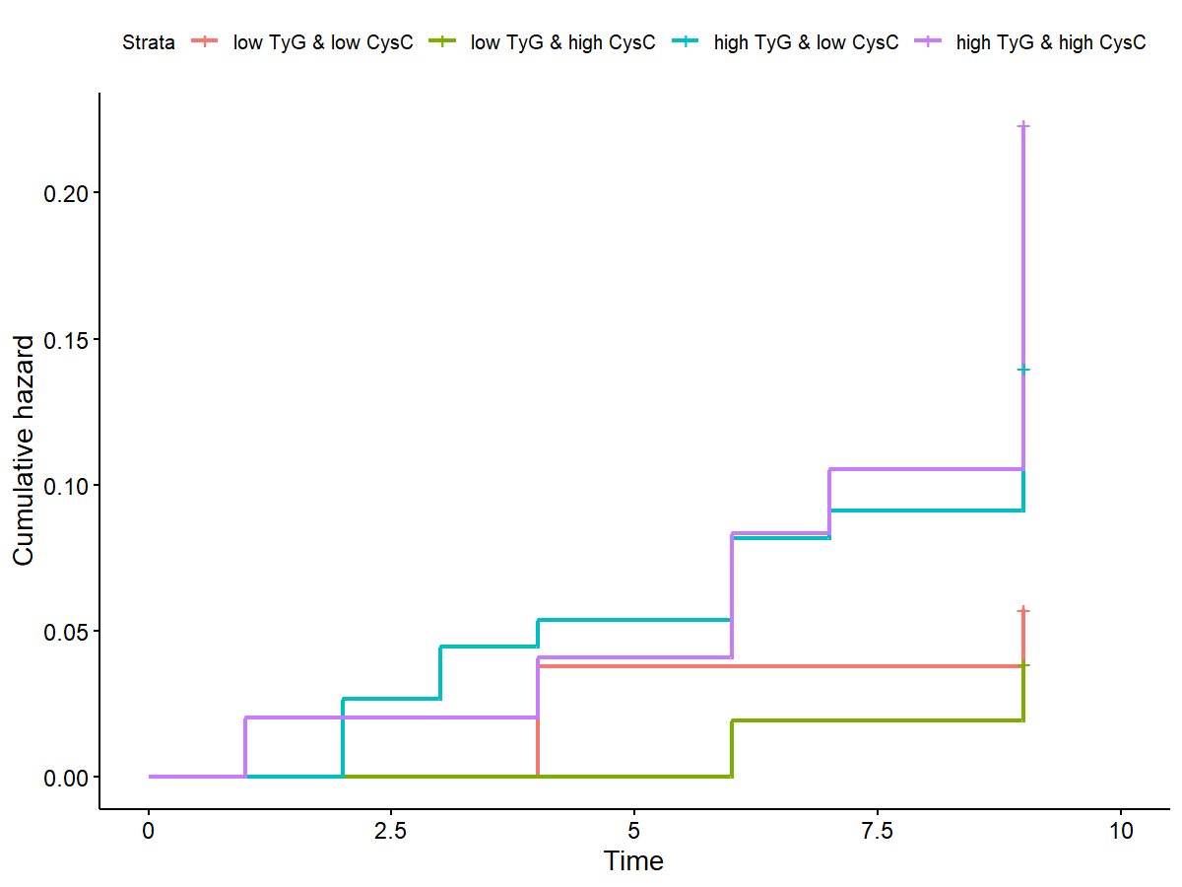
Fig.S1 K-M plot of Stroke risk by TyG index and Cystatin C in participants with kidney disease. Median of TyG index:8.52, cutoff of Cystatin C:1.06。

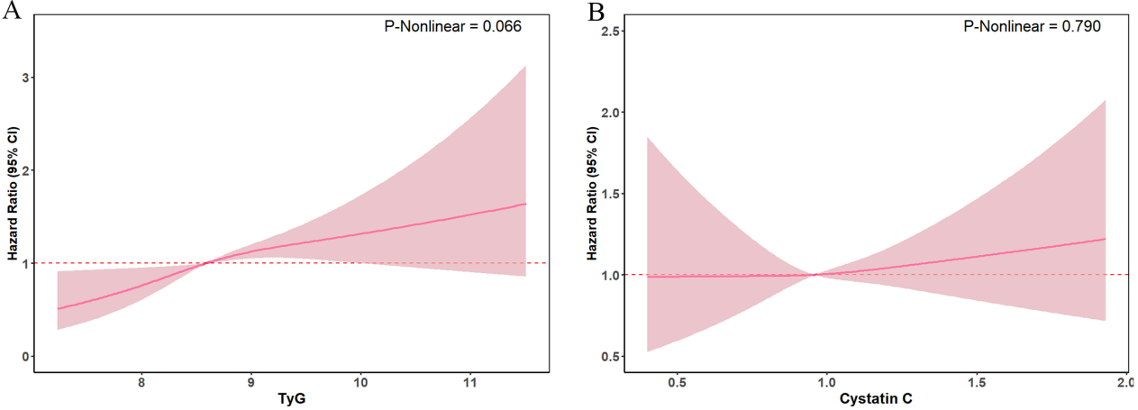
Fig.S2 Restricted cubic spline curves for stroke by TyG(A), Cystatin C(B). The model is adjusted for age, gender, BMI, diabetes, heart disease, smoking, drinking, living place, education, marital statue.

