Supporting Information for
Tailoring Plasmonic Hybrid States in Peropyrene Heterodimers by Charge Doping and Static Electric Field
Haoran Liu^{1, #}, Nan Gao^{1,2 #}, Yongqi Chen¹, Yurui Fang^{1, *}
¹ School of Physics, Dalian University of Technology, Dalian 116024, China
² Department of Physics, Zhejiang Sci-Tech University, Hangzhou, 310018, Zhejiang, China

* Corresponding authors: yrfang@dlut.edu.cn (Y.F.)
# The author contributed equally.

Figures.

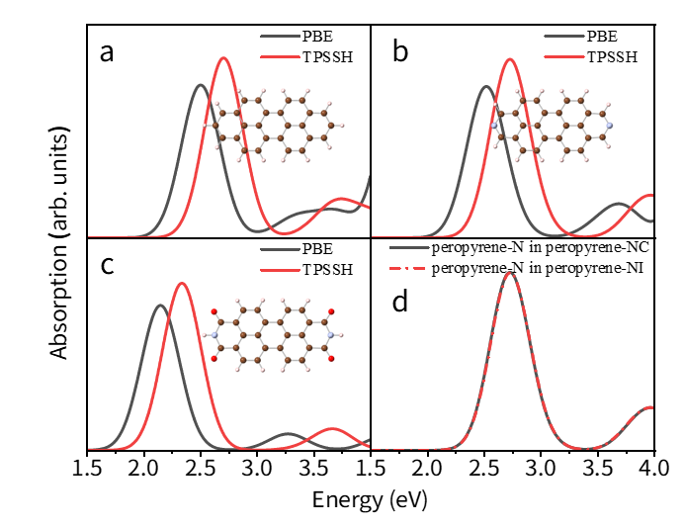
Figure S1. (a-c) Comparison of absorption spectra calculated with the functional adopted in this work (red lines) versus prior work (black lines) for (a) peropyrene, (b) peropyrene-N and (c) peropyrene-O. (d) Absorption spectra computed using extracted peropyrene-N coordinates from optimized peropyrene-NC (black line) and peropyrene-NO (red line) heterodimers.

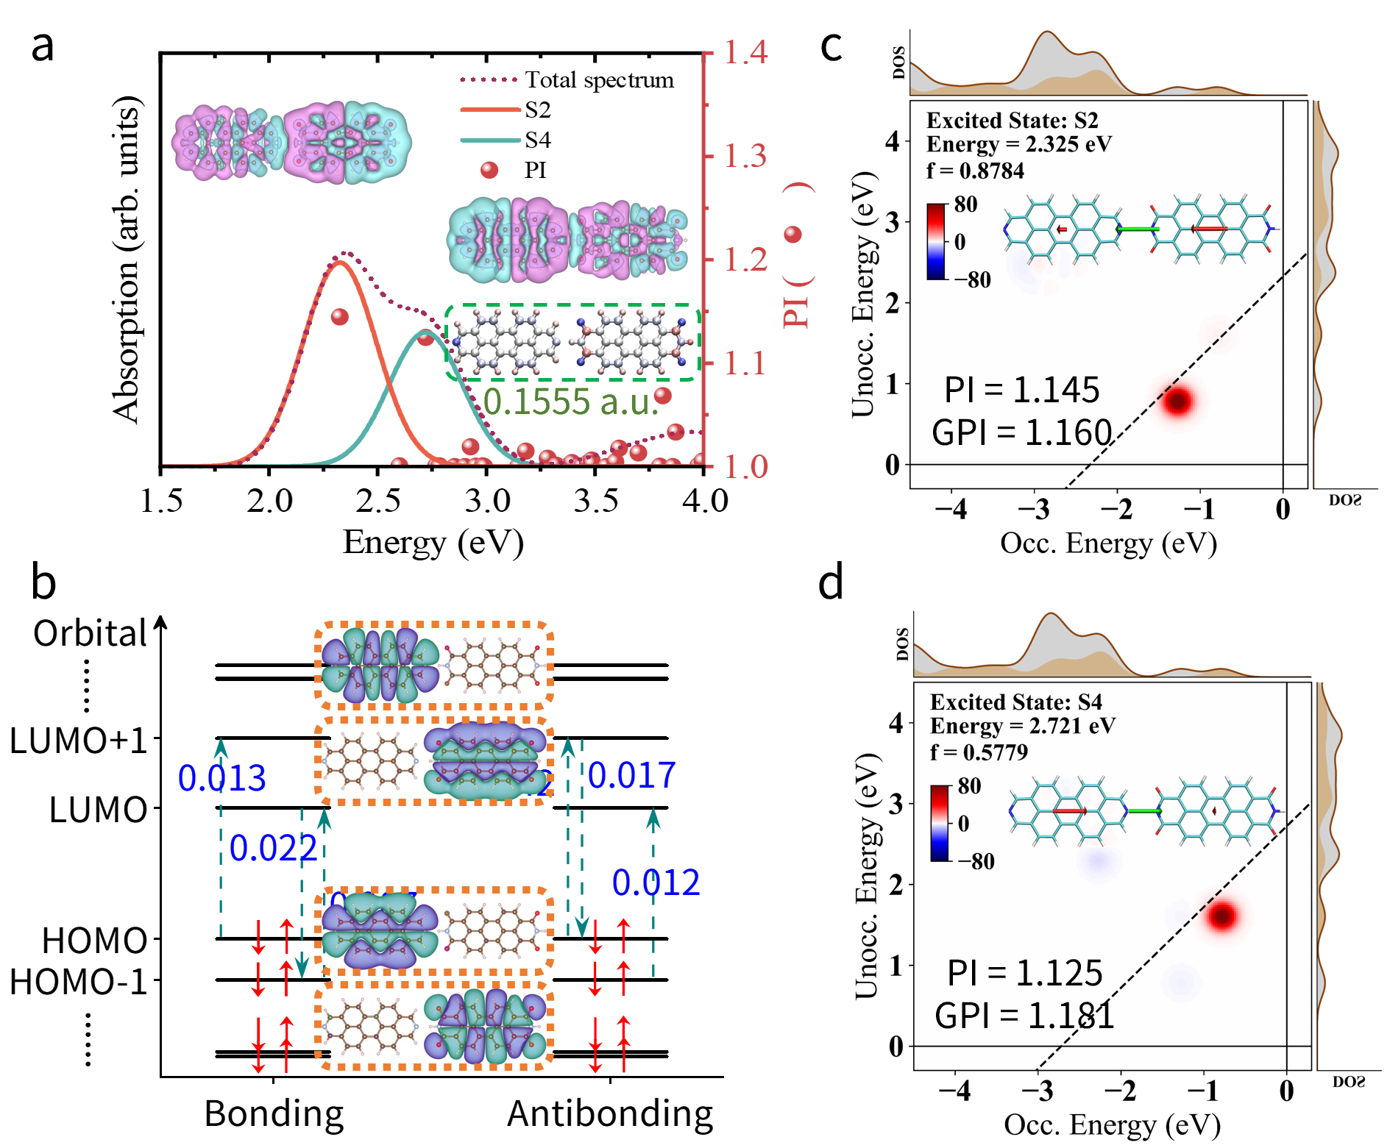
Figure S2. (a) Absorption spectra and corresponding PI values of peropyrene-NO, including the transition densities for both monometric and dimeric plasmonic excitation modes. The spectra indicate weak plasmonic interaction without observable hybridization effects. The inset in the lower-right corner displays the ground-state atomic charge distribution. For simplicity, we denote the low-energy plasmonic excitation as the bonding state and the high-energy excitation as the antibonding state throughout this work. (b) SPCA of bonding and antibonding states for peropyrene-NO. The dashed boxes show molecular orbital diagrams corresponding to the energy levels (bottom to top: HOMO-1, HOMO, LUMO, LUMO+1). (c-d) TCMs for the (c) bonding state and (d) antibonding state of peropyrene-NO. The insets depict the transition dipole moment contribution maps for the respective plasmonic states.

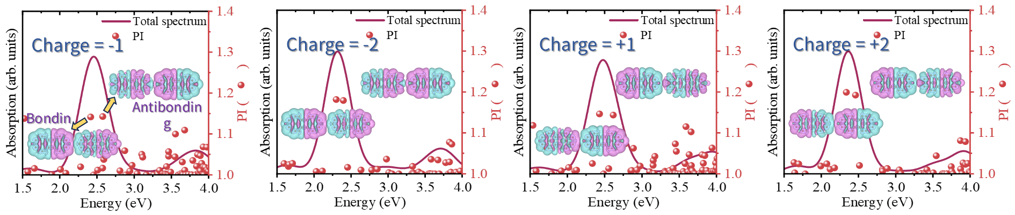
Figure S3. Absorption spectra and corresponding PI values of peropyrene-NC under charge doping levels from -2 to +2. The insets display the transition densities for the bonding and antibonding states.

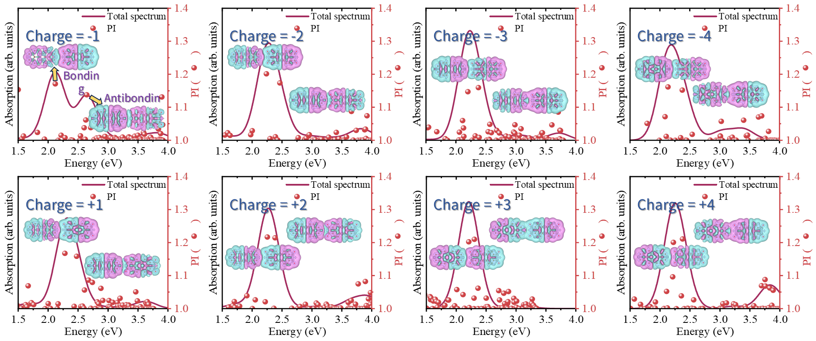
Figure S4. Absorption spectra and corresponding PI values of peropyrene-NO under charge doping levels from -4 to +4. The insets display the transition densities for the bonding and antibonding states.

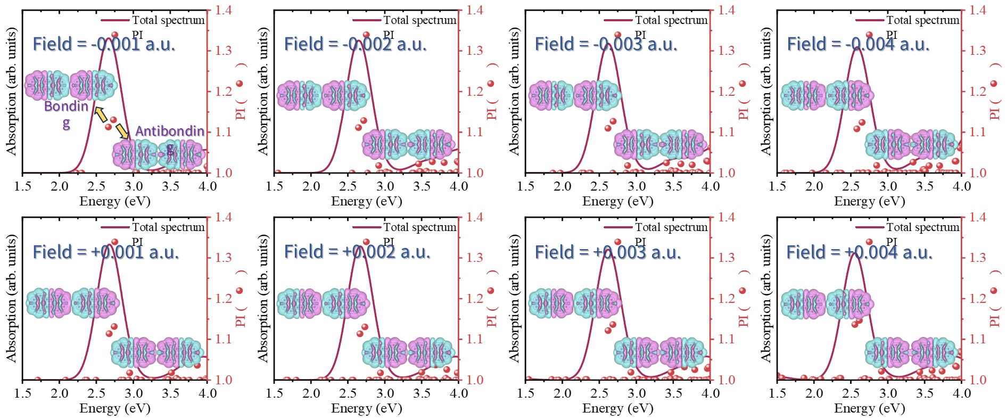
Figure S5. Absorption spectra and corresponding PI values of peropyrene-NC under static electric field strengths ranging from -0.004 a.u. to +0.004 a.u., with the electric field applied along the x direction. The insets display the transition densities for the bonding and antibonding states.

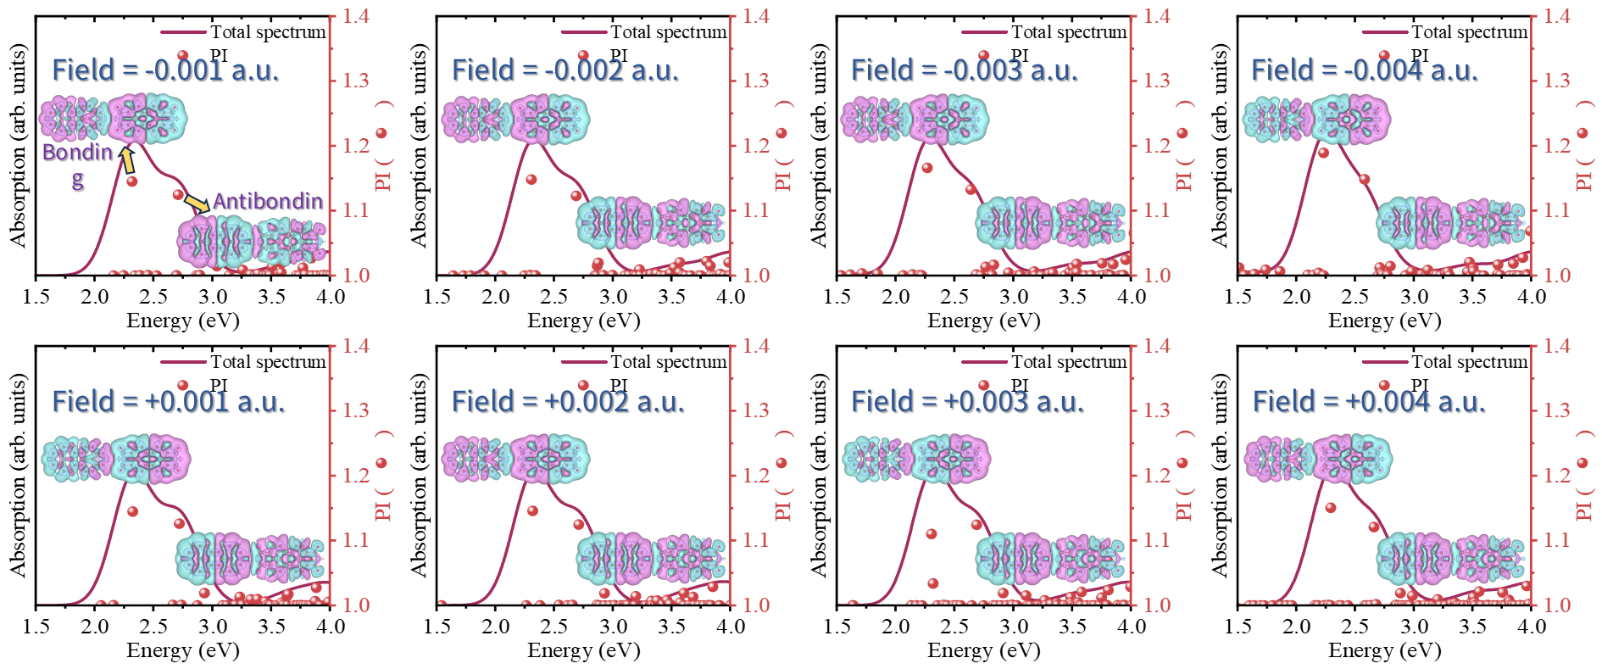
Figure S6. Absorption spectra and corresponding PI values of peropyrene-NO under static electric field strengths ranging from -0.004 a.u. to +0.004 a.u., with the electric field applied along the x direction. The insets display the transition densities for the bonding and antibonding states.

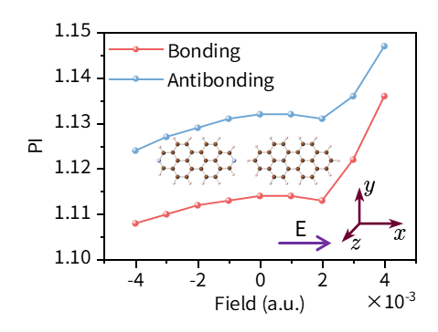
Figure S7. The PI values for the bonding and antibonding states plotted against applied static electric field strengths (from -0.004 a.u. to +0.004 a.u.), revealing systematic enhancement of plasmonic features with increasing field strength.

Tables.

Table S1. Calculated excitation properties of the first ten excited states for peropyrene, including excitation energies, oscillator strengths, PI values, and GPI values.
peropyrene
State | E/ev | f | PI | GPI
S1 | 2.705 | 0.624 | 1.123 | 3.347
S2 | 3.043 | 0.003 | 1.003 | 0.659
S3 | 3.463 | 0.000 | 1.001 | 0.311
S4 | 3.525 | 0.025 | 1.018 | 0.822
S5 | 3.719 | 0.109 | 1.042 | 1.333
S6 | 3.987 | 0.000 | 1.001 | 0.352
S7 | 4.035 | 0.075 | 1.026 | 1.642
S8 | 4.058 | 0.000 | 1.066 | 2.909
S9 | 4.121 | 0.000 | 1.009 | 0.960
S10 | 4.376 | 0.000 | 1.002 | 0.618

Table S2. Calculated excitation properties of the first ten excited states for peropyrene-N, including excitation energies, oscillator strengths, PI values, and GPI values.
peropyrene-N
State | E/ev | f | PI | GPI
S1 | 2.724 | 0.607 | 1.125 | 4.106
S2 | 2.960 | 0.034 | 1.017 | 1.233
S3 | 3.449 | 0.000 | 1.000 | 0.286
S4 | 3.471 | 0.000 | 1.000 | 0.287
S5 | 3.480 | 0.000 | 1.001 | 0.395
S6 | 3.582 | 0.000 | 1.005 | 0.652
S7 | 3.868 | 0.086 | 1.039 | 1.567
S8 | 4.010 | 0.000 | 1.004 | 0.630
S9 | 4.059 | 0.088 | 1.029 | 2.141
S10 | 4.083 | 0.000 | 1.068 | 3.520

Table S3. Calculated excitation properties of the first ten excited states for peropyrene-O, including excitation energies, oscillator strengths, PI values, and GPI values.
peropyrene-O
State | E/ev | f | PI | GPI
S1 | 2.338 | 0.582 | 1.151 | 3.436
S2 | 2.720 | 0.000 | 1.001 | 0.442
S3 | 2.726 | 0.000 | 1.001 | 0.449
S4 | 3.235 | 0.000 | 1.012 | 0.859
S5 | 3.278 | 0.000 | 1.001 | 0.482
S6 | 3.316 | 0.000 | 1.001 | 0.388
S7 | 3.320 | 0.000 | 1.001 | 0.496
S8 | 3.378 | 0.000 | 1.003 | 0.252
S9 | 3.428 | 0.007 | 1.015 | 0.862
S10 | 3.494 | 0.001 | 1.010 | 1.021
Table S4. Calculated excitation properties of the first fifteen excited states for peropyrene-NC, including excitation energies, oscillator strengths, PI values, and GPI values.
Peropyrene-NC
State | E/ev | f | PI | GPI
S1 | 1.639 | 0.000 | 1.000 | 0.000
S2 | 2.379 | 0.000 | 1.000 | 0.000
S3 | 2.674 | 1.454 | 1.114 | 1.112
S4 | 2.743 | 0.024 | 1.132 | 1.114
S5 | 2.755 | 0.000 | 1.000 | 0.000
S6 | 2.908 | 0.000 | 1.000 | 0.000
S7 | 2.950 | 0.033 | 1.018 | 0.328
S8 | 3.025 | 0.000 | 1.000 | 0.000
S9 | 3.047 | 0.002 | 1.003 | 0.213
S10 | 3.049 | 0.000 | 1.000 | 0.000
S11 | 3.175 | 0.000 | 1.000 | 0.000
S12 | 3.443 | 0.000 | 1.000 | 0.061
S13 | 3.463 | 0.001 | 1.001 | 0.104
S14 | 3.480 | 0.000 | 1.001 | 0.102
S15 | 3.494 | 0.002 | 1.000 | 0.001

Table S5. Calculated excitation properties of the first fifteen excited states for peropyrene-NO, including excitation energies, oscillator strengths, PI values, and GPI values.
Peropyrene-NO
State | E/ev | f | PI | GPI
S1 | 1.450 | 0.000 | 1.000 | 0.000
S2 | 2.325 | 0.878 | 1.145 | 1.160
S3 | 2.600 | 0.000 | 1.001 | 0.094
S4 | 2.721 | 0.578 | 1.125 | 1.181
S5 | 2.769 | 0.004 | 1.001 | 0.008
S6 | 2.785 | 0.000 | 1.001 | 0.097
S7 | 2.855 | 0.000 | 1.000 | 0.000
S8 | 2.902 | 0.000 | 1.000 | 0.000
S9 | 2.927 | 0.033 | 1.019 | 0.355
S10 | 2.951 | 0.001 | 1.000 | 0.006
S11 | 2.984 | 0.000 | 1.001 | 0.078
S12 | 2.991 | 0.000 | 1.000 | 0.000
S13 | 3.146 | 0.000 | 1.000 | 0.002
S14 | 3.182 | 0.000 | 1.015 | 0.260
S15 | 3.282 | 0.000 | 1.008 | 0.232

Table S6. Calculated excitation properties of the bonding and antibonding states for peropyrene-NC under charge doping levels from -2 to +2, including excitation energies, oscillator strengths, PI values, and GPI values.
peropyrene-NC
Charge | State | E/eV | f | PI | GPI
-2 | Bonding | 2.299 | 1.112 | 1.182 | 0.990
-2 | Antibonding | 2.395 | 0.220 | 1.179 | 1.012
-1 | Bonding | 2.414 | 0.966 | 1.142 | 1.042
-1 | Antibonding | 2.577 | 0.417 | 1.143 | 1.067
0 | Bonding | 2.674 | 1.454 | 1.114 | 1.112
0 | Antibonding | 2.743 | 0.024 | 1.132 | 1.114
+1 | Bonding | 2.430 | 0.937 | 1.146 | 1.055
+1 | Antibonding | 2.615 | 0.442 | 1.144 | 1.076
+2 | Bonding | 2.338 | 1.053 | 1.199 | 1.054
+2 | Antibonding | 2.459 | 0.300 | 1.192 | 1.073

Table S7. Calculated excitation properties of the bonding and antibonding states for peropyrene-NO under charge doping levels from -4 to +4, including excitation energies, oscillator strengths, PI values, and GPI values.
peropyrene-NO
Charge | State | E/eV | f | PI | GPI
-4 | Bonding | 2.134 | 0.979 | 1.162 | 1.114
-4 | Antibonding | 2.374 | 0.533 | 1.152 | 1.092
-3 | Bonding | 2.200 | 1.140 | 1.147 | 1.118
-3 | Antibonding | 2.376 | 0.418 | 1.160 | 1.106
-2 | Bonding | 2.239 | 1.096 | 1.202 | 1.078
-2 | Antibonding | 2.465 | 0.396 | 1.174 | 1.108
-1 | Bonding | 2.119 | 0.907 | 1.171 | 1.131
-1 | Antibonding | 2.644 | 0.597 | 1.138 | 1.160
0 | Bonding | 2.325 | 0.878 | 1.145 | 1.160
0 | Antibonding | 2.721 | 0.578 | 1.125 | 1.181
+1 | Bonding | 2.280 | 0.984 | 1.168 | 1.143
+1 | Antibonding | 2.477 | 0.388 | 1.159 | 1.143
+2 | Bonding | 2.254 | 1.145 | 1.217 | 1.134
+2 | Antibonding | 2.383 | 0.232 | 1.214 | 1.168
+3 | Bonding | 2.208 | 1.353 | 1.202 | 1.192
+3 | Antibonding | 2.303 | 0.044 | 1.210 | 1.231
+4 | Bonding | 2.223 | 1.103 | 1.201 | 1.247
+4 | Antibonding | 2.375 | 0.319 | 1.211 | 1.240

Table S8. Calculated excitation properties of the bonding and antibonding states for peropyrene-NC under static electric field strengths ranging from -0.004 a.u. to +0.004 a.u., including excitation energies, oscillator strengths, PI values, and GPI values.
peropyrene-NC
Field/a.u. | State | E/eV | f | PI | GPI
-0.004 | Bonding | 2.582 | 1.316 | 1.108 | 1.034
-0.004 | Antibonding | 2.653 | 0.050 | 1.124 | 1.029
-0.003 | Bonding | 2.616 | 1.365 | 1.110 | 1.062
-0.003 | Antibonding | 2.687 | 0.044 | 1.127 | 1.063
-0.002 | Bonding | 2.644 | 1.406 | 1.112 | 1.086
-0.002 | Antibonding | 2.714 | 0.036 | 1.129 | 1.088
-0.001 | Bonding | 2.664 | 1.437 | 1.113 | 1.104
-0.001 | Antibonding | 2.733 | 0.030 | 1.131 | 1.105
0.000 | Bonding | 2.674 | 1.454 | 1.114 | 1.112
0.000 | Antibonding | 2.743 | 0.024 | 1.132 | 1.114
+0.001 | Bonding | 2.674 | 1.453 | 1.114 | 1.108
+0.001 | Antibonding | 2.742 | 0.021 | 1.132 | 1.109
+0.002 | Bonding | 2.664 | 1.436 | 1.113 | 1.093
+0.002 | Antibonding | 2.731 | 0.019 | 1.131 | 1.093
+0.003 | Bonding | 2.618 | 1.406 | 1.122 | 1.065
+0.003 | Antibonding | 2.683 | 0.007 | 1.136 | 1.069
+0.004 | Bonding | 2.554 | 1.375 | 1.136 | 1.032
+0.004 | Antibonding | 2.615 | 0.000 | 1.147 | 1.034

Table S9. Calculated excitation properties of the bonding and antibonding states for peropyrene-NO under static electric field strengths ranging from -0.004 a.u. to +0.004 a.u., including excitation energies, oscillator strengths, PI values, and GPI values.
peropyrene-NO
Field/a.u. | State | E/eV | f | PI | GPI
-0.004 | Bonding | 2.233 | 0.909 | 1.189 | 1.148
-0.004 | Antibonding | 2.581 | 0.515 | 1.148 | 1.119
-0.003 | Bonding | 2.271 | 0.888 | 1.166 | 1.160
-0.003 | Antibonding | 2.640 | 0.535 | 1.133 | 1.131
-0.002 | Bonding | 2.301 | 0.883 | 1.148 | 1.166
-0.002 | Antibonding | 2.689 | 0.554 | 1.123 | 1.150
-0.001 | Bonding | 2.319 | 0.875 | 1.145 | 1.157
-0.001 | Antibonding | 2.710 | 0.572 | 1.125 | 1.175
0.000 | Bonding | 2.325 | 0.878 | 1.145 | 1.160
0.000 | Antibonding | 2.721 | 0.578 | 1.125 | 1.181
+0.001 | Bonding | 2.325 | 0.877 | 1.145 | 1.157
+0.001 | Antibonding | 2.721 | 0.582 | 1.126 | 1.188
+0.002 | Bonding | 2.320 | 0.884 | 1.146 | 1.156
+0.002 | Antibonding | 2.711 | 0.568 | 1.125 | 1.168
+0.003 | Bonding | 2.304 | 0.691 | 1.110 | 0.875
+0.003 | Antibonding | 2.690 | 0.554 | 1.124 | 1.151
+0.004 | Bonding | 2.293 | 0.901 | 1.151 | 1.153
+0.004 | Antibonding | 2.661 | 0.520 | 1.121 | 1.103

