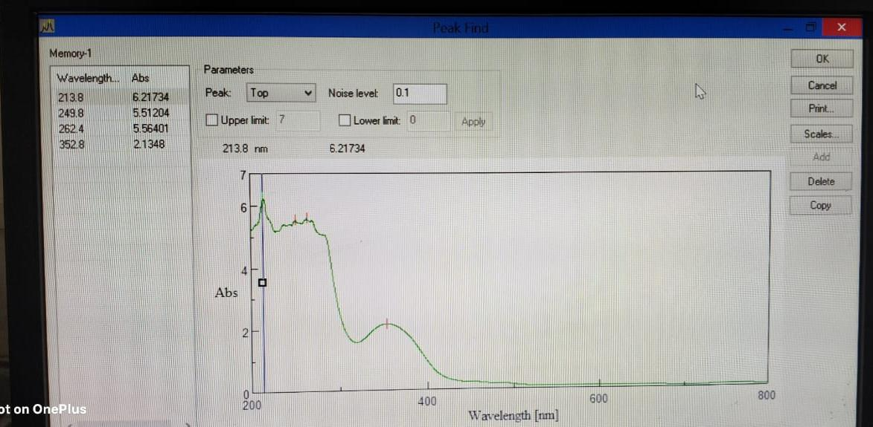
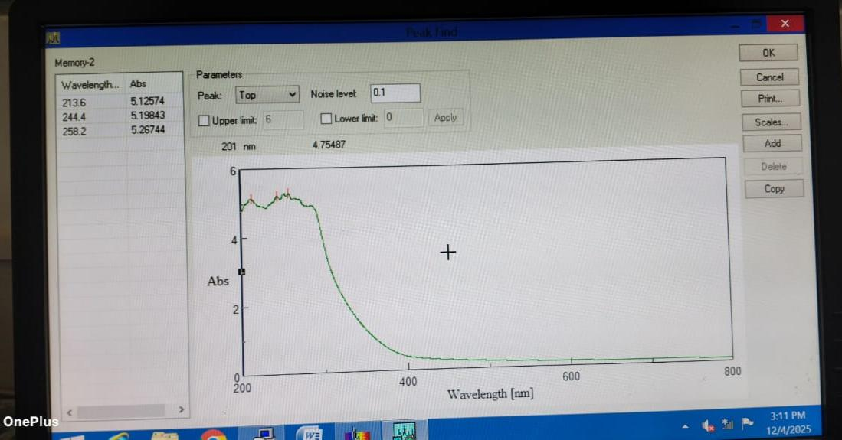
(UV-Visible spectra for Yellow Marigold Flower Dye)

( UV-Visible spectra for Dried Walnut Shells Dye )
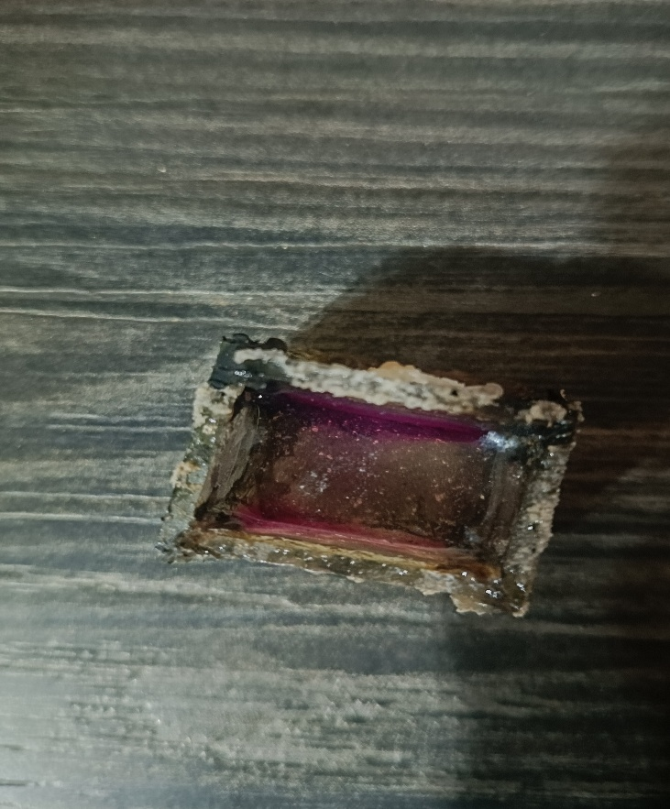
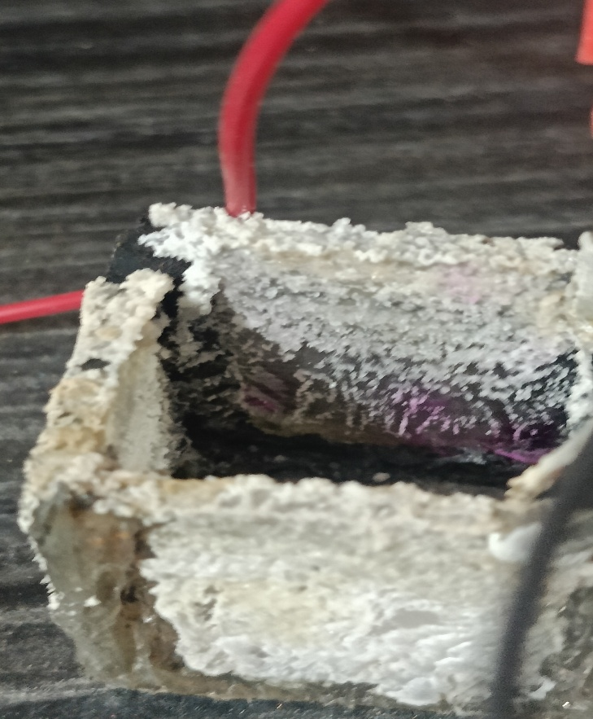
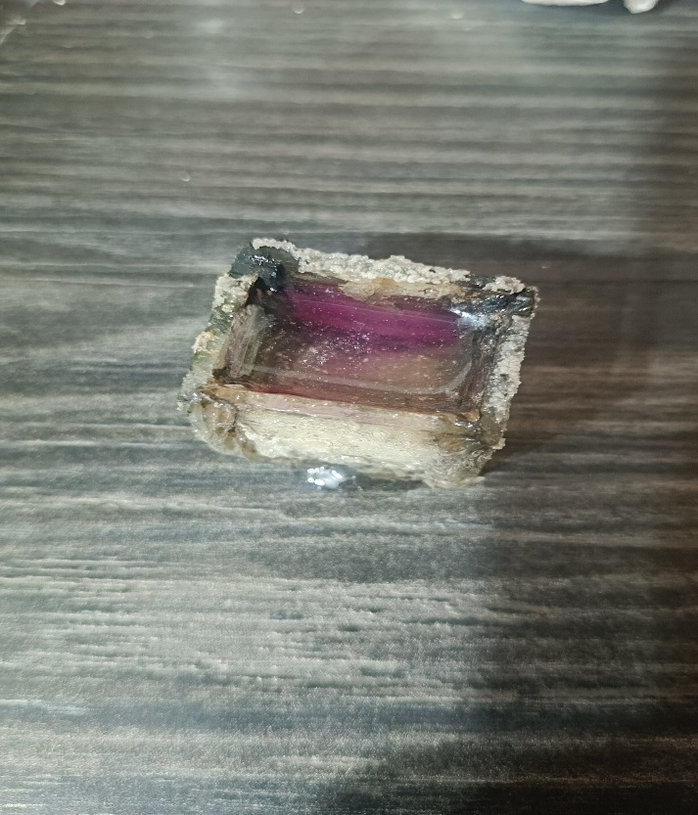
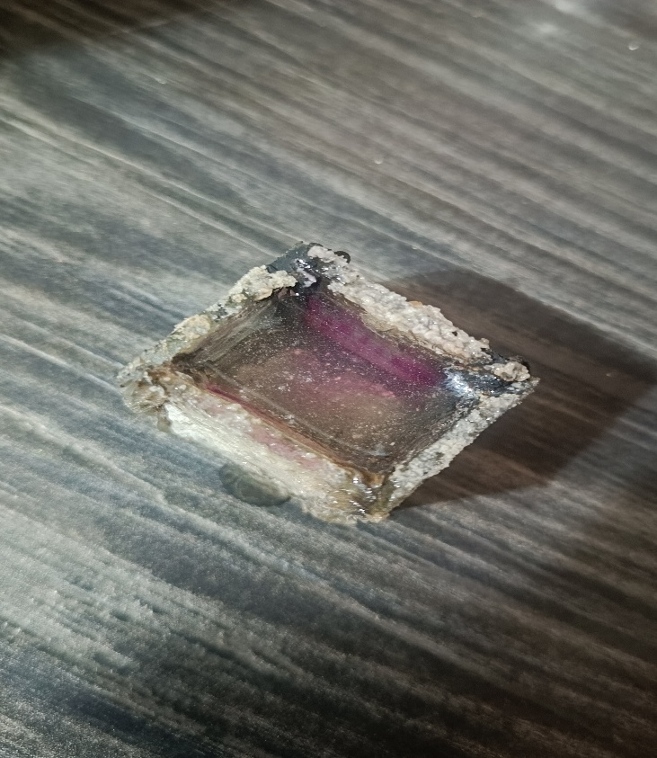
• Sodium Hydroxide production at cathode in two Cuboidal-DSSC’s sensitized with Cocktail Dye (of yellow marigold flower petals dye and dried walnut shells dye in 1:1ratio) connected in series in Sunlight after 12 hours:-

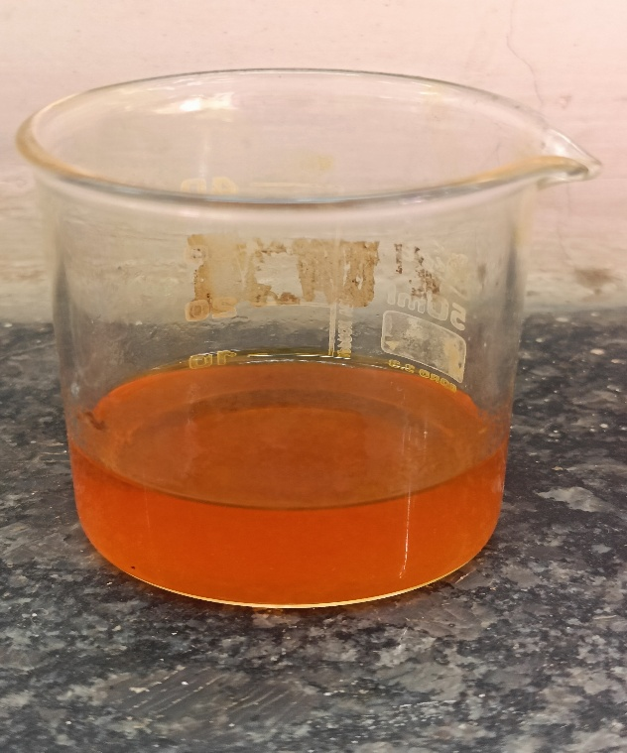
- Yellow Marigold Flower Petals Dye :-

- Dried Walnut Shells Dye :-
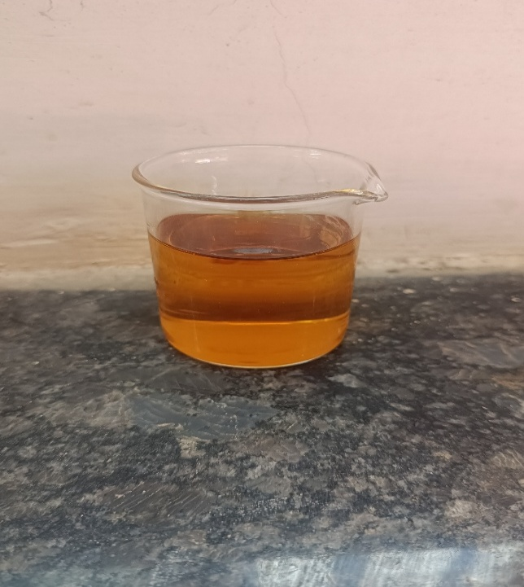

• Graphical Representation :-

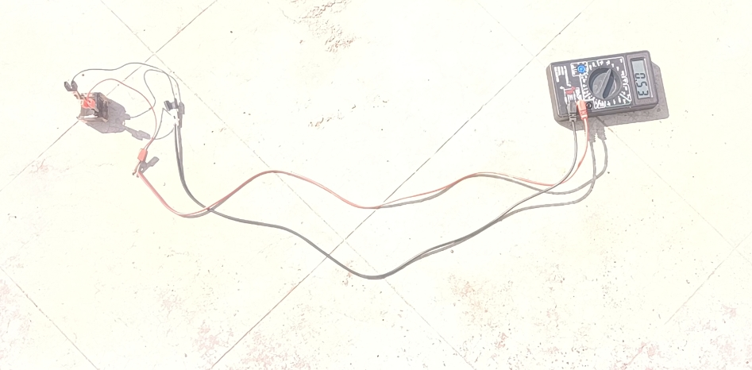
Open-circuit voltage [V(oc)] of Cuboidal-DSSC sensitized with Yellow Marigold Flower Dye in Sunlight :-

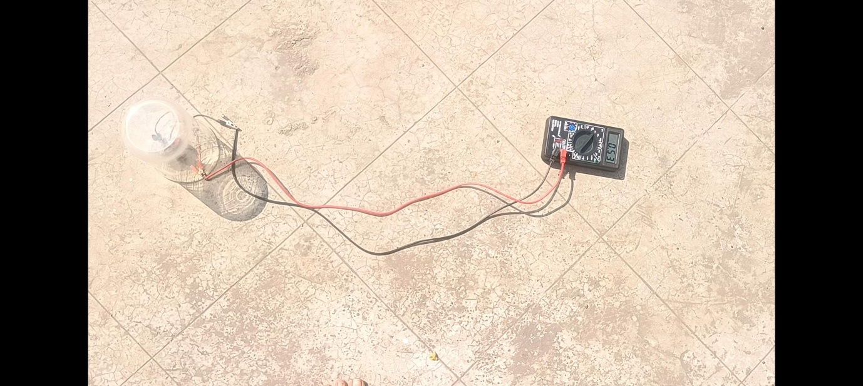
Open-circuit voltage [V(oc)] of Cuboidal-DSSC sensitized with Dried Walnut Shells Dye in Sunlight :-

Open-circuit voltage [V(oc)] of Cuboidal-DSSC sensitized with the Cocktail Dye (of Yellow Marigold Flower Dye and Dried Walnut Shells Dye in 1:1 ratio) in Sunlight :-
