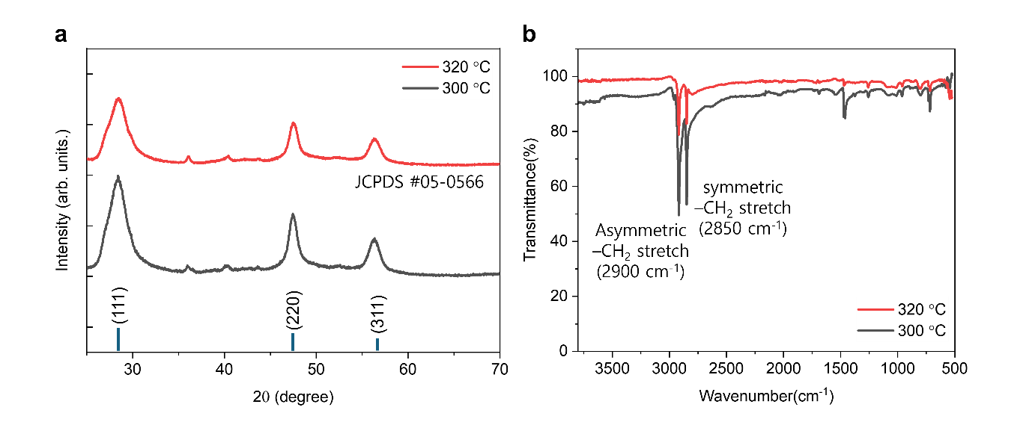
Figure S1. (a) XRD patterns and (b) FT-IR spectra of ZnS nanoparticles synthesized at different temperatures, confirming nanocrystalline structure and surface functionalization with organic ligands.

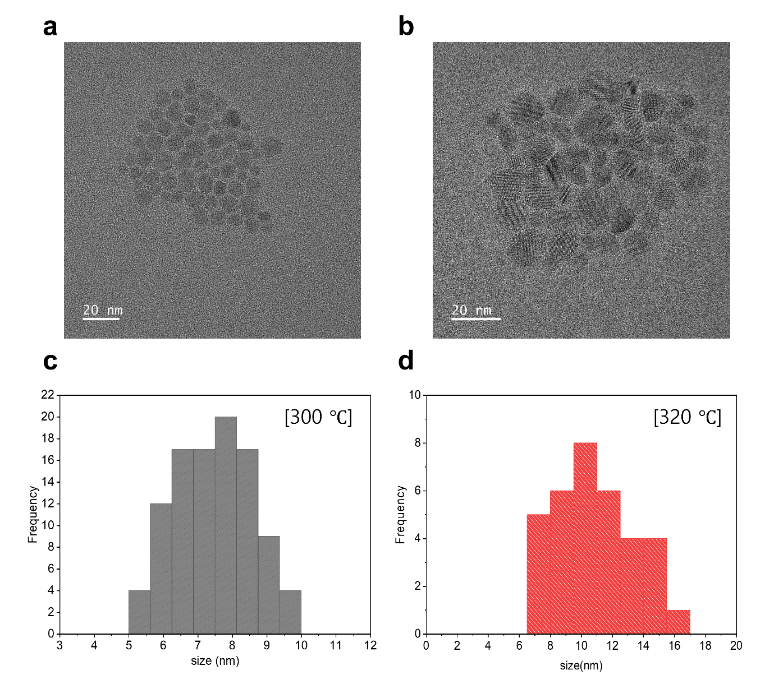
Figure S2. TEM images (a,b) and size distribution (c,d) of ZnS nanoparticles synthesized at 300 ℃ (a,c) and 320 ℃ (b,d).

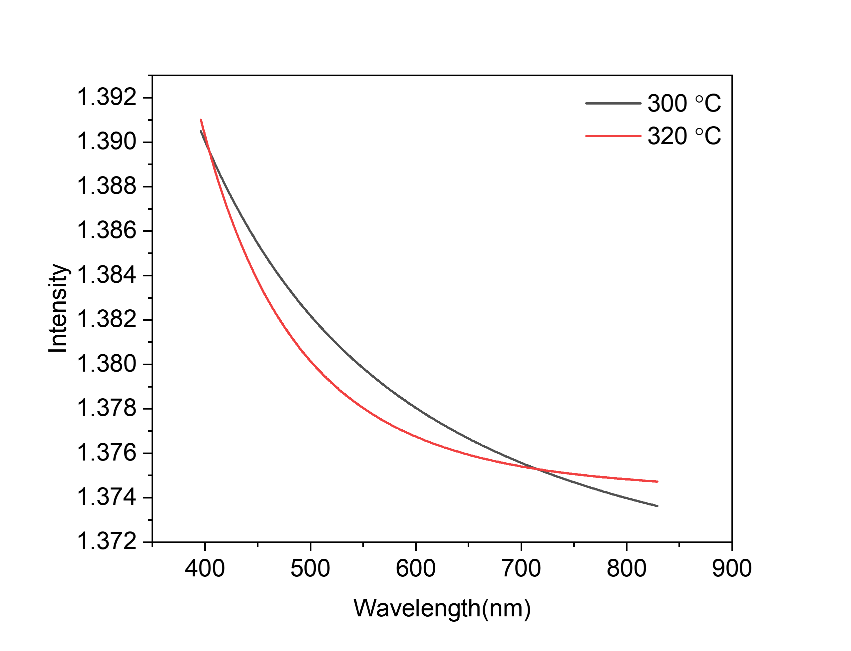 Figure S3. Wavelength-dependent refractive index of ZnS synthesized at 300 ℃ (black line) and 320 ℃ (red line).
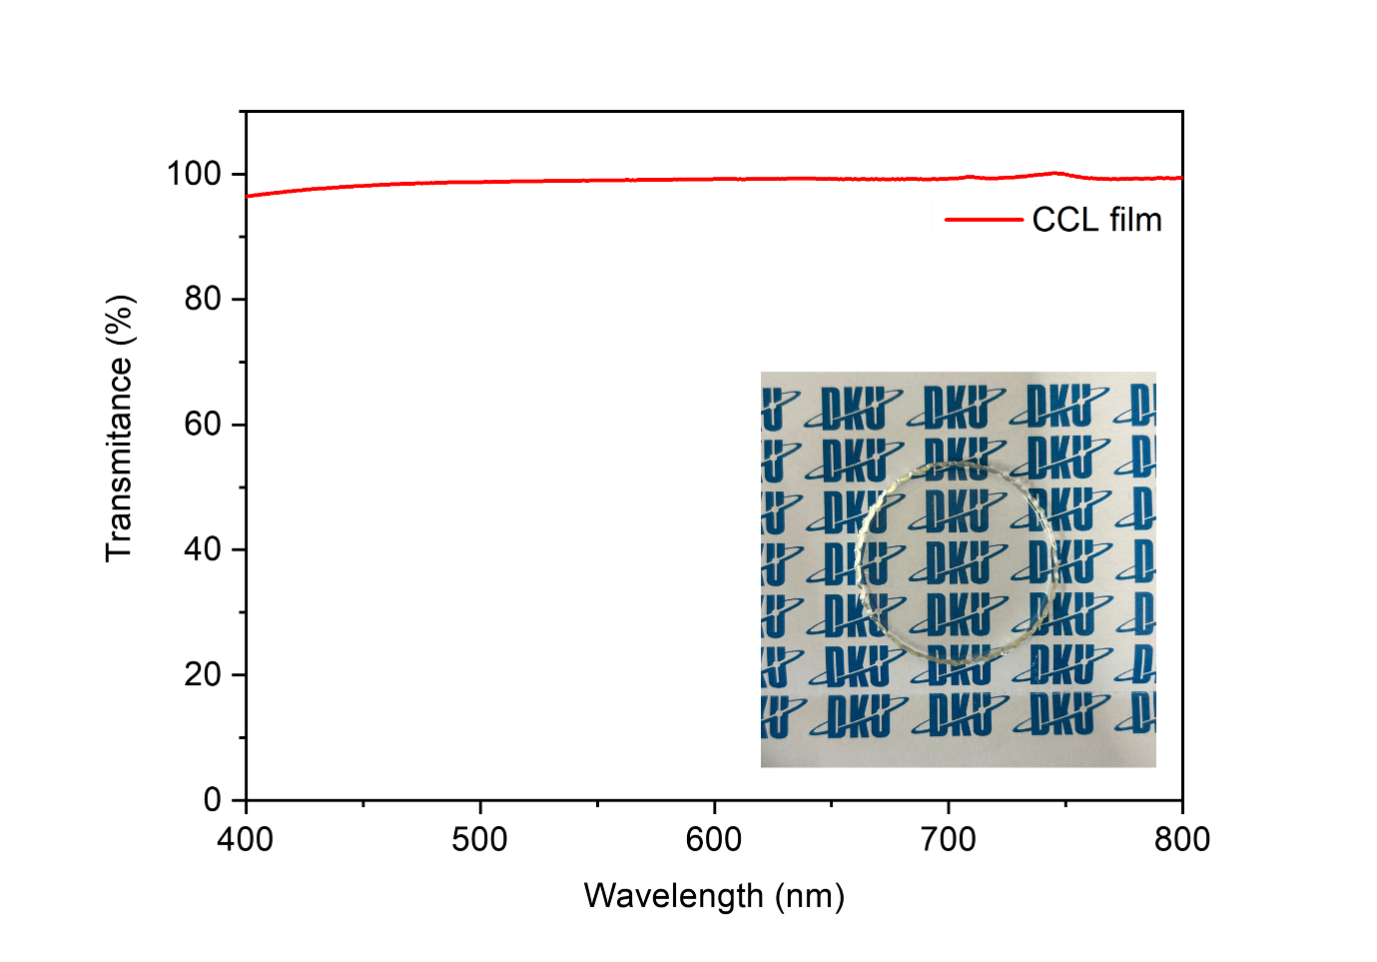
Figure S4. Transmission spectra of the CCL film without QDs, with inset photograph showing optical transparency.

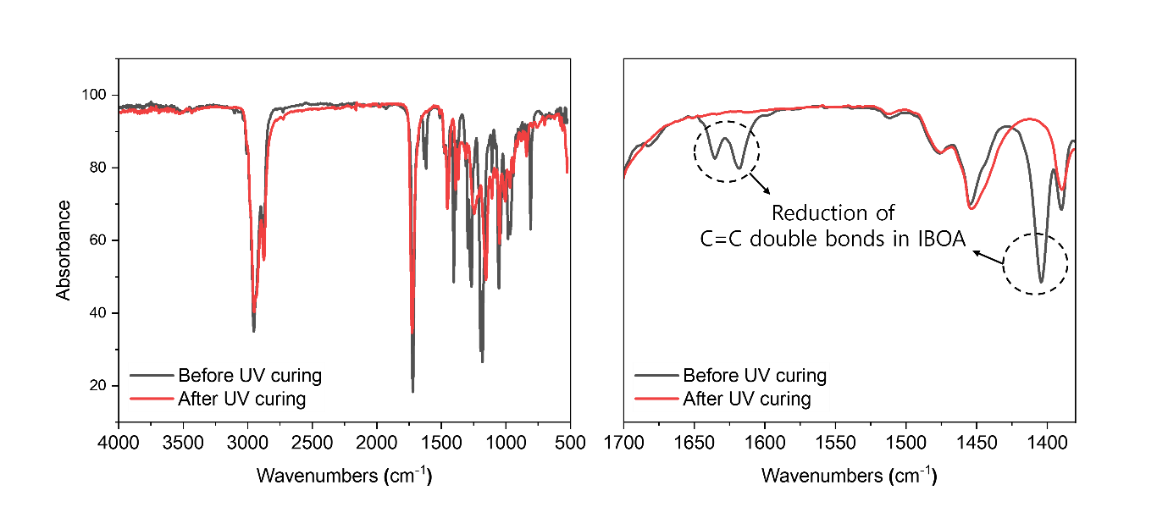
Figure S5. FT-IR spectra of QD CCL films before (black line) and after (red line) UV curing process, showing reductions of C=C double bonds.
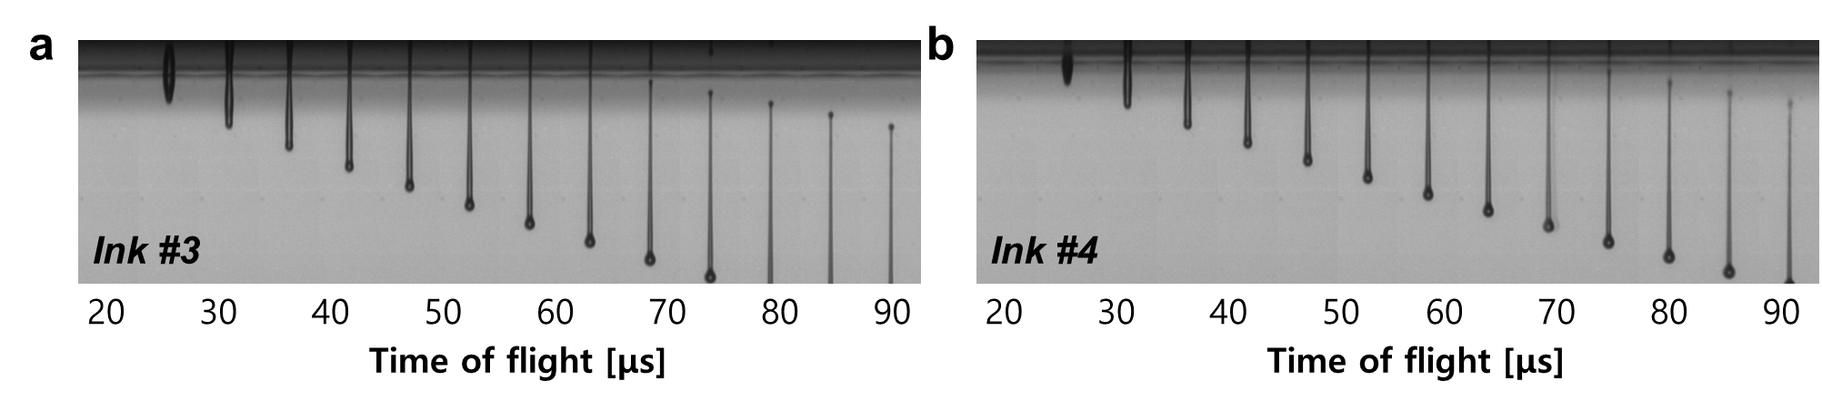
Figure S6. Droplet ejection of Ink #3 (a) and Ink #4 (b) was enabled by increasing the printhead temperature to 55 ℃.

