Supplementary Appendix 1
Association of Radiation Exposure and Blood Lipid Derived Indices with Hypertension Risk in Radiation Workers
Authors: Ruihua Ma¹, Yi Wang¹, Jiali Chen¹, Lina Yan¹, Xia Gao^{1*}
Affiliation: ¹ Department of Epidemiology and Health Statistics, School of Public Health, Hebei Medical University, Shijiazhuang, Hebei, China
* Correspondence author:
Lina Yan, 18400900@hebmu.edu.cn, Department of Epidemiology and Health Statistics, School of Public Health, Hebei Medical University, Shijiazhuang, 050017, Hebei, China. Xia Gao, gaoxia915@126.com , Department of Epidemiology and Health Statistics, School of Public Health, Hebei Medical University, Shijiazhuang, 050017, Hebei, China.
Description of supplementary appendix:
Supplementary Fig. 1 Restricted Cubic Splines of Working Years, Lipid Indices and Hypertension
Supplementary Fig. 2 Restricted Cubic Splines of Working Years and Lipid Indices
Supplementary Fig. 3 Restricted Cubic Splines of Baseline Lipid Indices and Hypertension
Supplementary Table 1 Analysis of the Association between Blood Lipids and Their Derivative Indicators and Hypertension
Supplementary Table 2 Subgroup analysis for the risk of hypertension associated with radiation
Supplementary Table 3 Gender-specific analysis of the association between blood lipids or their derived indicators and the risk of hypertension
Supplementary Table 4 Overweight stratified analysis of the association between blood lipids or their derived indicators and the risk of hypertension
Supplementary Table 5 Stratified analysis of the association between blood lipids or their derived indicators and hypertension risk by working years
Supplementary Table 6 Stratified analysis of job classification associated with blood lipids or their derived indicators and hypertension risk
Supplementary Table 7 Association analysis of continuous or the three-classification indicators of blood lipids or their derived variables with the risk of hypertension (Exclude those whose follow-up period is less than half a year)

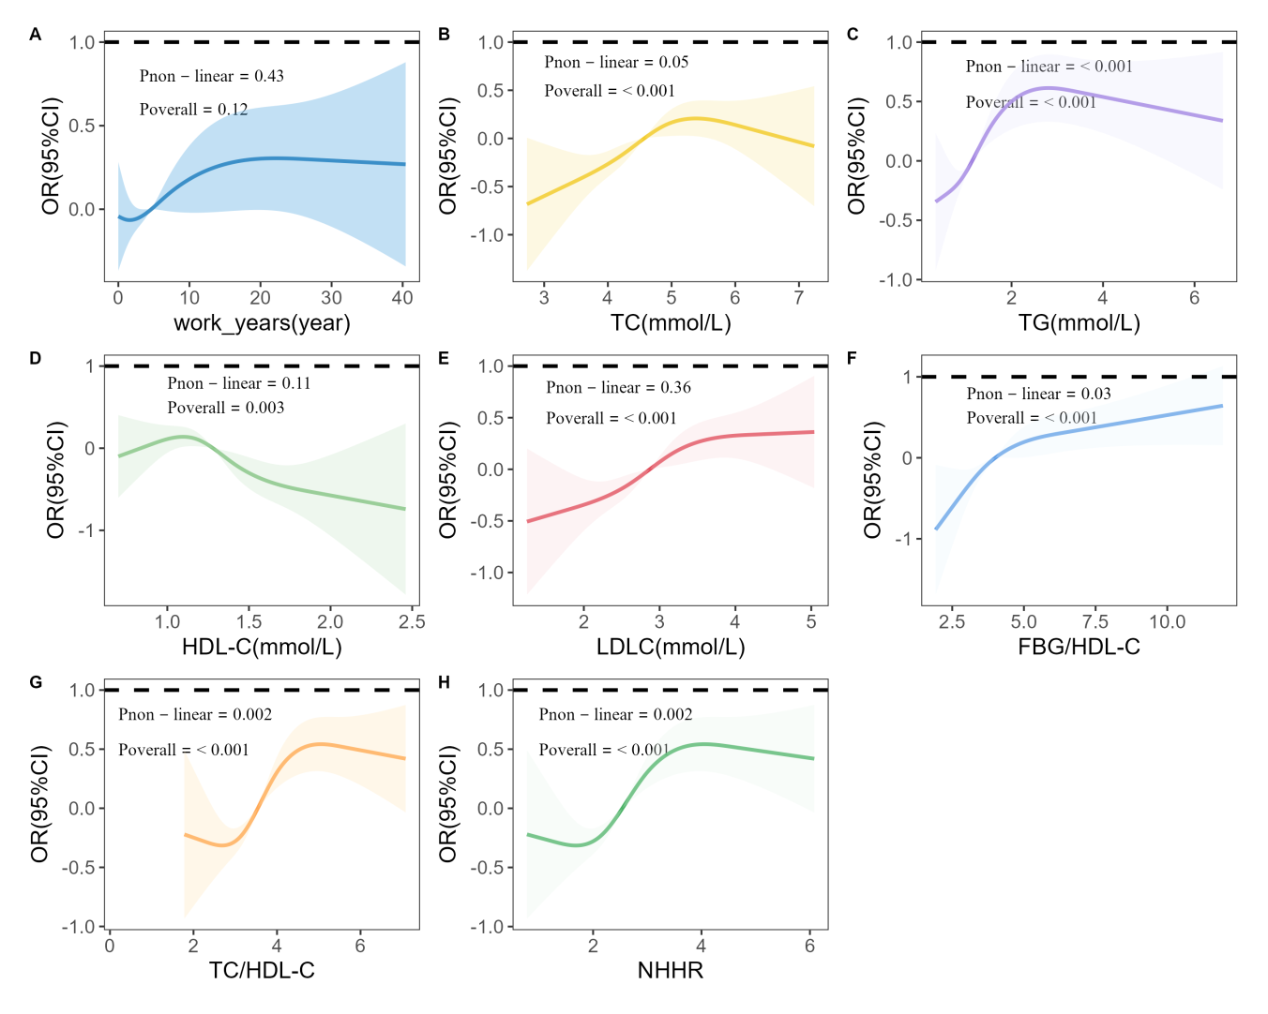
Supplementary Fig.1 Restricted Cubic Splines of Working Years, Lipid Indices and Hypertension. Restricted cubic spline analysis for the association of working years (A), TC (B), TG (C), HDL-C (D), LDL-C (E), FBG/HDL-C (F), TC/HDL-C (G), and NHHR (H) with hypertension.
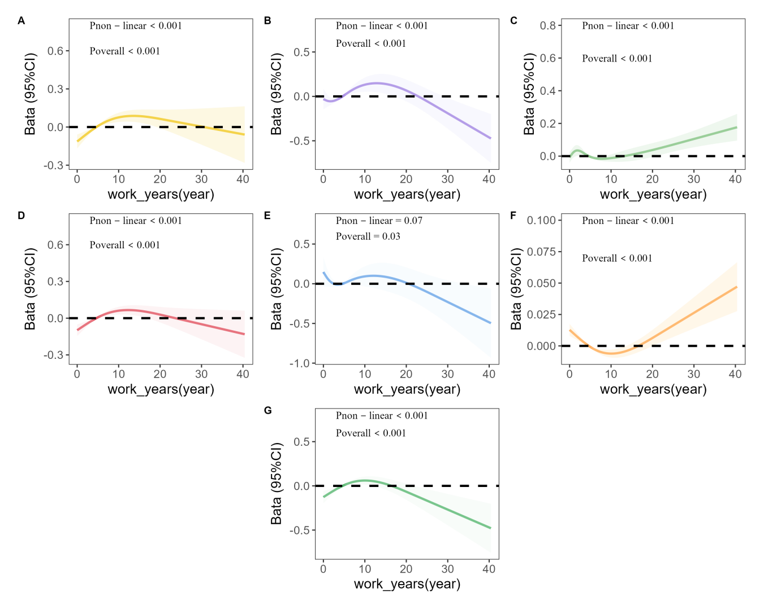
Supplementary Fig.2 Restricted Cubic Splines of Working Years and Lipid Indices. Restricted cubic spline analysis of the associations between working years and TC (A), TG (B), HDL-C (C), LDL-C (D), FBG/HDL-C (E), TC/HDL-C (F), and NHHR (G) .
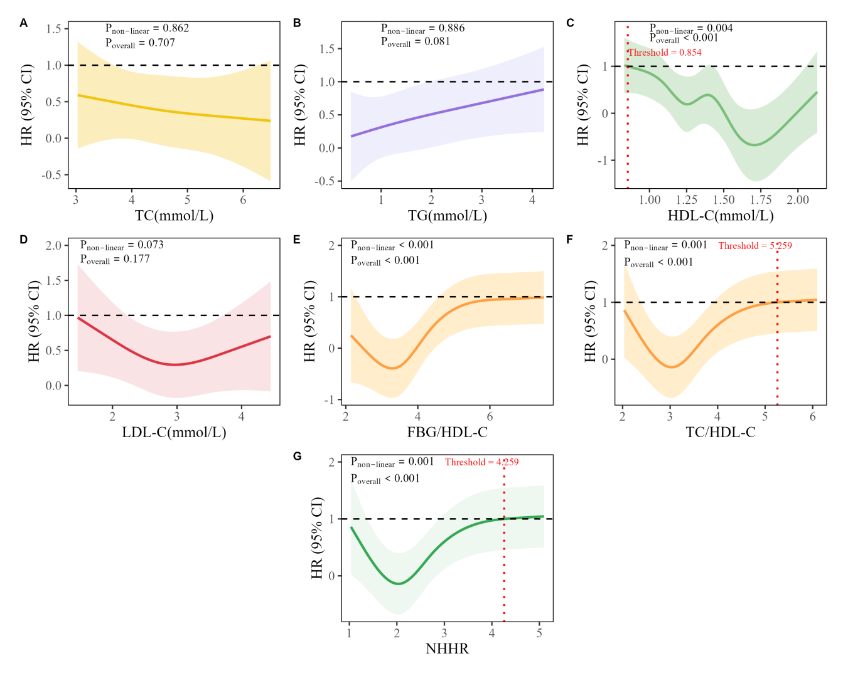
Supplementary Fig.3 Restricted Cubic Splines of Baseline Lipid Indices and Hypertension. Restricted cubic spline analysis illustrating the associations between baseline TC (A), TG (B), HDL-C (C), LDL-C (D), FBG/HDL-C (E), TC/HDL-C (F), and NHHR (G) and the risk of hypertension.
Table S1 Analysis of the Association between Blood Lipids and Their Derivative Indicators and Hypertension
Blood Lipids and Their Derivative Indicators | Hypertension OR(95% CI)
Blood Lipids and Their Derivative Indicators | Model 1 | Model 2 | Model 3
TC | 1.410(1.267,1.571) | 1.270(1.130,1.427) | 1.235(1.095,1.393)
TG | 1.512(1.389,1.648) | 1.229(1.124,1.344) | 1.202(1.099,1.317)
HDL-C | 0.208(0.148,0.291) | 0.485(0.333,0.700) | 0.538(0.366,0.787)
LDL-C | 1.725(1.523,1.956) | 1.422(1.242,1.628) | 1.361(1.183,1.566)
FBG/HDL-C | 1.367(1.280,1.463) | 1.147(1.079,1.226) | 1.128(1.062,1.206)
TC/HDL-C | 1.650(1.507,1.808) | 1.287(1.168,1.420) | 1.229(1.115,1.360)
NHHR | 1.650(1.507,1.808) | 1.287(1.167,1.420) | 1.229(1.115,1.360)
TC groups
Low (<4.21) | Reference | Reference | Reference
Middle (4.21-4.95) | 1.546(1.209,1.981) | 1.401(1.081,1.818) | 1.344(1.031,1.756)
High (>4.95) | 2.288(1.808,2.906) | 1.724(1.340,2.224) | 1.631(1.259,2.118)
TG groups
Low (<0.87) | Reference | Reference | Reference
Middle (0.87-1.52) | 2.147(1.643,2.821) | 1.620(1.224,2.155) | 1.539(1.157,2.057)
High (>1.52) | 4.282(3.328,5.553) | 2.464(1.882,3.246) | 2.230(1.693,2.955)
HDL-C groups
Low (<1.16) | Reference | Reference | Reference
Middle (1.16-1.43) | 0.787(0.636,0.974) | 0.955(0.764,1.195) | 1.001(0.795,1.261)
High (>1.43) | 0.324(0.250,0.418) | 0.593(0.447,0.783) | 0.622(0.464,0.830)
LDL-C groups
Low (<2.57) | Reference | Reference | Reference
Middle (2.57-3.21) | 1.857(1.442,2.401) | 1.447(1.108,1.895) | 1.395(1.063,1.834)
High (>3.21) | 2.973(2.332,3.810) | 1.992(1.538,2.590) | 1.819(1.395,2.379)
FBG/HDL-C groups
Low (<3.53) | Reference | Reference | Reference
Middle (3.53-4.52) | 2.346(1.802,3.071) | 1.565(1.183,2.079) | 1.523(1.143,2.038)
High (>4.52) | 3.899(3.028,5.057) | 1.942(1.474,2.572) | 1.826(1.375,2.439)
TC/HDL-C groups
Low (<3.12) | Reference | Reference | Reference
Middle (3.12-3.99) | 2.124(1.624,2.792) | 1.438(1.083,1.919) | 1.356(1.015,1.819)
High (>3.99) | 4.327(3.359,5.617) | 2.221(1.687,2.940) | 2.007(1.515,2.672)
NHHR groups
Low (<2.12) | Reference | Reference | Reference
Middle (2.12-2.99) | 2.124(1.624,2.792) | 1.438(1.083,1.919) | 1.356(1.015,1.819)
High (>2.99) | 4.327(3.359,5.617) | 2.221(1.687,2.940) | 2.007(1.515,2.672)
Model 1: Unadjusted model; Model 2: Adjusted for sex and age; Model 3: Further adjusted for BMI, education level, smoking status, and alcohol consumption on the basis of Model 2.

Table S2 Subgroup analysis of radiation exposure and the risk of hypertension
Subgroup variables | Working years | P-interaction | Working years groups |  | P-interaction | Type of physical examination |  | P-interaction | Job classification | P-interaction
Subgroup variables | Working years | P-interaction | Middle ª | High ª | P-interaction | During employment ^{b} | Post-employment ^{b} | P-interaction | Industrial ^{c} | P-interaction
Sex |  | 0.609 |  |  | 0.222 |  |  | 0.474 |  | 0.751
Female | 0.981  (0.950,1.012) |  | 1.349  (0.752,2.442) | 0.871  (0.463,1.638) |  | 0.876  (0.511,1.546) | 0.234  (0.035,0.886) |  | 2.300  (1.265,4.082)
Male | 1.020  (1.006,1.034) |  | 1.007  (0.753,1.346) | 1.599  (1.191,2.152) |  | 1.268  (0.945,1.714) | 0.863  (0.463,1.558) |  | 1.869  (1.471,2.381)
Age groups |  | 0.423 |  |  | 0.846 |  |  | 0.261 |  | 0.985
<35 | 1.031  (0.986,1.077) |  | 1.016  (0.713,1.449) | 1.409  (0.834,2.338) |  | 1.247  (0.857,1.835) | 0.415  (0.119,1.111) |  | 1.662  (1.175,2.368)
≥35 | 1.017  (1.005,1.030) |  | 1.209  (0.822,1.782) | 1.566  (1.131,2.186) |  | 1.210  (0.849,1.747) | 1.039  (0.529,1.980) |  | 1.854  (1.407,2.441)
Educational level |  | 0.706 |  |  | 0.554 |  |  | 0.731 |  | 0.500
Junior high school or below | 1.012  (0.992,1.031) |  | 1.040  (0.706,1.536) | 1.417  (0.944,2.135) |  | 1.207  (0.808,1.830) | 0.863  (0.395,1.800) |  | 2.170  (1.562,3.026)
Senior high school / polytechnic | 1.017  (0.996,1.038) |  | 1.059  (0.692,1.623) | 1.726  (1.130,2.654) |  | 1.356  (0.882,2.130) | 0.648  (0.205,1.710) |  | 1.621  (1.152,2.288)
Junior college or above | 1.002  (0.973,1.031) |  | 1.208  (0.637,2.277) | 0.911  (0.470,1.748) |  | 0.828  (0.471,1.467) | 0.402  (0.079,1.509) |  | 2.242  (1.165,4.282)
Smoking |  | 0.232 |  |  | 0.084 |  |  | 0.543 |  | 0.614
No | 1.017  (1.003,1.032) |  | 1.231  (0.918,1.652) | 1.603  (1.193,2.159) |  | 1.238  (0.926,1.669) | 0.805  (0.432,1.440) |  | 2.005  (1.567,2.570)
Yes | 0.993  (0.966,1.021) |  | 0.616  (0.341,1.101) | 0.834  (0.434,1.578) |  | 0.986  (0.546,1.807) | 0.381  (0.077,1.411) |  | 1.650  (1.001,2.741)
Alcohol drinking |  | 0.355 |  |  | 0.229 |  |  | 0.488 |  | 0.518
No | 1.000  (0.984,1.017) |  | 1.125  (0.802,1.579) | 1.147  (0.817,1.614) |  | 1.032  (0.744,1.444) | 0.537  (0.238,1.109) |  | 1.911  (1.430,2.557)
Yes | 1.032  (1.012,1.054) |  | 1.042  (0.692,1.574) | 2.097  (1.360,3.260) |  | 1.486  (0.972,2.316) | 1.037  (0.445,2.300) |  | 1.958  (1.388,2.778)
Overweight |  | 0.776 |  |  | 0.331 |  |  | 0.005 |  | 0.279
No | 1.013  (0.989,1.038) |  | 0.833  (0.512,1.351) | 1.388  (0.867,2.237) |  | 0.663  (0.431,1.028) | 0.361  (0.114,0.937) |  | 2.479  (1.652,3.734)
Yes | 1.011  (0.996,1.026) |  | 1.182  (0.868,1.611) | 1.418  (1.031,1.954) |  | 1.663  (1.201,2.332) | 0.971  (0.490,1.848) |  | 1.731  (1.333,2.253)
ª For working years groups, the medium and high level groups were both referenced to the low level group; ^{b} For type of physical examination, during employment and post-employment were both referenced to pre-employment; ^{c} For job classification, industrial radiation workers were referenced to medical radiation workers.

Table S3 Gender-specific analysis of the association between blood lipids or their derived indicators and the risk of hypertension
Blood Lipids and Their Derivative Indicators | Hypertension  n(%) | HR(95% CI)
Blood Lipids and Their Derivative Indicators | Hypertension  n(%) | Model 1 | Model 2 | Model 3
TC
Female | 27(12.8) | 1.269(0.813,1.980) | 0.822(0.500,1.353) | 0.720(0.426,1.216)
Male | 91(33.3) | 0.978(0.757,1.264) | 0.867(0.654,1.151) | 0.924(0.698,1.224)
P-interaction |  | 0.393 | 0.329 | 0.354
TG
Female | 27(12.8) | 1.683(1.047,2.704) | 1.223(0.705,2.122) | 1.228(0.690,2.188)
Male | 91(33.3) | 1.221(1.047,1.423) | 1.185(1.011,1.388) | 1.165(0.985,1.377)
P-interaction |  | 0.235 | 0.325 | 0.315
HDL-C
Female | 27(12.8) | 0.793(0.241,2.613) | 1.054(0.311,3.572) | 0.726(0.200,2.629)
Male | 91(33.3) | 0.285(0.136,0.597) | 0.268(0.126,0.570) | 0.255(0.113,0.574)
P-interaction |  | 0.211 | 0.142 | 0.114
LDL-C
Female | 27(12.8) | 1.203(0.715,2.026) | 0.689(0.382,1.243) | 0.630(0.338,1.172)
Male | 91(33.3) | 1.031(0.746,1.424) | 0.908(0.645,1.279) | 0.992(0.704,1.397)
P-interaction |  | 0.681 | 0.616 | 0.706
FBG/HDL-C
Female | 27(12.8) | 1.293(0.905,1.848) | 1.084(0.699,1.682) | 1.247(0.806,1.931)
Male | 91(33.3) | 1.058(1.016,1.101) | 1.062(1.018,1.108) | 1.082(1.032,1.135)
P-interaction |  | 0.231 | 0.359 | 0.387
TC/HDL-C
Female | 27(12.8) | 1.458(0.958,2.220) | 1.050(0.627,1.758) | 1.134(0.656,1.962)
Male | 91(33.3) | 1.068(1.007,1.133) | 1.075(1.009,1.144) | 1.107(1.034,1.185)
P-interaction |  | 0.157 | 0.336 | 0.361
NHHR
Female | 27(12.8) | 1.458(0.958,2.220) | 1.05(0.627,1.758) | 1.126(0.650,1.950)
Male | 91(33.3) | 1.068(1.007,1.133) | 1.075(1.009,1.144) | 1.107(1.034,1.185)
P-interaction |  | 0.157 | 0.336 | 0.367
Model 1: Unadjusted; Model 2: Adjusted for age; Model 3: Further adjusted for BMI, educational level, smoking, alcohol drinking, and job category on the basis of Model 2.

Table S4 Overweight stratified analysis of the association between blood lipids or their derived indicators and the risk of hypertension
Blood Lipids and Their Derivative Indicators | Hypertension  n(%) | HR(95% CI)
Blood Lipids and Their Derivative Indicators | Hypertension  n(%) | Model 1 | Model 2 | Model 3
TC
No | 40(20.0) | 0.894(0.604,1.323) | 0.665(0.429,1.030) | 0.635(0.395,1.021)
Yes | 78(27.5) | 1.132(0.877,1.461) | 1.008(0.760,1.338) | 1.083(0.809,1.450)
P-interaction |  | 0.302 | 0.172 | 0.140
TG
No | 40(20.0) | 1.492(1.105,2.015) | 1.388(0.994,1.938) | 1.449(1.018,2.063)
Yes | 78(27.5) | 1.277(1.093,1.492) | 1.122(0.945,1.334) | 1.150(0.960,1.379)
P-interaction |  | 0.395 | 0.571 | 0.639
HDL-C
No | 40(20.0) | 0.422(0.170,1.047) | 0.384(0.130,1.129) | 0.363(0.126,1.044)
Yes | 78(27.5) | 0.201(0.088,0.460) | 0.338(0.144,0.792) | 0.288(0.120,0.690)
P-interaction |  | 0.266 | 0.261 | 0.206
LDL-C
No | 40(20.0) | 0.904(0.582,1.404) | 0.613(0.369,1.018) | 0.562(0.319,0.989)
Yes | 78(27.5) | 1.350(0.971,1.878) | 1.113(0.779,1.590) | 1.230(0.853,1.775)
P-interaction |  | 0.143 | 0.045 | 0.021
FBG/HDL-C
No | 40(20.0) | 1.054(1.000,1.110) | 1.067(1.006,1.131) | 1.055(0.992,1.121)
Yes | 78(27.5) | 1.378(1.226,1.548) | 1.247(1.082,1.436) | 1.276(1.110,1.467)
P-interaction |  | <0.001 | 0.034 | 0.022
TC/HDL-C
No | 40(20.0) | 1.070(0.995,1.150) | 1.082(0.996,1.176) | 1.064(0.976,1.159)
Yes | 78(27.5) | 1.413(1.201,1.663) | 1.262(1.046,1.524) | 1.426(1.157,1.757)
P-interaction |  | 0.004 | 0.045 | 0.011
NHHR
No | 40(20.0) | 1.070(0.995,1.150) | 1.082(0.996,1.176) | 1.064(0.976,1.159)
Yes | 78(27.5) | 1.413(1.201,1.663) | 1.262(1.046,1.524) | 1.426(1.157,1.756)
P-interaction |  | 0.004 | 0.045 | 0.011
Model 1: Unadjusted; Model 2: Adjusted for sex and age; Model 3: Further adjusted for educational level, smoking, alcohol drinking and job category based on Model 2.

Table S5 Stratified analysis of the association between blood lipids or their derived indicators and hypertension risk by working years
Blood Lipids and Their Derivative Indicators | Hypertension  n(%) | HR(95% CI)
Blood Lipids and Their Derivative Indicators | Hypertension  n(%) | Model 1 | Model 2 | Model 3
TC
<4.51 years | 52(21.5) | 1.213(0.848,1.735) | 1.135(0.775,1.661) | 1.126(0.763,1.663)
≥4.51 years | 66(27.3) | 0.876(0.644,1.192) | 0.716(0.511,1.005) | 0.722(0.512,1.017)
P-interaction |  | 0.189 | 0.141 | 0.156
TG
<4.51 years | 52(21.5) | 1.555(1.174,2.061) | 1.349(0.975,1.868) | 1.317(0.942,1.840)
≥4.51 years | 66(27.3) | 1.269(1.076,1.497) | 1.159(0.970,1.385) | 1.161(0.963,1.400)
P-interaction |  | 0.224 | 0.672 | 0.685
HDL-C
<4.51 years | 52(21.5) | 0.284(0.123,0.652) | 0.381(0.144,1.009) | 0.309(0.110,0.869)
≥4.51 years | 66(27.3) | 0.250(0.108,0.581) | 0.297(0.119,0.742) | 0.286(0.110,0.742)
P-interaction |  | 0.914 | 0.643 | 0.811
LDL-C
<4.51 years | 52(21.5) | 1.399(0.943,2.077) | 1.224(0.797,1.881) | 1.243(0.799,1.933)
≥4.51 years | 66(27.3) | 0.931(0.646,1.343) | 0.696(0.468,1.034) | 0.701(0.465,1.054)
P-interaction |  | 0.143 | 0.119 | 0.126
FBG/HDL-C
<4.51 years | 52(21.5) | 1.059(1.009,1.111) | 1.049(0.993,1.108) | 1.066(1.006,1.131)
≥4.51 years | 66(27.3) | 1.619(1.375,1.906) | 1.404(1.151,1.712) | 1.463(1.182,1.810)
P-interaction |  | <0.001 | 0.005 | 0.009
TC/HDL-C
<4.51 years | 52(21.5) | 1.084(1.019,1.152) | 1.072(1.000,1.148) | 1.096(1.016,1.181)
≥4.51 years | 66(27.3) | 1.354(1.110,1.651) | 1.241(0.976,1.578) | 1.255(0.976,1.614)
P-interaction |  | 0.051 | 0.252 | 0.268
NHHR
<4.51 years | 52(21.5) | 1.084(1.019,1.152) | 1.072(1.000,1.148) | 1.096(1.016,1.181)
≥4.51 years | 66(27.3) | 1.354(1.110,1.651) | 1.241(0.976,1.578) | 1.255(0.976,1.6131)
P-interaction |  | 0.051 | 0.252 | 0.272
Model 1: Unadjusted; Model 2: Adjusted for sex and age; Model 3: Further adjusted for BMI, educational level, smoking, alcohol drinking and job category on the basis of Model 2.

Table S6 Stratified analysis of job classification associated with blood lipids or their derived indicators and hypertension risk
Blood Lipids and Their Derivative Indicators | Hypertension  n(%) | HR(95% CI)
Blood Lipids and Their Derivative Indicators | Hypertension  n(%) | Model 1 | Model 2 |  | Model 3
TC
Medical | 66(22.8) | 1.144(0.865,1.513) | 0.909(0.660,1.251) | 0.919(0.664,1.271)
Industrial | 52(26.7) | 0.931(0.656,1.320) | 0.865(0.591,1.265) | 0.909(0.624,1.323)
P-interaction |  | 0.382 | 0.428 | 0.473
TG
Medical | 66(22.8) | 1.479(1.209,1.811) | 1.156(0.910,1.468) | 1.143(0.892,1.465)
Industrial | 52(26.7) | 1.261(1.041,1.528) | 1.219(0.994,1.493) | 1.264(1.017,1.569)
P-interaction |  | 0.271 | 0.818 | 0.949
HDL-C
Medical | 66(22.8) | 0.213(0.102,0.442) | 0.303(0.129,0.712) | 0.298(0.124,0.719)
Industrial | 52(26.7) | 0.371(0.144,0.952) | 0.411(0.145,1.167) | 0.374(0.133,1.054)
P-interaction |  | 0.401 | 0.474 | 0.418
LDL-C
Medical | 66(22.8) | 1.335(0.948,1.880) | 0.960(0.663,1.390) | 0.983(0.671,1.441)
Industrial | 52(26.7) | 0.970(0.642,1.465) | 0.854(0.542,1.346) | 0.916(0.578,1.451)
P-interaction |  | 0.257 | 0.303 | 0.316
FBG/HDL-C
Medical | 66(22.8) | 1.067(1.023,1.112)) | 1.054(0.996,1.115) | 1.058(0.996,1.123)
Industrial | 52(26.7) | 1.338(1.158,1.547) | 1.321(1.131,1.544) | 1.332(1.137,1.561)
P-interaction |  | 0.006 | 0.023 | 0.026
TC/HDL-C
Medical | 66(22.8) | 1.090(1.031,1.152) | 1.084(1.010,1.164) | 1.097(1.018,1.182)
Industrial | 52(26.7) | 1.311(1.039,1.653) | 1.257(0.973,1.624) | 1.382(1.048,1.822)
P-interaction |  | 0.126 | 0.488 | 0.432
NHHR
Medical | 66(22.8) | 1.090(1.031,1.152) | 1.084(1.010,1.164) | 1.097(1.018,1.182)
Industrial | 52(26.7) | 1.311(1.039,1.653) | 1.257(0.973,1.624) | 1.380(1.047,1.820)
P-interaction |  | 0.126 | 0.488 | 0.439
Model 1: Unadjusted; Model 2: Adjusted for sex and age; Model 3: Further adjusted for educational level, smoking and alcohol drinking on the basis of Model 2.

Table S7 Association analysis of continuous or the three-classification indicators of blood lipids or their derived variables with the risk of hypertension (Exclude those whose follow-up period is less than half a year)
Blood Lipids and Their Derivative Indicators(mmol/L) | Number of participants | Cases / person-years | HR(95% CI)
Blood Lipids and Their Derivative Indicators(mmol/L) | Number of participants | Cases / person-years | Model 1 | Model 2 | Model 3
TC | 440 | 108/670.4 | 1.042(0.826,1.313) | 0.910(0.704,1.177) | 0.936(0.722,1.215)
TG | 440 | 108/670.4 | 1.316(1.138,1.521) | 1.163(0.988,1.368) | 1.157(0.978,1.367)
HDL-C | 440 | 108/670.4 | 0.280(0.152,0.514) | 0.410(0.208,0.811) | 0.393(0.194,0.793)
LDL-C | 440 | 108/670.4 | 1.171(0.887,1.545) | 0.927(0.681,1.260) | 0.970(0.710,1.327)
FBG/HDL-C | 440 | 108/670.4 | 1.075(1.036,1.115) | 1.063(1.018,1.110) | 1.072(1.024,1.123)
TC/HDL-C | 440 | 108/670.4 | 1.095(1.039,1.153) | 1.076(1.010,1.146) | 1.090(1.020,1.164)
NHHR | 440 | 108/670.4 | 1.095(1.039,1.153) | 1.076(1.008,1.146) | 1.090(1.020,1.164)
TC groups
Low (<4.21) | 141 | 31/215 | Reference | Reference | Reference
Middle (4.21-4.91) | 151 | 37/226 | 1.196(0.741,1.928) | 1.028(0.635,1.666) | 1.010(0.618,1.651)
High (>4.91) | 148 | 40/229 | 1.122(0.700,1.799) | 0.838(0.506,1.389) | 0.864(0.519,1.438)
P for trend |  |  | 0.872 | 0.980 | 0.928
TG groups
Low (<0.83) | 147 | 26/222 | Reference | Reference | Reference
Middle (0.83-1.39) | 146 | 26/223 | 1.007(0.585,1.735) | 0.822(0.474,1.427) | 0.819(0.471,1.422)
High (>1.39) | 147 | 56/225 | 2.148(1.347,3.426) | 1.412(0.855,2.334) | 1.418(0.855,2.351)
P for trend |  |  | 0.866 | 0.772 | 0.701
HDL-C groups
Low (<1.20) | 144 | 53/212 | Reference | Reference | Reference
Middle (1.20-1.50) | 141 | 32/213 | 0.566(0.364,0.878) | 0.639(0.410,0.997) | 0.612(0.390,0.961)
High (>1.50) | 155 | 23/245 | 0.315(0.191,0.519) | 0.419(0.246,0.712) | 0.412(0.241,0.705)
P for trend |  |  | 0.343 | 0.359 | 0.324
LDL-C groups
Low (<2.56) | 142 | 27/213 | Reference | Reference | Reference
Middle (2.56-3.14) | 150 | 37/224 | 1.319(0.802,2.167) | 0.946(0.566,1.580) | 0.977(0.583,1.638)
High (>3.14) | 148 | 44/233 | 1.337(0.826,2.167) | 0.913(0.545,1.528) | 0.971(0.577,1.1633)
P for trend |  |  | 0.643 | 0.788 | 0.867
FBG/HDL-C groups
Low (<3.38) | 153 | 25/235 | Reference | Reference | Reference
Middle (3.38-4.33) | 143 | 24/219 | 1.061(0.602,1.869) | 0.869(0.487,1.552) | 0.840(0.467,1.511)
High (>4.33) | 144 | 59/216 | 2.950(1.829,4.757) | 1.976(1.164,3.352) | 1.969(1.141,3.398)
P for trend |  |  | 0.199 | 0.241 | 0.239
TC/HDL-C groups
Low (<3.01) | 147 | 20/225 | Reference | Reference | Reference
Middle (3.01-3.75) | 149 | 28/229 | 1.341(0.755,2.381) | 1.068(0.593,1.924) | 1.065(0.589,1.925)
High (>3.75) | 144 | 60/217 | 3.201(1.927,5.317) | 2.154(1.242,3.735) | 2.223(1.280,3.859)
P for trend |  |  | 0.302 | 0.276 | 0.236
NHHR groups
Low (<2.01) | 147 | 20/225 | Reference | Reference | Reference
Middle (2.01-2.75) | 148 | 28/228 | 1.341(0.755,2.381) | 1.068(0.593,1.924) | 1.065(0.589,1.925)
High (>2.75) | 145 | 60/217 | 3.201(1.927,5.317) | 2.153(1.242,3.735) | 2.223(1.280,3.859)
P for trend |  |  | 0.301 | 0.276 | 0.185
Model 1: Unadjusted; Model 2: Adjusted for sex and age; Model 3: Further adjusted for educational level, BMI, smoking, alcohol drinking and job category on the basis of Model 2.

