Supplementary Material for “Strengthened tropical Pacific influence on tropical Atlantic variability in global warming projections”

Table 1. Information about the 23 CMIP6 models used in this study. The rightmost column indicates the number of years analyzed in the piControl experiment, and the number of ensemble members analyzed in the ssp585 and historical experiments.
Model name | Country  /Region | Atmosphere model | Ocean model | #yrs/ #ens/ #ens (piC/ssp585/hist/ ocean var)
Model name | Country  /Region | Atmospheric resolution | Oceanic resolution | #yrs/ #ens/ #ens (piC/ssp585/hist/ ocean var)
ACCESS-CM2 | Australia | MetUM-HadGEM3-GA7.1 N96 (~192˚ × 144˚); 85 levels | ACCESS-OM2 (GFDL-MOM5)  tripolar primarily 1 ˚; 50 levels | 500/ 10/ 10/ 10
ACCESS-ESM1-5 | Australia | HadGAM2  N96 (~192˚ x 145˚); 38 levels | ACCESS-OM2 (GFDL-MOM5)  tripolar primarily 1 ˚; 50 levels | 1000/ 40/ 40/ 31
CanESM5 | Canada | CanAM5  T63 linear gaussian grid  (~2.8125˚× 2.8125˚); 49 levels | NEMO3.4.1  1˚ with refinement to 1/3˚ in 20˚S-20˚N; 45 levels | 1000/ 50/ 65/ 13
CESM2-WACCM | USA | CAM6  Finite volume grid (0.9˚×1.25˚);  70 levels | POP2  320x384 longitude/latitude; 60 levels | 500/ 5/ 3/ 4
CESM2 | USA | CAM6  Finite volume grid (0.9˚×1.25˚);  32 levels | POP2  320x384 longitude/latitude; 60 levels | 1200/ 5/ 11/ 5
CNRM-CM6-1 | France | Arpege 6.3  T127 (~100km); 91 levels | NEMO3.6  Primarily 1˚; 362 x 294 longitude/latitude; 75 levels | 500/ 6/ 29/ 6
CNRM-ESM2-1 | France | Arpege 6.3  T127 (~100km); 91 levels | NEMO3.6  Primarily 1˚; 362 x 294 longitude/latitude; 75 levels | 500/ 5/ 11/ 3
E3SM-1-0 | USA | EAM v1.0  1˚ average grid spacing; 72 levels | MPAS-Ocean v6  Variable resolution 60 km to 30 km; 60 levels | 500/ 5/ 25/ 5
EC-Earth3-Veg | European countries | IFS cy36r4  TL255 (~70km); 91 levels | NEMO3.6  Primarily 1˚; 362 x 294 longitude/latitude; 75 levels | 500/ 9/ 11/ 7
EC-Earth3 | European countries | IFS cy36r4  TL255 (~70km); 91 levels | NEMO3.6  Primarily 1˚; 362 x 294 longitude/latitude; 75 levels | 502/ 8/ 23/ 7
FGOALS-g3 | China | GAMIL2  180˚ x 90˚ (~200km); 26 levels | LICOM3.0  Primarily 1˚; 360 x 218 longitude/latitude; 30 levels | 700/ 4/ 6/ 4
FIO-ESM-2-0 | China | CAM4  0.9˚ x 1.25˚ finite volume; 26 levels | POP2-W  Displaced pole; Primarily 1˚; 60 levels | 300/ 3/ 3/ 3
GISS-E2-1-G | USA | GISS-E2.1  2.5˚x2˚; 40 levels | GISS Ocean  1.25˚x1˚; 32 levels | 852/ 15/ 46/ 7
GISS-E2-1-H | USA | GISS-E2.1  2.5˚x2˚; 40 levels | HYCOM Ocean  ~1˚×1˚; 26 levels | 402/ 10/ 25/ 7
HadGEM3-GC31-LL | UK | MetUM-HadGEM3-GA7.1  N96 (1.875˚x1.25˚); 85 levels | NEMO-HadGEM3-GO6.0  Primarily 1˚ with meridional refinement down to 1/3 ˚ in the tropics; 75 levels | 500/ 4/ 55/ 4
HadGEM3-GC31-MM | UK | MetUM-HadGEM3-GA7.1  N216 (~0.83˚x0.55˚); 85 levels | NEMO-HadGEM3-GO6.0  Primarily 0.25˚; 1440 x 1205 longitude/latitude; 75 levels | 500/ 4/ 4/ 4
IPSL-CM6A-LR | France | LMDZ  N96 (2.5˚x1.259˚); 79 levels | NEMO-OPA  Primarily 1˚; 75 levels | 1200/ 7/ 33/ 3
KACE-1-0-G | South Korea | MetUM-HadGEM3-GA7.1  N96 (~ 192˚ x 144˚); 85 levels | MOM4p1  tripolar primarily 1˚; 50 levels | 450/ 3/ 3/ 0
MIROC-ES2L | Japan | CCSR AGCM  T42 (~2.8125˚× 2.8125˚); 42 levels | COCO4.9  Primarily 1˚; 360 x 256 longitude/latitude; 63 levels | 500/ 10/ 31/ 3
MIROC6 | Japan | CCSR AGCM  T85 (~1.4˚× 1.4˚); 81 levels | COCO4.9  Primarily 1˚; 360 x 256 longitude/latitude; 63 levels | 800/ 50/ 50/ 30
MPI-ESM1-2-LR | Germany | ECHAM6.3  T63 (~1.875˚ × 1.875˚); 47 levels | MPIOM1.63  bipolar primarily 1.5˚; 256 x 220 longitude/latitude; 40 levels | 1000/50/50/ 30
MRI-ESM2-0 | Japan | MRI-AGCM3.5  TL159 (~120km); 80 levels | MRI.COM4.4  ~1˚x0.5˚; 360 x 364 longitude/latitude; 61 levels | 702/ 6/ 12/ 6
UKESM1-0-LL | UK | MetUM-HadGEM3-GA7.1  N96 (1.875˚x1.25˚); 85 levels | NEMO-HadGEM3-GO6.0  Primarily 1˚ with meridional refinement down to 1/3 ˚ in the tropics; 75 levels | 750/ 5/ 19/ 5

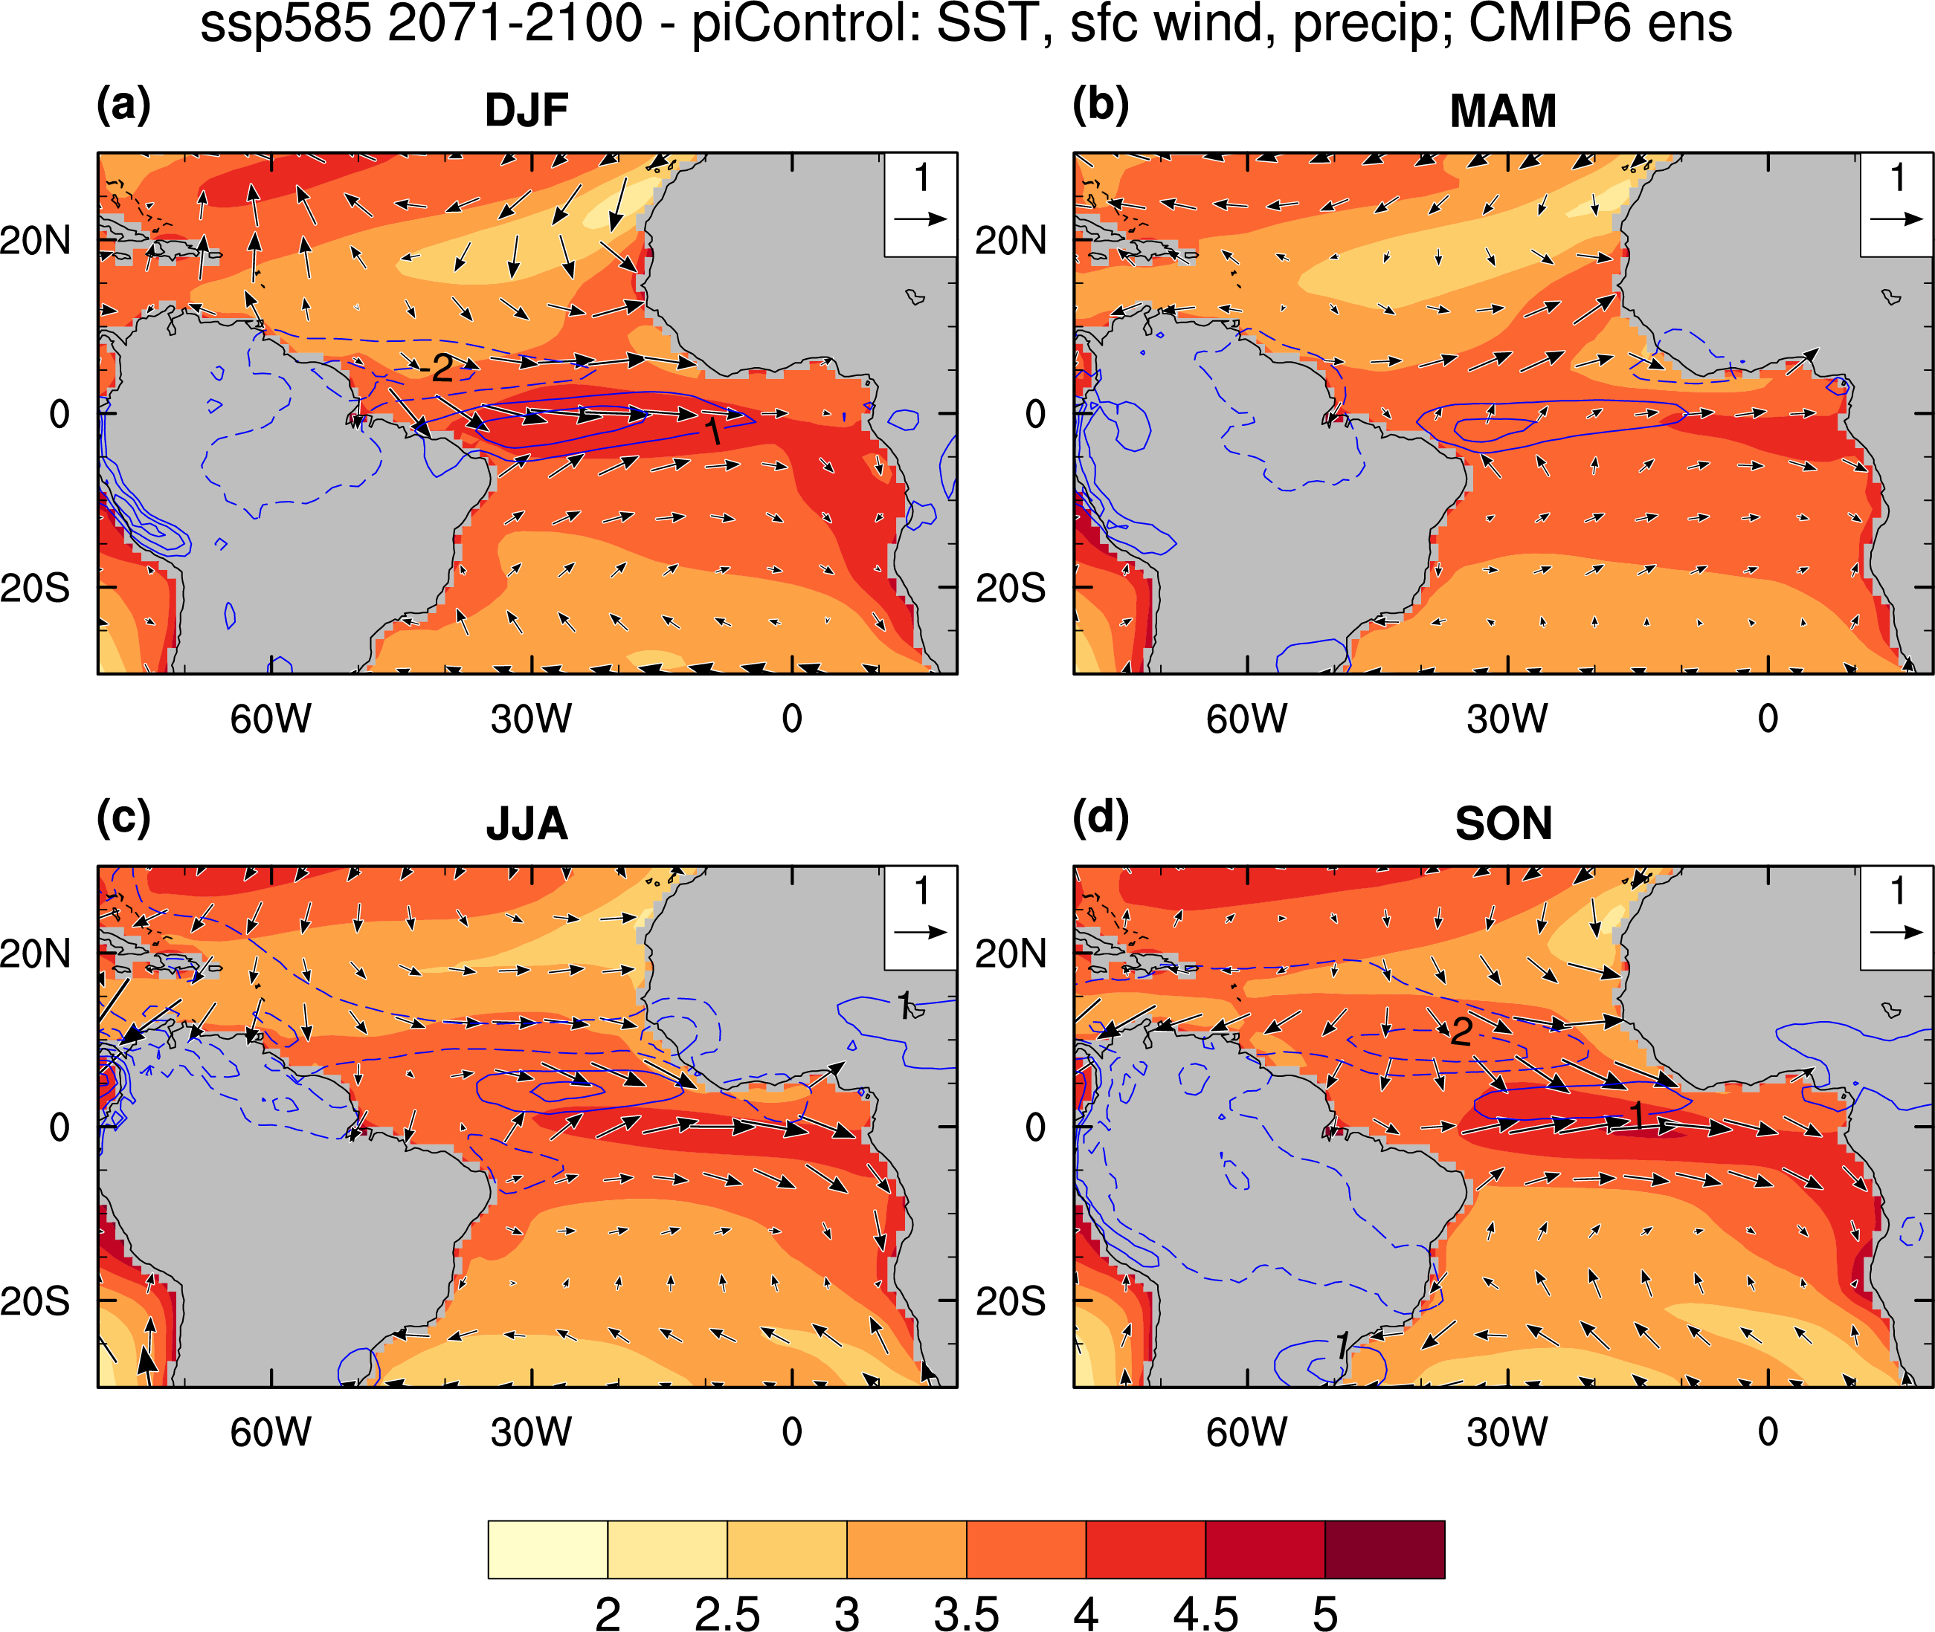
Figure S1. Like Fig. 1 in the main text, but with all values shown, regardless of statistical significance.

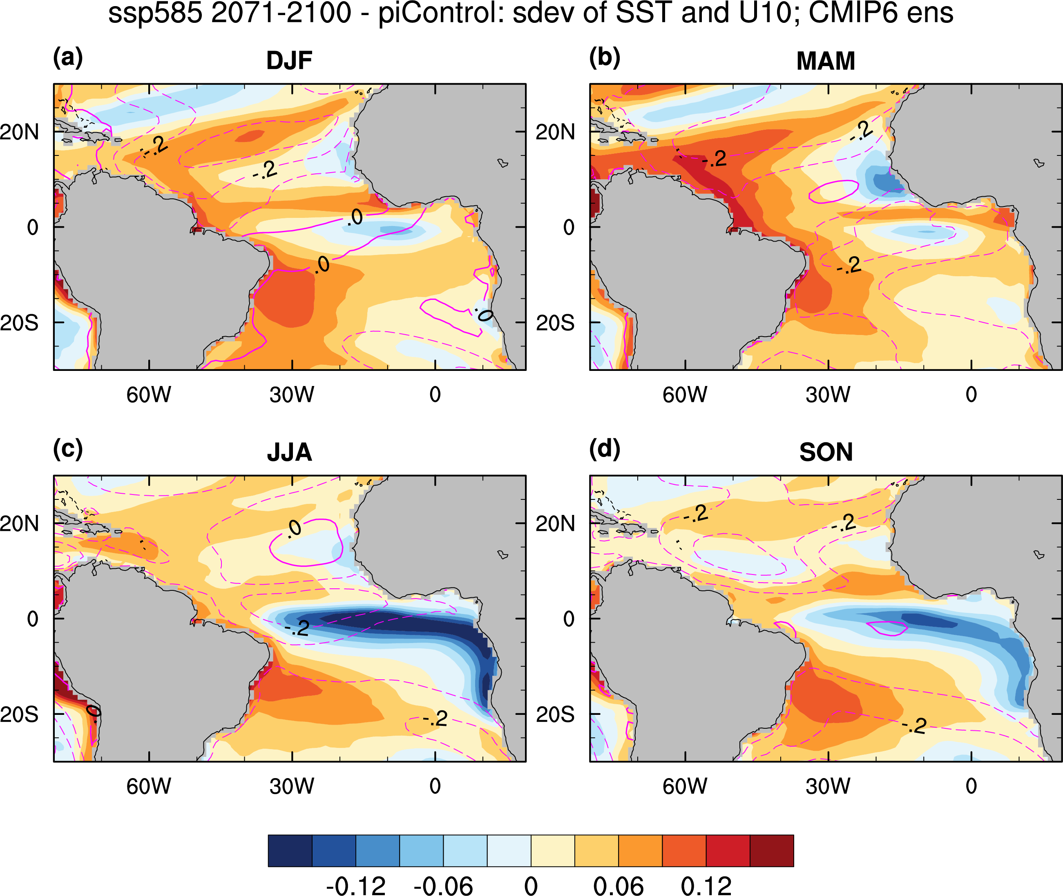
Figure S2. Like Fig. 3 in the main text, but with all values shown, regardless of statistical significance.

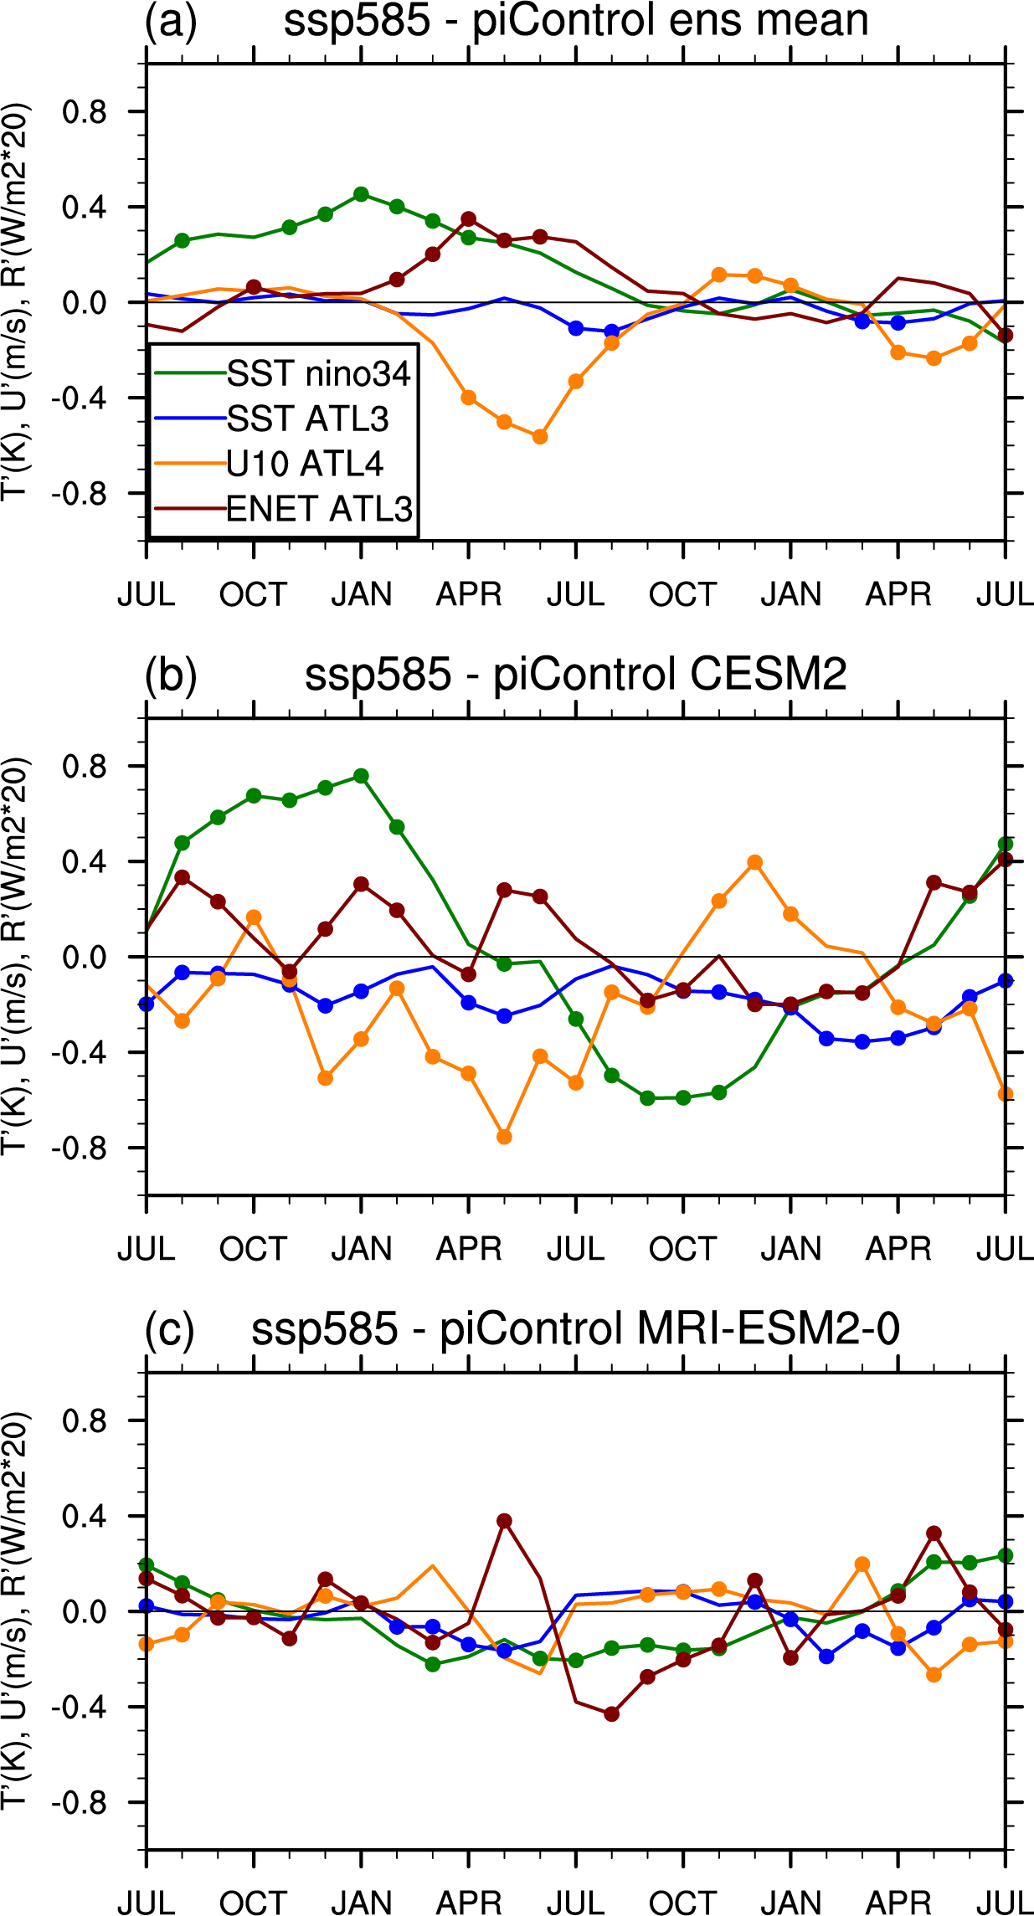
Figure S3. Similar to Fig. 5 in the main text but showing the difference between the ssp585 and piControl composites.
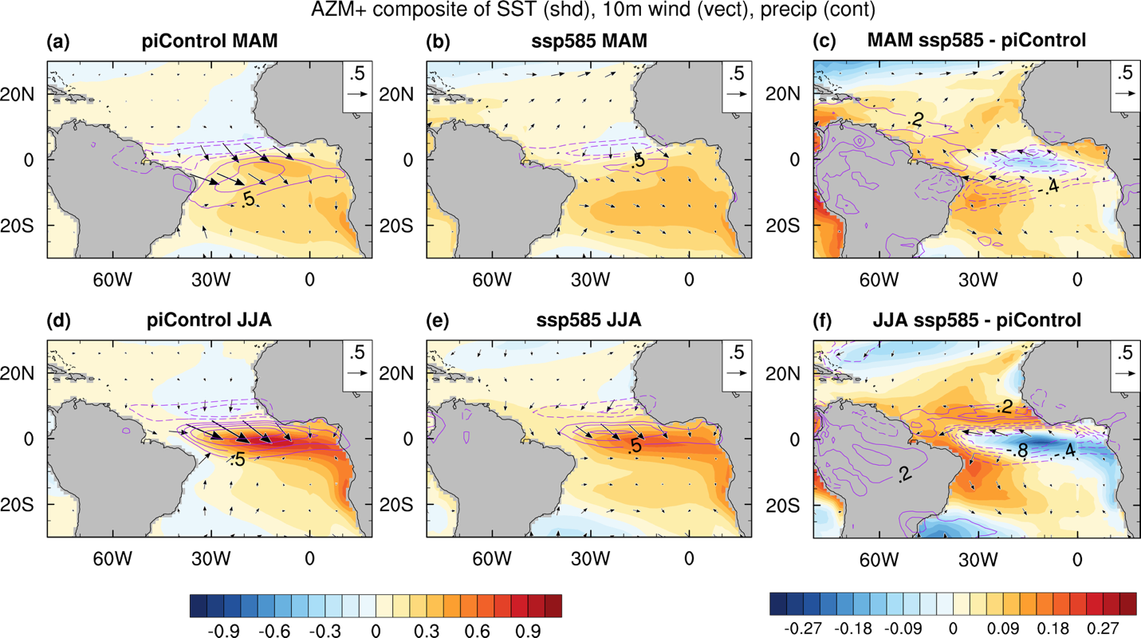
Figure S4. Like Fig. 6 in the main text, but with all values shown, regardless of statistical significance.

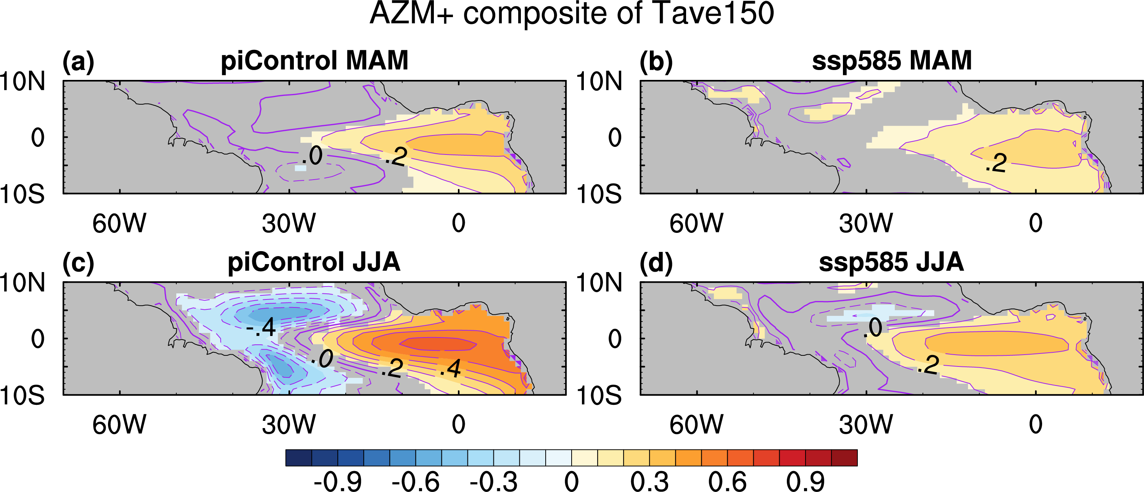
Figure S5. Similar to the composite of Fig. 6 in the main text, but for anomalous upper ocean temperature (K; contours; averaged from 0 to 150 m depth). Values that are significant at the 95% confidence level are shaded.

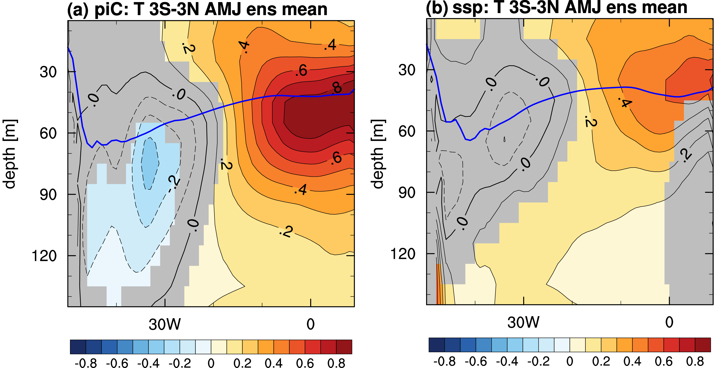
Figure S6. Longitude-depth sections of anomalous ocean temperature along the equatorial Atlantic (K), averaged from 3°S to 3°N, for composite AZM+ events in April-May-June (AMJ). The panels show the multimodel ensemble means of (a) piControl, and (b) ssp585. Values that are statistically significant at the 95% level are shaded. The blue line indicates the climatological depth of the thermocline in AMJ.

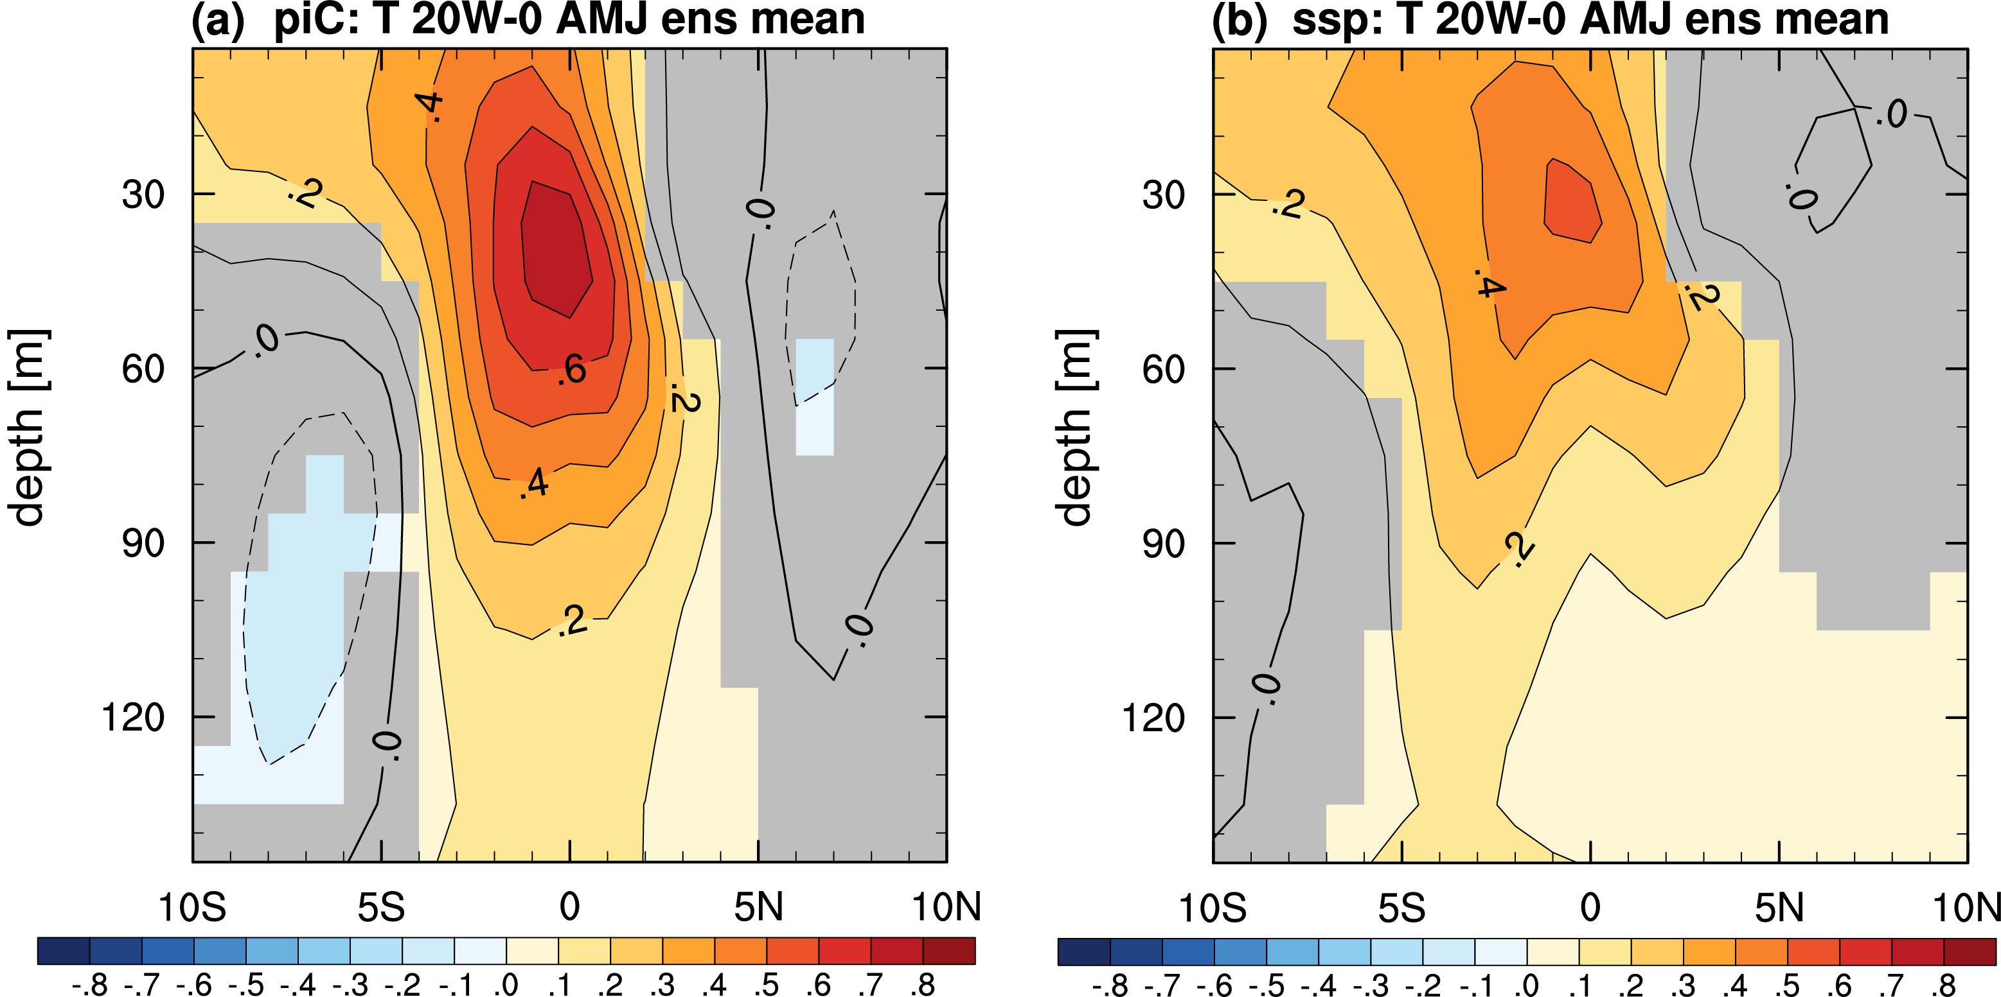
Figure S7. Latitude-depth sections of anomalous ocean temperature in the tropical Atlantic (K), averaged from 20°W to 0°W, for composite AZM+ events. The panels show the multimodel ensemble means of (a) piControl, and (b) ssp585. Values that are statistically significant at the 95% level are shaded.

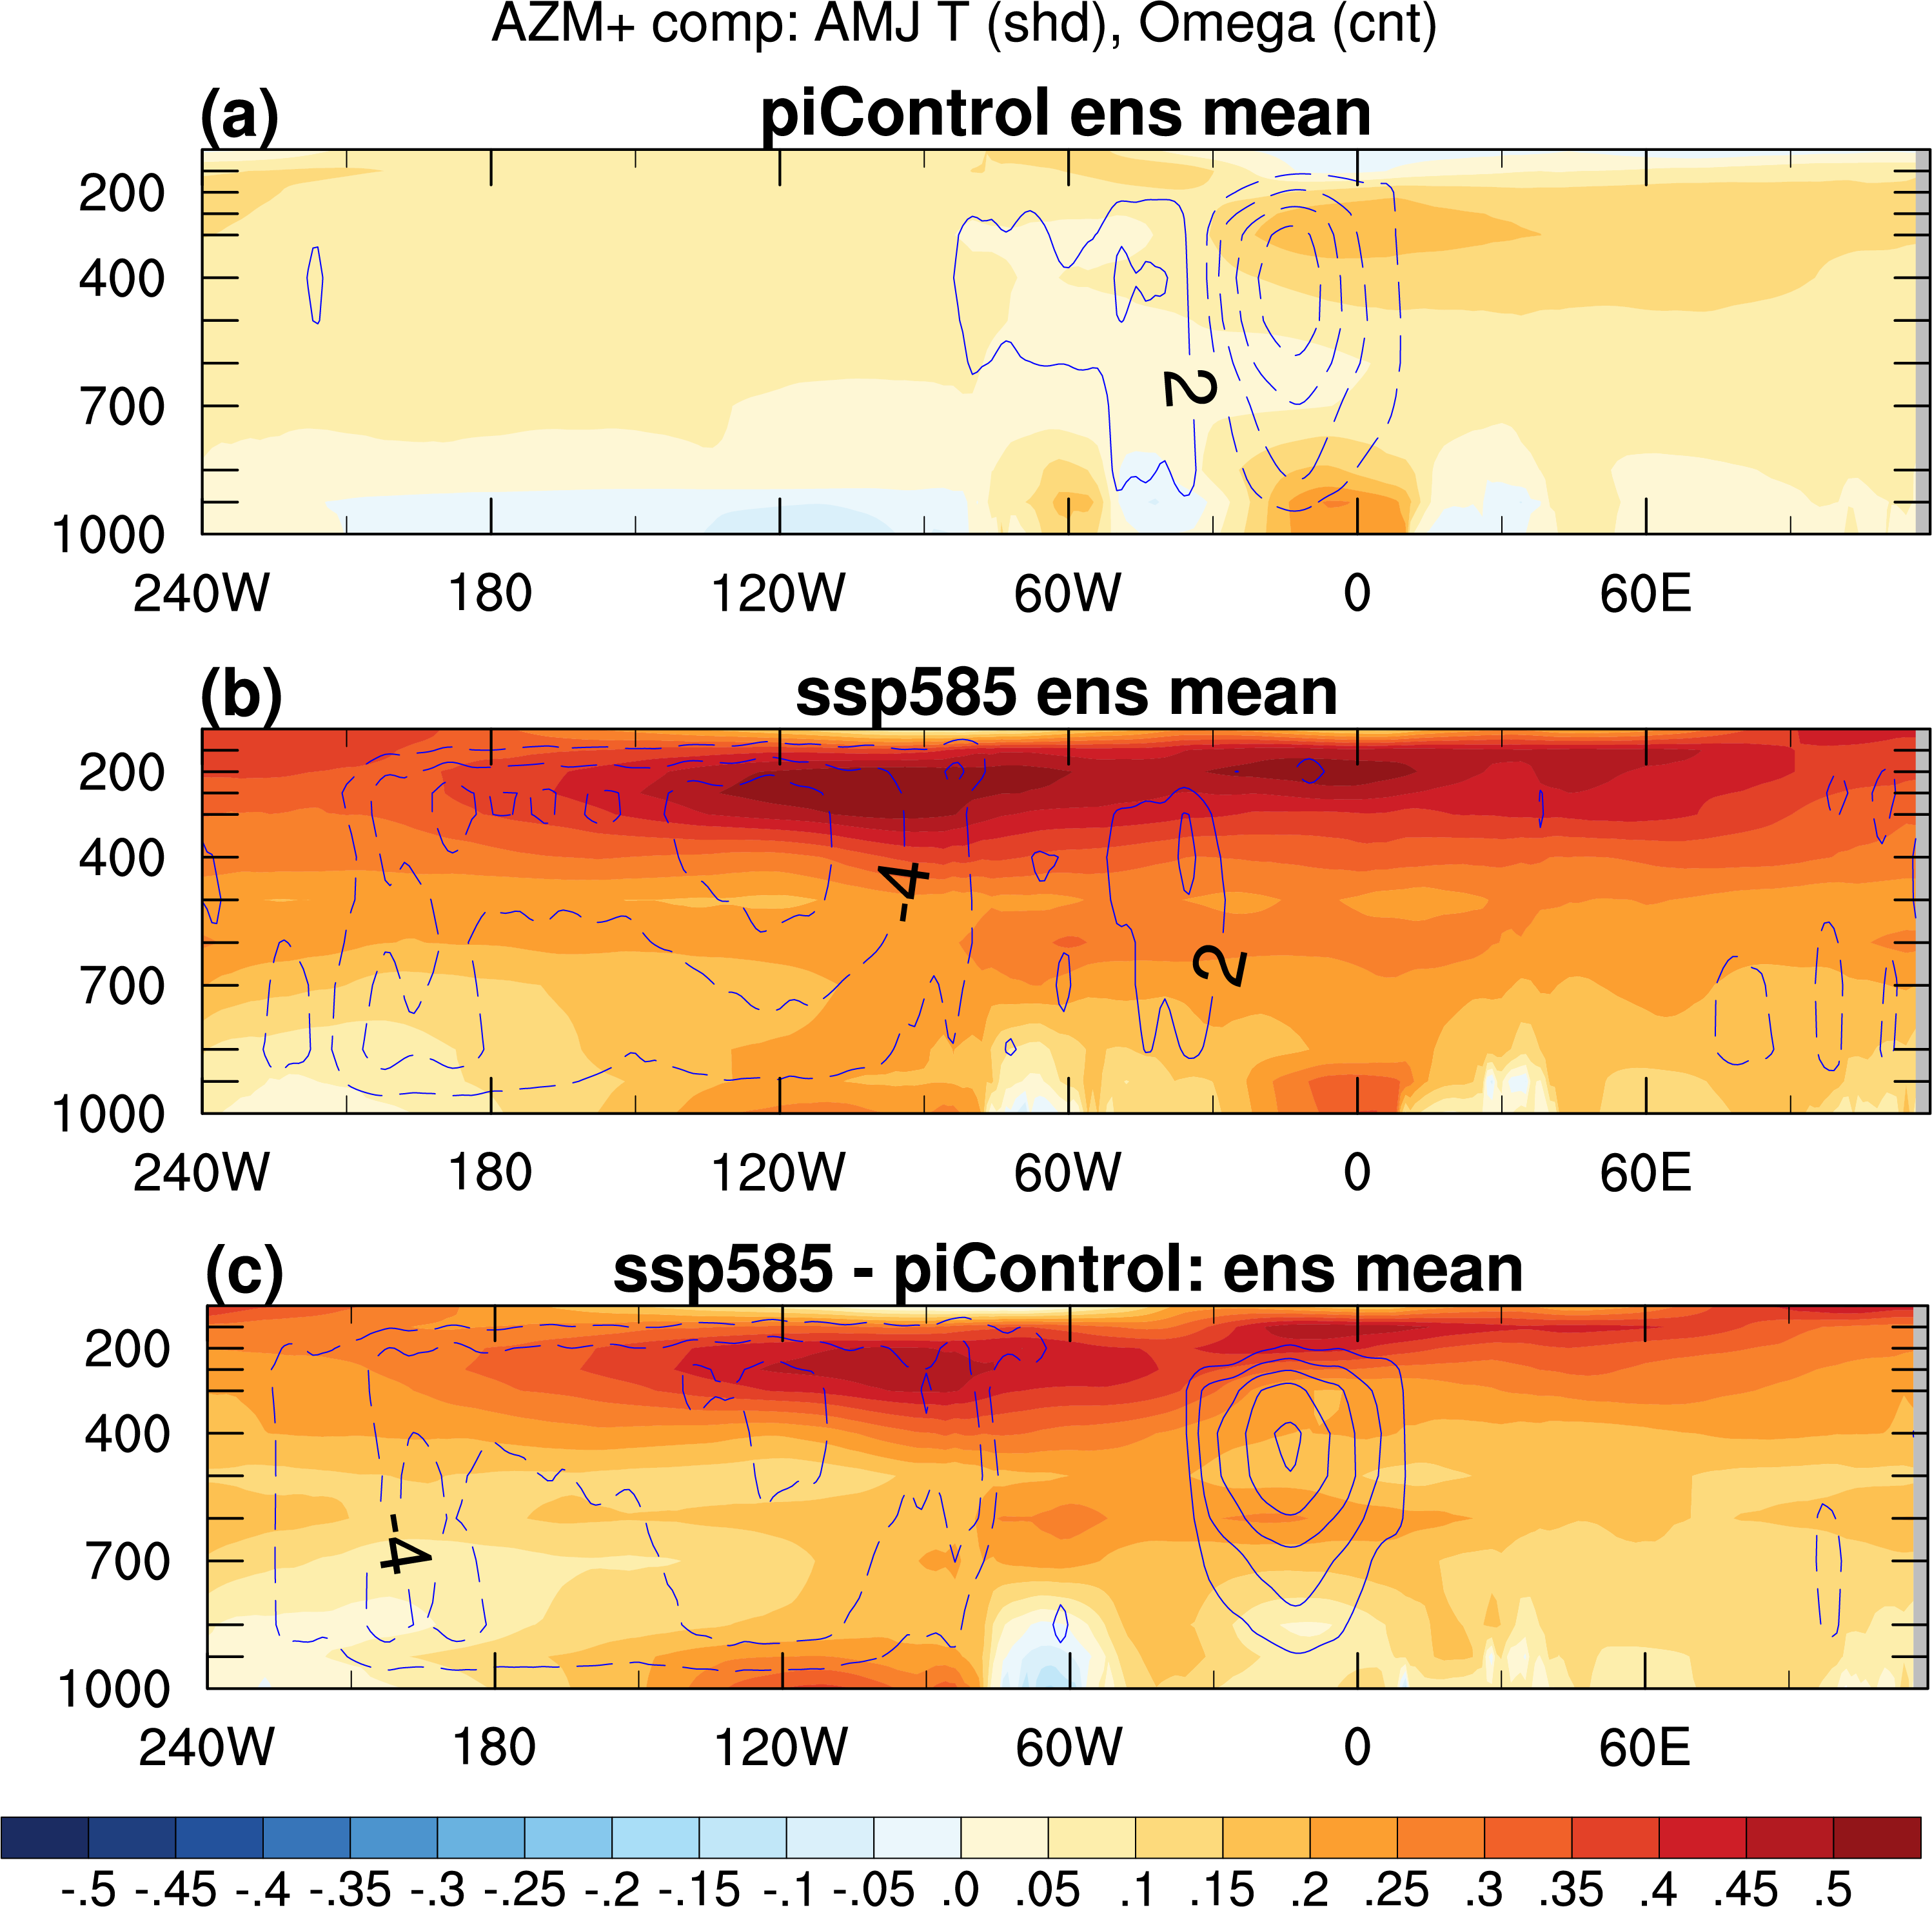
Figure S8. Like Fig. 12 in the main text, but with all values shown, regardless of statistical significance.

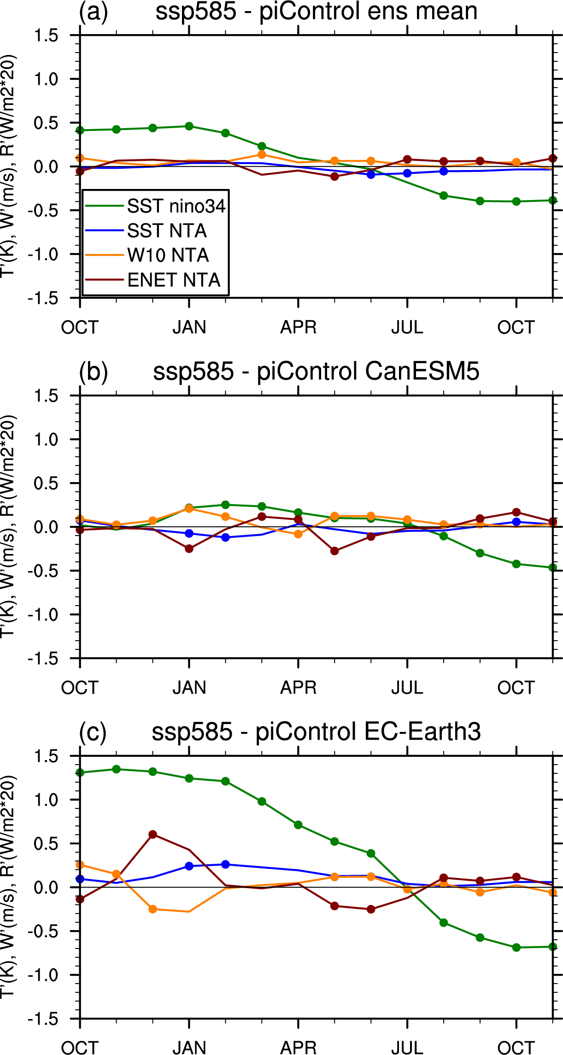
Figure S9. Similar to Fig. 9 in the main text but showing the difference between the ssp585 and piControl composites.

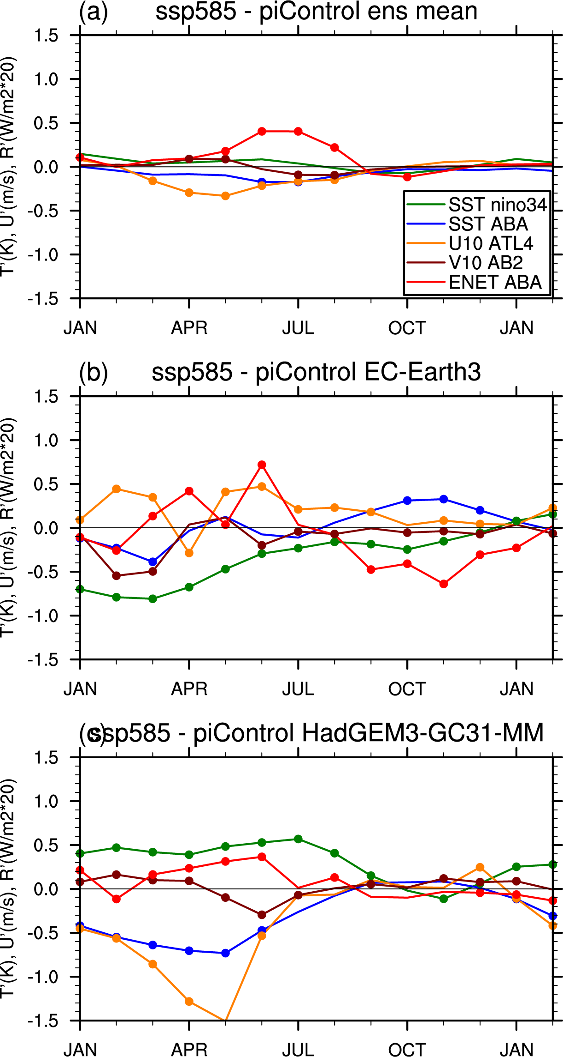
Figure S10. Similar to Fig. 10 in the main text but showing the difference between the ssp585 and piControl composites.

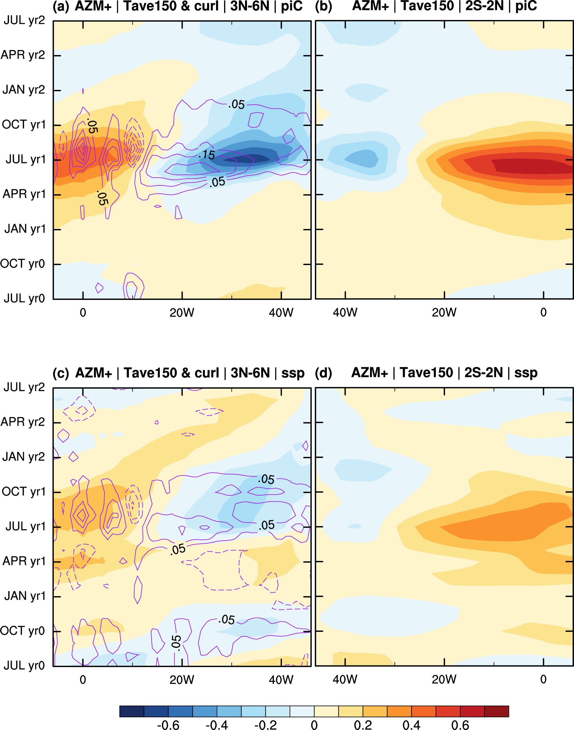
Figure S11. Multimodel means of composite longitude–time sections. (a) Anomalous upper ocean temperature (shading; K; averaged from 0 to 100 m depth), and wind stress curl (contours; interval 0.05 × 10−8 N m−3; dashed contours indicate negative values; zero-contour omitted) over the Atlantic for positive AZM events in experiment piControl. The fields are meridionally averaged from 3° to 6°N. (b) As in (a), but averaged from 2°S to 2°N and only showing upper ocean temperature. (c) As in (a), but for experiment ssp585. (d) As in (b), but for experiment ssp585. Note that the direction of the x axis is reversed in the left panels in order to facilitate visual inspection of the wave reflection at the western boundary.

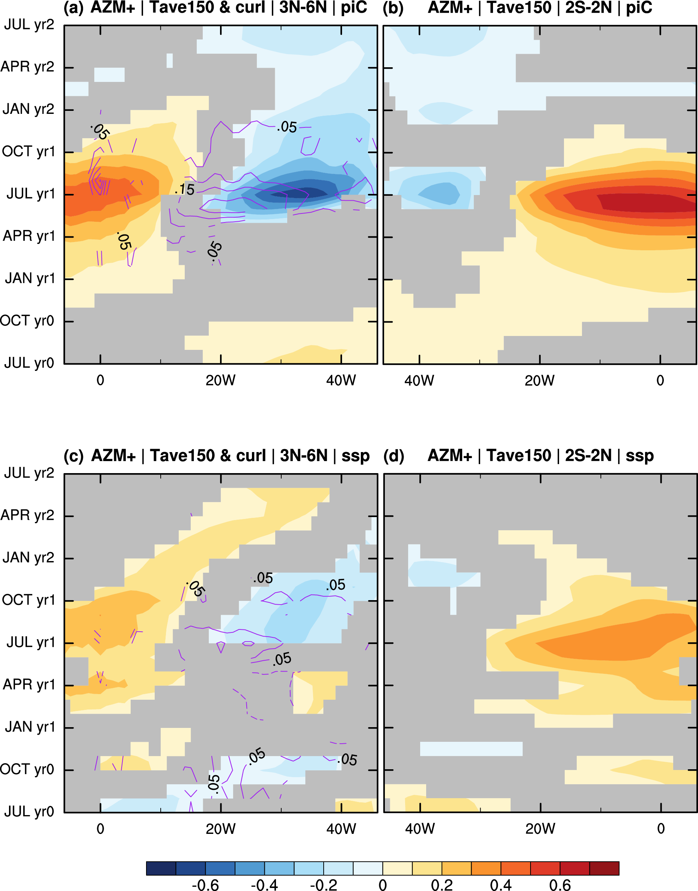
Figure S12. Like Fig. S11 but only showing values that are significant at the 95% level.

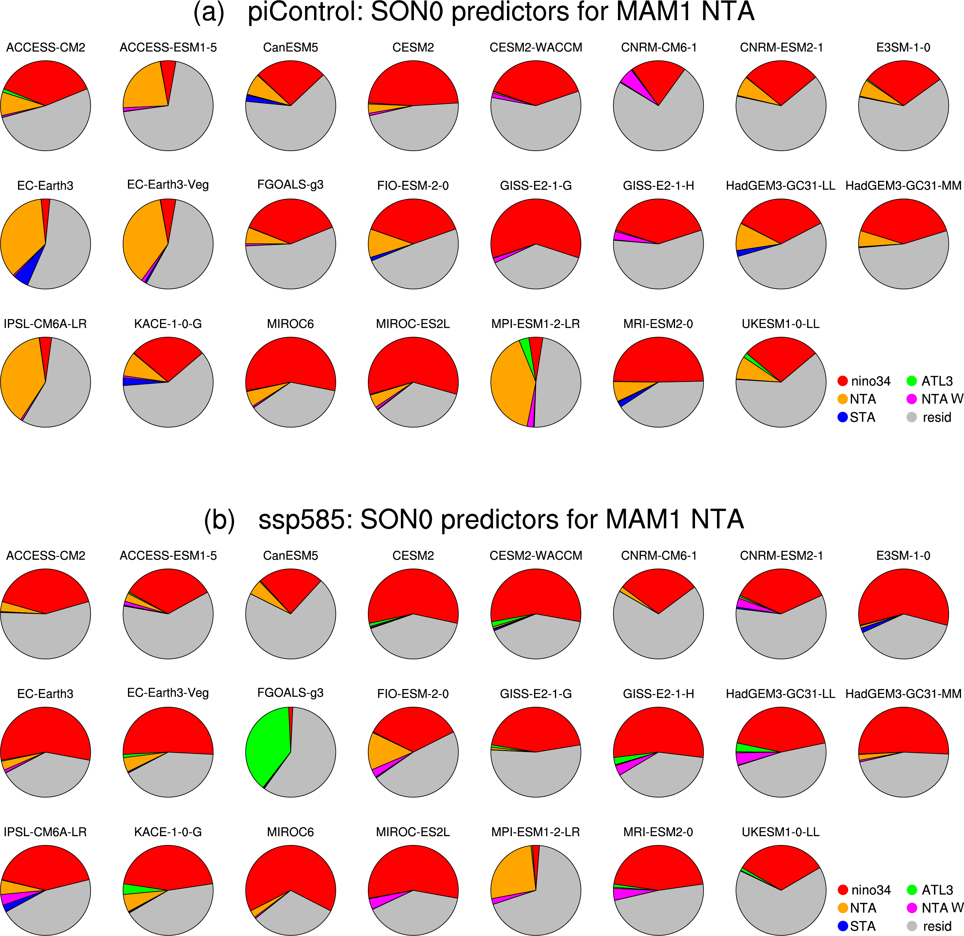
Figure S13. Similar to Fig. 13 in the main text, but for the prediction of the NTA SST index in MAM1 from SON0 (two seasons ahead). The contributions of the following predictors are shown: Niño 3.4 SST (red), ATL3 SST (green), NTA SST (orange), NTA wind speed (magenta), STA SST (blue), and the residual (gray).

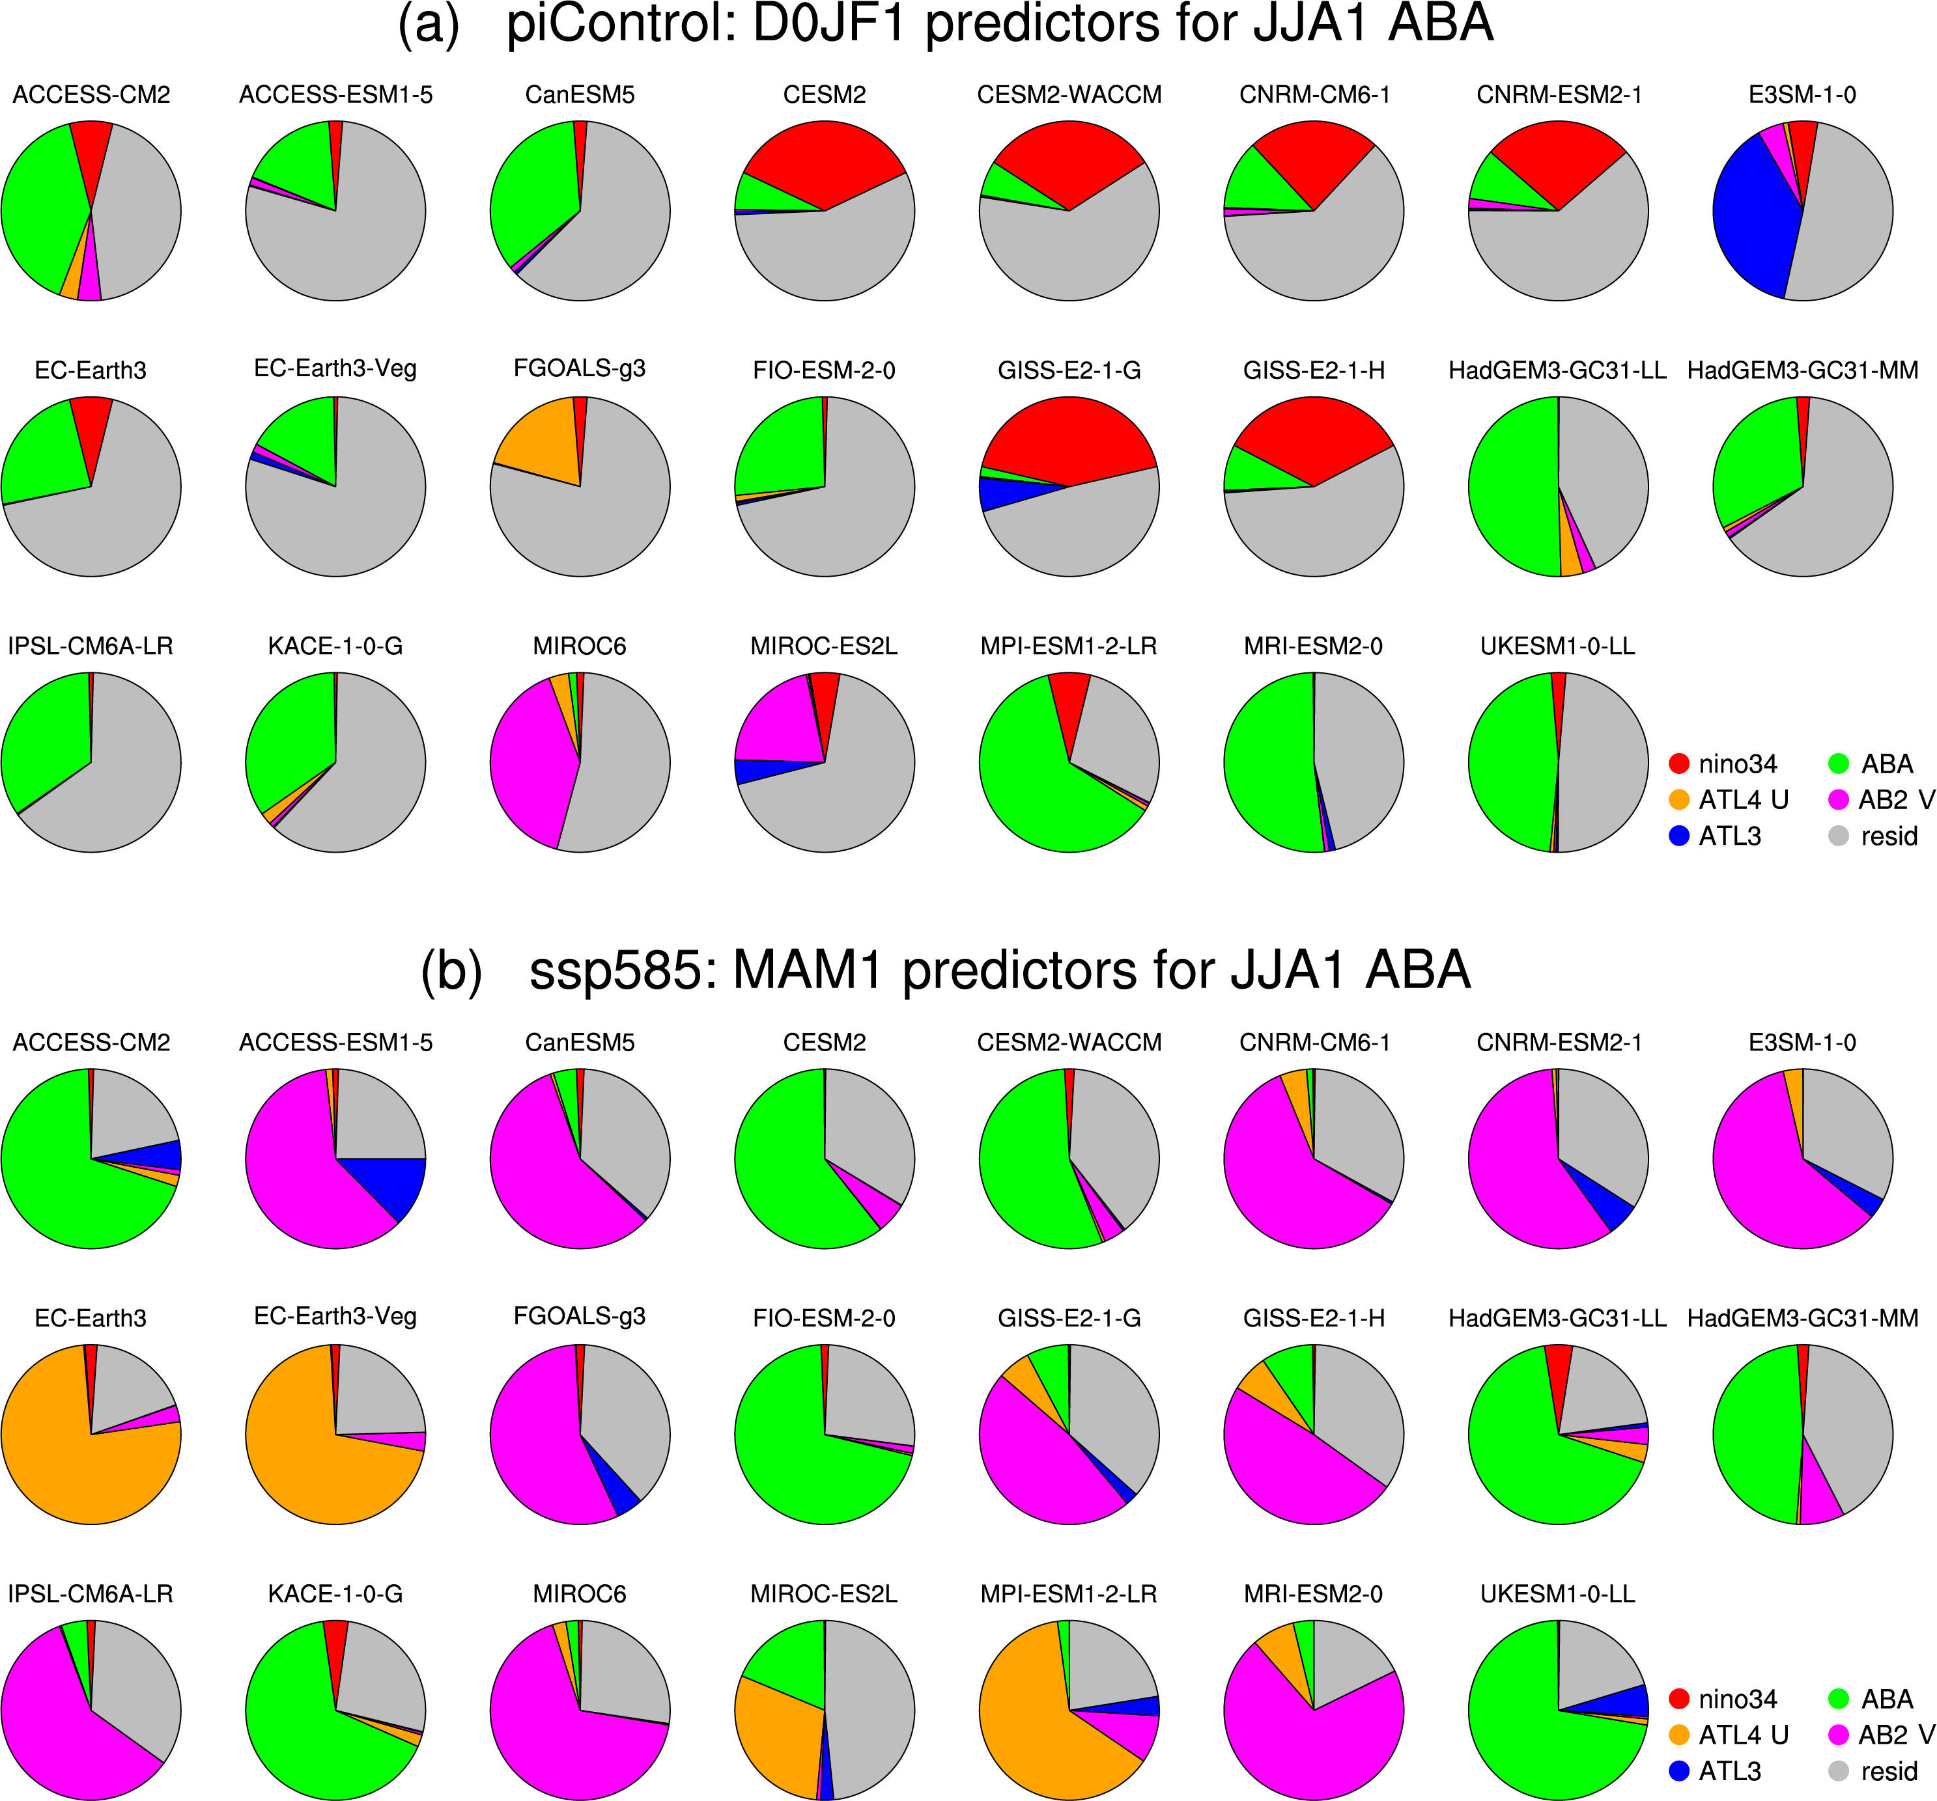
Figure S14. Similar to Fig. 13 in the main text, but for the prediction of the ABA SST index in JJA1 from MAM1 (one season ahead). The contributions of the following predictors are shown: Niño 3.4 SST (red), ABA SST (green), ATL4 10 m zonal wind (orange), AB2 10 m meridional wind (magenta), ATL3 SST (blue), and the residual (gray).

