Appendix - Survey 2014/2015 results
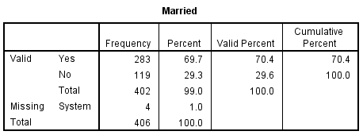
Table 1 – Respondents’ marital status

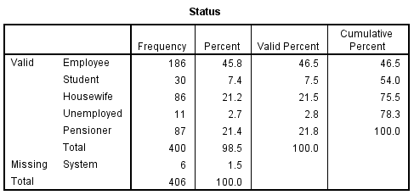
Table 2 – Respondents’ occupational status

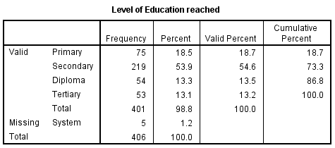
Table 3 – Respondents’ level of education

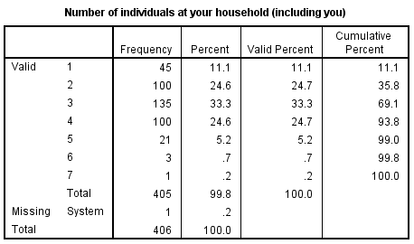
Table 4 – Respondents’ number of individuals in their household

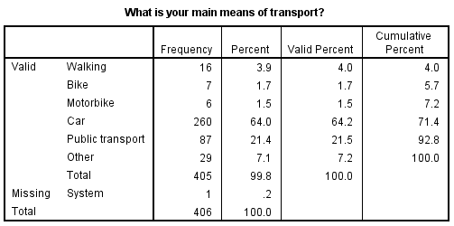
Table 5 – Respondents’ main means of transport

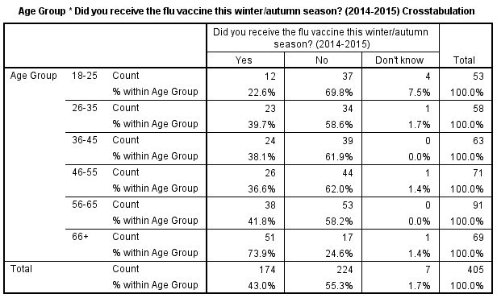
Table 6 – Respondents’ flu vaccine uptake compared with their respective age group.

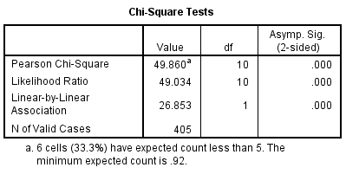
Table 7 – Chi-Square test of association between flu vaccine uptakes compared with their respective age group.

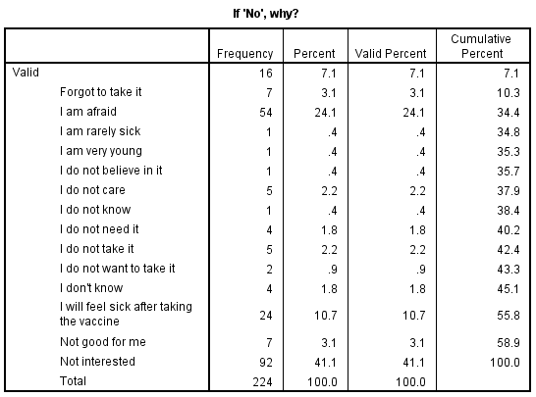
Table 8 – Respondents’ reasons for not taking the flu vaccine.

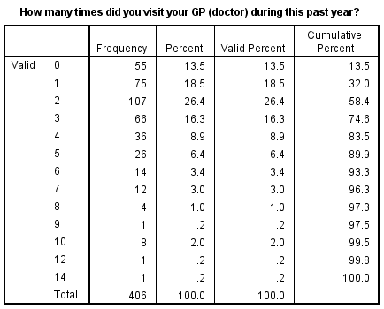
Table 9 – The number of times respondents visit their GP throughout the whole year.

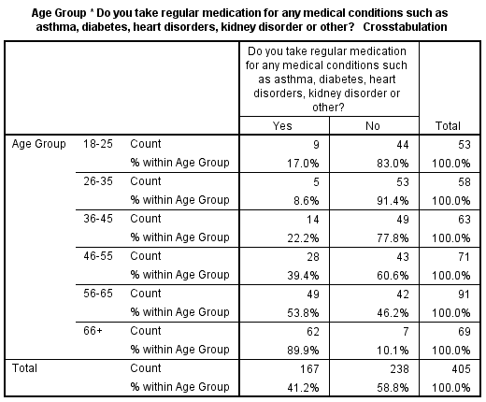
Table 10 – Respondents’ frequency of regular medication compared with their respective age group.

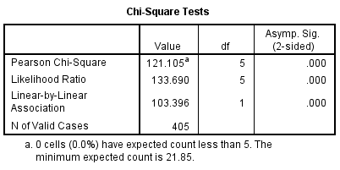
Table 11 – Chi-Square test of association between the frequencies of regular medication compared with their respective age group.

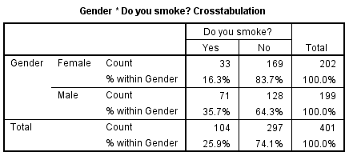
Table 12 – Cross tabulation between the frequencies of smokers compared with gender.

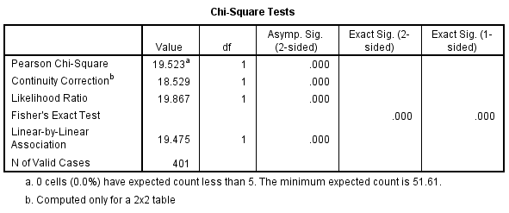
Table 13 – Chi-Square test of association between the frequencies of smokers compared with gender.

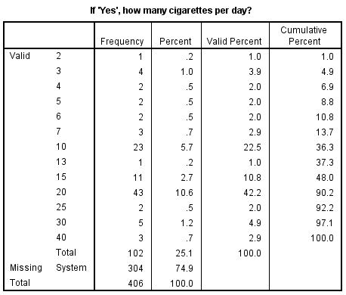
Table 14 – The number of cigarettes respondents consume per day.
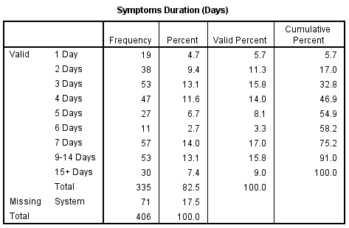
Table 15 – The number of days for the influenza-like-illness symptoms to persist according to survey respondents.

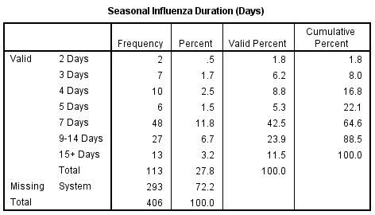
Table 16 – The number of days for the seasonal influenza to persist according to survey respondents.

Nights at hospital due to the seasonal influenza: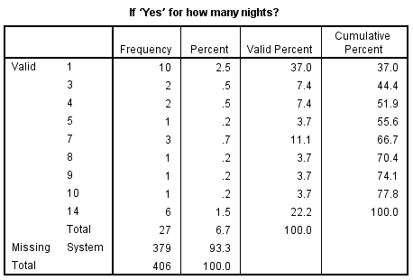
Table 17 – The number of days of hospitalisation due to seasonal influenza.

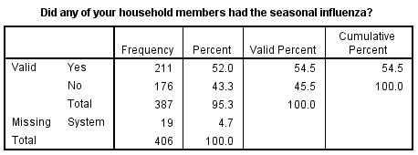
Table 18 – Household members that had acquired the seasonal influenza.

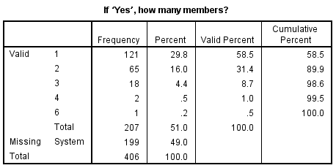
Table 19 – The number of members within the respondents’ household that had acquired the seasonal influenza.

