Protein | The first experiment | The second experiment | The third experiment
TRAF6 | 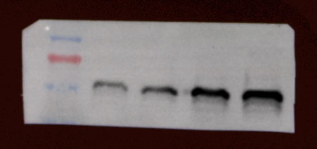 | 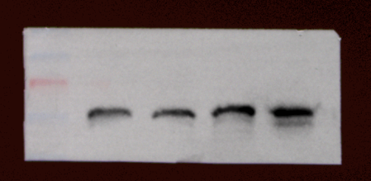 | 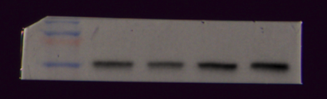
GAPDH | 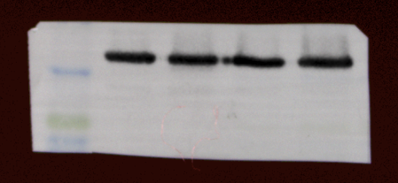 | 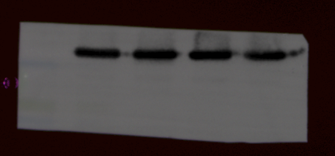 | 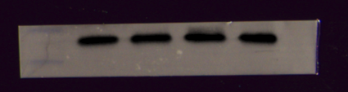
Bcl-2 | 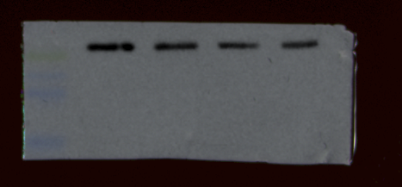 | 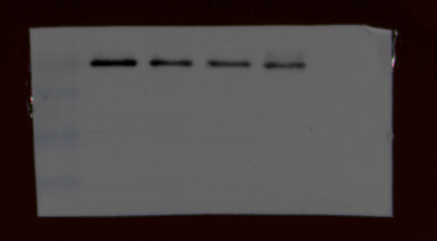 | 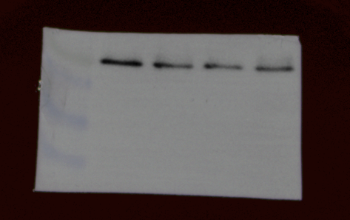
BAX | 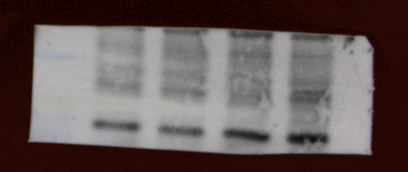 | 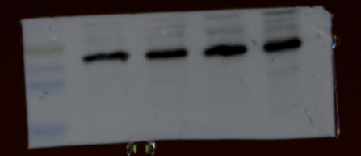 | 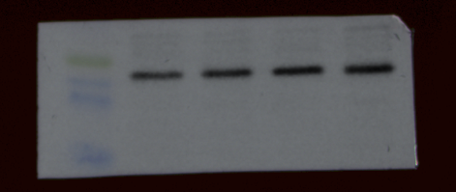
β-actin | 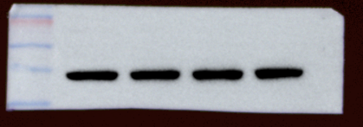 | 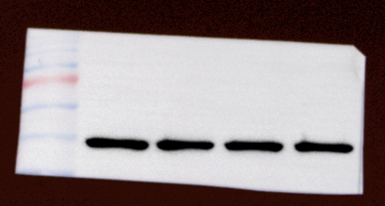 | 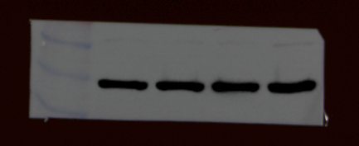

The WB experiment was completed by washing the same gel strip and then incubating with different antibodies. The relevant experimental details have been supplemented and annotated in the text. Now, we are submitting the original images of this experiment conducted three times independently to ensure the completeness and reproducibility of the data. If the journal has any other supplementary requirements in the future, we will do our best to cooperate.

