Supporting Information

Preparation of Fe₃O₄/Ag nanoparticles-functionalized fishnet-like calcium alginate nanonetwork composite and its application in heavy metal ion removal

Xiaojun Tao *, Shaomin Zhou
Key Laboratory for Special Functional Materials, Ministry of Education, Henan University, Kaifeng 475004, China
* Corresponding author.
E-mail address: xjtao819@163.com (X. Tao)
Note S1 Synthetic details of naked CAN, Ag-CAN, and Fe₃O₄-CAN.
The preparation of naked CAN: 200 mL absolute ethanol was added to a round-bottom three-necked flask equipped with a condenser pipe and heated to reflux. Next, 30 mL SA solution (0.5 wt%) was dropwise added under vigorous magnetic stirring. After 2 h, the experiment was stopped and the mixture was cooled to RT naturally. The formed precipitate (SAN) was obtained by centrifugation. Then, the obtained SAN was immersed into 80 mL of CaCl₂ solution (2.0 wt%) under slow magnetic stirring at RT. After 1 h cross-linking reaction, the solid product in the flask was separated from the solution by centrifugation and washed three times with deionized water. The solid product was CAN.
The preparation of Ag-CAN: The obtained CAN and 80 ml deionized water were added to a round-bottom three-necked flask and ultrasonicated for 10 min. Subsequently, 20 mL AgNO₃ (0.024 g) solution was slowly added, accompanied by continuous magnetic stirring. After 1 h, N₂H₄·H₂O (2 mL) was poured directly into the flask and the reaction was conducted at RT for 30 min. The as-formed solid sediment was separated by centrifugation, accompanied by washing three times with deionized water and ethanol. The final product was named as Ag-CAN. The obtained SAN, CAN, and Ag-CAN were dried in an oven at 50 ºC for 5 h and then collected for characterization and/or performance testing.
The preparation of Fe₃O₄-CAN: Refer to experimental section 2.2 (Ⅰ) and (Ⅱ).

Fig. S1. FESEM images of SAN (a) and CAN (c). FESEM images of SAN (b) and CAN (d) after magnetic stirring for 1 h in aqueous solution.
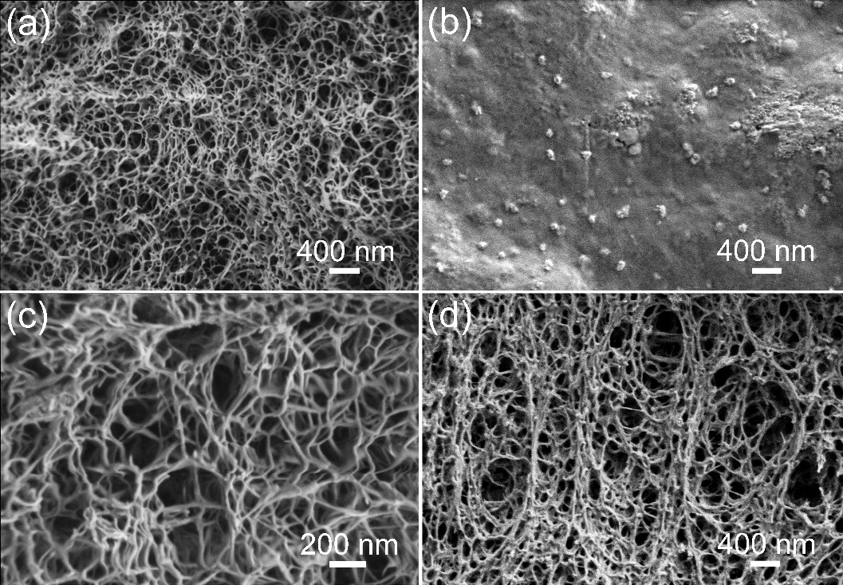
Fig. S2. Zeta potentials of Fe₃O₄/Ag-CAN composite under different pH conditions.

Fig. S3. Effect of pH (a), dosage (b), initial concentration (c), contact time (d), and temperature (e) on the Cd(Ⅱ) and Cu(Ⅱ) adsorption capacity of Fe₃O₄/Ag-CAN composite. Detailed experimental parameters are shown in Table 1.

