EXTENDED FIGURES
Extended figure 1: 3D graph tracking of metabolite concentrations across 3 different diets along the GI-tract. Diet BC (pink) corresponds to broken cells, diet SC (blue) corresponds to single cells and diet CC (green) corresponds to cell clusters. Z-axis shows samples in the following order: three gastric samples, three duodenal samples and ileal samples. Inset blue box (dashed) within sugars are chickpea markers.

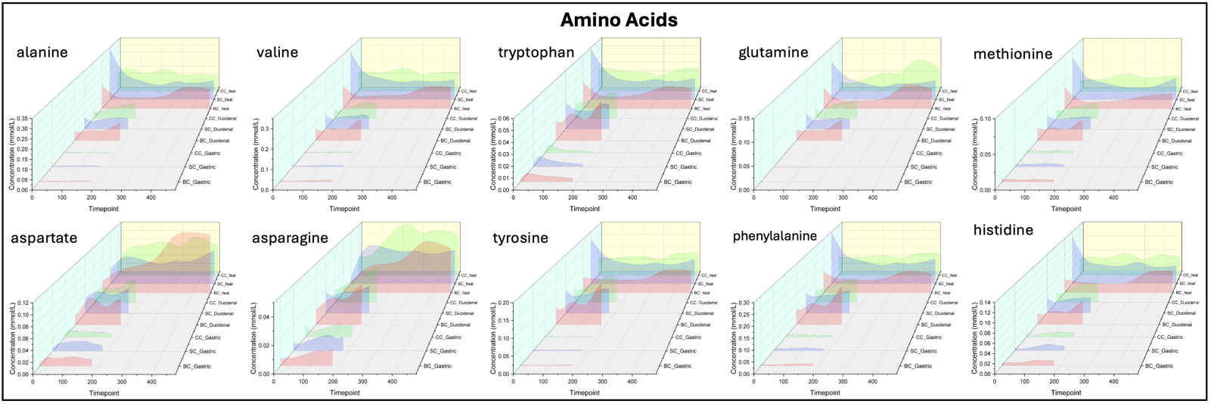

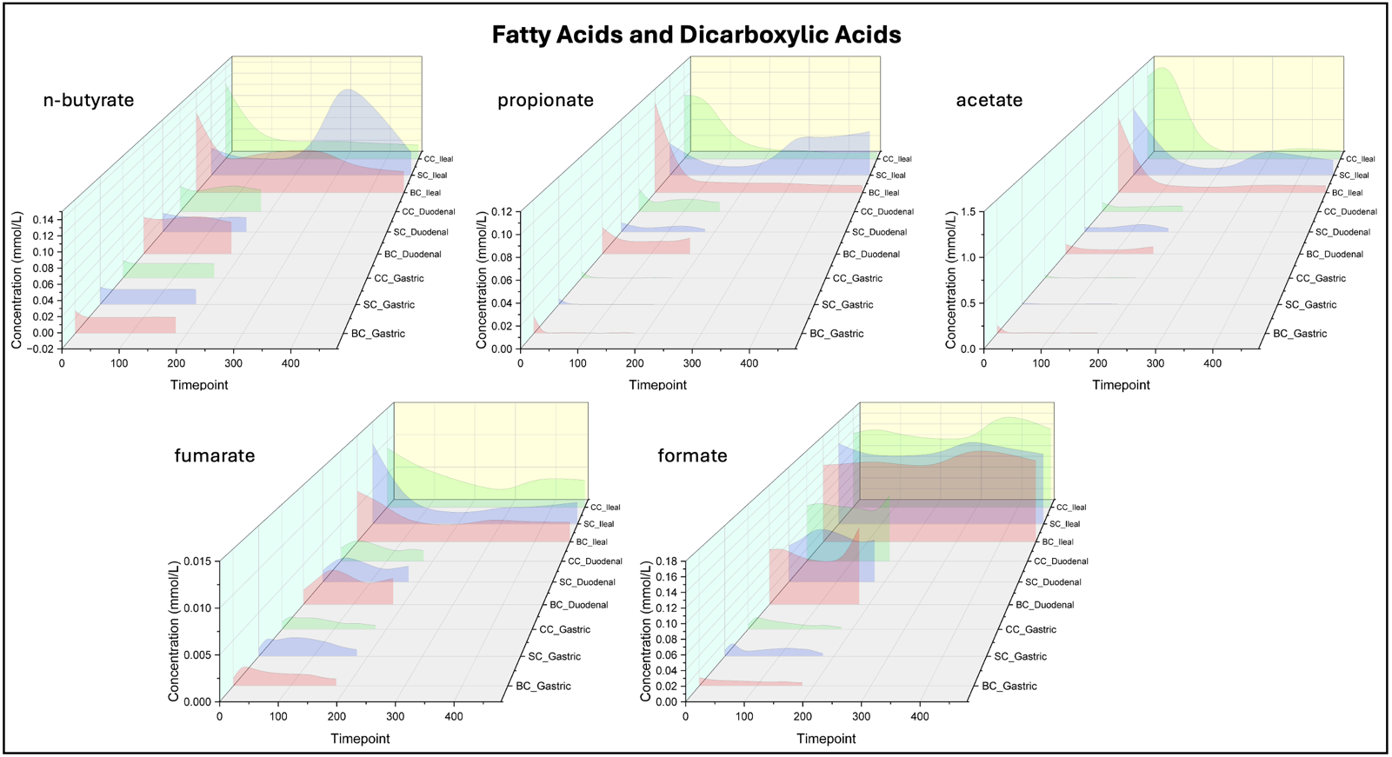
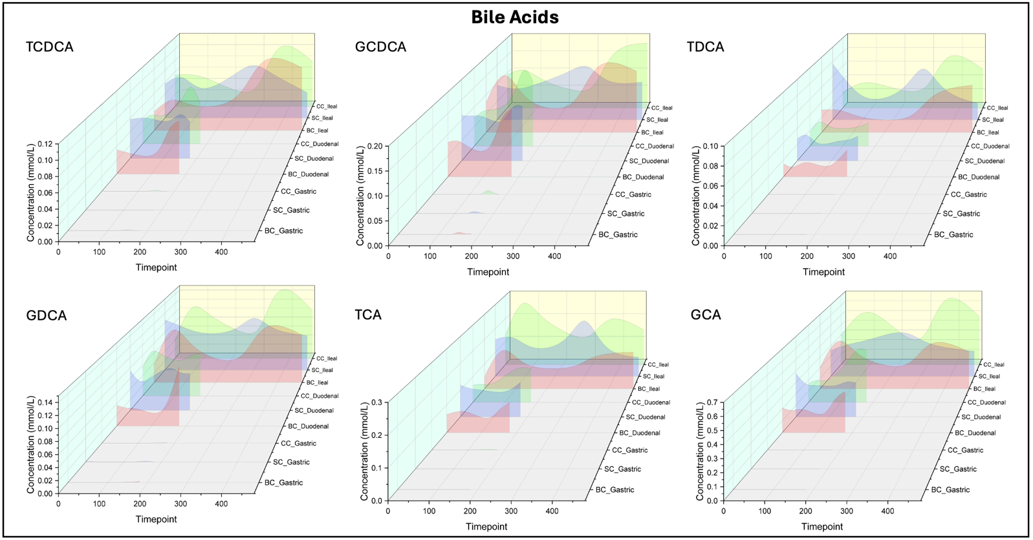

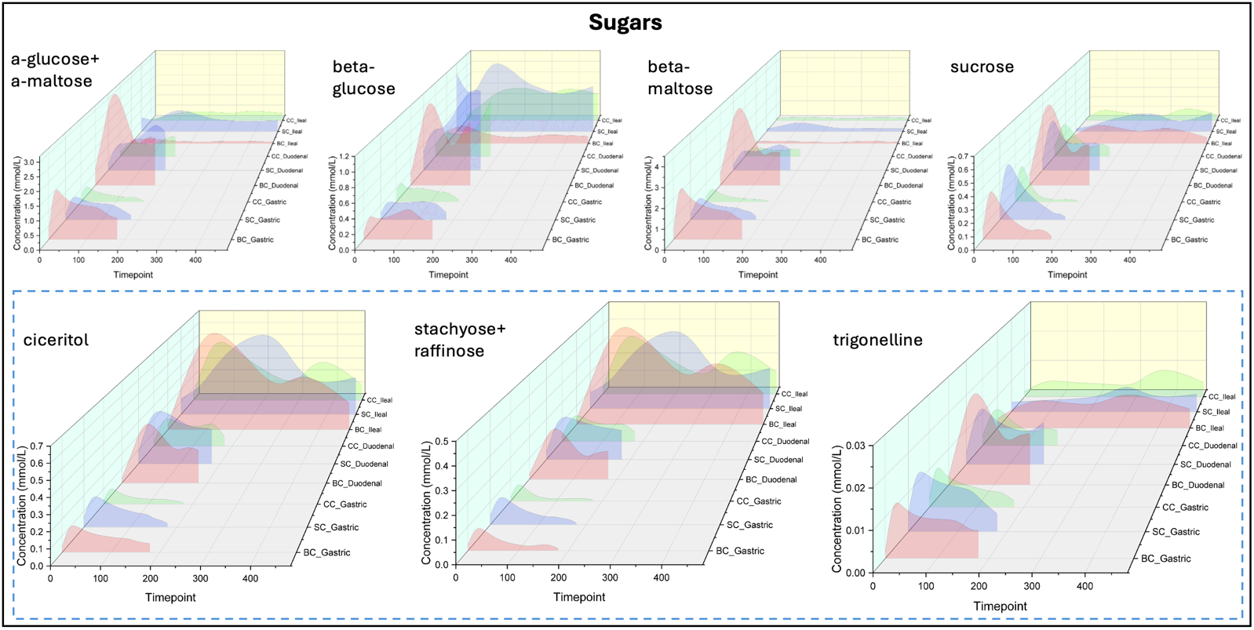

Extended Figure 2: Principal Component Analysis of all metabolites at all timepoint, colored by timepoint, diet, location of sampling within the gastrointestinal tract and patient ID.
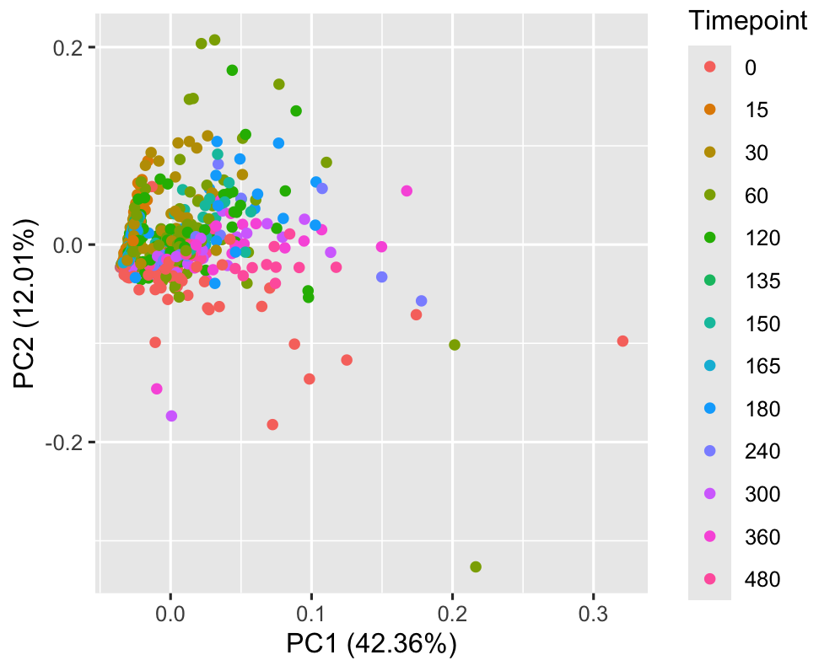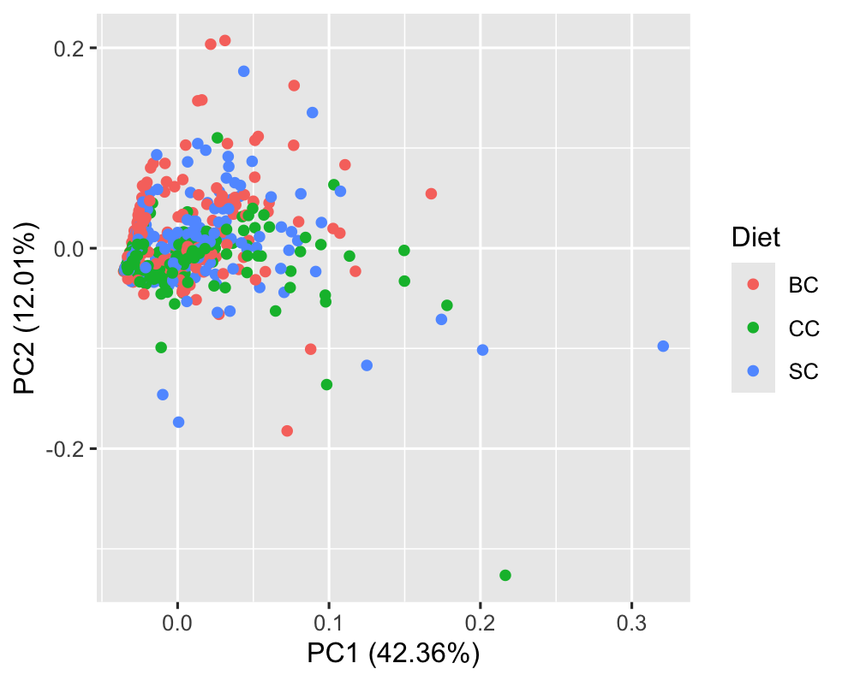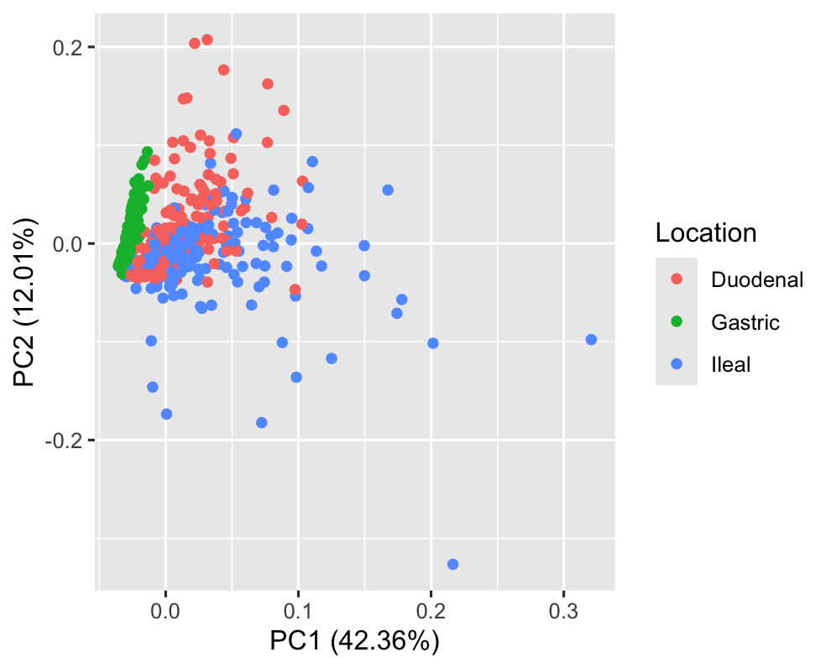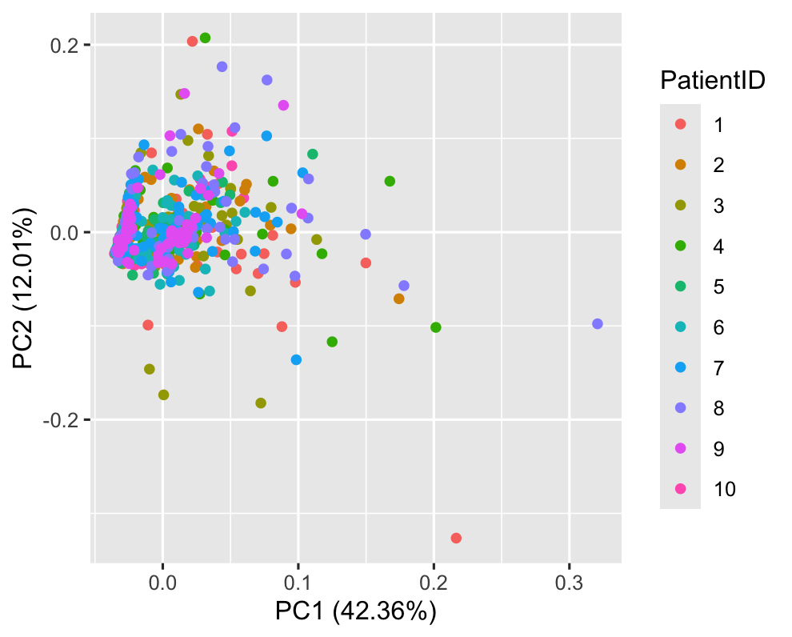
Extended Figure 3: Per individual metabolic concentration in mmol/L plotted against time after meal consumption, within gastric samples. Green curves are diet BC, Red curves are diet CC, Black curves are diet SC.
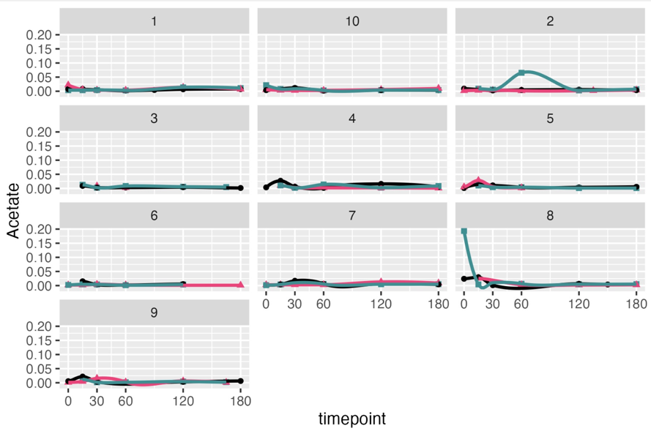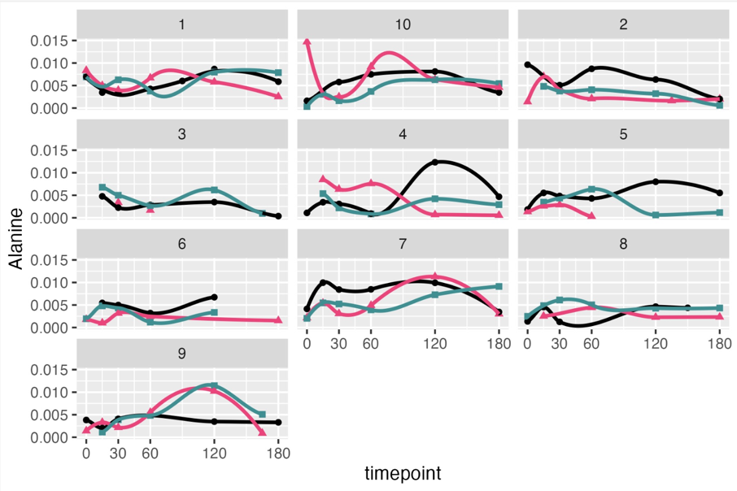
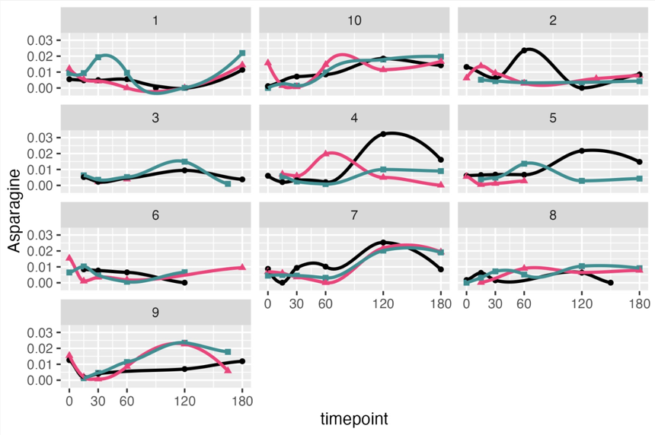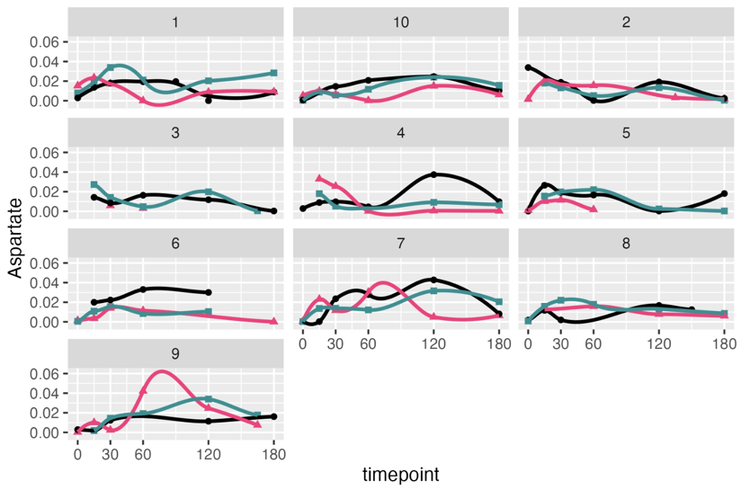

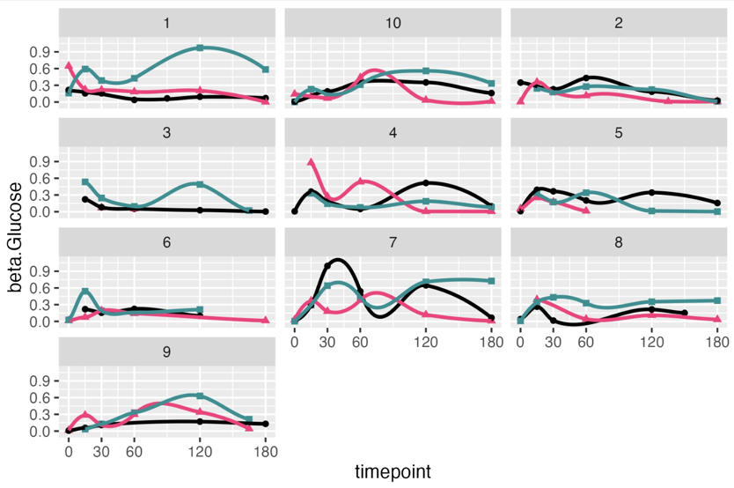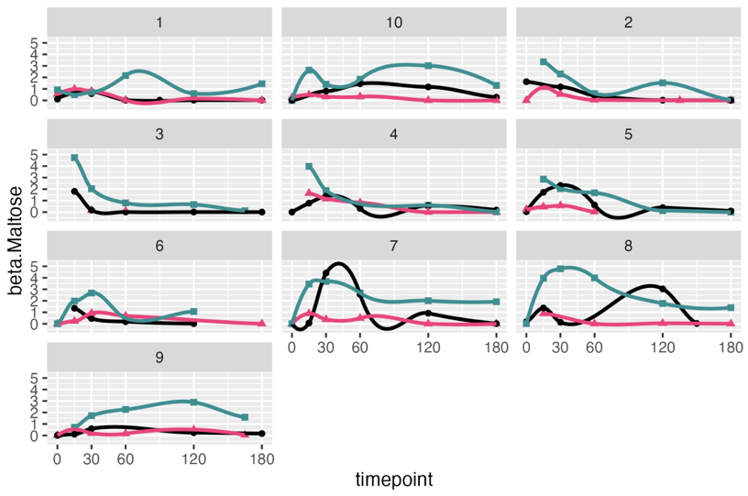
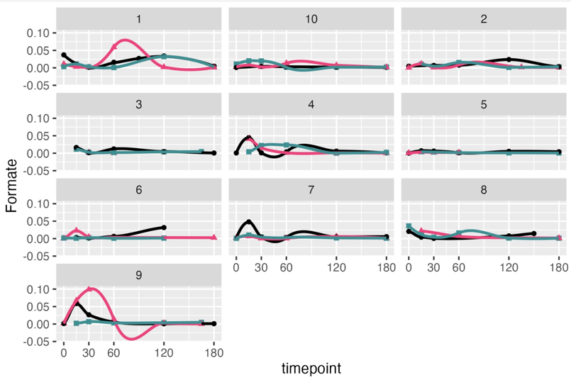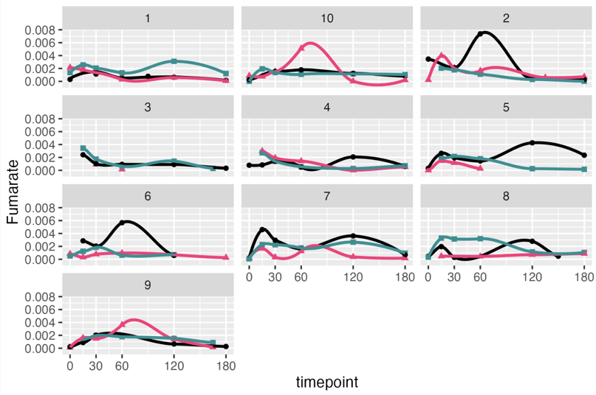
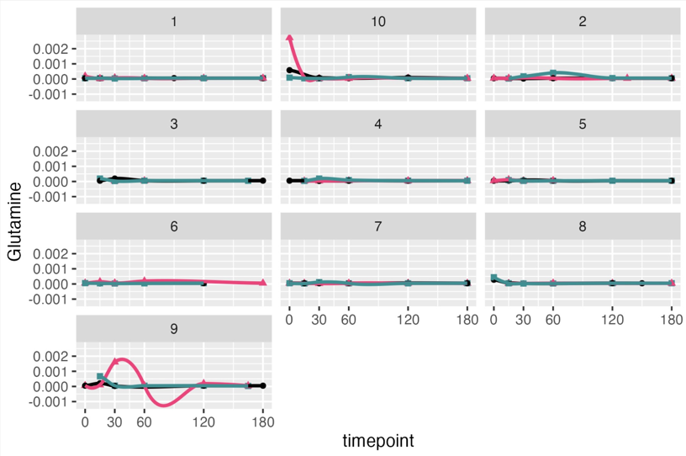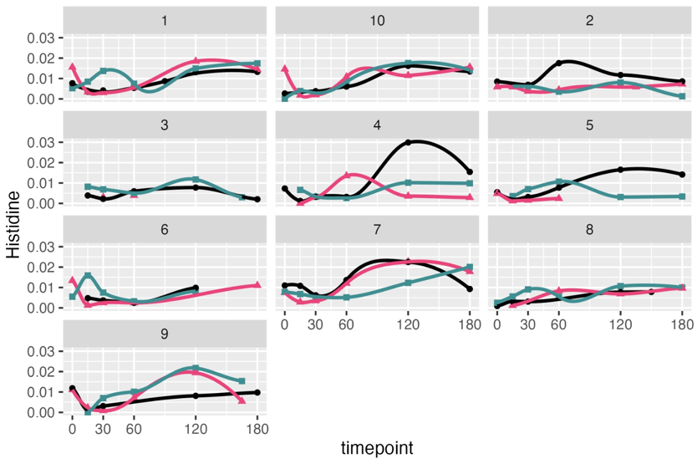
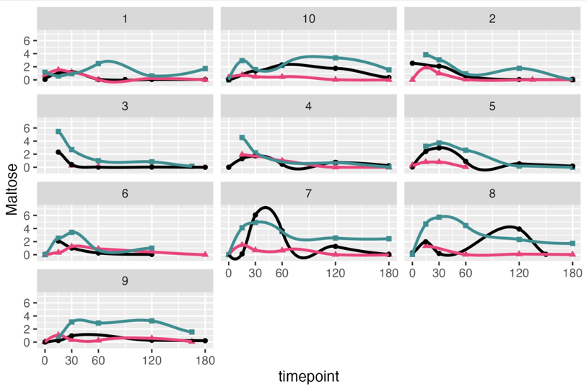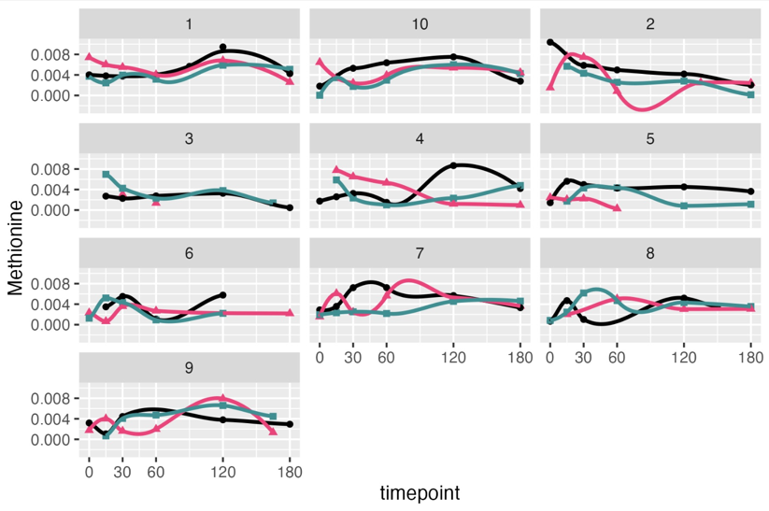
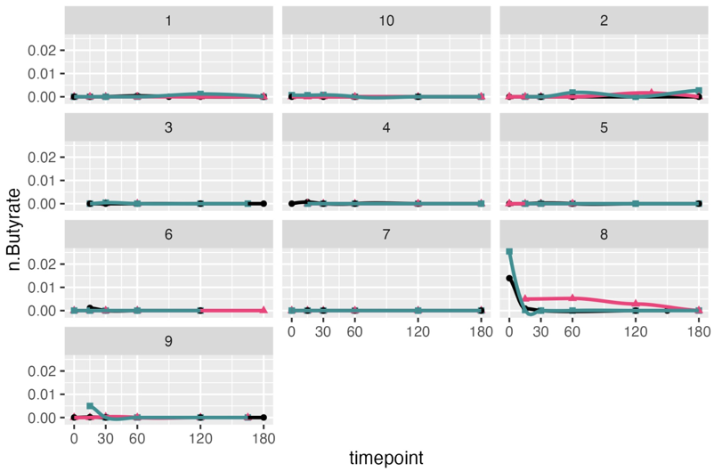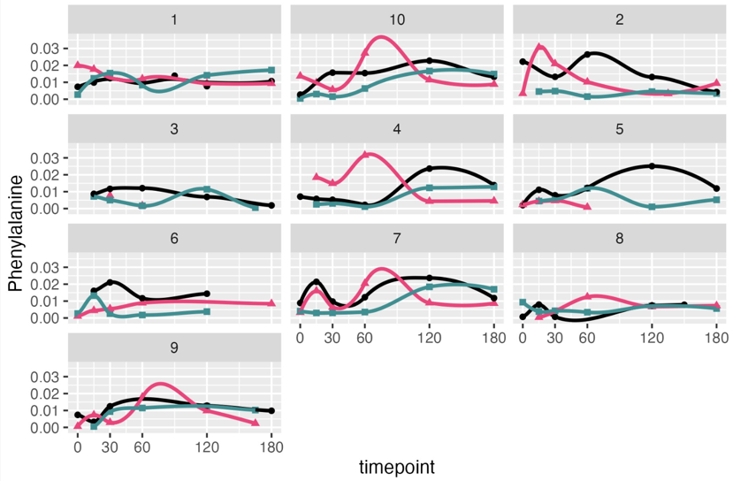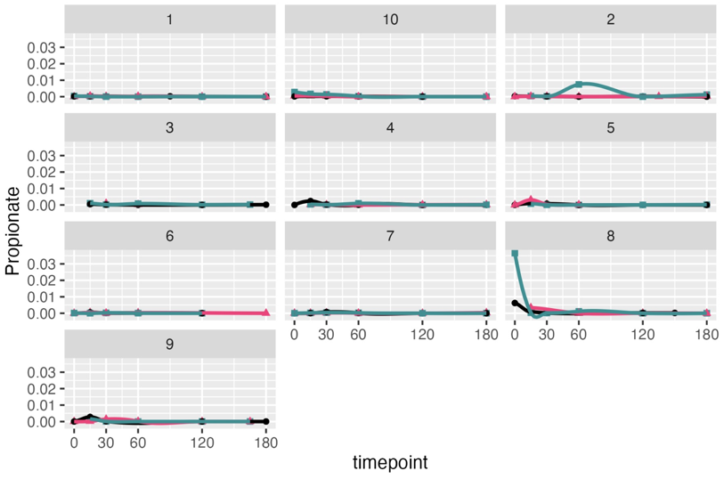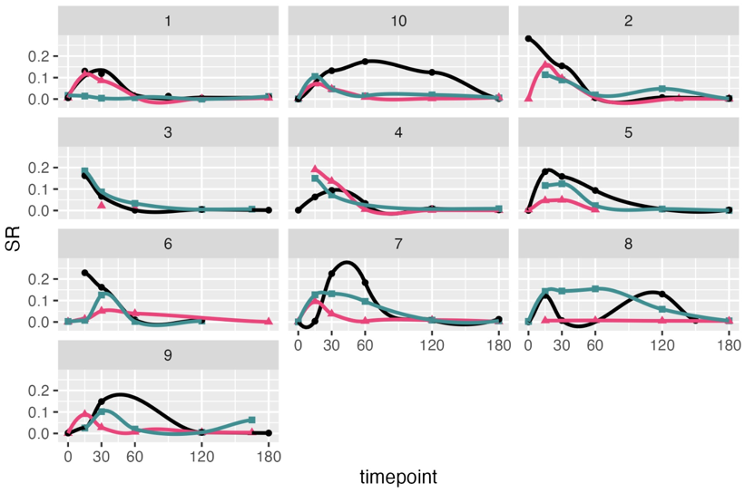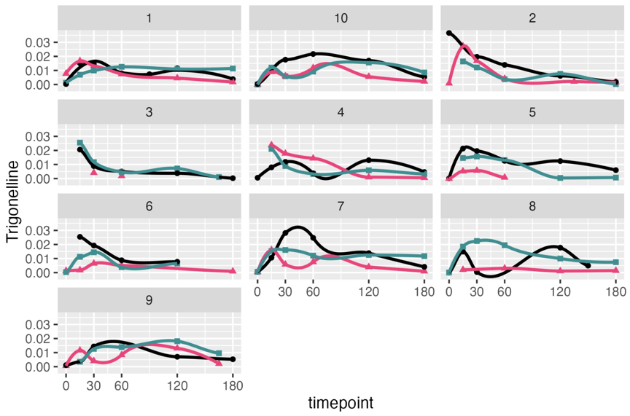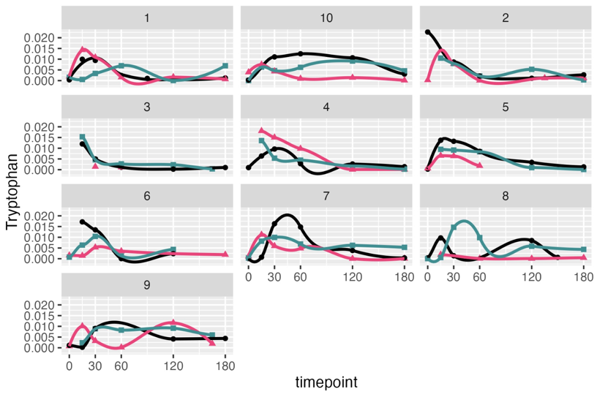
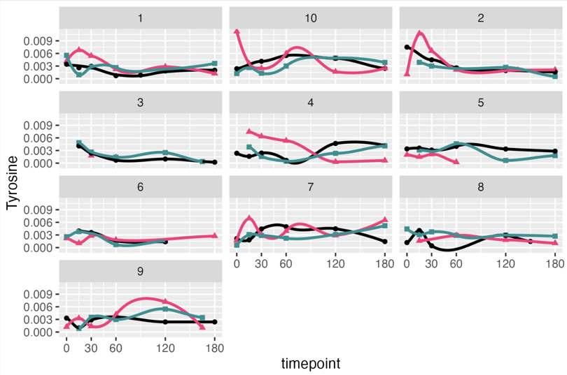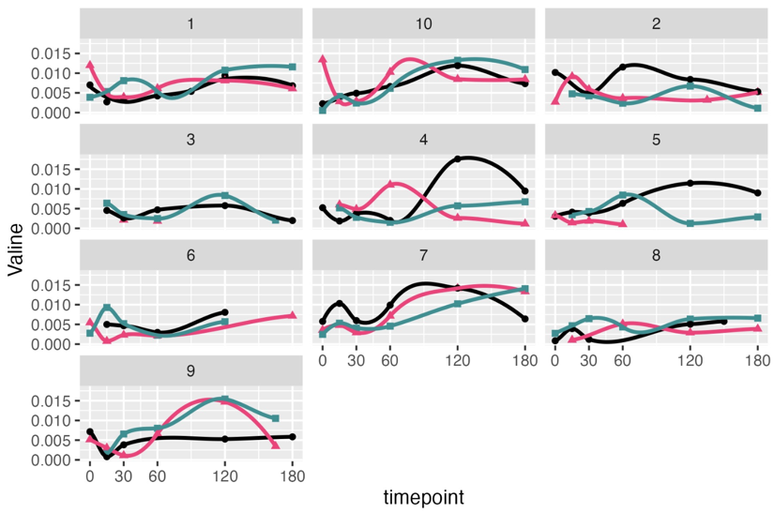

Extended Figure 4: Per individual metabolic concentration in mmol/L plotted against time after meal consumption, within duodenal samples. Green curves are diet BC, Red curves are diet CC, Black curves are diet SC.
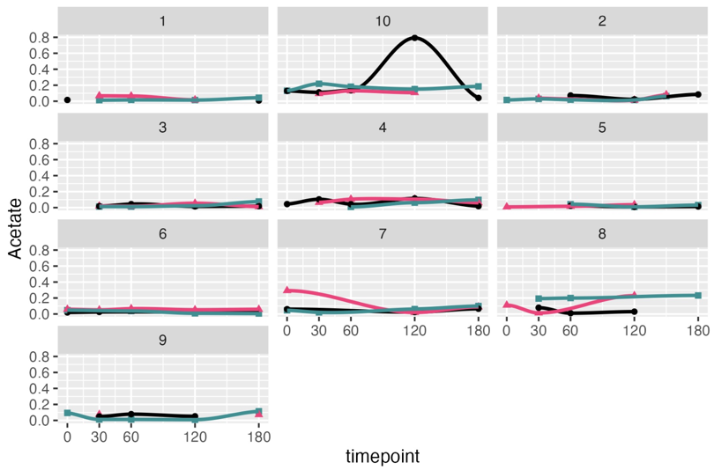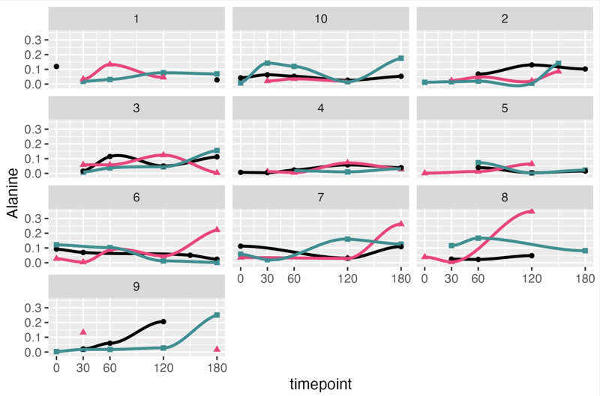
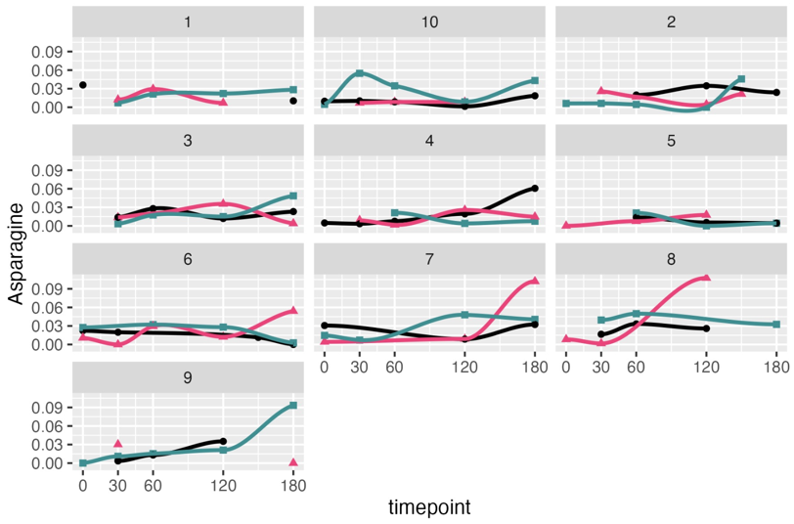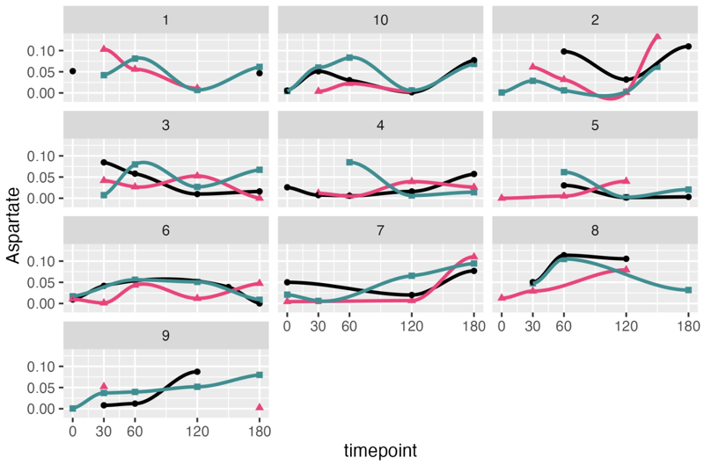
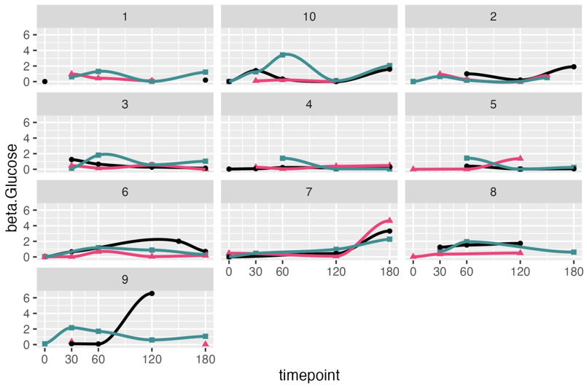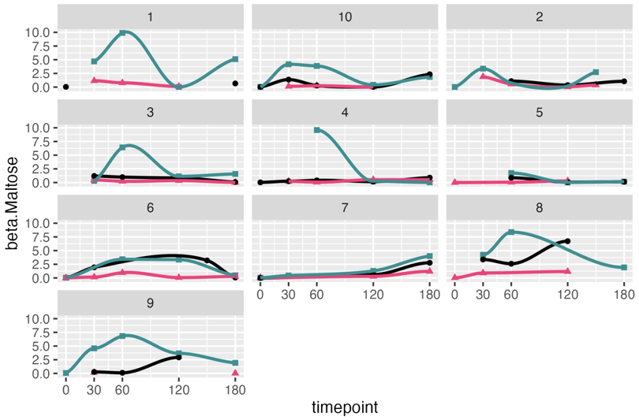
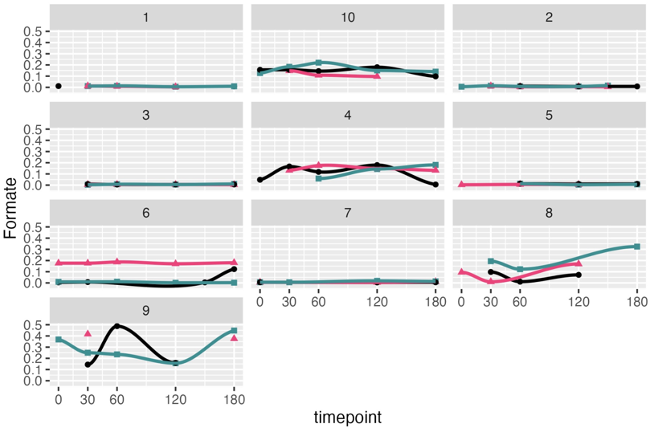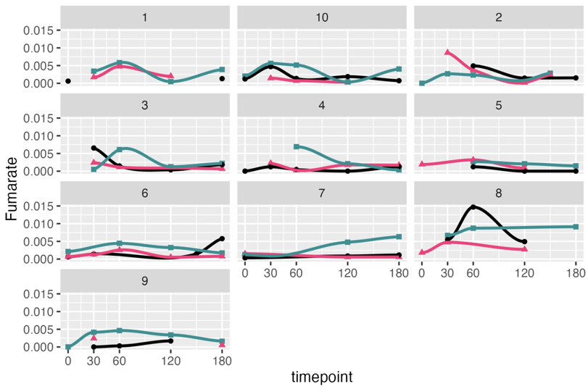
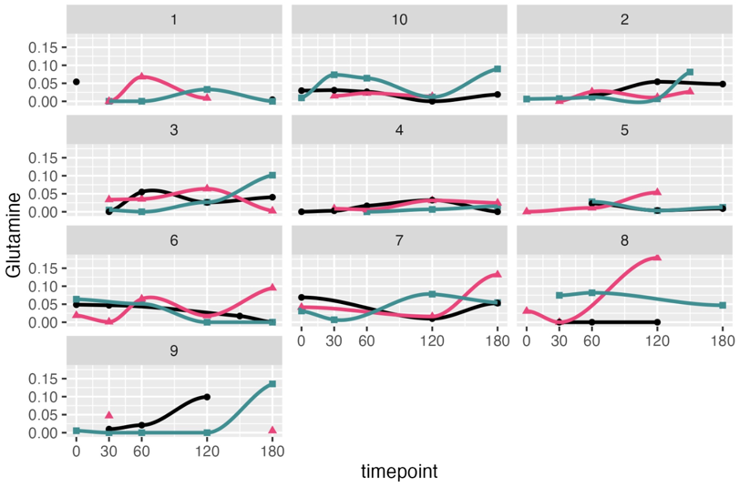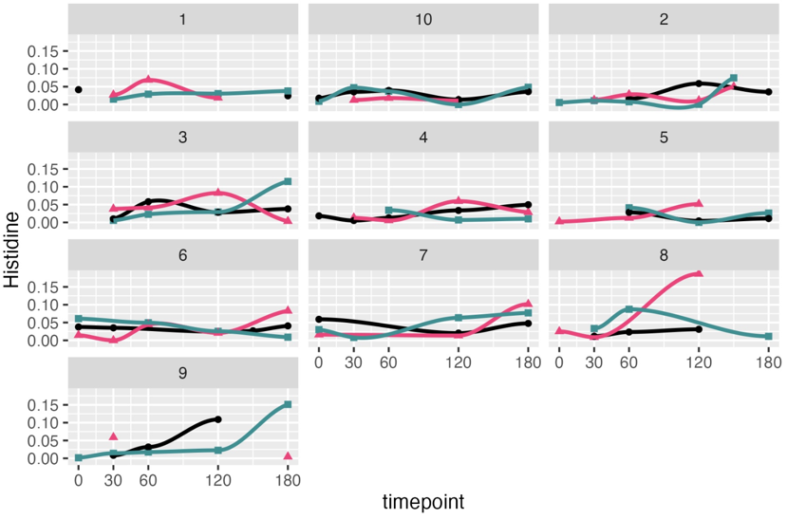
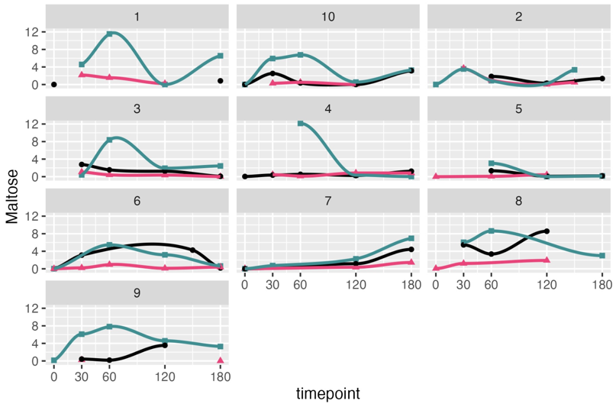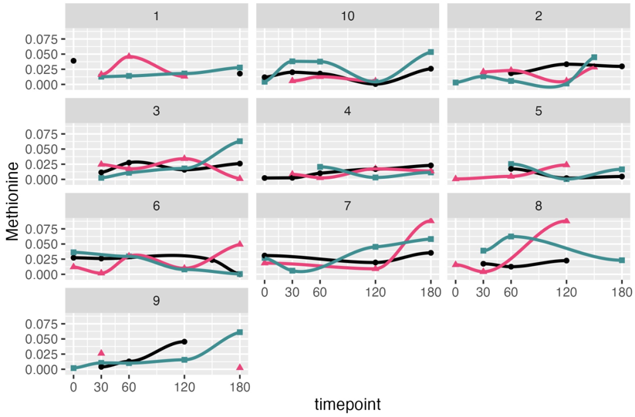
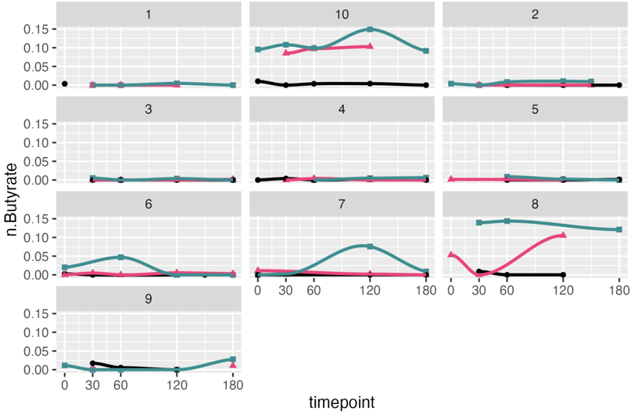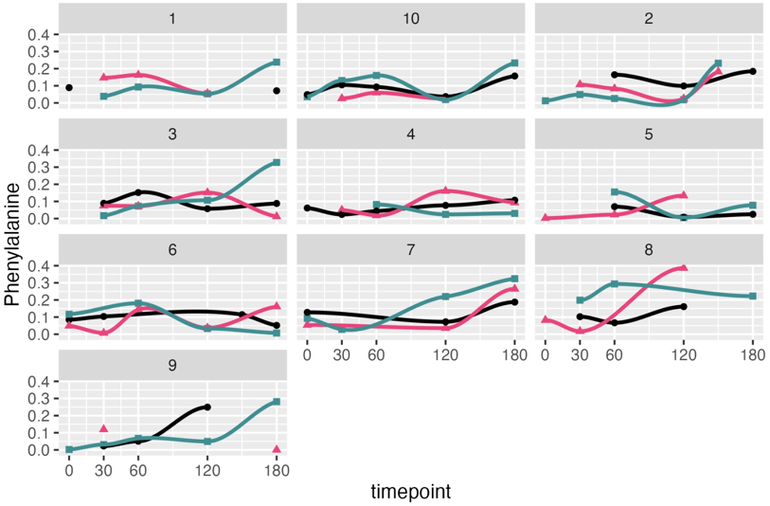
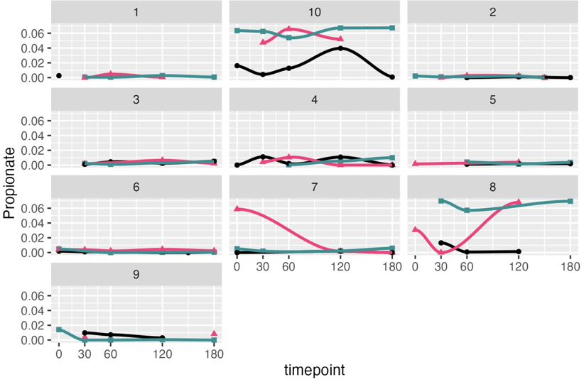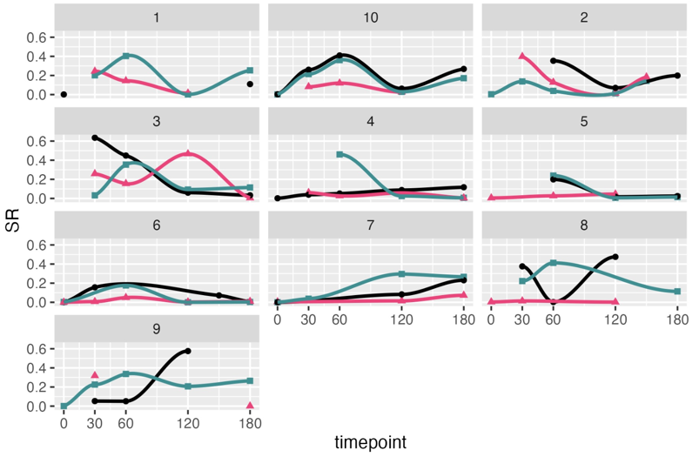
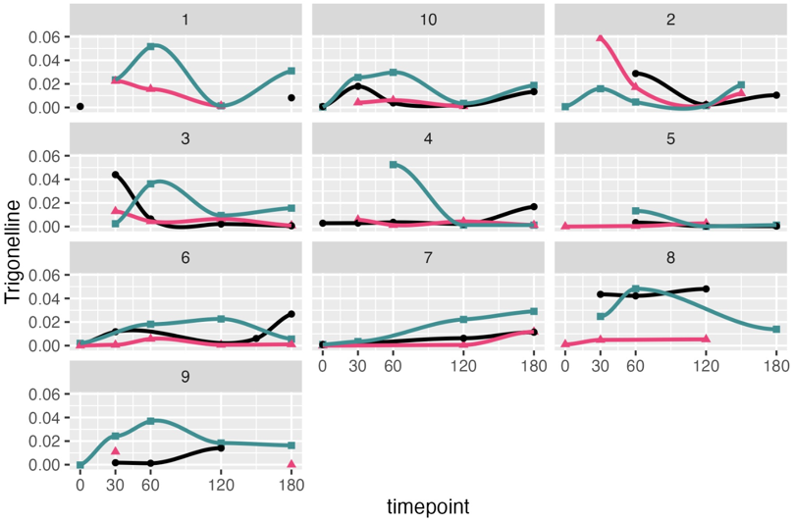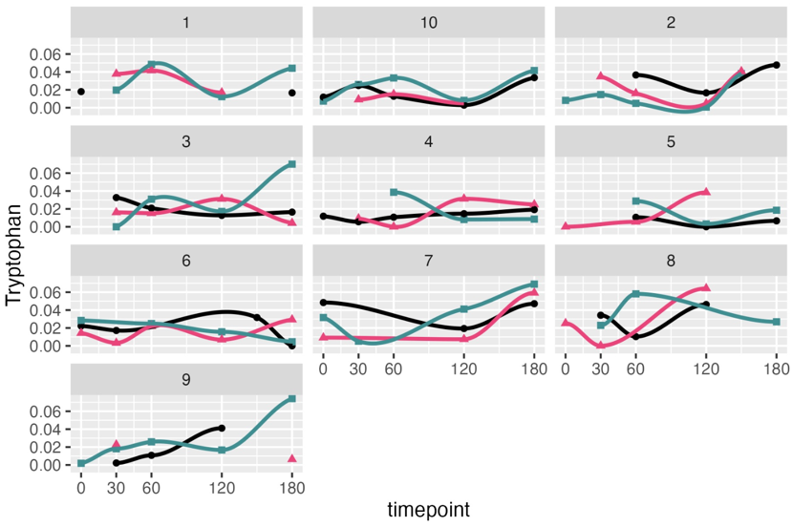

Extended Figure 5: Per individual metabolic concentration in mmol/L plotted against time after meal consumption, within ileal samples. Green curves are diet BC, Red curves are diet CC, Black curves are diet SC.
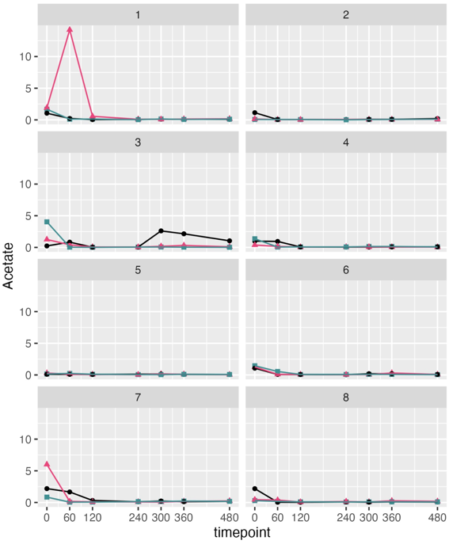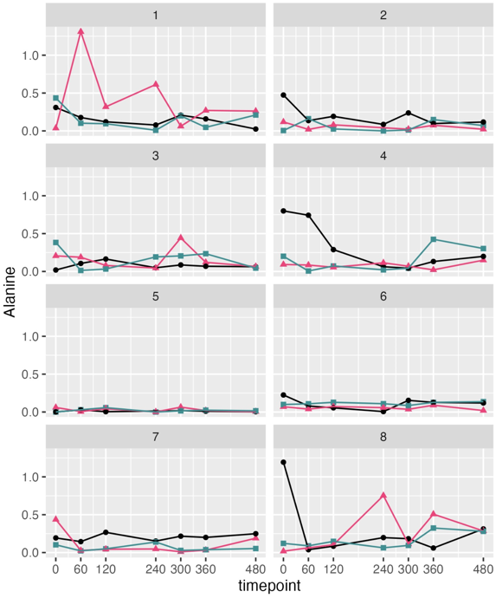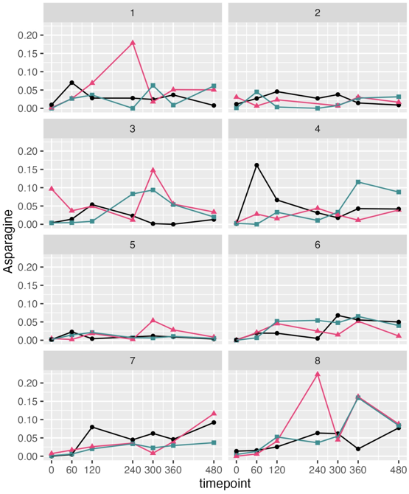
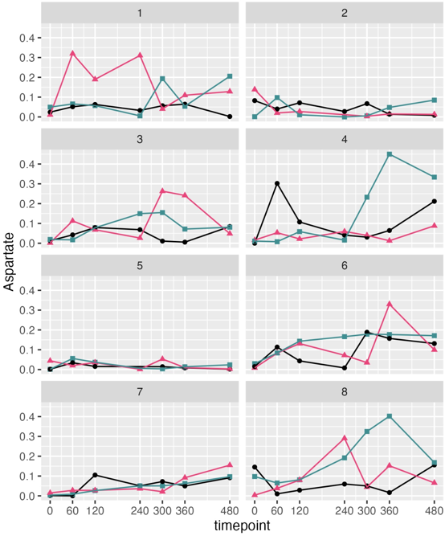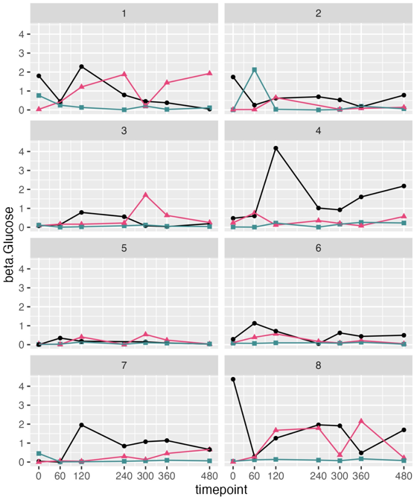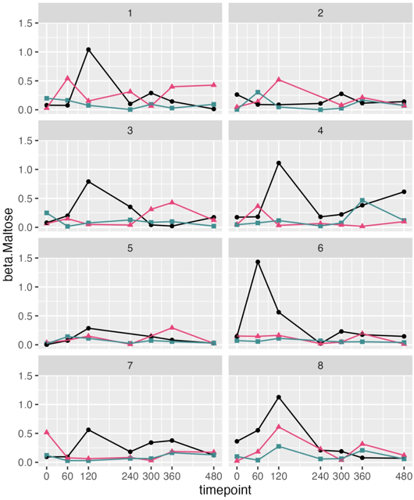
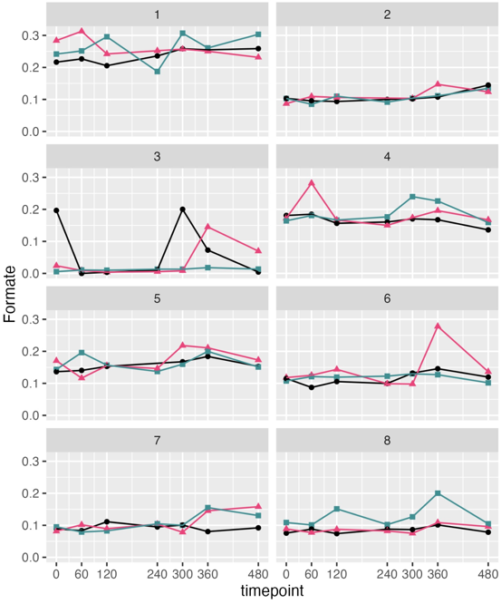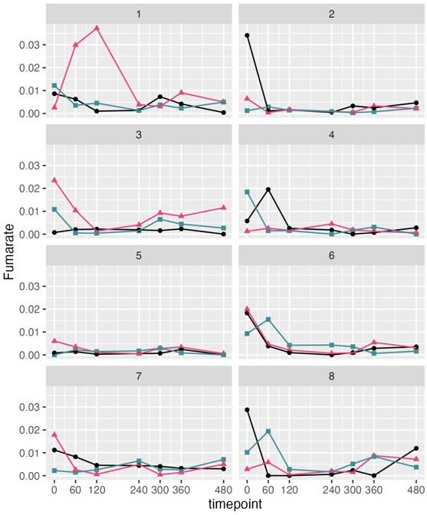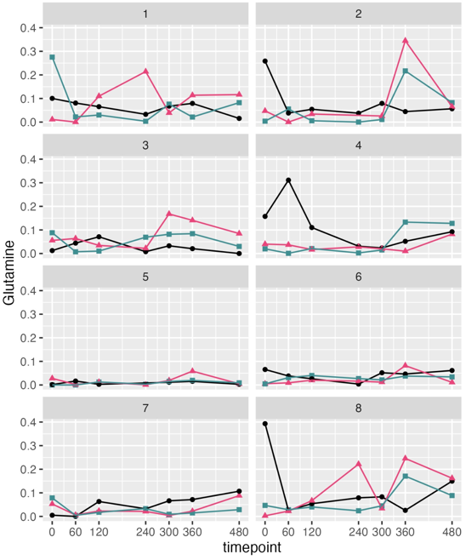
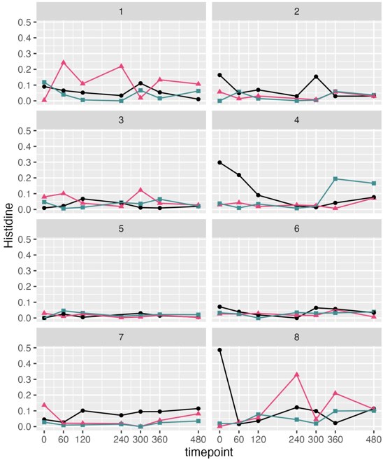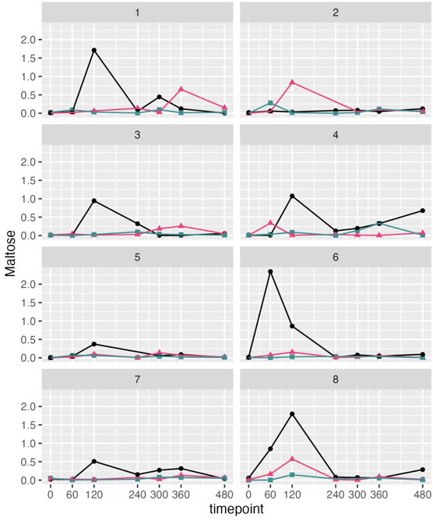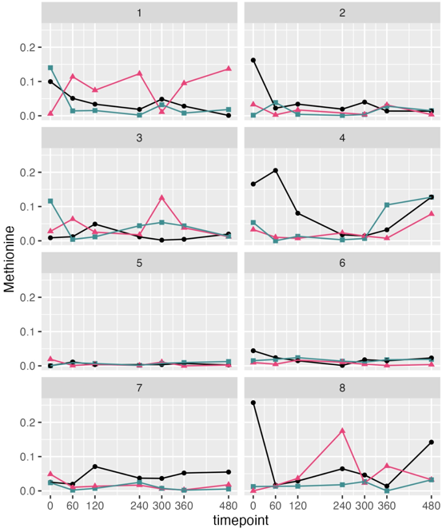
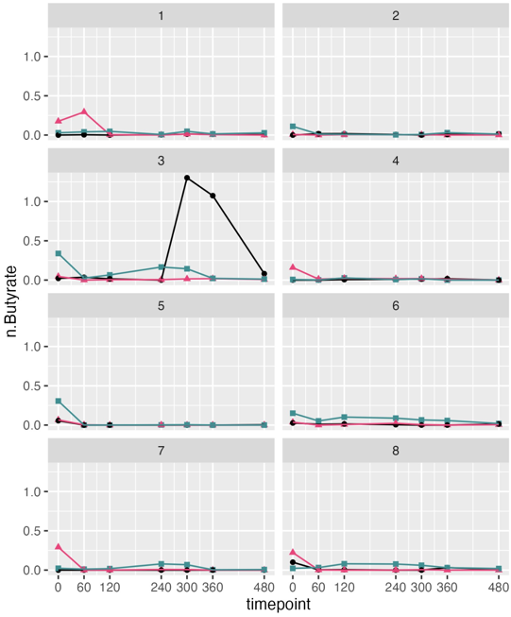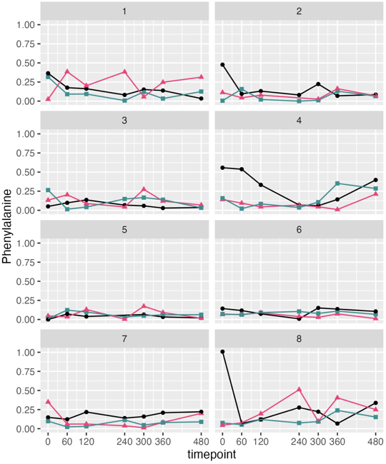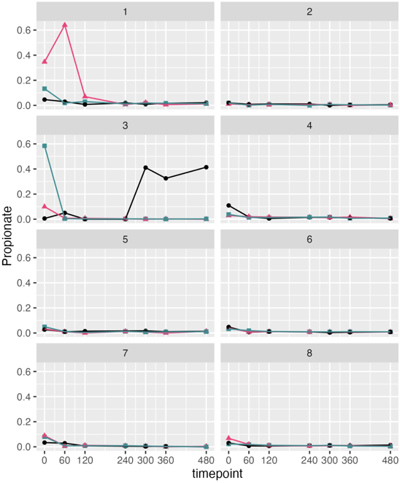
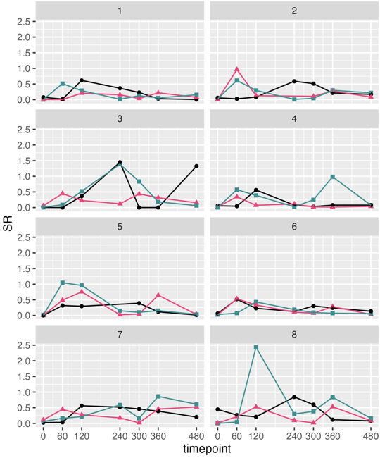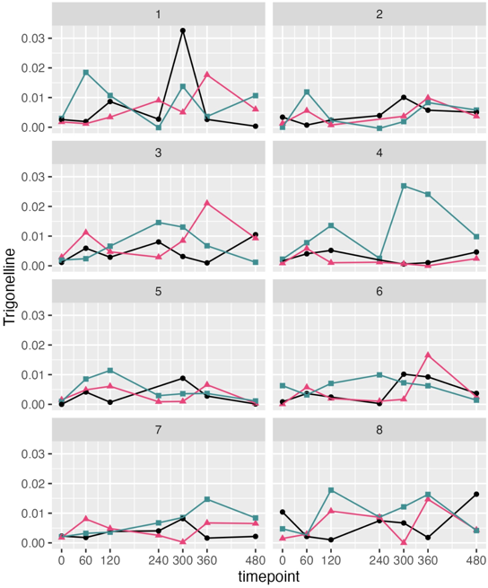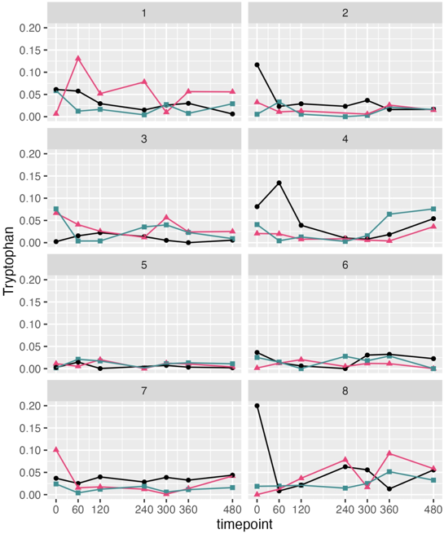
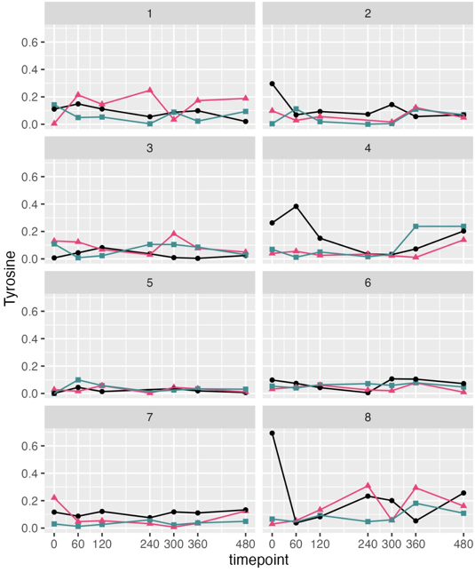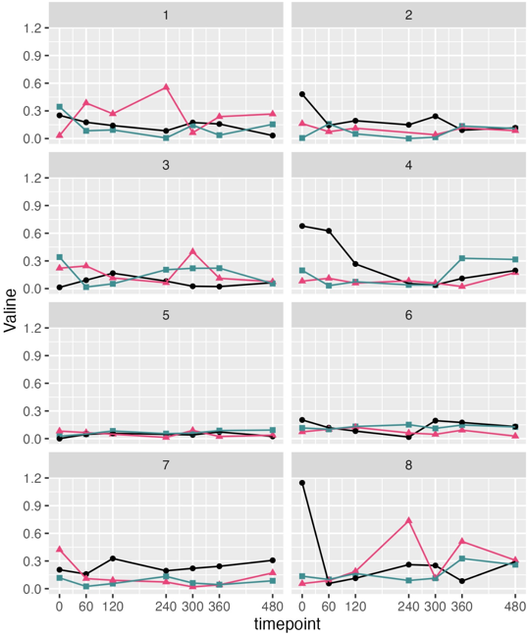

Extended Figure 6: Box and whisker plots of metabolite concentrations across 3 different diets along the GI-tract, demonstrating the full range of datapoints per timepoint. Diet BC (pink) corresponds to broken cells, diet SC (blue) corresponds to single cells and diet CC (green) corresponds to cell clusters. Pairwise comparisons were assessed using the Wilcoxon rank-sum test (*** p ≤ 0.001; ** p ≤ 0.01; * p ≤ 0.05; ns, not significant).
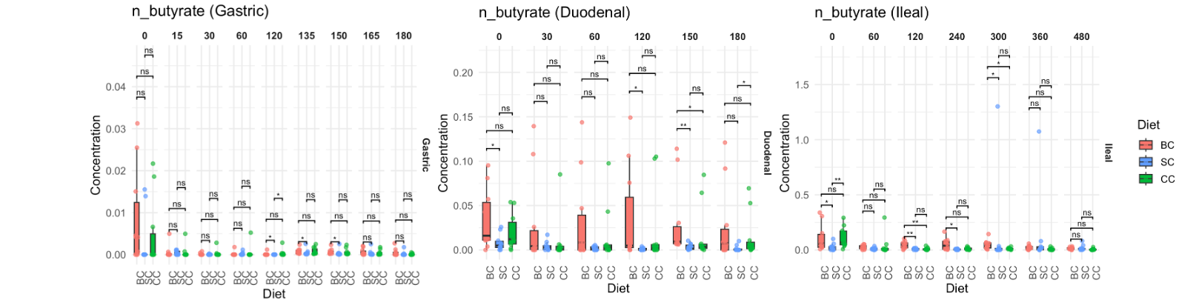
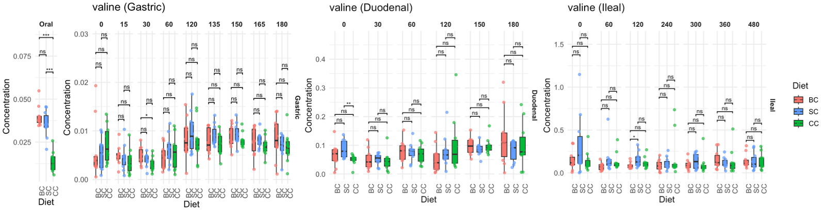
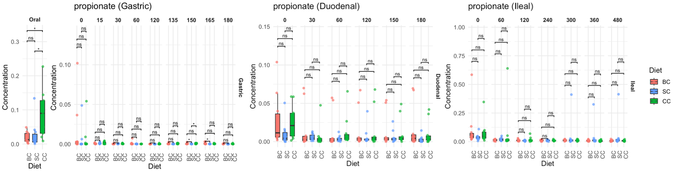
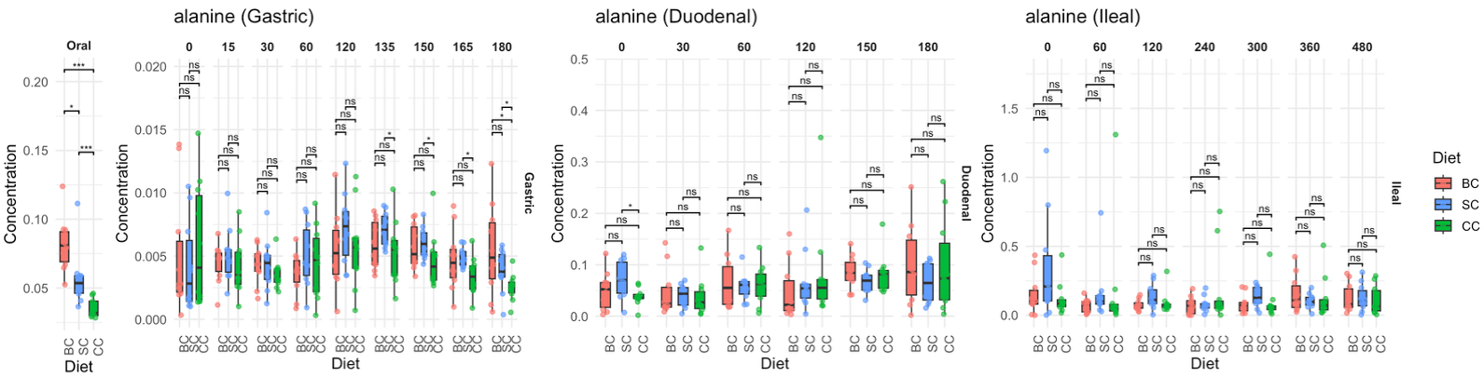
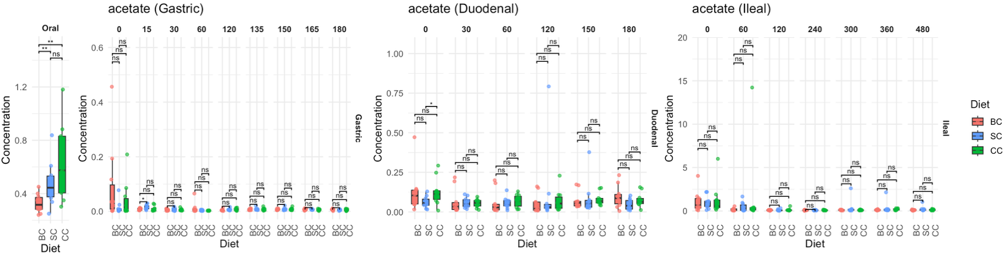
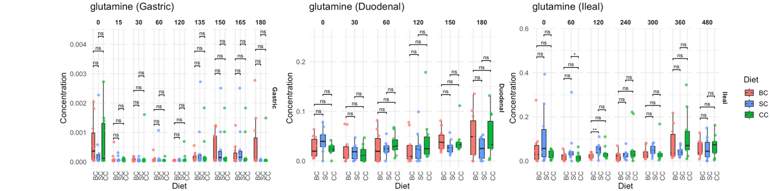
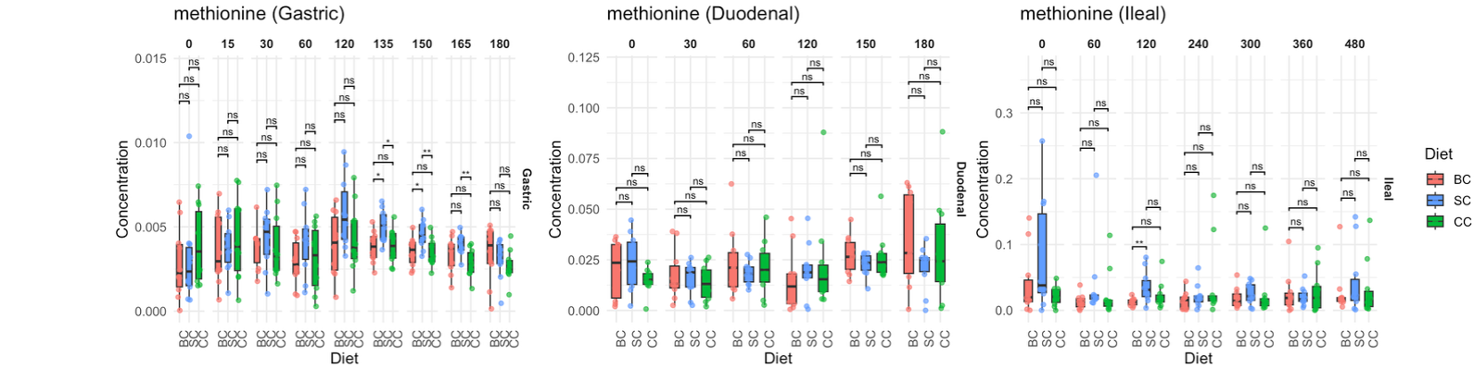
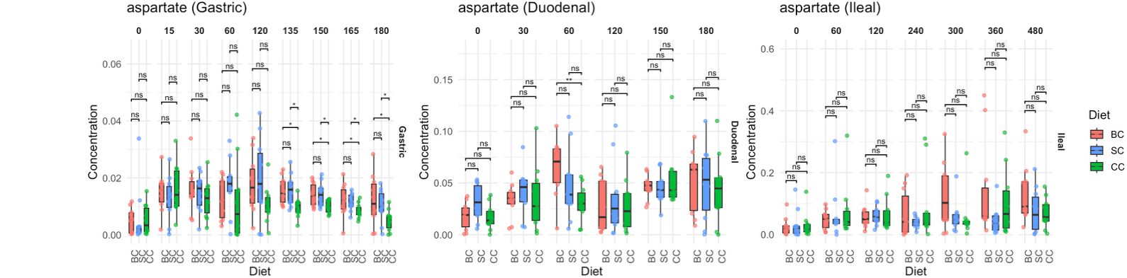
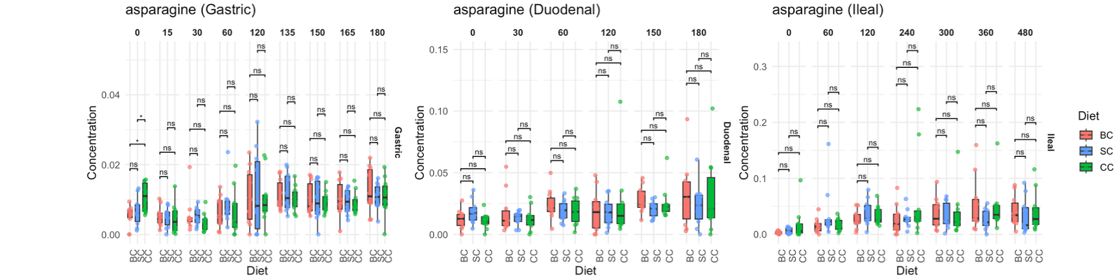
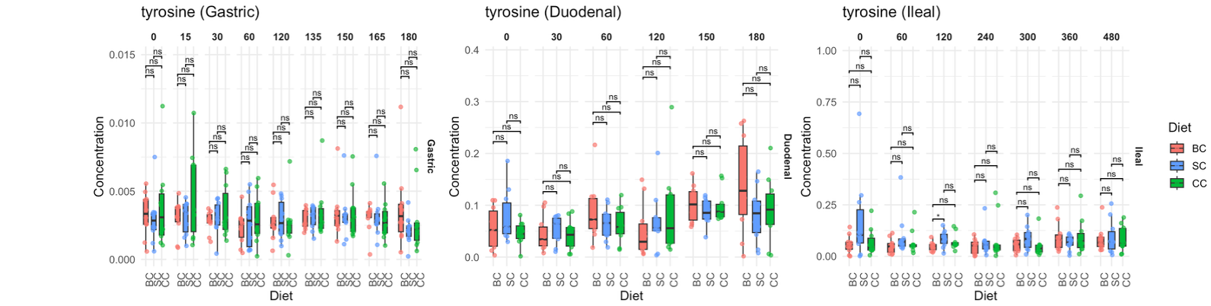
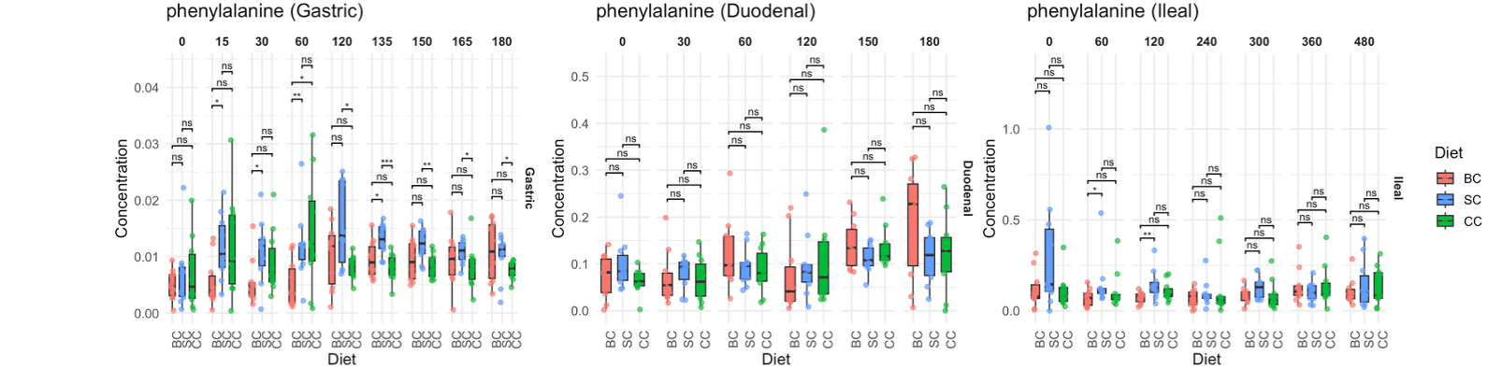
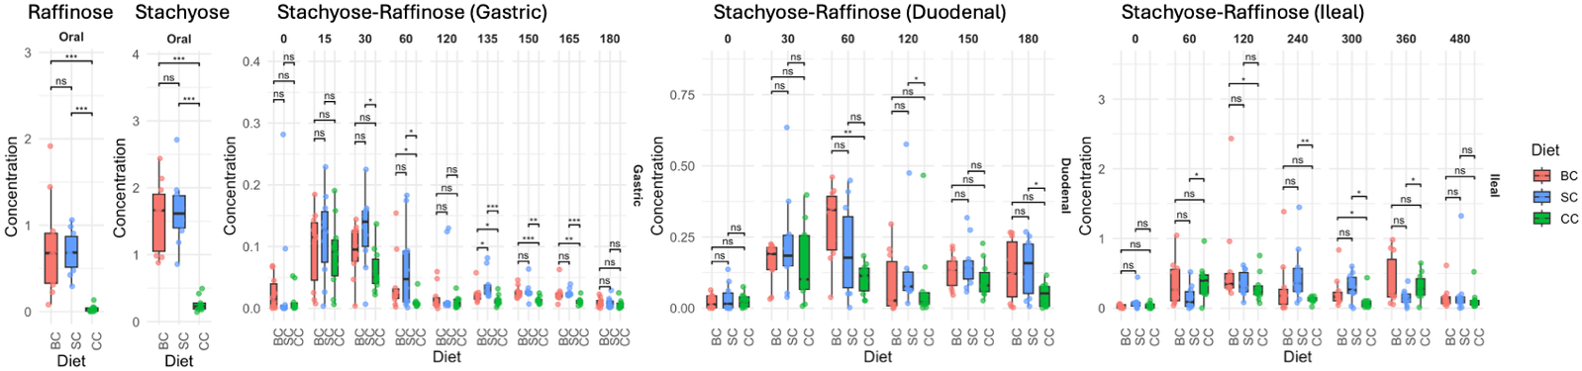
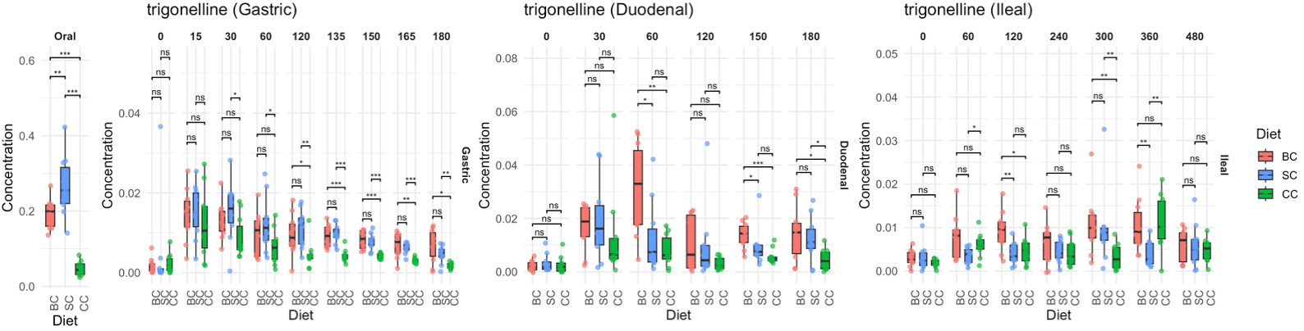
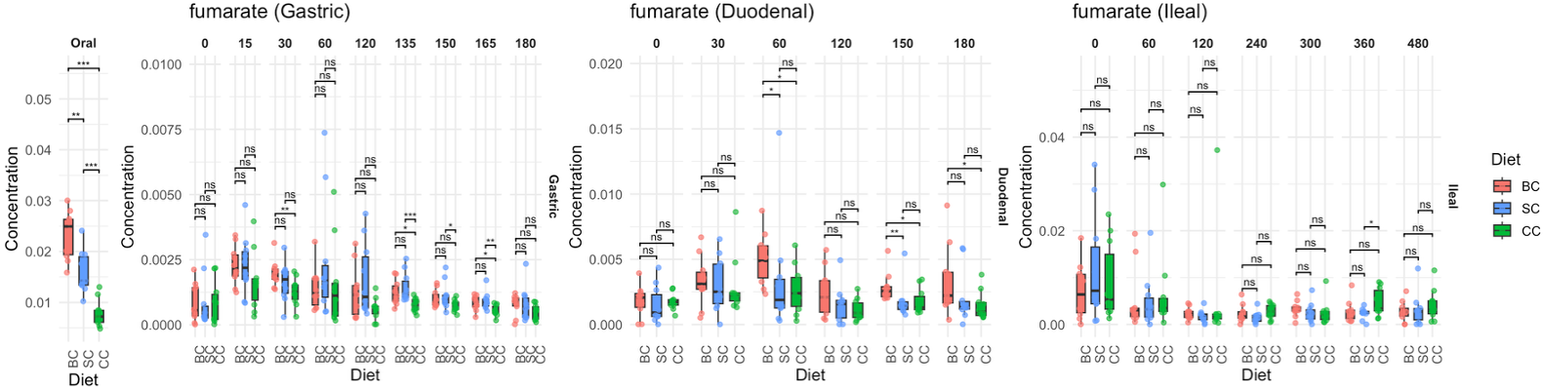
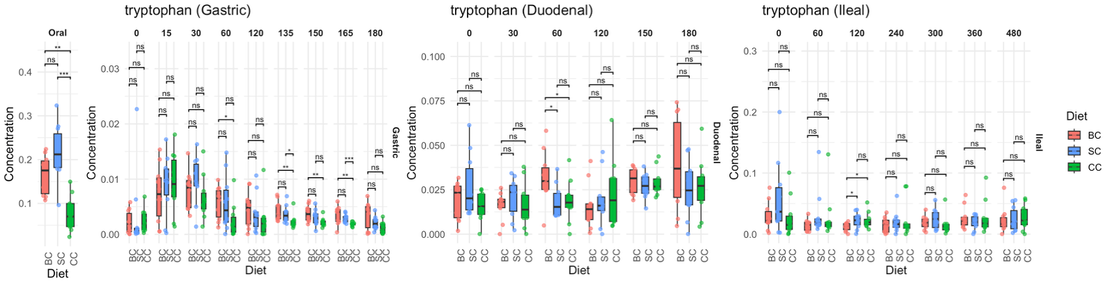
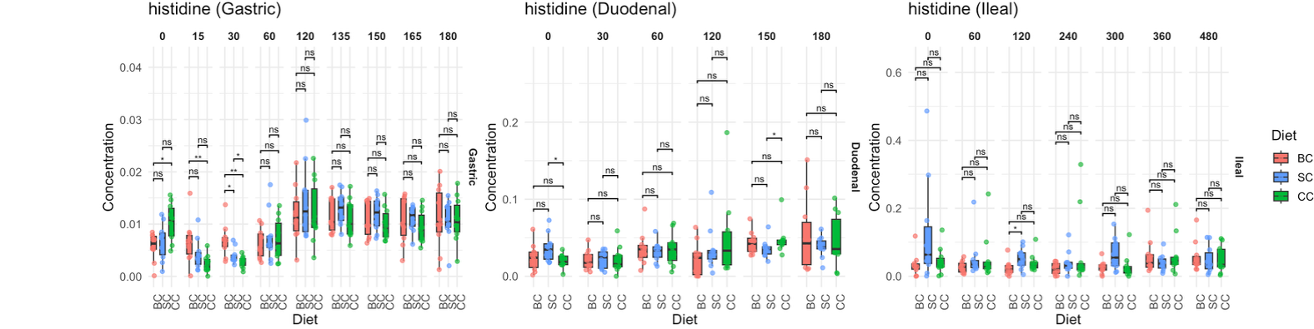
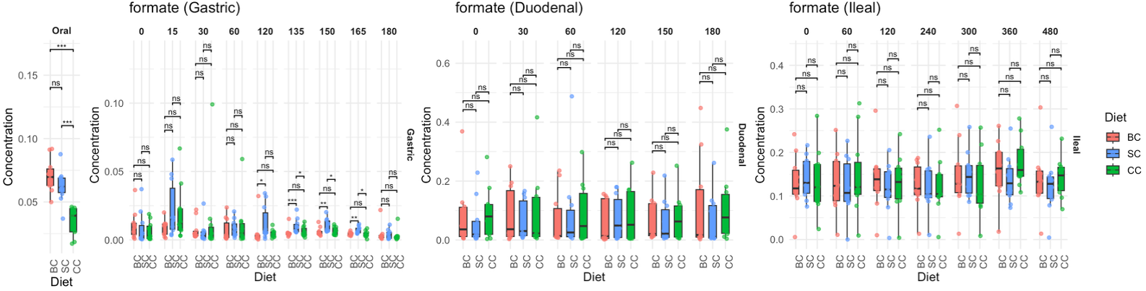
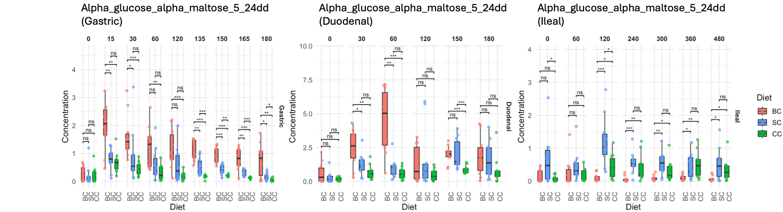
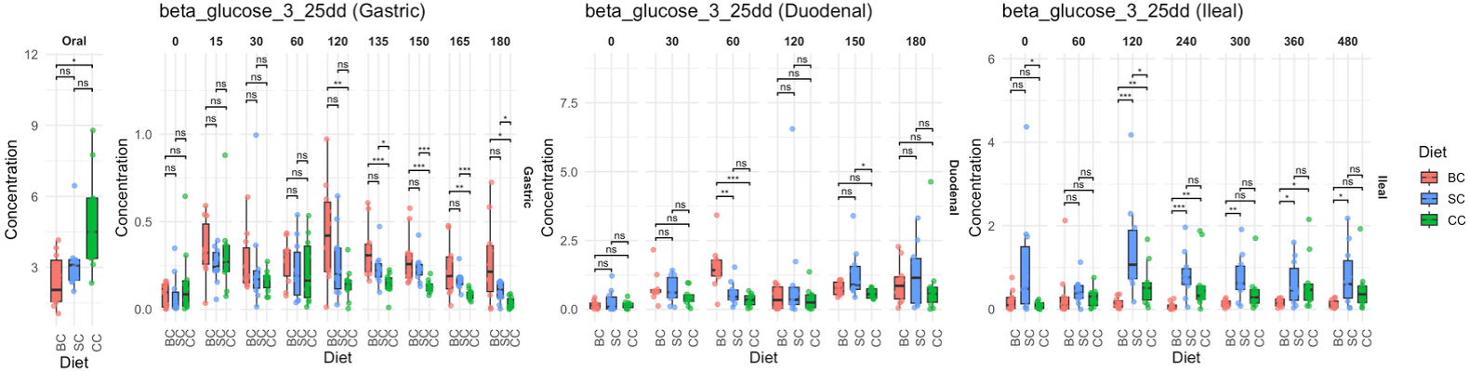
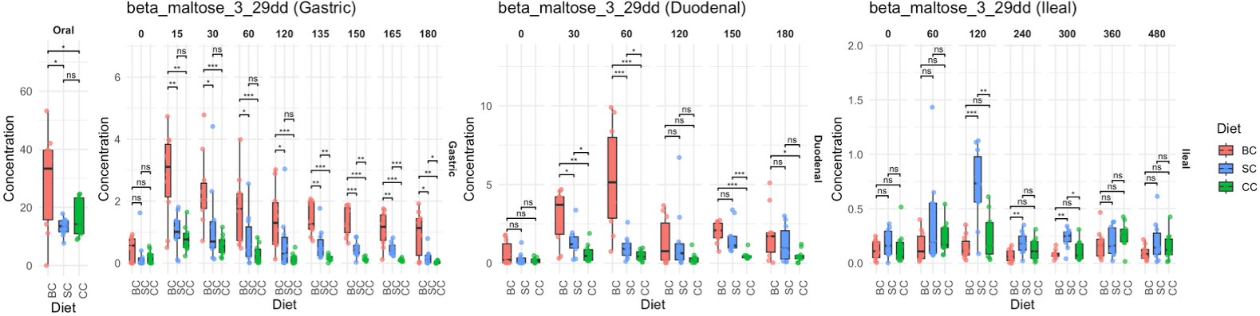
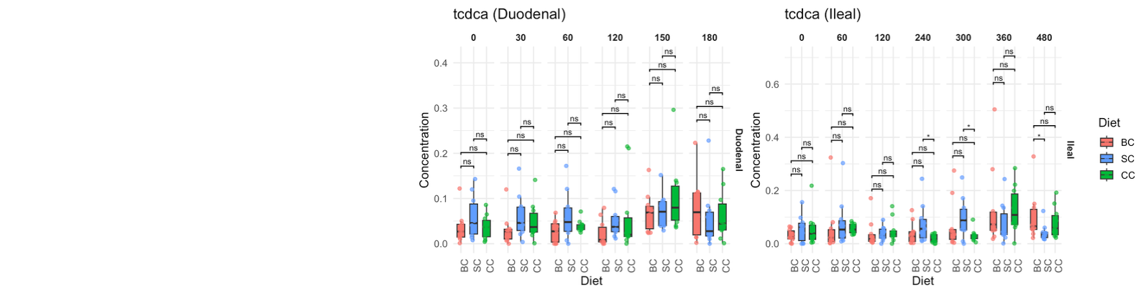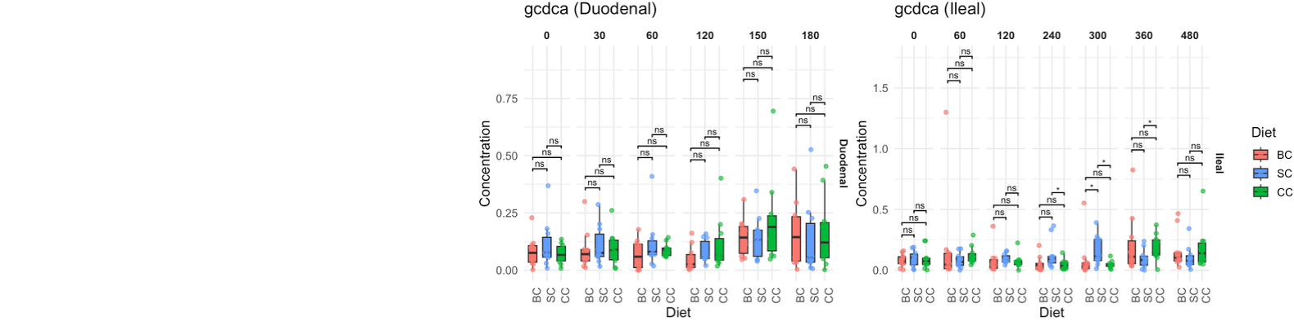
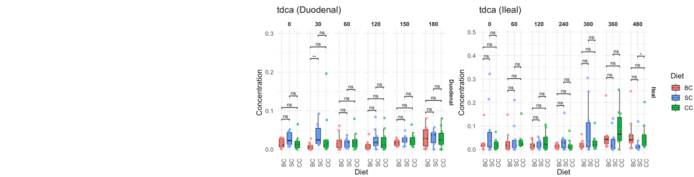
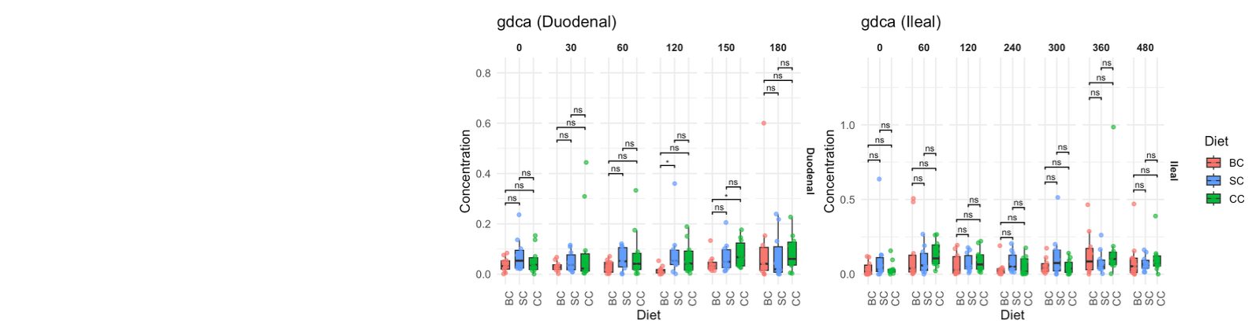
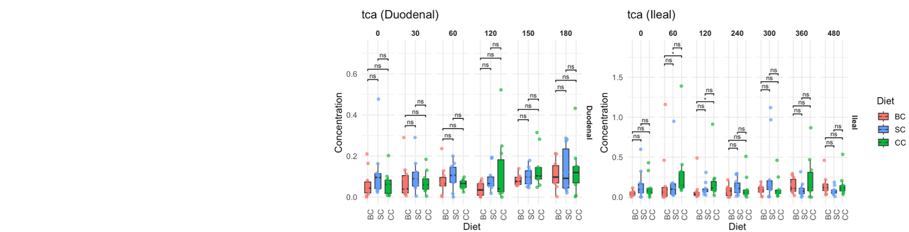
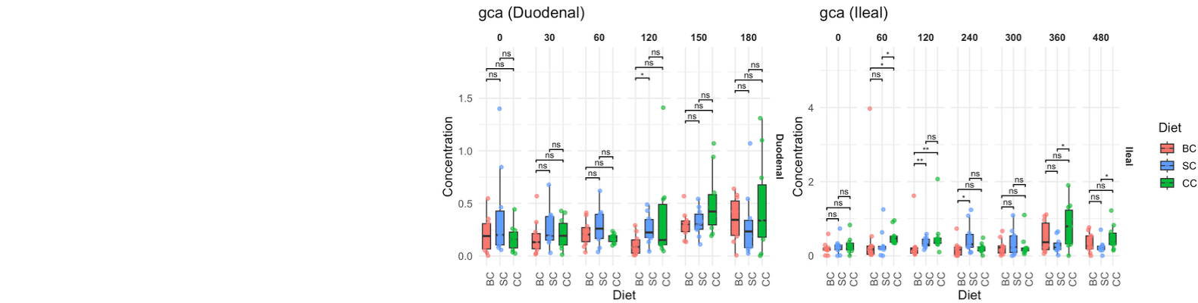
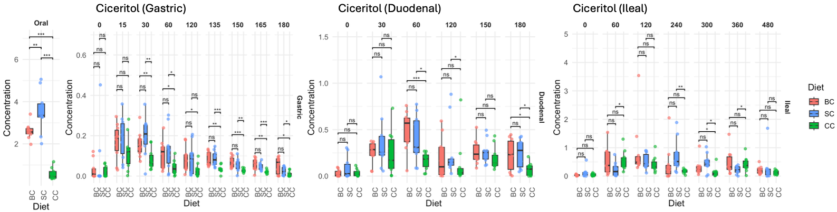
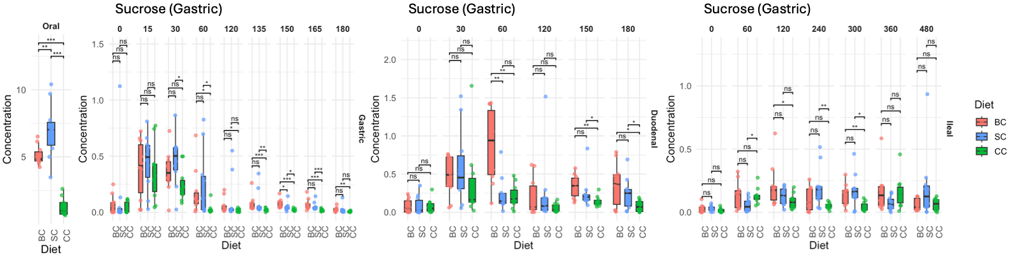
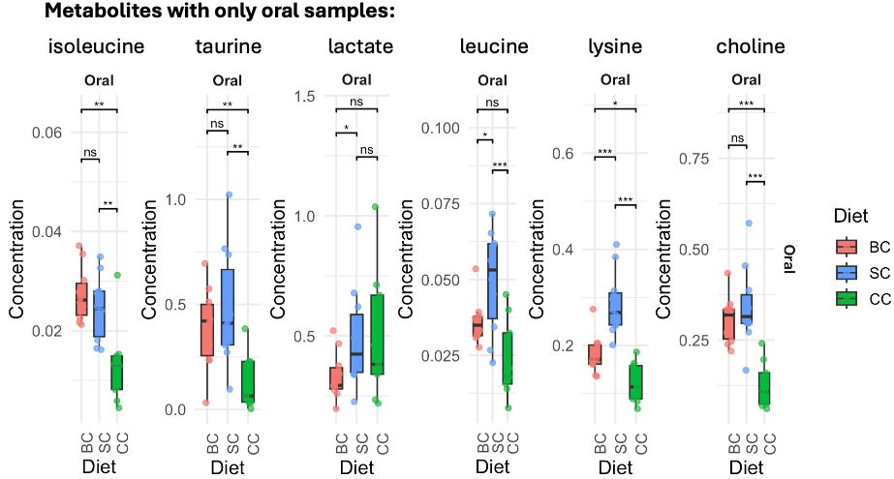
Extended Figure 7: Peak concentration timepoints by diet and location. The timepoint (minutes) of maximal concentration is shown for each participant, stratified by diet [BC (broken cells), SC (single cells), CC (cell clusters)] and sampling location (gastric, duodenal, ileal). Pairwise comparisons were assessed using the Wilcoxon rank-sum test (*** p ≤ 0.001; ** p ≤ 0.01; * p ≤ 0.05; ns, not significant).
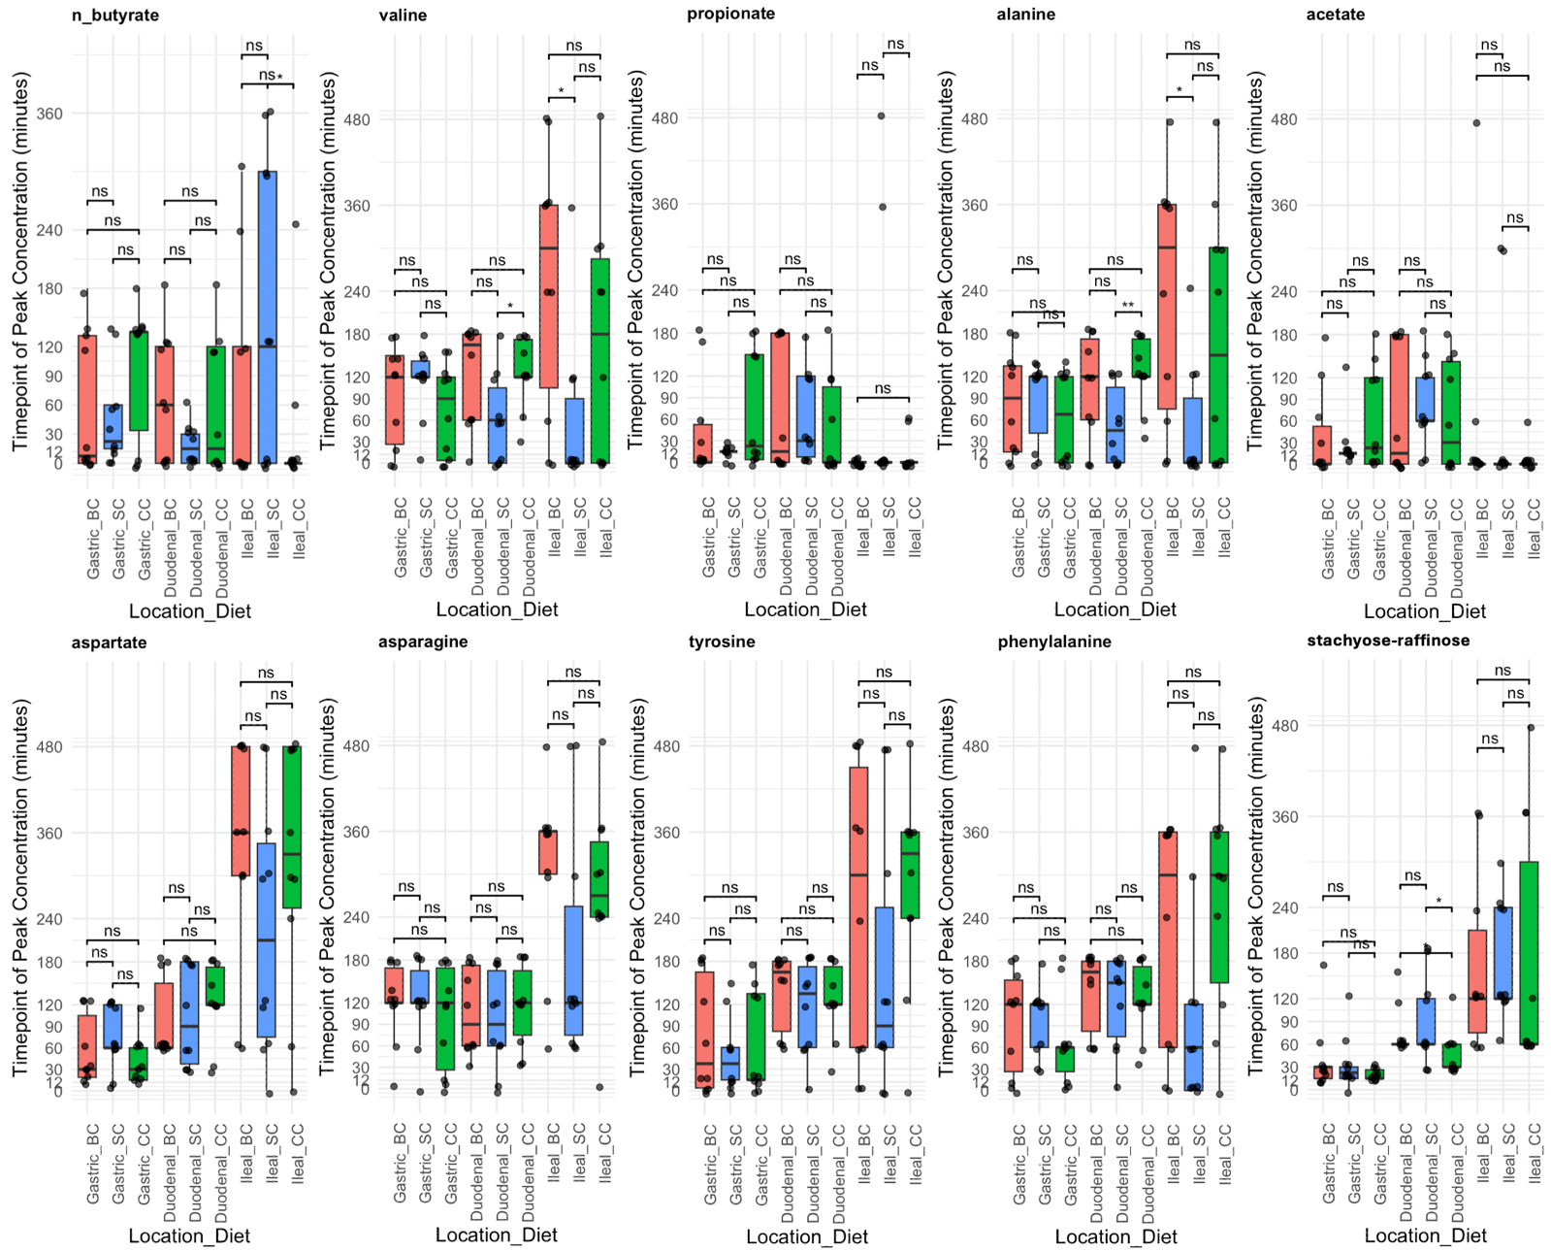
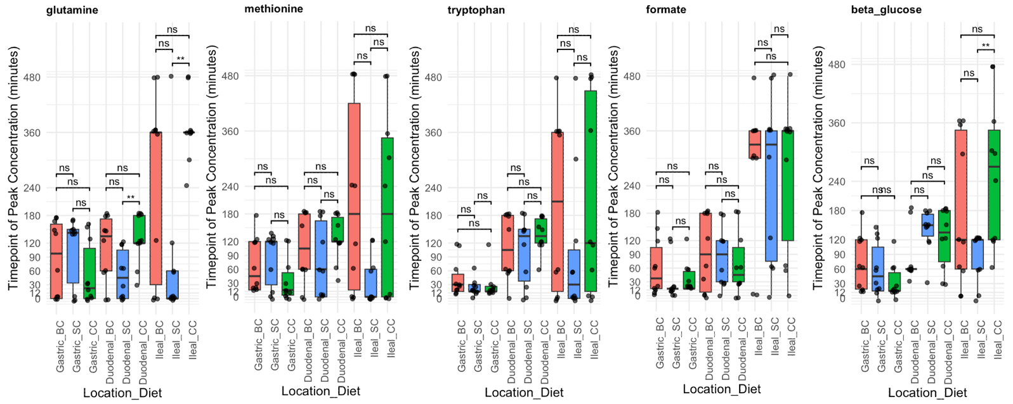
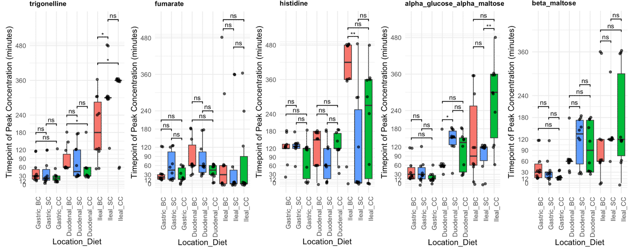
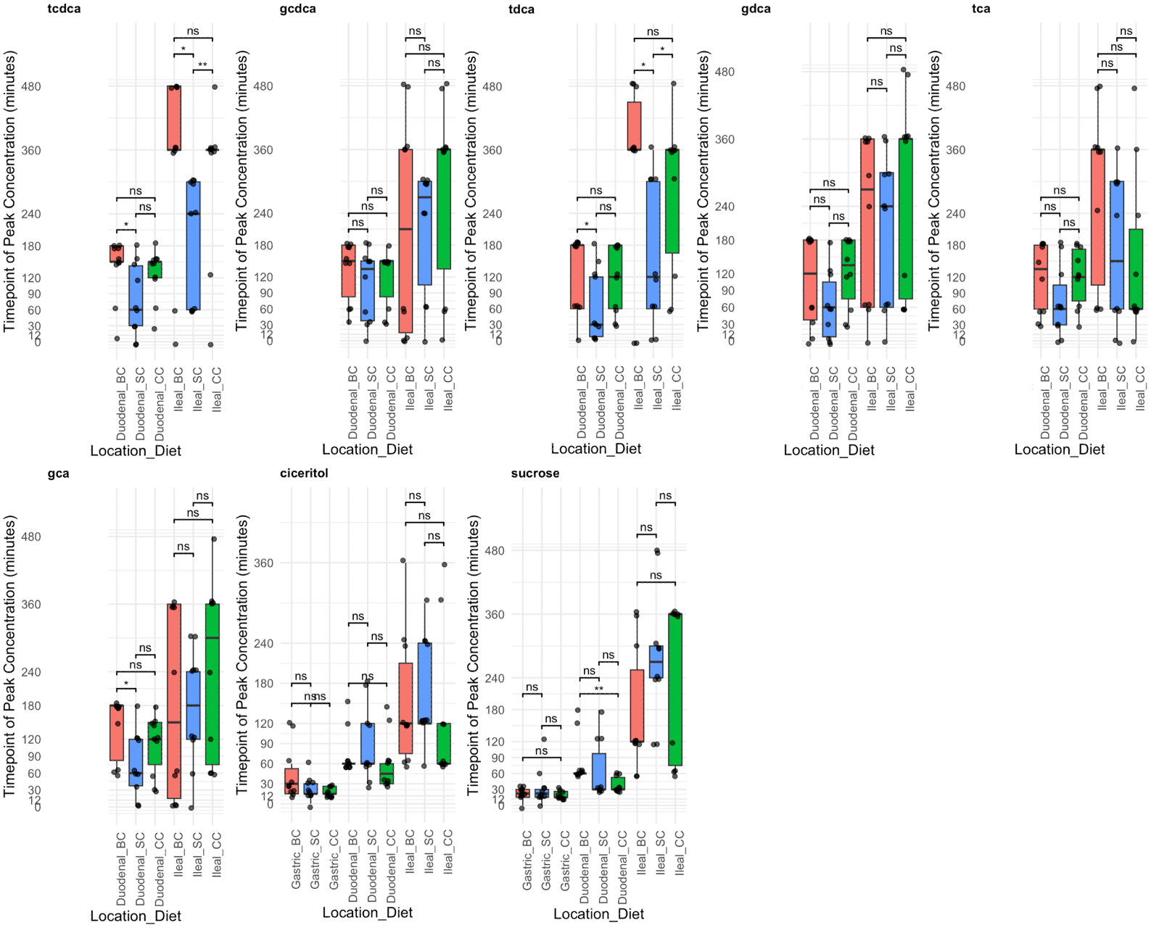

Extended Figure 8. (a) Baseline family-level taxonomic composition of the ileal microbiome across participants and meal types. Stacked bar plots showing relative abundance of bacterial families in ileal aspirates collected at baseline (time 0, pre-meal) for each participant, faceted by meal type: single cell (SC), cell clusters (CC) and broken cells (BC). Taxonomy was assigned at family level, with the top 15 families by mean relative abundance shown individually and remaining taxa collapsed into 'Other'. The ileal microbiome at baseline was dominated by Pasteurellaceae and Streptococcaceae, with substantial inter-individual variation in community structure. Not all participants provided baseline samples for every meal due to the crossover design (SC, n = 5; CC, n = 7; BC, n = 5). Relative abundances were calculated from OTU counts normalised to proportions within each sample. (b) Temporal dynamics of ileal microbiome family-level composition following three meal types. Stacked bar plots showing mean relative abundance of bacterial families in ileal aspirates sampled at nine time points (0, 60, 120, 180, 240, 300, 360, 420 and 480 min post-meal), averaged across participants for each meal type: single cell (SC), cell clusters (CC) and broken cells (BC). The top 15 families by overall mean relative abundance are shown individually; remaining taxa are collapsed into 'Other'. Pasteurellaceae and Streptococcaceae remained the dominant families across all meals and time points. Enterobacteriaceae showed a notable increase in relative abundance at later time points, particularly in the SC and CC meals, whereas the BC meal exhibited a distinct compositional profile characterised by higher Lachnospiraceae and lower Pasteurellaceae abundance at baseline that shifted over the postprandial period. Sample sizes varied across time points due to sample availability (n = 5–8 per time point per meal).
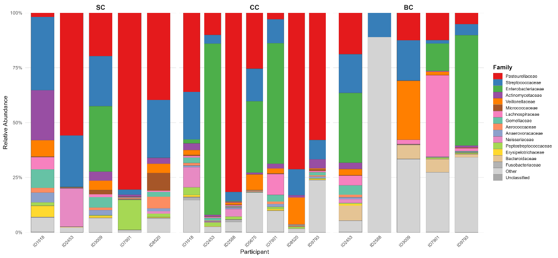
(b)
(a)
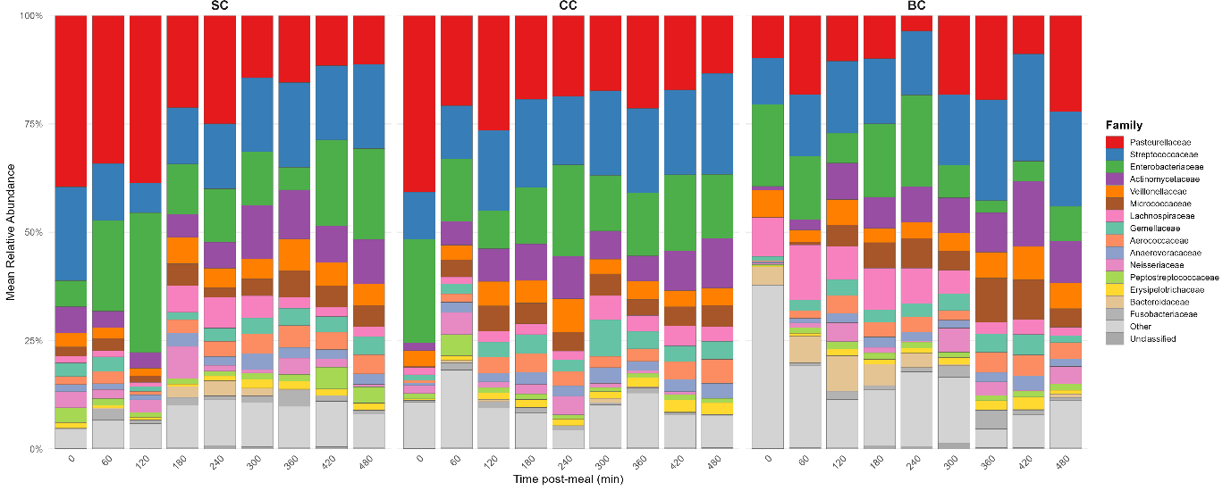

Extended Figure 9: Percentage of reads from chickpea, human and other within the ileal shotgun sequencing data. Chickpea meals legend: Broken cells (red), single cells (blue) and clustered cells (green).

Extended Figure 10: Correlations between gut hormones (GLP1 and PYY) and metagenome abundances. Associations are determined by linear modelling, with standard error shown by the error bars. Each point is coloured by the proportion of strain sharing, with red indicating that strain sharing has not been identified between the oral and ileal compartments, while blue indicates that in all instances strains are shared between oral and ileal compartments.
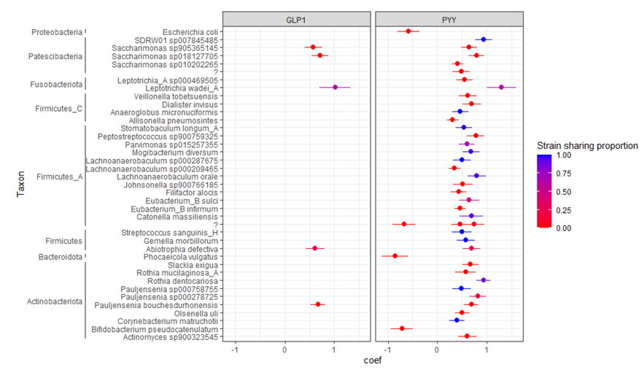
EXTENDED FIGURES
Extended figure 1: 3D graph tracking of metabolite concentrations across 3 different diets along the GI-tract. Diet BC (pink) corresponds to broken cells, diet SC (blue) corresponds to single cells and diet CC (green) corresponds to cell clusters. Z-axis shows samples in the following order: three gastric samples, three duodenal samples and ileal samples. Inset blue box (dashed) within sugars are chickpea markers.

Extended Figure 2: Principal Component Analysis of all metabolites at all timepoint, colored by timepoint, diet, location of sampling within the gastrointestinal tract and patient ID.
Extended Figure 3: Per individual metabolic concentration in mmol/L plotted against time after meal consumption, within gastric samples. Green curves are diet BC, Red curves are diet CC, Black curves are diet SC.

Extended Figure 4: Per individual metabolic concentration in mmol/L plotted against time after meal consumption, within duodenal samples. Green curves are diet BC, Red curves are diet CC, Black curves are diet SC.

Extended Figure 5: Per individual metabolic concentration in mmol/L plotted against time after meal consumption, within ileal samples. Green curves are diet BC, Red curves are diet CC, Black curves are diet SC.

Extended Figure 6: Box and whisker plots of metabolite concentrations across 3 different diets along the GI-tract, demonstrating the full range of datapoints per timepoint. Diet BC (pink) corresponds to broken cells, diet SC (blue) corresponds to single cells and diet CC (green) corresponds to cell clusters. Pairwise comparisons were assessed using the Wilcoxon rank-sum test (*** p ≤ 0.001; ** p ≤ 0.01; * p ≤ 0.05; ns, not significant).
Extended Figure 7: Peak concentration timepoints by diet and location. The timepoint (minutes) of maximal concentration is shown for each participant, stratified by diet [BC (broken cells), SC (single cells), CC (cell clusters)] and sampling location (gastric, duodenal, ileal). Pairwise comparisons were assessed using the Wilcoxon rank-sum test (*** p ≤ 0.001; ** p ≤ 0.01; * p ≤ 0.05; ns, not significant).

Extended Figure 8. (a) Baseline family-level taxonomic composition of the ileal microbiome across participants and meal types. Stacked bar plots showing relative abundance of bacterial families in ileal aspirates collected at baseline (time 0, pre-meal) for each participant, faceted by meal type: single cell (SC), cell clusters (CC) and broken cells (BC). Taxonomy was assigned at family level, with the top 15 families by mean relative abundance shown individually and remaining taxa collapsed into 'Other'. The ileal microbiome at baseline was dominated by Pasteurellaceae and Streptococcaceae, with substantial inter-individual variation in community structure. Not all participants provided baseline samples for every meal due to the crossover design (SC, n = 5; CC, n = 7; BC, n = 5). Relative abundances were calculated from OTU counts normalised to proportions within each sample. (b) Temporal dynamics of ileal microbiome family-level composition following three meal types. Stacked bar plots showing mean relative abundance of bacterial families in ileal aspirates sampled at nine time points (0, 60, 120, 180, 240, 300, 360, 420 and 480 min post-meal), averaged across participants for each meal type: single cell (SC), cell clusters (CC) and broken cells (BC). The top 15 families by overall mean relative abundance are shown individually; remaining taxa are collapsed into 'Other'. Pasteurellaceae and Streptococcaceae remained the dominant families across all meals and time points. Enterobacteriaceae showed a notable increase in relative abundance at later time points, particularly in the SC and CC meals, whereas the BC meal exhibited a distinct compositional profile characterised by higher Lachnospiraceae and lower Pasteurellaceae abundance at baseline that shifted over the postprandial period. Sample sizes varied across time points due to sample availability (n = 5–8 per time point per meal).
(b)
(a)

Extended Figure 9: Percentage of reads from chickpea, human and other within the ileal shotgun sequencing data. Chickpea meals legend: Broken cells (red), single cells (blue) and clustered cells (green).

Extended Figure 10: Correlations between gut hormones (GLP1 and PYY) and metagenome abundances. Associations are determined by linear modelling, with standard error shown by the error bars. Each point is coloured by the proportion of strain sharing, with red indicating that strain sharing has not been identified between the oral and ileal compartments, while blue indicates that in all instances strains are shared between oral and ileal compartments.

