SUPPLEMENTARY MATERIAL

Human physiology at the upper limit of extreme heat exposure

Jem L. Cheng¹, Jake A. McCahon¹, Lee Y. Jin¹, Jennifer Vanos², Ollie Jay¹

¹Heat and Health Research Centre, Faculty of Medicine and Health, University of Sydney, Sydney, NSW, Australia
²School of Sustainability, Arizona State University, Tempe, AZ, USA

Corresponding Author:
Professor Ollie Jay
Heat and Health Research Centre,
Faculty of Medicine and Health,
University of Sydney,
NSW Australia
E-mail: ollie.jay@sydney.edu.au

Table of Contents

Supplementary Methods | 3
Supplemental Table S1. Modified Environmental Symptoms Questionnaire | 3
Supplementary Results: Check of model assumptions | 4
Data distribution | 4
Supplemental Figure S1. Histograms of numerical outcomes | 5
Supplemental Figure S2. Proportional stacked bar graphs of categorical outcomes | 6
Residual plots | 7
Supplemental Figure S3. Residual plots to examine assumptions for numerical outcomes | 9
Supplemental Figure S4. Residual plots to examine assumptions for categorical outcomes | 13
Supplementary Results: Sensitivity analyses | 16
Supplemental Table S2. Main effects of sensitivity analyses on numerical outcomes | 16
Supplemental Table S3. Pairwise comparisons from final model vs. fitted with design variables found to have a significant main effect | 17
Statistical Analysis Plan | 18

Supplementary Methods

Supplemental Table S1. Modified Environmental Symptoms Questionnaire

Select the number of each item to correspond to HOW YOU CURRENTLY FEEL. Please respond to every item and if you do not have the symptom, select zero (Not At All).

 | Not at all | Slight | Somewhat | Moderate | Quite a bit | Extreme
I feel lightheaded, dizzy, and/or faint | 0 | 1 | 2 | 3 | 4 | 5
I have a headache | 0 | 1 | 2 | 3 | 4 | 5
I’m finding it hard to breathe | 0 | 1 | 2 | 3 | 4 | 5
I have a muscle or stomach cramp | 0 | 1 | 2 | 3 | 4 | 5
I feel numbness and tingling in parts of my body | 0 | 1 | 2 | 3 | 4 | 5
I feel tired and weak | 0 | 1 | 2 | 3 | 4 | 5
I feel sick, nauseous or like I might vomit | 0 | 1 | 2 | 3 | 4 | 5
My vision is blurry | 0 | 1 | 2 | 3 | 4 | 5
Modified Environmental Symptoms Questionnaire – USARIEM, 1993.

Do you feel well enough to continue?
YES / NO
Supplementary Results: Check of model assumptions

Data distribution
Numerical variables were plotted with histograms displaying (a) the full dataset and (b) separated by condition, with the outcome variable on the x-axis and probability density on the y-axis (Supplemental Figure S1). These histograms were used to evaluate the shape and spread of the data. All variables are approximately normally distributed.

Categorical variables were plotted with proportional stacked bar graphs with condition on the x-axis and the proportion expressed as a percentage on the y-axis (Supplemental Figure S2). These graphs were used to evaluate the spread of the data and to ensure that there are an adequate number of cases (≥5-6 counts per category) in each category for analysis. Several variables, including trial completion rate, reason for trial termination, symptom #4 (stomach or muscle cramp), and symptom #8 (blurry vision) did not meet this criterion, which was taken into consideration in the analysis and reporting approach.

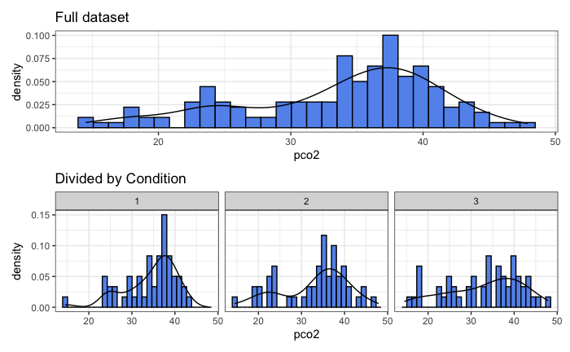
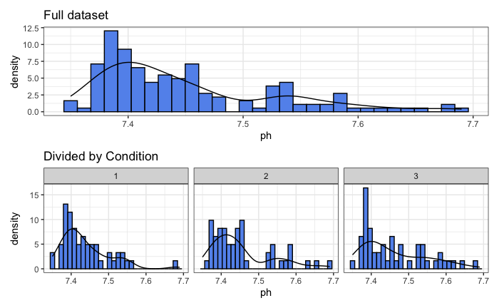
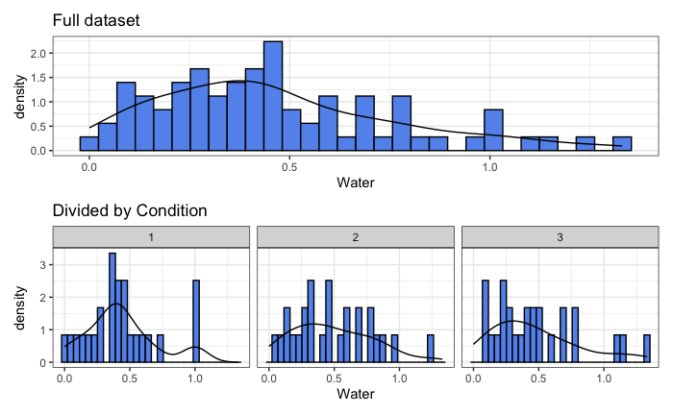
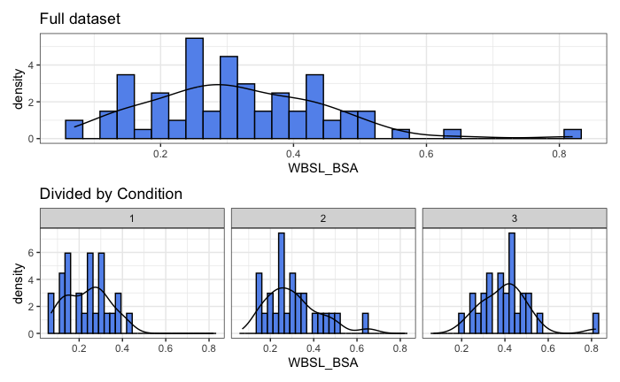
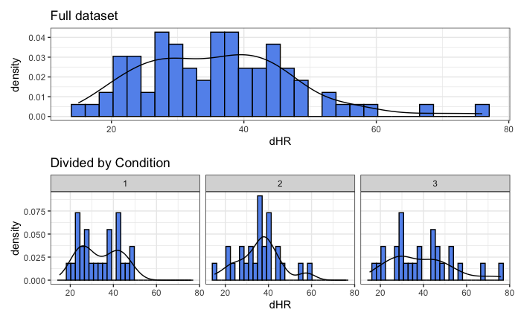
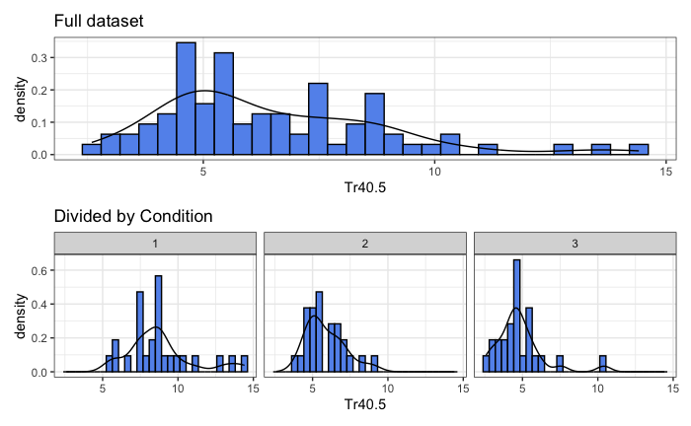
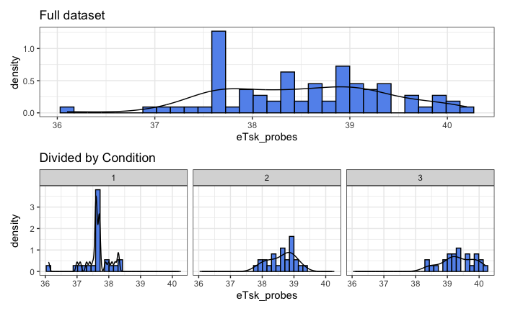
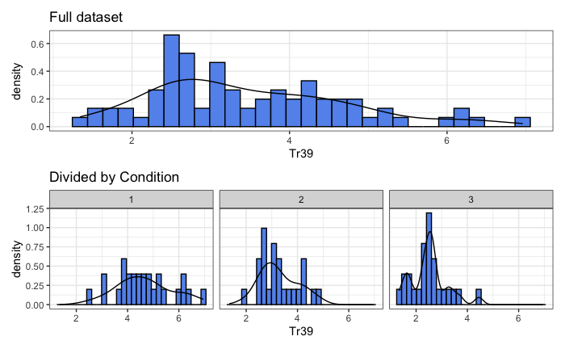
Supplemental Figure S1. Histograms of numerical outcomes. Tr39 = projected time to reach a core temperature of 39 °C; Tr40.5 = projected time to reach a core temperature of 40.5 °C; eTsk_probes = end-trial mean skin temperature; dHR = change in heart rate; WBSL_BSA = whole-body sweat rate per unit body surface area; Water = rate of water consumption; ph = blood pH, pco2 = partial pressure of carbon dioxide.

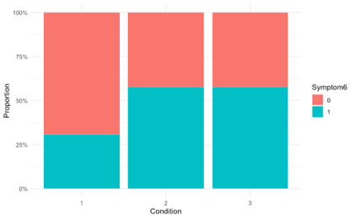
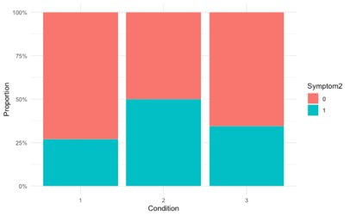
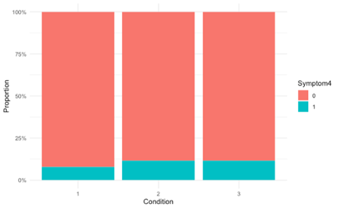
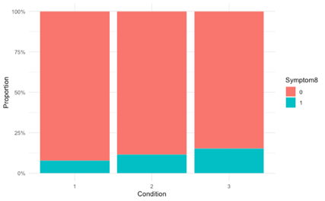
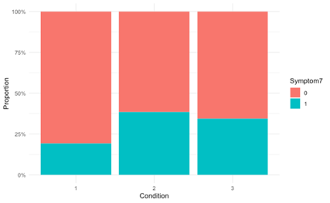
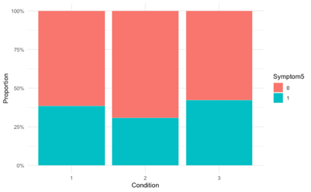
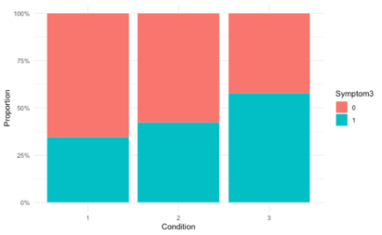
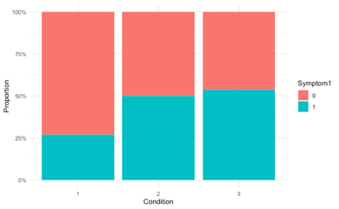
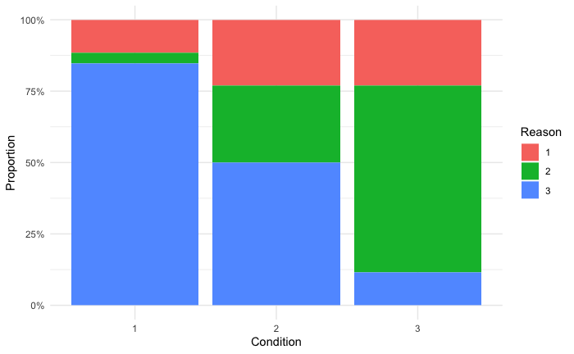
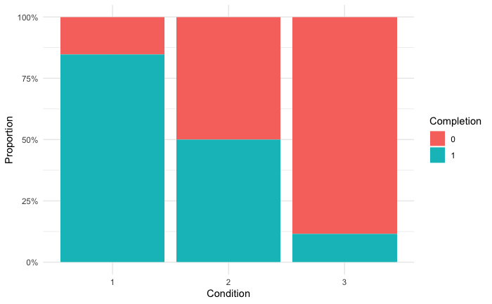
Supplemental Figure S2. Proportional stacked bar graphs of categorical outcomes. Outcome variables: Completion = trial completion status, Reason = reason for trial termination, Symptom1 = lightheadedness, dizziness, or feeling faint, Symptom2 = headache, Symptom3 = difficulty breathing, Symptom4 = stomach or muscle cramp, Symptom5 = numbness and weakness, Symptom6 = tiredness and weakness, Symptom7 = nausea, Symptom8 = blurry vision. Factor levels: Condition: 1 = 38/81, 2 = 46/46, 3 = 54/26; Reason: 1 = severe symptoms of heat distress, 2 = reached core temperature safety threshold, 3 = completed 3-hour protocol; Completion or Symptom: 0 = No, 1 = Yes.

Residual plots of statistical models

Numerical outcomes
Once final models were selected following model-fitting, residual diagnostic plots (Supplemental Figure S3) were generated to evaluate whether models satisfied the assumptions of a normal distribution and constant variances.

Residual plot. This graph plots model-predicted values on the x-axis and Pearson’s residuals on the y-axis to assess the assumptions of linearity and constant variance. For the most part, there is no discernible pattern in the way the points are scattered and there is a horizontal blue line suggesting these assumptions have been met.

Index plot. This graph plots observation number on the x-axis and Pearson’s residuals on the y-axis to determine whether any patterns that are dependent on the order of the data emerge. The points are evenly scattered and there is a horizontal blue line on all graphs suggesting that there are no other identifiable trends that need to be accounted for.

Response vs Predicted. This graph plots model-predicted values on the x-axis and trial-derived responses on the y-axis to assess model goodness-of-fit. These graphs show reasonably tight clustering of the points along the line representing the model, suggesting that the models fit the data well.

Q-Q Plot, Histogram, and Boxplot. These graphs provide a visual representation of how the residuals are distributed for the assessment of the assumption of normality. The Q-Q plots are aligned with the 45-degree line and histograms have a bell-shaped curve and no skewness or kurtosis. Although the boxplots show a handful of outliers, testing using the DHARMa package revealed that these were not statistically significant.

Categorical outcomes
Once final models were selected, residual diagnostics plots and goodness-of-fit tests were applied to assess whether the assumptions of a uniform distribution, homoscedasticity, dispersion, and zero-inflation have been met (Supplemental Figure S4).

Q-Q plot residuals. This graph plots the expected residuals on the x-axis and observed scaled residuals on the y-axis to assess the assumption that the residuals follow a uniform distribution. The Kolmogorov-Smirnov test was significant for trial completion and symptom #4 (stomach or muscle cramp) suggesting poor goodness-of-fit for these models. Otherwise, the residuals cluster tightly and align well with the 45 degree line for the remaining categorical variables, indicating that these models are correctly specified.

Within group deviation from uniformity and Levene test for homogeneity of variance. This graph plots the conditions (3 levels) on the x-axis and scaled residuals on the y-axis. The condition uniformity test assesses whether residuals are uniformly distributed within each level of the factor Condition, and the Levene test assesses the assumption of homoscedasticity. Similar to the QQ plots, there were violations of the condition uniformity test for trial completion and symptom #4. No other tests were statistically significant.

Non-parametric dispersion test. This graph plots the simulated dispersion statistic values on the x-axis and frequency (how many simulations produced each dispersion value) on the y-axis to assess whether there is over- or underdispersion in the model. This test was significant (P <0.001) for trial completion rate, indicating underdispersion as the vertical red line indicating the model’s observed dispersion has a value <1. No other variables had over- or underdispersion issues.

Zero-inflation test. This graph plots the number of zeros per simulated dataset on the x-axis and frequency (how often the zero count occurred across simulations) on the y-axis to evaluate whether there are fewer zeros predicted than observed in each of the models. This test is relevant as these categorical outcomes are binary. We observed P > 0.05 for all tests indicating that the models predict zeros appropriately.

Model diagnostics and goodness-of-fit assessments were not performed for the categorical variable ‘reason for trial termination’ as the model failed to converge in the model-fitting stage.

All research questions involving categorical outcomes were secondary; therefore, the sample size calculation was not conducted with these variables in mind and it is likely that we do not have a sufficient sample size to confidently answer these questions. Given the issues that emerged in the exploratory data analysis (inadequate counts identified by proportional stacked bar graphs) and model diagnostic and assumption testing phases (non-uniformity and underdispersion), we have opted to report these findings in-text descriptively rather than statistically. This approach was taken for all categorical variables for consistency.

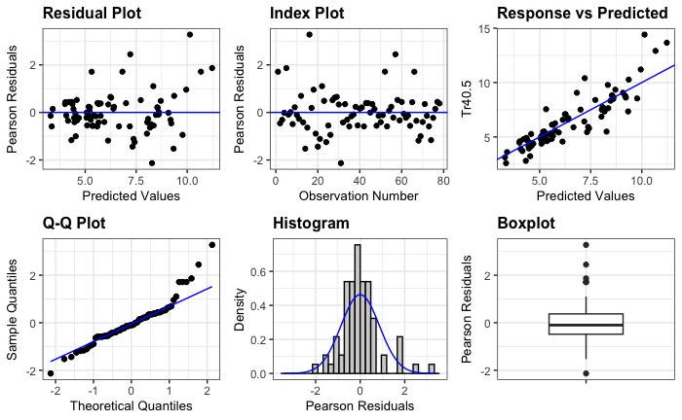
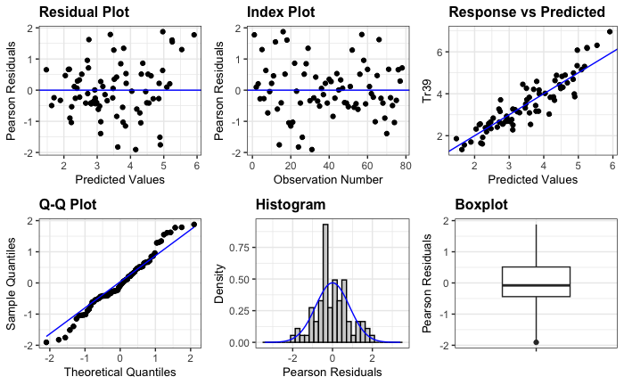
- Projected time to reach heat exhaustion (39 °C) B. Projected time to reach heat stroke (40.5 °C)

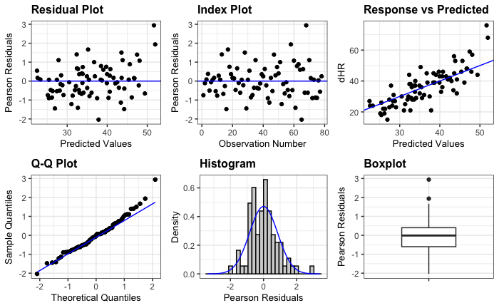
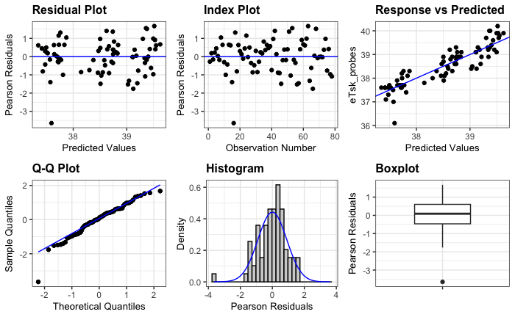
C. Mean skin temperature D. Change in heart rate

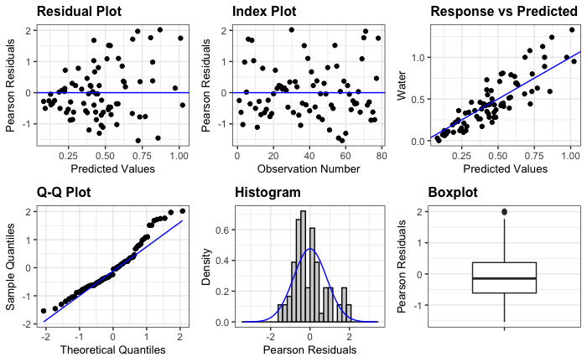
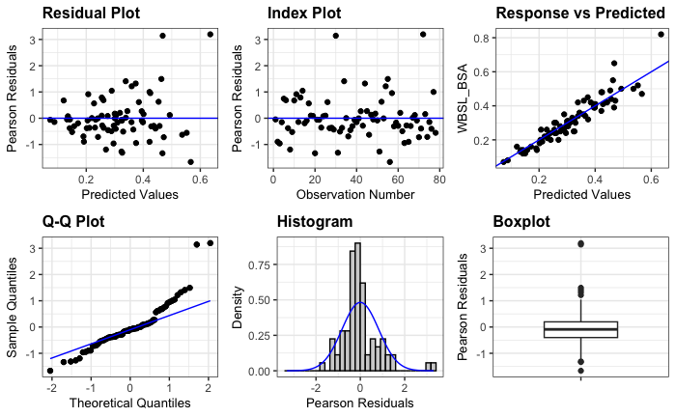
E. Whole-body sweat rate relative to body surface area F. Rate of water consumption

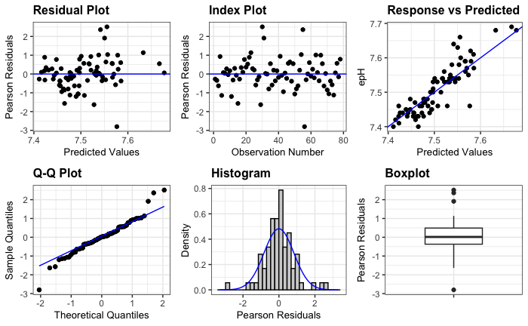
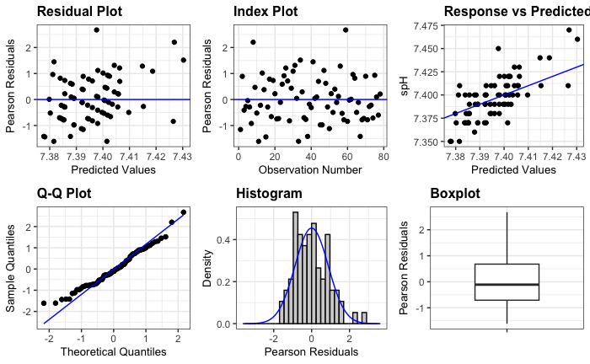
G. pH at start timepoint H. pH at end timepoint

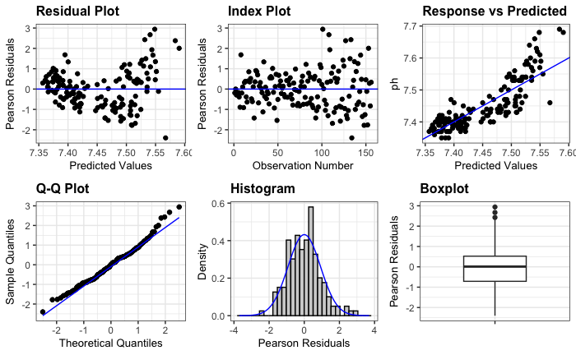
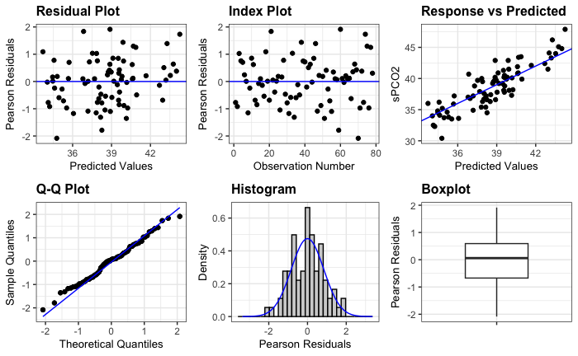
I. pH over time J. pCO₂ at start timepoint

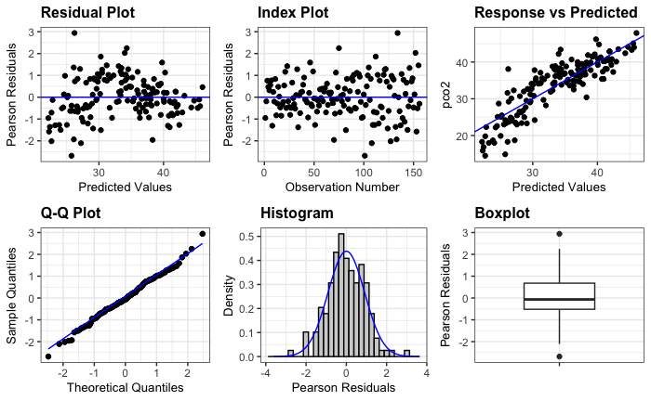
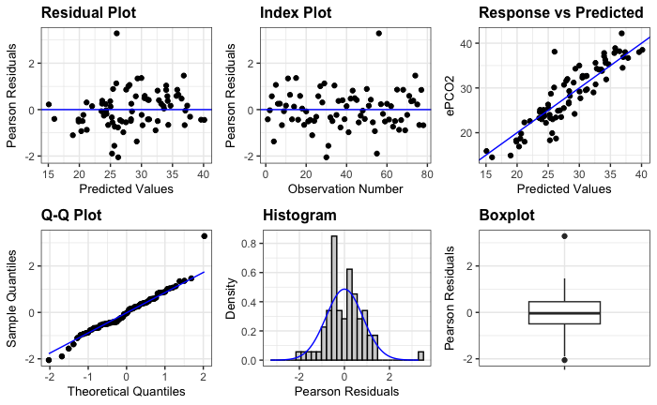
K. pCO₂ at end timepoint L. pCO₂ over time
Supplemental Figure S3. Residual plots to examine assumptions for numerical outcomes.
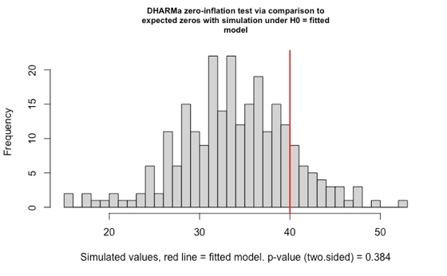
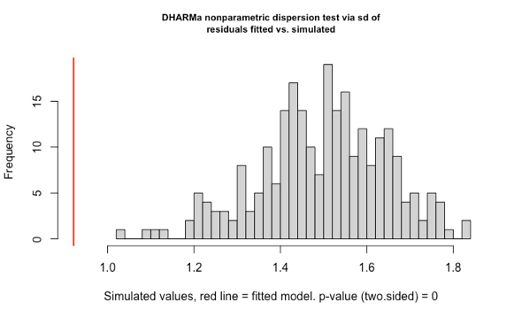
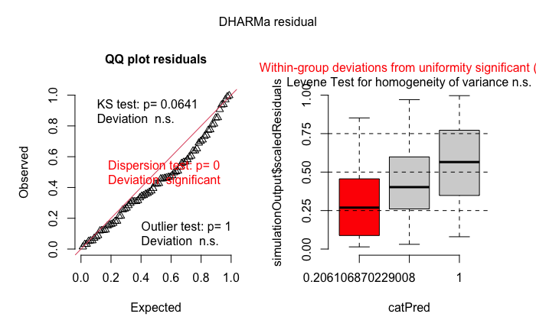
- Trial completion
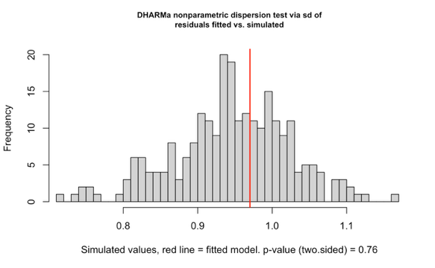
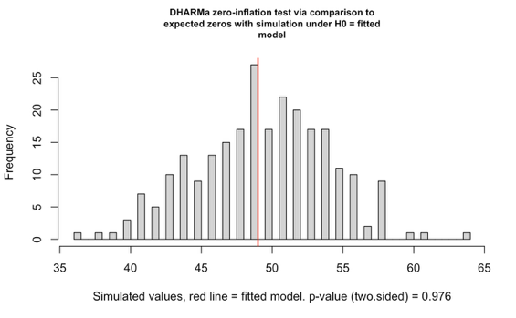
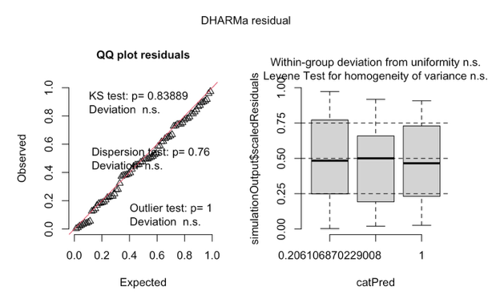
- Symptom 1 – lightheadedness, dizziness, or feeling faint
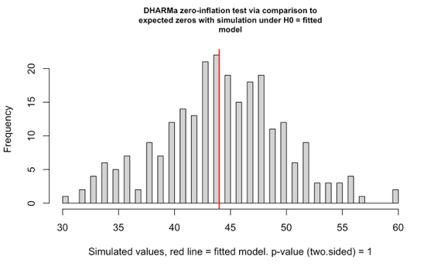
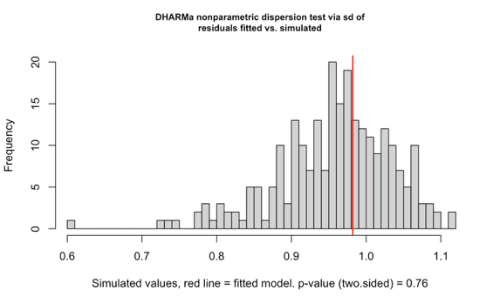
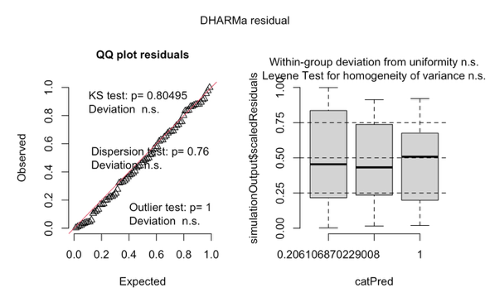
- Symptom 2 – headache

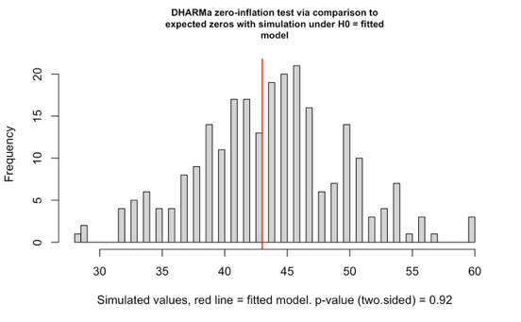
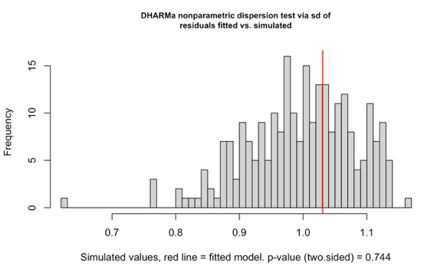
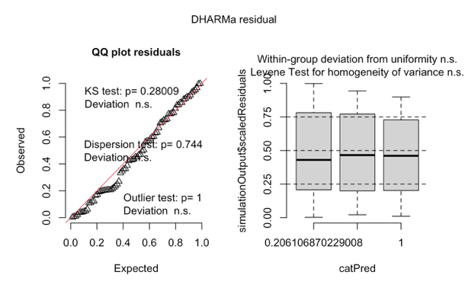
- Symptom 3 – difficulty breathing
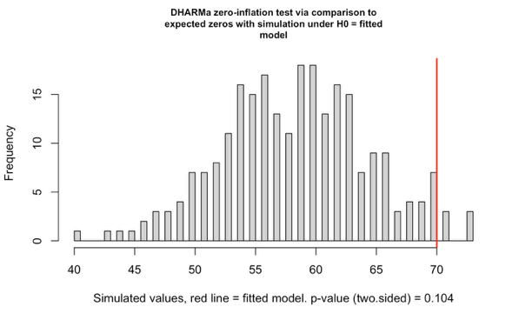
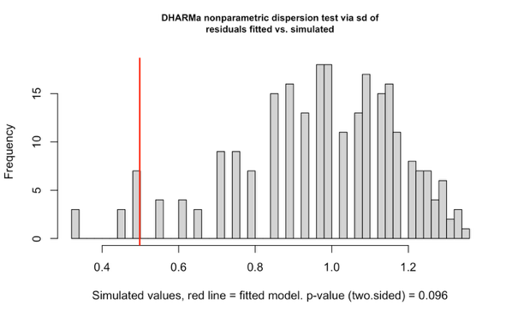
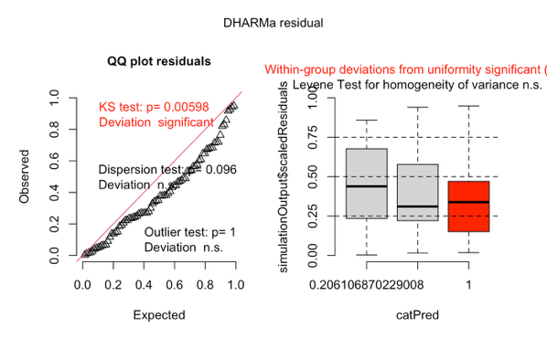
- Symptom 4 – stomach or muscle cramp
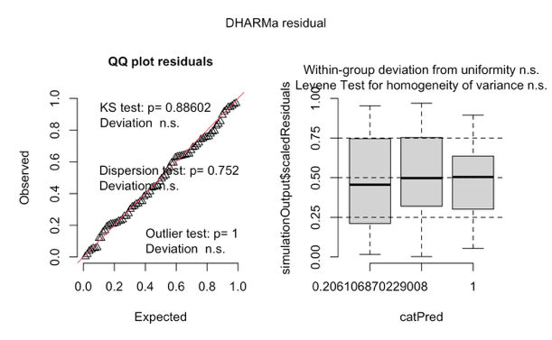
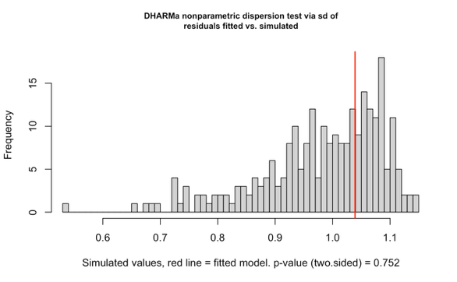
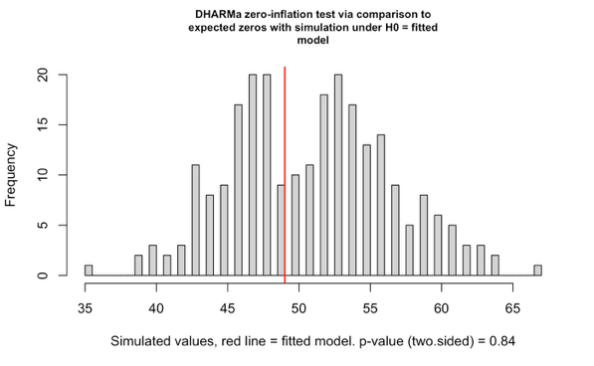
- Symptom 5 – numbness and weakness

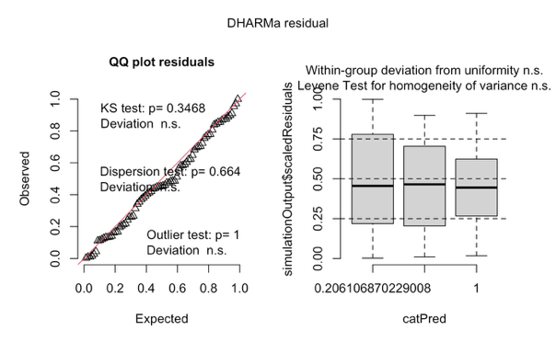
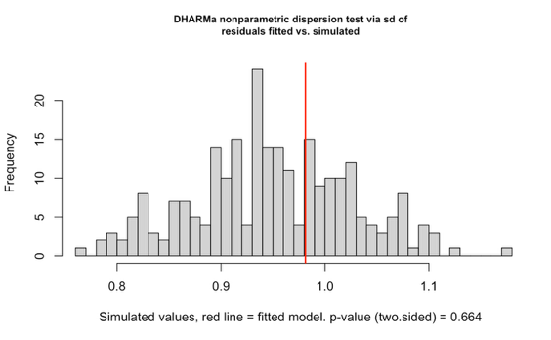
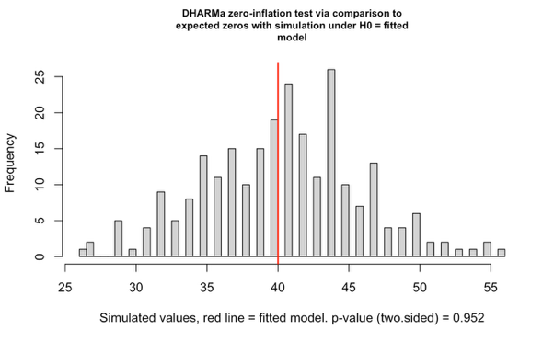
- Symptom 6 – tiredness and weakness
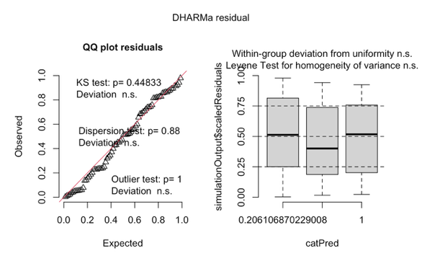
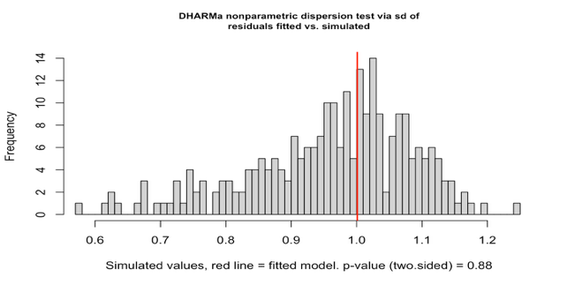
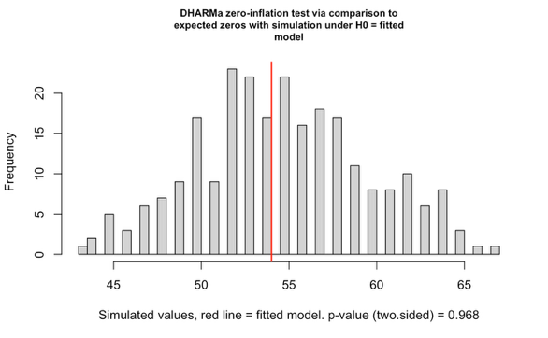
- Symptom 7 – nausea
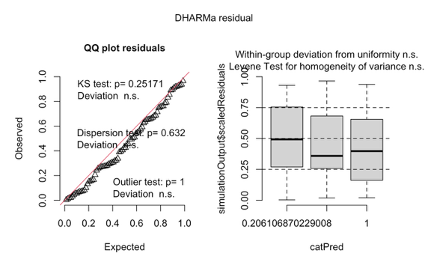
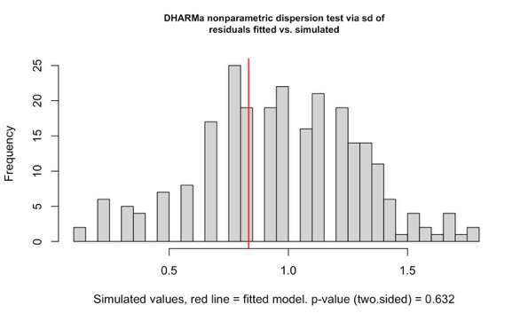
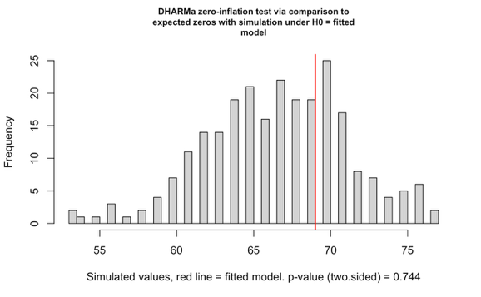
- Symptom 8 – blurry vision

Supplemental Figure S4. Residual plots to examine assumptions for categorical variables.
Supplementary Results: Sensitivity Analyses

Sensitivity analyses fitting the design variables “Trial order” (4 levels) and “Previous trial” (4 levels) into final models were conducted to examine any potential order or carryover effects.

Supplemental Table S2. Main effects of sensitivity analyses on numerical outcomes.
 | Main effect of design variables on outcomes (P values)
Outcome Variable | Trial order | Previous trial (Carryover)
Projected time to reach heat exhaustion (39.0 °C) (hrs) | 0.147 | 0.003
Projected time to reach heat stroke (40.5 °C) (hrs) | 0.534 | 0.032
End-trial mean skin temperature (°C) | 0.096 | 0.012
Change in heart rate (bpm) | 0.836 | 0.887
Whole-body sweat rate relative to body surface area (L/h/m²) | 0.511 | 0.053
Rate of water consumption (L/h) | 0.005 | 0.179
pH at start timepoint | 0.138 | 0.097
pH at end timepoint | 0.638 | 0.694
pH over time | 0.687 | 0.754
pCO₂ at start timepoint (mmHg) | 0.282 | 0.103
pCO₂ at end timepoint (mmHg) | 0.118 | 0.488
pCO₂ over time (mmHg) | 0.452 | 0.493

There were significant carryover effects for the projected times to reach critical core temperatures and end-trial mean skin temperature and a significant order effect for the rate of water consumption (Supplementary Table S2). Pairwise comparisons were conducted and findings were compared to the final models to determine whether the interpretation of the results is impacted (Supplemental Table S3). The evidence shows that despite variations based on carryover and trial order, parameter estimates were only marginally different. Moreover, the directionality of the estimates and significance of the pairwise comparisons remained the same.

Supplemental Table S3. Pairwise comparisons from final model vs. fitted with design variables found to have a significant main effect.
Outcome | Contrast | Estimate ± SE | P value | Estimate ± SE | P value | Absolute difference between estimates | Relative difference between estimates (%)
 |  | Final model* |  | Final model + Previous trial (Carryover)**
Tr39 (hrs) | 38/81 vs. 46/46 | 1.38 ± 0.16 | <0.001 | 1.51 ± 0.18 | <0.001 | -0.13 | 9.4
 | 38/81 vs. 54/26 | 2.15 ± 0.16 | <0.001 | 2.33 ± 0.17 | <0.001 | -0.18 | 8.4
 | 46/46 vs. 54/26 | 0.76 ± 0.16 | <0.001 | 0.82 ± 0.16 | <0.001 | -0.06 | 7.9
Tr40.5 (hrs) | 38/81 vs. 46/46 | 2.95 ± 0.36 | <0.001 | 3.25 ± 0.41 | <0.001 | -0.30 | 10.2
 | 38/81 vs. 54/26 | 4.02 ± 0.36 | <0.001 | 4.46 ± 0.39 | <0.001 | -0.44 | 10.9
 | 46/46 vs. 54/26 | 1.07 ± 0.36 | 0.013 | 1.22 ± 0.38 | 0.007 | -0.15 | 14.0
Mean T_{sk} (°C) | 38/81 vs. 46/46 | -1.03 ± 0.12 | <0.001 | -0.99 ± 0.13 | <0.001 | -0.04 | 3.9
 | 38/81 vs. 54/26 | -1.85 ± 0.15 | <0.001 | -1.79 ± 0.13 | <0.001 | -0.06 | 3.2
 | 46/46 vs. 54/26 | -0.82 ± 0.13 | <0.001 | -0.80 ± 0.12 | <0.001 | -0.02 | 2.4
 |  | Final model* |  | Final model + Trial order***
Water (L/h) | 38/81 vs. 46/46 | -0.05 ± 0.05 | 0.590 | 0.00 ± 0.05 | 0.998 | 0.05 | -1.0
 | 38/81 vs. 54/26 | -0.04 ± 0.05 | 0.753 | 0.02 ± 0.05 | 0.877 | 0.06 | -1.5
 | 46/46 vs. 54/26 | 0.01 ± 0.05 | 0.962 | 0.02 ± 0.05 | 0.891 | -0.01 | -1.0
Mean differences ± standard error (SE) for each combination of conditions. Absolute and relative differences of adjusted estimates compared to the final model are presented.
Tr39 = projected time to reach a core temperature of 39.0 °C, Tr40.5 = projected time to reach a core temperature of 40.5 °C, Mean T_{sk} = end-trial mean skin temperature, Water = rate of water consumption.
*Final model = outcome ~ Condition + Sex + (1|Participant_ID)
**Final model + Previous trial (Carryover) = outcome ~ Condition + Sex + Previous_trial + (1|Participant_ID)
***Final model + Trial order = outcome ~ Condition + Sex + Trial_order + (1|Participant_ID)



EVALUATING THE HUMAN PHYSIOLOGICAL HEAT STRAIN RESPONSES TO ENVIRONMENTAL CONDITIONS EQUIVALENT TO 35 °C WET-BULB TEMPERATURE

Statistical Analysis Plan
Version 1.0
March 5, 2025

Authors:
Jem L. Cheng
Jake A. McCahon
Lee Y. Jin
Jennifer Vanos
Ollie Jay

Study identifiers:
University of Sydney Human Research Ethics Committee: 2023-HE000884
Australia New Zealand Clinical Trials Registry: ACTRN12624000258550

Document Version History
Date | Version | Author | Signature | Change Description | Comment
05-Mar-2025 | 1 | Jem Cheng |  | Initial release | N/A

TABLE OF CONTENTS
List of abbreviations
- Study objectives
  - Primary objective
  - Secondary objectives
  - Tertiary objectives
- Background and introduction
- Study design
- Study population
- Sample size
- Study procedure
- Outcome variables
- Primary outcomes
- Secondary outcomes
- Tertiary outcomes
- Demographic variables
- Explanatory variables
- Statistical methodology
- Descriptive statistics
- Analyses
Primary outcomes
    - Secondary outcomes – numerical
    - Secondary outcomes – categorical
    - Tertiary outcomes
    - Sensitivity analyses
- Software

List of abbreviations
HR | Heart rate
MAP | Mean arterial pressure
pO₂ | Partial pressure of oxygen
pCO₂ | Partial pressure of carbon dioxide
PV | Plasma volume
RPP | Rate pressure product
T_{rec} | Core (rectal) temperature
T_{skin} | Skin temperature
VO₂peak | Cardiorespiratory fitness
WBSL | Whole-body sweat loss
38/81 | 38 °C and 81.1% relative humidity
46/46 | 46 °C and 45.8% relative humidity
54/26 | 54 °C and 26.2% relative humidity
54/13 | 54 °C and 13.1% relative humidity

- Study objectives
  - Primary objective
    - To determine whether projected exposure times to reach critical core temperatures (39.0 °C = heat exhaustion and 40.5 °C = heat stroke) are different across conditions (38/81,46/46, 54/26) and/or between sexes (males vs. females)

  - Secondary objectives
To compare the following outcome variables across conditions and between sexes:
    - Change in heart rate
    - Rates of whole-body sweat loss relative to body surface area
    - Rates of water consumption
    - Blood pH, pO₂, pCO₂ between the start and end of each trial
    - End-trial mean T_{skin}
To compare the following outcome variables across conditions:
    - Prevalence of heat stress symptoms
    - Trial duration and completion rates
    - Reasons for trial termination

  - Tertiary objectives
    - To quantify the magnitude of heat adaptation by comparing the changes in resting T_{rec}, resting HR, WBSL, work output, and plasma volume pre-post heat acclimation protocol

- Background and introduction
  - Study design
Using a within-subjects design, participants underwent four extreme environmental conditions following 7 days of exercise heat acclimation to determine the limits of heat tolerance with participants in the optimal, heat-adapted state, as will be the case in future climate change scenarios.
Prior to completing any part of the study, interested individuals attended a consent and information session on Zoom to go over the study protocols and have any questions answered. If willing to continue, participants signed the consent form before completing a General Health Screening Questionnaire and Physical Activity Readiness Questionnaire, both of which were used to confirm participants’ eligibility.
Following this session, participants attended the laboratory for a familiarization visit in which they underwent a step-wise VO₂peak test to exhaustion for the assessment of baseline cardiorespiratory fitness. This occurred no more than two weeks prior to the main study protocol. Exercise heat acclimation then took place in the climate chamber set to 40 °C and 50% RH (wet-bulb temperature (T_{wet}) = 30.89 °C) for 7 consecutive days using the controlled hyperthermia method. The subsequent experimental trials involved exposure to the following conditions for a maximum of 3 hours, in a randomized order spaced exactly 48 hours apart: (1) 38 °C, 81.1% relative humidity (RH) (38/81; T_{wet} = 35.00 °C), (2) 46 °C, 45.8% RH (46/46; T_{wet} = 35.00 °C), (3) 54 °C, 26.2% RH (54/26; T_{wet} = 34.99 °C), and (4) 54 °C, 13.1% RH (54/13; T_{wet} = 28.54 °C). The fourth condition is included here for completeness, but was not involved in any of the research questions for this manuscript. For each trial, participants remained seated in the chamber until a critical T_{rec} of 39.0 °C or any other termination criterion was reached.

All experimental trials took place in the Thermal Ergonomics Laboratory on Level 9 of the Susan Wakil Health Building at the University of Sydney Camperdown Campus.

  - Study population
Participants were young, healthy adults residing in Sydney, Australia.
Inclusion criteria:
- 18-40 years old
- Generally healthy
- Able to read and understand English to provide informed written consent to participate in the study
Exclusion criteria:
- Those with contraindications to the use of a rectal thermistor (e.g., haemorrhoids, heterotopic ossification, rectal bleeding or bleeding disorders, fissures or active infections, anticoagulant therapy, colitis)
- Smokers
- Pregnancy
- Currently diagnosed or have a history of hypertension, cardiovascular, respiratory, and/or metabolic disorders
- Medication use associated with any of the aforementioned conditions

  - Sample size
Sample size was determined a priori based on expected differences across conditions and the minimally clinically important difference between sexes in the rates of core temperature change in response to the exposures. Using a simulation-based R package, we entered the following information: (1) anticipated rates of change (°C/h) of 0.49 and 0.57 for 38/81, 0.67 and 0.75 for 46/46, and 0.86 and 0.93 for 54/26 and 54/13 in males and females, respectively; (2) a common standard deviation of 0.05 °C/h based on typical measurement error; (3) ɑ level set at 0.05; and (4) N = 12 per group. These parameters yielded >80% power to detect differences between all relevant comparisons.

  - Study procedure
Heat Acclimation
Heat acclimation was induced in a climate chamber set to 40 °C and 50% RH (T_{wet} = 30.89 °C) using the controlled hyperthermia method. Participants were able to view their rectal temperature live throughout each session, and they were asked to aim to reach a T_{rec} = 38.5 °C in 30 minutes and then to maintain this temperature at or above target for a further 60 minutes. Each acclimation session therefore totaled 90 minutes. HR, T_{rec}, WBSL, and work output was recorded at each session and a blood draw was performed before and after the heat acclimation protocol for the determination of plasma volume to quantify the magnitude of heat adaptation.

Experimental Trials
Upon arrival to the laboratory, the participant confirmed whether they have adhered to the alcohol, caffeine, and exercise restrictions, and provided a urine sample to assess hydration status via urine specific gravity. Participants were then instrumented prior to beginning 15 minutes of seated rest in a thermoneutral environment (24 °C). During this time, participants wore standardized minimal clothing to ensure they felt thermally comfortable during this phase. Afterwards, the participant was led into the climate chamber set to one of the four exposure conditions where they remained seated for the rest of the trial. To maintain adequate hydration, participants were allowed to drink room temperature water ad libitum, and the volume ingested was recorded for the calculation of WBSL. T_{rec}, HR, and T_{skin} were assessed continuously throughout each trial. Blood pressure was taken every 10 minutes, symptoms were captured every 20 minutes, and a blood sample (for quantification of blood gases) was taken every 60 minutes.
The trial was terminated if any of the following criteria were met: (i) participant reached a Trec ≥ 39 °C, (ii) HR > 80% HR_{max} or < 50 bpm, (iii) SBP > 200 mmHg or < 90 mmHg, (iv) exposure time reached 3 hours, (v) participant showed any signs or reported symptoms of distress (e.g., breathlessness, nausea, cramping, light-headedness, dizziness, feeling faint) that progressively worsened over 3 x 5-minute periods from when they were initially observed or recorded, (vi) participant showed any signs or reported any symptoms of heat illness (e.g., pale, dry skin, headache, weakness, cramps) that progressively worsened over 3 x 5-minute periods from they wre initially observed or recorded, or (vii) volitional termination for any reason.

Table 1. Trial timeline
 |  |  | Heat acclimation |  |  |  |  |  |  | Exposures
Day of study | - | -14* | 1 | 2 | 3 | 4 | 5 | 6 | 7 | 8 | 9 | 10 | 11
Study visits | S | F | 1 | 2 | 3 | 4 | 5 | 6 | 7 | 1 | 2 | 3 | 4
RECRUITMENT & SCREENING
Consent | X
PARQ+ | X
GHSQ | X
ASSESSMENTS
VO₂peak |  | X
T_{rec} |  |  | X | X | X | X | X | X | X | X | X | X | X
HR |  | X | X | X | X | X | X | X | X | X | X | X | X
BP |  |  |  |  |  |  |  |  |  | X | X | X | X
WBSL |  |  | X | X | X | X | X | X | X | X | X | X | X
Mean T_{skin} |  |  |  |  |  |  |  |  |  | X | X | X | X
Blood sample |  |  | X |  |  |  |  |  |  | X | X | X | X
Modified ESQ |  |  |  |  |  |  |  |  |  | X | X | X | X
Work output |  |  | X | X | X | X | X | X | X
Abbreviations: S = Screening, F = Familiarization, PARQ+ = Physical Activity Readiness Questionnaire, GHSQ = General Health Screening Questionnaire, T_{rec} = rectal temperature, HR = heart rate, BP = blood pressure, WBSL = whole-body sweat loss, T_{skin} = skin temperature, ESQ = Environmental Symptoms Questionnaire. *The familiarization visit must have taken place a minimum of 48h and a maximum of 2 weeks prior to completing the study protocol.

- Outcome variables
  - Primary outcomes
 | Outcome | Method
1 | Projected exposure time to heat exhaustion (T_{rec} = 39.0 °C) (hours) | - Calculated the slope of the line for the final 60 minutes of T_{rec} data  - Calculated the difference between target critical core temperature and final achieved core temperature  - Divided the delta difference by the T_{rec} rate of change to yield time in minutes  - Added this duration to the trial duration to yield a total projected exposure time in minutes  - Divided by 60 to convert this final value to hours
2 | Projected exposure time to heat stroke (T_{rec} = 40.5 °C) (hours)

  - Secondary outcomes
 | Outcome | Method | Timepoint  (for analysis) | Timepoint (resolution)
Numerical variables
1 | Change in heart rate (bpm) | Calculated as the preceding 5-minute average | Baseline, end-trial | Every 1 minute
2 | Rate of whole-body sweat loss relative to body surface area (L/h/m²) | - Calculated the difference between pre- and post-trial (after towelling) nude body mass measured in triplicate  - Added the total volume of water consumed throughout the trial  - Subtracted any urine produced throughout the trial  - Divided this value by body surface area calculated using the DuBois & DuBois equation | N/A | N/A
3 | Rate of water consumption (L/h) | Calculated as the total volume of water consumed divided by trial duration | N/A | N/A
4 | Blood pH and gases  - pH  - pO₂ (mmHg)  - pCO₂ (mmHg) | Values extracted from iSTAT output | Baseline, end-trial | Every 60 minutes
5 | End-trial mean skin temperature | Calculated as the preceding 5-minute average | End-trial | Every 1 minute
6 | Trial duration | Duration of exposure based on presence of T_{rec} data | N/A | N/A
Categorical variables
7 | Symptom prevalence | Defined as 0 = No or 1 = Yes based on whether the participant reported having the symptom at any point during the trial. Each of the eight symptoms was its own variable. | N/A | Every 20 minutes
8 | Trial completion | Defined as 0 = No or 1 = Yes based on whether the participant completed each trial (180 minutes) | N/A | N/A
9 | Reason for trial termination | Defined as 1 = severe symptoms, 2 = core temperature ≥ 39.0 °C, or 3 = trial duration of 180 minutes based on the reason the trial is stopped | N/A | N/A

  - Tertiary outcomes
 | Outcome | Method | Timepoint  (for analysis) | Timepoint (resolution)
1 | Magnitude of heat adaptation  - Resting T_{rec}  - Resting HR  - Work output  - WBSL  - Plasma volume (PV) | Comparison between first and last heat acclimation session (i.e., work output, WBSL) OR first heat acclimation session and first exposure trial (i.e., resting T_{rec}, resting HR, plasma volume) | T_{rec}, HR, PV: day 1 heat acclimation vs. day 1 exposure trial  Work output and WBSL: day 1 vs. 7 heat acclimation | T_{rec} and HR: Every 1 minute  Work output and WBSL: Every session  PV: Pre- and post-acclimation

  - Demographic variables
 | Outcome | Units/Notes
1 | Sex | Male or female
2 | Age | Years
3 | Body mass index | kg/m²
4 | Cardiorespiratory fitness | Relative - ml/kg/min
5 | Average menstrual cycle length | For females only – days
6 | Contraception status | For females only – naturally cycling, oral contraceptive pill, intrauterine device, vaginal ring, contraceptive patch, hormonal implant
7 | Phase of cycle at protocol start | For females only – early follicular, late follicular, early luteal, late luteal

  - Explanatory variables
 | Outcome | Units/Notes
1 | Trial duration | Covariate included for time-dependent outcome variables  Numerical
2 | Trial order | Covariate included for assessment of potential order effects  Categorical: 1 = first, 2 = second, 3 = third, 4 = fourth
3 | Previous trial | Covariate included assessment of potential carryover effects  Categorical: 1 = 38/81, 2 = 46/46, 3 = 54/26, 4 = 54/13

- Statistical methodology
  - Descriptive statistics
Demographic data will be presented as mean ± standard deviation while experimental data will be presented as mean with 95% confidence intervals for continuous, normally distributed data. Frequencies and percentages will be used to describe categorical data.

  - Analyses
4.2.1. Primary outcomes
To analyse the primary outcomes, a linear mixed-effects model will be fitted with Condition (three levels: 38/81, 46/46, 54/26) and Sex (two levels: males, females) as fixed effects and Participant ID as a random intercept to account for the within-subject dependence of the data. A Condition*Sex interaction term will only be included if it explains further variance in the model. Model diagnostics and goodness-of-fit will be assessed by examining residual plots. Significant main effects or interactions will be probed further by performing pairwise comparisons and applying the Tukey’s honest significant difference post-hoc to control for family-wise error rate.

Survival analyses will also be performed by generating Kaplan-Meier curves and comparing them across conditions using a Logrank test.

4.2.2. Secondary outcomes – numerical
To analyse the secondary numerical outcomes, the same linear mixed-effects model as described above will be fitted. Additionally, trial duration will be included as a term for the change in heart rate, end-trial mean skin temperature, blood pH, pCO₂ and pO₂ to account for variable exposure times across conditions. Survival analyses will be performed for the outcome variable trial duration.

4.2.3. Secondary outcomes – categorical
To analyse the secondary categorical outcomes, generalized linear mixed models will be fitted for binary outcomes (i.e., trial completion and symptom prevalence) and a multinomial logistic regression will be fitted for the multinomial outcome reasons for trial termination. All models will include Condition as a fixed effect (three levels: 38/81, 46/46, 54/26) and Participant ID as a random intercept to model the within-subject dependence of the data. Model diagnostics and goodness-of-fit will be assessed by examining residual plots.

4.2.4. Tertiary outcomes
To analyse the tertiary outcomes, a paired Student’s t-test will be conducted to compare the outcome variables pre- to post-heat acclimation protocol.

4.2.5. Sensitivity analyses
To ensure the robustness of the models for the numerical outcomes, a series of sensitivity analyses will be conducted. Trial order (four levels: first, second, third, fourth) will be fitted to final models to account for any potential order effects and Previous trial (five levels: none, 38/81, 46/46, 54/26, 54/13) will be fitted to final models to account for any potential carryover effects.

  - Software
All analyses will be conducted using R and RStudio. All tests will be two-sided and the acceptable significance level will be set to p < 0.05.

