Supporting Information
Synergistic effect between rare-earth and copper species enhances hydrothermal stability of Cu-SSZ-13 for NO abatement
Liu Yang ^{a, 1}, Yuanjiang Wang ^{a, 1}, Tiantian Zhang ª, Hao Qu ª, Xin Guo ª, Cheng Zhang ª, Yan Wang ^{a,} *, Mi Yan ^{a, d}, and Pengfei Xie^{a, b, c}*

ª State Key Laboratory of Baiyunobo Rare Earth Resource Researches and Comprehensive Utilization, Baotou Research Institute of Rare Earths, Baotou 014030, China
^{b} Key Laboratory of Biomass Chemical Engineering of Ministry of Education, College of Chemical and Biological Engineering, Zhejiang University, Hangzhou 310058, China
^{c} Institute of Zhejiang University-Quzhou, Quzhou 324000, China
^{d} Zhejiang Province Key Laboratory of Advanced Information Materials, School of Materials Science and Engineering, Zhejiang University, Hangzhou 310058, China
¹ Liu Yang and Yuanjiang Wang contributed equally to this work.
* Corresponding Authors Email: pfxie@zju.edu.cn; wy_brire@brire.com.

Text S1. Catalyst Characterization
X-ray Fluorescence Spectrometer (XRF) was employed to analyze the contents of Si and Al in the samples, utilizing a Shimadzu EDX-7000 instrument. ICP (Inductive Coupled Plasma Emission Spectrometer) was used to analyze other elements content used Agilent 725ES & Agilent 5110 instrument. X-ray powder diffraction (XRD) tests were collected on a Rigaku SmartLab SE diffractometer with Cu Kα radiation at a scanning range from 5 to 55º. X-ray photoelectron spectroscopy (XPS) was performed on a Thermo ESCALAB 250XI spectrometer using Al Kα X-ray radiation. The binding energies of C 1s (284.6 eV) were corrected all XPS spectrum. Electron paramagnetic resonance (EPR) spectroscopy was performed using a Bruker A300 instrument to analyze Cu²⁺ species at -150 ℃ and room temperature.
Temperature programmed reduction of hydrogen (H₂-TPR) and Temperature programmed desorption of ammonia (NH₃-TPD) tests were conducted on a Antom Paar Chem 3000 instrument. For H₂-TPR test, 100mg of 60 ~ 100 mesh catalyst was pretreated under pure helium (He) at 300 ℃ for 1 h and then cooled down to 30 ℃, which was heated to 900 ℃ at 10 ℃ min⁻¹ in a 5% H₂/Ar at a flow rate of 100 ml/min. For NH₃-TPD teat, 50 mg catalyst was pretreated by nitrogen for 1 h at 400 ℃. Then, the sample was adsorbed by 6000 ppm NH₃/He at 100 ℃ for 150 min and purged by N₂ for 40 min. Desorption signal was collected from 150 to 900 ℃ at a heating rate of 10 ℃/min. Luo^{[1]} indicate that each ZCu(OH)⁺ site can adsorb 1 NH₃ molecule, while each Z₂Cu site can adsorb up to 2 NH₃ molecules.
The diffuse reflectance infrared Fourier transform spectroscopy (DRIFTS) experiments were implemented on a Fourier transform infrared spectrometer (FTIR, Nicolet iS50) with the MCT/A detector. For the NH₃ adsorption, the catalyst was pretreated at 450 ℃ in 20% O₂/N₂ for 60 min and subsequently cooled to 50 ℃. After the background spectra were collected under pure N₂, 500 ppm of NH₃ in N₂ was introduced. In the transient studies, each catalyst was first at 450 ℃ for 60 min with 100 mL/min N₂ and then cooled to 170 ℃ to collect the background spectra. Subsequently, 500 ppm NH₃/N₂ was introduced 60 min and then the gas was switched to 500 ppm NO + 5 vol% O₂, in order to collect the changes of the pre-adsorbed NH₃ species. By altering the sequence of gas introduction, the spectrum corresponding to the process where NO & O₂ are first adsorbed, followed by the introduction of NH₃ for the reaction, was obtained.

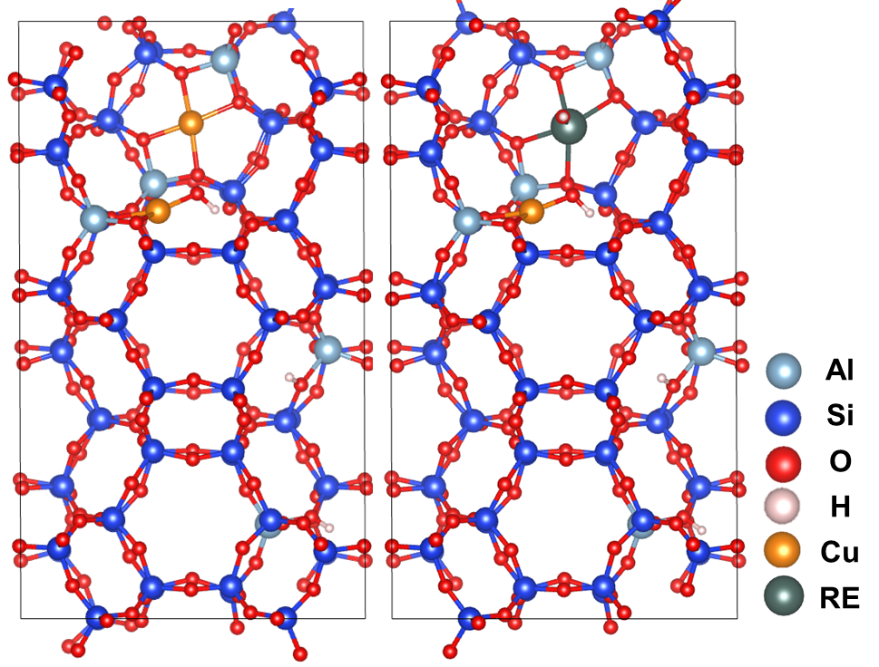

Fig. S1. Structural schematics of various RECuSSZ-13 catalysts.

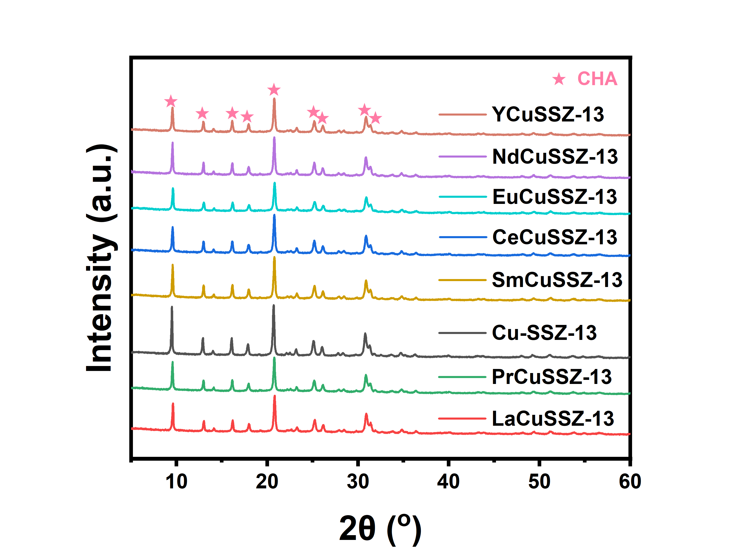

Fig. S2. XRD patterns of Cu-SSZ-13 and RECuSSZ-13 catalysts.

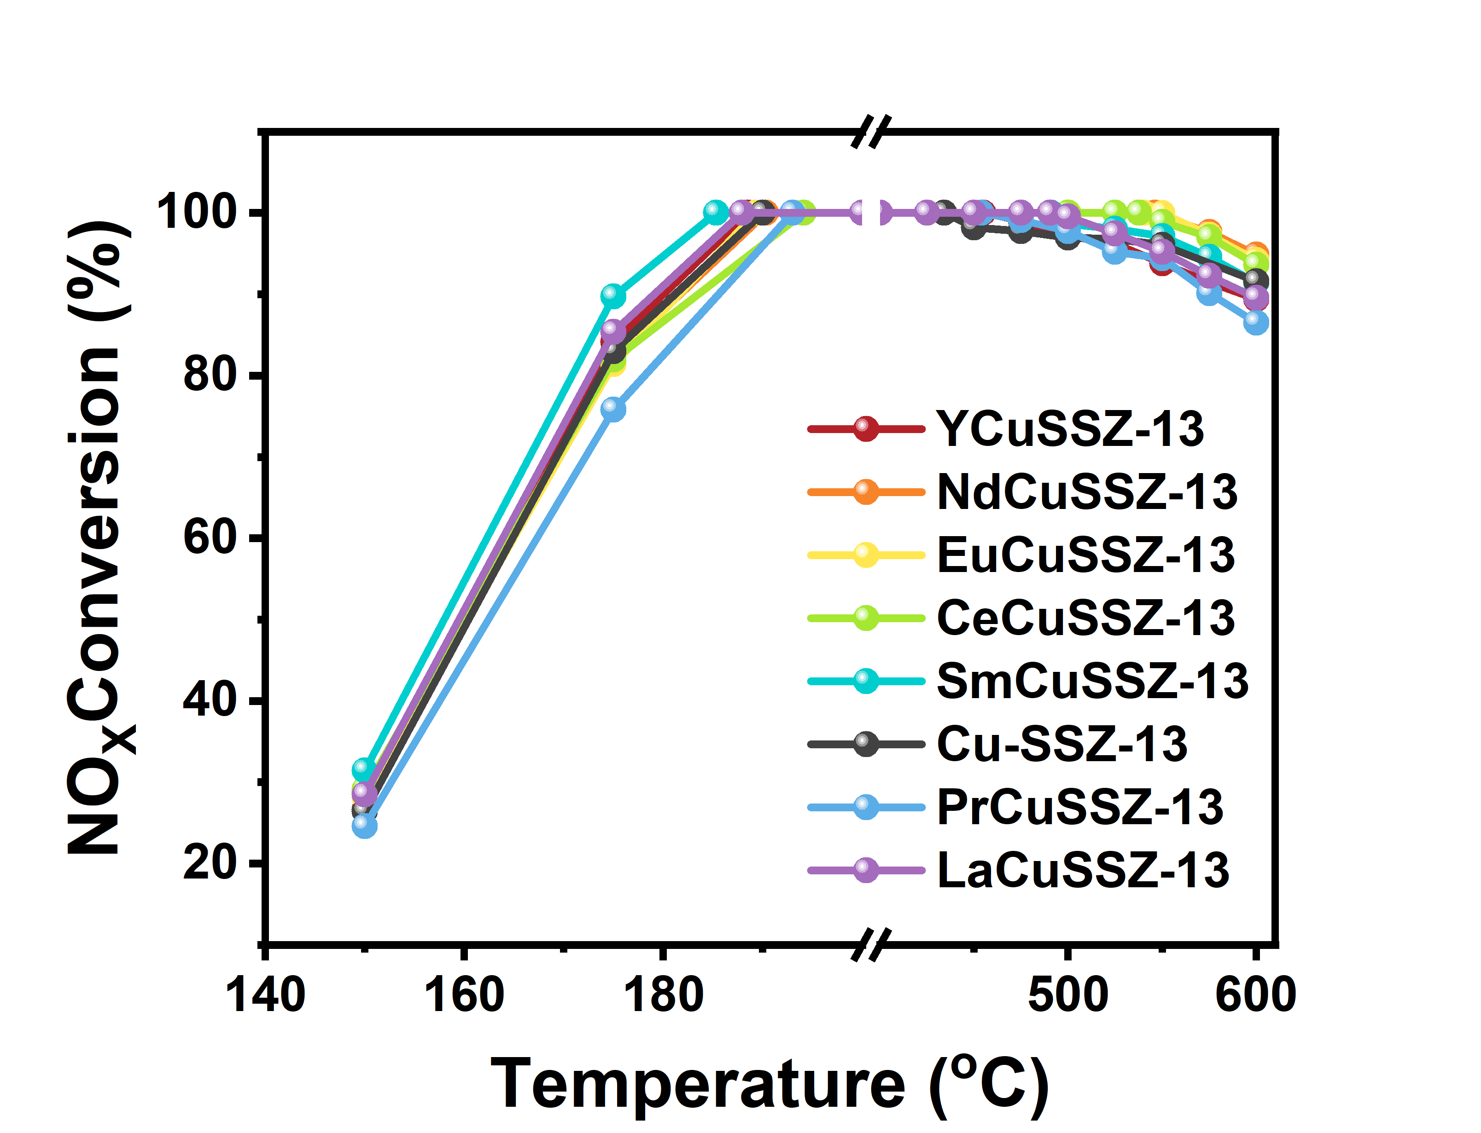

Fig. S3. NO_{x} conversion of Cu-SSZ-13 and RECuSSZ-13 samples.

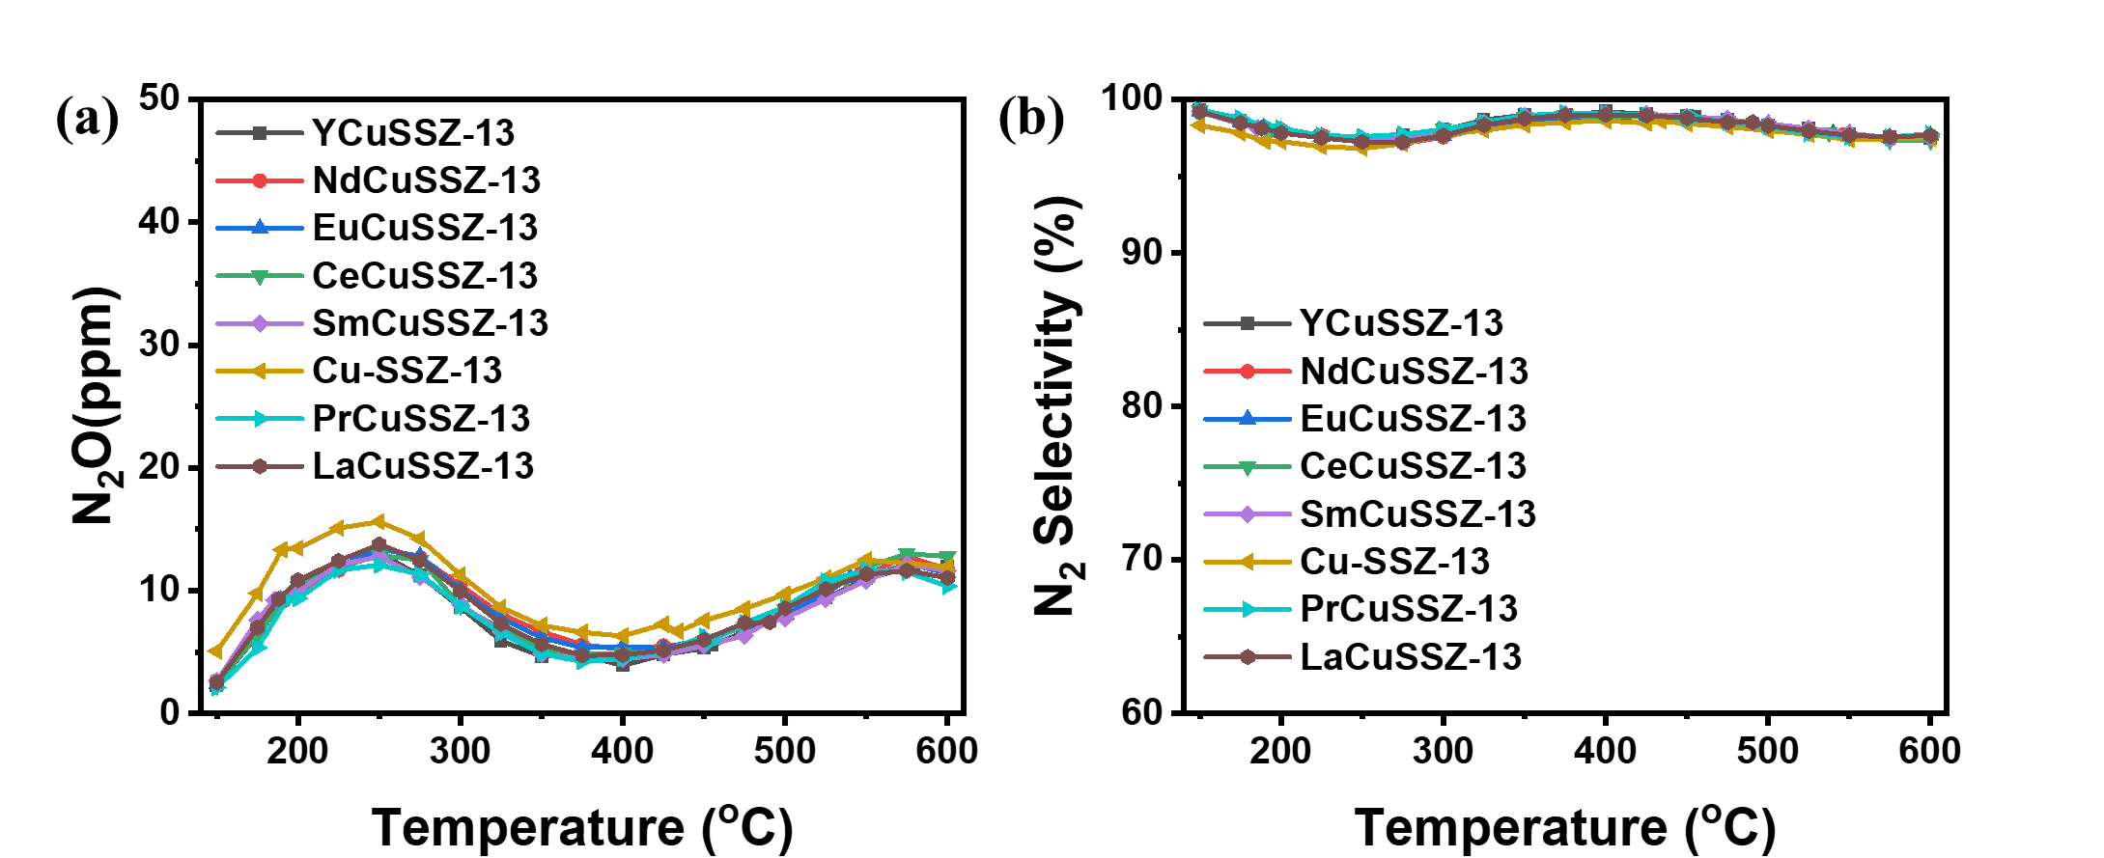

Fig. S4. (a) N₂O formation and (b) N₂ selectivity of Cu-SSZ-13 and RECuSSZ-13 catalysts. Reaction conditions: 500 ppm NO, 500 ppm NH₃, 10% O₂, and 5% H₂O, balance N₂; GHSV = 100000 h⁻¹.

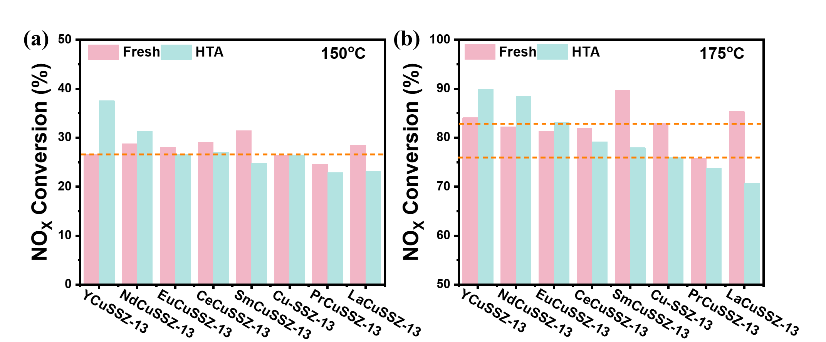

Fig. S5. NO_{x} conversions at 150 ℃ (a) and 175 ℃ (b) over Cu-SSZ-13 and RECuSSZ-13 samples before and after high-temperature hydrothermal ageing.

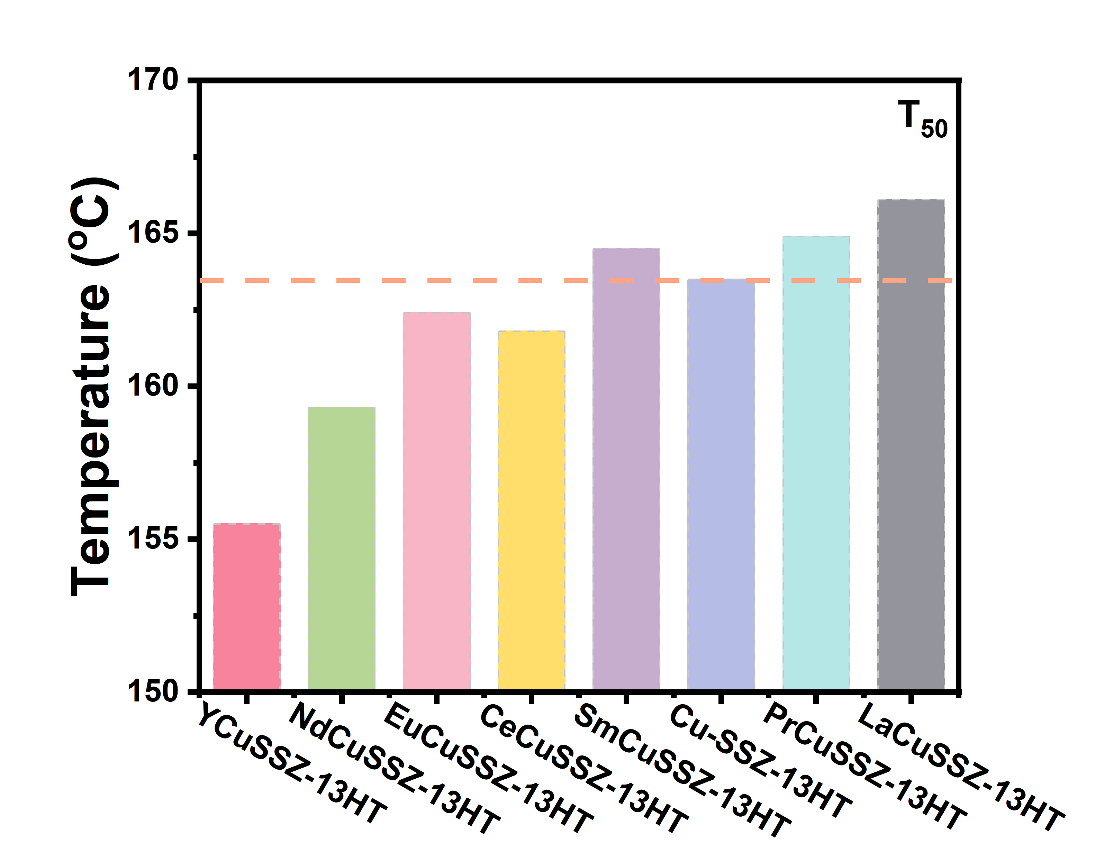

Fig. S6. Comparison of the T₅₀ values for Cu-SSZ-13HT and RECuSSZ-13HT samples.

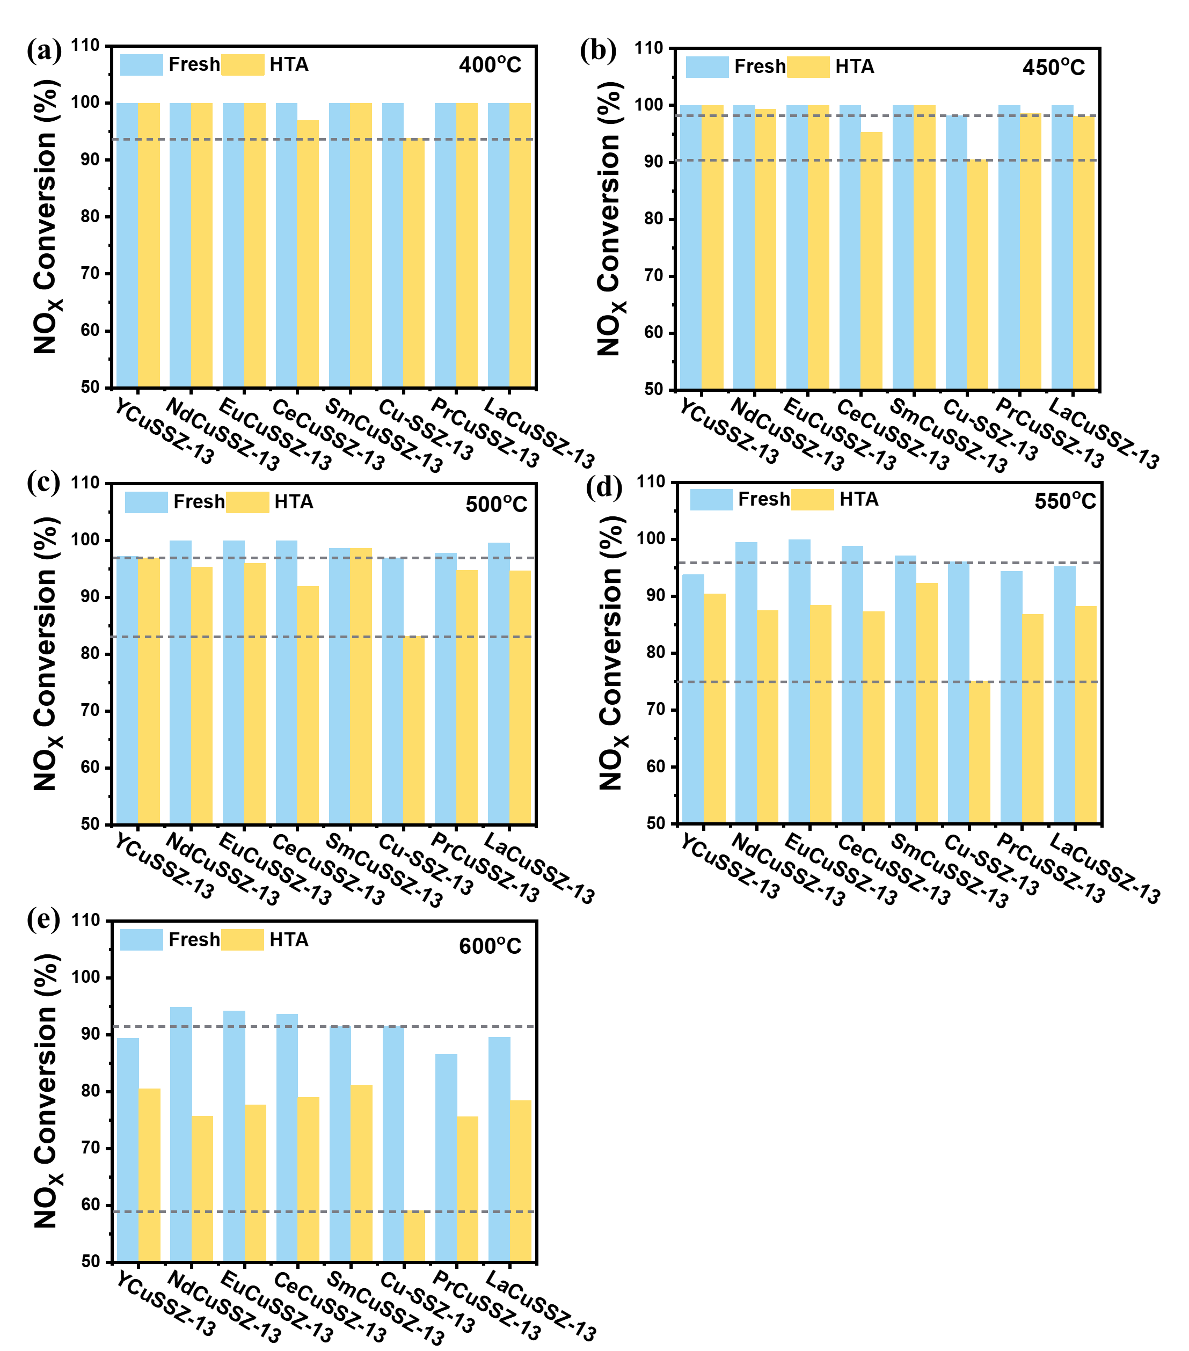

Fig. S7. NO_{x} conversions at 400~600 ℃ over Cu-SSZ-13 and RECuSSZ-13 samples before and after high-temperature hydrothermal ageing.

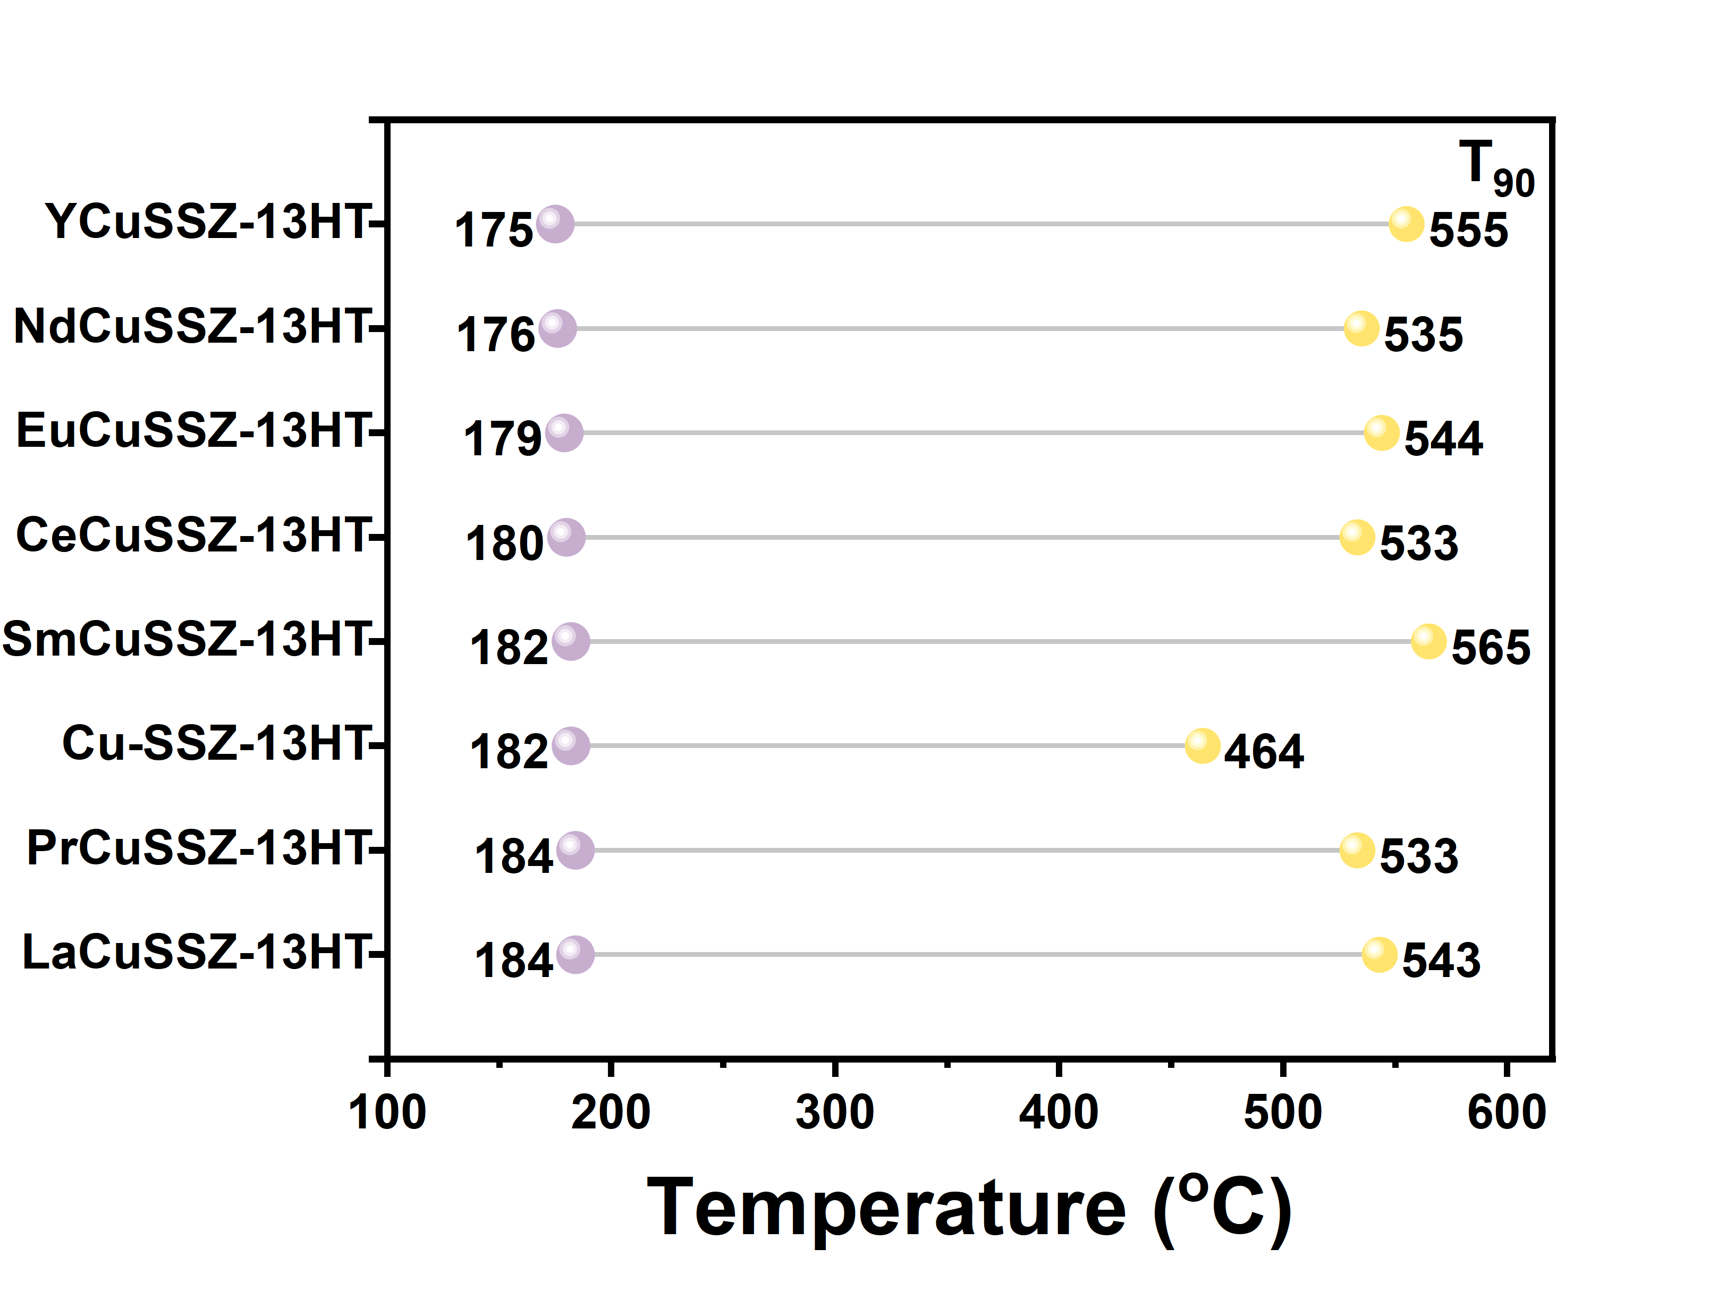

Fig. S8. The corresponding T₉₀ temperature window of Cu-SSZ-13HT and RECuSSZ-13HT catalysts.

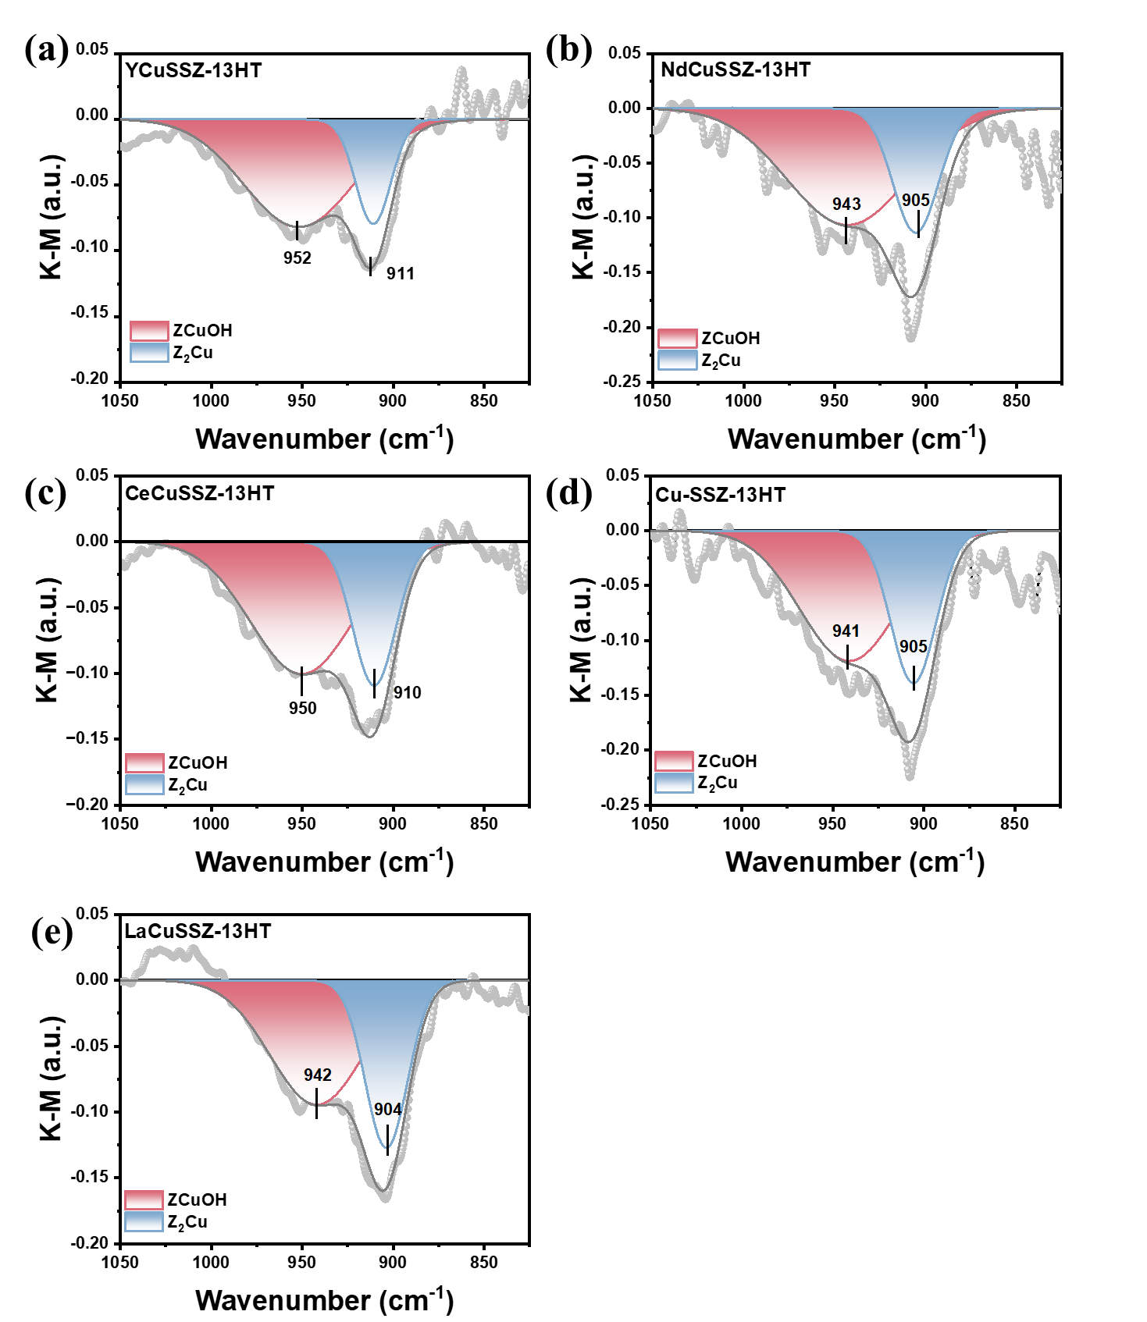

Fig. S9. In situ DRIFTS spectra after NH₃ adsorption saturation (T-O-T vibrations portion) over Cu-SSZ-13HT and RECuSSZ-13HT. Reaction conditions: 500 ppm NH₃ balanced with N₂.

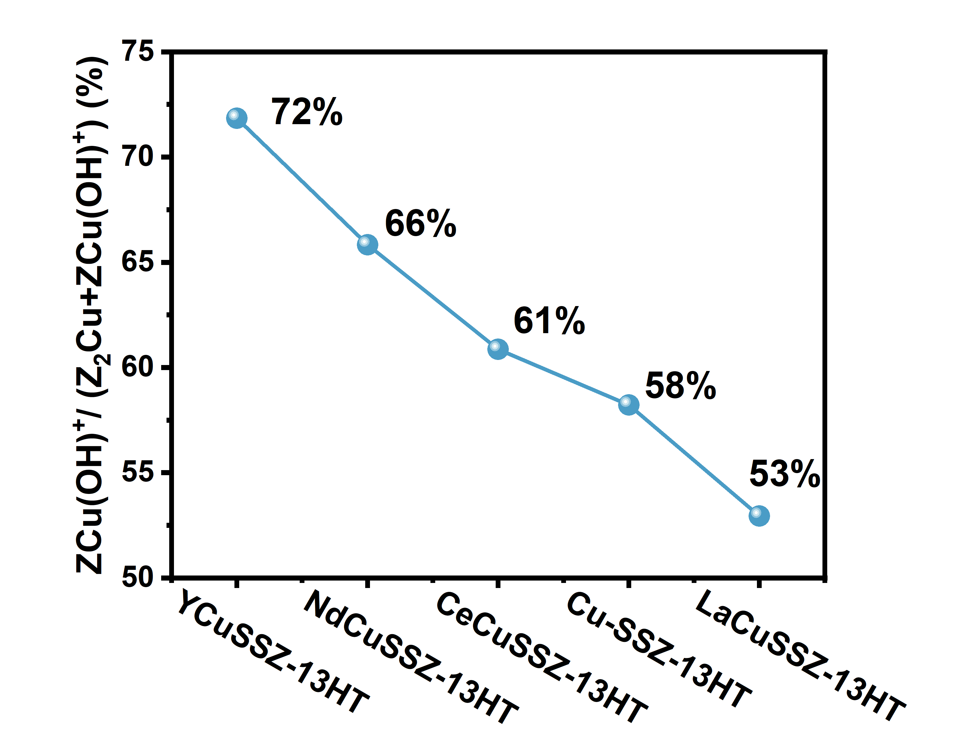

Fig. S10. The percentage of ZCu(OH)⁺ based on quadratic integration of H₂-TPR profiles.

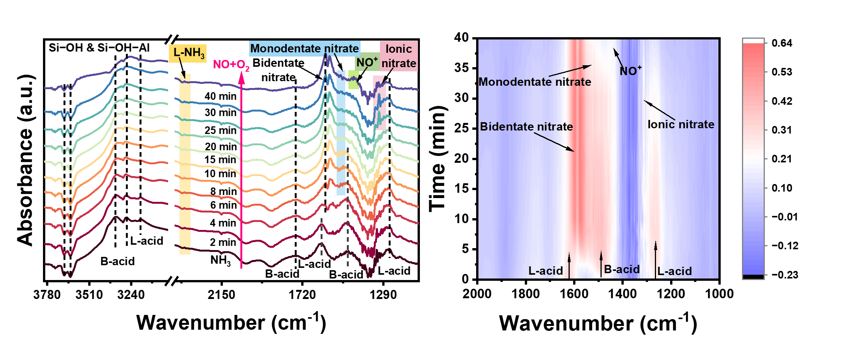

Fig. S11. In situ DRIFT spectra of the reaction between 500 ppm NO + 5% O₂ and pre-adsorbed NH₃ at 170 ℃ on the NdCuSSZ-13HT catalyst.

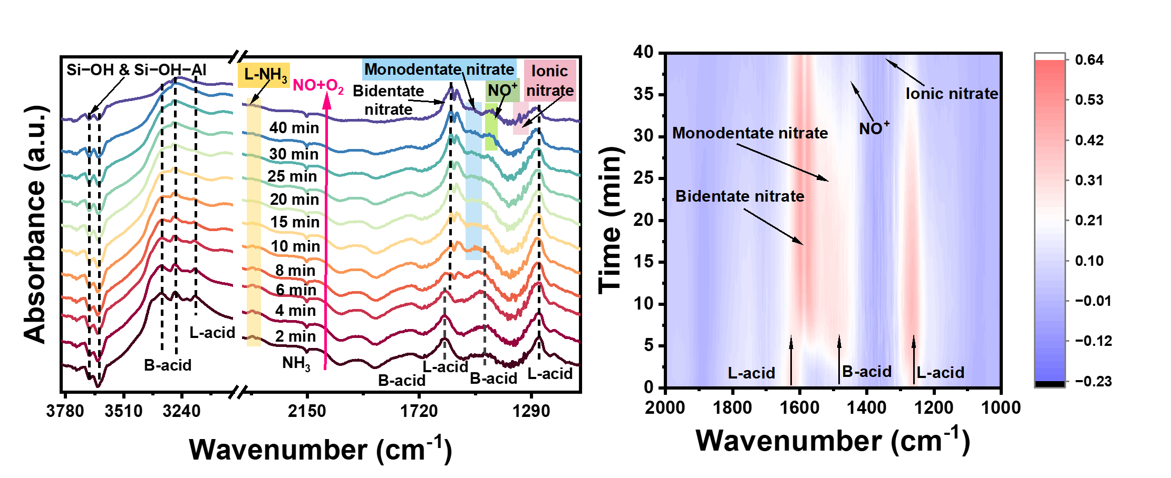

Fig. S12. In situ DRIFT spectra of the reaction between 500 ppm NO + 5% O₂ and pre-adsorbed NH₃ at 170 ℃ on the CeCuSSZ-13HT catalyst.

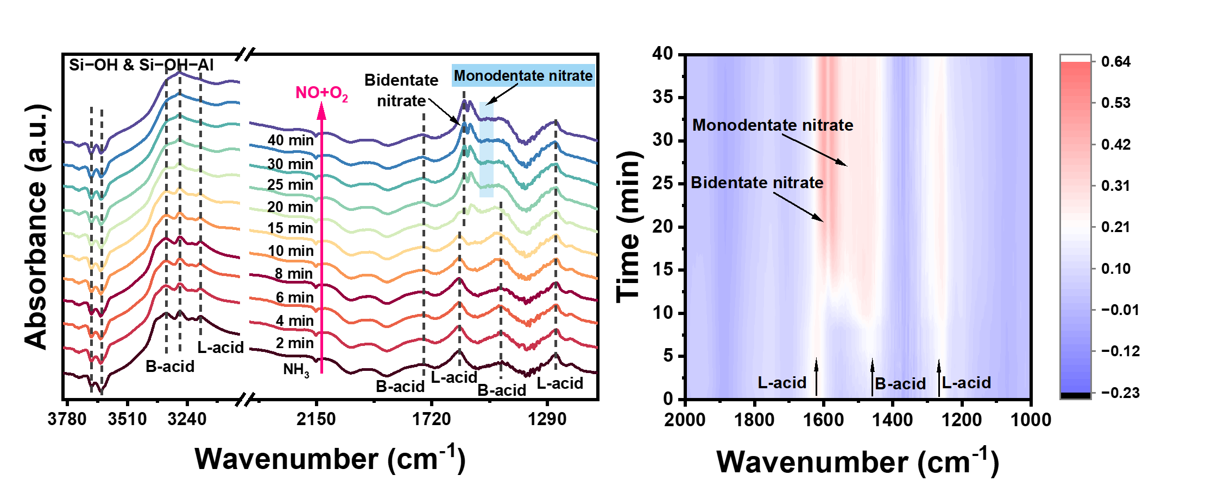

Fig. S13. In situ DRIFT spectra of the reaction between 500 ppm NO + 5% O₂ and pre-adsorbed NH₃ at 170 ℃ on the LaCuSSZ-13HT catalyst.

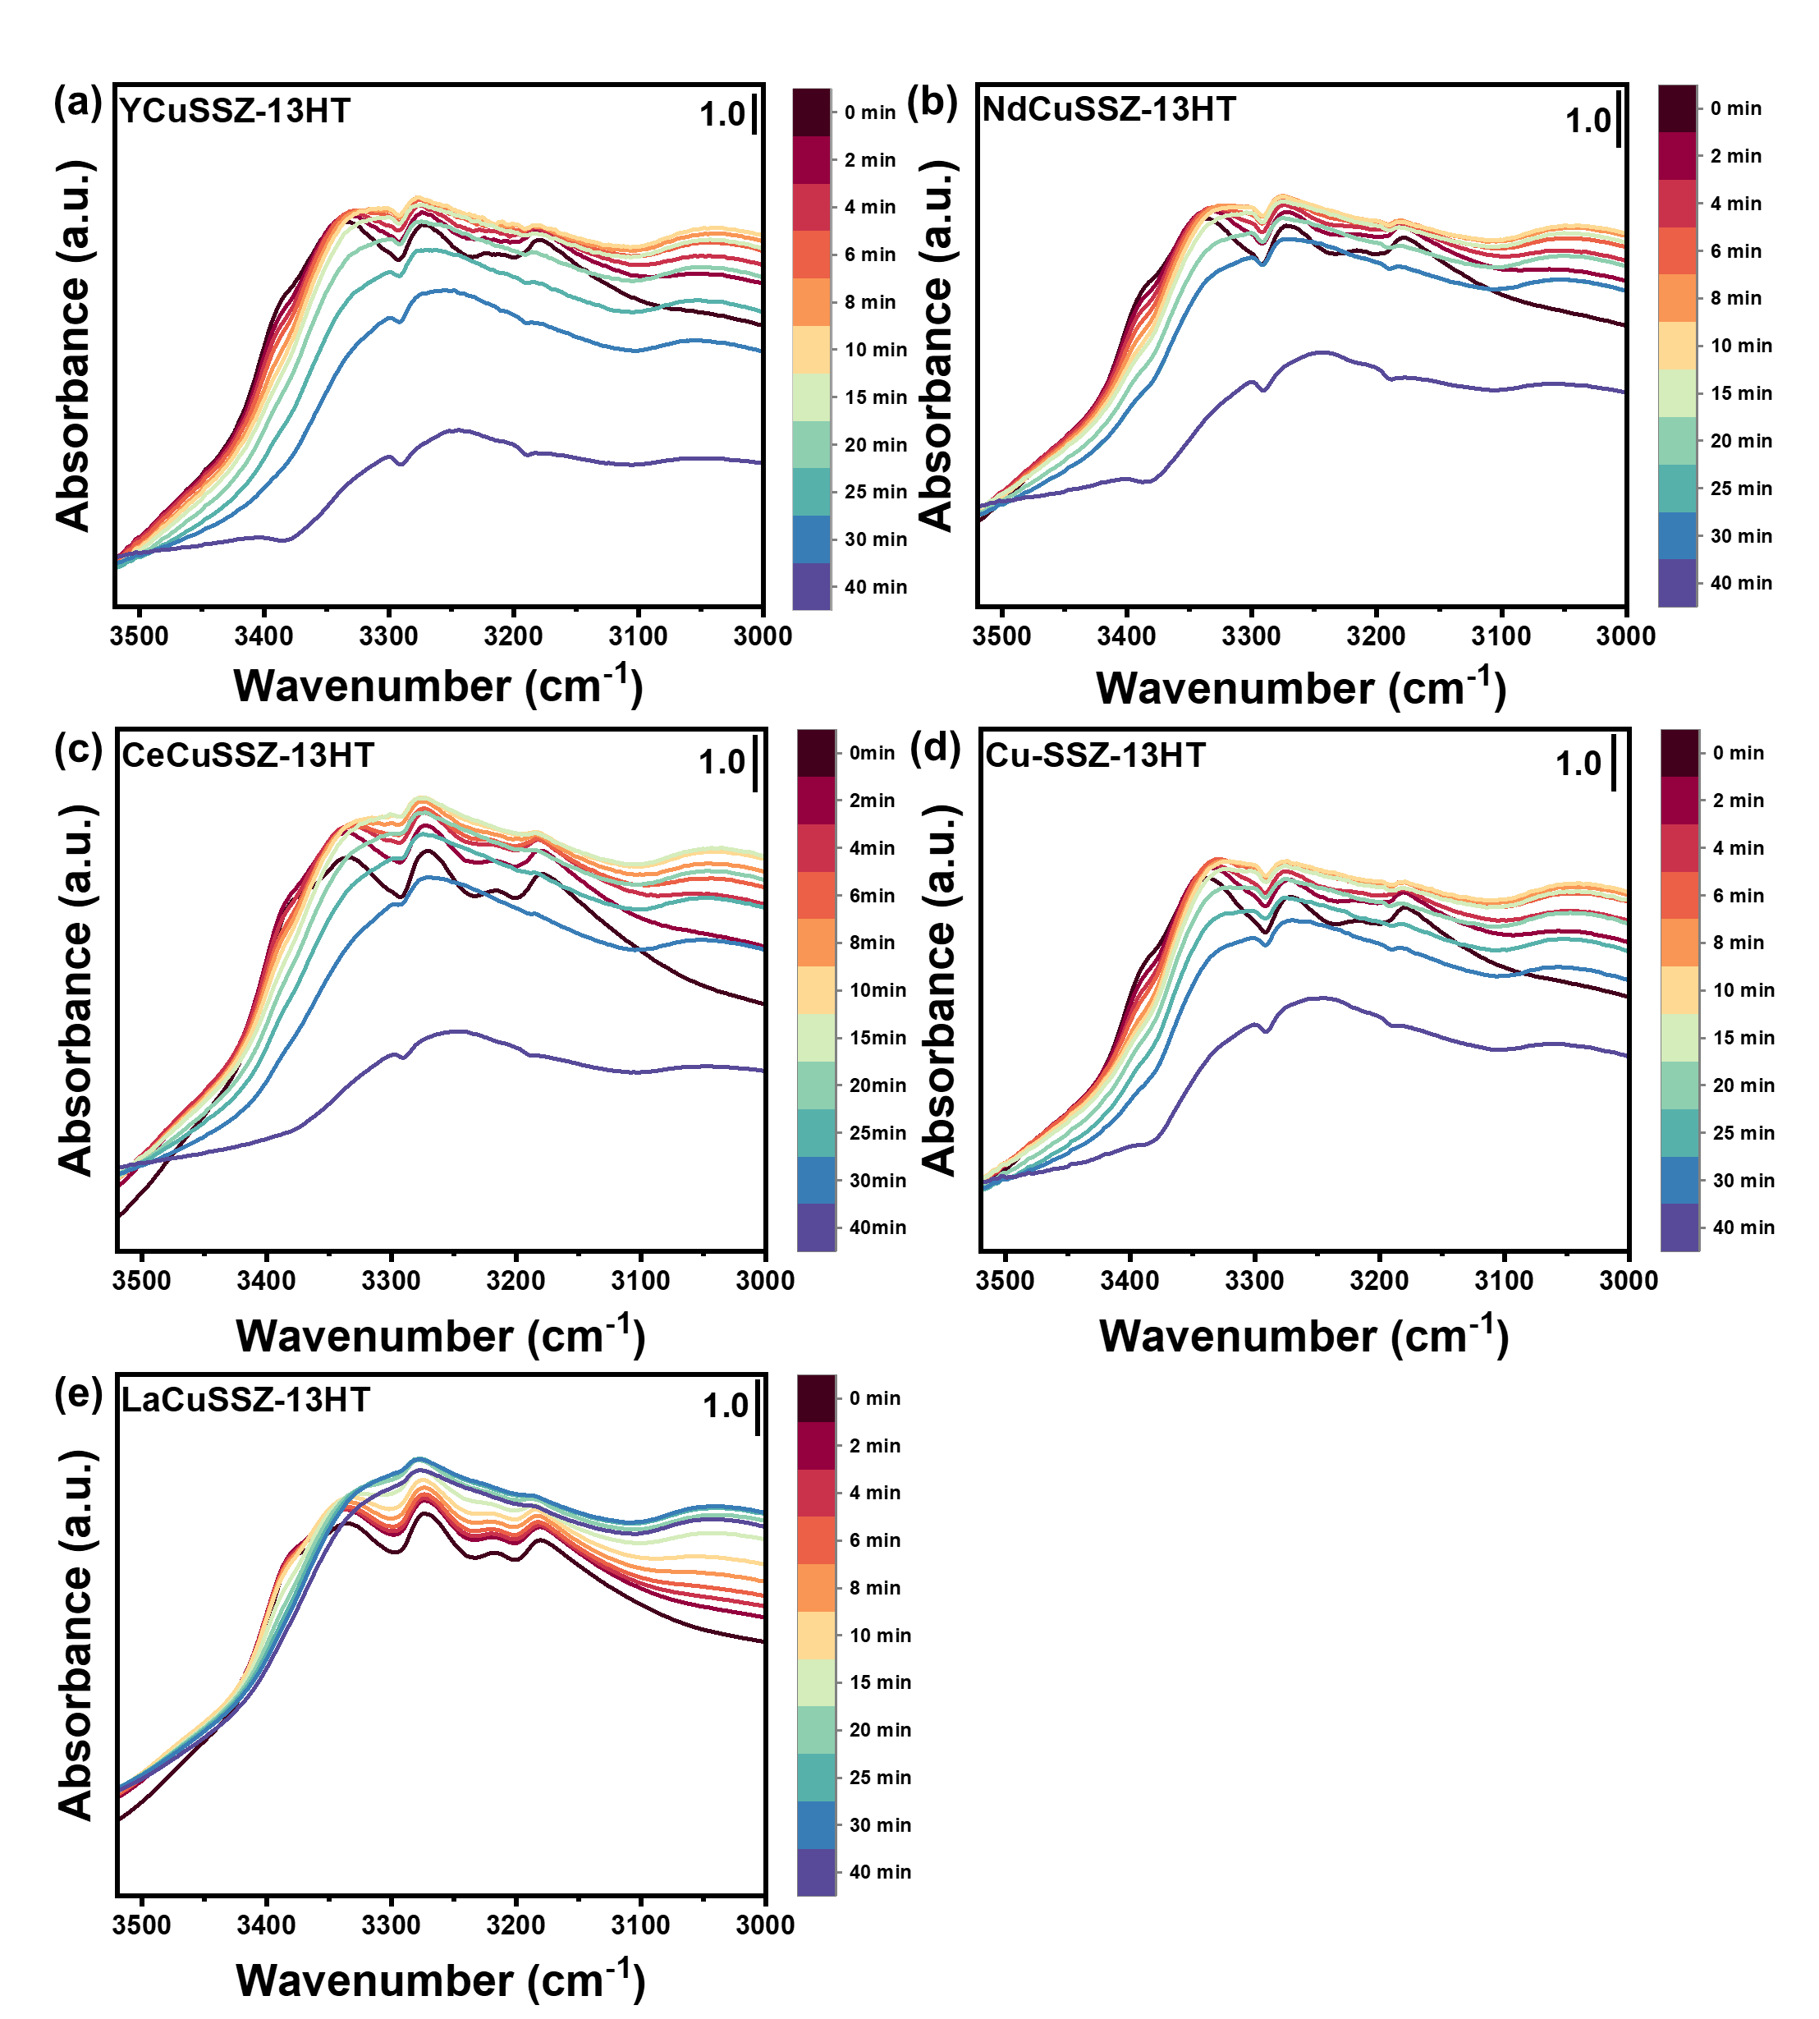

Fig. S14. In situ DRIFT spectra of the reaction between 500 ppm NO + 5% O₂ and pre-adsorbed NH₃ at 170 ℃ in the 3500~3000 cm⁻¹ region.

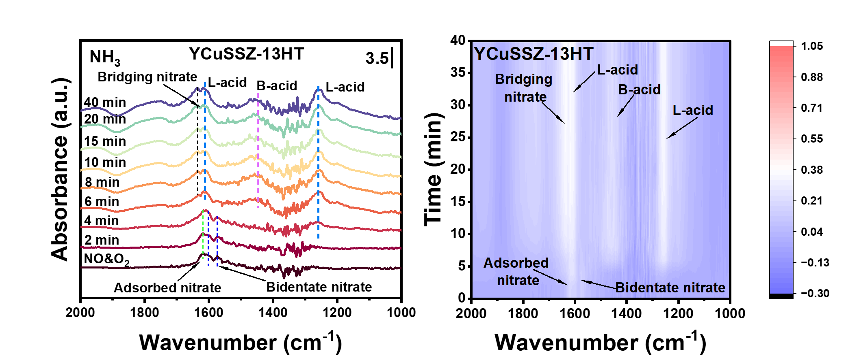

Fig. S15. In situ DRIFT spectra of the reaction between 500 ppm NH₃ and pre-adsorbed NO + O₂ at 170 ℃ on the YCuSSZ-13HT catalyst.

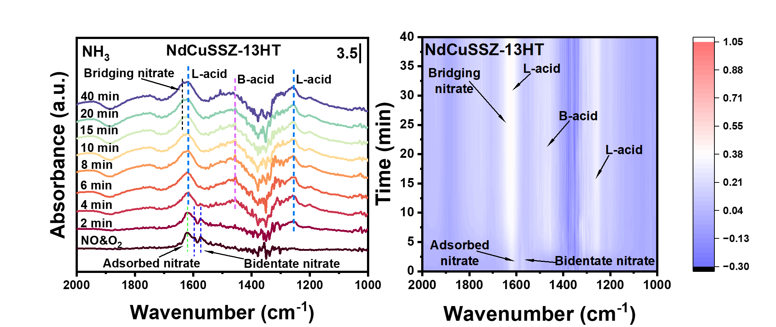

Fig. S16. In situ DRIFT spectra of the reaction between 500 ppm NH₃ and pre-adsorbed NO + O₂ at 170 ℃ on the NdCuSSZ-13HT catalyst.

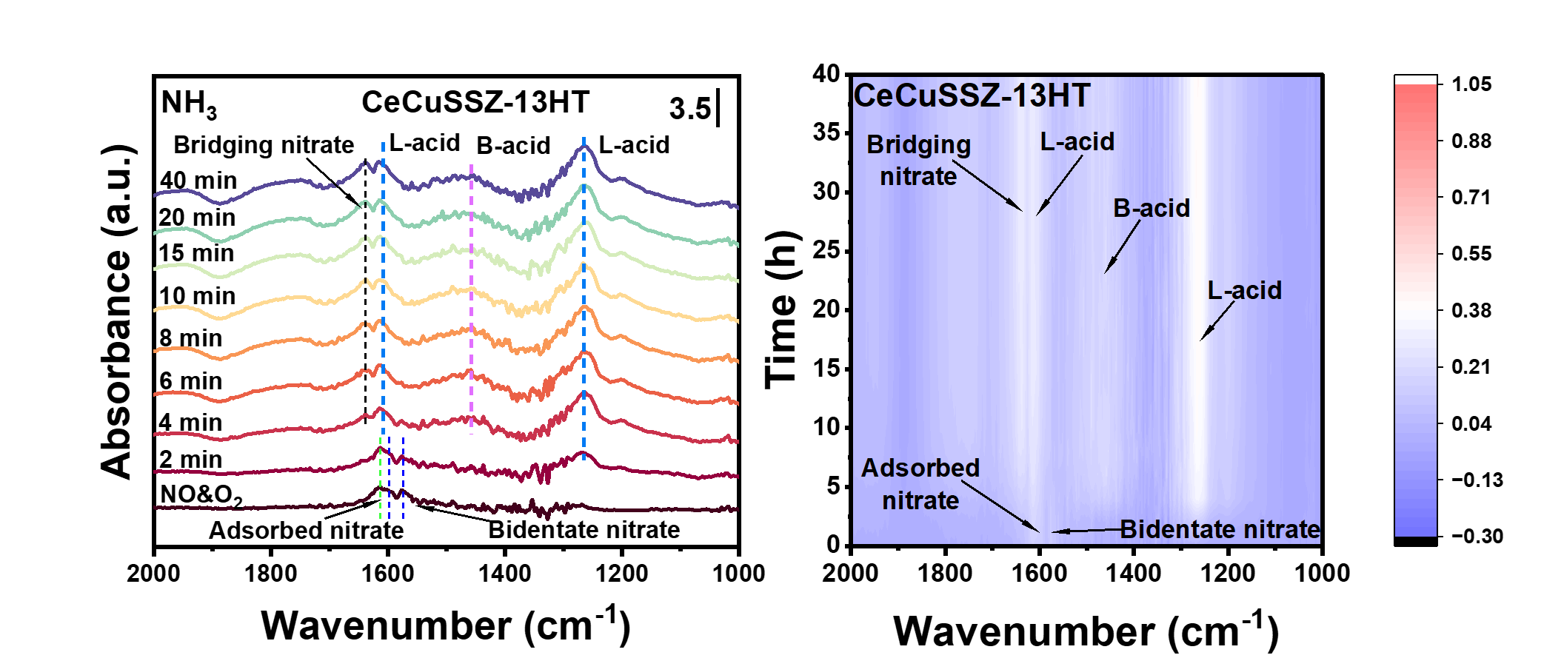

Fig. S17. In situ DRIFT spectra of the reaction between 500 ppm NH₃ and pre-adsorbed NO + O₂ at 170 ℃ on the CeCuSSZ-13HT catalyst.

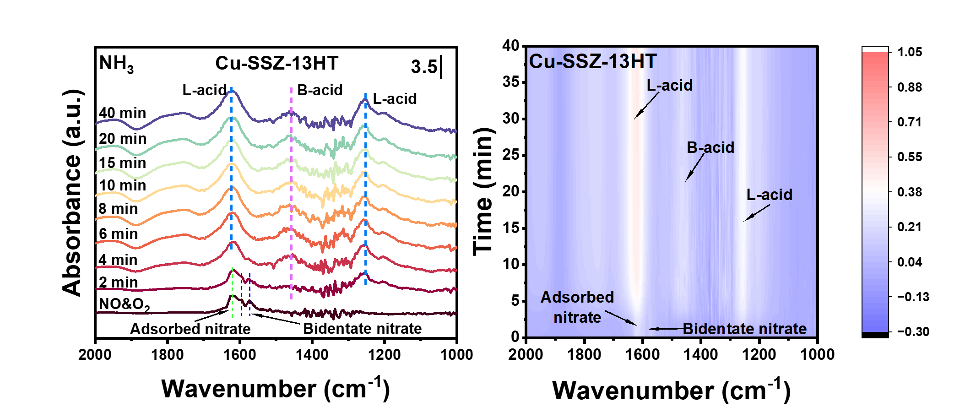

Fig. S18. In situ DRIFT spectra of the reaction between 500 ppm NH₃ and pre-adsorbed NO + O₂ at 170 ℃ on the Cu-SSZ-13HT catalyst.

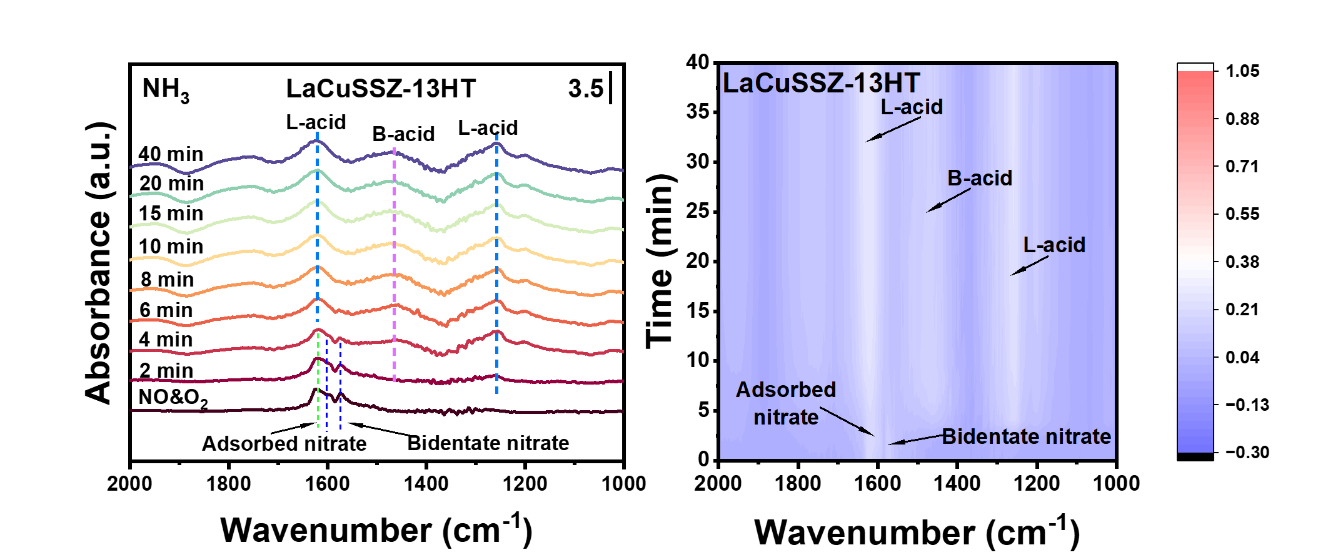

Fig. S19. In situ DRIFT spectra of the reaction between 500 ppm NH₃ and pre-adsorbed NO + O₂ at 170 ℃ on the LaCuSSZ-13HT catalyst.

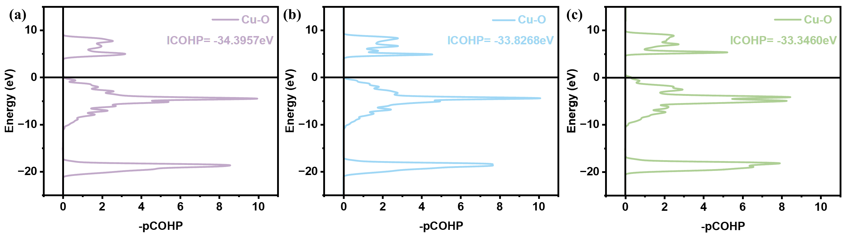

Fig. S20. The pCOHP and ICOHP results for (a) NdCuSSZ-13, (b) CeCuSSZ-13, and (c) LaCuSSZ-13 systems.

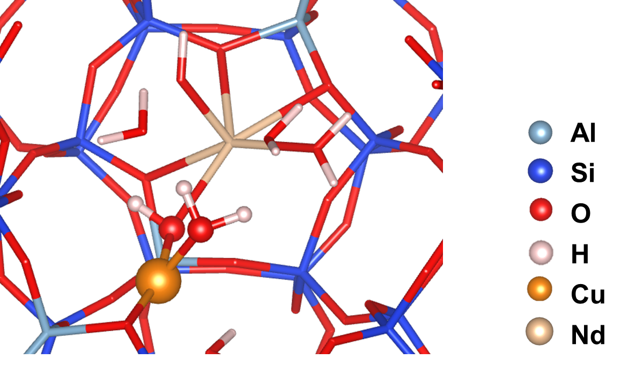

Fig. S21. Configuration from AIMD revealing a Cu(OH)₂ unit within the NdCuSSZ-13 framework.

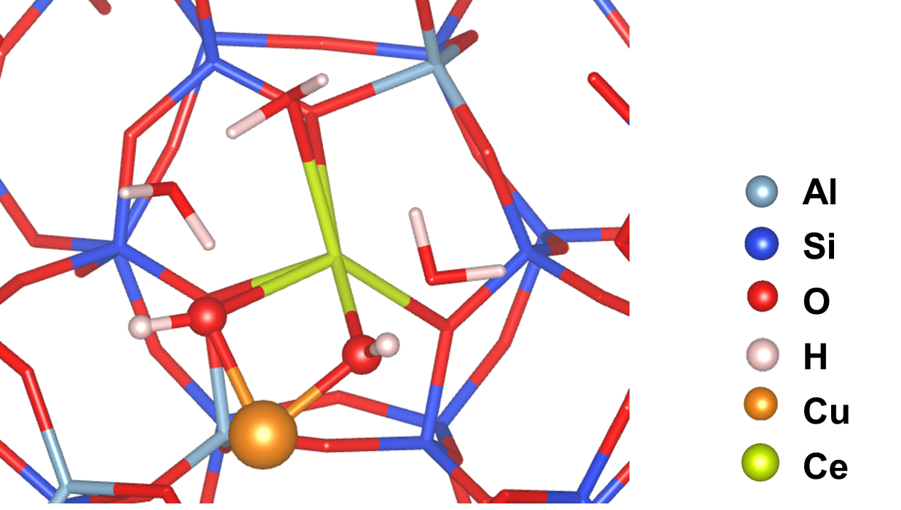

Fig. S22. Configuration from AIMD revealing a Cu(OH)₂ unit within the CeCuSSZ-13 framework.

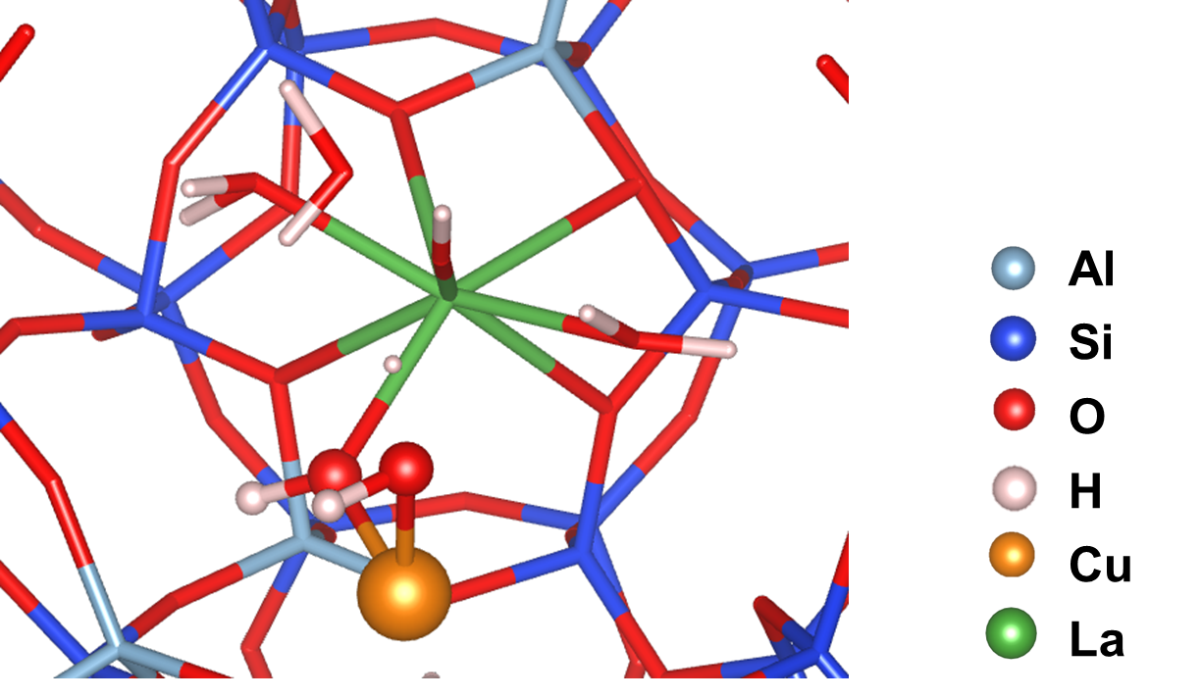

Fig. S23. Configuration from AIMD revealing a Cu(OH)₂ unit within the LaCuSSZ-13 framework.

Table S1. Characterization of the Si/Al ratio and elemental composition of the catalysts.
Samples | Si/Alª | Cu^{b} | RE^{b}
LaCuSSZ-13 | 6.4 | 3.4% | 0.5%
CeCuSSZ-13 | 6.2 | 3.5% | 0.5%
PrCuSSZ-13 | 6.2 | 3.2% | 0.4%
NdCuSSZ-13 | 6.2 | 3.6% | 0.4%
SmCuSSZ-13 | 6.3 | 3.7% | 0.5%
EuCuSSZ-13 | 6.1 | 3.5% | 0.4%
YCuSSZ-13 | 6.1 | 3.2% | 0.4%
a: Calculated by XRF.
b: Calculated by ICP.

Table S2. Data results related to Fig. 2e.
Catalysts | C₁₇₅ ª | C₆₀₀ ^{b} | △T₉₀ ^{c} | △C_{F-A} ^{d} | △S₉₅ ^{e}
YCuSSZ-13HT | 89.9 | 80.5 | 379.4 | -1.1 | 450
NdCuSSZ-13HT | 88.6 | 75.7 | 358.9 | 2.2 | 450
EuCuSSZ-13HT | 83.1 | 77.7 | 364.2 | 2.9 | 450
CeCuSSZ-13HT | 79.2 | 79 | 352.8 | 4.6 | 400
SmCuSSZ-13HT | 78 | 81.2 | 382.6 | 4.1 | 450
Cu-SSZ-13HT | 76 | 59.1 | 281.7 | 8.7 | 300
PrCuSSZ-13HT | 73.8 | 75.6 | 349.1 | 2.7 | 450
LaCuSSZ-13HT | 70.8 | 78.4 | 359.1 | 5.4 | 450
a: The NO_{x} conversion at 175 ℃;
b: The NO_{x} conversion at 600 ℃;
c: Temperature window corresponding to 90 % conversion;
d: The average value of the decrease in NO_{x} conversions for the fresh catalysts and the hydrothermal-aged catalysts within the temperature range of 150 to 600 ℃;
e: The temperature range of N₂ selectivity ≥95%.

Table S3. Representative rare earth modified Cu-zeolites for the NH₃-SCR reaction.
Catalyst | NO_{x} Conv. (175 ℃) -HT (%) | NOₓ Conv. (550 ℃) -HT (%) | ΔT₉₀ (HT) | Ref.
YCuSSZ-13HT | 90 | 80 | 380 | This work
Cu-Sm-SSZ-13 | 35 | 80 | 120 | ^{[2]}
Cu-Pr-SSZ-13 | 33 | 78 | 100 | ^{[3]}
Cu-Cd-SSZ-13 | 85 | 80 | 340 | ^{[4]}
CM/CSZ-BM | 50 | 70 | 190 | ^{[5]}
Cu-Fe-SSZ-13 | 85 | 80 | 100 | ^{[6]}
CuLa_{0.5}-SAPO34 | 95 | 72 | 290 | ^{[7]}
Cu/Y-S | 65 | 70 | 180 | ^{[8]}
Cu/SSZ-13@CeO₂ | 32 | 60 | 0 | ^{[9]}
The references (2~9) are consistent with those cited in Fig. 2f in the manuscript.

Table S4. EPR results of catalysts.
Samples | Total peak area of the curve (Hydrate-Dehydrate) | Percentage increase upon RE incorporation (%)
YCuSSZ-13HT | 916029.5 | 19.3
NdCuSSZ-13HT | 832503.3 | 8.5
CeCuSSZ-13HT | 827794.9 | 7.8
Cu-SSZ-13HT | 767646.5 | -
LaCuSSZ-13HT | 742274.0 | -3.3

Table S5. Integral results of the NH₃-TPD profile.
Samples | Relative Proportion of Integrated Peak Area (%)
Samples | Peak position |  |  |  |  | Peak Area
YCuSSZ-13HT | 231.7 | 274.5 | 337.2 | 463.5 | 677.4 |  | 2086.6 | 3376.4 | 2565.1
NdCuSSZ-13HT | 235.8 | 276.0 | 344.7 | 466.3 | 886.5 |  | 2447.4 | 2983.2 | 2363.2
CeCuSSZ-13HT | 234.8 | 275.7 | 348.5 | 464.0 | 600.0 |  | 2622.4 | 2721.7 | 2581.3
Cu-SSZ-13HT | 236.6 | 288.3 | 352.1 | 482.6 | 1200.0 |  | 2754.6 | 2504.6 | 2568.4
LaCuSSZ-13HT | 238.2 | 295.0 | 358.2 | 480.8 | 1735.3 |  | 2803.1 | 2410.9 | 2064.4

Table S6. Comparison of the occurrence times of various nitrate species in in-situ DRIFT spectra.
Samples | Monodentate nitrate |  |  | Bidentate nitrate |  | Nitrate
Samples | Occurrence time |  | Disappearance time | Occurrence times of nitrate species (min)
YCuSSZ-13HT | 2 | 20 |  |  | 4 |  | 25
NdCuSSZ-13HT | 6 | 40 |  |  | 4 |  | 25
CeCuSSZ-13HT | 8 | 40 |  |  | 6 |  | 40
Cu-SSZ-13HT | 4 | 40 |  |  | 4 |  | 40
LaCuSSZ-13HT | 20 | 40 |  |  | 15 |  | -

Reference
[1] Luo J, et al. New Insights into Cu/SSZ-13 SCR Catalyst Acidity. Part I: Nature of Acidic Sites Probed by NH₃ Titration. J. Catal. 348, 291-299 (2017).
[2] Chen MY, et al. Unveiling secondary-ion-promoted catalytic properties of Cu-SSZ-13 zeolites for selective catalytic reduction of NO_{x}. J. Am. Chem. Soc. 144, 12816-12824 (2022).
[3] Chen MY, et al. Improving the hydrothermal stability of Al-rich Cu-SSZ-13 zeolite via Pr-ion modification. Chem. Sci. 15, 5548-5554 (2024).
[4] Li M, et al. The preferential occupying effect regulated atomically dispersed Cu site over Cu-SSZ-13 for enhancing NH₃-SCR performance. Fuel 380, 133202 (2025).
[5] Andana T, et al. Selective catalytic reduction of NO_{x} with NH₃ over Ce-Mn oxide and Cu-SSZ-13 composite catalysts – low temperature enhancement. Appl. Catal. B Environ. 316, 121522 (2022).
[6] Tan MJ, et al. Introduction of iron by a feasible way to regulate Cu sites of Cu-SSZ-13 with enhanced hydrothermal stability and SO₂ resistance for NH₃-SCR. Micropor Mesopor Mat. 394, 113668 (2025).
[7] Li GB, et al. One stone four birds: The redox and acid-basic site integral regulation by La in Cu-SAPO-34 for boosting NO reduction. Appl. Catal. B Environ. 378, 125647 (2025).
[8] Gao LY, et al. Boosting low-temperature and high-temperature hydrothermal stability of Cu/SAPO-34 for NO removal via Yttrium decoration. Chem. Eng. J. 455, 140520 (2023).
[9] Zhang JN, et al. Enhancing hydrothermal stability in Cu/SSZ-13 catalyst for diesel SCR applications through a novel core-shell structure. Chin. Chem. Lett. 36, 110516 (2025).

