Appendix figure 2: Screening rates during and post implementation support

Implementation
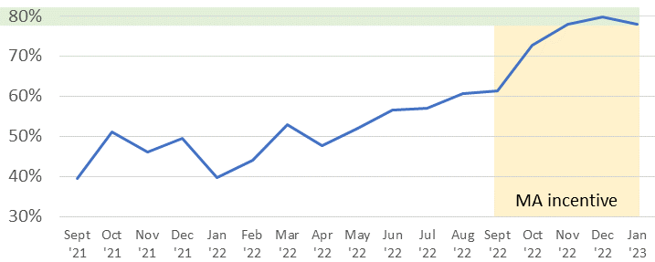

Post-implementation
